# Australian Commission on Safety and Quality logotypeOn the Radar

Issue 600

1 May 2023

*On the Radar* is a summary of some of the recent publications in the areas of safety and quality in health care. Inclusion in this document is not an endorsement or recommendation of any publication or provider. Access to particular documents may depend on whether they are Open Access or not, and/or your individual or institutional access to subscription sites/services. Material that may require subscription is included as it is considered relevant.

*On the Radar* is available online, via email or as a PDF or Word document from <https://www.safetyandquality.gov.au/publications-and-resources/newsletters/radar>

If you would like to receive *On the Radar* via email, you can subscribe on our website <https://www.safetyandquality.gov.au/publications-and-resources/newsletters>  
or by emailing us at H[Umail@safetyandquality.gov.auU](mailto:mail@safetyandquality.gov.au).   
You can also send feedback and comments to H[Umail@safetyandquality.gov.auU](mailto:mail@safetyandquality.gov.au).

For information about the Commission and its programs and publications, please visit <https://www.safetyandquality.gov.au>

You can also follow us on Twitter @ACSQHC.

**On the Radar**

Editor: Dr Niall Johnson [niall.johnson@safetyandquality.gov.au](mailto:niall.johnson@safetyandquality.gov.au)

Contributors: Niall Johnson

**Journal articles**

*Use of Technology to Improve Adherence to Surgical Safety Checklists in the Operating Room*

Mishra TS, Preetam C, Venkateshan M, Kunjanpillai JS, Pati AB

The Joint Commission Journal on Quality and Patient Safety. 2023.

|  |  |
| --- | --- |
| DOI | <https://doi.org/10.1016/j.jcjq.2023.04.005> |
| Notes | Paper describing the development and implementation of a smartphone version of a surgical safety checklist in an Indian hospital. The authors report that ‘The frequency of use was 100.0% for the electronic checklist, compared with 97.9% for the traditional checklist.’ The smartphone application was linked to the operating theatre’s ‘electrocautery equipment, which could not be started before the electronic checklist was completed on the screen of the personal device.’ |

*Reducing the environmental impact of surgery on a global scale: systematic review and co-prioritization with healthcare workers in 132 countries*

National Institute for Health Care Research Global Health Research Unit on Global Surgery

British Journal of Surgery. 2023:znad092.

|  |  |
| --- | --- |
| DOI | <https://doi.org/10.1093/bjs/znad092> |
| Notes | Issues around the environmental impact and sustainability of healthcare delivery are garnering greater attention. This paper reports on an international survey of clinicians that sought to identify and prioritize interventions to reduce the environmental impact of operating theatres. The study used a four-phase Delphi consensus approach.  The authors report that:   * top three shortlisted interventions for high-income countries were: introducing recycling; reducing use of anaesthetic gases; and appropriate clinical waste processing * the top three shortlisted interventions for low–middle-income countries were: introducing reusable surgical devices; reducing use of consumables; and reducing the use of general anaesthesia.   Sustainability is not just an environmental issue. A number of issues can interact, including environmental impact, variation, appropriateness of care, low value care, workforce, etc. |

*Creating a Stronger Culture of Safety Within US Community Pharmacies*

Lewis NJW, Marwitz KK, Gaither CA, Haugtvedt CL, Selkow L, Sinha S

The Joint Commission Journal on Quality and Patient Safety. 2023;49(5):280-284.

|  |  |
| --- | --- |
| DOI | <https://doi.org/10.1016/j.jcjq.2023.01.012> |
| Notes | The extent of safety and quality issues in primary care remains something of an unknown. This paper looks at community pharmacy in the USA and the authors observe that ‘Compared to the focus on patient safety initiatives within hospital settings, relatively little attention has been given to prescription safety within community pharmacy settings.’ While discussing ‘prescription safety’, prescription errors and safety practices they also note that ‘The linchpin to effectively preventing prescription errors in community pharmacies is the presence of a culture of safety that is built on shared trust and communication extending from corporate leadership to frontline pharmacy staff.’ But is culture and putting the onus on pharmacists the optimal approach? Could better solutions that move the burden from the community pharmacist be devised? |

*The Joint Commission Journal on Quality and Patient Safety*

Volume 49, Issue 5, May 2023

|  |  |
| --- | --- |
| URL | <https://www.sciencedirect.com/journal/the-joint-commission-journal-on-quality-and-patient-safety/vol/49/issue/5> |
| Notes | A new issue of *The Joint Commission Journal on Quality and Patient Safety* has been published. Articles in this issue of *The Joint Commission Journal on Quality and Patient Safety* include:   * Editorial: Understanding A Surgeon's Worst Nightmare: **Wrong Site Surgery** (Tyler P Robinson, Karl Y Bilimoria, Anthony D Yang) * Real-World Observational Evaluation of Common Interventions to Reduce **Emergency Department Prescribing of Opioid Medications** (Rohit B Sangal, Craig Rothenberg, Kathryn Hawk, Gail D'Onofrio, Allen L Hsiao, Yauheni Solad, Arjun K Venkatesh) * Improving Safety During **Transitions of Care** Through the Use of Electronic Referral Loops to Receive and Reconcile Health Information (Gary Allen, Jessica Setzer, Rose Jones, Gregory Knapp) * Integrating **Implementation Science in a Quality and Patient Safety Improvement Learning Collaborative**: Essential Ingredients and Impact (Lianne Jeffs, Frances Bruno, Rui Lin Zeng, Noah Schonewille, Kim Kinder, Gina De Souza, Maryanne D'Arpino, G Ross Baker) * A Contemporary Analysis of Closed Claims Related to **Wrong-Site Surgery** (Joy Tan, Jacqueline M Ross, Daniel Wright, Marc Philip Tanedo Pimentel, Richard D. Urman) * Extending **Maternal Care After Pregnancy**: An Initiative to Address Health Care Disparities and Enhance Access to Care After Delivery (David B Nelson, Robert Martin, Elaine L Duryea, Ashlyn K Lafferty, Donald D McIntire, Jessica Pruszynski, Elizabeth Rochin, Catherine Y Spong) * Creating a Stronger **Culture of Safety Within US Community Pharmacies** (Nancy J W Lewis, Kathryn K Marwitz, Caroline A Gaither, Candace L Haugtvedt, Larry Selkow, Soosmita Sinha) * A Description of the Variation in **Quality and Patient Safety Structures Within a Health System** (Laura C Myers, Hojjat Salmasian, Christine Iannaccone, Michelle L Frits, Lynn A Volk, David W Bates, Elizabeth Mort) |

*Patient Experience Journal*

Volume 10, Issue 1, 2023

|  |  |
| --- | --- |
| URL | https://pxjournal.org/journal/vol10/iss1/ |
| Notes | A new issue of *Patient Experience Journal* (PXJ)has been published. Articles in this issue of *Patient Experience Journal* include:   * Editorial: Building on a decade of hope: Why we must **champion the human experience** (Jason A Wolf) * Partnering with healthcare: The experiences of **consumer representatives** (Corey Adams and Anthony J Brown) * Everything I needed to know to be a **pediatric emergency room doctor**, I learned as a waitress (Sarah Gard Lazarus) * **Seeking answers through the pain** (Gillian Pearce) * A concept analysis of the **patient experience** (Tanja Avlijas; Janet E Squires; Michelle Lalonde; and Chantal Backman) * **Listening as medicine**: A thematic analysis (Rachel Kishton., Heta Patel, Divya Saini, Jeffrey Millstein, and Aaron Levy) * **Patient experiences through head and neck cancer**: Information delivery combatting psychological distress (Eleah Stringer., Julian J Lum, Jonathan Livergant, and Andre Kushniruk) * **Patient experience in an interprofessional collaborative practice** for underserved patients with heart failure (Connie White-Williams, Maria R Shirey, Reid Eagleson, Wei Su, Terri Poe, Brittany Fitts, and Vera Bittner) * **Patients’ and family caregivers’ experiences with a newly implemented hospital at home program** in British Columbia, Canada: Preliminary results (Sean P Spina; Rounak Haddadi; Katy Mukai; Michelle Riddle; Beth Bourke; Lisa Thompson; Elizabeth Borycki; David Forbes; Taylor Hainstock; Curtis K Harder; N Humber; A Kushniruk; T McMillan; S Tierney; and M Z Mullins) * **Interventions that improve patient experience** evidenced by raising HCAHPS and CG-CAHPS Scores: A narrative literature review (Heather McKee Hurwitz, MaryBeth Mercer, and Susannah L Rose) * **Living with COVID-19 in the community** during the first wave of the pandemic: Lessons from patients for healthcare providers and policy makers (Linda Rozmovits, Michelle Marcinow, Ilja Ormel, Terence Tang, Elizabeth Mansfield, Kerry Kuluski, Seema Marwaha, and Susan Law) * **Strengthening patient-family engagement** amidst a pandemic: Lessons learned and paths forward (Kyle J. Rehder, S Haney, J Freeman, and A West) * Draws and windfalls: Comparing **patient experiences in inpatient telehealth and non-telehealth acute care units** (Geoffrey A Silvera, Erin Blanchard, Varun Natarajan, Eric Wallace, William Steve Stigler, Bart Kelly, Terri Scarborough, and Sue S Feldman) * **Digital patient engagement** at a perioperative surgical home implemented community hospital (Srinivasan Sridhar, Amy Mount Hunter, and B McCrory) * A roadmap to **engaging patients in research**: The experience of a large academic research hospital in Canada (Rabia Zaheer, Sara Morassaei, Sander L Hitzig, Laurie Legere, Mary Jane Torrie, and Lisa Di Prospero) * Part of the team: Effecting change and **sharing power in healthcare settings** (Jessica Stanier, Rachel Purtell, Dave Thomas, and William Murray) * Storytelling at board meetings: A case study of **co-developing recommendations** (Dawn Richards, Kimberly Strain, Lisa Hawthornthwaite, Isabel Jordan, and Carol Fancott) |

*Healthcare Quarterly*

Volume 26, Number 1, April 2023

|  |  |
| --- | --- |
| URL | <https://www.longwoods.com/publications/healthcare-quarterly/27049/1/vol.-26-no.-1-2023> |
| Notes | A new issue of *Healthcare Quarterly* has been published. Articles in this issue of *Healthcare Quarterly* include:   * **Cancer Risk among Adults Living with HIV** in Ontario (Ioana A Nicolau and Ann N. Burchell) * Filling Data Gaps in **Access to Mental Health and Substance Use Services** (Allison Sabad, Sara Grimwood, Andrea Foebel and Mélanie Josée Davidson) * Innovations to Address **Social Isolation for Elderly Canadians** Aging at Home (Neil Seeman) * Beyond Housing: Supporting the **Health and Well-Being of Individuals Residing in Toronto’s Temporary Shelter** Hotels (John Ecker, Oluwagbenga Dada, Katherine Francombe Pridham and Stephen W Hwang) * Palliative Education and Care for the Homeless (PEACH): A Model of **Outreach Palliative Care for Structurally Vulnerable Populations** (Nicole Buchanan, Naheed Dosani, Andrew Bond, Donna Spaner, Alissa Tedesco, Nadine Persaud and Trevor Morey) * **Community Wellness Bus**: A Partner-Led Initiative to Improve Service Integration and Address Unmet Needs of Underserved Populations in Algoma District, Ontario (Jeffrey Dorans, Cassandra Lepore, Erin M Mulroney, Victoria Aceti Chlebus and Sophia Myles) * Recommendations to Enhance **Physical Health for Individuals with Severe Mental Illness** in Canadian Healthcare Organizations (Tania Tajirian, Cristina de Lasa, Caroline Chessex, Brian Lo, Po-Yen (Brian) Chang, Rola Moghabghab, D Sinclair, D Jankowicz, S Sockalingam and V Stergiopoulos) * **After The Pandemic**. Shadows and Light: An Interview with Heather Patterson (Neil Stuart and Anne Wojtak) * Adapting Our SCOPE: Lessons Learned from **Spreading and Scaling Efforts to Integrate Care** (Parisa Mehrfar, Jaclyn Martyn, Celia Laur, Noah Ivers, Aleisha Fernandes, Harpreet Bassi, M Alarakhia, N Alam and P Pariser) * Key Stakeholder Perceptions of Standard vs. Total Cost of Ownership: A **Procurement Analysis for Orthopaedic-Powered Instruments** (Aazad Abbas, Olumide Olotu, Sejla Abdic, Albert Yee, Jeremie Larouche, Cari Whyne, Dante Morra and Jay Toor) |

*The Milbank Quarterly*

Volume 47, Number 2, April 2023

|  |  |
| --- | --- |
| URL | <https://onlinelibrary.wiley.com/toc/14680009/2023/101/S1> |
| Notes | A new issue of *The Milbank Quarterly* has been published. This is the centennial issue of *The Milbank Quarterly* and has a theme of The Future of Population Health*.* Articles in this issue of *The Milbank Quarterly* include:   * **Population Health Over the Next Decade**: Major Challenges and Policy Prospects (Alan B Cohen, Sandro Galea, Paula M Lantz) * Upstream Policy Changes to Improve **Population Health and Health Equity**: A Priority Agenda (Rashwn Ray, Paula M Lantz, David Williams) * The Future of **Social Determinants of Health**: Looking Upstream to Structural Drivers (Tyson H Brown, Patricia Holman) * The Perils of Medicalization for **Population Health and Health Equity** (Paula M Lantz, Daniel S Goldberg, Sarah E Gollust) * Framing **Commercial Determinants of Health**: An Assessment of Potential for Guiding More Effective Responses to the Public Health Crises of the 21st Century (Nichola Freudenberg) * **Human Health and Well-being in a Warming World** (Amruta Nori-Sarma, Gregory Wellenius) * **Immigration and Immigrant Policies, Health, and Health Equity** in the United States (Alana M W Lebrón, Ivy R Torres, Nolan Kline, William D Lopaz, Maria-Elena de Trinidad Young, Nicole Novak) * **Urbanization and the Future of Population Health** (Kushal T Kadakia, Sandro Galea) * Futureproofing **Social Support Policies for Population Health** (P Muennig) * US **State Policy Contexts and Population Health** (Jennifer Karas Montez, Jacob M Grumbach) * The **Politics of Population Health** (Daniel Dawes, Juan Gonzalez) * **Cities as Platforms for Population Health**: Past, Present, and Future (Suhas Gondi, Dave A Chokshi) * **Abortion Policy** in the United States: The New Legal Landscape and Its Threats to Health and Socioeconomic Well-Being (Paula M Lantz, Katherine Michelmore, Michelle H Moniz, O Mmeje, W G Axinn, K Spector-Bagdady) * Making Communities More Visible: **Equity-Centered Data to Achieve Health Equity** (Ninez A Ponce, Riti Shimkhada, Paris B Adkins-Jackson) * **Racism and Health**: Three Core Principles (Jamila Michener, T N Ford) * The **Black-White Disparity in Preterm Birth**: Race or Racism? (Paula Braveman) * **Child Poverty and Health**: The Role of Income Support Policies (Natasha Pilkaukas) * Dynamic Changes in the Association Between **Education and Health** in the United States (Mark D Hayward, Matea P Farina) * **Without Affordable, Accessible, and Adequate Housing, Health Has No Foundation** (Roshanak Mehdipanah) * **Policing and Population Health**: Past, Present, and Future (Hedwig Lee, Savannah Larimore, Michael Esposito) * **Obesity** as a Main Threat to Future Improvements in Population Health: Policy Opportunities and Challenges (Neil K Mehta) * The Future of the United States **Overdose Crisis**: Challenges and Opportunities (Magdalena Cerdá, Noa Krawczyk, Katherine Keyes) * **Improving Older Adults’ Health** by Reducing Administrative Burden (Pamela Heard) * The Future of **Public Mental Health**: Challenges and Opportunities (Beth McGinty) * **Alcohol and Public Health**: Failure and Opportunity (David H Jernigan) * Challenges, Successes, and the Future of **Firearm Injury Prevention** (Jessica S Roche, Patrick M Carter, April M Zeoli, P J Cunningham, M A Zimmerman) * The Future of **Road Safety**: Challenges and Opportunities (Johnathon P Ehsani, Jeffrey P Michael, Ellen J Mackenzie) * The Future of **Public Health**: Ensuring An Adequate **Infrastructure** (George C Benjamin) * **Public Health Emergency Preparedness** After COVID-19 (Joshua M Sharfstein, Nicole Lurie) * Transforming **Public Health Data Systems** to Advance the Population’s Health (Kushal T Kadakia, Karen B Desalvo) * **Judicial Power and Influence on Population Health** (Lawrence O Gostin) * The Global Health Architecture: **Governance and International Institutions to Advance Population Health** Worldwide (Lawrence O Gostin, Eric A Friedman, Alexandra Finch) * A **Population Health Impact Pyramid for Health Care** (Philip M Alberti, Heather H Pierce) * The **Role of Primary Care in Improving Population Health** (Kurt C Strange, William I Miller, Rebecca S Etz) * The **Workforce Needed to Address Population Health** (Bianca K Frogner, Davis Patterson, Susan M Skillman) * The Next Generation of **Payment Reforms for Population Health** – An Actionable Agenda for 2035 Informed by Past Gains and Ongoing Lessons (Kushal T Kadakia, Anaeze C Offodile) |

*BMJ Quality & Safety* online first articles

|  |  |
| --- | --- |
| URL | <https://qualitysafety.bmj.com/content/early/recent> |
| Notes | *BMJ Quality &Safety* has published a number of ‘online first’ articles, including:   * **Reducing opioid use for chronic non-cancer pain in primary care** using an evidence-based, theory-informed, multistrategic, multistakeholder approach: a single-arm time series with segmented regression (Anna K Moffat, Jemisha Apajee, Vanessa T Le Blanc, Kerrie Westaway, Andre Q Andrade, Emmae N Ramsay, Natalie Blacker, Nicole L Pratt, Elizabeth E Roughead) |

*International Journal for Quality in Health Care* online first articles

|  |  |
| --- | --- |
| URL | <https://academic.oup.com/intqhc/advance-articles> |
| Notes | *International Journal for Quality in Health Care* has published a number of ‘online first’ articles, including:   * Changes in cervical dysplasia, carcinoma in situ, and cervical cancer after expanding the **National Cancer Screening Program** to younger women in Korea (Woorim Kim et al) * Measuring **Health System Responsiveness** in a national community health worker primary care program in rural Liberia (Savior Flomo Mendin et al) |

**Online resources**

***[UK] NHS Impact***

<https://www.england.nhs.uk/nhsimpact/>

NHS England has developed this approach to continuous improvement and high performance. The NHS Impact website includes the statement that ‘By creating the right conditions for continuous improvement and high performance, systems and organisations can respond to today’s challenges, deliver better care for patients and give better outcomes for communities.’ Further, it notes that ‘Five components form the ‘DNA’ of all evidence-based improvement methods, which underpin a systematic approach to continuous improvement:

1. Building a shared purpose and vision
2. Investing in people and culture
3. Developing leadership behaviours
4. Building improvement capability and capacity
5. Embedding improvement into management systems and processes’

The Health Foundation in the UK has posted a ‘long read’ on *Five principles for implementing the NHS Impact approach to improvement in England* at <https://www.health.org.uk/publications/long-reads/five-principles-for-implementing-the-nhs-impact-approach>

[](https://www.england.nhs.uk/nhsimpact/)

***[UK] NICE Guidelines and Quality Standards***

<https://www.nice.org.uk/guidance>

The UK’s National Institute for Health and Care Excellence (NICE) has published new (or updated) guidelines and quality standards. The latest reviews or updates include:

* Clinical Guideline CG104 ***Metastatic malignant disease*** *of unknown primary origin in adults: diagnosis and management* <https://www.nice.org.uk/guidance/cg104>

***[USA] AHRQ Perspectives on Safety***

<https://psnet.ahrq.gov/psnet-collection/perspectives>

The US Agency for Healthcare Research and Quality (AHRQ) publishes occasional Perspectives on Safety essays. Recent essays include:

* ***Improving Diagnostic Safety and Quality*** <https://psnet.ahrq.gov/perspective/improving-diagnostic-safety-and-quality>

**COVID-19 resources**

https://www.safetyandquality.gov.au/covid-19

The Australian Commission on Safety and Quality in Health Care has developed a number of resources to assist healthcare organisations, facilities and clinicians. These and other material on COVID-19 are available at <https://www.safetyandquality.gov.au/covid-19>

These resources include:

* ***OVID-19 infection prevention and control risk management*** This primer provides an overview of three widely used tools for investigating and responding to patient safety events and near misses. Tools covered in this primer include incident reporting systems, Root Cause Analysis (RCA), and Failure Modes and Effects Analysis (FMEA).   
  <https://www.safetyandquality.gov.au/publications-and-resources/resource-library/covid-19-infection-prevention-and-control-risk-management-guidance>
* ***Poster – Combined contact and droplet precautions*** <https://www.safetyandquality.gov.au/publications-and-resources/resource-library/infection-prevention-and-control-poster-combined-contact-and-droplet-precautions>  
  [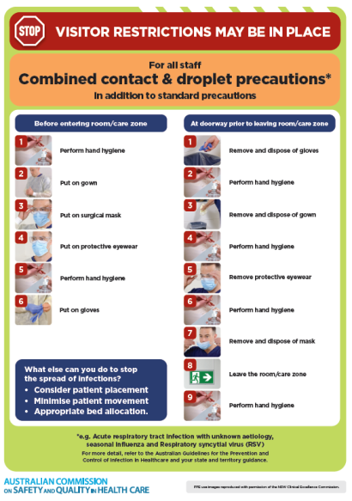](https://www.safetyandquality.gov.au/publications-and-resources/resource-library/infection-prevention-and-control-poster-combined-contact-and-droplet-precautions)
* ***Poster – Combined airborne and contact precautions*** <https://www.safetyandquality.gov.au/publications-and-resources/resource-library/poster-combined-airborne-and-contact-precautions>   
  [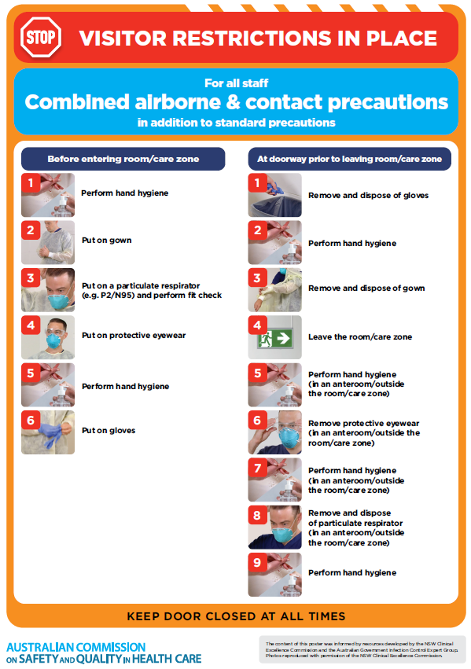](https://www.safetyandquality.gov.au/publications-and-resources/resource-library/poster-combined-airborne-and-contact-precautions)
* ***Environmental Cleaning and Infection Prevention and Control*** [www.safetyandquality.gov.au/environmental-cleaning](http://www.safetyandquality.gov.au/environmental-cleaning)
* ***COVID-19 infection prevention and control risk management – Guidance*** <https://www.safetyandquality.gov.au/publications-and-resources/resource-library/covid-19-infection-prevention-and-control-risk-management-guidance>
* ***Safe care for people with cognitive impairment during COVID-19***<https://www.safetyandquality.gov.au/our-work/cognitive-impairment/cognitive-impairment-and-covid-19>
* ***Stop COVID-19: Break the chain of infection*** posterhttps://www.safetyandquality.gov.au/publications-and-resources/resource-library/break-chain-infection-poster-a3  
  **[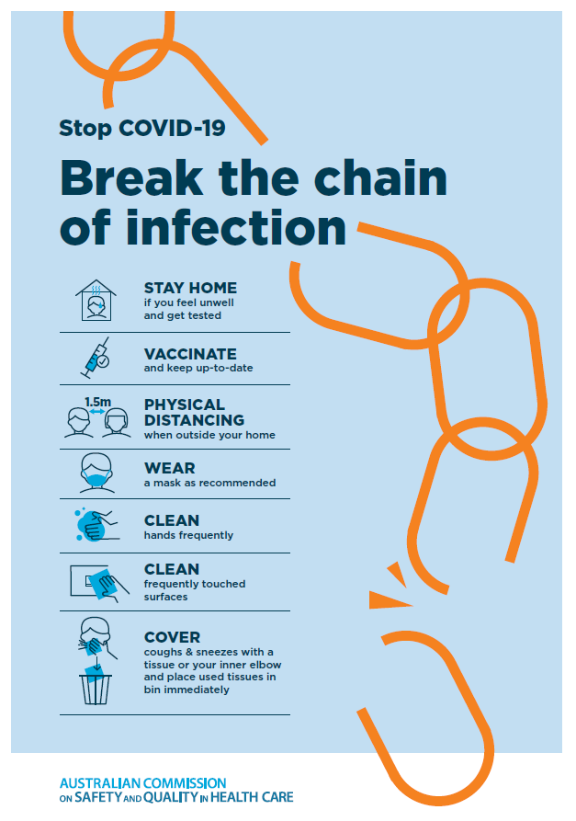](https://www.safetyandquality.gov.au/publications-and-resources/resource-library/break-chain-poster-a3https:/www.safetyandquality.gov.au/publications-and-resources/resource-library/break-chain-poster-a3)**
* ***COVID-19 and face masks – Information for consumers*** <https://www.safetyandquality.gov.au/publications-and-resources/resource-library/covid-19-and-face-masks-information-consumers>

[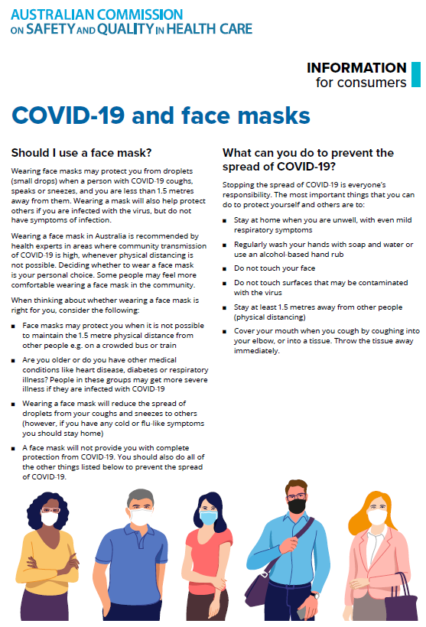](https://www.safetyandquality.gov.au/sites/default/files/2020-07/covid-19_and_face_masks_-_information_for_consumers.pdf)

*National COVID-19 Clinical Evidence Taskforce*

<https://covid19evidence.net.au/>

The National COVID-19 Clinical Evidence Taskforce is a collaboration of peak health professional bodies across Australia whose members are providing clinical care to people with COVID-19. The taskforce is undertaking continuous evidence surveillance to identify and rapidly synthesise emerging research in order to provide national, **evidence-based guidelines and clinical flowcharts for the clinical care of people with COVID-19**. The guidelines address questions that are specific to managing COVID-19 and cover the full disease course across mild, moderate, severe and critical illness. These are ‘living’ guidelines, updated with new research in near real-time in order to give reliable, up-to-the minute advice to clinicians providing frontline care in this unprecedented global health crisis.

*COVID-19 Critical Intelligence Unit*

<https://www.aci.health.nsw.gov.au/covid-19/critical-intelligence-unit>

The Agency for Clinical Innovation (ACI) in New South Wales has developed this page summarising rapid, evidence-based advice during the COVID-19 pandemic. Its operations focus on systems intelligence, clinical intelligence and evidence integration. The content includes a daily evidence digest, a COVID status monitor, a risk monitoring dashboard and evidence checks on a discrete topic or question relating to the current COVID-19 pandemic. There is also a ‘Living evidence’ section summarising key studies and emerging evidence on **COVID-19 vaccines** and **SARS-CoV-2 variants**. The most recent updates include:

* ***SARS-CoV-2 variants - retired living evidence*** – What is the evidence on SARS-CoV-2 variants that are under monitoring by the World Health Organization?
* ***COVID-19 vaccines - retired living evidence*** – What is the evidence on COVID-19 vaccine effectiveness and safety?
* ***Current and emerging patient safety issues during COVID-19*** – What is the evidence on the current and emerging patient safety issues arising from the COVID-19 pandemic?
* ***Bivalent COVID-19 vaccines*** – What is the available regulatory and research evidence for bivalent COVID-19 vaccines?
* ***Surgery post COVID-19*** – What is the evidence for the timing of surgery, and outcomes following surgery, for people who have recovered from COVID-19?
* ***Paxlovid*** – What is the evidence for Paxlovid for treatment of COVID-19?
* ***Molnupiravir*** –What is the evidence for and regulatory context of molnupiravir for treatment of COVID-19?
* ***Eating disorders and COVID-19*** – What is the impact of the COVID-19 pandemic on the prevalence of eating disorders?
* ***Long COVID –*** What is the evidence on the prevalence, presentation and management of long-COVID?
* ***Oseltamivir (Tamiflu) use in healthcare settings*** – What is the evidence that use of oseltamivir in healthcare workers with a symptomatic influenza diagnosis result in an earlier return to work and reduced absenteeism? What is the evidence that use of oseltamivir in adults and children with symptomatic influenza reduces influenza transmission in health care settings?
* ***Alternative models of care for acute medical conditions*** – What is the evidence on alternative models of care for managing patients with acute medical conditions outside of emergency or inpatient hospital settings?
* ***Exercise and long COVID*** – Is exercise helpful in individuals with long COVID? Is post-exertional symptom exacerbation a risk in long COVID?
* ***Influenza and seasonal prophylaxis with oseltamivir*** – What is the place or evidence for seasonal influenza prophylaxis (such as taking oseltamivir for 10 to 12 weeks continuously) in healthcare and aged care settings?
* ***Rapid access models of care for respiratory illnesses*** – What is the evidence for rapid access models of care for respiratory illnesses, especially during winter seasons, in emergency departments?
* ***Post-acute sequelae of COVID-19*** – What is the evidence on the post-acute sequelae of COVID-19?
* ***Emerging variants*** – What is the available evidence for emerging variants?
* ***Chest pain or dyspnoea following COVID-19 vaccination*** – What is evidence for chest pain or dyspnoea following COVID-19 vaccination?
* ***Cardiac investigations and elective surgery post-COVID-19*** – What is evidence for cardiac investigations and elective surgery post-COVID-19?
* ***Breathlessness post COVID-19*** – How to determine those patients who present with ongoing breathlessness in need of urgent review or intervention due to suspected pulmonary embolus?
* ***COVID-19 pandemic and influenza*** – What is the evidence for COVID-19 pandemic and influenza?
* ***Budesonide and aspirin for pregnant women with COVID-19 –*** What is the evidence for the use of Budesonide for pregnant women with COVID-19? What is the evidence for aspirin prophylaxis for pre-eclampsia in pregnant women with a COVID-19 infection?
* ***COVID-19 vaccines in Australia*** – What is the evidence on COVID-19 vaccines in Australia?
* ***COVID-19 pandemic and wellbeing of critical care and other healthcare workers*** – Evidence in brief on the impact of the COVID-19 pandemic on the wellbeing of critical care and other healthcare workers.
* ***Disease modifying treatments for COVID-19 in children*** – What is the evidence for disease modifying treatments for COVID-19 in children?
* ***Mask type for COVID-19 positive wearer*** – What is the evidence for different mask types for COVID-19 positive wearers?
* ***Post acute and subacute COVID-19 care*** – What published advice and models of care are available regarding post-acute and subacute care for COVID-19 patients?
* ***Hospital visitor policies*** – What is the evidence for hospital visitor policies during and outside of the COVID-19 pandemic?
* ***Surgical masks, eye protection and PPE guidance*** –What is the evidence for surgical masks in the endemic phase in hospitals and for eyewear to protect against COVID-19?

**Disclaimer**

On the Radar is an information resource of the Australian Commission on Safety and Quality in Health Care. The Commission is not responsible for the content of, nor does it endorse, any articles or sites listed. The Commission accepts no liability for the information or advice provided by these external links. Links are provided on the basis that users make their own decisions about the accuracy, currency and reliability of the information contained therein. Any opinions expressed are not necessarily those of the Australian Commission on Safety and Quality in Health Care.