# Australian Commission on Safety and Quality logotypeOn the Radar

Issue 601

8 May 2023

*On the Radar* is a summary of some of the recent publications in the areas of safety and quality in health care. Inclusion in this document is not an endorsement or recommendation of any publication or provider. Access to particular documents may depend on whether they are Open Access or not, and/or your individual or institutional access to subscription sites/services. Material that may require subscription is included as it is considered relevant.

*On the Radar* is available online, via email or as a PDF or Word document from <https://www.safetyandquality.gov.au/publications-and-resources/newsletters/radar>

If you would like to receive *On the Radar* via email, you can subscribe on our website <https://www.safetyandquality.gov.au/publications-and-resources/newsletters>  
or by emailing us at H[Umail@safetyandquality.gov.auU](mailto:mail@safetyandquality.gov.au).   
You can also send feedback and comments to H[Umail@safetyandquality.gov.auU](mailto:mail@safetyandquality.gov.au).

For information about the Commission and its programs and publications, please visit <https://www.safetyandquality.gov.au>

You can also follow us on Twitter @ACSQHC.

**On the Radar**

Editor: Dr Niall Johnson [niall.johnson@safetyandquality.gov.au](mailto:niall.johnson@safetyandquality.gov.au)

Contributors: Niall Johnson

**Journal articles**

*Introducing Australia's clinical care standard for low back pain*

Maher CG, Archambeau A, Buchbinder R, French SD, Morphet J, Nicholas MK, et al

Medical Journal of Australia. 2023;218(8):354-356.

|  |  |
| --- | --- |
| DOI | <https://doi.org/10.5694/mja2.51915> |
| Notes | Editorial in a recent issue of the *Medical Journal of Australia* noting the late 2022 release of the *Low Back Pain Clinical Care Standard*. The editorial describes the need for the standard, summarises the clinical care standard and notes the resources to support adoption of the clinical care standard. The authors conclude that ‘The Low Back Pain Clinical Care Standard meets an urgent need to provide a resource to ensure curricula relevant to low back pain are up to date, and a clear roadmap for existing clinicians to deliver best care for people with low back pain. The Standard presents challenges and opportunities for clinicians (both individually and collectively), policymakers and funders to adopt models of care that are aligned with the evidence to ensure the best outcomes for people with low back pain.’ |

For information on the *Low Back Pain Clinical Care Standard*, including information and resources for consumers, clinicians and healthcare services, see <https://www.safetyandquality.gov.au/standards/clinical-care-standards/low-back-pain-clinical-care-standard>

*Medical line entanglement: The unspoken patient safety hazard of medical devices*

Larimer C, Sumner V, Wander D

Nutrition in Clinical Practice. 2023 [epub]

|  |  |
| --- | --- |
| DOI | <https://doi.org/10.1002/ncp.11000> |
| Notes | Paper reporting a study surveying paediatric healthcare providers and caregivers on their perceptions of the risk of medical line entanglement (MLE). This study followed a February 2022 (US) Food and Drug Administration alert around the risk of strangulation by enteral feeding delivery sets. The survey received responses from 191 clinicians and 117 caregivers. The authors report that:   * ‘A majority of clinicians reported awareness of the risk of entanglement; however, few received direction from their employer on managing these risks. * Caregivers (N = 106) reported that their child had experienced MLE, however only 9% of those caregivers recalled receiving any education on MLE from their healthcare providers.’ |

*Screening for Latent Tuberculosis Infection in Adults: US Preventive Services Task Force Recommendation Statement*

U. S. Preventive Services Task Force

Journal of the American Medical Association. 2023;329(17):1487-1494.

|  |  |
| --- | --- |
| DOI | <https://doi.org/10.1001/jama.2023.4899> |
| Notes | The US Preventive Services Task Force (USPSTF) commissioned a systematic review to inform its updated recommendation on screening for latent tuberculosis infection in adults. Latent tuberculosis infection (LTBI) is asymptomatic and not infectious but can later progress to active tuberculosis. From their evidence assessment the USPSTF concluded that ‘there is a moderate net benefit in preventing active tuberculosis disease by screening for LTBI in persons at increased risk for tuberculosis infection’ and thus ‘recommends screening for LTBI in populations at increased risk’. Those populations include people with a weakened immune system and ‘persons who were born in, or are former residents of, countries with high tuberculosis prevalence and persons who live in, or have lived in, high-risk congregate settings (eg, homeless shelters or correctional facilities).’ |

*Journal of Patient Safety and Risk Management*

Volume 28, Number 2, April 2023

|  |  |
| --- | --- |
| URL | <https://journals.sagepub.com/toc/cric/28/2> |
| Notes | A new issue of the *Journal of Patient Safety and Risk Management* has been published. Articles in this issue of the *Journal of Patient Safety and Risk Management* include:   * Editorial: **Creating a “just culture”**: More work to be done (Albert W Wu, Allen B Kachalia) * **Risk mapping in community pharmacies** (Joon Ho Lee, Benoit A Aubert, James R Barker) * The **association of patient safety culture with patient satisfaction**: The role of the pharmacist's performance (Main Naser Alolayyan) * Supply side stakeholders’ viewpoints about **medical tourism** in India and the effects of COVID 19 (Jiwanjot Kaur Hira, Ratinder Kaur) * **Improving patient safety**: Did we learn from the story of Jean-Pierre Adams? (David Mawufemor Azilagbetor, Maimuna Jawara) |

*Journal for Healthcare Quality*

Volume 45, Issue 3, May/June2023

|  |  |
| --- | --- |
| URL | <https://journals.lww.com/jhqonline/toc/2023/06000> |
| Notes | A new issue of the *Journal for Healthcare Quality* has been published. Articles in this issue of the *Journal for Healthcare Quality* include:   * Implementing an Electronic Root Cause Analysis Reporting System to Decrease **Hospital-Acquired Pressure Injuries** (Amy Alvarez Armstrong) * Provider-To-Provider **Communication About Care Transitions**: Considering Different Health Technology Tools (Eliza W Beal, Natasha Kurien, Matthew J DePuccio, Allan Tsung, Ann Scheck McAlearney) * Implementation of ED I-PASS as a **Standardized Handoff Tool in the Pediatric Emergency Department** (Evan Yanni, Sharon Calaman, Ethan Wiener, Jeffrey S Fine, Selin T Sagalowsky) * Review of the **National Quality Forum's Measure Endorsement** Process (Sujith Ramachandran, Shishir Maharjan, Irene Nsiah, Benjamin Y Urick, Alexcia Carr, Matthew Foster) * **Cervical Collars and Dysphagia** Among Geriatric TBIs and Cervical Spine Injuries: A Retrospective Cohort Study (Stephanie Jarvis, Alexandre Sater, Jeffrey Gordon, Allan Nguyen, Kaysie Banton, David Bar-Or) * Provider and Patient Experiences of **Delays in Primary Care During the Early COVID-19 Pandemic** (Kimberly A Muellers, Katerina Andreadis, Jessica S Ancker, Carol R Horowitz, Rainu Kaushal, Jenny J Lin) * The **Combined Effect of Delirium and Falls** on Length of Stay and Discharge (Benjamin Kalivas, Jingwen Zhang, Kristine Harper, Jennifer Dulin, Marc Heincelman, Justin Marsden, Kelly J Hunt, Patrick D Mauldin, William P Moran, Meghan K Thomas) |

*Health Expectations*

Volume 26, Issue 3, June 2023

|  |  |
| --- | --- |
| URL | <https://onlinelibrary.wiley.com/toc/13697625/2023/26/3> |
| Notes | A new issue of *Health Expectations* has been published. Articles in this issue of *Health Expectations* include:   * A rapid review of interventions to improve **medicine self‐management for older people living at home** (Giorgia Previdoli, V-Lin Cheong, David Alldred, Justine Tomlinson, S Tyndale-Biscoe, J Silcock, D Okeowo, B Fylan) * Acceptability of **risk stratification within population‐based cancer screening** from the perspective of the general public: A mixed‐methods systematic review (Lily C Taylor, Alison Hutchinson, Katie Law, Veeraj Shah, Juliet A Usher-Smith, Rebecca A Dennison) * **Gender bias in shared decision‐making** among cancer care guidelines: A systematic review (Mario Rivera-Izquierdo, Marta Maes-Carballo, José J Jiménez-Moleón, Virginia Martínez-Ruiz, Jan Blaakær, Rocío Olmedo-Requena, Khalid S Khan, Jan S Jørgensen) * Using World Cafés to engage an Australian culturally and linguistically diverse community around **human papillomavirus vaccination** (Kathleen Prokopovich, Lyn Phillipson, Leissa West (Pitts), Biljana Stanoevska, Jackie Street, Annette Braunack-Mayer) * Decisions about adopting novel **COVID‐19 vaccines** among White adults in a rural state, USA: A qualitative study (Mike Kohut, Liz Scharnetzki, Joseph Pajka, Elizabeth A Jacobs, Kathleen M Fairfield) * A consensus approach: Understanding the support needs of women in Newport West, Wales, to participate in **breast screening** (Juping Yu, Sarah Wallace, Joyce Kenkre) * Women's experiences of age‐related discontinuation from **mammography screening**: A qualitative interview study (Emma G Gram, Sigrid W Knudsen, John Brandt Brodersen, Alexandra Brandt R Jønsson) * The **Patient Activation Measure (PAM)** **and the pandemic**: Predictors of patient activation among Australian health consumers during the COVID‐19 pandemic (Genevieve Dammery, Kathryn Vitangcol, James Ansell, Louise A Ellis, Carolynn L Smith, Ann Carrigan, Jeffrey Braithwaite, Yvonne Zurynski) * Development and psychometric properties of a short version of the **Patient Continuity of Care Questionnaire** (Emma Safstrom, Kristofer Arestedt, H D Hadjistavropoulos, M Liljeroos, L Nordgren, T Jaarsma, A Stromberg) * Developing the **Resident Measure of Safety in Care Homes (RMOS)**: A Delphi and Think Aloud Study (Natasha Tyler, Claire Planner, Bethany Shears, Andrea Hernan, Maria Panagioti, Sally Giles) * The functions of **self‐harm in young people** and their perspectives about future general practitioner‐led care: A qualitative study (Faraz Mughal, Carolyn A Chew-Graham, Opeyemi O Babatunde, B Saunders, A Meki, L Dikomitis) * **Transvaginal mesh in Australia**: An analysis of news media reporting from 1996 to 2021 (Mina Motamedi, Stacy M Carter, Chris Degeling) * What are the **information needs of people with dementia and their family caregivers** when they are admitted to a mental health ward and do current ward patient information leaflets meet their needs? (Emma Wolverson, Karen H Dening, Z Gower, P Brown, J Cox, V McGrath, A Pepper, J Prichard) * Development of the Pharm‐SAVES educational module for gatekeeper **suicide prevention training** for community pharmacy staff (Amanda N Stover, Jill E Lavigne, Alexis Shook, Catherine MacAllister, Wendi F Cross) * Development of the **Engage with Impact Toolkit**: A comprehensive resource to support the evaluation of patient, family and caregiver engagement in health systems (Julia Abelson, Laura Tripp, Maggie MacNeil, Amy Lang, Carol Fancott, Rebecca Ganann, Marisa Granieri, Cathie Hofstetter, Bernice King, Betty-Lou Kristy, Alies Maybee, Maureen Smith, Jeonghwa You, The Evaluating Patient Engagement Working Group) * **Transitional care decision‐making** through the eyes of older people and informal caregivers: An in‐depth interview‐based study (Lotan Kraun, Theo van Achterberg, Ellen Vlaeyen, B Fret, S M Briké, M Ellen, K De Vliegher) * **Participation in healthcare consultations**: A qualitative study from the perspectives of persons diagnosed with hand osteoarthritis (Hege Johanne Magnussen, Ingvild Kjeken, Irma Pinxsterhuis, Trine Amalie Sjøvold, Toril Hennig, Eva Thorsen, Marte Feiring) * **Mindfulness for people with chronic pain**: Factors affecting engagement and suggestions for programme optimisation (Fathima L Marikar Bawa, Stewart W Mercer, Jane W Sutton, Christine M Bond) |

*Health Affairs*

Volume 42, Number 5, May 2023

|  |  |
| --- | --- |
| URL | <https://www.healthaffairs.org/toc/hlthaff/42/5> |
| Notes | A new issue of *Health Affairs* has been published with the themes ‘Markets, Payments & More’. Articles in this issue of *Health Affairs* include:   * **Hospital-Physician Integration** Is Associated With Greater Use Of Cardiac Catheterization And Angioplasty (Brady Post, Farbod Alinezhad, Sunit Mukherjee, and Gary J Young) * **Insurer Market Power And Hospital Prices** In The US (Anthony T LoSasso, Kevin Toczydlowski, and Yanchao Yang) * Benchmarking Changes And Selective Participation In The **Medicare Shared Savings Program** (Peter F Lyu, Michael E Chernew, and J M McWilliams) * The Role Of Financial Incentives In **Biosimilar Uptake In Medicare**: Evidence From The 340B Program (A M Bond, E B Dean, and S M Desai) * **Federal Funding For Discovery And Development Of Costly HIV Drugs** Was Far More Than Previously Estimated (Frazer A Tessema, Rachel E Barenie, Jerry Avorn, and Aaron S Kesselheim) * The **Home Care Workforce** Has Not Kept Pace With Growth In Home And Community-Based Services (Amanda R Kreider and Rachel M Werner) * **Buprenorphine Treatment For Opioid Use Disorder**: Comparison Of Insurance Restrictions, 2017–21 (Barbara Andraka-Christou, Kosali I Simon, W David Bradford, and Thuy Nguyen) * Medicaid Payment For **Postpartum Long-Acting Reversible Contraception** Prompts More Equitable Use (Taryn A G Quinlan, Richard C Lindrooth, Maryam Guiahi, Beth M McManus, and Glen P Mays) * Trend Toward Older Maternal Age Contributed To Growing **Racial Inequity In Very-Low-Birthweight Infants** In The US (Arline T. Geronimus, John Bound, and Landon Hughes) * Enrollment And Characteristics Of **Dual-Eligible Medicare And Medicaid Beneficiaries** In Integrated Care Programs (David E Velasquez, E John Orav, and José F Figueroa) * The Costs Of Disparities In **Preventable Heart Failure Hospitalizations** In The US South, 2015–17 (Andrew Anderson, Nurzhan Mukashev, Danju Zhou, and William Bigler) * The **Neighborhood Atlas Area Deprivation Index** For Measuring Socioeconomic Status: An Overemphasis On Home Value (Edward L Hannan, Yifeng Wu, Kimberly Cozzens, and Brett Anderson) * The Neighborhood Atlas Area Deprivation Index And Recommendations For **Area-Based Deprivation Measures** (David H Rehkopf and R L Phillips) * Availability Versus Accessibility: Identifying **COVID-19 Testing Deserts** Across Massachusetts (Caitlin E Radford, Kaitlyn E James, Mark Clapp, Allison S Bryant, and Ilona T Goldfarb) * Changes In **Health Coverage During The COVID-19 Pandemic** (Paul D Jacobs and Asako S Moriya) * **‘We’ll Decide For You’: A Patient Is Rushed At Hospital Discharge** (Albert L Siu) |

*BMJ Quality & Safety* online first articles

|  |  |
| --- | --- |
| URL | <https://qualitysafety.bmj.com/content/early/recent> |
| Notes | *BMJ Quality &Safety* has published a number of ‘online first’ articles, including:   * A realist synthesis of educational outreach visiting and integrated academic detailing to influence **prescribing in ambulatory care**: why relationships and dialogue matter (Karen Luetsch, Geoff Wong, Debra Rowett) * Editorial :Imperfection in **adverse event detection**: is this the opportunity to mature our focus on preventing harm in paediatrics? (Chris Wong, Charles Macias, Marlene Miller) |

*International Journal for Quality in Health Care* online first articles

|  |  |
| --- | --- |
| URL | <https://academic.oup.com/intqhc/advance-articles> |
| Notes | *International Journal for Quality in Health Care* has published a number of ‘online first’ articles, including:   * International approaches for **implementing accreditation programs** in different healthcare facilities: A comparative case study in Australia, Botswana, Denmark and Jordan (Ellen Joan van Vliet et al) * **Clinical resilience**: toward a unified definition (Edwin Krogh et al) |

**Online resources**

***[USA] AHRQ Perspectives on Safety***

<https://psnet.ahrq.gov/psnet-collection/perspectives>

The US Agency for Healthcare Research and Quality (AHRQ) publishes occasional Perspectives on Safety essays. Recent essays include:

* ***Surveillance Monitoring*** *to Improve Patient Safety in Acute Hospital Care Units* <https://psnet.ahrq.gov/perspective/surveillance-monitoring-improve-patient-safety-acute-hospital-care-units>

***[USA] Patient Safety Primers***

<https://psnet.ahrq.gov/primers/>

The Patient Safety Primers from the (US) Agency for Healthcare Research and Quality (AHRQ) discuss key concepts in patient safety. Each primer defines a topic, offers background information on its epidemiology and context, and provides links to relevant materials.

* ***Patient Safety Indicators*** <https://psnet.ahrq.gov/primer/patient-safety-indicators>

***[UK] NIHR Evidence alerts***

<https://evidence.nihr.ac.uk/>

The UK’s National Institute for Health Research (NIHR) has posted new evidence alerts on its site. Evidence alerts are short, accessible summaries of health and care research which is funded or supported by NIHR. This is research which could influence practice and each Alert has a message for people commissioning, providing or receiving care. The latest alerts include:

* NHS 111 service reliably identified people with **COVID-19** who needed urgent care
* One-stage hip revisions are as good as 2-stage surgery to replace **infected artificial hips**
* Combination therapy for painful **diabetic neuropathy** is safe and effective
* Online support improved **eczema** symptoms in children and young people
* One-session treatment is as effective as multi-session therapy for young people with **phobias**
* **Antipsychotics** are increasingly prescribed to children and teenagers
* Online approaches boosted public involvement in **assistive technologies** during the pandemic.

**[UK] Winter Improvement Collaborative urgent and emergency care improvement guides**

The NHS England has released a series of guides produced by the Winter Improvement Collaborative. These guides include:

* Urgent and emergency care improvement guide same day emergency care pathways <https://www.england.nhs.uk/publication/uec-improvement-guide-same-day-emergency-care-pathways/>
* Urgent and emergency care improvement guide same day emergency care flow <https://www.england.nhs.uk/publication/uec-improvement-guide-same-day-emergency-care-flow/>
* Urgent and emergency care improvement guide to direct access <https://www.england.nhs.uk/publication/uec-improvement-guide-to-direct-access/>
* Urgent and emergency care improvement guide to contact hubs for primary, ambulance and clinical calls <https://www.england.nhs.uk/publication/uec-improvement-guide-to-contact-hubs-for-primary-ambulance-and-clinical-calls/>

**COVID-19 resources**

https://www.safetyandquality.gov.au/covid-19

The Australian Commission on Safety and Quality in Health Care has developed a number of resources to assist healthcare organisations, facilities and clinicians. These and other material on COVID-19 are available at <https://www.safetyandquality.gov.au/covid-19>

These resources include:

* ***OVID-19 infection prevention and control risk management*** This primer provides an overview of three widely used tools for investigating and responding to patient safety events and near misses. Tools covered in this primer include incident reporting systems, Root Cause Analysis (RCA), and Failure Modes and Effects Analysis (FMEA).   
  <https://www.safetyandquality.gov.au/publications-and-resources/resource-library/covid-19-infection-prevention-and-control-risk-management-guidance>
* ***Poster – Combined contact and droplet precautions*** <https://www.safetyandquality.gov.au/publications-and-resources/resource-library/infection-prevention-and-control-poster-combined-contact-and-droplet-precautions>  
  [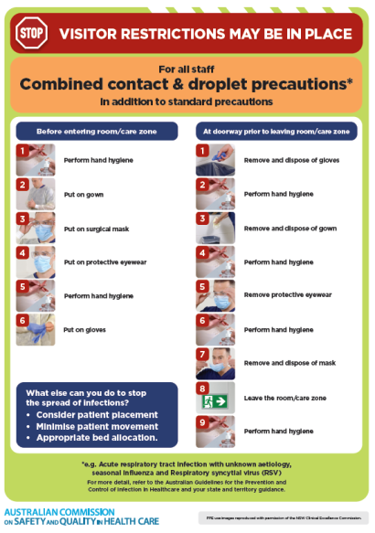](https://www.safetyandquality.gov.au/publications-and-resources/resource-library/infection-prevention-and-control-poster-combined-contact-and-droplet-precautions)
* ***Poster – Combined airborne and contact precautions*** <https://www.safetyandquality.gov.au/publications-and-resources/resource-library/poster-combined-airborne-and-contact-precautions>   
  [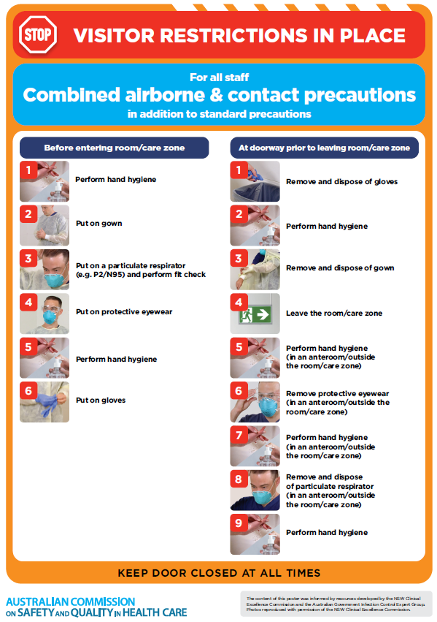](https://www.safetyandquality.gov.au/publications-and-resources/resource-library/poster-combined-airborne-and-contact-precautions)
* ***Environmental Cleaning and Infection Prevention and Control*** [www.safetyandquality.gov.au/environmental-cleaning](http://www.safetyandquality.gov.au/environmental-cleaning)
* ***COVID-19 infection prevention and control risk management – Guidance*** <https://www.safetyandquality.gov.au/publications-and-resources/resource-library/covid-19-infection-prevention-and-control-risk-management-guidance>
* ***Safe care for people with cognitive impairment during COVID-19***<https://www.safetyandquality.gov.au/our-work/cognitive-impairment/cognitive-impairment-and-covid-19>
* ***Stop COVID-19: Break the chain of infection*** posterhttps://www.safetyandquality.gov.au/publications-and-resources/resource-library/break-chain-infection-poster-a3  
  **[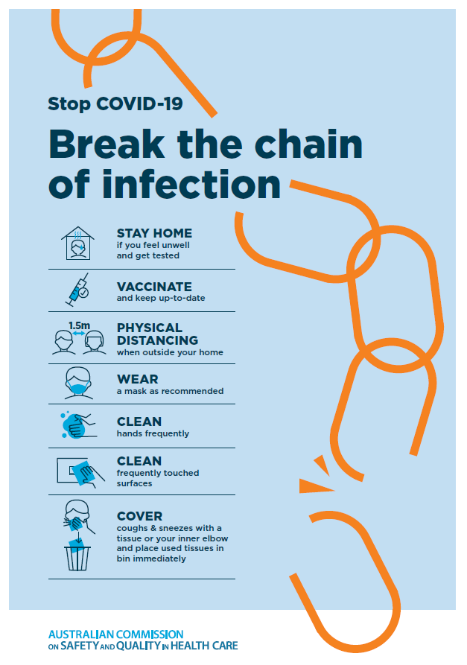](https://www.safetyandquality.gov.au/publications-and-resources/resource-library/break-chain-poster-a3https:/www.safetyandquality.gov.au/publications-and-resources/resource-library/break-chain-poster-a3)**
* ***COVID-19 and face masks – Information for consumers*** <https://www.safetyandquality.gov.au/publications-and-resources/resource-library/covid-19-and-face-masks-information-consumers>

[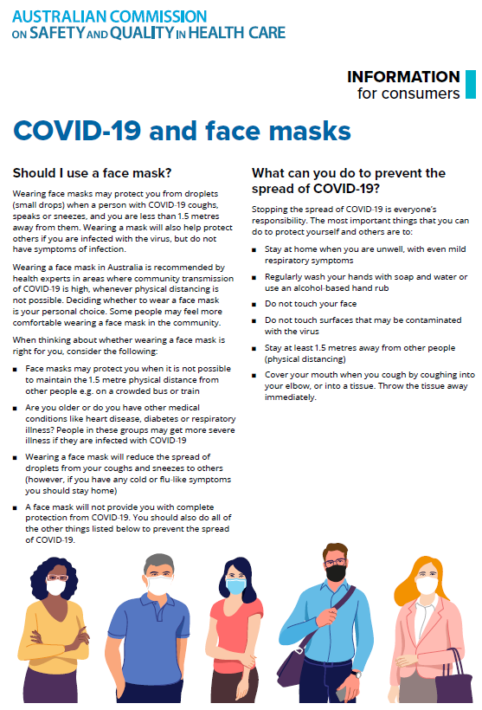](https://www.safetyandquality.gov.au/sites/default/files/2020-07/covid-19_and_face_masks_-_information_for_consumers.pdf)

*National COVID-19 Clinical Evidence Taskforce*

<https://covid19evidence.net.au/>

The National COVID-19 Clinical Evidence Taskforce is a collaboration of peak health professional bodies across Australia whose members are providing clinical care to people with COVID-19. The taskforce is undertaking continuous evidence surveillance to identify and rapidly synthesise emerging research in order to provide national, **evidence-based guidelines and clinical flowcharts for the clinical care of people with COVID-19**. The guidelines address questions that are specific to managing COVID-19 and cover the full disease course across mild, moderate, severe and critical illness. These are ‘living’ guidelines, updated with new research in near real-time in order to give reliable, up-to-the minute advice to clinicians providing frontline care in this unprecedented global health crisis.

*COVID-19 Critical Intelligence Unit*

<https://www.aci.health.nsw.gov.au/covid-19/critical-intelligence-unit>

The Agency for Clinical Innovation (ACI) in New South Wales has developed this page summarising rapid, evidence-based advice during the COVID-19 pandemic. Its operations focus on systems intelligence, clinical intelligence and evidence integration. The content includes a daily evidence digest, a COVID status monitor, a risk monitoring dashboard and evidence checks on a discrete topic or question relating to the current COVID-19 pandemic. There is also a ‘Living evidence’ section summarising key studies and emerging evidence on **COVID-19 vaccines** and **SARS-CoV-2 variants**. The most recent updates include:

* ***SARS-CoV-2 variants - retired living evidence*** – What is the evidence on SARS-CoV-2 variants that are under monitoring by the World Health Organization?
* ***COVID-19 vaccines - retired living evidence*** – What is the evidence on COVID-19 vaccine effectiveness and safety?
* ***Current and emerging patient safety issues during COVID-19*** – What is the evidence on the current and emerging patient safety issues arising from the COVID-19 pandemic?
* ***Bivalent COVID-19 vaccines*** – What is the available regulatory and research evidence for bivalent COVID-19 vaccines?
* ***Surgery post COVID-19*** – What is the evidence for the timing of surgery, and outcomes following surgery, for people who have recovered from COVID-19?
* ***Paxlovid*** – What is the evidence for Paxlovid for treatment of COVID-19?
* ***Molnupiravir*** –What is the evidence for and regulatory context of molnupiravir for treatment of COVID-19?
* ***Eating disorders and COVID-19*** – What is the impact of the COVID-19 pandemic on the prevalence of eating disorders?
* ***Long COVID –*** What is the evidence on the prevalence, presentation and management of long-COVID?
* ***Oseltamivir (Tamiflu) use in healthcare settings*** – What is the evidence that use of oseltamivir in healthcare workers with a symptomatic influenza diagnosis result in an earlier return to work and reduced absenteeism? What is the evidence that use of oseltamivir in adults and children with symptomatic influenza reduces influenza transmission in health care settings?
* ***Alternative models of care for acute medical conditions*** – What is the evidence on alternative models of care for managing patients with acute medical conditions outside of emergency or inpatient hospital settings?
* ***Exercise and long COVID*** – Is exercise helpful in individuals with long COVID? Is post-exertional symptom exacerbation a risk in long COVID?
* ***Influenza and seasonal prophylaxis with oseltamivir*** – What is the place or evidence for seasonal influenza prophylaxis (such as taking oseltamivir for 10 to 12 weeks continuously) in healthcare and aged care settings?
* ***Rapid access models of care for respiratory illnesses*** – What is the evidence for rapid access models of care for respiratory illnesses, especially during winter seasons, in emergency departments?
* ***Post-acute sequelae of COVID-19*** – What is the evidence on the post-acute sequelae of COVID-19?
* ***Emerging variants*** – What is the available evidence for emerging variants?
* ***Chest pain or dyspnoea following COVID-19 vaccination*** – What is evidence for chest pain or dyspnoea following COVID-19 vaccination?
* ***Cardiac investigations and elective surgery post-COVID-19*** – What is evidence for cardiac investigations and elective surgery post-COVID-19?
* ***Breathlessness post COVID-19*** – How to determine those patients who present with ongoing breathlessness in need of urgent review or intervention due to suspected pulmonary embolus?
* ***COVID-19 pandemic and influenza*** – What is the evidence for COVID-19 pandemic and influenza?
* ***Budesonide and aspirin for pregnant women with COVID-19 –*** What is the evidence for the use of Budesonide for pregnant women with COVID-19? What is the evidence for aspirin prophylaxis for pre-eclampsia in pregnant women with a COVID-19 infection?
* ***COVID-19 vaccines in Australia*** – What is the evidence on COVID-19 vaccines in Australia?
* ***COVID-19 pandemic and wellbeing of critical care and other healthcare workers*** – Evidence in brief on the impact of the COVID-19 pandemic on the wellbeing of critical care and other healthcare workers.
* ***Disease modifying treatments for COVID-19 in children*** – What is the evidence for disease modifying treatments for COVID-19 in children?
* ***Mask type for COVID-19 positive wearer*** – What is the evidence for different mask types for COVID-19 positive wearers?
* ***Post acute and subacute COVID-19 care*** – What published advice and models of care are available regarding post-acute and subacute care for COVID-19 patients?
* ***Hospital visitor policies*** – What is the evidence for hospital visitor policies during and outside of the COVID-19 pandemic?
* ***Surgical masks, eye protection and PPE guidance*** –What is the evidence for surgical masks in the endemic phase in hospitals and for eyewear to protect against COVID-19?

**Disclaimer**

On the Radar is an information resource of the Australian Commission on Safety and Quality in Health Care. The Commission is not responsible for the content of, nor does it endorse, any articles or sites listed. The Commission accepts no liability for the information or advice provided by these external links. Links are provided on the basis that users make their own decisions about the accuracy, currency and reliability of the information contained therein. Any opinions expressed are not necessarily those of the Australian Commission on Safety and Quality in Health Care.