

National Site‑Specific Assessment Survey Report

Addendum 2a – National One Stop Shop and National Clinical Trials Front Door Consultation Report
March 2023
Published by the Australian Commission on Safety and Quality in Health Care
Level 5, 255 Elizabeth Street, Sydney NSW 2000
Phone: (02) 9126 3600
Email: mail@safetyandquality.gov.au
Website: www.safetyandquality.gov.au
ISBN: 978-1-922563-86-6
© Australian Commission on Safety and Quality in Health Care 2022
All material and work produced by the Australian Commission on Safety and Quality in Health Care (the Commission) is protected by copyright. The Commission reserves the right to set out the terms and conditions for the use of such material.
As far as practicable, material for which the copyright is owned by a third party will be clearly labelled. The Commission has made all reasonable efforts to ensure that this material has been reproduced in this publication with the full consent of the copyright owners.
With the exception of any material protected by a trademark, any content provided by third parties, and where otherwise noted, all material presented in this publication is licensed under a Creative Commons Attribution-NonCommercial-NoDerivatives 4.0 International licence.

Enquiries about the licence and any use of this publication are welcome and can be sent to communications@safetyandquality.gov.au.
The Commission’s preference is that you attribute this publication (and any material sourced from it) using the following citation:
Australian Commission on Safety and Quality in Health Care. National Site-Specific Assessment Survey Report. Addendum 2a – National One Stop Shop and National Clinical Trials Front Door Consultation Report. Sydney: ACSQHC; 2022.
Disclaimer
The content of this document is published in good faith by the Commission for information purposes. The document is not intended to provide guidance on particular healthcare choices. You should contact your healthcare provider for information or advice on particular healthcare choices.
The Commission does not accept any legal liability for any injury, loss or damage incurred by the use of, or reliance on, this document.

Contents
Executive summary 6
Introduction 6
Background 6
Survey method 7
Consultation participation and survey findings 7
Sample overview 9
Stakeholder groups 9
Respondents, by stakeholder group and jurisdiction 10
Experience of existing Site‑Specific Assessment process 13
Site-Specific Assessment submission in the past 12 months 13
Review of SSA submission in the past 12 months 14
Satisfaction with existing Site‑Specific Assessment process 16
Satisfaction with existing Site‑Specific Assessment process 16
Satisfaction with existing SSA process, by jurisdiction 16
Satisfaction with existing SSA process, by stakeholder 17
Satisfaction with existing SSA process, by stakeholder group and jurisdiction 18
Reasons for dissatisfaction with existing SSA process 20
National Site-Specific Assessment process 23
Core Site-Specific Assessment requirements 23
Review of draft ‘Registration’ section 24
Minimum requirements for ‘Registration’ section 24
Satisfaction with draft ‘Registration’ section 26
Dissatisfaction with draft ‘Registration’ section 26
Additional feedback on draft ‘Registration’ section 28
Review of draft ‘HREC approvals’ section 29
Minimum requirements for ‘HREC approvals’ section 29
Satisfaction with draft ‘HREC approvals’ section 30
Dissatisfaction with draft ‘HREC approvals’ section 31
Additional feedback on draft ‘HREC approvals’ section 33
Review of draft ‘Recruitment and financial information’ section 34
Minimum requirements for ‘Recruitment and financial information’ section 34
Satisfaction with draft ‘Recruitment and financial information’ section 35
Dissatisfaction with draft ‘Recruitment and financial information’ section 36
Additional feedback on draft ‘Recruitment and financial information’ section 38
Review of draft ‘Department approvals’ section 39
Minimum requirements for ‘Department approvals’ section 39
Satisfaction with ‘Department approvals’ section 41
Dissatisfaction with ‘Department approvals’ section 42
Additional feedback on ‘Department approvals’ section 44
Overall perceptions 45
Overall perceptions, length of draft National SSA 45
Overall perceptions, complexity of draft National SSA 49
Overall perceptions, above‑the‑line requirements 50
Jurisdictional below‑the‑line requirements 51
Other fields required 52

List of figures
Figure 1: Survey respondents, by stakeholder type (n=582) 10
Figure 2: Respondents who have submitted an SSA application in the last 12 months (n=554) 13
Figure 3: Respondents who have submitted an SSA application in the last 12 months, by stakeholder group and jurisdiction (n=478)Figure 3: Respondents who have submitted an SSA application in the last 12 months, by stakeholder group and jurisdiction (n=478) 14
Figure 4: Respondents who have reviewed one or more SSA submissions in the last 12 months (n=552) 15
Figure 5: Respondents who have reviewed one or more SSA submissions in the last 12 months, by stakeholder group and jurisdiction 15
Figure 6: Satisfaction with existing SSA process (n=551) 16
Figure 7: Satisfaction with existing SSA process, by jurisdiction (n=551) 17
Figure 8: Satisfaction with existing SSA process, by stakeholder group (n=551) 18
Figure 9: Satisfaction with existing SSA process, by stakeholder group and jurisdiction (n=273) 19
Figure 10: Dissatisfaction with existing SSA process, by stakeholder group and jurisdiction (n=308) 20
Figure 11: Reasons for dissatisfaction with existing SSA process (n=214) 21
Figure 12: Stimulus 1 – Proposed registration fields 24
Figure 13: Questions in the ‘Registration’ section of draft national SSA meeting local jurisdictional minimum requirements (n=431) 25
Figure 14: Questions in the ‘Registration’ section of draft national SSA meeting local jurisdictional minimum requirements, by stakeholder group and jurisdiction (n=420) 26
Figure 15: Stimulus 2 – Proposed HREC approval fields 29
Figure 16: Questions in the ‘HREC approvals’ section of draft national SSA meeting local jurisdictional minimum requirements (n=419) 30
Figure 17: Questions in the ‘HREC approvals’ section of draft national SSA meeting local jurisdictional minimum requirements, by stakeholder group and jurisdiction (n=523) 31
Figure 18: Stimulus 3 – Proposed recruitment and financial information fields 34
Figure 19: Questions in the ‘Recruitment and financial information’ section of draft national SSA meeting local jurisdictional minimum requirements (n=402) 35
Figure 20: Questions in the ‘Recruitment and financial information’ section of draft national SSA meeting local jurisdictional minimum requirements, by stakeholder group and jurisdiction (n=488) 36
Figure 21: Stimulus 4 – Proposed department approval fields 40
Figure 22: Questions in the ‘Department approvals’ section of draft national SSA meeting local jurisdictional minimum requirements (n=398) 41
Figure 23: Questions in the ‘Department approvals’ section of draft national SSA meeting local jurisdictional minimum requirements, by stakeholder group and jurisdiction (n=484) 41
Figure 24: Overall perceptions, length of draft national SSA (n=396) 45
Figure 25: Overall perceptions, length of draft national SSA, by stakeholder group (n=350) 46
Figure 26: Overall perceptions, length of draft national SSA, by stakeholder group: NSW (n=202) 47
Figure 27: Overall perceptions, length of draft national SSA, by stakeholder group: QLD (n=98) 47
Figure 28: Overall perceptions, length of draft national SSA, by stakeholder group: SA (n=54) 48
Figure 29: Overall perceptions, length of draft national SSA, by stakeholder group: VIC (n=145) 48
Figure 30: Overall perceptions, length of draft national SSA, by stakeholder group: WA (n=45) 49
Figure 31: Overall perceptions, complexity of draft national SSA (n=397) 49
Figure 32: Overall perceptions, complexity of draft national SSA, by stakeholder group (n=352) 50
Figure 33: Overall perceptions, above the line requirements (n=398) 50
Figure 34: Overall perceptions, above the line requirements, by stakeholder group (n=352) 51

List of tables
Table 1: Survey respondents, by stakeholder group and jurisdiction (n=582) 10

Executive summary

Introduction
The Australian Commission on Safety and Quality in Health Care (the Commission) has been engaged by the Australian Government Department of Health, in partnership with all jurisdictions, to finalise the core elements of a national Site-Specific Assessment (SSA) process through the One Stop Shop and National Clinical Trials Front Door national consultations.
The Clinical Trials Project Reference Group (CTPRG) agreed that development of a single national SSA was critical to the successful development of the One Stop Shop platform. The aim of the single national SSA is to ensure a single process for local site (risk) assessment and authorisation for health-related human research. The core principles underpinning the national SSA are:
- Aim to streamline the SSA process, minimising duplication and unnecessary requirements, and maximising consistency
- Include common national (above the line) requirements
- Include jurisdictional specific, legislated (below the line) requirements
- Be consistent with minimum requirements specified in the National Clinical Trials Governance Framework and all relevant legal or regulatory requirements, as well as being sufficient to provide decision-makers with confidence that patient safety and clinical standards are being maintained
- Collect sufficient quality data to strengthen the oversight provided by governing bodies
- Be adaptable, and enable periodic planned updates and modifications, to accommodate evolving requirements over time.
- This survey was conducted by the Friday Collective on behalf of the Commission.

Background
The development of the proposed single national SSA requirements have been informed by a variety of methods and mechanisms, including but not limited to the findings of this survey; a series of targeted consultations; the consideration of an expert Reference Group, and input received via the CTPRG.
In 2018, the drafting of the national core SSA elements was led by ACT Department of Health on behalf of the CTPRG. In 2019, the core elements of the draft national SSA were refined through a formative evaluation process in partnership with all jurisdictions however, this work was paused due to COVID-19 pandemic. In 2021, the CTPRG agreed to progress the development and finalisation of a single national SSA via the one Stop Shop national and National Clinical Trial Front Door consultations.
In December 2021, there was a decision under the Overlapping Regulations agenda to expedite development of single national SSA requirements for jurisdictional agreement by end March 2022. As part of this process, in February 2022 an expert SSA Reference Group was established with membership nominated by the CTPRG. Reference Group members also nominated individuals currently responsible for undertaking local SSA or recommending authorisation, to participate in the targeted consultations.

Survey method
The survey was designed to collect feedback on the existing draft national SSA. Respondents were exposed to the draft, section by section, and asked to indicate whether or not it satisfied their requirements. Where respondents indicated that it did not satisfy their requirements, they were prompted to elaborate on missing elements in a comment box. Respondents were also provided with an open-ended question for each section, to collect general feedback, insights and recommendations.
The survey also sought to capture insights related to respondents’ levels of satisfaction with existing SSA processes, with an open-ended question prompting a more detailed response.
Additionally, respondents were asked to give their overall assessment of the length, complexity and suitability of the draft national SSA, in a set of close‑ended questions at the end of the survey.
Time in the field | Average time spent to complete the survey | Survey completion rate | Completed surveys submitted
12 days  28 February 2022 to 11 March 2022 | 13 minutes | 67%* | 582
* Respondents were not required to answer every question and the verbatim responses provided have not been edited.

Consultation participation and survey findings
Approximately 812 individuals contributed to the consultation process (including the CTPRG; the SSA Reference Group and consultation participants). 582 completed surveys were received.
Within each of the four sections featured – Registration, HREC Approvals, Recruitment and Financial Information, and Departmental Approvals – most respondents indicated that the questions provided in the draft national SSA met their requirements. This is consistent from the advice received from the SSA Reference Group, expert targeted SSA consultation participants and participants attending the public webinars.
The survey revealed that for each of the core SSA components between 69–74% of respondents were satisfied with the core elements provided. Between 16–21% were not satisfied and the other 9–12% did not know.
Those individuals responding to the question relating to ‘overall perception’ (396 of 582; 68%) who identified as ‘Research investigators’ and ‘Researchers’ were the groups most likely to say that the draft national SSA was too long (37% and 36% respectively). Support for this statement was similarly high among ‘Directors of research’, ‘Clinician investigators as sponsors’, and ‘Research sponsors’, although the sample sizes of these groups were small (n<30).
Further analysis revealed that there were notable differences between stakeholder groups in terms of their assessment of the length, complexity and suitability of the draft national SSA.
Of note, 96 of the 398 (25%) responses received to the question relating to ‘Overall perception’ who identified as ‘Research governance officers’, indicated the draft national SSA was too short. A summary of these findings is provided in the section titled ‘Overall perceptions’.
Survey respondents indicating that the core SSA elements did not meet their requirements (16–21%) were prompted to elaborate on their response. Their insights, concerns and recommendations have been considered in addition to the feedback received from experts through the targeted consultations and broader consultation process.
Where additional feedback has been received responses have been provided to assist Reference Group and CTPRG members in their review. It is important to note that:
- In developing and refining the proposed SSA requirements, feedback from survey respondents has been balanced against feedback from the Reference Group and their nominated experts to ensure compliance with relevant minimum national/jurisdictional requirements
- A number of issues raised could effectively be addressed via the introduction of the proposed One Stop Shop national platform. Where it is considered that this potential capability would resolve issues or simplify requirements, this has been incorporated into the proposed logic/rationale underpinning the proposed SSA requirements. For example, the One Stop Shop platform could provide an intuitive digital smart form with skip logic; enable digital Chief Executive sign-off and configurable delegations according to structures/requirements in each jurisdiction; SSA core elements built into the single national approval workflow; the use of standard definitions; in-built guidance and explanatory notes on the process and requirements for all users
- Where there are variations between jurisdictions (these are minimal), these can easily be accommodated via configurable functionality anticipated for the One Stop Shop platform (that is, additional approvals by public health officials following HREC approval such as required by the Queensland Civil and Administrative Tribunal)
- The core elements enable sites to select ‘not applicable’ as appropriate throughout the process
- It is envisaged that the One Stop Shop could enable the provision of all approved and site‑specific documents across the approval process.

Sample overview

Stakeholder groups
As shown in Figure 1, respondents were asked to assign themselves to one or more of the following stakeholder groups:
- Board member
- CEO
- Clinical registry
- Clinical society
- Clinician investigator as sponsor
- Commercial trial sponsor
- Commonwealth officer
- Contract research organisation
- Data and infrastructure (patient registries/recruitment platforms, system developers)
- Director of research
- Government agency
- Health service general manager
- Health service organisation
- Health service organisation administrator
- HREC secretariat/manager
- Industry representative
- Jurisdictional health departmental officer
- Medical research institute
- Participant/public
- Patient support organisation
- Private sector HREC secretariat
- Research coordinator
- Research Governance Office undertaking local Site-Specific Assessments
- Research investigator
- Research network
- Research officer undertaking local Site‑Specific Assessments
- Research pharmacist
- Research sponsor
- Research support (pharmacy, pathology, radiology)
- Researcher
- Start-up specialist
- University governance board
- University HREC secretariat/manager
- University researcher
- Other.
As shown below, 582 responded and the most common responses were:
- Research coordinator (162; 28%)
- Researcher (110; 19%)
- Research investigator (85; 15%)
- Research Governance Officer (75; 13%)
- University researcher (73; 13%).
Within the ‘other’ category (55; 9%), descriptions provided by respondents included ’Research manager’, ‘Clinical trials manager’, ‘Clinicians’, ‘Consumers’ (including a ‘rare disease patient/advocate’), ‘Ethics committee members’, and ‘Nurses’.
Figure 1: Survey respondents, by stakeholder type (n=582)
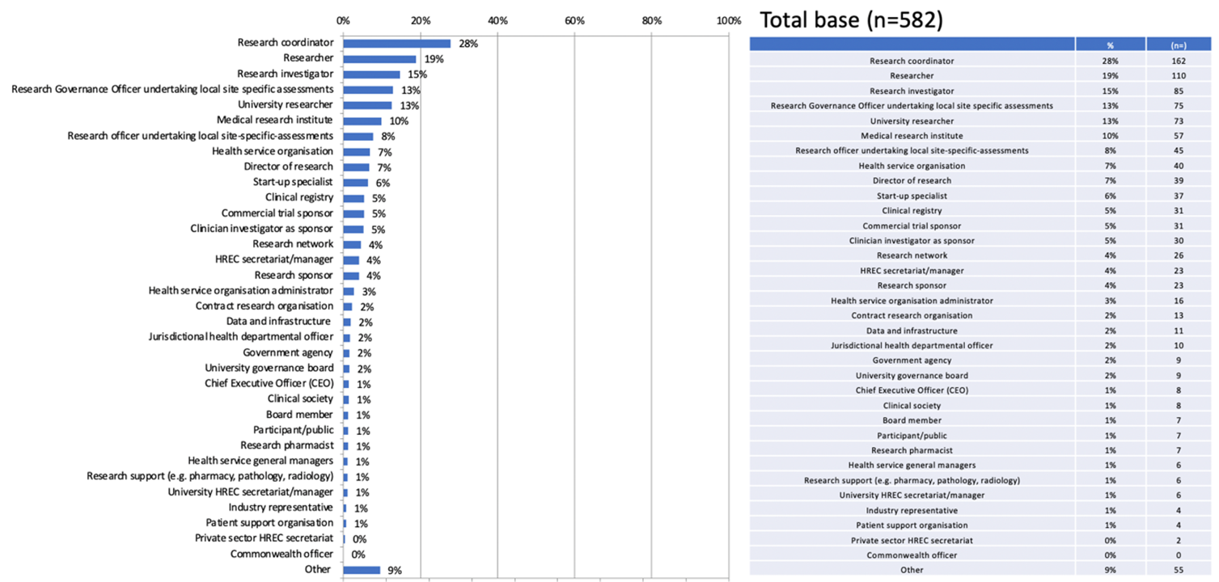

Respondents, by stakeholder group and jurisdiction
To provide some insight into how different categories of stakeholders were responding to SSA processes, they were sorted into four groups:
- Researchers
- Leaders
- Industry
- Other.
Respondents were further sorted by both stakeholder group and state, to enable exploration of the experiences and attitudes of different stakeholders, across different jurisdictions, as shown in Table 1:
- Cross-tabulated groups with a sample size of less than 30 were not included in the sub‑analysis of survey questions.
- As a multi-choice response, respondents were permitted to assign themselves to more than one stakeholder type where relevant. As a result, the total sample sizes of the sub-analyses differ from those of the core analysis for the relevant questions and respondents may belong to more than one grouping.
Table 1: Survey respondents, by stakeholder group and jurisdiction (n=582)
Category | Stakeholders | NSW | Vic | Qld | SA | WA | Tas | NT | ACT | Total
Group 1: Researchers | Researcher | 36 | 22 | 26 | 10 | 8 | 1 | 4 | 1 | 108
 | Research investigator | 32 | 16 | 14 | 11 | 7 | 0 | 3 | 0 | 83
 | University researcher | 21 | 20 | 16 | 9 | 4 | 1 | 2 | 0 | 73
 | Medical research institute | 21 | 13 | 7 | 5 | 6 | 1 | 2 | 0 | 55
 | Director of research | 11 | 11 | 8 | 4 | 3 | 0 | 1 | 0 | 38
 | Research network | 7 | 9 | 5 | 2 | 1 | 1 | 1 | 0 | 26
 | Total | 128 | 91 | 76 | 41 | 29 | 4 | 13 | 1 | 383
Group 2: Leaders | Research Governance Officer undertaking local SSAs | 24 | 15 | 16 | 3 | 14 | 0 | 2 | 1 | 75
 | Research officer undertaking local SSAs | 12 | 9 | 11 | 5 | 6 | 0 | 1 | 0 | 44
 | Health service organisation | 9 | 11 | 10 | 1 | 4 | 1 | 2 | 2 | 40
 | Health service organisation administrator | 6 | 4 | 3 | 0 | 1 | 0 | 2 | 0 | 16
 | Board member | 2 | 3 | 1 | 1 | 0 | 0 | 0 | 0 | 7
 | Chief Executive Officer (CEO) | 2 | 2 | 2 | 1 | 0 | 0 | 0 | 0 | 7
 | Total | 55 | 44 | 43 | 11 | 25 | 1 | 7 | 3 | 189
Group 3: Industry | Start-up specialist | 13 | 11 | 9 | 3 | 0 | 0 | 0 | 0 | 36
 | Commercial trial sponsor | 14 | 12 | 2 | 1 | 1 | 0 | 0 | 0 | 30
 | Contract research organisation | 5 | 5 | 1 | 1 | 1 | 0 | 0 | 0 | 13
 | Industry representative | 3 | 1 | 0 | 0 | 0 | 0 | 0 | 0 | 4
 | Total | 35 | 29 | 12 | 5 | 2 | 0 | 0 | 0 | 83
Group 4: Other | Research coordinator | 51 | 40 | 25 | 18 | 14 | 1 | 5 | 5 | 159
 | Other (please specify) | 19 | 15 | 8 | 3 | 8 | 0 | 2 | 0 | 55
 | Clinical registry | 6 | 15 | 3 | 5 | 1 | 0 | 0 | 0 | 30
 | Clinician investigator as sponsor | 13 | 5 | 6 | 3 | 1 | 0 | 2 | 0 | 30
 | HREC secretariat/ manager | 6 | 5 | 4 | 1 | 6 | 0 | 0 | 1 | 23
 | Research sponsor | 13 | 6 | 2 | 1 | 0 | 0 | 0 | 0 | 22
 | Data and infrastructure (patient registries/ recruitment platforms, system developers) | 2 | 7 | 0 | 1 | 1 | 0 | 0 | 0 | 11
 | Jurisdictional health departmental officer | 4 | 1 | 2 | 1 | 0 | 1 | 1 | 0 | 10
 | University governance board | 4 | 1 | 0 | 0 | 2 | 2 | 0 | 0 | 9
 | Clinical society | 1 | 2 | 0 | 0 | 3 | 1 | 1 | 0 | 8
 | Government agency | 4 | 1 | 1 | 1 | 0 | 1 | 0 | 0 | 8
 | Participant/public | 2 | 2 | 2 | 1 | 0 | 0 | 0 | 0 | 7
 | Research pharmacist | 4 | 0 | 3 | 0 | 0 | 0 | 0 | 0 | 7
 | Research support (e.g. pharmacy, pathology, radiology) | 3 | 1 | 1 | 0 | 1 | 0 | 0 | 0 | 6
 | University HREC secretariat/ manager | 3 | 2 | 0 | 0 | 1 | 0 | 0 | 0 | 6
 | Health service general managers | 3 | 3 | 0 | 0 | 0 | 0 | 0 | 0 | 6
 | Patient support organisation | 2 | 1 | 0 | 1 | 0 | 0 | 0 | 0 | 4
 | Private sector HREC secretariat | 1 | 0 | 0 | 1 | 0 | 0 | 0 | 0 | 2
 | Commonwealth officer | 0 | 0 | 0 | 0 | 0 | 0 | 0 | 0 | 0
 | Total | 141 | 107 | 57 | 37 | 38 | 6 | 11 | 6 | 403

Experience of existing Site‑Specific Assessment process

Site-Specific Assessment submission in the past 12 months
Respondents were asked whether they had submitted a Site-Specific Assessment (SSA) application in the past 12 months. Of the 554 responses received, 62% indicated that they had made a submission, as shown in Figure 2.
Figure 2: Respondents who have submitted an SSA application in the last 12 months (n=554)
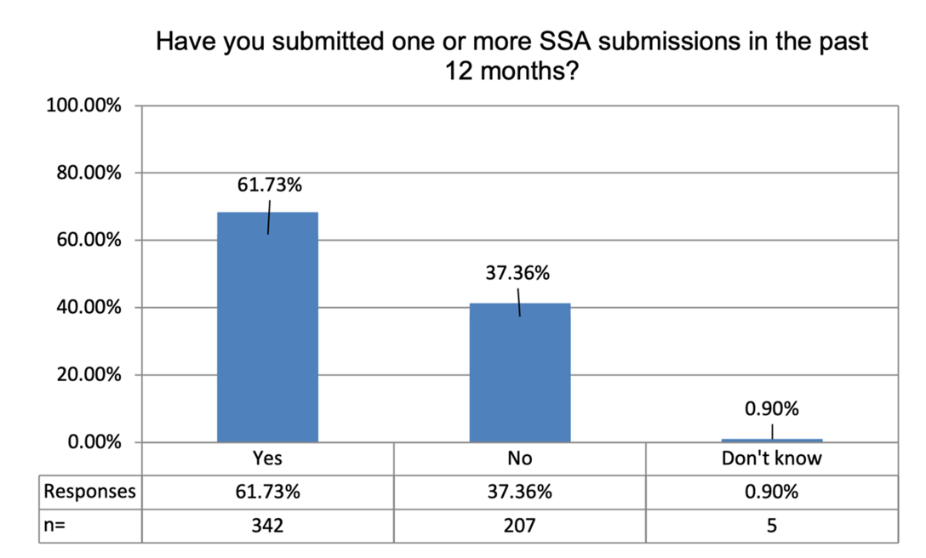
An analysis of the ‘yes’ response by both stakeholder group and jurisdiction, as shown in Figure 3, indicates that:
- ‘Researchers’ and ‘Industry’ were the groups most likely to have submitted an application in the last 12 months (74% and 77% respectively)
- ‘Leaders’ were the group least likely to have submitted an application (48%).
Figure 3: Respondents who have submitted an SSA application in the last 12 months, by stakeholder group and jurisdiction (n=478)
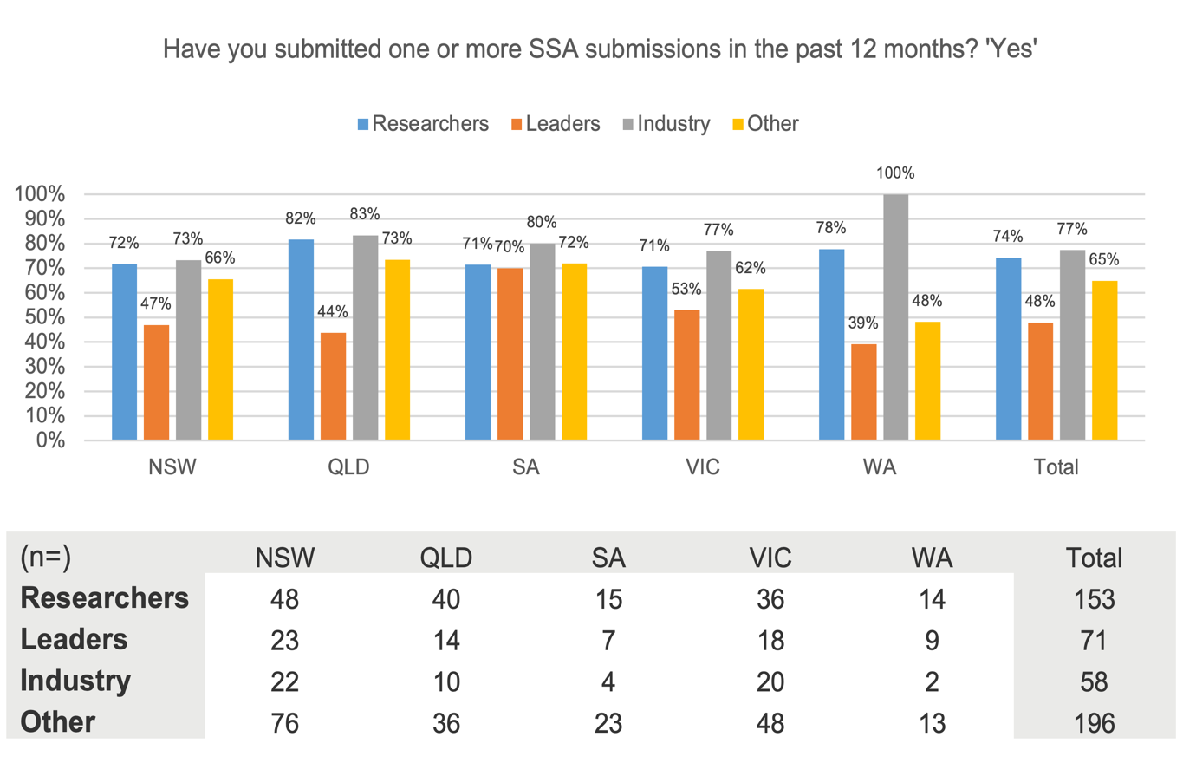

Review of SSA submission in the past 12 months
Respondents were asked whether they had reviewed one or more SSA submissions in the past 12 months. More than half (56%) of the 552 respondents had not reviewed a submission, while 42% indicated they had, as shown in Figure 4.
Figure 4: Respondents who have reviewed one or more SSA submissions in the last 12 months (n=552)
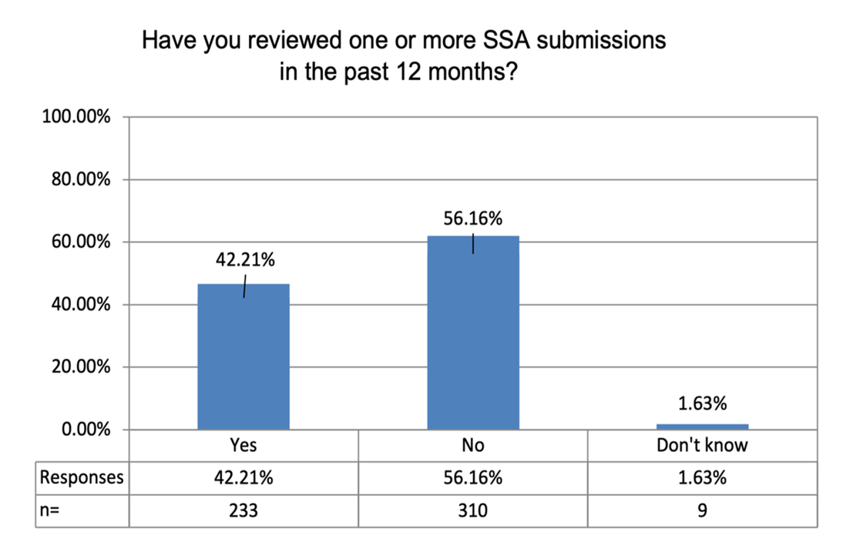
An analysis of the ‘no’ response by both stakeholder group and jurisdiction, as shown in Figure 5, indicates that proportionately, and across all states, the ‘Leader’ group were the most likely to have not reviewed an SSA submission in the past 12 months.
Figure 5: Respondents who have reviewed one or more SSA submissions in the last 12 months, by stakeholder group and jurisdiction
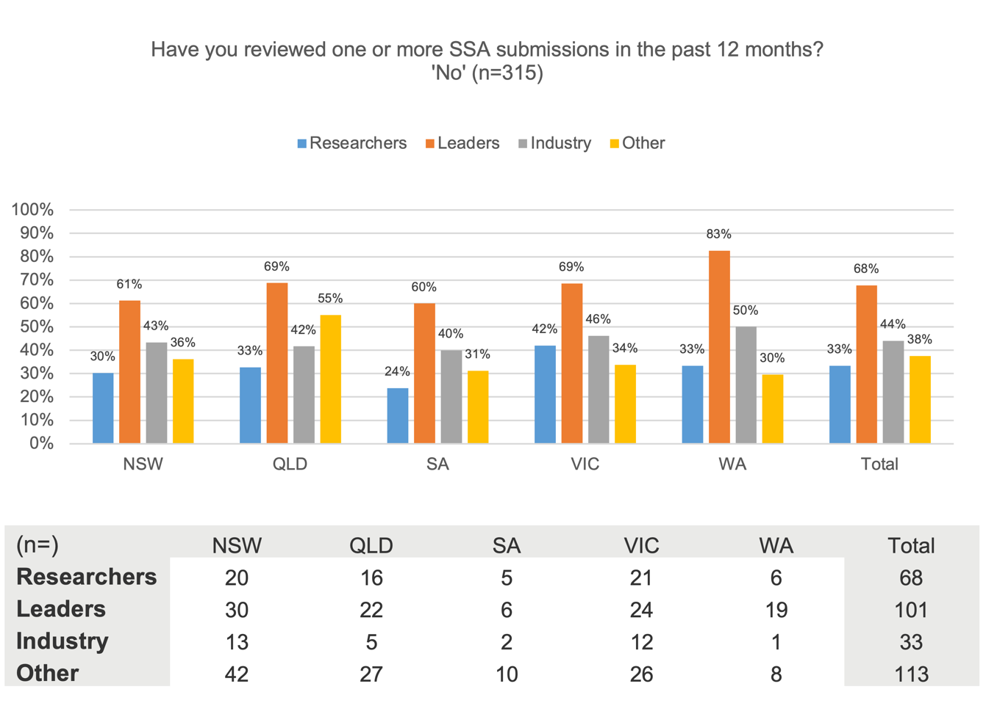

Satisfaction with existing Site‑Specific Assessment process

Satisfaction with existing Site‑Specific Assessment process
Respondents were asked to share their level of satisfaction with the Site-Specific Assessment (SSA) process as it currently exists in their jurisdiction.
Responses were polarised with a total of 38% describing themselves as ‘Very satisfied’ or ‘Somewhat satisfied’ (top 2 box score), and a total of 39% describing themselves as ‘Somewhat dissatisfied’ or ‘Very dissatisfied’ (bottom 2 box score). However, only 9% of respondents described themselves as being ‘Very satisfied’ with the existing SSA process in their jurisdiction (Figure 6).
Figure 6: Satisfaction with existing SSA process (n=551)
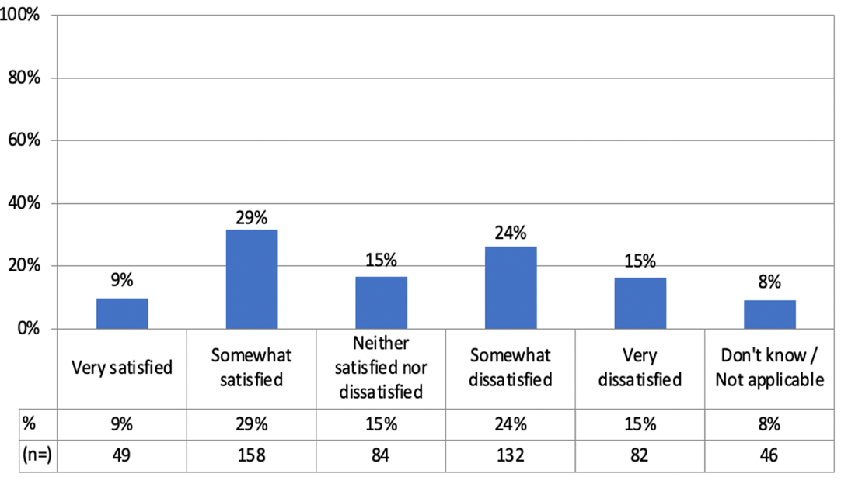

Satisfaction with existing SSA process, by jurisdiction
An analysis of the responses by jurisdiction, as shown in Figure 7, indicates that:
- New South Wales, Western Australia and South Australia all have more dissatisfied users than satisfied users
- South Australia has the lowest proportion of satisfied users and the highest proportion of dissatisfied users
- Queensland and Victoria have the highest proportion of satisfied users
- Victoria also has the lowest proportion of dissatisfied users.
Figure 7: Satisfaction with existing SSA process, by jurisdiction (n=551)
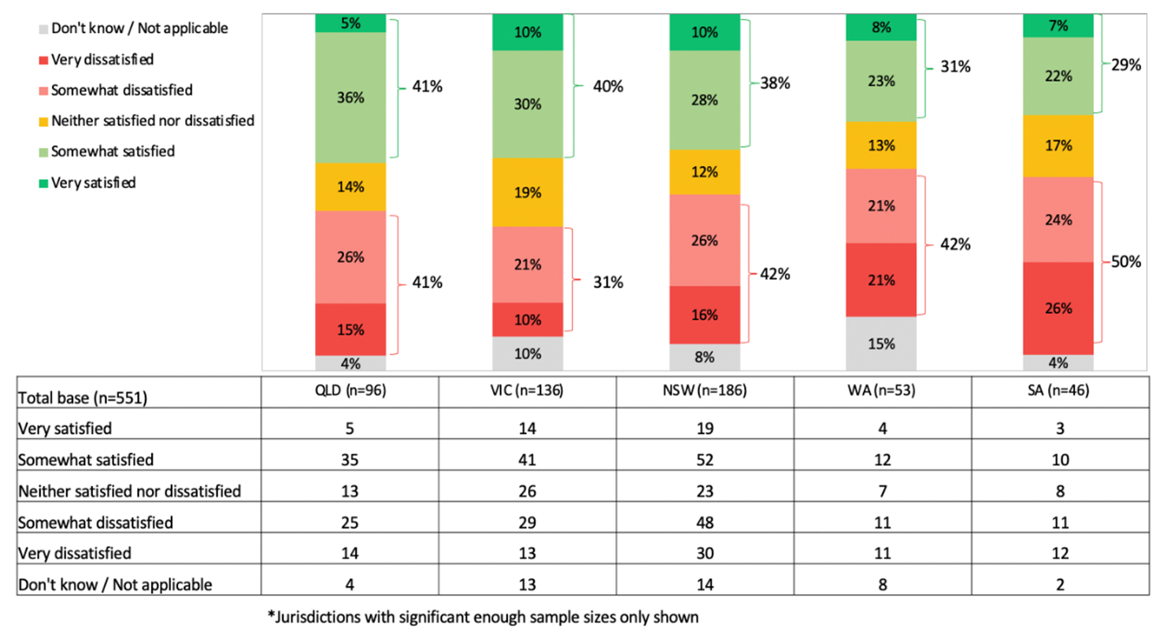

Satisfaction with existing SSA process, by stakeholder
An analysis of the responses by stakeholder group, as shown in Figure 8, indicates that:
- ‘Research governance officers’ and ‘Start-up specialists’ are the stakeholder groups most likely to report being ‘Very satisfied’ or ‘Somewhat satisfied’ with the existing SSA process.
- ‘Clinical registries’, ‘Clinical investigators as sponsors’, and ‘University researchers’ reported the highest proportion of dissatisfaction.
Figure 8: Satisfaction with existing SSA process, by stakeholder group (n=551)
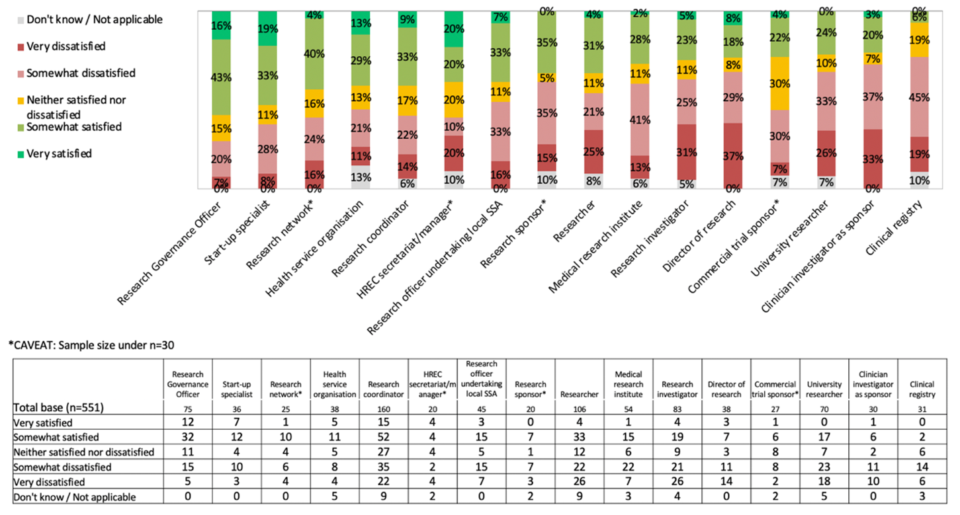

Satisfaction with existing SSA process, by stakeholder group and jurisdiction
A more detailed analysis of the responses by both stakeholder and jurisdiction revealed further insights.
In terms of those who were ‘Somewhat satisfied’ or ‘Very satisfied’ with the existing process (Figure 9):
- The groups least likely to report being ‘Somewhat satisfied’ or ‘Very satisfied’ included ‘Researchers’ in South Australia (10%), ‘Researchers’ and ‘Other’ stakeholders in Western Australia (17% and 19% respectively), and ‘Industry’ in Queensland.
- The groups most likely to report being ‘Somewhat satisfied’ or ‘Very satisfied’ included ‘Leaders’ and ‘Industry’ in Victoria (57% and 50% respectively), ‘Leaders’ and ‘Industry’ in Western Australia (52% and 50% respectively), and ‘Leaders’ in South Australia (50%).
Figure 9: Satisfaction with existing SSA process, by stakeholder group and jurisdiction (n=273)
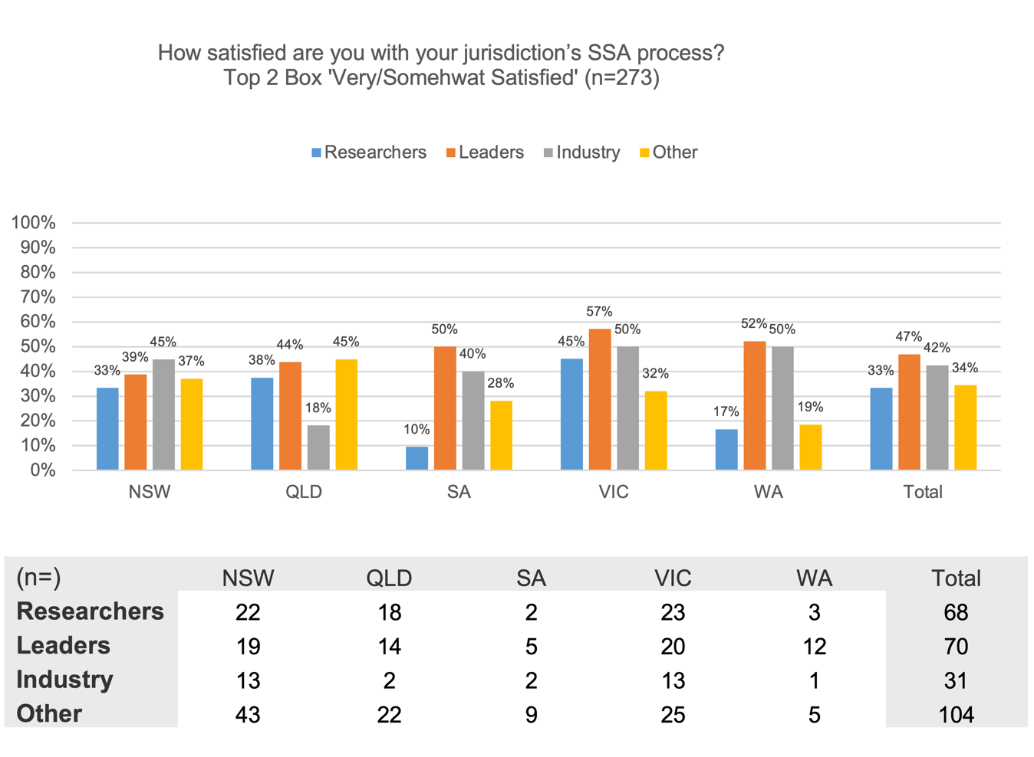
In terms of those who were ‘Somewhat dissatisfied’ or ‘Very dissatisfied’ with the existing process (Figure 10):
- In every state, the ‘Researchers’ group were the most likely to report being ‘Somewhat dissatisfied’ or ‘Very dissatisfied’.
- Groups in which half or more than half of respondents indicated that they were ‘Somewhat dissatisfied’ or ‘Very dissatisfied’ also included ‘Leaders’ and ‘Other’ stakeholders in South Australia (50% and 53% respectively), and ‘Industry’ in Western Australia (50%).
- Overall, the state with the lowest levels of dissatisfaction across all stakeholder groups was Victoria, an insight consistent with findings from previous consultations around the proposed National One Stop Shop.
Figure 10: Dissatisfaction with existing SSA process, by stakeholder group and jurisdiction (n=308)
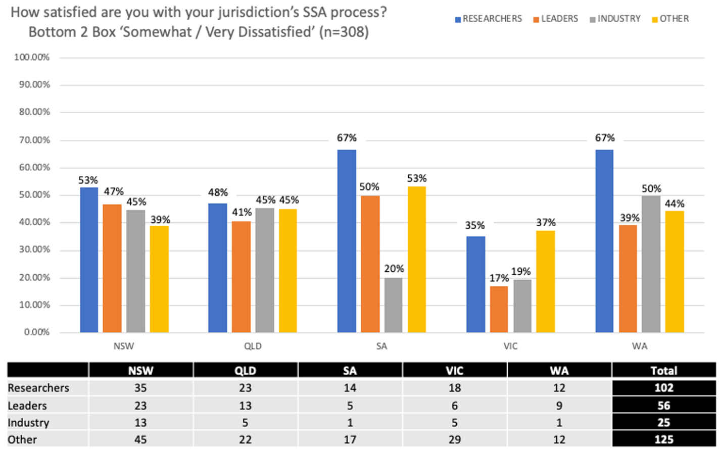

Reasons for dissatisfaction with existing SSA process
Those who reported being dissatisfied with the existing SSA process in their jurisdiction were asked for more information. They were provided with a closed list of possible issues, as well as an open-ended option to nominate a different issue. Respondents were free to select more than one issue (Figure 11).
Responding to a prompted-response list, more than half (58%) indicated that it was because the process was ‘too complicated’. Other prompted responses included:
- The process is ‘too slow’ (46%)
- It is ‘too time consuming’ to complete the form (36%)
- It is ‘too time consuming’ to gather up all the necessary documents (36%).
Around half (51%) indicated that there were other reasons for their dissatisfaction. In open-ended responses, the reasons provided included:
- Variation and inconsistency in processes
- Limited resources to complete the process
- System faults and glitches
- Repetition within the form
- Not being streamlined with other processes.
Figure 11: Reasons for dissatisfaction with existing SSA process (n=214)
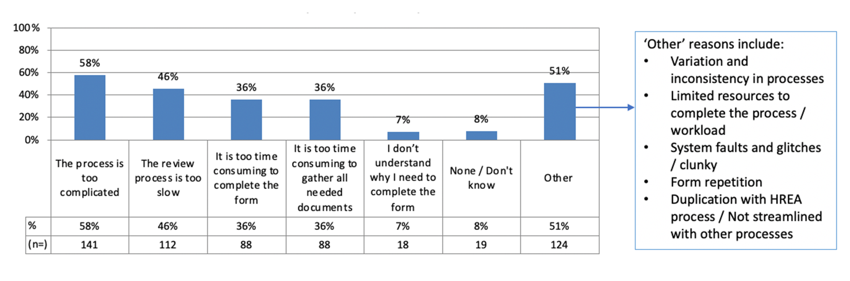
Those who indicated dissatisfaction were prompted to elaborate. Common themes among the 124 responses were as follows:
- Many respondents cited a lack of clarity and consistency around processes and the information required as significant sources of frustration.
- Many also referred to the repetitive nature of what was being asked for, which led to unnecessary and time-consuming duplication of data input.
- Several people made specific comments about the REGIS system, reporting that it was ‘clunky’ and difficult to navigate.
- Some respondents raised the issue of not being able to delegate sign-off authority in cases where the originally designated person was on leave or unavailable for extended periods of time.
- Other comments included lack of RGO resources, lack of appropriate training for reviewers, and a need for increased auto-population functionality.
Below are some representative verbatims from respondents prompted to elaborate on their dissatisfaction.
‘Process is not clear for large scale projects with multiple sites. Each RGO and hospital HREC also enforces their own rules, making the process cumbersome and not streamlined (cannot easily adapt/replicate SSAs across multiple sites)’
‘Some of the SSA form questions are ambiguous and applicants consistently submit responses incorrectly.’
‘The process is ever changing and inconsistent. Every single institution has an individual approach. The process and request for information can be over-reaching.’
‘There is now extreme dissatisfaction with varying state laws and processes that have reached a crisis point in being an obstacle to research. In particular the processes in QLD with QCAT and PHA have become intolerable in that QLD is fast becoming non-preferred for industry and collaborative group trials any longer due to the complicated processes and extreme length of time to obtain approvals.’
‘Massive duplication for multi-site projects, with different requirements at sites.’
‘Questions are duplicative. The ERM platform is slow and doesn’t allow you to submit multiple documents, the RGO doesn’t always look at the MDF (if applicable) so then asks for documents that have already been uploaded. Doctors don’t know their ERM username and passwords, so we end up having to do paper anyway and then upload.’
‘Duplication of having to undertake an SSA after ethics approval is time-consuming. Also, when participating in a national ethics-approved study, the different expectations at a state level have resulted in methodologies in data collection processes needing to be different.’
‘REGIS is the mother of all problems. The platform is so counter-intuitive and rigid that paperwork would be much easier than dealing with REGIS.’
‘The main problems are the duplication of effort when conducting multi-site studies and the online SSA systems (particularly ERM) have not been designed to be intuitive to the users. All sites seem to have a different process even when within the same organisation. The online software platforms (e.g. ERM) are unintuitive, confusing and unnecessarily require duplication of effort. Any new system needs to be designed with users in mind and providing testing to make it easy to understand and use so that employee time isn’t wasted trying to work with a confusing platform and duplicating tasks.’
‘The form is not fit for purposes other than commercial clinical trials.’
‘Multi-site research – little consistency between site processes. Reviews can be very slow and expensive to complete. SSA amendment process at some sites disincentivises protocol amendments.’
‘It is a byzantine mess that is made unnecessarily complicated by ridiculous bureaucracy and is stymying research in WA.’

National Site-Specific Assessment process

Core Site-Specific Assessment requirements
The proposed national Site-Specific Assessment (SSA) aims to include only the minimum number of data fields required by an organisation to conduct a risk assessment for the conduct of research on their premises.
This survey sought to identify the common elements required across all Australian jurisdictions by asking respondents to indicate what they considered to be those ‘core’ requirements.
Across the 418 responses received, there was strong endorsement for the following core requirements:
- Site-specific documentation including site-specific participant materials such as the PICF, insurance and indemnity documents, recruitment strategies, and impact on site personnel, facilities, services and budgets
- Approvals from Heads of Department (or equivalent) for departments that will be impacted by or expected to support the project
- Financial information, with a number of mentions made of the need to declare any in‑kind support the project may be receiving
- Legal documentation including contracts, indemnities, insurances, patient consent forms, conflict-of-interest declarations, risk assessments, and patient-safety procedures, with specific mention made of the need for radiation-risk reports along with biosafety and chemical safety requirements
- HREC approval documentation, as well as any other ethics approvals relevant to the site and/or the project
- Data considerations including information on how data would be shared and stored.

Review of draft ‘Registration’ section

Minimum requirements for ‘Registration’ section
Respondents were shown the questions for the ‘Registration’ section of the draft national SSA, and asked to nominate whether or not these matched the minimum requirements for SSA registration in their own jurisdiction. The draft questions are provided in Figure 12.
Figure 12: Stimulus 1 – Proposed registration fields
Research type
- Research type: Research type will be auto-populated from system
- If, interventional/clinical trial research, then select study type: Study type will be auto‑populated from system based on NHMRC definitions
- Is this a low/negligible risk research?
Site
- Site(s)
- Anticipated site start date
- Anticipated site completion date
Site type
- This question will prompt user to select one option: regular site, teletrial primary site, teletrial satellite site
Site Principal Investigator
- Site Principal Investigator: This question prompts the user to upload a CV (not mandatory) or a GCP (if clinical trials only)
- Title
- First name
- Surname
- Organisation
- Department
- Email address
- Phone
Site Associate Investigator/Co-investigator
- Site Associate Investigator or Co-investigator: This question prompts the user to upload a CV (not mandatory) or a GCP (if clinical trials only)
- Title
- First name
- Surname
- Organisation
- Department
- Email address
- Phone
Site Co-ordinator/Contact person
- Site Co-ordinator or Contact person: This question prompts the user to upload a CV (not mandatory) or a GCP (if clinical trials only)
- Title
- First name
- Surname
- Organisation
- Department
- Email address
- Phone
Conflicts of interest
- This question will prompt users to select options from the following checklist, and provide relevant details and justification: Board appointments; Bonus; Conference and travel; Consultancy; Direct payment; Equipment; Milestone payments; Patent; Recruitment incentive; Shares/options; Other – specify; None
Alignment with organisational strategic plan
- If this is a clinical trial, does conducting the trial at this site align with the organisational strategy as required under the National Clinical Trials Governance Framework? Y/N or N/A (this is not a clinical trial)
Overall, a majority (71%) of the 431 people who responded to this question indicated that the draft did meet the minimum requirements in their jurisdiction. The states with the highest proportion of respondents who indicated that the draft did not match minimum requirements were Victoria (23%) and Western Australia (28%) (Figure 13).
Figure 13: Questions in the ‘Registration’ section of draft national SSA meeting local jurisdictional minimum requirements (n=431)
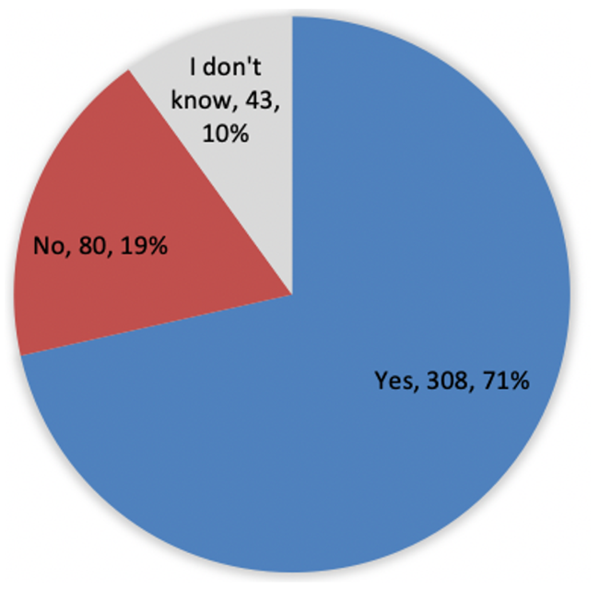

Satisfaction with draft ‘Registration’ section
An analysis by stakeholder group and jurisdiction reveals that endorsement of the ‘Registration’ section was fairly consistent across all stakeholder groups across New South Wales, Queensland, Victoria and Western Australia (Figure 14).
Figure 14: Questions in the ‘Registration’ section of draft national SSA meeting local jurisdictional minimum requirements, by stakeholder group and jurisdiction (n=420)
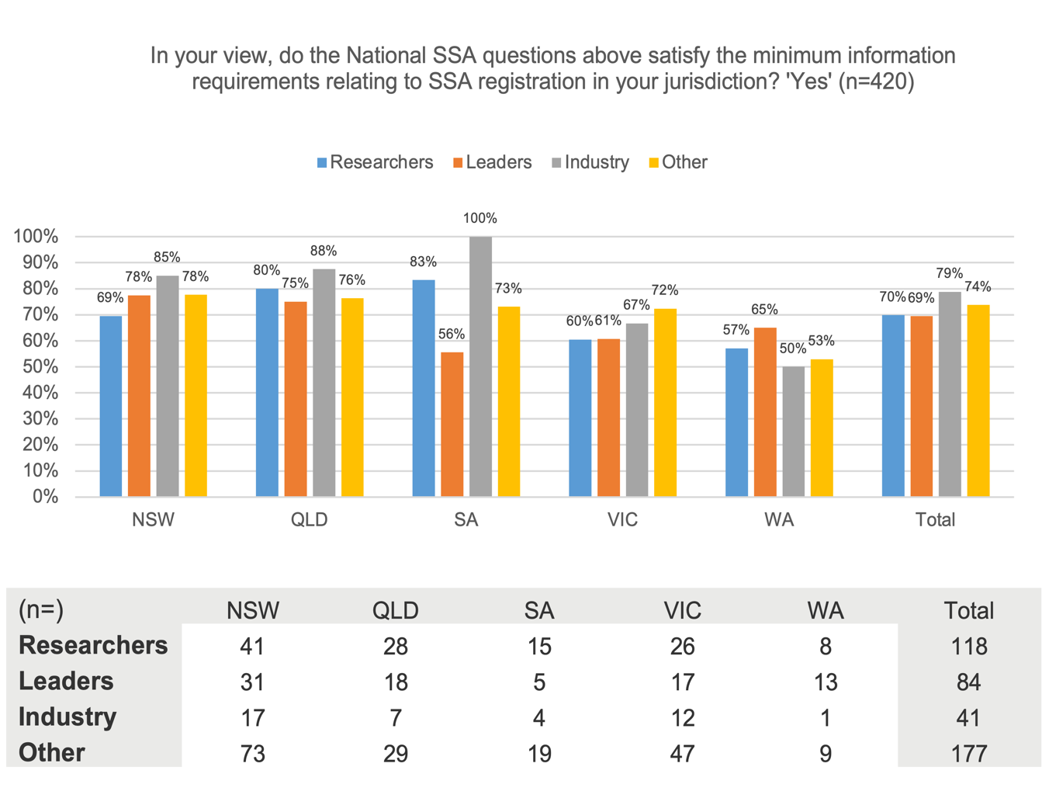

Dissatisfaction with draft ‘Registration’ section
Those who did not agree or were unsure if the Registration section satisfied local minimum requirements were asked to specify the additional information required in their jurisdiction.
The items most commonly noted by the 87 respondents who volunteered information were as follows:
- Project title
- Information about sponsors and funders
- Information about research agreements
- More detail about the recruitment strategy, and the requirements of the local sample
- Likely impacts on site and staff, including the need for training
- Confirmation of existing ethics approval
- Details of co-ordinating principal investigator
- Details for a main contact person.
Other issues raised by multiple respondents includes:
- Concern that the auto-population functionality should be as intuitive and comprehensive as possible
- Concern that the options for ‘research type’ and ‘study type’ must be accurate and detailed enough
- Concern that sites used for remote research require a different approach (and different questions) to those used for onsite research
- Uncertainty around the inclusion of the question on ‘strategic alignment’, including its relevance to non-hospital research, and the capacity of researchers to answer the question accurately
- Preference for making CVs and GCPs mandatory.
Below are some representative verbatims from respondents prompted to provide additional questions for the Registration section of the national SSA.
‘Not sure why alignment with strategic plan is included. This does not add value to the SSA process and is part of a different question relating to individual departmental level research plans.’
‘Yes [it meets minimum requirements] … BUT most of that will have been entered into the Ethics application. Why can’t the ethics application be used as the basis for the SSA rather than having to enter everything again?’
‘We are often asked to include site investigators when there is nothing being done on site, so this is challenging. e.g. when we access data from a health department, we have to complete an SSA for that site with the list of ‘site investigators’ – this makes no sense.’
‘The type of research will need careful consideration and may be better categorised with hierarchical system to achieve mutually exclusive categories. e.g. interventional v observational and, if interventional randomised and/or controlled/non-randomised and/or uncontrolled, if randomised individuals or populations. Need to be able to distinguish between patients as participants vs public vs staff of institutions (e.g. surveys), needs to manage many different types of research e.g. linked data and observational only, randomised but using linked data, action research, qualitative research of all types.’
‘Expand this to mandatory documents or evidence of necessary documents, otherwise this is no better than existing platforms, and governance bodies will keep imposing their own submission requirements on their websites.’
‘This information covers one site. Is there scope for adding all sites? And if so, how would the person completing the document answer the question relating to each site’s organisational strategic plan (such as satellite sites). Or by ‘site’ are you including all sites in the LHD? How is that captured? or excluded?’
‘GCP and CV are essential for this site. If it is optional, we would have to submit them to local ethics at a later date which defeats the whole purpose of this process.’
‘A lot of this content should auto populate from the HREC application. Repetition is such a waste of time. Why should I need to explain a link to the organisational strategic plan? Of what relevance is that to the RGO?’
‘The Registry administration team needs to be included! We have had local governance offices decide to close the registry site because the Local Investigator did not answer their emails (being busy clinicians) and the RGO failed to contact the Registry administration team to ask for information or even to inform them of their proposed action!!!! The Registry administration team is often responsible for all communication with the RGO including submission of annual progress reports.’
‘Have you already consulted with someone within this institution about your project? Who have you spoken to? Does your project require involvement of institution staff, clients/patients/residents or carers? What extent will be the involvement of staff, clients/patients/residents and carers? Do researchers have in place the appropriate insurance/indemnity, Police Check/Working with Children Checks?’

Additional feedback on draft ‘Registration’ section
Additionally, 148 respondents took the opportunity to supply further feedback on the ‘Registration’ section of the draft national SSA. Common themes were as follows:
- Consistent with earlier responses to the Registration section, many users felt the question about ‘strategic alignment’ was problematic, noting that many researchers would not have the capacity to respond accurately
- Many respondents flagged that much of the information listed here would also be covered in an HREC application and hoped that data entered as part of that process would pre‑populate to the SSA
- A number of respondents cautioned against gathering information that typically changes even before a project begins, noting that this would either make the assessment redundant, or require laborious updates. In particular, the requirement to include ‘start’ and ‘finish’ dates was identified as problematic. Several respondents suggested that requiring a ‘duration’ could be more useful
- Multiple respondents asked for the system to serve as a repository for professional CVs, GCPs and other key credentials, with the capacity for the applicant to ‘pull down’ these details as required. Respondents had various suggestions on how this could be maintained, including users being required to check/update/validate this information on a regular basis
- Several respondents raised concerns that the questions seemed to be built around the clinical trials process, and emphasised that the proposed national, centralised system must accommodate other forms of research.

Review of draft ‘HREC approvals’ section

Minimum requirements for ‘HREC approvals’ section
Respondents were shown the questions for the ‘HREC approvals’ section of the draft National SSA, and asked to nominate whether or not these matched the corresponding minimum requirements in their own jurisdiction. The draft questions are provided in Figure 15.
Figure 15: Stimulus 2 – Proposed HREC approval fields
HREC
- Reviewing HREC Name
- Reviewing HREC Reference The reference will be auto populated from system
- Reviewing HREC Project Approval Letter User will be prompted to upload attachment
- Reviewing HREC Approval to add Site User will be prompted to upload attachment
Other HREC approvals
- Other HREC relevant to site
- Other HREC Reference The reference will be auto-populated from system
- Other HREC Project Approval Letter User will be prompted to upload attachment
- Other HREC Approval to add Site User will be prompted to upload attachment
Advertising
- Approved advertising material for the research will be auto-populated from system
- Approved advertising material updated for site will be auto populated from system
Participant information and consent form
- Participant Information and Consent Form updated for site User will be prompted to upload attachment
A majority (70%) of the 419 people who responded to this question indicated that the ‘HREC approvals’ section of the draft did meet the minimum requirements in their jurisdiction. Again, Victoria and Western Australia had the highest proportion of respondents who indicated the draft did not match minimum requirements in their jurisdiction (25% and 24% respectively) (Figure 16).
Figure 16: Questions in the ‘HREC approvals’ section of draft national SSA meeting local jurisdictional minimum requirements (n=419)
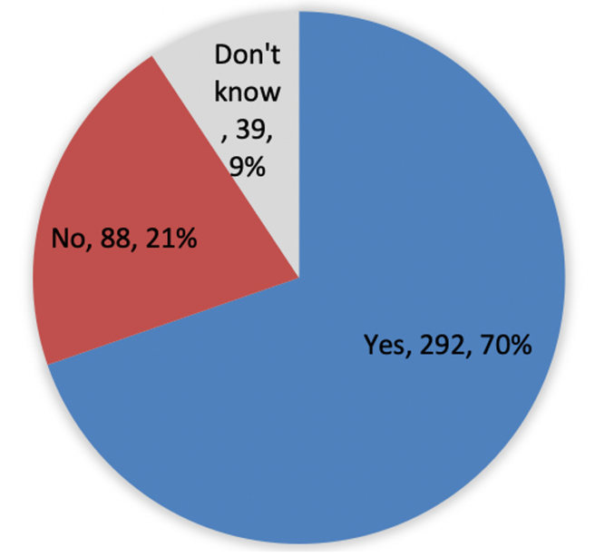

Satisfaction with draft ‘HREC approvals’ section
An analysis by stakeholder group and jurisdiction reveals that ‘Industry’ stakeholders were most likely to agree that the ‘HREC approvals’ section satisfied the minimum requirements. While sample sizes are small, ‘Industry’ from Queensland, South Australia, Victoria and Western Australia were most likely to agree that the ‘HREC approvals’ section satisfied the minimum requirements (Figure 17).
Figure 17: Questions in the ‘HREC approvals’ section of draft national SSA meeting local jurisdictional minimum requirements, by stakeholder group and jurisdiction (n=523)
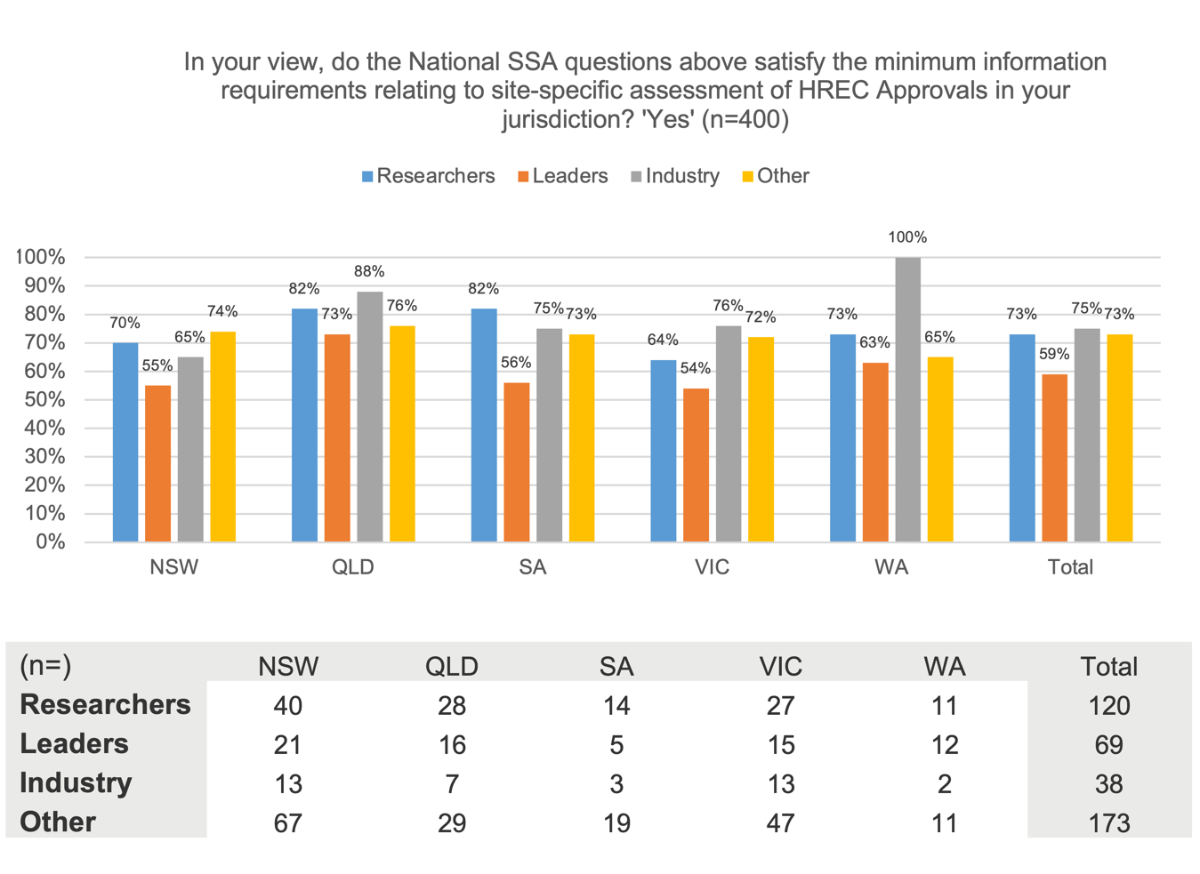

Dissatisfaction with draft ‘HREC approvals’ section
Those who did not agree or were unsure if the ‘HREC approvals’ section satisfied local minimum requirements were asked to specify the additional information required in their jurisdiction:
- The most common suggestion was that this section should require the upload of protocol documents (this was raised by just under a quarter of the 102 respondents who provided an answer to this question)
- It was also proposed that this section should require the upload of all approved documents, including all relevant participant or other study materials (such as questionnaires). Specifically, it was noted by many that the requirement for advertising and PICF materials only to be uploaded, was not sufficient
- Further to this, it was noted that participant and study materials may include multimedia resources such as video, and that the platform should enable the upload of these
- Additionally, there was commentary from multiple respondents around the value of requiring the upload of both the master document(s) and the site-specific document(s), with site-specific alterations clearly marked
- Again, respondents also wanted to be reassured that the platform logic would auto-populate accurately and intuitively.

Other items mentioned as additional requirements for the ‘HREC approvals’ section, included:
- HREC approval date
- HREC starting date and/or HREC period
- HREC amendments
- Level of type of risk
- Evidence of having met state legislation requirements
- Waiver of consent.
Below are some representative verbatims from respondents prompted to provide additional questions for the ‘HREC approvals’ section of the national SSA.
‘Other than the PICF there are often other site-specific documentation that will need to be uploaded. Auto-population of these documents will in most cases be a Master version and there needs to be a place to upload the site-specific versions.’
‘Additional fields may be required in the PICF section. e.g. Optional consent (biological sampling, genetic testing), withdrawal, PICF for children/adolescents & parents, pregnancy/pregnant partner consent, separate withdrawal forms.’
‘It would be best if site-specific documents or lead site documents were optional so it was clear where to submit the advertising materials for single-site studies. Advertising materials or the most recent PICF may not be approved under the initial or updated site HREC approval letter, so you would need a place to attach these approval letters, too, without duplicating efforts for studies with just one approval letter.’
‘I’m unclear why this section is only asking for the PICF and advertising materials, what about other patient-facing documents (diaries, etc.) or other approved documents?’
‘Applicants need to provide all ethically approved documents that will be used at the site, not just advertisements and PICFs, protocols are important too.’
‘It needs to work for non-clinical trials also e.g. Plain Language Statement (under consent).’
‘PICFs are not relevant for registries with waived consent, so this should be hidden.’
‘increasingly multimedia resources used with trials and studies – not just paper based. we have videos and infographics for consent – reliance on documents only is out dated.’
‘Level of risk assigned by the HREC to the project. Currently in NSW we get the level of risk assigned by the researcher which may be up-graded or down-graded by the HREC. The HRECs classification is most important.’
‘Risk type should be here rather than on previous page – low risk , neg risk etc. Single or multi-centre; type of ethical review and jurisdiction. [National Mutual Acceptance] NMA please highlight!’
‘The approved master information sheets should be listed here as how otherwise is the governance officer to know if the site has changed any important details in the ethically-approved forms. Also there may be other patient material that needs to be updated for the site.’
‘I would like to see the Master PICF/s uploaded, not just the site-specific. As an RGO, it was astonishing/disappointing to see how many errors there were in HREC Approved/CRC Reviewed PICFs. Clearly, PICFs are not well reviewed or read.’
‘1) Victoria is currently piloting having a site coversheet in lieu of a site PICF/advertising material. I think this reduces burden and risk. Maybe a site coversheet can be auto-generated from the system in lieu of another update. 2). Too many sub-categories. Just ask for HREC approval upload.’
‘Too much breakdown in HREC approval. it is unnecessary.’
‘It would be great if the researchers would not have to upload all the ethics approved documents again for an SSA application.’
‘I don’t believe additional questions are needed, but rather for the documents submitted and approved by HREC to automatically filter down to the governance office for review with the SSA. This section should be just to upload any site-specific forms and HREC approval letter for adding the site.’
‘I think this information is sufficient but I have had RGO request and undertake far more unnecessary steps.’
‘I think it’s too much. If you give this to governance you just get a second ethics review by people not qualified to do ethics review.’

Additional feedback on draft ‘HREC approvals’ section
Additionally, 145 respondents took the opportunity to supply further feedback on the ‘HREC approvals’ section of the draft national SSA. Common themes were as follows:
- The most commonly mentioned concern was that this section of the SSA process seemed to be requiring a duplication of the HREC application process. Respondents sought reassurance that all relevant information and documents would be pre-populated/shared with the SSA process
- Consistent with responses to the previous question, multiple respondents recommended that the SSA process include a requirement for the original master PICF document, as well as site-specific PICFs
- Respondents also mentioned the need for the upload of documents not currently identified in the ‘HREC approvals’ section, such as letters from GPs, NCAT approvals, biobank approvals and others
- A number of respondents raised issues concerning the possibility of multiple HRECs being involved in the process, as suggested by the proposed ‘Other HREC approvals’ questions in this section. Some respondents insisted that there should be a single HREC only and were unsure why ‘other HRECs’ were being noted here. Other respondents referred to site‑specific HRECs. Among these, some suggested site‑specific HRECs were problematic and confusing, while others suggested they were an essential part of the process. In summary, this seems to be an area of considerable confusion and conflicting interpretations
- Respondents again identified that the range of potential participant materials extended beyond PICFs, noting examples such as surveys, interview schedules, information brochures and others. This was often raised in the context of concern that the draft national SSA seemed to be built around the needs of clinical trials, and was not accommodating other types of research
- There was also some feedback on functionality. A number of respondents requested functionality to support simultaneous upload of multiple documents. Others noted the need for the system to support the upload of a range of document types including e-consents and emails.

Review of draft ‘Recruitment and financial information’ section

Minimum requirements for ‘Recruitment and financial information’ section
Respondents were shown the questions for the ‘Recruitment and financial information’ section of the draft national SSA, and asked to nominate whether or not these matched the corresponding minimum requirements in their own jurisdiction. The draft questions are provided in Figure 18.
Figure 18: Stimulus 3 – Proposed recruitment and financial information fields
Participants
- Participant recruitment target
Sponsor
- Sponsor Type This question will include a drop-down list: Commercially sponsored; Collaborative group; Investigator initiated group; Institution; University; Other
Funding
- Type of Funding Source This question will include a drop-down list: Commercially sponsored: Collaborative group; External (e.g. NHMRC grant); Internal/Departmental; Other
- Commercially sponsored source
- $xxxx per patient or per year
- Estimated funding for the project at this site $xxxx
- Name
- Sponsored, other (e.g. collaborative group) source
- $xxxx per patient or per year
- Estimated funding for the project at this site $xxxx
- Name
- External funding source (e.g. NHMRC grant)
- $xxxx per patient or per year
- Estimated funding for the project at this site $xxxx
- Name
- Internal/Departmental source
- $xxxx per patient or per year
- In-kind contribution
- Estimated funding for the project at this site $xxxx
- Name
- Other source
- $xxxx per patient or per year
- In-kind contribution
- Estimated funding for the project at this site $xxxx
- Name
- Signed finance summary user will be prompted to upload attachment

Almost three-quarters (74%) of the 402 people who responded to this question indicated that the ‘Recruitment and financial information’ section of the draft did meet the minimum requirements in their jurisdiction. Victoria and Queensland were the states with the highest proportion of respondents who indicated the draft did not match minimum requirements in their jurisdiction (25% and 23% respectively) (Figure 19).
Figure 19: Questions in the ‘Recruitment and financial information’ section of draft national SSA meeting local jurisdictional minimum requirements (n=402)
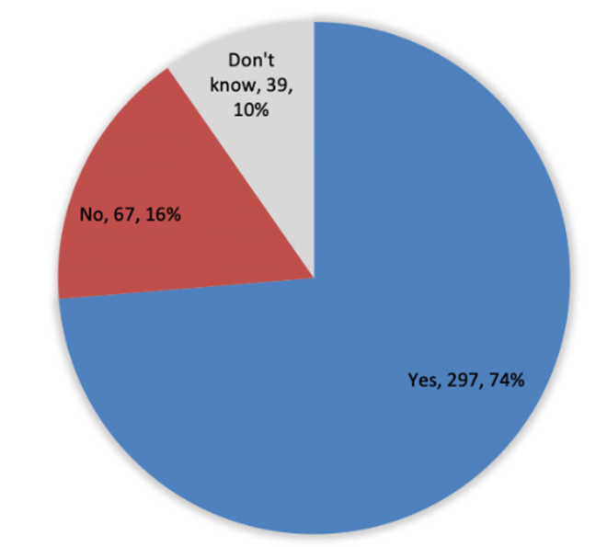

Satisfaction with draft ‘Recruitment and financial information’ section
An analysis by stakeholder group and jurisdiction reveals that there was particularly high endorsement for the statement among ‘Industry’ stakeholders in New South Wales (95%) (Figure 20).
Figure 20: Questions in the ‘Recruitment and financial information’ section of draft national SSA meeting local jurisdictional minimum requirements, by stakeholder group and jurisdiction (n=488)
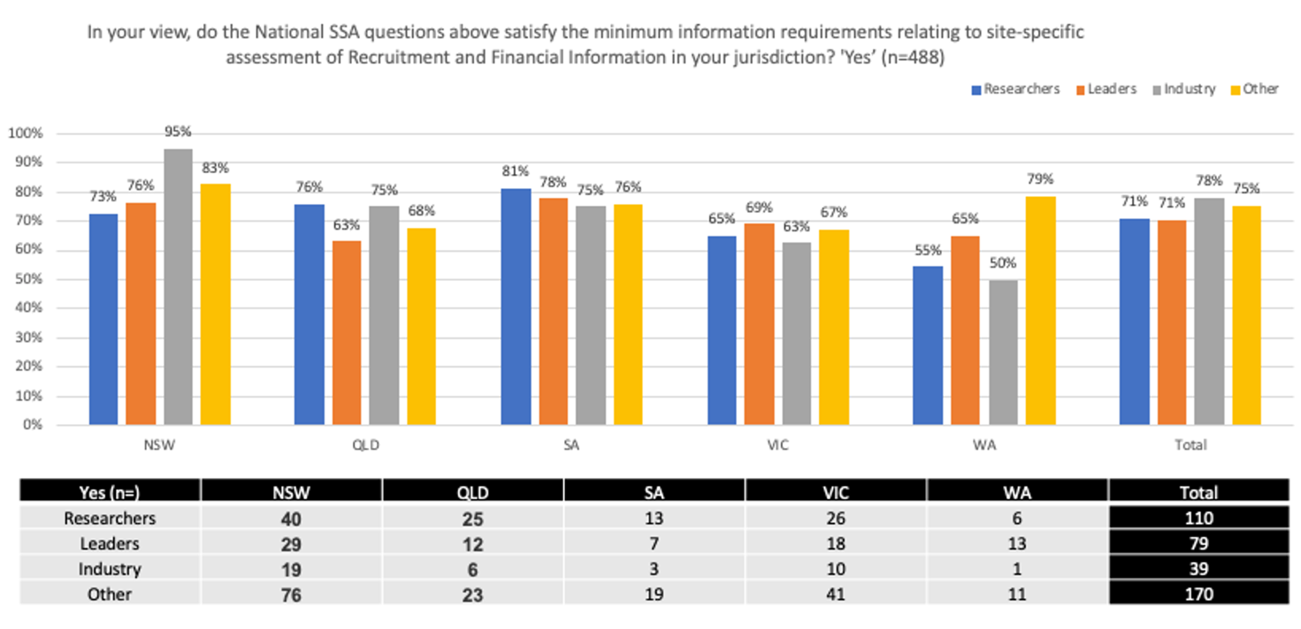

Dissatisfaction with draft ‘Recruitment and financial information’ section
Those who did not agree or were unsure if the ‘Recruitment and financial information’ section satisfied local minimum requirements were asked to specify the additional information required in their jurisdiction.
Among the 67 responses provided, there were some common themes:
- Regarding financial information
- the need to capture a variety of funding types, including costs associated with the site’s provision of people, equipment or services, set-up costs and ‘pass-through’ costs
- the need to capture multiple funding sources for a project, plus the possibility that financial information will differ from site to site depending on the available in‑house resources
- the fact that the questions currently in the draft do not reflect the requirements of certain types of sites or projects, such as emergency departments
- Regarding recruitment
- the need for more detail on recruitment, including proposed recruitment per month and per site, recruitment targets
- the need to capture issues surrounding the recruitment of high-risk/vulnerable participants, including consent issues, and insurance considerations
- There were also a number of comments questioning whether the SSA processes was the most appropriate place to collect this information, and whether it might already be collected as part of the relevant Clinical Trial Research Agreement (CTRA).
Other specific items noted for inclusion were:
- Governance fee
- Additional costs (health service)
- Institutional agreements associated with funding distributions
- Responsibility for signatures (simplified)
- Clinical trial details (Phase, CTN or CTA, registry number, CRO if relevant).
Below are some representative verbatims from respondents prompted to provide additional questions for the ‘Recruitment and financial information’ section of the national SSA.
‘This covers income but there are also expenses and pass-through costs like pharmacy, pathology or radiology charges.’
‘You have not asked about costs to the site. You have only asked about income or in-kind.’
‘No specification about requirement of resources from hospital like Xray, ECG, etc.’
‘Most studies in emergency medicine are unfunded (in-kind donations of time from each site chief investigator). This type of investigator initiated study isn’t catered for in your form.’
‘Is there a way to allow for both in-kind contributions and funding? We often see a combination of both in kind costs and grant funding …’
‘The per-patient payment on a trial and the estimated income from the trial are only half of the financial story of a trial. Without reference to expenditure it is impossible to assess whether the trial is financially viable at this site. The same trial may have varying costs at different sites: site #1 may do Ophthalmology assessments in-house at a set cost, but site #2 might need to outsource this to an external provider.
‘If [research team] falls short of participant target, or project closes early, there needs to be certainty that certain payments are still upheld – for example whether you have two patients or ten patients, the nurse or coordinator is still required.’
‘Much more information about recruitment required. For example exactly who will recruit at our site (internal/external), how they will recruit and approach potential participants etc. This is a big governance issue that can’t be glossed over – you need to make sure anyone external entering the site for recruitment has been cleared to do so, for example. students need a student placement agreement, others may need credentialling, access to data, etc.’
‘Recruitment: It’s not just the number of participants recruited. We also require details of how the recruitment will occur. Financial information: Will the options be to ‘choose one’ or will there be an option to select more than one funding source?’
‘There should be a prompt to upload a budget if required.’
‘The separate sections are starting to get overly complicated but this might be ameliorated by the drop-down lists, again in a simple and easy to follow format.’
‘Explanatory notes would be useful for the signed finance summary section.’
‘The whole premise is flawed. The SSA should not be doing this work. This is the business of the site and they will have their own mechanism to assess this. Sites often have different costings based on legitimate reasons. Groups like Cancer Trials Australia can fill you in on this.’
‘This information is not required in the SSA. It is in the CTRA so is time wasting. Budget has already been agreed on prior to SSA submission and approval.’
‘Finance summary not needed. Finance details are in signed CTRA which is submitted with governance.’
‘Will there be a standardised Finance Summary template that can be used? How can we properly estimate clinical trial costs when the national Independent Hospital Pricing Authority (IHPA) costing tool is not current?’
‘Not nearly comprehensive enough – need to ask clearly for overall trial recruitment numbers and recruitment targets for site. And in our institution, a financial summary and per-patient payment info alone is grossly inadequate for responsible financial management.’
‘One item about recruitment seems remarkably inadequate.’
‘Overly complicated financial information, that doesn’t fit the majority of studies I do.’
‘No additional [requirements], however much should be removed.’

Additional feedback on draft ‘Recruitment and financial information’ section
Additionally, 139 respondents took the opportunity to supply further feedback on the ‘Recruitment and financial information’ section of the draft National SSA. Common themes were as follows:
- Many respondents flagged that researchers are not well placed to develop the necessary financial documentation. Some suggested templates or other tools would support this task
- Further to this, many expressed uncertainty around what should and should not be included in financials, including in-kind contributions, ‘pass-through’ costs, and external services provided. A number explicitly queried what was meant by the term ‘signed financial agreement’
- Specifically, a number of respondents noted that the form should include the capacity for multiple funding sources to be named.
- A number of respondents flagged the need for on-screen definitions of ‘sponsor’ and ‘funder’, noting that it is not uncommon for researchers to use the terms interchangeably
- Again, many respondents wanted to know if parts of this section would be pre-populated form other processes including the HREC and CTRA processes
- Respondents also wanted reassurance that the online process would be ‘dynamic’, in other words, that users would be served relevant questions only, determined by responses to previous questions
- Again, multiple respondents noted that the form seemed to conform with the needs of clinical trials, and not with the needs of other types of research, including data-driven research.

Review of draft ‘Department approvals’ section

Minimum requirements for ‘Department approvals’ section
Respondents were shown the questions for the ‘Department approvals’ section of the draft national SSA, and asked to nominate whether or not these matched the corresponding minimum requirements in their own jurisdiction. The draft questions are provided in Figure 21.
Figure 21: Stimulus 4 – Proposed department approval fields
Approvals
- Joint Department approval by a joint Committee (attach)
- Pharmacy approval user will be prompted to upload attachment
- Pathology approval user will be prompted to upload attachment
- Imaging approval user will be prompted to upload attachment
- Radiology approval user will be prompted to upload attachment
- Approval for biosafety and chemical safety requirements user will be prompted to upload attachment
- Does the study require Institutional Biosafety Committee (IBC) notification and/or licence application to the Office of the Gene Technology Regulator (OGTR) for approval of genetically modified organisms? User will be prompted to upload attachment
- Does the study require NHMRC Gene and Related Therapies Research Advisory Panel (GTRAP) or Cellular Therapies Advisory Committee (CTAC) assessment? User will be prompted to upload attachment
- Does the study require Application for a licence to the NHMRC Licensing Committee to conduct embryo research? User will be prompted to upload attachment
- Approval to access medical records Y/N or N/A user will be prompted to upload attachment
- Other (15w. attach signed Heads of Department approval as required)
Therapeutic Goods Administration (TGA)
- TGA notification required?
- If yes, select either CTN or CTA
Insurance
- Insurance user will be prompted to upload Certificate of Currency
Indemnity
- Indemnity user will be prompted to upload Medicines Australia form of Indemnity signed by sponsor
Research agreements
- Research agreements user will be prompted to upload Medicines Australia or other approved contract or agreements such as material/data sharing agreements, signed by principal investigator
- Does the project require a teletrial sub-agreement at this site? User will be prompted to upload approved contract
Intellectual property
- Does the Clinical Research Agreement address intellectual property (IP) ownership?
- If No / N/A, please provide details on who will own the IP
Over two-thirds (69%) of the 398 people who responded to this question indicated that the ‘Department approvals’ section of the draft did meet the minimum requirements in their jurisdiction. Victoria and Queensland were the states with the highest proportion of respondents who indicated the draft did not match minimum requirements in their jurisdiction (25% and 29% respectively) (Figure 22).
Figure 22: Questions in the ‘Department approvals’ section of draft national SSA meeting local jurisdictional minimum requirements (n=398)
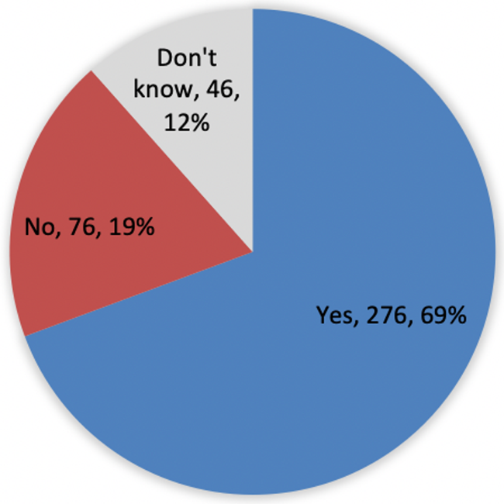

Satisfaction with ‘Department approvals’ section
An analysis by stakeholder group and jurisdiction reveals that endorsement was reasonably consistent for all stakeholders in New South Wales, ranging from 68% for ‘Researchers’ to 75% for both ‘Industry’ and ‘Other’ stakeholders (Figure 23).
Figure 23: Questions in the ‘Department approvals’ section of draft national SSA meeting local jurisdictional minimum requirements, by stakeholder group and jurisdiction (n=484)
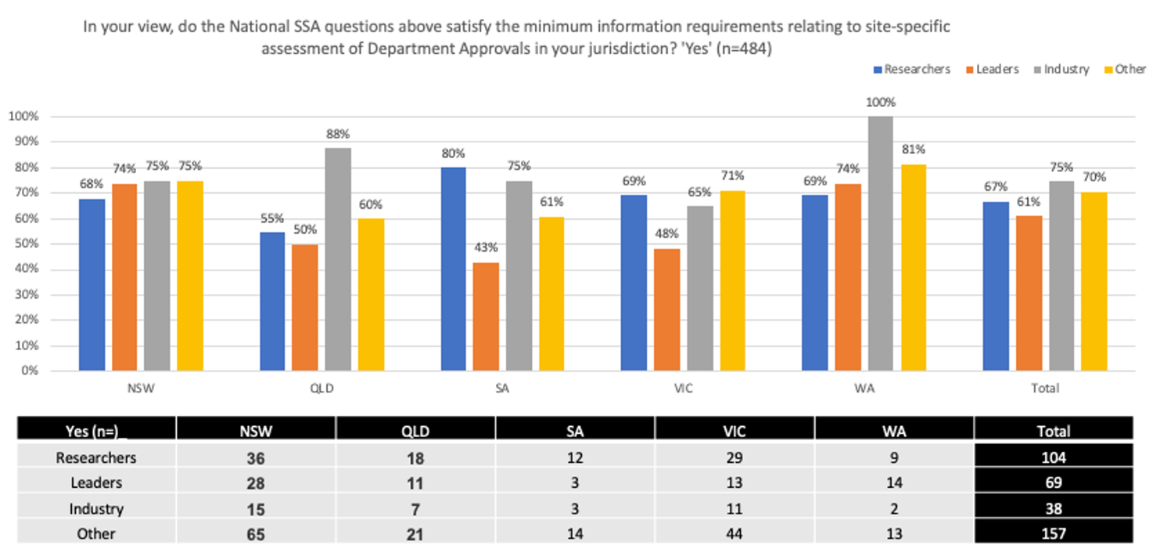

Dissatisfaction with ‘Department approvals’ section
Those who did not agree or were unsure if the ‘Department approvals’ section satisfied local minimum requirements were asked to specify the additional information required in their jurisdiction.
Among the 85 responses provided, there were some common themes:
- A number of respondents noted that the list of departments was not comprehensive. Examples of some of the other departments suggested include: paediatric, intensive care, radiology, oncology, emergency, critical care, treatment centres, outpatients, wards
- Similarly, some emphasised the need for the Research Agreements question to capture a variety of options, including: Service Agreements, Material and Data Transfer Agreements, Clinical Trial Research Agreements, Multi-Institutional Agreements
- Further to the above, several respondents called out the need for radiation dosage safety agreements
- Many respondents noted the importance of including approvals for data access and data management. In particular it was noted that the question about ‘medical records’ did not acknowledge the high use of data outside of ‘medical records’
- The use of genetic materials and genetic data was also a concern for some, with several noting the need for genetic compliance and/or management plans to be included here. One respondent specifically called out the need for such plans to be included in the SSA, even where genetic research is not the primary activity being undertaken, due to the increasing relevance of genetics across all medical research
- Several respondents felt that the area of intellectual property (IP) required more detail, including who owns IP ongoing, how the collection of personal data is covered by IP, and consideration of future commercial potential for IP
- Many respondents were looking for reassurance that questions in this section would be flexible and/or that ‘not applicable’ options would be available, noting that their projects did not require all the approvals currently listed here
- Many respondents specifically requested a ‘Head of Department’ approval. Others suggested some sort of overall organisational approval would be preferable to the department-by-department approach.
A number of jurisdictional considerations were raised including:
- South Australia
- procurement restrictions on where agreements can be stored
- compulsory wording regarding radiation in PICFs
- Western Australia
- requirement for insurance policy wording
- Victoria
- requirement for Head of Department approvals on capacity, financials and strategic alignment
- Queensland
- QCAT approvals
- Public Health Act 2005 processes.
Below are some representative verbatims from respondents prompted to provide additional questions for the ‘Department approvals’ section of the national SSA.
‘Usually we see just a head of department approval being requested for research with other institutions. At CMAX our purpose is to do research, not to provide clinical care, so the head of department fields above are not applicable and should be able to be overridden by overall sign off.’
‘The upper half of the questions are irrelevant to a registry and should automatically jump to the latter half.’
‘This form is specifically designed for clinical trials governance reviews and doesn’t capture the other individual approvals. Why pharmacy but not paediatric, ICU, radiology, oncology – or are they captured by the joint heads of department option?
‘Head of Department, and Head of Department’s Manager should be required to sign off to say they approve of the research occurring. Private organisations may have different signature needs to public health organisations.’
‘Uploading approvals is moving backwards! This system should be entirely digital with the ability to push digital approval sign-off to other departments.’
‘Research Agreements should not be prompted to be uploaded. In SA there are procurement restrictions on where Agreements can be stored.’
‘Intellectual property should include access to personal data by candidates and perhaps a data authority who can ensure a pathway to build-in future multi-platform or twinning machine functionality, and particularly approval from a genomics authority despite absence of genetic therapy as genetics must be a consideration in all research and medical treatment ongoing.’
‘Intellectual property question should not simply state ‘Does the agreement address IP ownership’ as investigators will simply click ‘yes’. This is a recurring issue where agreements are an afterthought. Likewise some agreements need to be reviewed by legal services. The questions should state who will own the future IP and who owns the background IP for this project.’
‘Commercialisation potential would be good to include under IP section.’
‘You have not included ‘Access to Data’ – you have included ‘Access to Medical Records’ but not every research project uses Medical Records, but most want data of some kind. Individual jurisdictional requirements will kick in here, for example in Queensland, we have the Public Health Act process. We also have QCAT approvals for clinical trials involving participants who are not competent to provide consent.’
‘Trials using ionising radiation require a radiation safety assessment. This could be added as one of the approval options. This is relevant to most oncology trials where response assessment is via medical imaging.’
‘In fact, I think some of this is way too much – needs to be as minimal as possible. Or will this be drop down/not applicable?’
‘This is a very complex set of approvals.’
‘Why is it necessary to gather department approval if they are all part of the same institution? Institutional approval should be sufficient, eliminating this extra step.’
‘Why does there need to be a Teletrial sub‑agreement in the SSA? What information does this add or assist with. Running a Teletrial is an arrangement between a Primary and a Satellite site, this does not need to be formally agreed with a document.’
‘Not all these fields are required and may make smaller research programs unnecessarily bureaucratic. Should include an option stating that some fields are not applicable.’

Additional feedback on ‘Department approvals’ section
Additionally, 138 respondents took the opportunity to supply further feedback on the ‘Department approvals’ section of the draft national SSA. Common themes were as follows:
- Several respondents wanted this section to include a comprehensive list of departments. At the same time, several respondents asked for this section to include a ‘not applicable’ option so that users could skip any non-relevant departments
- Respondents voiced a need for the process to be supported by both clear instructions and intuitive functionality. Suggestions included a set of questions or checklist that would clarify which departments should be approached for approvals, and links to relevant definitions, forms and/or templates
- Again, respondents sought reassurance that relevant data items would be pre-populated from existing HREC submissions
- The functionality to upload multiple documents at once was again noted here.

Overall perceptions

Overall perceptions, length of draft National SSA
Respondents were asked to indicate whether they believed the draft national SSA form was ‘Too long’, ‘Too short’ or Jjust right’. Of the 396 who responded to this question, just under a quarter (24%) indicated they believed it was ‘Too long’, while the majority (68%) felt it was ‘Just right’ (Figure 24).
Figure 24: Overall perceptions, length of draft national SSA (n=396)
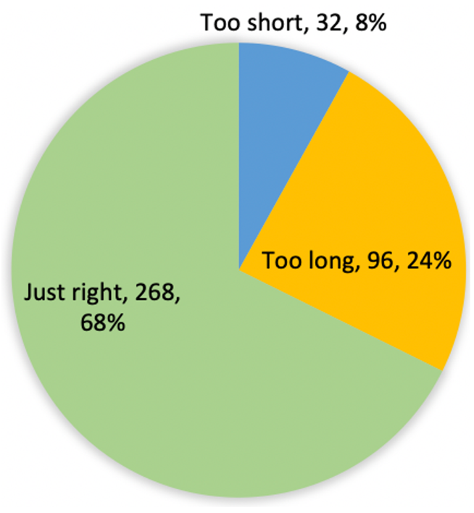
Analysis of the responses by stakeholder group indicates that ‘Research investigators’ and ‘Researchers’ were the groups most likely to say that the draft national SSA was ‘Too long’ (37% and 36% respectively). Support for this statement was similarly high among ‘Directors of research’, ‘Clinician investigators as sponsors’, and ‘Research sponsors’, however the sample sizes of these groups were small (n<30).
A quarter (25%) of ‘Research governance officers’ indicated the draft national SSA was ‘Too short’, making them the stakeholder group most likely to align with this sentiment (Figure 25).
Figure 25: Overall perceptions, length of draft national SSA, by stakeholder group (n=350)
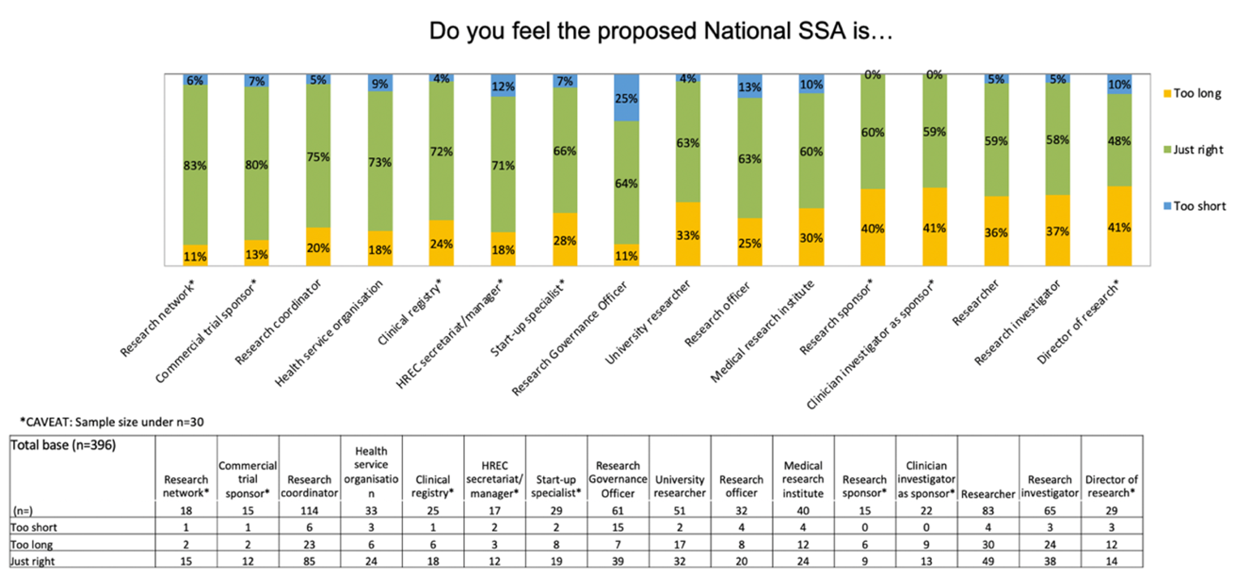
An analysis of the responses by both stakeholder group, and jurisdiction are shown in Figures 26–30 on the following pages.
- In New South Wales, Queensland, Victoria and Western Australia, the most common response across all stakeholder groups was that the length of the draft national SSA was ‘Just right’.
- In South Australia, the ‘Leaders’ and ‘Industry’ groups were more likely to report that the draft was ‘Too long’, while ‘Researchers’ and ‘Other’ stakeholders were more likely to report that it was ‘Just right’ (Figure 28).
Figure 26: Overall perceptions, length of draft national SSA, by stakeholder group: NSW (n=202)
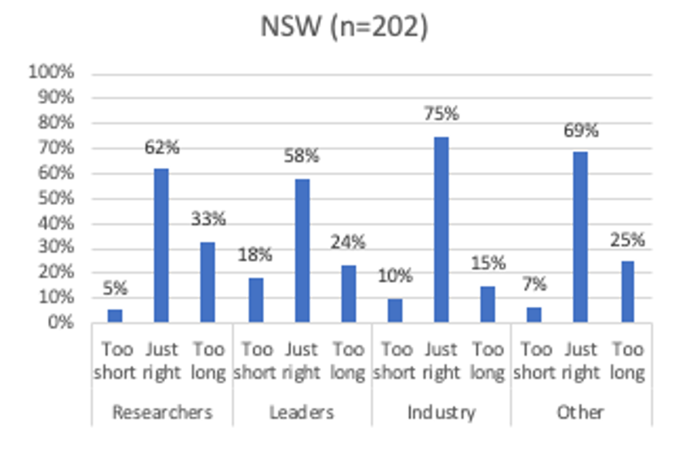
Figure 27: Overall perceptions, length of draft national SSA, by stakeholder group: QLD (n=98)
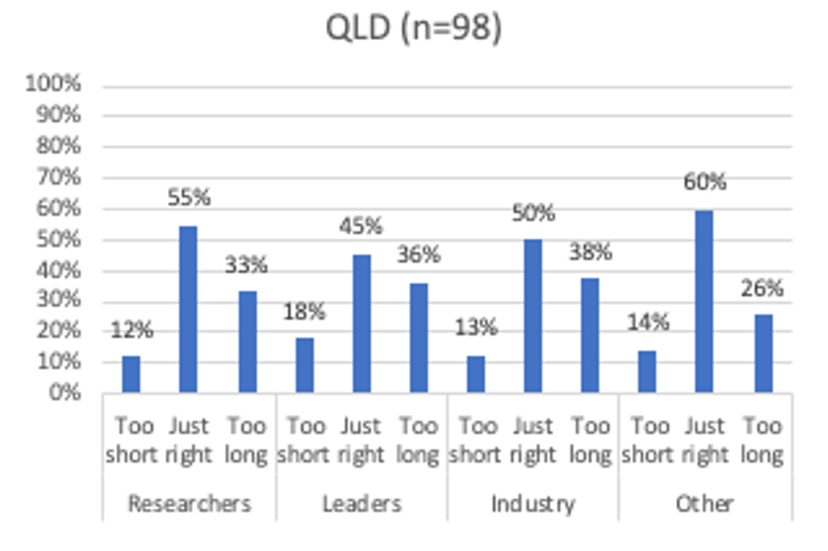

Figure 28: Overall perceptions, length of draft national SSA, by stakeholder group: SA (n=54)
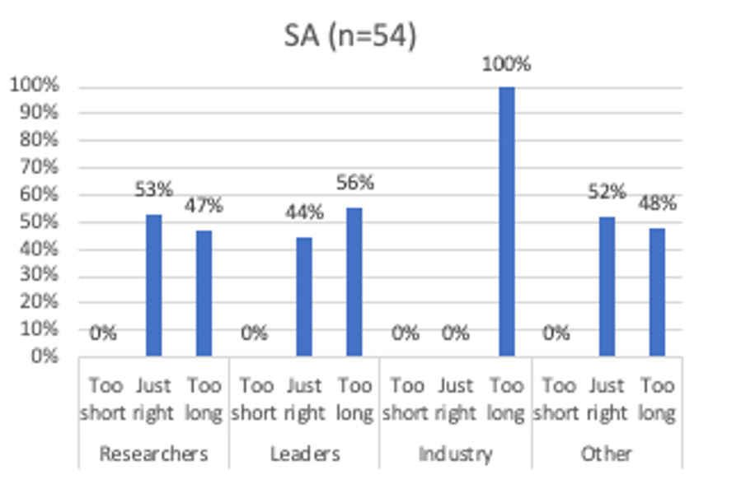
Figure 29: Overall perceptions, length of draft national SSA, by stakeholder group: VIC (n=145)
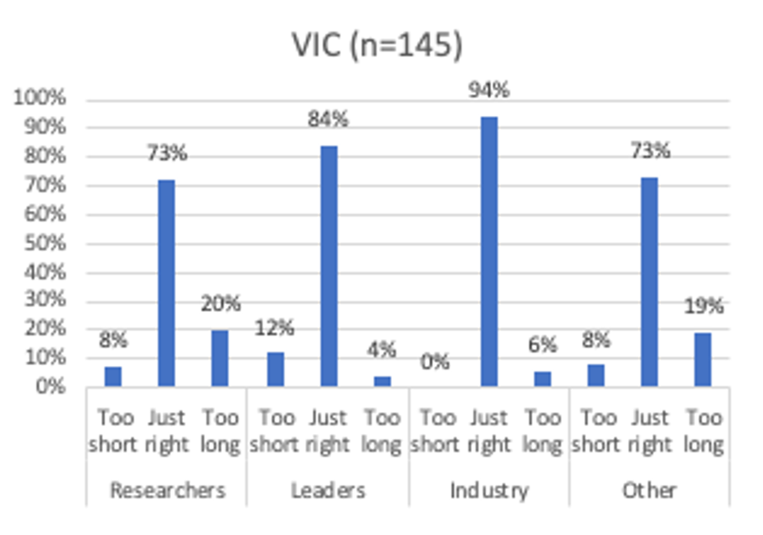

Figure 30: Overall perceptions, length of draft national SSA, by stakeholder group: WA (n=45)
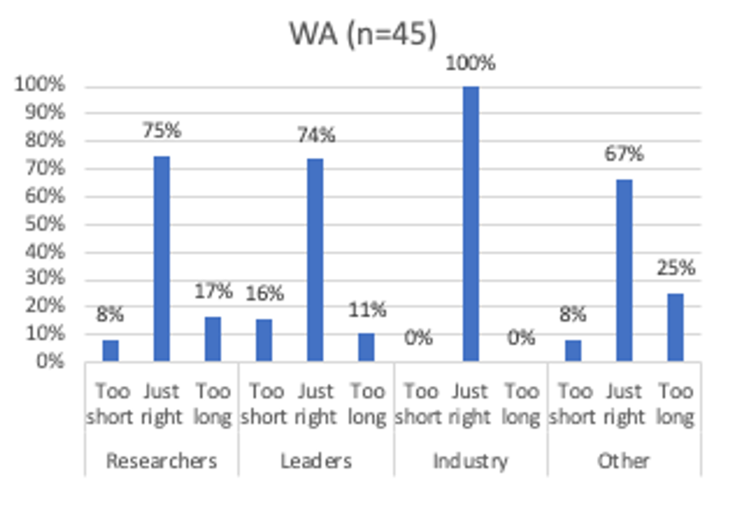

Overall perceptions, complexity of draft National SSA
Respondents were also asked to give their assessment of the complexity of the draft national SSA form. Of the 397 who responded to this question, the majority (70%) felt it was either ‘Comprehensive’ or ‘Just right’. Outside of this majority, 18% felt the draft national SSA was ‘Overly complicated’, while 12% felt it was ‘Not detailed enough’ (Figure 31).
Figure 31: Overall perceptions, complexity of draft national SSA (n=397)
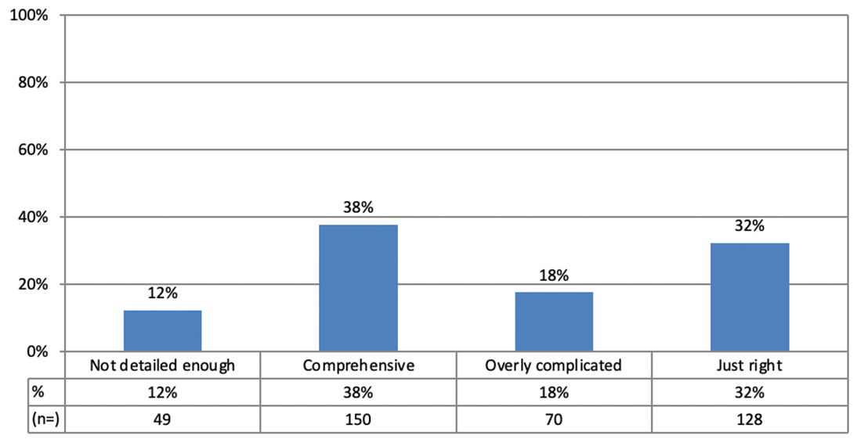
Analysis of the responses by stakeholder group indicates that ‘Research coordinators’, ‘Researchers’, ‘Research investigators’, and ‘University researchers’ were those most likely to align with the statement that the complexity of the draft national SSA was ‘Just right’.
More than a third (35%) of ‘Research governance officers’ indicated the draft national SSA was ‘Not detailed enough’, making them the stakeholder group most likely to align with this sentiment (Figure 32).
Figure 32: Overall perceptions, complexity of draft national SSA, by stakeholder group (n=352)
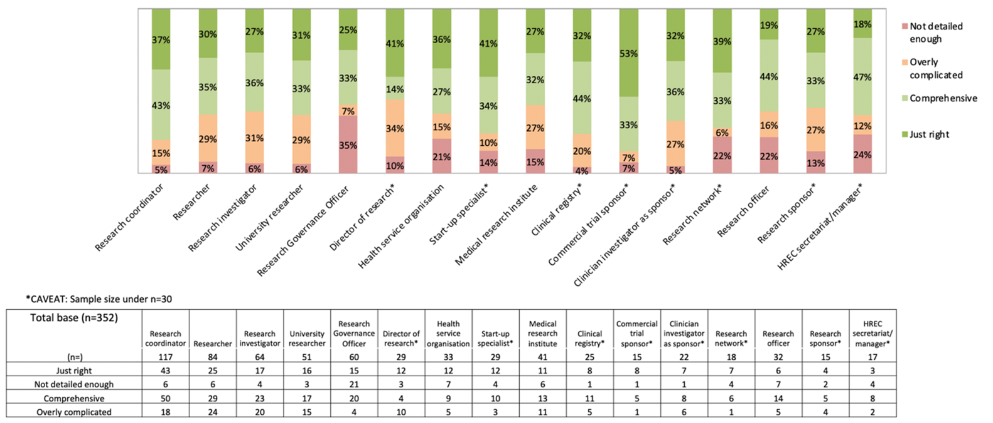

Overall perceptions, above‑the‑line requirements
Respondents were asked whether they agreed that the fields proposed in the draft national SSA represented the above-the-line requirements, in support of site risk assessment. Of the 398 who responded to this question, the majority (68%) agreed with the statement, while 15% disagreed. Almost one in five respondents (17%), answered ‘Don’t know’ (Figure 33).
Figure 33: Overall perceptions, above the line requirements (n=398)
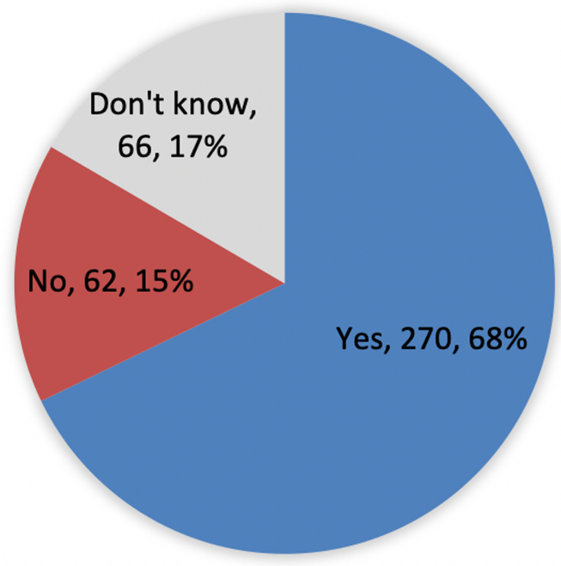
Analysis of the responses indicates that ‘Research coordinators’ were the stakeholder group most likely to agree with the statement (75%). Agreement with the statement was similarly high among ‘HREC secretariat/managers’, ‘Start-up specialists’, ‘Research networks’, ‘Commercial trial sponsors’ and ‘Clinical registries’, however the sample sizes of these groups were small (n<30).
Almost a third (30%) of ‘Research governance officers’ did not agree the fields proposed in the draft national SSA represented the above-the-line requirements, making them the stakeholder group most likely to align with this sentiment (Figure 34).
Figure 34: Overall perceptions, above the line requirements, by stakeholder group (n=352)
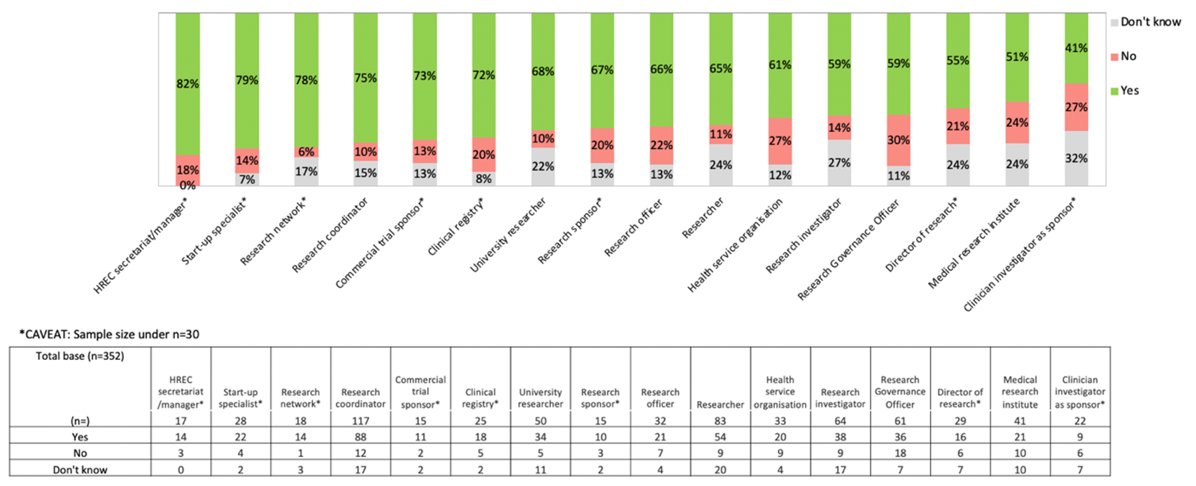

Jurisdictional below‑the‑line requirements
Respondents were asked to identify jurisdictional below-the-line requirements, not already considered in the HREC process, that should be included in the national SSA process. Responses were provided by 185 people. Common themes were as follows:
- Broadly speaking, respondents identified a need for the national SSA process to consider jurisdictional requirements related to
- models of consent
- data access and/or management
- state privacy legislation
- There were also calls for some specific state‑based considerations, namely
- the Queensland Public Health Act 2005 and QCAT approvals for Queensland
- the Victorian Specific Module (VSM) for Victoria
- the Western Australian Guardianship and Administration Act 1990
- the New South Wales Human Tissue Act 1983
- Numerous respondents raised the issue of radiation safety, and the need to include related state-based reports and assessments
- Also of note were comments from a number of private research organisations concerned that their own requirements were not fully met in the draft national SSA process. In particular, a number of respondents referred to ‘Catholic’ requirements around PICFs and certain specific types of research such as IVF.
Additionally, multiple respondents volunteered more generalised commentary:
- Some called for an end to jurisdictional inconsistencies and the development of a truly national, standardised system
- Others expressed scepticism that HREC processes dealt adequately with jurisdictional requirements, proposing that these should be included in the SSA process as something of a safety net.

Other fields required
The final question of the survey invited respondents to nominate any other fields they believed should be included in the national SSA. Several respondents commented that there were already too many fields, and that there should be less rather than more. Among those who felt differently, common responses:
- Some sort of facility for researcher credentialling, noting that this could aid in identifying those working outside their scope
- Capture of pre-existing agreements for sites that run large programs of trials
- Fields for relevant legislative documentation, noting that HREC approvals do not always consider legislative requirements
- Capacity to easily update with amendments
- Sponsor contact details
- Fields for information about designated Research Assistances, noting that these are often the people undertaking research at the site (rather than site personnel)
- Fields relating to research studies other than clinical trials, for example surveys and other data-based studies.
Responses also included a request for a glossary of terms and/or other clear instructions to support the submissions of less experienced applicants.


Level 5, 255 Elizabeth Street, Sydney NSW 2000
GPO Box 5480, Sydney NSW 2001
Phone: (02) 9126 3600
Email: mail@safetyandquality.gov.au
Website: www.safetyandquality.gov.au

