# Australian Commission on Safety and Quality logotypeOn the Radar

Issue 605

5 June 2023

*On the Radar* is a summary of some of the recent publications in the areas of safety and quality in health care. Inclusion in this document is not an endorsement or recommendation of any publication or provider. Access to particular documents may depend on whether they are Open Access or not, and/or your individual or institutional access to subscription sites/services. Material that may require subscription is included as it is considered relevant.

*On the Radar* is available online, via email or as a PDF or Word document from <https://www.safetyandquality.gov.au/publications-and-resources/newsletters/radar>

If you would like to receive *On the Radar* via email, you can subscribe on our website <https://www.safetyandquality.gov.au/publications-and-resources/newsletters>  
or by emailing us at H[Umail@safetyandquality.gov.auU](mailto:mail@safetyandquality.gov.au).   
You can also send feedback and comments to H[Umail@safetyandquality.gov.auU](mailto:mail@safetyandquality.gov.au).

For information about the Commission and its programs and publications, please visit <https://www.safetyandquality.gov.au>

You can also follow us on Twitter @ACSQHC.

**On the Radar**

Editor: Dr Niall Johnson [niall.johnson@safetyandquality.gov.au](mailto:niall.johnson@safetyandquality.gov.au)

Contributors: Niall Johnson

**Reports**

*Consultation Report – Requirements for the National One Stop Shop, the National Clinical Trials Front Door and core elements of the National Site-Specific Assessment*

Australian Commission on Safety and Quality in Health Care

Sydney: ACSQHC; 2023. p. 100.

|  |  |
| --- | --- |
| URL | <https://www.safetyandquality.gov.au/our-work/health-and-human-research/national-one-stop-shop-national-platform-health-related-human-research> |
| Notes | National One Stop Shop – a national cross government platform for health-related human research.  The Commission convened the [Health and Medical Research Advisory Group](https://www.safetyandquality.gov.au/our-work/health-and-human-research/national-one-stop-shop-national-platform-health-related-human-research/health-and-medical-research-advisory-group) chaired by Professor Ian Chubb AC, to guide national consultations on the National One Stop Shop on behalf of the Australian Department of Health and Aged Care and all jurisdictions via the Clinical Trials Project Reference Group.  Consultations revealed broad support and a sense of genuine enthusiasm for the proposed National One Stop Shop. It is seen as a rare transformational opportunity for Australia to address longstanding challenges. Participants supported the approach to implementation through cross-jurisdictional governance arrangements that would assist all governments to respond to areas of need in a rapid, coordinated and strategic manner based on accurate information.  The National One Stop Shop consultation report has been endorsed for publication by all health ministers. You can the report and addenda from <https://www.safetyandquality.gov.au/our-work/health-and-human-research/national-one-stop-shop-national-platform-health-related-human-research> |

**Journal articles**

*Patient safety in prisons: a multi-method analysis of reported incidents in England*

McFadzean IJ, Davies K, Purchase T, Edwards A, Hellard S, Ashcroft DM, et al.

Journal of the Royal Society of Medicine. 2023 [epub].

|  |  |
| --- | --- |
| DOI | https://doi.org/10.1177/01410768231166138 |
| Notes | Paper reporting on a study into patient safety incidents reported in prisons in England between April 2019 and March 2019. Using 4112 reports in the National Reporting and Learning System, the authors report that ‘the most frequently observed incidents were **medication-**related (n = 1167, 33%), specifically whilst **administering medications** (n = 626, 54%). Next, were **access-**related (n = 559,15%), inclusive of delays in patients accessing healthcare professionals (n = 236, 42%) and managing medical appointments (n = 171, 31%).’ The authors conclude that their study ‘highlights the importance of improving medication safety and access to healthcare services for prisoners.’ |

*Improving Low-Value Clinical Practices In Murcia: A Healthcare Management Area In Spain*

Lopez-Picazo JJ, Moreno AB, Vidal-Abarca I, López-Ibáñez M

International Journal for Quality in Health Care. 2023:mzad035.

|  |  |
| --- | --- |
| DOI | <https://doi.org/10.1093/intqhc/mzad035> |
| Notes | Paper reporting on an effort to reduce low value care in a Spanish health care organisation. Based on a ‘Do Not Do’ (DND) approach – a somewhat similar approach to other low value care initiatives such as Choosing Wisely. Using a list of DND recommendations developed for the Spanish context, the study sought to reduce ‘the prevalence of DND practices … in a Spanish health management area of 264,579 inhabitants, 14 primary care teams and a 920-bed 3rd level reference hospital.’ The effort included the ‘the measurement of a set of 25 valid and reliable indicators on DND prevalence’ followed by a number of interventions, including:  ‘(1) inclusion in the annual objectives of the clinical units involved;  (2) discussion of results in a general clinical session;  (3) educational outreach visits to the clinical units involved; and  (4) detailed feedback reports.’  The authors report ‘. The results of this strategy were positive, with 75% of the "do not do" practices showing improvement and the target prevalence values (or lower) being achieved in over two-thirds of them.’ |

*Australian Health Review*

Volume 47, Number 3, June 2023

|  |  |
| --- | --- |
| URL | <https://www.publish.csiro.au/ah/issue/11458> |
| Notes | A new issue of *Australian Health Review* has been published. Articles in this issue of *Australian Health Review* include:   * An organisational approach to improving **diagnostic safety** (Ian A Scott and Carmel Crock) * **Time to analgesia for musculoskeletal presentations in Tasmanian emergency departments**: a case-controlled comparative observational study investigating the impact of advanced practice physiotherapists (David Jovic, Kirby Tuckerman, Claire Bergenroth and Viet Tran) * ‘I thought they would do it on the spot’: **why do people with non-traumatic musculoskeletal pain present to emergency departments?** (Grace French, Karen Richards, Robert Waller and Ivan Lin) * **Risk of hospital admission or emergency department presentation due to diabetes complications**: a retrospective cohort study in Tasmania, Australia (Ngan T T Dinh, Barbara de Graaff, Julie A Campbell, Matthew D Jose, John Burgess, Timothy Saunder, Alex Kitsos, P Otahal and A J Palmer) * Do **Australian state and territory cancer plans** include survivorship-related objectives and propose quality survivorship outcomes and measures? (Megan Petrie, Helana Kelly and Michael Jefford) * Higher fees and out-of-pocket costs in **radiotherapy** point to a need for **funding reform** (Kees van Gool, Jane Hall, Philip Haywood, Dan Liu, Serena Yu, Samuel B. G. Webster, Bahare Moradi and Sanchia Aranda) * Effects of the Child Dental Benefits Schedule on **dental hospitalisation rates in Australian children** (Parmis Aminian, Estie Kruger and Marc Tennant) * Physicians’ legal duty to disclose more cost-effective treatment options: an examination of Australian civil law applied to **personal importation** (Narcyz Ghinea) * Health-related outcomes of a facility-based **transition care program for older adults**: a prospective cohort study (Jo-Aine Hang, Jacqueline Francis-Coad, Angela Jacques, Nicholas Waldron, Kate Purslowe and Anne-Marie Hill) * In Australian hospitals and residential aged care facilities, how do we **train nursing and direct care staff to assist patients and residents to move**? A national survey (Natasha Brusco, Terry Haines, Nicholas F Taylor, Helen Rawson, Leanne Boyd, Christina Ekegren, Helen Kugler, Helen Dawes, Camilla Radia-George, Christine Graven and Keith Hill) * Client and staff perspectives regarding **effective work injury rehabilitation** (Diana Dorstyn, Melissa Oxlad, Sharni Whitburn, Boris Fedoric, Rachel Roberts and Anna Chur-Hansen) * Optimising **rostering patterns for Australian junior doctors** (Calvin M Fletcher and Laila L Rotstein) * Experiences of peer messengers as part of a professional accountability culture change program to reduce **unprofessional behaviour**: a cross-sectional study across eight hospitals (Ryan D McMullan, Rachel Urwin, Neroli Sunderland, Kate Churruca, Neil Cunningham and Johanna Westbrook) * **Nurse job task analysis**: a profile of medical and surgical nursing activities (Julie Considine, Olumuyiwa Omonaiye, Jordana Schlieff and Leanne Boyd) * Projecting the future: modelling **Australian dialysis prevalence** 2021–30 (Dominic Keuskamp, Christopher E Davies, Georgina L Irish, Shilpanjali Jesudason and Stephen P McDonald) * Identifying opportunities to optimise the **electronic medical record for allied health professionals**: a concept mapping study (Maria Schwarz, Elizabeth C Ward, Anne Coccetti, Joshua Simmons, Sara Burrett, Philip Juffs, Kristy Perkins and Jasmine Foley) * Geospatial **distribution of** **tertiary hospitals across Australian cities** (Mazen Baazeem, Estie Kruger and Marc Tennant) * Prevalence of **Patient Vigilance System management plans** before and after rapid response system calls (Cindy Chau, Winston Cheung, Vineta Sahai, Kirrilee Phillips, Michelle Waite, Rodney Jacobs and Lawrence Mead) * Response to Raymond et al. **Health policy evaluation in rural and remote Australia**: a qualitative exploration and lessons from the Northern Territory (Bryce Brickley, Oliver Black, Chris Rissel, Kalinda Griffiths (Yawuru) and James A Smith) |

*International Journal for Quality in Health Care* online first articles

|  |  |
| --- | --- |
| URL | <https://academic.oup.com/intqhc/advance-articles> |
| Notes | *International Journal for Quality in Health Care* has published a number of ‘online first’ articles, including:   * Editorial: **Health system resilience, accreditation, high-quality care, and continuous quality improvement**: what is the destination and how do we get there? (Wendy Nicklin and David Greenfield) * The impact of the **COVID-19 Pandemic on Emergency Care of Acute Myocardial Infarction**: Findings from the Taiwan Clinical Performance Indicator (TCPI) (Chia-Ling Hsu et al). * Improving **Low-Value Clinical Practices** In Murcia: A Healthcare Management Area In Spain (Julio J Lopez-Picazo et al.) |

**Online resources**

***[UK] NIHR Evidence alerts***

<https://evidence.nihr.ac.uk/>

The UK’s National Institute for Health Research (NIHR) has posted new evidence alerts on its site. Evidence alerts are short, accessible summaries of health and care research which is funded or supported by NIHR. This is research which could influence practice and each Alert has a message for people commissioning, providing or receiving care. The latest alerts include:

* Who needs **antibiotics after an assisted vaginal birth**?
* Is a male sling as good as more complex surgery for incontinence after **prostate surgery**?
* Discover 5 strategies to increase the long-term success of **prescribing interventions**
* How to reduce **medications for people with multiple long-term conditions**
* Find out how an **antibiotic review kit changed prescribing behaviour**
* Are **decisions shared during labour**?
* Are race and ethnicity associated with poorer **pregnancy outcomes**?
* Was an NHS quality improvement programme effective at reducing the risk of **cerebral palsy** in newborns?

***[USA] Effective Health Care Program reports***

<https://effectivehealthcare.ahrq.gov/>

The US Agency for Healthcare Research and Quality (AHRQ) has an Effective Health Care (EHC) Program. The EHC has released the following final reports and updates:

* *Management of* ***Postpartum Hypertensive Disorders*** *of Pregnancy* <https://effectivehealthcare.ahrq.gov/products/hypertensive-disorders-pregnancy/research>

***[USA] Patient Safety Primers***

<https://psnet.ahrq.gov/primers/>

The Patient Safety Primers from the (US) Agency for Healthcare Research and Quality (AHRQ) discuss key concepts in patient safety. Each primer defines a topic, offers background information on its epidemiology and context, and provides links to relevant materials.

* *Strategies to Improve Organizational* ***Health Literacy***  
  <https://psnet.ahrq.gov/primer/strategies-improve-organizational-health-literacy>
* *Personal* ***Health Literacy*** <https://psnet.ahrq.gov/primer/personal-health-literacy>

**COVID-19 resources**

https://www.safetyandquality.gov.au/covid-19

The Australian Commission on Safety and Quality in Health Care has developed a number of resources to assist healthcare organisations, facilities and clinicians. These and other material on COVID-19 are available at <https://www.safetyandquality.gov.au/covid-19>

These resources include:

* ***OVID-19 infection prevention and control risk management*** This primer provides an overview of three widely used tools for investigating and responding to patient safety events and near misses. Tools covered in this primer include incident reporting systems, Root Cause Analysis (RCA), and Failure Modes and Effects Analysis (FMEA).   
  <https://www.safetyandquality.gov.au/publications-and-resources/resource-library/covid-19-infection-prevention-and-control-risk-management-guidance>
* ***Poster – Combined contact and droplet precautions*** <https://www.safetyandquality.gov.au/publications-and-resources/resource-library/infection-prevention-and-control-poster-combined-contact-and-droplet-precautions>  
  [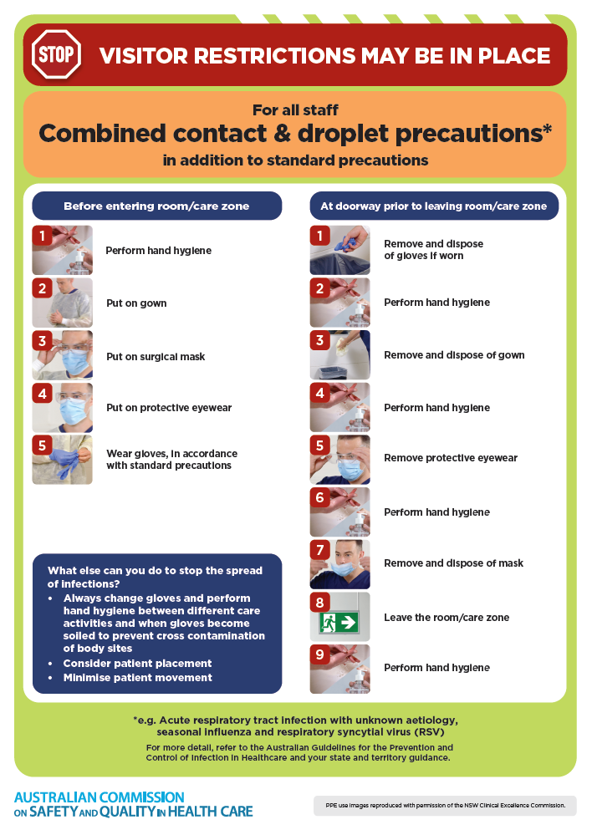](https://www.safetyandquality.gov.au/publications-and-resources/resource-library/infection-prevention-and-control-poster-combined-contact-and-droplet-precautions)
* ***Poster – Combined airborne and contact precautions*** <https://www.safetyandquality.gov.au/publications-and-resources/resource-library/poster-combined-airborne-and-contact-precautions>   
  [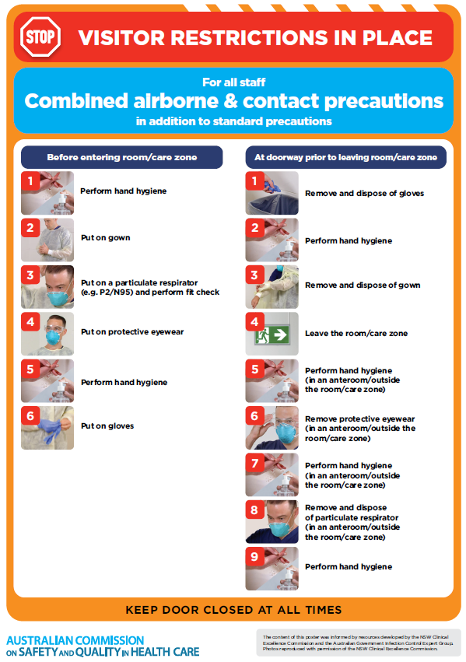](https://www.safetyandquality.gov.au/publications-and-resources/resource-library/poster-combined-airborne-and-contact-precautions)
* ***Environmental Cleaning and Infection Prevention and Control*** [www.safetyandquality.gov.au/environmental-cleaning](http://www.safetyandquality.gov.au/environmental-cleaning)
* ***COVID-19 infection prevention and control risk management – Guidance*** <https://www.safetyandquality.gov.au/publications-and-resources/resource-library/covid-19-infection-prevention-and-control-risk-management-guidance>
* ***Safe care for people with cognitive impairment during COVID-19***<https://www.safetyandquality.gov.au/our-work/cognitive-impairment/cognitive-impairment-and-covid-19>
* ***Stop COVID-19: Break the chain of infection*** posterhttps://www.safetyandquality.gov.au/publications-and-resources/resource-library/break-chain-infection-poster-a3  
  **[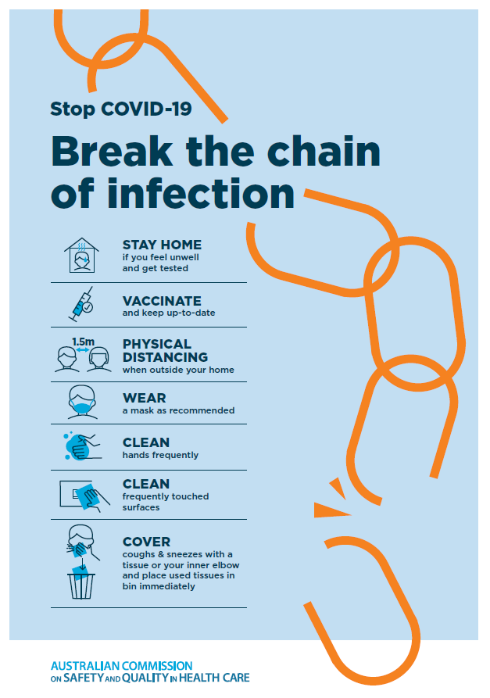](https://www.safetyandquality.gov.au/publications-and-resources/resource-library/break-chain-poster-a3https:/www.safetyandquality.gov.au/publications-and-resources/resource-library/break-chain-poster-a3)**
* ***COVID-19 and face masks – Information for consumers*** <https://www.safetyandquality.gov.au/publications-and-resources/resource-library/covid-19-and-face-masks-information-consumers>

[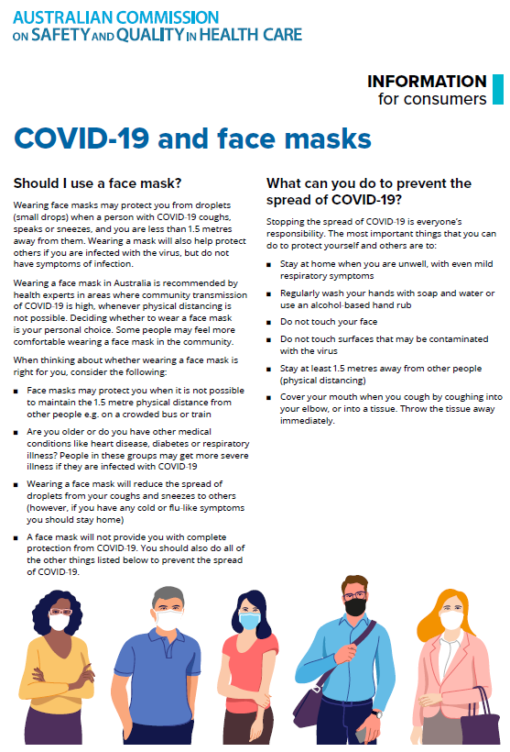](https://www.safetyandquality.gov.au/sites/default/files/2020-07/covid-19_and_face_masks_-_information_for_consumers.pdf)

*National COVID-19 Clinical Evidence Taskforce*

<https://covid19evidence.net.au/>

The National COVID-19 Clinical Evidence Taskforce is a collaboration of peak health professional bodies across Australia whose members are providing clinical care to people with COVID-19. The taskforce is undertaking continuous evidence surveillance to identify and rapidly synthesise emerging research in order to provide national, **evidence-based guidelines and clinical flowcharts for the clinical care of people with COVID-19**. The guidelines address questions that are specific to managing COVID-19 and cover the full disease course across mild, moderate, severe and critical illness. These are ‘living’ guidelines, updated with new research in near real-time in order to give reliable, up-to-the minute advice to clinicians providing frontline care in this unprecedented global health crisis.

*COVID-19 Critical Intelligence Unit*

<https://www.aci.health.nsw.gov.au/covid-19/critical-intelligence-unit>

The Agency for Clinical Innovation (ACI) in New South Wales has developed this page summarising rapid, evidence-based advice during the COVID-19 pandemic. Its operations focus on systems intelligence, clinical intelligence and evidence integration. The content includes a daily evidence digest, a COVID status monitor, a risk monitoring dashboard and evidence checks on a discrete topic or question relating to the current COVID-19 pandemic. There is also a ‘Living evidence’ section summarising key studies and emerging evidence on **COVID-19 vaccines** and **SARS-CoV-2 variants**. The most recent updates include:

* ***SARS-CoV-2 variants - retired living evidence*** – What is the evidence on SARS-CoV-2 variants that are under monitoring by the World Health Organization?
* ***COVID-19 vaccines - retired living evidence*** – What is the evidence on COVID-19 vaccine effectiveness and safety?
* ***Current and emerging patient safety issues during COVID-19*** – What is the evidence on the current and emerging patient safety issues arising from the COVID-19 pandemic?
* ***Bivalent COVID-19 vaccines*** – What is the available regulatory and research evidence for bivalent COVID-19 vaccines?
* ***Surgery post COVID-19*** – What is the evidence for the timing of surgery, and outcomes following surgery, for people who have recovered from COVID-19?
* ***Paxlovid*** – What is the evidence for Paxlovid for treatment of COVID-19?
* ***Molnupiravir*** –What is the evidence for and regulatory context of molnupiravir for treatment of COVID-19?
* ***Eating disorders and COVID-19*** – What is the impact of the COVID-19 pandemic on the prevalence of eating disorders?
* ***Long COVID –*** What is the evidence on the prevalence, presentation and management of long-COVID?
* ***Oseltamivir (Tamiflu) use in healthcare settings*** – What is the evidence that use of oseltamivir in healthcare workers with a symptomatic influenza diagnosis result in an earlier return to work and reduced absenteeism? What is the evidence that use of oseltamivir in adults and children with symptomatic influenza reduces influenza transmission in health care settings?
* ***Alternative models of care for acute medical conditions*** – What is the evidence on alternative models of care for managing patients with acute medical conditions outside of emergency or inpatient hospital settings?
* ***Exercise and long COVID*** – Is exercise helpful in individuals with long COVID? Is post-exertional symptom exacerbation a risk in long COVID?
* ***Influenza and seasonal prophylaxis with oseltamivir*** – What is the place or evidence for seasonal influenza prophylaxis (such as taking oseltamivir for 10 to 12 weeks continuously) in healthcare and aged care settings?
* ***Rapid access models of care for respiratory illnesses*** – What is the evidence for rapid access models of care for respiratory illnesses, especially during winter seasons, in emergency departments?
* ***Post-acute sequelae of COVID-19*** – What is the evidence on the post-acute sequelae of COVID-19?
* ***Emerging variants*** – What is the available evidence for emerging variants?
* ***Chest pain or dyspnoea following COVID-19 vaccination*** – What is evidence for chest pain or dyspnoea following COVID-19 vaccination?
* ***Cardiac investigations and elective surgery post-COVID-19*** – What is evidence for cardiac investigations and elective surgery post-COVID-19?
* ***Breathlessness post COVID-19*** – How to determine those patients who present with ongoing breathlessness in need of urgent review or intervention due to suspected pulmonary embolus?
* ***COVID-19 pandemic and influenza*** – What is the evidence for COVID-19 pandemic and influenza?
* ***Budesonide and aspirin for pregnant women with COVID-19 –*** What is the evidence for the use of Budesonide for pregnant women with COVID-19? What is the evidence for aspirin prophylaxis for pre-eclampsia in pregnant women with a COVID-19 infection?
* ***COVID-19 vaccines in Australia*** – What is the evidence on COVID-19 vaccines in Australia?
* ***COVID-19 pandemic and wellbeing of critical care and other healthcare workers*** – Evidence in brief on the impact of the COVID-19 pandemic on the wellbeing of critical care and other healthcare workers.
* ***Disease modifying treatments for COVID-19 in children*** – What is the evidence for disease modifying treatments for COVID-19 in children?
* ***Mask type for COVID-19 positive wearer*** – What is the evidence for different mask types for COVID-19 positive wearers?
* ***Post acute and subacute COVID-19 care*** – What published advice and models of care are available regarding post-acute and subacute care for COVID-19 patients?
* ***Hospital visitor policies*** – What is the evidence for hospital visitor policies during and outside of the COVID-19 pandemic?
* ***Surgical masks, eye protection and PPE guidance*** –What is the evidence for surgical masks in the endemic phase in hospitals and for eyewear to protect against COVID-19?

**Disclaimer**

On the Radar is an information resource of the Australian Commission on Safety and Quality in Health Care. The Commission is not responsible for the content of, nor does it endorse, any articles or sites listed. The Commission accepts no liability for the information or advice provided by these external links. Links are provided on the basis that users make their own decisions about the accuracy, currency and reliability of the information contained therein. Any opinions expressed are not necessarily those of the Australian Commission on Safety and Quality in Health Care.