# Australian Commission on Safety and Quality logotypeOn the Radar

Issue 606

13 June 2023

*On the Radar* is a summary of some of the recent publications in the areas of safety and quality in health care. Inclusion in this document is not an endorsement or recommendation of any publication or provider. Access to particular documents may depend on whether they are Open Access or not, and/or your individual or institutional access to subscription sites/services. Material that may require subscription is included as it is considered relevant.

*On the Radar* is available online, via email or as a PDF or Word document from <https://www.safetyandquality.gov.au/publications-and-resources/newsletters/radar>

If you would like to receive *On the Radar* via email, you can subscribe on our website <https://www.safetyandquality.gov.au/publications-and-resources/newsletters>  
or by emailing us at H[Umail@safetyandquality.gov.auU](mailto:mail@safetyandquality.gov.au).   
You can also send feedback and comments to H[Umail@safetyandquality.gov.auU](mailto:mail@safetyandquality.gov.au).

For information about the Commission and its programs and publications, please visit <https://www.safetyandquality.gov.au>

You can also follow us on Twitter @ACSQHC.

**On the Radar**

Editor: Dr Niall Johnson [niall.johnson@safetyandquality.gov.au](mailto:niall.johnson@safetyandquality.gov.au)

Contributors: Niall Johnson

**Journal articles**

*Twenty years of monitoring acute stroke care in Australia through the national stroke audit programme (1999–2019): A cross-sectional study*

Purvis T, Cadilhac DA, Hill K, Reyneke M, Olaiya MT, Dalli LL, et al

Journal of Health Services Research & Policy. 2023:13558196231174732.

|  |  |
| --- | --- |
| DOI | <https://doi.org/10.1177/13558196231174732> |
| Notes | The authors of this paper sought to ‘determine the association between repeated national audit cycles on stroke service provision and care delivery from 1999 to 2019.’ Across that period national organisational surveys and clinical audits have been used to monitor and guide improvements to the delivery of evidence-based acute stroke care, with the development of stroke registry also occurring more latterly. The study found ‘significant improvements in service organisation between 1999 and 2019 for access to stroke units (1999: 42%, 2019: 81%), thrombolysis services (1999: 6%, 2019: 85%), and rapid assessment/management for patients with transient ischaemic attack (1999: 11%, 2019: 61%).’ |

*The impact of nursing skill-mix on adverse events in intensive care: a single centre cohort study*

Ross P, Hodgson CL, Ilic D, Watterson J, Gowland E, Collins K, et al

Contemporary Nurse. 2023.

|  |  |
| --- | --- |
| DOI | <https://doi.org/10.1080/10376178.2023.2207687> |
| Notes | Paper reporting on an Australian study that sought to ‘investigate if the percentage of Critical Care Registered Nurses (CCRN) within an Intensive Care Unit (ICU) is associated with an increased risk of patients experiencing an AE [adverse event]. This was a retrospective cohort study of 13,560 patients admitted to a tertiary ICU in Melbourne between 2016 and 2020. The authors report that 854 (6.3%) of these patients experienced an AE. The authors also note that ‘Patients with an AE were associated with higher illness severity and frailty scores. They were more commonly admitted after medical emergency team response calls and were less commonly elective ICU admissions. Those with an AE had longer ICU and in-hospital length of stay, and higher ICU and in-hospital mortality, on average.’ Further, ‘After adjusting for ICU LOS and acute severity of illness, being admitted during a month of higher critical care nursing skill-mix was associated with a statistically significant lower odds of having a subsequent AE (OR 0.966 [95% CI: 0.944–0.988], p 0.003).’ |

*Patients admitted on weekends have higher in-hospital mortality than those admitted on weekdays: Analysis of national inpatient sample*

Manadan A, Arora S, Whittier M, Edigin E, Kansal P

American Journal of Medicine Open. 2023;9:100028.

|  |  |
| --- | --- |
| DOI | <https://doi.org/10.1016/j.ajmo.2022.100028> |
| Notes | The ‘weekend effect’ has been identified and debated for a long time. This paper reports on a US study that used a dataset covering more than 121 million adult hospital discharges from 2016 to 2019. The authors reported that their multivariable analysis showed a number of variables were associated with higher in-hospital death, including age, Charlson Comorbidity Index, male, income, non-elective admission and weekend admission. They also report that the percentage of deaths for weekend versus weekday admissions was 2.7% versus 2.1%, and that fewer procedures were done in first 24 hours of weekend admissions when compared to weekday admissions (34.8% vs 46.8%1). |

*Incidence and Outcomes of Non–Ventilator-Associated Hospital-Acquired Pneumonia in 284 US Hospitals Using Electronic Surveillance Criteria*

Jones BE, Sarvet AL, Ying J, Jin R, Nevers MR, Stern SE, et al

JAMA Network Open. 2023;6(5):e2314185-e2314185.

|  |  |
| --- | --- |
| DOI | <https://doi.org/10.1001/jamanetworkopen.2023.14185> |
| Notes | This retrospective cohort analysis of 284 hospitals covering 6 022 185 hospitalizations sought to examine the ‘incidence and mortality burden of non–ventilator-associated hospital-acquired pneumonia (NV-HAP) in US hospitals’. Among this approximately 6 million patients, the authors report that ‘there were 32 797 NV-HAP events (0.55 per 100 admissions [95% CI, 0.54-0.55] per 100 admissions and 0.96 per 1000 patient-days [95% CI, 0.95-0.97] per 1000 patient-days).’ Further, the authors also found ‘inpatient mortality of 22.4%, and an additional 8.0% discharged to hospice. NV-HAP may account for an estimated 7.3% of all hospital deaths.’ This cohort included Veterans Health Administration hospitals and had ‘median [IQR] age, 66 [54-75] years’. |

*Learning from experience: a qualitative study of surgeons’ perspectives on reporting and dealing with serious adverse events*

Øyri SF, Søreide K, Søreide E, Tjomsland O

BMJ Open Quality. 2023;12(2):e002368.

|  |  |
| --- | --- |
| DOI | <https://dx.doi.org/10.1136/bmjoq-2023-002368> |
| Notes | Paper reporting on a survey of Norwegian surgeons and their experiences of serious adverse events. The study aimed ‘to investigate facilitators and barriers to transparency around, reporting of and learning from serious adverse events among surgeons.’ The analyses of the results of the semi-structured interviews revealed a number of themes, including Individual and structural factors influencing serious adverse events and positive and negative implications of transparency. The authors consider that ‘transparency associated with serious adverse events is hampered by concerns at both personal and professional levels among surgeons’ and that the ‘results emphasise the importance of improved systemic learning and the need for structural changes; it is crucial to increase the focus on education and training curriculums and offer advice on coping strategies and establish arenas for safe discussions after serious adverse events.’ |

*Health Affairs*

Volume 42, Number 6, June 2023

|  |  |
| --- | --- |
| URL | <https://www.healthaffairs.org/toc/hlthaff/42/6> |
| Notes | A new issue of *Health Affairs* has been published with the themes ‘Medicaid, Drug Pricing, Aging, And More’. Articles in this issue of *Health Affairs* include:   * **Health Insurance For People Younger Than Age 65**: Expiration Of Temporary Policies Projected To Reshuffle Coverage (Caroline Hanson, Claire Hou, Allison Percy, Emily Vreeland, and Alexandra Minicozzi) * Continuous Eligibility And Coverage Policies Expanded **Children’s Medicaid Enrollment** (Aditi Vasan, Chén C. Kenyon, Alexander G. Fiks, and Atheendar S. Venkataramani) * Evaluating **Medicaid Managed Care Network Adequacy Standards** And Associations With Specialty Care Access For Children (Ju-Chen Hu, Janet R Cummings, Xu Ji, and Adam S Wilk) * **Inflationary Rebates For Generic Drugs Sold Through Medicaid** Saved Billions During 2017–20 (Benjamin N Rome, Aayan N Patel, and Aaron S Kesselheim) * **Cancer Drug Trastuzumab And Its Biosimilars** Compete On Price For Market Share (Alice J Chen, Katrina M Kaiser, Laura Gascue, Maria-Alice Manetas, and Karen Van Nuys) * **Access To Oncology Services In Rural Areas**: Influence Of The 340B Drug Pricing Program (Kelsey M Owsley and Cathy J Bradley) * **Dementia Care** Is Widespread In US Nursing Homes; Facilities With The Most Dementia Patients May Offer Better Care (Dana B Mukamel, Debra Saliba, Heather Ladd, and R Tamara Konetzka) * Controlling **Spending For Health Care And Long-Term Care**: Japan’s Experience With A Rapidly Aging Society (Naoki Ikegami and Thomas Rice) * **Value-Based Purchasing** Design And Effect: A Systematic Review And Analysis (Abhinav Pandey, Diana Eastman, Heather Hsu, Michaela J Kerrissey, Meredith B Rosenthal, and Alyna T Chien) * Health Care Impacts Of **Resource Navigation For Health-Related Social Needs** In The Accountable Health Communities Model (William Parish, Heather Beil, Fang He, Noah D’Arcangelo, Melissa Romaire, Lucia Rojas-Smith, and Susan G Haber) * Addressing **Health-Related Social Needs** Via Community Resources: Lessons From Accountable Health Communities (Jeanette Renaud, Sean R McClellan, Kelli DePriest, Katharine Witgert, Shannon O’Connor, Kate Abowd Johnson, Natalia Barolin, Laura M Gottlieb, Emilia H De Marchis, Lucia Rojas-Smith, and Susan G Haber) * **COVID-19 Restrictions In Jails And Prisons**: Perspectives From Carceral Leaders (Brendan Saloner, Camille Kramer, Minna Song, Brandon Doan, Gabriel B Eber, Leonard S. Rubenstein, and Carolyn Sufrin) * **Jail Conditions And Mortality**: Death Rates Associated With Turnover, Jail Size, And Population Characteristics (Jessica L Adler and Weiwei Chen) * **Health Insurance Coverage And Access To Care Among LGBT Adults**, 2013–19 (Andrew Bolibol, Thomas C Buchmueller, Benjamin Lewis, and Sarah Miller) * **Nonprofit Hospitals**: Profits And Cash Reserves Grow, Charity Care Does Not (Derek Jenkins and Vivian Ho) * **Caring For The Body And Mind In Long-Term Care** (Sharon Joag) |

*BMJ Quality & Safety* online first articles

|  |  |
| --- | --- |
| URL | <https://qualitysafety.bmj.com/content/early/recent> |
| Notes | *BMJ Quality &Safety* has published a number of ‘online first’ articles, including:   * **Choosing Wisely and the climate crisis**: a role for clinicians (Karen B Born, Wendy Levinson, Emma Vaux) * Factors that influence the **implementation of (inter)nationally endorsed health and social care standards**: a systematic review and meta-summary (Yvonne Kelly, Niamh O'Rourke, Rachel Flynn, Laura O’Connor, Josephine Hegarty) * Editorial: **Clinical decision-making and algorithmic inequality** (Robert Challen, Leon Danon) |

*International Journal for Quality in Health Care* online first articles

|  |  |
| --- | --- |
| URL | <https://academic.oup.com/intqhc/advance-articles> |
| Notes | *International Journal for Quality in Health Care* has published a number of ‘online first’ articles, including:   * With much of England’s NHS under severe pressure, should **health inequalities** be a priority? (Richard M Wood) * Developing **online medical service quality indicators** in China from the perspective of online-offline integration: a modified Delphi-AHP study (Zhenlin Li and Rui Guo) |

**Online resources**

***[UK] NICE Guidelines and Quality Standards***

<https://www.nice.org.uk/guidance>

The UK’s National Institute for Health and Care Excellence (NICE) has published new (or updated) guidelines and quality standards. The latest reviews or updates include:

* Clinical Guideline CG57 ***Atopic eczema*** *in under 12s: diagnosis and management* <https://www.nice.org.uk/guidance/cg57>

***[USA] Effective Health Care Program reports***

<https://effectivehealthcare.ahrq.gov/>

The US Agency for Healthcare Research and Quality (AHRQ) has an Effective Health Care (EHC) Program. The EHC has released the following final reports and updates:

* ***Postpartum Care*** *up to 1 Year After Pregnancy: A Systematic Review and Meta-analysis* <https://effectivehealthcare.ahrq.gov/products/postpartum-care-one-year/research>
* *Management of* ***Postpartum Hypertensive Disorders*** *of Pregnancy* <https://effectivehealthcare.ahrq.gov/products/hypertensive-disorders-pregnancy/research>

**COVID-19 resources**

https://www.safetyandquality.gov.au/covid-19

The Australian Commission on Safety and Quality in Health Care has developed a number of resources to assist healthcare organisations, facilities and clinicians. These and other material on COVID-19 are available at <https://www.safetyandquality.gov.au/covid-19>

These resources include:

* ***OVID-19 infection prevention and control risk management*** This primer provides an overview of three widely used tools for investigating and responding to patient safety events and near misses. Tools covered in this primer include incident reporting systems, Root Cause Analysis (RCA), and Failure Modes and Effects Analysis (FMEA).   
  <https://www.safetyandquality.gov.au/publications-and-resources/resource-library/covid-19-infection-prevention-and-control-risk-management-guidance>
* ***Poster – Combined contact and droplet precautions*** <https://www.safetyandquality.gov.au/publications-and-resources/resource-library/infection-prevention-and-control-poster-combined-contact-and-droplet-precautions>  
  [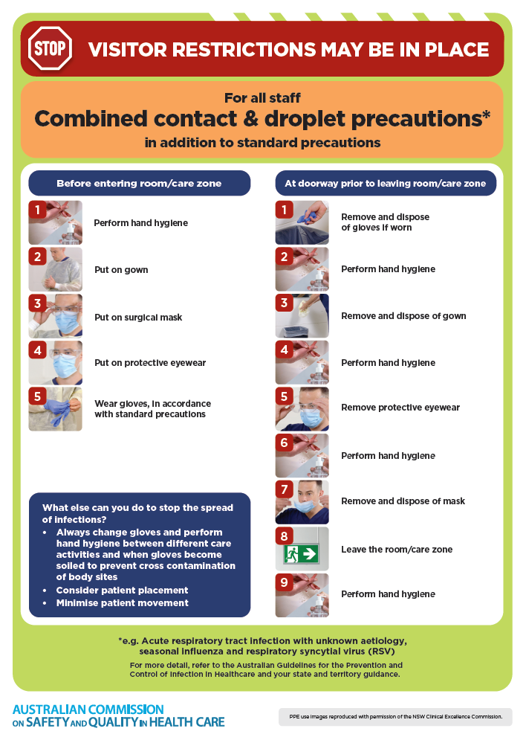](https://www.safetyandquality.gov.au/publications-and-resources/resource-library/infection-prevention-and-control-poster-combined-contact-and-droplet-precautions)
* ***Poster – Combined airborne and contact precautions*** <https://www.safetyandquality.gov.au/publications-and-resources/resource-library/poster-combined-airborne-and-contact-precautions>   
  [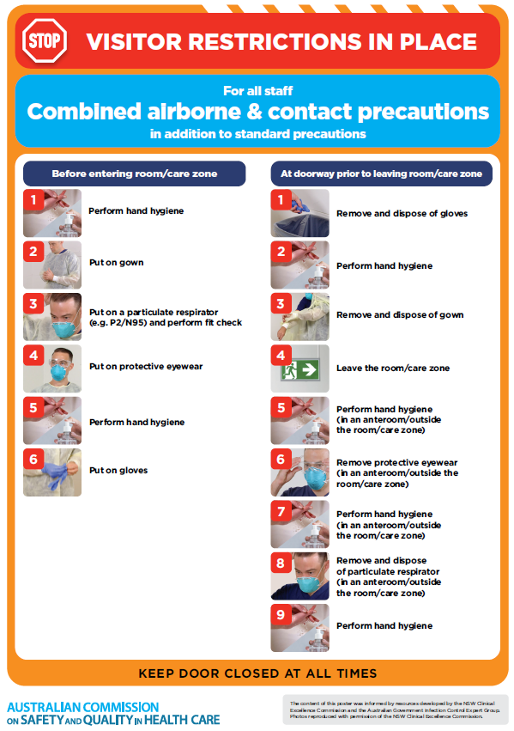](https://www.safetyandquality.gov.au/publications-and-resources/resource-library/poster-combined-airborne-and-contact-precautions)
* ***Environmental Cleaning and Infection Prevention and Control*** [www.safetyandquality.gov.au/environmental-cleaning](http://www.safetyandquality.gov.au/environmental-cleaning)
* ***COVID-19 infection prevention and control risk management – Guidance*** <https://www.safetyandquality.gov.au/publications-and-resources/resource-library/covid-19-infection-prevention-and-control-risk-management-guidance>
* ***Safe care for people with cognitive impairment during COVID-19***<https://www.safetyandquality.gov.au/our-work/cognitive-impairment/cognitive-impairment-and-covid-19>
* ***Stop COVID-19: Break the chain of infection*** posterhttps://www.safetyandquality.gov.au/publications-and-resources/resource-library/break-chain-infection-poster-a3  
  **[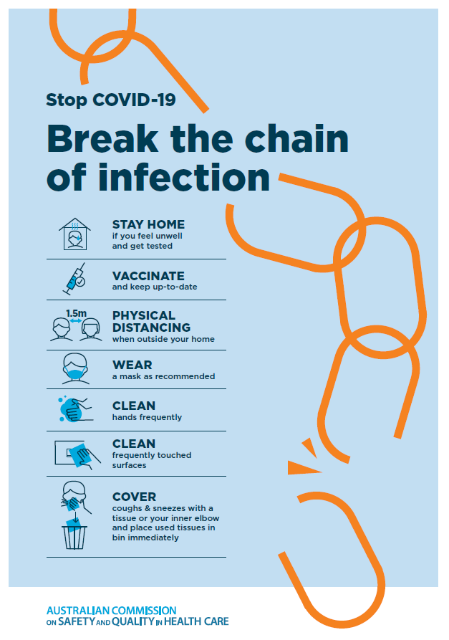](https://www.safetyandquality.gov.au/publications-and-resources/resource-library/break-chain-poster-a3https:/www.safetyandquality.gov.au/publications-and-resources/resource-library/break-chain-poster-a3)**
* ***COVID-19 and face masks – Information for consumers*** <https://www.safetyandquality.gov.au/publications-and-resources/resource-library/covid-19-and-face-masks-information-consumers>

[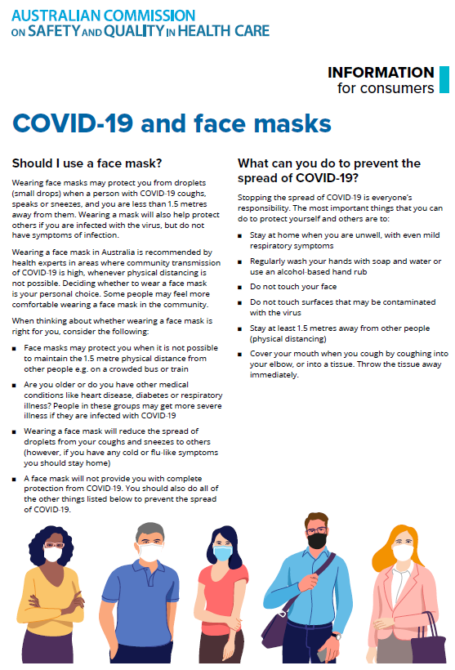](https://www.safetyandquality.gov.au/sites/default/files/2020-07/covid-19_and_face_masks_-_information_for_consumers.pdf)

*National COVID-19 Clinical Evidence Taskforce*

<https://covid19evidence.net.au/>

The National COVID-19 Clinical Evidence Taskforce is a collaboration of peak health professional bodies across Australia whose members are providing clinical care to people with COVID-19. The taskforce is undertaking continuous evidence surveillance to identify and rapidly synthesise emerging research in order to provide national, **evidence-based guidelines and clinical flowcharts for the clinical care of people with COVID-19**. The guidelines address questions that are specific to managing COVID-19 and cover the full disease course across mild, moderate, severe and critical illness. These are ‘living’ guidelines, updated with new research in near real-time in order to give reliable, up-to-the minute advice to clinicians providing frontline care in this unprecedented global health crisis.

*COVID-19 Critical Intelligence Unit*

<https://www.aci.health.nsw.gov.au/covid-19/critical-intelligence-unit>

The Agency for Clinical Innovation (ACI) in New South Wales has developed this page summarising rapid, evidence-based advice during the COVID-19 pandemic. Its operations focus on systems intelligence, clinical intelligence and evidence integration. The content includes a daily evidence digest, a COVID status monitor, a risk monitoring dashboard and evidence checks on a discrete topic or question relating to the current COVID-19 pandemic. There is also a ‘Living evidence’ section summarising key studies and emerging evidence on **COVID-19 vaccines** and **SARS-CoV-2 variants**. The most recent updates include:

* ***SARS-CoV-2 variants - retired living evidence*** – What is the evidence on SARS-CoV-2 variants that are under monitoring by the World Health Organization?
* ***COVID-19 vaccines - retired living evidence*** – What is the evidence on COVID-19 vaccine effectiveness and safety?
* ***Current and emerging patient safety issues during COVID-19*** – What is the evidence on the current and emerging patient safety issues arising from the COVID-19 pandemic?
* ***Bivalent COVID-19 vaccines*** – What is the available regulatory and research evidence for bivalent COVID-19 vaccines?
* ***Surgery post COVID-19*** – What is the evidence for the timing of surgery, and outcomes following surgery, for people who have recovered from COVID-19?
* ***Paxlovid*** – What is the evidence for Paxlovid for treatment of COVID-19?
* ***Molnupiravir*** –What is the evidence for and regulatory context of molnupiravir for treatment of COVID-19?
* ***Eating disorders and COVID-19*** – What is the impact of the COVID-19 pandemic on the prevalence of eating disorders?
* ***Long COVID –*** What is the evidence on the prevalence, presentation and management of long-COVID?
* ***Oseltamivir (Tamiflu) use in healthcare settings*** – What is the evidence that use of oseltamivir in healthcare workers with a symptomatic influenza diagnosis result in an earlier return to work and reduced absenteeism? What is the evidence that use of oseltamivir in adults and children with symptomatic influenza reduces influenza transmission in health care settings?
* ***Alternative models of care for acute medical conditions*** – What is the evidence on alternative models of care for managing patients with acute medical conditions outside of emergency or inpatient hospital settings?
* ***Exercise and long COVID*** – Is exercise helpful in individuals with long COVID? Is post-exertional symptom exacerbation a risk in long COVID?
* ***Influenza and seasonal prophylaxis with oseltamivir*** – What is the place or evidence for seasonal influenza prophylaxis (such as taking oseltamivir for 10 to 12 weeks continuously) in healthcare and aged care settings?
* ***Rapid access models of care for respiratory illnesses*** – What is the evidence for rapid access models of care for respiratory illnesses, especially during winter seasons, in emergency departments?
* ***Post-acute sequelae of COVID-19*** – What is the evidence on the post-acute sequelae of COVID-19?
* ***Emerging variants*** – What is the available evidence for emerging variants?
* ***Chest pain or dyspnoea following COVID-19 vaccination*** – What is evidence for chest pain or dyspnoea following COVID-19 vaccination?
* ***Cardiac investigations and elective surgery post-COVID-19*** – What is evidence for cardiac investigations and elective surgery post-COVID-19?
* ***Breathlessness post COVID-19*** – How to determine those patients who present with ongoing breathlessness in need of urgent review or intervention due to suspected pulmonary embolus?
* ***COVID-19 pandemic and influenza*** – What is the evidence for COVID-19 pandemic and influenza?
* ***Budesonide and aspirin for pregnant women with COVID-19 –*** What is the evidence for the use of Budesonide for pregnant women with COVID-19? What is the evidence for aspirin prophylaxis for pre-eclampsia in pregnant women with a COVID-19 infection?
* ***COVID-19 vaccines in Australia*** – What is the evidence on COVID-19 vaccines in Australia?
* ***COVID-19 pandemic and wellbeing of critical care and other healthcare workers*** – Evidence in brief on the impact of the COVID-19 pandemic on the wellbeing of critical care and other healthcare workers.
* ***Disease modifying treatments for COVID-19 in children*** – What is the evidence for disease modifying treatments for COVID-19 in children?
* ***Mask type for COVID-19 positive wearer*** – What is the evidence for different mask types for COVID-19 positive wearers?
* ***Post acute and subacute COVID-19 care*** – What published advice and models of care are available regarding post-acute and subacute care for COVID-19 patients?
* ***Hospital visitor policies*** – What is the evidence for hospital visitor policies during and outside of the COVID-19 pandemic?
* ***Surgical masks, eye protection and PPE guidance*** –What is the evidence for surgical masks in the endemic phase in hospitals and for eyewear to protect against COVID-19?

**Disclaimer**

On the Radar is an information resource of the Australian Commission on Safety and Quality in Health Care. The Commission is not responsible for the content of, nor does it endorse, any articles or sites listed. The Commission accepts no liability for the information or advice provided by these external links. Links are provided on the basis that users make their own decisions about the accuracy, currency and reliability of the information contained therein. Any opinions expressed are not necessarily those of the Australian Commission on Safety and Quality in Health Care.