# Australian Commission on Safety and Quality logotypeOn the Radar

Issue 607

19 June 2023

*On the Radar* is a summary of some of the recent publications in the areas of safety and quality in health care. Inclusion in this document is not an endorsement or recommendation of any publication or provider. Access to particular documents may depend on whether they are Open Access or not, and/or your individual or institutional access to subscription sites/services. Material that may require subscription is included as it is considered relevant.

*On the Radar* is available online, via email or as a PDF or Word document from <https://www.safetyandquality.gov.au/publications-and-resources/newsletters/radar>

If you would like to receive *On the Radar* via email, you can subscribe on our website <https://www.safetyandquality.gov.au/publications-and-resources/newsletters>  
or by emailing us at H[Umail@safetyandquality.gov.auU](mailto:mail@safetyandquality.gov.au).   
You can also send feedback and comments to H[Umail@safetyandquality.gov.auU](mailto:mail@safetyandquality.gov.au).

For information about the Commission and its programs and publications, please visit <https://www.safetyandquality.gov.au>

You can also follow us on Twitter @ACSQHC.

**On the Radar**

Editor: Dr Niall Johnson [niall.johnson@safetyandquality.gov.au](mailto:niall.johnson@safetyandquality.gov.au)

Contributors: Niall Johnson

**Journal articles**

*Danger in discharge summaries: abbreviations create confusion for both author and recipient*

Coghlan Anna, Turner Sophie, Coverdale Steven

Internal Medicine Journal. 2023;53(4):550-558.

|  |  |
| --- | --- |
| DOI | <https://doi.org/10.1111/imj.15582> |
| Notes | Transitions of care, including discharge, are known to have risks. Many of the issues around transitions stem from communications. This paper reports on a retrospective audit of 802 discharge summaries completed at Queensland regional health service. The study was examining ‘use of abbreviations in clinical handover documents from inpatient hospital teams to general practitioners (GP), and the interpretation of these abbreviations by GP and hospital-based junior doctors.’ The study found that **99% of the discharge summaries included abbreviations**. ‘A total of 1612 different abbreviations was used on 16 327 occasions. The median number of abbreviations per discharge summary was 17 (range 0–86).’ From a survey of 254 GPs and 62 junior doctors, it was found that ‘no abbreviation was interpreted the same by all respondents. GP and junior doctors were unable to offer any interpretation in 17.9% and 15.2% of cases respectively’. The authors concluded that ‘Abbreviations are often used in discharge summaries, yet poorly understood. This has the potential to impact patient care in the transition period after hospitalisation.’ |

*Integrated multi-omics for rapid rare disease diagnosis on a national scale*

Lunke Sebastian, Bouffler Sophie E., Patel Chirag V., Sandaradura Sarah A., Wilson Meredith, Pinner Jason, et al

Nature Medicine. 2023.

|  |  |
| --- | --- |
| DOI | <https://doi.org/10.1038/s41591-023-02401-9> |
| Notes | The potential for ‘omics’ to improve the delivery of care has been mooted for some time. This paper describes two years of activity of an Acute Care Genomics program in Australia. In that period, the program ‘provided whole-genome sequencing to 290 families whose critically ill infants and children were admitted to hospitals throughout Australia with suspected genetic conditions. The average time to result was 2.9 d and diagnostic yield was 47%.’ Further analyses yielded additional diagnoses. The findings led to changes in the management of care. The authors consider that these results ‘provide preliminary evidence of the clinical utility of integrating multi-omic approaches into mainstream diagnostic practice to fully realize the potential of rare disease genomic testing in a timely manner.’ |

*The Joint Commission Journal on Quality and Patient Safety*

Volume 49, Issue 6, June–July 2023

|  |  |
| --- | --- |
| URL | <https://www.sciencedirect.com/journal/the-joint-commission-journal-on-quality-and-patient-safety/vol/49/issue/6>? |
| Notes | A new issue of *The Joint Commission Journal on Quality and Patient Safety* has been published. Articles in this issue of *The Joint Commission Journal on Quality and Patient Safety* include:   * Editorial: Hypertensive Crises Nearly Four Decades Later: Evidence-Based Practice in **Severe Asymptomatic Hypertension** and a Need for Cultural Change (Zachary G. Jacobs) * Reduction of **Intravenous Antihypertensives** through Clinical Decision Support in a Large Safety Net System (Mona Krouss, Surafel Tsega, Daniel Alaiev, Joseph Talledo, Hyung J Cho) * In Situ Simulation as a Quality Improvement Tool to Identify and Mitigate Latent Safety Threats for **Emergency Department SARS-CoV-2 Airway Management**: A Multi-Institutional Initiative (Christina J Yang, Vinay Saggar, Namal Seneviratne, Alex Janzen, Farrukh N Jafri) * Reducing **Inappropriate Simultaneous Ordering of Heparin Antibody and Serotonin Release Assays** (Joseph Talledo, Hyung J Cho, Daniel Alaiev, Sigal Israilov, Mona Krouss) * **Home Health Agency Patient Experience Measures** and Their Relationship to Joint Commission Accreditation (Beth A Longo, Stephen P Schmaltz, Stacey C Barrett, Jamie Patrianakos, Scott C Williams) * **Reducing Sharps Injuries in the Operating Rooms** of an Academic Tertiary Care Center (Naveen F Sangji, Hannan A Maqsood, Sharon Bouyer-Ferullo, David C Chang, Catherine O'Malley) * **Social Determinants of Health Screening and Management**: Lessons at a Large, Urban Academic Health System (Patricia Peretz, Amelia Shapiro, Luisa Santos, Koma Ogaye, Julia Iyasere) * Standardized Electronic Order Entry to Improve **Enteral Nutrition Prescribing** in the Critically Ill (BreAnna L Davids, Robert C Ross, Miranda P Boraas, Andrew J Franck) * **Bringing Environmental Sustainability into the Quality Agenda**: Time to Act on Reducing Health Care Pollution and Waste (Jodi D Sherman, Hardeep Singh) |

*Pediatric Quality & Safety*

Volume 8, Number 3, May/June 2023

|  |  |
| --- | --- |
| URL | <https://journals.lww.com/pqs/toc/2023/05000> |
| Notes | A new issue of *Pediatric Quality & Safety* has been published. Articles in this issue of *Pediatric Quality & Safety* include:   * Improving Outcomes through Implementation of an **Infant Spinal Anesthesia Program for Urologic Surgery Patients** (Cronin, J A; Satterthwaite, B; Robalino G; Casella D; Hsieh M; Sohel R; Fink A; Pestieau S) * Qualitative Study on **Safe and Effective Handover Information** during a Rapid Response Team Encounter (Greenberg, Justin M.; Schmidt, Anita; Chang, Todd P; Rake, Alyssa) * The Impact of **Medication Synchronization** on Proportion of Days Covered within the Pediatric Setting (Maletic, Brooke E; Swick, Alex; Murray, Leanne; Abdel-Rasoul, Mahmoud; Braughton, Ashley; Petkus, Kayla) * Reduction of **Very Rapid Emergency Transfers to the Pediatric Intensive Care Unit** (Kuehn, Stacy E; Melvin, Jennifer E; Creech, Pamela S; Fitch, Jill; Noritz, Garey; Perry, Michael F; Stewart, Claire; Bode, Ryan S) * **Safer Type 1 Diabetes Care** at Home: SEIPS-based Process Mapping with Parents and Clinicians (Kirkendall, Eric S; Brady, Patrick W; Corathers, Sarah D; Ruddy, R M; Fox, C; Nelson, H; Wetterneck, T B; Rodgers, I; Walsh, K E) * Improving Adherence to Evidence-based Practice for **Uncomplicated UTI in a Pediatric Emergency Department** (Kline, Jaclyn N; Powell, Lauren N; Albert, J D; Bishara, A C; Heffren, J C; Badolato, G M; Berkowitz, D D) * **Improving Wait Times** for Children with Caregivers with Limited English Proficiency in the Emergency Department (Valderrama, Gisella; Badolato, Gia M.; Diaz, Pedro; Berkowitz, Deena) * Utilizing Clinical Decision Support in the Treatment of **Urinary Tract Infection** across a Large Pediatric Primary Care Network (Karas, David R; Upadhyayula, Shankar; Love, April; Bigham, Michael T) * **Pediatric Trauma and Posttraumatic Symptom Screening** at Well-child Visits (DiGiovanni, Stephen S; Hoffmann Frances, Rebecca J; Brown, Rebecca S; Wilkinson, Barrett T; Coates, Gillian E; Faherty, Laura J; Craig, Alexa K.; Andrews, Elizabeth R; Gabrielson, Sarah M. B) * Eliminating **Central Line Associated Bloodstream Infections** in Pediatric Oncology Patients: A Quality Improvement Effort (Willis, Daniel N; Looper, Karen; Malone, Rema A; Ricken, Barbara; Slater, Ashley; Fuller, Amanda; McCaughey, Meagan; Niesen, Angela; Smith, Joan R; Brozanski, Beverly) * Causal Association of Physician-in-Triage with Improved **Pediatric Sepsis Care**: A Single-Center, Emergency Department Experience (Moorthy, Ganga S; Pung, Jordan S; Subramanian, Neel; Theiling, B Jason; Sterrett, Emily C) * Improving On-time Administration of the Initial **Hepatitis B Vaccine in the NICU** (Gontasz, Michelle M; Chalk, Bethany S; Liang, Caroline) * New strategies to Reduce **Unnecessary Antibiotic Use in the NICU**: A Quality Improvement Initiative (Pantoja, Alfonso; Sveum, Scott; Frost, Sandra; Duran, Amanda; Burks, Jeanne; Schernecke, Christi; Feinberg, Michelle) * Quality Report: Postoperative Guideline Implementation Reduces **Length of Stay after Fontan Procedure** (Cox, Virginia; Hart, Stephen; Hersey, Diane; Gauntt, Jennifer; Carrillo, Sergio; McConnell, Patrick; Simsic, Janet) * Standardizing **Anaphylaxis Treatment in Pediatric Care** Settings (Anvari, Sara; Szafron, Vibha; Hilliard, Tanya J; Forbes-Satter, Lisa; Shah, Mona D) * Pediatric Inpatient Leaders, Views Changed with COVID-19: **A Call to Re-engage in Quality Improvement** (Quigley, Denise D; Slaughter, Mary Ellen; Hays, Ron D) * Commentary: Establishing **Causality in Quality Improvement Studies** (Provost, Lloyd P) |

*BMJ Quality & Safety* online first articles

|  |  |
| --- | --- |
| URL | <https://qualitysafety.bmj.com/content/early/recent> |
| Notes | *BMJ Quality &Safety* has published a number of ‘online first’ articles, including:   * Editorial: **Choosing Wisely for quality improvement**: more is not always better (Timothy J Stephens, William RN Thomson) |

**Online resources**

***Cultural Safety Audit Tools***

<https://www.lowitja.org.au/page/services/tools/cultural-safety-audit-tool-for-individuals>

The Lowitja Institute has made available two cultural safety audit tools:

* The *Cultural Safety Audit Tool for Individuals* is designed to assess an individual’s level of development in understanding critical elements of cultural safety and working to create culturally safe experiences with Aboriginal and Torres Strait Islander individuals.
* The *Cultural Safety Audit Tool for Organisations* is designed to assess an organisation’s commitment to a level of development in embedding cultural safety.

***[UK] NICE Guidelines and Quality Standards***

<https://www.nice.org.uk/guidance>

The UK’s National Institute for Health and Care Excellence (NICE) has published new (or updated) guidelines and quality standards. The latest reviews or updates include:

* NICE Guideline NG101 *Early and locally advanced* ***breast cancer****: diagnosis and management* <https://www.nice.org.uk/guidance/ng101>

***[USA] AHRQ Perspectives on Safety***

<https://psnet.ahrq.gov/psnet-collection/perspectives>

The US Agency for Healthcare Research and Quality (AHRQ) publishes occasional Perspectives on Safety essays. Recent essays include:

* ***Patient and Family Roles in Safety*** <https://psnet.ahrq.gov/perspective/patient-and-family-roles-safety>

**COVID-19 resources**

https://www.safetyandquality.gov.au/covid-19

The Australian Commission on Safety and Quality in Health Care has developed a number of resources to assist healthcare organisations, facilities and clinicians. These and other material on COVID-19 are available at <https://www.safetyandquality.gov.au/covid-19>

These resources include:

* ***OVID-19 infection prevention and control risk management*** This primer provides an overview of three widely used tools for investigating and responding to patient safety events and near misses. Tools covered in this primer include incident reporting systems, Root Cause Analysis (RCA), and Failure Modes and Effects Analysis (FMEA).   
  <https://www.safetyandquality.gov.au/publications-and-resources/resource-library/covid-19-infection-prevention-and-control-risk-management-guidance>
* ***Poster – Combined contact and droplet precautions*** <https://www.safetyandquality.gov.au/publications-and-resources/resource-library/infection-prevention-and-control-poster-combined-contact-and-droplet-precautions>  
  [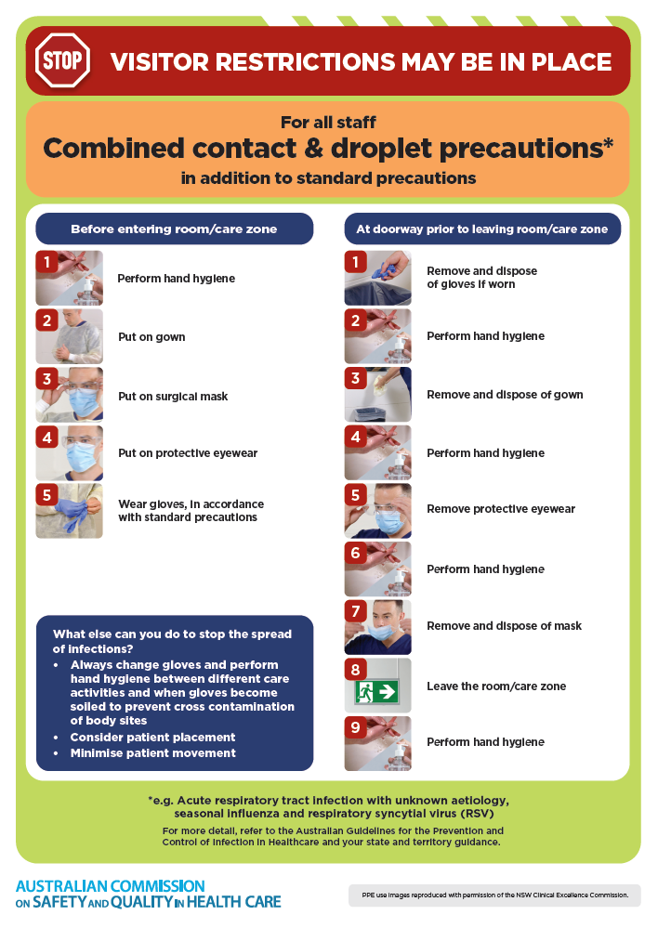](https://www.safetyandquality.gov.au/publications-and-resources/resource-library/infection-prevention-and-control-poster-combined-contact-and-droplet-precautions)
* ***Poster – Combined airborne and contact precautions*** <https://www.safetyandquality.gov.au/publications-and-resources/resource-library/poster-combined-airborne-and-contact-precautions>   
  [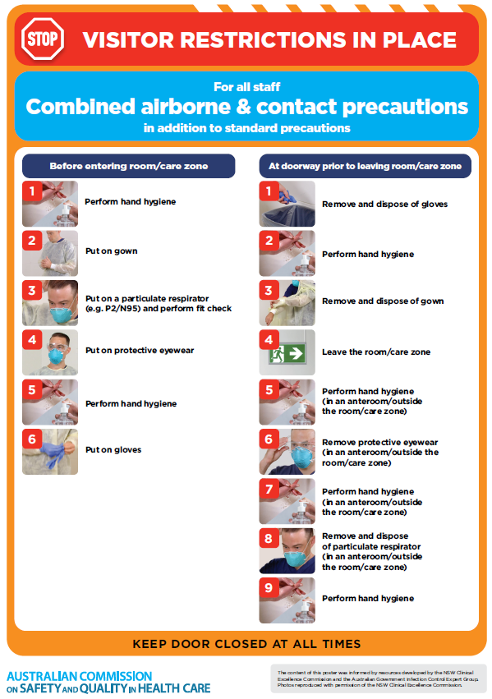](https://www.safetyandquality.gov.au/publications-and-resources/resource-library/poster-combined-airborne-and-contact-precautions)
* ***Environmental Cleaning and Infection Prevention and Control*** [www.safetyandquality.gov.au/environmental-cleaning](http://www.safetyandquality.gov.au/environmental-cleaning)
* ***COVID-19 infection prevention and control risk management – Guidance*** <https://www.safetyandquality.gov.au/publications-and-resources/resource-library/covid-19-infection-prevention-and-control-risk-management-guidance>
* ***Safe care for people with cognitive impairment during COVID-19***<https://www.safetyandquality.gov.au/our-work/cognitive-impairment/cognitive-impairment-and-covid-19>
* ***Stop COVID-19: Break the chain of infection*** posterhttps://www.safetyandquality.gov.au/publications-and-resources/resource-library/break-chain-infection-poster-a3  
  **[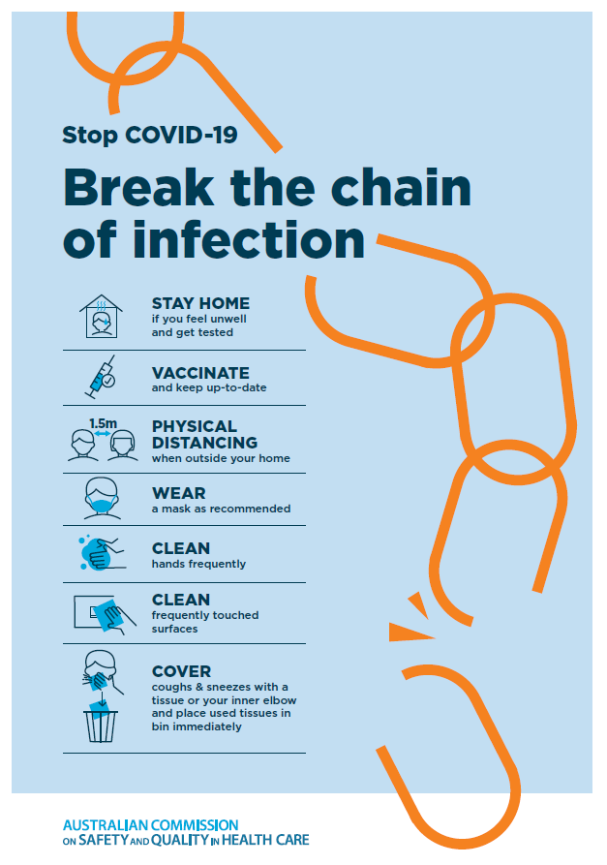](https://www.safetyandquality.gov.au/publications-and-resources/resource-library/break-chain-poster-a3https:/www.safetyandquality.gov.au/publications-and-resources/resource-library/break-chain-poster-a3)**
* ***COVID-19 and face masks – Information for consumers*** <https://www.safetyandquality.gov.au/publications-and-resources/resource-library/covid-19-and-face-masks-information-consumers>

[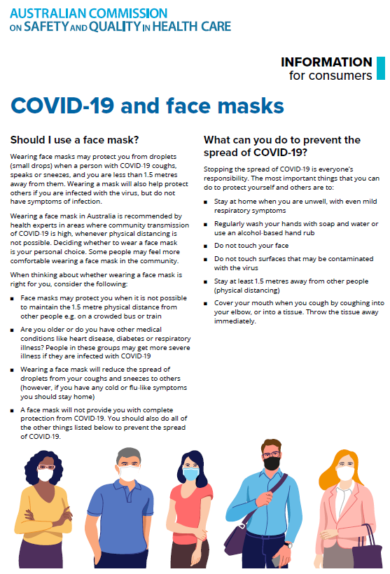](https://www.safetyandquality.gov.au/sites/default/files/2020-07/covid-19_and_face_masks_-_information_for_consumers.pdf)

*National COVID-19 Clinical Evidence Taskforce*

<https://covid19evidence.net.au/>

The National COVID-19 Clinical Evidence Taskforce is a collaboration of peak health professional bodies across Australia whose members are providing clinical care to people with COVID-19. The taskforce is undertaking continuous evidence surveillance to identify and rapidly synthesise emerging research in order to provide national, **evidence-based guidelines and clinical flowcharts for the clinical care of people with COVID-19**. The guidelines address questions that are specific to managing COVID-19 and cover the full disease course across mild, moderate, severe and critical illness. These are ‘living’ guidelines, updated with new research in near real-time in order to give reliable, up-to-the minute advice to clinicians providing frontline care in this unprecedented global health crisis.

*COVID-19 Critical Intelligence Unit*

<https://www.aci.health.nsw.gov.au/covid-19/critical-intelligence-unit>

The Agency for Clinical Innovation (ACI) in New South Wales has developed this page summarising rapid, evidence-based advice during the COVID-19 pandemic. Its operations focus on systems intelligence, clinical intelligence and evidence integration. The content includes a daily evidence digest, a COVID status monitor, a risk monitoring dashboard and evidence checks on a discrete topic or question relating to the current COVID-19 pandemic. There is also a ‘Living evidence’ section summarising key studies and emerging evidence on **COVID-19 vaccines** and **SARS-CoV-2 variants**. The most recent updates include:

* ***SARS-CoV-2 variants - retired living evidence*** – What is the evidence on SARS-CoV-2 variants that are under monitoring by the World Health Organization?
* ***COVID-19 vaccines - retired living evidence*** – What is the evidence on COVID-19 vaccine effectiveness and safety?
* ***Current and emerging patient safety issues during COVID-19*** – What is the evidence on the current and emerging patient safety issues arising from the COVID-19 pandemic?
* ***Bivalent COVID-19 vaccines*** – What is the available regulatory and research evidence for bivalent COVID-19 vaccines?
* ***Surgery post COVID-19*** – What is the evidence for the timing of surgery, and outcomes following surgery, for people who have recovered from COVID-19?
* ***Paxlovid*** – What is the evidence for Paxlovid for treatment of COVID-19?
* ***Molnupiravir*** –What is the evidence for and regulatory context of molnupiravir for treatment of COVID-19?
* ***Eating disorders and COVID-19*** – What is the impact of the COVID-19 pandemic on the prevalence of eating disorders?
* ***Long COVID –*** What is the evidence on the prevalence, presentation and management of long-COVID?
* ***Oseltamivir (Tamiflu) use in healthcare settings*** – What is the evidence that use of oseltamivir in healthcare workers with a symptomatic influenza diagnosis result in an earlier return to work and reduced absenteeism? What is the evidence that use of oseltamivir in adults and children with symptomatic influenza reduces influenza transmission in health care settings?
* ***Alternative models of care for acute medical conditions*** – What is the evidence on alternative models of care for managing patients with acute medical conditions outside of emergency or inpatient hospital settings?
* ***Exercise and long COVID*** – Is exercise helpful in individuals with long COVID? Is post-exertional symptom exacerbation a risk in long COVID?
* ***Influenza and seasonal prophylaxis with oseltamivir*** – What is the place or evidence for seasonal influenza prophylaxis (such as taking oseltamivir for 10 to 12 weeks continuously) in healthcare and aged care settings?
* ***Rapid access models of care for respiratory illnesses*** – What is the evidence for rapid access models of care for respiratory illnesses, especially during winter seasons, in emergency departments?
* ***Post-acute sequelae of COVID-19*** – What is the evidence on the post-acute sequelae of COVID-19?
* ***Emerging variants*** – What is the available evidence for emerging variants?
* ***Chest pain or dyspnoea following COVID-19 vaccination*** – What is evidence for chest pain or dyspnoea following COVID-19 vaccination?
* ***Cardiac investigations and elective surgery post-COVID-19*** – What is evidence for cardiac investigations and elective surgery post-COVID-19?
* ***Breathlessness post COVID-19*** – How to determine those patients who present with ongoing breathlessness in need of urgent review or intervention due to suspected pulmonary embolus?
* ***COVID-19 pandemic and influenza*** – What is the evidence for COVID-19 pandemic and influenza?
* ***Budesonide and aspirin for pregnant women with COVID-19 –*** What is the evidence for the use of Budesonide for pregnant women with COVID-19? What is the evidence for aspirin prophylaxis for pre-eclampsia in pregnant women with a COVID-19 infection?
* ***COVID-19 vaccines in Australia*** – What is the evidence on COVID-19 vaccines in Australia?
* ***COVID-19 pandemic and wellbeing of critical care and other healthcare workers*** – Evidence in brief on the impact of the COVID-19 pandemic on the wellbeing of critical care and other healthcare workers.
* ***Disease modifying treatments for COVID-19 in children*** – What is the evidence for disease modifying treatments for COVID-19 in children?
* ***Mask type for COVID-19 positive wearer*** – What is the evidence for different mask types for COVID-19 positive wearers?
* ***Post acute and subacute COVID-19 care*** – What published advice and models of care are available regarding post-acute and subacute care for COVID-19 patients?
* ***Hospital visitor policies*** – What is the evidence for hospital visitor policies during and outside of the COVID-19 pandemic?
* ***Surgical masks, eye protection and PPE guidance*** –What is the evidence for surgical masks in the endemic phase in hospitals and for eyewear to protect against COVID-19?

**Disclaimer**

On the Radar is an information resource of the Australian Commission on Safety and Quality in Health Care. The Commission is not responsible for the content of, nor does it endorse, any articles or sites listed. The Commission accepts no liability for the information or advice provided by these external links. Links are provided on the basis that users make their own decisions about the accuracy, currency and reliability of the information contained therein. Any opinions expressed are not necessarily those of the Australian Commission on Safety and Quality in Health Care.