# Australian Commission on Safety and Quality logotypeOn the Radar

Issue 608

26 June 2023

*On the Radar* is a summary of some of the recent publications in the areas of safety and quality in health care. Inclusion in this document is not an endorsement or recommendation of any publication or provider. Access to particular documents may depend on whether they are Open Access or not, and/or your individual or institutional access to subscription sites/services. Material that may require subscription is included as it is considered relevant.

*On the Radar* is available online, via email or as a PDF or Word document from <https://www.safetyandquality.gov.au/publications-and-resources/newsletters/radar>

If you would like to receive *On the Radar* via email, you can subscribe on our website <https://www.safetyandquality.gov.au/publications-and-resources/newsletters>  
or by emailing us at H[Umail@safetyandquality.gov.auU](mailto:mail@safetyandquality.gov.au).   
You can also send feedback and comments to H[Umail@safetyandquality.gov.auU](mailto:mail@safetyandquality.gov.au).

For information about the Commission and its programs and publications, please visit <https://www.safetyandquality.gov.au>

You can also follow us on Twitter @ACSQHC.

**On the Radar**

Editor: Dr Niall Johnson [niall.johnson@safetyandquality.gov.au](mailto:niall.johnson@safetyandquality.gov.au)

Contributors: Niall Johnson

**Journal articles**

*Integration and impact of pharmacists in general practice internationally: A rapid review*

Karampatakis Georgios Dimitrios, Patel Nilesh, Stretch Graham, Ryan Kath

Journal of Health Services Research & Policy. 2023:13558196231179831.

|  |  |
| --- | --- |
| DOI | <https://doi.org/10.1177/13558196231179831> |
| Notes | In recent years there has been a literature on the contribution pharmacists may make in various settings. This review examined the literature on embedding pharmacists into general practice. The review found 75 studies that met their inclusion criteria. The authors note that these studies on general practice-based pharmacists (GPBPs) were highly heterogeneous with varying approaches, funding sources, measures, tasks and activities. It was noted that medication reviews were the most common task. The authors conclude that their ‘findings suggest that GPBP services can lead to positive, quantifiable outcomes, mainly in relation to medication use’. |

For information on the Commission’s work on medication safety, see <https://www.safetyandquality.gov.au/our-work/medication-safety>

*Screening for Depression and Suicide Risk in Adults: US Preventive Services Task Force Recommendation Statement*

US Preventive Services Task Force

JAMA. 2023;329(23):2057-2067.

*Screening for Anxiety Disorders in Adults: US Preventive Services Task Force Recommendation Statement*

Force US Preventive Services Task

JAMA. 2023.

|  |  |
| --- | --- |
| DOI | <https://doi.org/10.1001/jama.2023.9297>  <https://doi.org/10.1001/jama.2023.9301> |
| Notes | The US Preventive Services Task Force has developed recommendation statements on evaluate the benefits and harms of screening for major depressive disorder and suicide risk and for anxiety disorders in asymptomatic adults. These recommendation statements have been published, along with the updated evidence reports and systematic reviews (<https://doi.org/10.1001/jama.2023.7787> and <https://doi.org/10.1001/jama.2023.6369>) and JAMA Patient Pages (<https://doi.org/10.1001/jama.2023.9449> and <https://doi.org/10.1001/jama.2023.9446>).  The US Preventive Services Task Force recommends screening for depression in all adults aged 18 years or older, including pregnant and postpartum individuals. This recommendation does not include screening specifically for suicide risk because the evidence on this is still unclear.  The US Preventive Services Task Force recommends screening for anxiety in adults aged 19 to 64 years, including pregnant and postpartum individuals. The evidence on screening in adults older than 65 years is still unclear. |

*BMJ Quality & Safety*

Volume 32, Issue 7, July 2023

|  |  |
| --- | --- |
| URL | <https://qualitysafety.bmj.com/content/32/7> |
| Notes | A new issue of *BMJ Quality & Safety* has been published. Many of the papers in this issue have been referred to in previous editions of *On the Radar* (when they were released online). Articles in this issue of *BMJ Quality & Safety* include:   * Editorial: **Emotional safety *is* patient safety** (Audrey Lyndon, Dána-Ain Davis, Anjana E Sharma, Karen A Scott) * Editorial: **High cost of broken relationships** (Christine A Sinsky, James Morrow) * Editorial: Improving risk stratification and decision support for **deteriorating hospital patients** (Judit Orosz, Daryl A Jones) * Editorial: How can **routine colorectal cancer screening** in the USA be considered low value in other countries? (Kelsey Chalmers, Shannon Brownlee, Vikas Saini) * How do **hospital inpatients conceptualise patient safety**? A qualitative interview study using constructivist grounded theory (Emily Barrow, Rachael A Lear, Abigail Morbi, Susannah Long, Ara Darzi, Erik Mayer, Stephanie Archer) * Predictors and population health outcomes of **persistent high GP turnover** in English general practices: a retrospective observational study (Rosa Parisi, Yiu-Shing Lau, Peter Bower, Katherine Checkland, Jill Rubery, Matt Sutton, Sally J Giles, Aneez Esmail, Sharon Spooner, Evangelos Kontopantelis) * Illness severity characteristics and outcomes of **patients remaining on an acute ward following medical emergency team review**: a latent profile analysis (Anthony Batterbury, Clint Douglas, Lee Jones, Fiona Coyer) * Development and validation of a new ICD-10-based screening **colonoscopy overuse measure** in a large integrated healthcare system: a retrospective observational study (Megan A Adams, Eve A Kerr, Jason A Dominitz, Yuqing Gao, Nicholas Yankey, Folasade P May, John Mafi, Sameer D Saini) |

*Healthcare Policy*

Volume 18, Number 4, April 2023

|  |  |
| --- | --- |
| URL | <https://www.longwoods.com/publications/healthcare-policy/27046/1/vol.-18-no.-4-2023> |
| Notes | A new issue of *Healthcare Policy* has been published. Articles in this issue of *Healthcare Policy* include:   * Editorial: A Problem of Money and Health: **The Need for Value in Healthcare** (Jason M Sutherland) * **Value-Based Healthcare**: Is It Just Another Buzzword? (Fiona Clement) * **Bilateral Federalism, Value-Based Healthcare** and the Future of Canadian Intergovernmental Diplomacy on Health (Tom McIntosh) * Innovating for **Value-Based Surgical Care** in Canada: A Post-Pandemic Necessity (Alana M. Flexman, Janny Ke and Julie Hallet) * **Value in Primary Care**: Evidence from the Canadian Primary Care Sentinel Surveillance Network (Sabrina T Wong, Rachael Morkem, Ayat Salman, David Barber and Jerome A Leis) * Use of Electronic Medical Record Data to Create a Dashboard on **Access to Primary Care** (Mylaine Breton, Isabelle Gaboury, François Bordeleau, Catherine Lamoureux-Lamarche, Élisabeth Martin, Véronique Deslauriers and Jean-Benoît Deville-Stoetzel) * Patients Living with Social Vulnerabilities Experience Reduced **Access at Team-Based Primary Healthcare** Clinics (Nadia Deville-Stoetzel, Isabelle Gaboury, Jeannie Haggerty and Mylaine Breton) * “A Band-Aid Solution”: Policy Maker and Primary Care Provider Perspectives on the Value of **Attachment Incentives** (Emily Gard Marshall, Mackenzie Cook, Lauren Moritz, Richard Buote, Maria Mathews and Mylaine Breton) * A North Star Vision: Results from a Deliberative Dialogue to Identify Policy Strategies to Improve **Value in Healthcare** (Amity E. Quinn, Rachelle Drummond, Fiona Clement, Melanie Columbus, Stephana J. Moss, Emily FitzGerald, Rukhsaar Daya, Karla Krewulak, Liza Mastikhina, Jeanna Parsons Leigh and Henry T. Stelfox) * **Psychedelics to Relieve Psychological Suffering** Associated with a Life-Threatening Diagnosis: Time for a Canadian Policy Discussion (Sarah Kratina, Christopher Lo, Carol Strike, Robert Schwartz and Brian Rush) * Commentary: Access to **Psychedelics for Psychological Suffering at the End of Life** – Prioritizing Our Priorities (Daniel Rosenbaum, Sarah Hales and Daniel Z. Buchman) |

*Journal of Patient Safety and Risk Management*

Volume 28, Issue 3, June 2023

|  |  |
| --- | --- |
| URL | <https://journals.sagepub.com/toc/cric/28/3> |
| Notes | A new issue of the *Journal of Patient Safety and Risk Management* has been published. Articles in this issue of the *Journal of Patient Safety and Risk Management* include:   * Editorial: **Social determinants of patient safety**: A bridge to better quality of care (Albert W Wu) * Critical vulnerabilities for **diversion of controlled substances in the emergency department**: Observations and healthcare failure mode and effect analysis (Maaike de Vries, Mark Fan, Dorothy Tscheng, Michael Hamilton, Patricia Trbovich) * What really matters for patient safety: **Correlation of nurse competence with international patient safety goals** (Zubia Kalsoom, Gideon Victor, Heli Virtanen, Nuzhat Sultana) * Assessing **patient safety culture among healthcare professionals** in Ibadan South-west region of Oyo State, Nigeria (Chukwuemeka Abel, Ezechi Oliver, Akinsolu Folahanmi) * The effect of the emergency service work environment on the **patient safety attitudes of nurses** (Nuriye Kizir, Esma Ozsaker) * Things are only fine until they are not! **Personal risk management in the newborn nursery and neonatal intensive care unit** (Bengt-Ola S Bengtsson) |

*Healthcare Papers*

Volume 21, Number 2, April 2023

|  |  |
| --- | --- |
| URL | <https://www.longwoods.com/publications/healthcarepapers/27104/1/vol.-21-no.-2-2023-strategies-to-mitigate-inequities-experienced-by-indigenous-peoples-in-the-he> |
| Notes | A new issue of *Healthcare Papers* has been published with a theme of ‘Strategies to Mitigate Inequities Experienced by Indigenous Peoples in the Healthcare System’. Articles in this issue of *Healthcare Papers* include:   * Less Talk, More Action: Strategies to Mitigate **Inequities Experienced by Indigenous Peoples in the Healthcare System** (Annette J Browne) * An **Inuit Perspective on Health and Healthcare** in Canada (Richard Budgell) * Action, Accountability and Transparency for **Indigenous Health Systems Safety** (Richard T. Oster, Pamela Roach, Fiona Clement, Esther Tailfeathers, Bonnie Healy, Lori Meckelborg, Joanna Gladue and Patrick McLane) * Moving Beyond Ignorance and Epistemic Violence: **Indigenous Health Nurses’ Response to Systems Transformation** (Colleen Seymour, Mona Lisa Bourque Bearskin, Liquaa Wazni, Rose Melnyk, Nikki Rose Hunter Porter and Michelle Padley) * Does Health Care? **Accountability Matters for Indigenous Patients** (Amy Shawanda) * **Call Individuals to Action** (Kimberly D. Fairman) |

*BMJ Quality & Safety* online first articles

|  |  |
| --- | --- |
| URL | <https://qualitysafety.bmj.com/content/early/recent> |
| Notes | *BMJ Quality &Safety* has published a number of ‘online first’ articles, including:   * Editorial: **Disclosing medical errors**: prioritising the needs of patients and families (Thomas H Gallagher, Carole Hemmelgarn, Evan M Benjamin) * Editorial: How can we finally reduce **repetitive routine laboratory tests for hospitalised patients**? (Christopher Moriates) * Temporal structures that determine **consistency and quality of care**: a case study in hyperacute stroke services (Georgia B Black, Angus I G Ramsay, Robert Simister, Abigail Baim-Lance, Jeannie Eng, Mariya Melnychuk, Naomi J Fulop) |

**Online resources**

***Australian Digital Health Agency - Online Learning Portal: Aboriginal and Torres Strait Islander health***

<https://training.digitalhealth.gov.au/mod/page/view.php?id=766>

Among the content on the Australian Digital Health Agency’s Online Learning Portal there are a number of resources focussing on Aboriginal and Torres Strait Islander health. These include:

* Using My Health Record in a health service courses
* My Health Record courses, including security, privacy and access
* Electronic Prescriptions courses, including electronic prescribing and Active Script List
* Digital Health courses.

***[UK] AI and Digital Regulations Service for health and social care***

<https://www.digitalregulations.innovation.nhs.uk/>

The AI and Digital Regulations Service has been launched in the UK. The service aims to provide guidance for NHS and social care adopters and digital health innovators.

The service is a multi-agency collaboration between the National Institute for Health and Care Excellence (NICE), the Care Quality Commission (CQC), the Health Research Authority and the Medicines and Healthcare products Regulatory Agency (MHRA) and is funded by the NHS AI Lab.

***[UK] NICE Guidelines and Quality Standards***

<https://www.nice.org.uk/guidance>

The UK’s National Institute for Health and Care Excellence (NICE) has published new (or updated) guidelines and quality standards. The latest reviews or updates include:

* NICE Guideline NG192 ***Caesarean birth*** <https://www.nice.org.uk/guidance/ng192>

***[UK] Should I stop my benzodiazepine or z-drug?***<https://www.nice.org.uk/guidance/ng215/resources/should-i-stop-my-benzodiazepine-or-zdrug-patient-decision-aid-full-version-pdf-13072600334>

The UK’s National Institute for Health and Care Excellence (NICE) has published this patient decision aid to help people who have been prescribed sleeping medications benzodiazepines and Z-drugs (zolpidem or zopiclone) to make an informed choice about their treatment in discussion with their GP or pharmacist. It aims to provide clear and easy-to-use advice and information to support people taking benzodiazepines or z-drugs to help them understand the benefits and risks of staying on their current dose, reducing their dose, or stopping taking the drugs altogether.

***[USA] Effective Health Care Program reports***

<https://effectivehealthcare.ahrq.gov/>

The US Agency for Healthcare Research and Quality (AHRQ) has an Effective Health Care (EHC) Program. The EHC has released the following final reports and updates:

* *Measuring Healthcare Organization Characteristics in* ***Cancer Care Delivery*** *Research* <https://effectivehealthcare.ahrq.gov/products/organization-cancer-care/tech-brief>

**COVID-19 resources**

https://www.safetyandquality.gov.au/covid-19

The Australian Commission on Safety and Quality in Health Care has developed a number of resources to assist healthcare organisations, facilities and clinicians. These and other material on COVID-19 are available at <https://www.safetyandquality.gov.au/covid-19>

These resources include:

* ***OVID-19 infection prevention and control risk management*** This primer provides an overview of three widely used tools for investigating and responding to patient safety events and near misses. Tools covered in this primer include incident reporting systems, Root Cause Analysis (RCA), and Failure Modes and Effects Analysis (FMEA).   
  <https://www.safetyandquality.gov.au/publications-and-resources/resource-library/covid-19-infection-prevention-and-control-risk-management-guidance>
* ***Poster – Combined contact and droplet precautions*** <https://www.safetyandquality.gov.au/publications-and-resources/resource-library/infection-prevention-and-control-poster-combined-contact-and-droplet-precautions>  
  [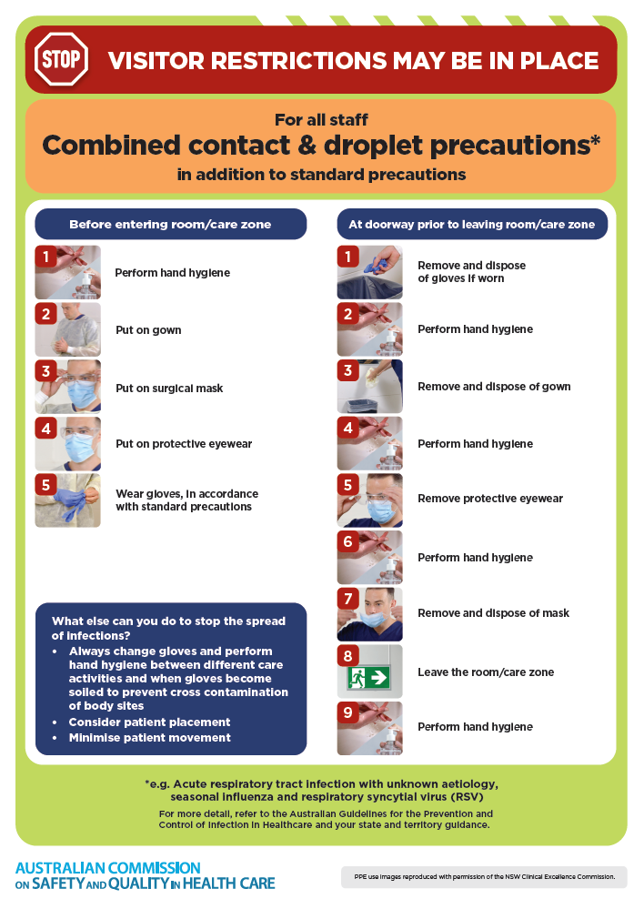](https://www.safetyandquality.gov.au/publications-and-resources/resource-library/infection-prevention-and-control-poster-combined-contact-and-droplet-precautions)
* ***Poster – Combined airborne and contact precautions*** <https://www.safetyandquality.gov.au/publications-and-resources/resource-library/poster-combined-airborne-and-contact-precautions>   
  [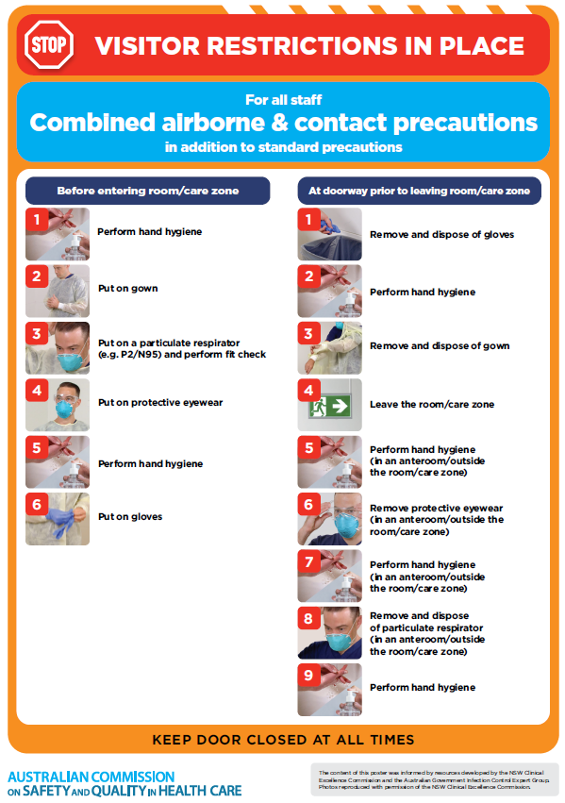](https://www.safetyandquality.gov.au/publications-and-resources/resource-library/poster-combined-airborne-and-contact-precautions)
* ***Environmental Cleaning and Infection Prevention and Control*** [www.safetyandquality.gov.au/environmental-cleaning](http://www.safetyandquality.gov.au/environmental-cleaning)
* ***COVID-19 infection prevention and control risk management – Guidance*** <https://www.safetyandquality.gov.au/publications-and-resources/resource-library/covid-19-infection-prevention-and-control-risk-management-guidance>
* ***Safe care for people with cognitive impairment during COVID-19***<https://www.safetyandquality.gov.au/our-work/cognitive-impairment/cognitive-impairment-and-covid-19>
* ***Stop COVID-19: Break the chain of infection*** posterhttps://www.safetyandquality.gov.au/publications-and-resources/resource-library/break-chain-infection-poster-a3  
  **[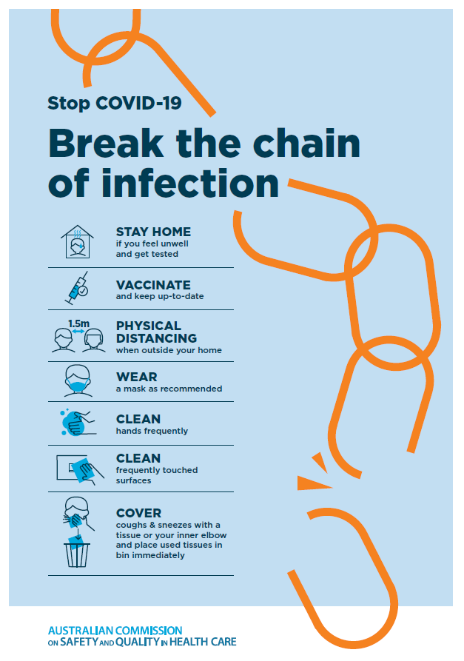](https://www.safetyandquality.gov.au/publications-and-resources/resource-library/break-chain-poster-a3https:/www.safetyandquality.gov.au/publications-and-resources/resource-library/break-chain-poster-a3)**
* ***COVID-19 and face masks – Information for consumers*** <https://www.safetyandquality.gov.au/publications-and-resources/resource-library/covid-19-and-face-masks-information-consumers>

[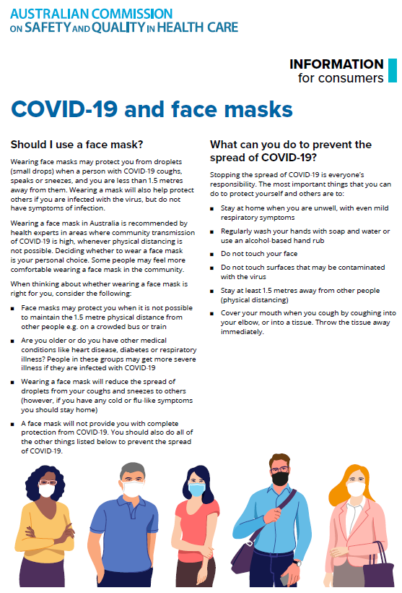](https://www.safetyandquality.gov.au/sites/default/files/2020-07/covid-19_and_face_masks_-_information_for_consumers.pdf)

*National COVID-19 Clinical Evidence Taskforce*

<https://covid19evidence.net.au/>

The National COVID-19 Clinical Evidence Taskforce is a collaboration of peak health professional bodies across Australia whose members are providing clinical care to people with COVID-19. The taskforce is undertaking continuous evidence surveillance to identify and rapidly synthesise emerging research in order to provide national, **evidence-based guidelines and clinical flowcharts for the clinical care of people with COVID-19**. The guidelines address questions that are specific to managing COVID-19 and cover the full disease course across mild, moderate, severe and critical illness. These are ‘living’ guidelines, updated with new research in near real-time in order to give reliable, up-to-the minute advice to clinicians providing frontline care in this unprecedented global health crisis.

*COVID-19 Critical Intelligence Unit*

<https://www.aci.health.nsw.gov.au/covid-19/critical-intelligence-unit>

The Agency for Clinical Innovation (ACI) in New South Wales has developed this page summarising rapid, evidence-based advice during the COVID-19 pandemic. Its operations focus on systems intelligence, clinical intelligence and evidence integration. The content includes a daily evidence digest, a COVID status monitor, a risk monitoring dashboard and evidence checks on a discrete topic or question relating to the current COVID-19 pandemic. There is also a ‘Living evidence’ section summarising key studies and emerging evidence on **COVID-19 vaccines** and **SARS-CoV-2 variants**. The most recent updates include:

* ***SARS-CoV-2 variants - retired living evidence*** – What is the evidence on SARS-CoV-2 variants that are under monitoring by the World Health Organization?
* ***COVID-19 vaccines - retired living evidence*** – What is the evidence on COVID-19 vaccine effectiveness and safety?
* ***Current and emerging patient safety issues during COVID-19*** – What is the evidence on the current and emerging patient safety issues arising from the COVID-19 pandemic?
* ***Bivalent COVID-19 vaccines*** – What is the available regulatory and research evidence for bivalent COVID-19 vaccines?
* ***Surgery post COVID-19*** – What is the evidence for the timing of surgery, and outcomes following surgery, for people who have recovered from COVID-19?
* ***Paxlovid*** – What is the evidence for Paxlovid for treatment of COVID-19?
* ***Molnupiravir*** –What is the evidence for and regulatory context of molnupiravir for treatment of COVID-19?
* ***Eating disorders and COVID-19*** – What is the impact of the COVID-19 pandemic on the prevalence of eating disorders?
* ***Long COVID –*** What is the evidence on the prevalence, presentation and management of long-COVID?
* ***Oseltamivir (Tamiflu) use in healthcare settings*** – What is the evidence that use of oseltamivir in healthcare workers with a symptomatic influenza diagnosis result in an earlier return to work and reduced absenteeism? What is the evidence that use of oseltamivir in adults and children with symptomatic influenza reduces influenza transmission in health care settings?
* ***Alternative models of care for acute medical conditions*** – What is the evidence on alternative models of care for managing patients with acute medical conditions outside of emergency or inpatient hospital settings?
* ***Exercise and long COVID*** – Is exercise helpful in individuals with long COVID? Is post-exertional symptom exacerbation a risk in long COVID?
* ***Influenza and seasonal prophylaxis with oseltamivir*** – What is the place or evidence for seasonal influenza prophylaxis (such as taking oseltamivir for 10 to 12 weeks continuously) in healthcare and aged care settings?
* ***Rapid access models of care for respiratory illnesses*** – What is the evidence for rapid access models of care for respiratory illnesses, especially during winter seasons, in emergency departments?
* ***Post-acute sequelae of COVID-19*** – What is the evidence on the post-acute sequelae of COVID-19?
* ***Emerging variants*** – What is the available evidence for emerging variants?
* ***Chest pain or dyspnoea following COVID-19 vaccination*** – What is evidence for chest pain or dyspnoea following COVID-19 vaccination?
* ***Cardiac investigations and elective surgery post-COVID-19*** – What is evidence for cardiac investigations and elective surgery post-COVID-19?
* ***Breathlessness post COVID-19*** – How to determine those patients who present with ongoing breathlessness in need of urgent review or intervention due to suspected pulmonary embolus?
* ***COVID-19 pandemic and influenza*** – What is the evidence for COVID-19 pandemic and influenza?
* ***Budesonide and aspirin for pregnant women with COVID-19 –*** What is the evidence for the use of Budesonide for pregnant women with COVID-19? What is the evidence for aspirin prophylaxis for pre-eclampsia in pregnant women with a COVID-19 infection?
* ***COVID-19 vaccines in Australia*** – What is the evidence on COVID-19 vaccines in Australia?
* ***COVID-19 pandemic and wellbeing of critical care and other healthcare workers*** – Evidence in brief on the impact of the COVID-19 pandemic on the wellbeing of critical care and other healthcare workers.
* ***Disease modifying treatments for COVID-19 in children*** – What is the evidence for disease modifying treatments for COVID-19 in children?
* ***Mask type for COVID-19 positive wearer*** – What is the evidence for different mask types for COVID-19 positive wearers?
* ***Post acute and subacute COVID-19 care*** – What published advice and models of care are available regarding post-acute and subacute care for COVID-19 patients?
* ***Hospital visitor policies*** – What is the evidence for hospital visitor policies during and outside of the COVID-19 pandemic?
* ***Surgical masks, eye protection and PPE guidance*** –What is the evidence for surgical masks in the endemic phase in hospitals and for eyewear to protect against COVID-19?

**Disclaimer**

On the Radar is an information resource of the Australian Commission on Safety and Quality in Health Care. The Commission is not responsible for the content of, nor does it endorse, any articles or sites listed. The Commission accepts no liability for the information or advice provided by these external links. Links are provided on the basis that users make their own decisions about the accuracy, currency and reliability of the information contained therein. Any opinions expressed are not necessarily those of the Australian Commission on Safety and Quality in Health Care.