



April 2023

CARAlert annual report

2022

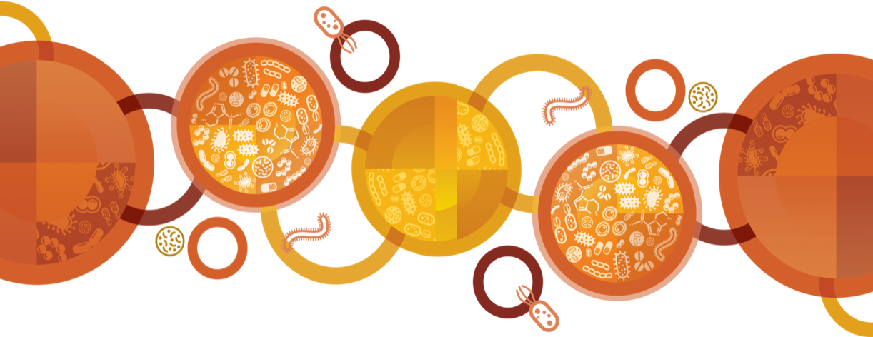

Published by the Australian Commission on Safety and Quality in Health Care  
Level 5, 255 Elizabeth Street, Sydney NSW 2000

Phone: (02) 9126 3600

Email: mail@safetyandquality.gov.au   
Website: www.safetyandquality.gov.au

ISBN: 978-1-922880-24-6

© Australian Commission on Safety and Quality in Health Care 2023

All material and work produced by the Australian Commission on Safety and Quality in Health Care is protected by copyright. The Commission reserves the right to set out the terms and conditions for the use of such material.

As far as practicable, material for which the copyright is owned by a third party will be clearly labelled. The Australian Commission on Safety and Quality in Health Care has made all reasonable efforts to ensure that this material has been reproduced in this publication with the full consent of the copyright owners.

With the exception of any material protected by a trademark, any content provided by third parties, and where otherwise noted, all material presented in this publication is licensed under a [Creative Commons Attribution–NonCommercial–NoDerivatives 4.0 International licence](http://creativecommons.org/licenses/by-nc-nd/4.0/).

Creative Commons Licence

Enquiries about the licence and any use of this publication are welcome and can be sent to [communications@safetyandquality.gov.au](mailto:communications@safetyandquality.gov.au).

The Commission’s preference is that you attribute this publication (and any material sourced from it) using the following citation:

Australian Commission on Safety and Quality in Health Care. CARAlert annual report: 2022. Sydney: ACSQHC; 2023

**Disclaimer**

The content of this document is published in good faith by the Australian Commission on Safety and Quality in Health Care for information purposes. The document is not intended to provide guidance on particular healthcare choices. You should contact your healthcare provider on particular healthcare choices.

The Commission does not accept any legal liability for any injury, loss or damage incurred by the use of, or reliance on, this document.

Contents

Executive Summary 4

Results from CARAlert, 2022 6

Critical antimicrobial resistances by state and territory 6

Critical antimicrobial resistances by age group 9

Critical antimicrobial resistances by facility type 10

Critical antimicrobial resistances by specimen type 11

Summary by CAR, with trend data for 2017–2022 12

*Acinetobacter baumannii* complex 12

*Candida auris* 13

*Enterobacterales* 13

*Enterococcus* species 21

*Mycobacterium tuberculosis* 23

*Neisseria gonorrhoeae* 24

*Pseudomonas aeruginosa* 26

*Salmonella* species 27

*Shigella* species 29

*Staphylococcus aureus* 32

*Streptococcus pyogenes* 34

Discussion 35

References 38

Appendix 1 About CARAlert 40

Appendix 2 Methodology 42

Appendix 3 CARAlert confirming laboratories, 2022 44

## Executive Summary

This report provides analyses of data on confirmed critical antimicrobial resistances (CARs) submitted to the National Alert System for Critical Antimicrobial Resistances (CARAlert) for 2022, and trend data between 2017 and 2022.

There was an overall 10.2% increase of CARs reported between 2021 (*n* = 1,303) and 2022 (*n* = 1,436). As the most frequently reported CAR to CARAlert, carbapenemase-producing *Enterobacterales* (CPE), continues to be a concern for patient safety. Bacteria that produce carbapenemase enzymes are almost always resistant to other important antibiotic classes, such as other β-lactams, β-lactamase inhibitor combinations, fluoroquinolones and aminoglycosides. This means that effective treatment options for infections may be very limited, and lengths of stay for hospital admissions may increase.

Implications for health care and patient safety identified by analyses of 2022 CARAlert data include:

* Increasing rates of CPE in Australian hospitals
* Increases in the community-onset CARs including multidrug-resistant (MDR) *Shigella* species and *Salmonella* species corresponding with the easing of travel restrictions associated with the COVID-19 pandemic, and changes in *Neisseria gonorrhoeae*
* Ongoing reports of low levels of CARs in aged care home residents
* Ongoing implications for increased health service demand and complexity of care due to CARs.

#### What will be done to improve patient safety?

In response to the issues identified in analyses of CARAlert data between 2017 and 2022, the Commission will continue to:

* Monitor CARs reported to CARAlert, maintain the CARAlert system and communicate key findings to states, territories, the Department of Health and Aged Care and relevant experts
* Promote compliance with the *Australian Guidelines for the Prevention and Control of Infection in Healthcare*1 as required by the National Safety and Quality Health Service (NSQHS) Standards2
* Promote implementation of guidance for specific organisms, such as the *Recommendations for the control of carbapenemase-producing* Enterobacterales *(CPE): A guide for acute care health service organisations*3
* Use CARAlert and other Antimicrobial Use and Resistance in Australia (AURA) data to refine and strengthen approaches to infection prevention and control and antimicrobial stewardship, and support implementation of the NSQHS Standards2, the National Safety and Quality Primary and Community Healthcare Standards4 and the Antimicrobial Stewardship Clinical Care Standard5
* Liaise with the Aged Care Quality and Safety Commission and aged care provider organisations and develop resources to support implementation of infection prevention and control programs in aged care homes to meet the requirements of the Aged Care Quality Standards, particularly the strengthened Aged Care Clinical Standard6
* Support collaboration between states and territories and hospital and community care settings to prevent and control CARs
* Prepare analyses of antimicrobial resistance data for, and liaise with Therapeutic Guidelines Limited, the organisation that develops guidance on antimicrobial prescribing in Australia.

#### National overview of key findings: 2022 compared to 2021

* CPE (including those with ribosomal methyltransferase or transmissible colistin resistance) was the most frequently reported CAR (827/1,436, 57.6%) in 2022, followed by daptomycin-nonsusceptible *Staphylococcus aureus* (DNSA) (170/1,436, 11.8%)
* The total number of CPE (either alone or in combination with other CARs) reported in 2022, compared to 2021, increased by 37.8% (*n* = 827 in 2022; *n* = 600 in 2021). The increase was mostly seen in Victoria and South Australia. The number of CPE reported in 2022 was similar to the number reported in 2019 (*n* = 878)
* In 2022, of all CARAlert reports for *N. gonorrhoeae*, 23.4% (37/158) were ceftriaxone-nonsusceptible (minimum inhibitory concentration [MIC] ≥ 0.125 mg/L) and 5.1% (8/158) were azithromycin-nonsusceptible (high-level resistance, MIC ≥ 256 mg/L); these reports were from NSW (30/45, 66.7%), Victoria (*n* = 7), Queensland (*n* = 5) and Western Australia (*n* = 3). The remaining *N. gonorrhoeae* reports were azithromycin-nonsusceptible (low-level resistance, MIC < 256 mg/L)
* The number of reports of carbapenemase-producing *Pseudomonas aeruginosa* (*n*= 57 in 2022; *n*= 67 in 2021) and carbapenemase-producing *Acinetobacter baumannii* complex (*n* = 23 in 2022; *n*= 17 in 2021) were comparable to the number reported in 2021
* There was an increase in the overall number of reports of MDR *Shigella* species (*n* = 99 in 2022; *n* = 42 in 2021), with a four-fold increase in both Victoria (*n* = 37 in 2022; *n* = 9 in 2021) and Queensland (*n* = 20 in 2022; *n* = 5 in 2021)
* There was an increase in the number of ceftriaxone-nonsusceptible *Salmonella* species (*n* = 51 in 2022; *n* = 24 in 2021, up 112.5%). One-quarter (13/51, 25.5%) of reports were typhoidal species
* There were nine reports of MDR *Mycobacterium tuberculosis* in 2022, compared to 13 reports in 2021
* There were nine reports of *Candida auris* in 2022, from six states and territories. In 2021 there was only one report
* Where the setting was known, the majority of CARs were reported from hospitals (993/1,350, 73.6%). There were 333 (24.7%) CARs reported from community settings and 24 (1.8%) from aged care homes.

## Results from CARAlert, 2022

Information about the National Alert System for Critical Antimicrobial Resistances (CARAlert), and methods used for the analyses presented in this report are included in Appendices 1 and 2.

Between 1 January 2022 and 31 December 2022, a total of 1,436 critical antimicrobial resistances (CARs) from 78 originating laboratories across Australia were entered into CARAlert by 22 of the 28 confirming laboratories nationally that contribute to CARAlert (Appendix 3). There was an average of 120 entries per month.

### Critical antimicrobial resistances by state and territory

Most CARs were reported for patients who lived in the most populous states (New South Wales [NSW], *n =*458, 31.9%; Victoria, *n =*386, 26.9%; Queensland, *n =*331, 23.1%). There were 10 or less reports from Tasmania and the Northern Territory (NT), and fewer than 30 reports from the Australian Capital Territory (ACT) (Table 1).

Carbapenemase-producing *Enterobacterales* (CPE) (including those with ribosomal methyltransferase or transmissible resistance to colistin) was the most frequently reported CAR (827/1,436, 57.6%) in 2022. Compared to 2021 (*n* = 600), there was a 37.8% increase in overall reports of CPE in 2022; the greatest increase was seen in Victoria (*n*= 199 in 2022; *n*= 128 in 2021, up 55.5%) and South Australia (SA) (*n*= 41 in 2022; *n*= 26 in 2021, up 57.7%). The number of CPE reported in 2022 was similar to the number reported in 2019 (*n* = 878).

Reports of daptomycin-nonsusceptible *Staphylococcus aureus* (DNSA) decreased by 35.8% in 2022 (*n*= 170 in 2022; *n*= 265 in 2021). The greatest decrease was in Queensland (*n*= 26 in 2022; *n*= 133 in 2021, down 80.5%).

In 2022, the number of azithromycin-nonsusceptible *Neisseria gonorrhoeae* (low-level resistance [LLR], minimum inhibitory concentration [MIC] < 256 mg/L) reports declined by 54.8% (*n*= 113 in 2022; *n*= 250 in 2021). The greatest decline was seen in NSW (*n* = 9 in 2022; *n* = 167 in 2021, down 94.6%). There was an increase in reports of this CAR in Queensland (*n* = 28 in 2022; *n* = 13 in 2021, up 115.4%) and Victoria (*n* = 56 in 2022; *n* = 45 in 2021, up 24.4%). There were no reports from the NT or the ACT.

There was a sharp increase in the number of ceftriaxone-nonsusceptible (*n* = 37) and azithromycin-nonsusceptible (high-level resistance [HLR], MIC ≥ 256 mg/L) (*n* = 8) *N. gonorrhoeae* reports in 2022. These reports were from NSW (*n*= 30, 66.7%), Victoria (*n*= 7), Queensland (*n*= 5) and Western Australia (WA) (*n*= 3).

Reports of multidrug-resistant (MDR) *Shigella* species increased overall by 135.7% from 2021 to 2022 (*n*= 99 in 2022; *n*= 42 in 2021). Increases were seen across all states and territories except WA, with the greatest increase seen in reports from Victoria and Queensland.

Carbapenemase-producing *Pseudomonas aeruginosa* were reported predominantly from NSW (35/57, 61.4%).

There was a two-fold increase in the number of ceftriaxone-nonsusceptible *Salmonella* species reported in 2022 (*n* = 51 in 2022; *n* = 24 in 2021). The greatest increase was in reports from NSW (*n* = 12 in 2022; *n* = 2 in 2021) and WA (*n* = 12 in 2022; *n* = 1 in 2021). One-quarter (13/51, 25.5%) of all reports were typhoidal species.

*Candida auris* was reported from all states and territories except Tasmania and the ACT.

Enterobacterales with transmissible resistance to colistin (*mcr-1.1*) was only reported from Victoria (n = 2); one isolate also harboured *bla*OXA-48.

**Table 1:** Number of critical antimicrobial resistances reported to CARAlert, by state and territory, 2022 and 2021

|  |  |  |  |  |  |  |  |  |  |  |  |  |
| --- | --- | --- | --- | --- | --- | --- | --- | --- | --- | --- | --- | --- |
|  |  | State or territory, 2022 | | | | | | | | Year | |  |
| **Species** | **Critical resistance** | **NSW** | **Vic** | **Qld** | **SA** | **WA** | **Tas** | **NT** | **ACT** | **2021** | **2022** | **Relative change\*** |
| *Acinetobacter baumannii* complex | Carbapenemase-producing | 5 | 3 | 4 | 1 | 1 | 0 | 4 | 0 | 15 | 18 | ▲ 20.0% |
| Carbapenemase- and ribosomal methyltransferase-producing | 0 | 5 | 0 | 0 | 0 | 0 | 0 | 0 | 2 | 5 | ▲ 150% |
| *Candida auris* | – | 1 | 1 | 2 | 3 | 1 | 0 | 1 | 0 | 1 | 9 | ▲ 800% |
| *Enterobacterales* | Carbapenemase-producing (alone or in combination with other CARs) | 298 | 199 | 232 | 41 | 37 | 5 | 2 | 13 | 600 | 827 | ▲ 37.8% |
| Carbapenemase-producing | 289 | 170 | 230 | 40 | 31 | 5 | 2 | 13 | 589 | 780 | ▲ 32.4% |
| Carbapenemase- and ribosomal methyltransferase-producing | 9 | 28 | 2 | 1 | 6 | 0 | 0 | 0 | 11 | 46 | ▲ 318% |
| Carbapenemase-producing and transmissible resistance to colistin | 0 | 1 | 0 | 0 | 0 | 0 | 0 | 0 | 0 | 1 | – |
| Ribosomal methyltransferase-producing | 4 | 4 | 0 | 0 | 2 | 0 | 0 | 0 | 9 | 10 | ▲ 11.1% |
| Transmissible colistin resistance† | 0 | 1 | 0 | 0 | 0 | 0 | 0 | 0 | 0 | 1 | – |
| *Enterococcus* species | Linezolid-resistant | 5 | 3 | 2 | 1 | 4 | 1 | 0 | 1 | 13 | 17 | ▲ 30.8% |
| *Mycobacterium tuberculosis* | Multidrug-resistant – at least rifampicin- and isoniazid-resistant strains | 1 | 5 | 2 | 0 | 0 | 0 | 0 | 1 | 13 | 9 | ▼ 30.8% |
| *Neisseria gonorrhoeae* | Azithromycin-nonsusceptible (low-level)§ | 9 | 56 | 28 | 2 | 15 | 3 | 0 | 0 | 250 | 113 | ▼ 54.8% |
| Azithromycin-nonsusceptible (high-level)# | 3 | 0 | 4 | 0 | 1 | 0 | 0 | 0 | 0 | 8 | – |
| Ceftriaxone-nonsusceptible | 27 | 3 | 1 | 0 | 2 | 0 | 0 | 0 | 0 | 33 | – |
| Ceftriaxone-nonsusceptible and azithromycin-nonsusceptible (low-level) § | 0 | 4 | 0 | 0 | 0 | 0 | 0 | 0 | 1 | 4 | ▲ 300% |

*Continued*

Table 1: *continued*

|  |  |  |  |  |  |  |  |  |  |  |  |  |
| --- | --- | --- | --- | --- | --- | --- | --- | --- | --- | --- | --- | --- |
|  |  | State or territory, 2022 | | | | | | | | Year | |  |
| **Species** | **Critical resistance** | **NSW** | **Vic** | **Qld** | **SA** | **WA** | **Tas** | **NT** | **ACT** | **2021** | **2022** | **Relative change\*** |
| *Pseudomonas aeruginosa* | Carbapenemase-producing | 35 | 15 | 2 | 0 | 3 | 0 | 0 | 0 | 65 | 55 | ▼ 15.4% |
| Carbapenemase- and ribosomal methyltransferase-producing | 0 | 1 | 0 | 1 | 0 | 0 | 0 | 0 | 2 | 2 | 0.0% |
| *Salmonella* species | Ceftriaxone-nonsusceptible | 12 | 17 | 7 | 2 | 12 | 0 | 1 | 0 | 24 | 51 | ▲ 113% |
| *Shigella* species | Multidrug-resistant | 32 | 37 | 20 | 2 | 5 | 1 | 1 | 1 | 42 | 99 | ▲ 136% |
| *Staphylococcus aureus* | Daptomycin-nonsusceptible | 23 | 31 | 26 | 31 | 47 | 0 | 0 | 12 | 265 | 170 | ▼ 35.8% |
| Daptomycin- and vancomycin-nonsusceptible | 1 | 1 | 0 | 0 | 0 | 0 | 0 | 0 | 0 | 2 | – |
| Linezolid-nonsusceptible | 2 | 0 | 1 | 0 | 0 | 0 | 0 | 0 | 1 | 3 | ▲ 200% |
| Vancomycin-nonsusceptible | 0 | 0 | 0 | 0 | 0 | 0 | 0 | 0 | 0 | 0 | – |
| *Streptococcus pyogenes* | Penicillin reduced susceptibility | 0 | 0 | 0 | 0 | 0 | 0 | 0 | 0 | 0 | 0 | – |
|  | **Total (reported by 31 January 2023)** | **458** | **386** | **331** | **84** | **130** | **10** | **9** | **28** | **1,303** | **1,436** | ▲ **10.2%** |

CAR = critical antimicrobial resistance; MIC = minimum inhibitory concentration; ▲ = increase; ▼ = decrease; – = not applicable

* Relative change = absolute change between 2021 and 2022, for each CAR, expressed as a percentage of 2021 base

† When not seen in combination with carbapenemase-producing *Enterobacterales*

§ Azithromycin MIC < 256 mg/L

# Azithromycin MIC ≥ 256 mg/L

### Critical antimicrobial resistances by age group

CARs were isolated from patients of all age groups; the median age was 60–69 years (Figure 1). Just over three-quarters of CPE were isolated from people aged 50 years and older (632/827, 76.4%). Most of ceftriaxone- and/or azithromycin-nonsusceptible *N. gonorrhoeae* was reported for people aged 15–59 years (153/158, 96.8%); and 76.8% (76/99) of MDR *Shigella* species were in people aged 20–59 years.

Only 6.5% (94/1,436) of all CARs were reported in children aged less than 15 years; CPE (*n* = 57), MDR *Shigella* species (*n* = 19) and ceftriaxone-nonsusceptible *Salmonella* species (*n* = 11) were most frequently reported for this age group (87/94, 92.6%). For the 0–4-year age group, CPE was the most frequently reported CAR (*n* = 46); followed by MDR *Shigella* species (*n* = 14) and ceftriaxone-nonsusceptible *Salmonella* species (*n*= 6).

**Figure 1:** Critical antimicrobial resistances reported to CARAlert, by age groups, 2022

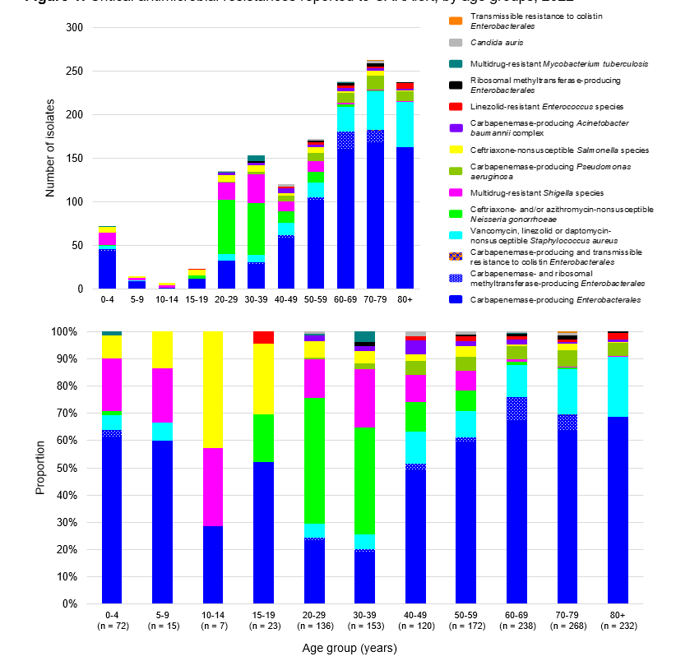

### Critical antimicrobial resistances by facility type

Where the setting was known, a substantial majority of CARs were detected in either hospitalised patients or hospital outpatients (993/1,350, 73.6%). Smaller proportions were isolated in the community (333/1,350, 24.7%) and in aged care homes (24/1,350, 1.8%) (Table 2).

**Table 2:** Number of critical antimicrobial resistance isolates reported to CARAlert, by setting, national, 2022

|  |  |  |  |  |  |  |  |
| --- | --- | --- | --- | --- | --- | --- | --- |
|  |  | Setting | | | | |  |
| **Species** | **Critical resistance** | **Public hospitals** | **Private hospitals** | **Aged care homes** | **Community** | **Unknown** | **Total** |
| *Acinetobacter baumannii* complex | Carbapenemase-producing | 15 | 0 | 0 | 3 | 0 | 18 |
| Carbapenemase- and ribosomal methyltransferase-producing | 4 | 0 | 0 | 1 | 0 | 5 |
| *Candida auris* | – | 8 | 0 | 0 | 1 | 0 | 9 |
| *Enterobacterales* | Carbapenemase-producing | 628 | 57 | 12 | 67 | 16 | 780 |
| Carbapenemase and ribosomal methyltransferase-producing | 32 | 1 | 0 | 8 | 5 | 46 |
| Carbapenemase-producing and transmissible colistin resistance | 1 | 0 | 0 | 0 | 0 | 1 |
| Ribosomal methyltransferase-producing | 9 | 0 | 0 | 1 | 0 | 10 |
| Transmissible colistin resistance | 1 | 0 | 0 | 0 | 0 | 1 |
| *Enterococcus* species | Linezolid-resistant | 14 | 0 | 0 | 2 | 1 | 17 |
| *Mycobacterium tuberculosis* | Multidrug-resistant – at least rifampicin- and isoniazid-resistant | 6 | 0 | 0 | 1 | 2 | 9 |
| *Neisseria gonorrhoeae* | Azithromycin-nonsusceptible (low-level) | 5 | 0 | 0 | 90 | 18 | 113 |
| Azithromycin-nonsusceptible (high-level) | 0 | 0 | 0 | 8 | 0 | 8 |
| Ceftriaxone-nonsusceptible | 1 | 0 | 0 | 24 | 8 | 33 |
| Ceftriaxone-nonsusceptible and azithromycin-nonsusceptible (low-level) | 0 | 0 | 0 | 3 | 1 | 4 |
| *Pseudomonas aeruginosa* | Carbapenemase-producing | 42 | 3 | 1 | 9 | 0 | 55 |
| Carbapenemase- and ribosomal methyltransferase-producing | 2 | 0 | 0 | 0 | 0 | 2 |
| *Salmonella* species | Ceftriaxone-nonsusceptible | 24 | 1 | 0 | 16 | 10 | 51 |
| *Shigella* species | Multidrug-resistant | 26 | 1 | 0 | 57 | 15 | 99 |
| *Staphylococcus aureus*\* | Daptomycin-nonsusceptible | 107 | 3 | 10 | 41 | 9 | 170 |
| Daptomycin- and vancomycin-nonsusceptible | 2 | 0 | 0 | 0 | 0 | 2 |
| Linezolid-nonsusceptible | 0 | 0 | 1 | 2 | 0 | 3 |
| Vancomycin-nonsusceptible | 0 | 0 | 0 | 0 | 0 | 0 |
| *Streptococcus pyogenes* | Penicillin reduced susceptibility | 0 | 0 | 0 | 0 | 0 | 0 |
|  | **Total (reported by 31 January 2023)** | **927** | **66** | **24** | **333** | **86** | **1,436** |

High-level = azithromycin MIC ≥ 256 mg/L; Low-level = azithromycin MIC < 256 mg/L; MIC = minimum inhibitory concentration

* For CARAlert, *S. aureus* complex includes *S. argenteus* and *S. schweitzeri*

Note: Information on setting for *N. gonorrhoeae* is often not available.

CPE accounted for a little over two-thirds of all reports from hospitals (719/993, 72.4%). In the community, a little over two-thirds of reports were ceftriaxone and/or azithromycin-nonsusceptible *N. gonorrhoeae* (125/333, 37.5%), CPE (75/333, 22.5%) or MDR Shigella species (57/333, 17.1%). Almost all reports from aged care homes were CPE (12/24, 50.0%) or DNSA (10/24, 41.7%).

### Critical antimicrobial resistances by specimen type

Almost two-thirds of all CARs reported in 2022 were from clinical specimens (916/1,436, 63.8%), which are specimens collected for diagnostic purposes, rather than for screening. These included wound (*n* = 196), urine (*n* = 315), blood (*n* = 53) and other (*n* = 352) such as genital or respiratory specimens (Figure 2).

Of CPE reports, 52.4% (433/827) were from clinical specimens. Of CPE isolates from clinical specimens, 61.4% (266/433) were from urine – an important specimen for *Enterobacterales* as the urinary tract is a common site of infection. Almost 1 in 15 (29/433, 6.7%) CPE from clinical specimens were from blood cultures. CPE comprised 54.7% (29/53) of all CARs confirmed from blood specimens.

Seven other CARs were also reported from blood cultures in 2022: ceftriaxone-nonsusceptible *Salmonella* species (*n* = 11), DNSA (*n*= 5), carbapenemase-producing *P. aeruginosa* (*n* = 3), linezolid-resistant *Enterococcus* species (*n*= 2), MDR *Shigella* species (*n* = 1), ribosomal methyltransferase-producing *Enterobacterales* (*n* = 1) and *C. auris* (*n*= 1).

**Figure 2:** Critical antimicrobial resistances reported to CARAlert, by specimen type, 2022

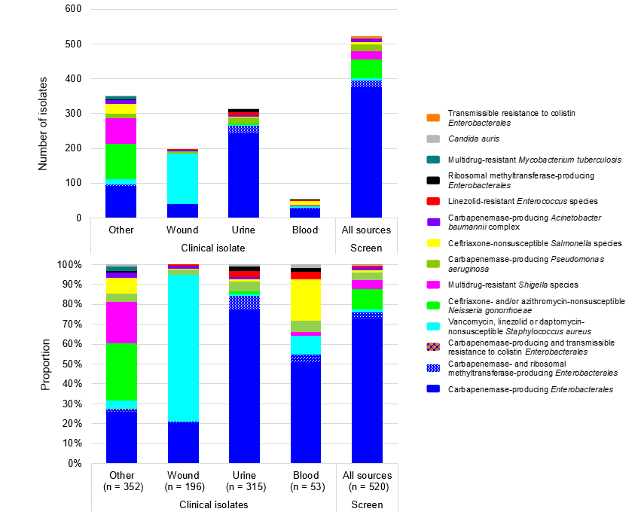

Note: 'Other’ refers to specimen types other than urine, wound or blood, such as genital, faecal or respiratory tract.

## Summary by CAR, with trend data for 2017–2022

Data for each CAR for 2022, nationally and by state and territory, are shown in Figures 3 to 29. Trend data for 2017 to 2022 are also presented, where applicable.

### *Acinetobacter baumannii* complex

*Acinetobacter baumannii* complex is a group of environmental organisms that have caused prolonged outbreaks in hospital settings, such as intensive care and severe burns units. *A. baumannii* infections are associated with patients with compromised physical barriers and immunity, most commonly in hospital. The most common infections caused by this species complex are ventilator-associated pneumonia and severe burn infections. Reporting of carbapenemase-producing *A. baumannii* complex to CARAlert began in July 2019.

There were 23 reports of carbapenemase-producing *A. baumannii* complex in 2022, from all states and territories except the ACT and Tasmania (Figures 3 and 4). OXA-23-like types were dominant (*n*= 18, either alone [14] or in combination with NDM [4]). Eight NDM types (alone [4] or in combination with OXA-23-like [4]) were reported. One OXA-24/40-like type was also reported. A decrease in 2020–2022 compared with 2019 may reflect border closures and changes in hospital practices following the onset of the COVID-19 pandemic.

A substantial majority (19/23, 82.6%) of carbapenemase-producing *A. baumannii* complex were reported from hospitals (Table 3).

**Figure 3:** Carbapenemase-producing *Acinetobacter baumannii* complex, number reported to CARAlert by specimen type, national, 2019–2022

Figure 4: Carbapenemase-producing *Acinetobacter baumannii* complex, number reported to CARAlert by carbapenemase type and specimen type, state and territory, 2022

Table 3: Carbapenemase-producing *Acinetobacter baumannii* complex, number reported to CARAlert by setting, state and territory, 2022

|  |  |  |  |  |  |  |  |  |  |
| --- | --- | --- | --- | --- | --- | --- | --- | --- | --- |
|  | State or territory | | | | | | | |  |
| **Setting** | **NSW** | **Vic** | **Qld** | **SA** | **WA** | **Tas** | **NT** | **ACT** | **Total** |
| **Total** | **5** | **8** | **4** | **1** | **1** | **0** | **4** | **0** | **23** |
| Public hospital | 5 | 7 | 2 | 1 | 0 | 0 | 4 | 0 | 19 |
| Private hospital | 0 | 0 | 0 | 0 | 0 | 0 | 0 | 0 | 0 |
| Aged care home | 0 | 0 | 0 | 0 | 0 | 0 | 0 | 0 | 0 |
| Community | 0 | 1 | 2 | 0 | 1 | 0 | 0 | 0 | 4 |

### *Candida auris*

*C. auris* is an emerging, MDR *Candida* species that has been associated with international outbreaks of invasive infections in healthcare facilities. Reporting to CARAlert for *C. auris* began in July 2019.

In 2022, nine *C. auris* were reported from all states and territories except the ACT and Tasmania: three reports from SA, two reports from Queensland, and one report each from NSW, Victoria, WA and the NT. Previously, one *C. auris* was reported in 2021 from Victoria; five were reported in 2020 from Victoria (*n* = 3) and NSW (*n* = 2); and there were six reports in 2019 from Victoria (*n* = 3), NSW (*n* = 2) and WA (*n* = 1).

### *Enterobacterales*

Infections of the urinary tract, biliary tract, intra-abdomen, and bloodstream are commonly associated with *Enterobacterales*. From 2019 to 2021 there was a gradual decline in reports of this CAR. However, in 2022 there was an increase in the number of reports of carbapenemase- and/or ribosomal methyltransferase-producing *Enterobacterales* (Figures 5 and 6). The overall number of CPE reports increased in 2022 (*n* = 827) compared to 2021 (*n* = 600, up 37.8%); there were 878 reports in 2019. Reports from all states and territories increased or remained stable in 2022 (Figure 9).

Carbapenemases were found in 27 species (11 genera) of *Enterobacterales*, with eight carbapenemase types reported (Figure 7). Three carbapenemase types – IMP (433/827, 52.4%), NDM (252/827, 30.5%) and OXA-48-like (74/827, 8.9%) – when produced alone, accounted for over 90% (759/827) of all *Enterobacterales* with a confirmed carbapenemase.

IMP types alone accounted for 52.4% (433/827) of all carbapenemases; they were found in 24 different species (Figure 7). Enterobacter cloacae complex accounted for 41.3% (179/433) of all IMP types and 21.6% (179/827) of all CPE.

NDM carbapenemase types were found mainly in *Escherichia* coli (147/252, 58.3%), and OXA-48-like types in E. *coli* (33/74, 44.6%) and *Klebsiella pneumoniae* (34/74, 45.9%).

Monthly trends for the top five carbapenemase types (IMP, NDM, OXA-48-like, KPC and NDM-OXA-48-like) reported over five years are shown in Figure 8 (national). Three-year trends by state and territory are shown in Figure 10.

The number of IMP types (alone or co-produced with other types) reported in 2022 (*n*= 438), increased by 14.4% compared to 2021 (*n* = 383). IMP-types accounted for 72% (167/232) of all CPE reported from Queensland, 64.4% (192/298) from NSW, and 40.5% (15/37) from WA. All CPE from the NT were IMP-types (*n* = 2) while only 2.4% (1/41) of CPE from SA were IMP-types. All the strains that have been genetically sequenced to date (280/438, 63.9%) were either blaIMP‑4 (*n* = 170), blaIMP‑59 (*n* = 1), blaIMP‑1 (*n* = 1) or IMP-4-like (*n* = 108).

The number of NDM types reported in 2022 (alone or co-produced with other types) also increased (*n* = 294 in 2022; *n* = 157 in 2021, up 87.3%). NDM types, either alone or in combination, were found in all states and territories except the NT. In SA, NDM types accounted for three-quarters (31/41, 75.6%) of all CPE reported. In Victoria, NDM types accounted for 56.3% (112/199) of all CPE reported, up from 46.1% (59/128) in 2021. Six different genes were found in the isolates sequenced (193/294, 65.6%): blaNDM-5 (118/193; 61.1%), blaNDM-1(42/193; 21.8%), blaNDM-7(23/193; 11.9%), blaNDM‑4(8/193; 4.1%), *bla*NDM-18 (*n* = 1) and *bla*NDM-19 (*n* = 1).

Reports of OXA-48-like CPE (alone or co-produced) increased by 88.1% in 2022 (*n* = 111) compared with 2021 (*n* = 59). Six genes were detected in the isolates that were sequenced (72/111, 64.9%); the most common was *bla*OXA-181 (36/72, 50%), followed by *bla*OXA-48 (14/72, 19.4%), *bla*OXA‑232 (12/72, 16.7%), *bla*OXA‑484 (8/72, 11.1%), *bla*OXA‑244 (*n*= 1) and *bla*OXA‑922 (*n*= 1).

Reports of KPC-producing *Enterobacterales* increased in 2022 compared to 2021 (*n* = 14 in 2022; *n* = 9 in 2021). KPC types were predominantly reported from Victoria (*n*= 10), mostly from different hospitals. Three other states reported cases (SA [2], Queensland [1] and WA [1]). Three KPC variants were detected from the 11 isolates that were sequenced: *bla*KPC-2 (*n*= 7), blaKPC-3 (*n*= 3) and *bla*KPC-33 (*n*= 1). One KPC-producing *K. pneumoniae* isolate from WA also co-produced ribosomal-methyltransferase (*rmtB1*).

Other carbapenemase types reported were IMI (*n* = 8), OXA-23-like (*n* = 2), VIM (*n* = 1) and SME (*n* = 1).

Co-production of carbapenemase was seen at low levels (42/827, 5.1%). The co-produced genes in 2022 were NDM+OXA-48-like (*n* = 37, up from *n* = 6 in 2021) and IMP+NDM (*n* = 5).

In 2022, there was variation in the proportion of isolates reported from clinical and screening specimens by state and territory (Figure 11). This may be due to differences in local infection prevention and control policies or in response to local outbreaks. Relatively fewer reports from screening specimens were identified in WA and Victoria.

There were notable regional differences in the distribution of the top five carbapenemases by specimen type (Figure 12) and by setting (Table 4).

The clinical impact of each of the CPE types, and the potential impact of co-infection, are not well understood.7 This aspect of the data provided by CARAlert will be monitored.

Since 2016, 273 hospitals have reported at least one CPE. CPE were reported from 137 hospitals during 2022. One-eighth (17/137) of these hospitals did not report a CPE during the period 2016 to 2021. Of the hospitals that reported CPE prior to 2022, 136 did not have any reports in 2022.

Ribosomal methyltransferases were detected in 56 isolates of *Enterobacterales*, representing four species; 82.1% (46/56) of these also had a carbapenemase. The ribosomal methyltransferases were mostly found among *K. pneumoniae* (31/56, 55.4%) and E. coli (22/56, 39.3%). Four ribosomal methyltransferase genes were found in the isolates sequenced: rmtB (32/45, 71.1%), *rmtF* (6/45, 13.3%), armA (5/45, 11.1%), rmtC (*n*= 1) and *rmtB*+*rmtF* (*n*= 1).

Transmissible resistance to colistin refers to the presence of mcr genes other than mcr‑9. This variant is not associated with a colistin-resistant phenotype but is typically found on HI2 plasmids which may carry *bla*IMP-4.8 Two *K. pneumoniae* isolates with *mcr-1.1* were reported from Victoria in 2022. One isolate also harboured *bla*OXA-48. This CAR has been reported to CARAlert since July 2019.

#### National data

Figure 5: Carbapenemase-producing *Enterobacterales*, number reported to CARAlert by month and specimen type, national, 2017–2022

Note: Carbapenemase-producing *Enterobacterales*, including those co-producing ribosomal methyltransferase and/or transmissible colistin resistance.

Figure 6: Ribosomal methyltransferase-producing *Enterobacterales*, number reported to CARAlert by month, national, 2017–2022

Note: Ribosomal methyltransferase-producing Enterobacterales, including those that also produced carbapenemase.

**Figure 7:** Carbapenemase-producing *Enterobacterales*\*, number reported to CARAlert by species and carbapenemase type, national, 2022

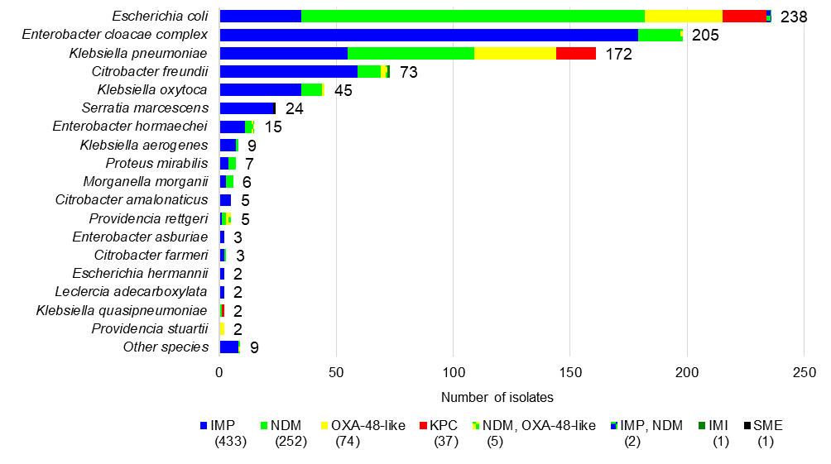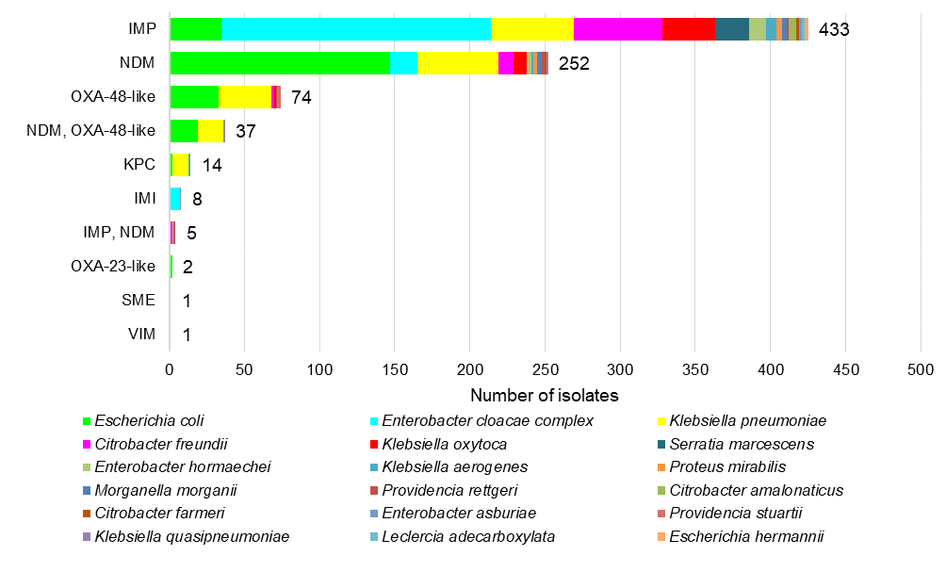

* Carbapenemase-producing (n = 780), carbapenemase- and ribosomal methyltransferase-producing (n = 46), carbapenemase-producing plus transmissible colistin resistance (n = 1)

Figure 8: Trend for the top five carbapenemase types* reported to CARAlert, by month, national, 2017–2022

* Alone or in combination with another type for the reporting period indicated

#### State and territory data

Figure 9: Carbapenemase-producing *Enterobacterales,* number reported to CARAlert by state and territory, 2017–2022

Note: Transmissible colistin resistance reported from July 2019.

**Figure 10:** Three-year trend for the top five carbapenemase types from *Enterobacterales* reported to CARAlert, by state and territory andnationally, (three-month moving average), 2020–2022

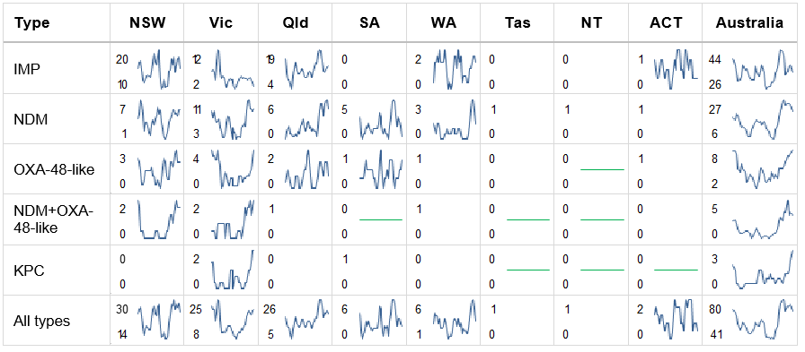Straight green line in cell = no carbapenemase type for that state or territory during the reporting period;   
Blank cell = maximum monthly average was one or less

Note: Line graphs represent three-month moving average for the period 1 January 2020 to 31 December 2022, for each type (reported alone or in combination with another type), where maximum monthly average was greater than one.

Figure 11: Carbapenemase-producing *Enterobacterales*\*, number reported to CARAlert by carbapenemase type and specimen type, by state and territory, 2022

* Carbapenemase-producing (n = 780), carbapenemase- and ribosomal methyltransferase-producing (n = 46), carbapenemase-producing plus transmissible colistin resistance (n = 1); Other types: OXA-23-like (n = 2: NSW [1], Victoria [1]); VIM (n = 1: Victoria); SME (n = 1: NSW)

Figure 12: Top five carbapenemase-producing *Enterobacterales* types reported to CARAlert by specimen type, by state and territory, 2017–2022

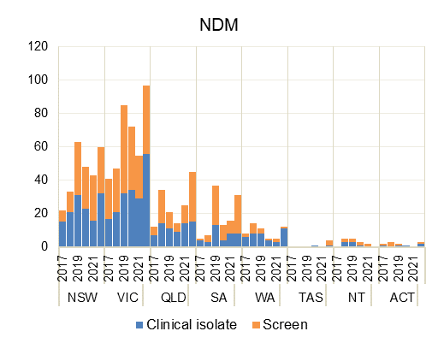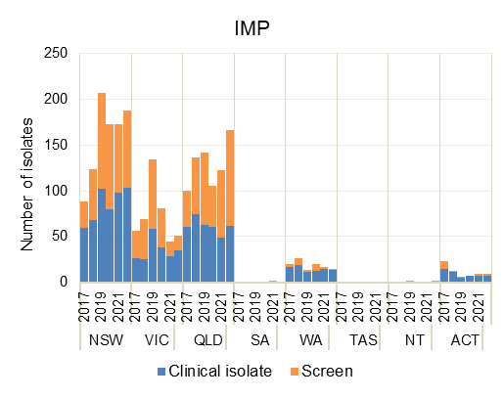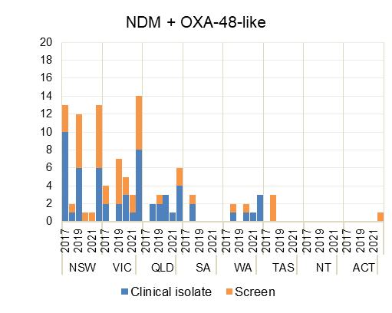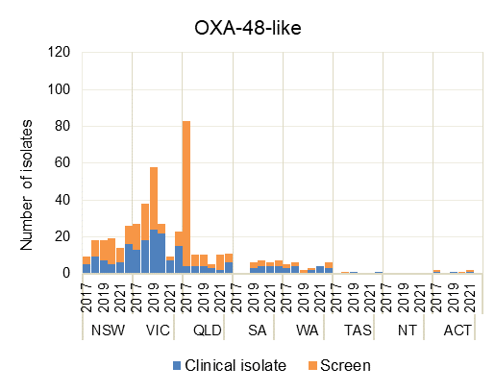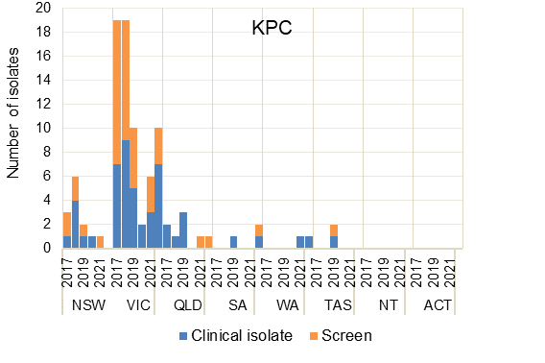

Table 4: Top five carbapenemase types from *Enterobacterales*\*, number reported to CARAlert by setting, state and territory, 2022

|  |  |  |  |  |  |  |  |  |  |  |
| --- | --- | --- | --- | --- | --- | --- | --- | --- | --- | --- |
| Carbapenemase type† |  | State or territory | | | | | | | |  |
| **Setting** | **NSW** | **Vic** | **Qld** | **SA** | **WA** | **Tas** | **NT** | **ACT** | **Total** |
| IMP | **Total** | **188** | **51** | **167** | **1** | **15** | **0** | **2** | **9** | **433** |
|  | Public hospital | 174 | 44 | 124 | 1 | 4 | 0 | 2 | 8 | 357 |
|  | Private hospital | 6 | 2 | 26 | 0 | 6 | 0 | 0 | 1 | 41 |
|  | Aged care home | 1 | 1 | 1 | 0 | 2 | 0 | 0 | 0 | 5 |
|  | Community | 6 | 4 | 15 | 0 | 2 | 0 | 0 | 0 | 27 |
|  | Unknown | 1 | 0 | 1 | 0 | 1 | 0 | 0 | 0 | 3 |
| NDM | **Total** | **60** | **97** | **45** | **31** | **12** | **4** | **0** | **3** | **252** |
|  | Public hospital | 54 | 68 | 34 | 28 | 5 | 2 | 0 | 3 | 194 |
|  | Private hospital | 1 | 2 | 7 | 0 | 2 | 0 | 0 | 0 | 12 |
|  | Aged care home | 0 | 4 | 0 | 0 | 0 | 1 | 0 | 0 | 5 |
|  | Community | 4 | 15 | 3 | 3 | 5 | 0 | 0 | 0 | 30 |
|  | Unknown | 1 | 8 | 1 | 0 | 0 | 1 | 0 | 0 | 11 |
| OXA-48-like | **Total** | **26** | **23** | **11** | **7** | **6** | **1** | **0** | **0** | **74** |
|  | Public hospital | 26 | 17 | 9 | 6 | 2 | 1 | 0 | 0 | 61 |
|  | Private hospital | 0 | 0 | 0 | 0 | 2 | 0 | 0 | 0 | 2 |
|  | Aged care home | 0 | 0 | 0 | 0 | 0 | 0 | 0 | 0 | 0 |
|  | Community | 0 | 4 | 2 | 1 | 2 | 0 | 0 | 0 | 9 |
|  | Unknown | 0 | 2 | 0 | 0 | 0 | 0 | 0 | 0 | 2 |
| NDM, OXA-48-like | **Total** | **13** | **14** | **6** | **0** | **3** | **0** | **0** | **1** | **37** |
|  | Public hospital | 11 | 10 | 3 | 0 | 1 | 0 | 0 | 1 | 26 |
|  | Private hospital | 0 | 0 | 0 | 0 | 0 | 0 | 0 | 0 | 0 |
|  | Aged care home | 0 | 0 | 1 | 0 | 0 | 0 | 0 | 0 | 1 |
|  | Community | 2 | 1 | 2 | 0 | 2 | 0 | 0 | 0 | 7 |
|  | Unknown | 0 | 3 | 0 | 0 | 0 | 0 | 0 | 0 | 3 |
| KPC | **Total** | **0** | **10** | **1** | **2** | **1** | **0** | **0** | **0** | **14** |
|  | Public hospital | 0 | 7 | 1 | 0 | 1 | 0 | 0 | 0 | 9 |
|  | Private hospital | 0 | 1 | 0 | 2 | 0 | 0 | 0 | 0 | 3 |
|  | Aged care home | 0 | 0 | 0 | 0 | 0 | 0 | 0 | 0 | 0 |
|  | Community | 0 | 0 | 0 | 0 | 0 | 0 | 0 | 0 | 0 |
|  | Unknown | 0 | 2 | 0 | 0 | 0 | 0 | 0 | 0 | 2 |

* The top five carbapenemase types account for 97.9% (810/827) of all CPE reported for this period. Other types were IMI (n = 8: NSW, Vic, Queensland); IMP+NDM (n = 5: NSW, Victoria); OXA-23-like (n = 2: NSW, Victoria); VIM (n = 1: Victoria); and SME (n = 1: NSW)

† Alone or coproduced with another type for the reporting period indicated

### *Enterococcus* species

*Enterococcus* species including *E. faecalis* and *E. faecium*, commonly cause urinary tract, biliary tract and other intra-abdominal infections, and bloodstream infections. In 2022, reports of linezolid-resistant *Enterococcus* species(*n*= 17)increased by 30.8% compared to 2021 (*n*= 13) (Figure 13). In 2019, there were 22 reports.

Linezolid-resistant *Enterococccus* species were reported from all states and territories except the NT in 2022 (Figure 14). Variation in the number of reports from the states and territories may be due to differences in testing and reporting practices by the originating laboratories. Some laboratories may only test linezolid on *Enterococcus* species if other resistances are detected.

Figure 13: Linezolid-resistant *Enterococcus* species, number reported to CARAlert by month, national, 2017–2022

Figure 14: Linezolid-resistant *Enterococcus* species, number reported to CARAlert by state and territory, 2017–2022

### *Mycobacterium tuberculosis*

*Mycobacterium tuberculosis* causes tuberculosis, which has a variety of clinical manifestations, but most commonly presents as lung disease. Low numbers of MDR *M. tuberculosis* were reported to CARAlert from 2017 to 2022 (Figure 15). In 2022, half of the MDR *M. tuberculosis* reports were from Victoria (5/9, 56%) (Figure 16).

Figure 15: Multidrug-resistant *Mycobacterium tuberculosis,* number reported to CARAlert by month, national, 2017–2022

Figure 16: Multidrug-resistant *Mycobacterium tuberculosis*, numberreported to CARAlert by state and territory, 2017–2022

Note: Dark bars indicate values for 2022.

### *Neisseria gonorrhoeae*

*N. gonorrhoeae* causes gonorrhoea, a largely sexually transmitted infection that most commonly manifests as urethritis in men and cervicitis in women. There were sporadic reports of ceftriaxone-nonsusceptible and/or azithromycin-nonsusceptible (HLR) *N. gonorrhoeae* between 2017 and 2021 (Figure 17). Ceftriaxone-nonsusceptible isolates were reported to CARAlert for the first time in 2018 (*n* = 6); there were four reports in 2019, three in 2020 and one in 2021. There were 37 reports from three states in 2022: NSW (*n* = 27), Victoria (*n* = 7), WA (*n* = 2) and Queensland (*n* = 1).

Eight azithromycin-nonsusceptible N. gonorrhoeae (HLR) were reported in 2022 (Queensland [4], NSW [3], WA [1]); there were none reported in 2021.

Almost all (250/251; >99%) of the CAR types associated with N. gonorrhoeae in 2021 had low-level azithromycin resistance. In 2022, this fell to 71.5% (113/158).

Figure 17: Ceftriaxone-nonsusceptible and/or azithromycin-nonsusceptible (high-level resistance) *Neisseria gonorrhoeae,* number reported to CARAlert by month, national, 2017–2022

High-level = azithromycin MIC ≥ 256 mg/L; Low-level = azithromycin MIC < 256 mg/L; MIC = minimum inhibitory concentration

Reports of azithromycin-nonsusceptible *N. gonorrhoeae* (LLR) decreased from 2017 to 2022 (Figure 18). The majority of reports over the period were from NSW and Victoria (Figure 19). There was a decrease in the total number of reports of this CAR in 2022 compared to 2021 (*n* = 113 in 2022; *n* = 250 in 2021, down 54.8%). There was a substantial‑decrease in the number reported from NSW (*n* = 9 in 2022; *n* = 167 in 2021), and a two-fold increase in the number of reports from Queensland (*n* = 28 in 2022; *n* = 13 in 2021) over the two-year period.

Figure 18: Azithromycin-nonsusceptible *Neisseria gonorrhoeae* (low-level resistance), number reported to CARAlert by month, national, 2017–2022

Low-level = azithromycin MIC < 256 mg/L; MIC = minimum inhibitory concentration

Figure 19: Azithromycin-nonsusceptible *Neisseria gonorrhoeae* (low-level resistance),number reported to CARAlert by state and territory, 2017–2022

Low-level = azithromycin MIC < 256 mg/L; MIC = minimum inhibitory concentration

Note: Dark bars indicate values for 2022.

### *Pseudomonas aeruginosa*

*P. aeruginosa* infections primarily affect hospitalised or immunocompromised patients. Patients with catheters or drains are considered at high risk for carbapenemase acquisition. Reporting for carbapenemase-producing *P. aeruginosa* began in July 2019.

In 2022, 57 carbapenemase-producing *P. aeruginosa* were reported from five states: NSW (*n* = 35), Victoria (*n* = 16), WA (*n* = 3), Queensland (*n* = 2) and SA (*n* = 1). This was a decrease from 2021 (*n* = 67, down 14.9%) (Figures 20 and 21). Three-quarters (75.4%) were either GES (*n* = 33), or VIM (*n* = 10) either alone (*n* = 9) or in combination with IMP (*n* = 1). GES-types dominated the reports from NSW (28/35, 80%), while VIM-types were most common in reports from Victoria (8/16, 50%). NDM-types were reported from four of the states who reported this CAR.

A substantial majority (47/57, 82.5%) of carbapenemase-producing *P. aeruginosa* were reported from hospitals (Table 5).

**Figure 20:** Carbapenemase-producing *Pseudomonas aeruginosa*, number reported to CARAlert by specimen type, national, 2022

Figure 21: Carbapenemase-producing *Pseudomonas aeruginosa*, number reported to CARAlert by carbapenemase type and specimen type, by state and territory, 2022

**Table 5:** Carbapenemase-producing *Pseudomonas aeruginosa*, number reported to CARAlert by setting and state and territory, 2022

|  |  |  |  |  |  |  |  |  |  |
| --- | --- | --- | --- | --- | --- | --- | --- | --- | --- |
|  | State or territory | | | | | | | |  |
| **Setting** | **NSW** | **Vic** | **Qld** | **SA** | **WA** | **Tas** | **NT** | **ACT** | **Total** |
| **Total** | **35** | **16** | **2** | **1** | **3** | **0** | **0** | **0** | **57** |
| Public hospitals | 28 | 13 | 0 | 1 | 2 | 0 | 0 | 0 | 44 |
| Private hospitals | 0 | 2 | 1 | 0 | 0 | 0 | 0 | 0 | 3 |
| Aged care homes | 1 | 0 | 0 | 0 | 0 | 0 | 0 | 0 | 1 |
| Community | 6 | 1 | 1 | 0 | 1 | 0 | 0 | 0 | 9 |

### *Salmonella* species

*Salmonella* species are important causes of bacterial gastroenteritis. Most cases are acquired through food-borne transmission. The number of reports of ceftriaxone-nonsusceptible *Salmonella* species more than doubled from 2021 (*n* = 24) to 2022 (*n*= 51) (Figure 22).

Three-quarters of the ceftriaxone-nonsusceptible *Salmonella* reports were from non-typhoidal species (38/51, 74.5%). The non-typhoidal species contained a plasmid-mediated AmpC (15/38, 39.5%), or extended-spectrum β-lactamase (ESBL) (23/39, 59%) (Figure 23).

There were 13 typhoidal species reported in 2022 (from NSW [6], Victoria [5] and WA [2]); all harboured an ESBL (*bla*CTX-M-15 [10], *bla*CTX-M-104 [2], *bla*CTX-M-65 [1]) (Figure 23). Typhoidal species were reported sporadically in the preceding five years (*n* = 12). The proportion of ceftriaxone-nonsusceptible typhoidal species, as reported to CARAlert, to the number of paratyphoidal or typhoid fever notifications9 was 5.7 (23/229) in 2022; it was 1.3 (4/319) in 2019.

Across states and territories, the greatest increase in reports of ceftriaxone-nonsusceptible *Salmonella* in 2022 was in NSW (*n* = 12 in 2022; *n* = 2 in 2021) and WA (*n* = 12 in 2022; *n* = 1 in 2021). There was a decrease in reports from Queensland (*n* = 7 in 2022; *n* = 12 in 2021), while there were no reports from Tasmania and the ACT (Figure 24).

Reports from public hospitals are likely due to admissions associated with severe disease acquired in the community (Table 6).

#### National data

Figure 22: Ceftriaxone-nonsusceptible *Salmonella* species, number reported to CARAlert by month, national, 2017–2022

**Figure 23:** Ceftriaxone-nonsusceptible *Salmonella* species, by resistance phenotype, national, 2017–2022

AmpC = plasmid-mediated AmpC; ESBL = extended-spectrum β-lactamase

#### State and territory data

Figure 24: Ceftriaxone-nonsusceptible *Salmonella* species, number reported to CARAlert by state and territory, 2017–2022

Table 6: Ceftriaxone-nonsusceptible *Salmonella* species, number reported to CARAlert by setting, state and territory, 2022

|  |  |  |  |  |  |  |  |  |  |
| --- | --- | --- | --- | --- | --- | --- | --- | --- | --- |
|  | State or territory | | | | | | | |  |
| **Setting** | **NSW** | **Vic** | **Qld** | **SA** | **WA** | **Tas** | **NT** | **ACT** | **Total** |
| **Total** | **12** | **17** | **7** | **2** | **12** | **0** | **1** | **0** | **51** |
| Public hospital | 8 | 6 | 2 | 2 | 6 | 0 | 0 | 0 | 24 |
| Private hospital | 0 | 0 | 0 | 0 | 1 | 0 | 0 | 0 | 1 |
| Aged care home | 0 | 0 | 0 | 0 | 0 | 0 | 0 | 0 | 0 |
| Community | 4 | 1 | 5 | 0 | 5 | 0 | 1 | 0 | 16 |
| Unknown | 0 | 10 | 0 | 0 | 0 | 0 | 0 | 0 | 10 |

### *Shigella* species

*Shigella* species infections are commonly food-borne or sexually transmitted. In 2022, there was a 2.4-fold increase in the number of MDR *Shigella* species reports compared to 2021 (*n* = 99 in 2022; *n* = 42 in 2021); there were 299 reports in 2020. The reports were predominantly from Victoria (37/99, 37.4%) and NSW (32/99, 32.3%) (Figures 25 and 26). Reports increased four-fold from Victoria (*n* = 37 in 2022; *n* = 9 in 2021) and Queensland (*n* = 20 in 2022; *n* = 5 in 2021).

*S. sonnei* was the predominant species (69/99, 69.7%) in all states and territories (Figure 26).

The estimated proportion of shigellosis notifications to the National Notifiable Diseases Surveillance System that were MDR decreased from 8.9% (42/471) nationally in 2021 to 7% in 2022 (99/1,405: range, 1% [1/102] in the NT to 13.3% [37/279] in Victoria) (Figure 27). In 2020, the proportion was 18.7% (299/1,603).

Where setting was known (84/99, 84.8%), just over two-thirds (57/84, 67.9%) of the MDR *Shigella* species were reported from community settings (Table 7).

Reports of MDR *Shigella* species increased rapidly from 2018 due to a prolonged clonal outbreak of *S. sonnei* with *bla*CTX‑M‑27 associated with men who have sex with men. There were two large outbreaks across two states, with a peak in numbers in April 2019 (74.5% from Victoria) and another in January 2020 (61.4% from NSW). There was a sharp fall in the monthly number of reports of this CAR from April 2020 onwards, continuing throughout 2021 to reach the lowest level since CARAlert began. This fall coincided with the introduction of COVID-19 restrictions throughout Australia. However, as borders re-opened, the number of reports of ESBL-producing *S. sonnei* has again increased from 17 in 2021 to 62 in 2022. Of isolates that were sequenced, a little over one-third of ceftriaxone-nonsusceptible *S. sonnei* in 2022 (21/56, 37.5%) harboured *bla*CTX-M-15. In 2021, nearly all harboured *bla*CTX-M-27 (15/16, 93.8%).

The majority of MDR S. flexneri were ceftriaxone-susceptible (19/28, 67.9% in 2022; 5/12, 41.7% in 2021). However, both ESBL (CTX-M) and pAmpC (blaDHA) types were detected in low numbers.

#### National data

Figure 25: Multidrug-resistant *Shigella* species, number reported to CARAlert by month, national, 2017–2022

#### State and territory data

Figure 26: Multidrug-resistant *Shigella* species, number reported to CARAlert by state and territory, 2017–2022

Table 7: Multidrug-resistant *Shigella* species, number reported to CARAlert by setting, state and territory, 2022

|  |  |  |  |  |  |  |  |  |  |
| --- | --- | --- | --- | --- | --- | --- | --- | --- | --- |
|  | State or territory | | | | | | | |  |
| **Setting** | **NSW** | **Vic** | **Qld** | **SA** | **WA** | **Tas** | **NT** | **ACT** | **Total** |
| **Total** | **32** | **37** | **20** | **2** | **5** | **1** | **1** | **1** | **99** |
| Public hospitals | 8 | 9 | 3 | 2 | 4 | 0 | 0 | 0 | 26 |
| Private hospitals | 0 | 1 | 0 | 0 | 0 | 0 | 0 | 0 | 1 |
| Aged care homes | 0 | 0 | 0 | 0 | 0 | 0 | 0 | 0 | 0 |
| Community | 24 | 14 | 17 | 0 | 0 | 1 | 0 | 1 | 57 |
| Unknown | 0 | 13 | 0 | 0 | 1 | 0 | 1 | 0 | 15 |

**Figure 27:** Multidrug-resistant *Shigella* species as reported to CARAlert as a percentage of shigellosis notifications, by state and territory, 2017–2022

Note: Notifications of shigellosis may include diagnosis by PCR only.

Source: National Notifiable Diseases Surveillance System9

### *Staphylococcus aureus*

*S. aureus* is a common pathogen causing a wide variety of infections of varying severity. The number of vancomycin-, linezolid- or daptomycin-nonsusceptible *S. aureus* reports decreased in 2022 (*n* = 175 in 2022; *n* = 266 in 2021; *n* = 216 in 2020) (Figure 28). Almost all reports were DNSA. Three linezolid-nonsusceptible *S. aureus* (from NSW [2] and Queensland [1]) and two daptomycin- and vancomycin-nonsusceptible *S. aureus* (from NSW and Victoria) were reported in 2022. Of all reports, 26.9% (47/175) were from WA (Figure 29).

The total number of reports of DNSAdecreased in 2022 (*n* = 170 in 2022; *n*= 265 in 2021, down 35.8%); Reports from Queensland (*n* = 26 in 2022; *n* = 133 in 2021), NSW (*n* = 23 in 2022; *n* = 43 in 2021) and Tasmania (*n* = 0 in 2022; *n* = 3 in 2021) decreased. However, there was an increase in DNSA reported from SA (*n* = 31 in 2022; *n* = 17 in 2021), Victoria (*n* = 31 in 2022; *n* = 24 in 2021), WA (*n* = 47 in 2022; *n* = 39 in 2021) and the ACT (*n* = 12 in 2022; *n* = 6 in 2021) compared to 2021. Differences in testing and reporting practices by originating laboratories for this CAR, and the difficulty in interpreting phenotypic tests, may contribute to disproportionate state and territory numbers.

In 2022, where the setting was known, reports of DNSA were predominantly from hospitals (110/161, 68.3%) and the community (41/161, 25.5%); while 6.2% (10/161) were from aged care homes (Table 8).

#### National data

Figure 28: Vancomycin-, linezolid- or daptomycin-nonsusceptible *Staphylococcus aureus,* number reported to CARAlert by month, national, 2017–2022

Notes:

1. For CARAlert, *S. aureus* complex includes *S. argenteus* and *S. schweitzeri*.
2. No *S. argenteus* and *S. schweitzeri* were reported from 2017 to 2022.

#### State and territory data

Figure 29: Vancomycin-, linezolid- or daptomycin-nonsusceptible *Staphylococcus aureus,* number reported to CARAlert, national, 2017–2022

**Table 8**.Daptomycin-nonsusceptible *Staphylococcus aureus,* number reported to CARAlert by setting and state and territory, 2022

|  |  |  |  |  |  |  |  |  |  |
| --- | --- | --- | --- | --- | --- | --- | --- | --- | --- |
|  | State or territory | | | | | | | |  |
| **Setting** | **NSW** | **Vic** | **Qld** | **SA** | **WA** | **Tas** | **NT** | **ACT** | **Total** |
| **Total** | **23** | **31** | **26** | **31** | **47** | **0** | **0** | **12** | **170** |
| Public hospital | 16 | 16 | 12 | 16 | 42 | 0 | 0 | 5 | 107 |
| Private hospital | 0 | 1 | 2 | 0 | 0 | 0 | 0 | 0 | 3 |
| Aged care home | 2 | 2 | 5 | 0 | 1 | 0 | 0 | 0 | 10 |
| Community | 5 | 4 | 6 | 15 | 4 | 0 | 0 | 7 | 41 |
| Unknown | 0 | 8 | 1 | 0 | 0 | 0 | 0 | 0 | 9 |

### *Streptococcus pyogenes*

*Streptococcus pyogenes* most commonly causes skin and soft tissue infections, and acute pharyngitis, but may cause serious and life-threatening infections such as scarlet fever, bloodstream infections, bone and joint infections, toxic shock syndrome, necrotising fasciitis and pneumonia.

There have been no reports of *S. pyogenes* with reduced susceptibility to penicillin between 2017 and 2022.

## Discussion

#### Rates of carbapenemase-producing *Enterobacterales* in Australian hospitals

*Enterobacterales* commonly cause urinary tract, biliary tract and other intra-abdominal infections, and bloodstream infections. Patients are likely to be affected by CPE predominantly where they have been hospitalised.

There was a 37.8% increase in the number of carbapenemase- and/or ribosomal methyltransferase-producing *Enterobacterales* reports in 2022 compared to 2021 after a gradual decline in reports of this CAR between January 2019 and November 2020. Numbers increased slightly in the first half of 2021 then remained steady for the rest of the year. Factors that may have contributed to the overall decline of CPE reported to CARAlert since 2019 include improvements in recognition and infection prevention and control efforts over this period.

CPE continue to be dominated by those of the IMP type, found most often in the *E. cloacae* complex. NDM-producing *Enterobacterales* were reported from all states and territories except the NT. Reports have increased in 2022, after a decrease in both 2020 and 2021, and are higher than 2019. Although NDM types are generally thought to be acquired overseas, identification of local transmission and appropriate infection prevention and control actions are important priorities. The range and number of CPE types will continue to evolve because of changing local and global epidemiology. Each carbapenemase type has a slightly different spectrum of activity against different β-lactam antimicrobials. Typing of CPE is important for supporting appropriate antimicrobial prescribing to treat infections caused by CPE.

The differences between states and territories in the proportion of screening isolates may indicate local variations in surveillance, infection prevention and control, and screening practices. Local outbreaks are likely to have required increased infection prevention and control and surveillance resources in affected hospitals over short periods of time. The impact of outbreaks on other aspects of hospital work and patient flows may be substantial in the absence of timely infection prevention and control action. The variation between states and territories in reports of CPE as a proportion of all CARs, and the frequency of reporting of CPE, indicates the need for local decisions about containment priorities.

A total of 5.6% of all CPE reports occurred in the 0–4-year age group. The mode of acquisition of these CARs is not known; however, CPE outbreaks can occur in the neonatal intensive care unit setting. The long-term impact of this type of resistance on neonates is unknown. Education of clinicians on the risks of neonatal acquisition of antimicrobial-resistant organisms, and review of the appropriateness of antimicrobial use and infection prevention and control in the neonatal care setting are encouraged.

Patients are likely to be affected by CPE if they are hospitalised for a prolonged period; have been hospitalised or had surgery overseas; have had multiple, or recent exposure to different antimicrobial agents, especially cephalosporins, fluoroquinolones and carbapenems; have diabetes mellitus; are on mechanical ventilation; are admitted to the intensive care unit; or have an indwelling medical device (such as a central venous catheter, urinary catheter or biliary catheter).

Ongoing reports of CPE albeit at low levels, highlight the value of active surveillance and the importance of compliance with the *Australian Guidelines for the Prevention and Control of Infection in Healthcare*1, and use of guidance for specific organisms, such as *Recommendations for the control of carbapenemase-producing* Enterobacterales *(CPE): A guide for acute health service organisations*.3

Arrangements for specialist oversight of and access to restricted antimicrobials, such as carbapenems, should continue to be a priority all Australian hospitals along with implementation of systems that meet the antimicrobial stewardship (AMS) actions of the National Safety and Quality Health Service (NSQHS) Standards.2

#### Changes in community-onset critical antimicrobial resistances

*N. gonorrhoeae* was the most commonly reported CAR from the community setting for all years since CARAlert commenced, except for 2019 where MDR *Shigella* species dominated. Reports of azithromycin-nonsusceptible *N. gonorrhoeae* (LLR) continued to decline in 2022 from its peak in 2017. Reports of ceftriaxone-nonsusceptible and/or azithromycin-nonsusceptible *N. gonorrhoeae* (HLR) increased sharply in 2022. Two-thirds of the reports were from NSW, although there were also reports from Victoria, Queensland and WA.

Reports of MDR *Shigella* species increased 2.4-fold in 2022, compared to 2021. However, the proportion of shigellosis notifications that were MDR decreased overall in 2022 compared to 2021. The decrease was noted in all states and territories where there were five or more reports, except in Queensland, where the proportion increased.

The increase in reports in 2022 in these two CARs corresponded with the resumption of usual social interaction and international travel following easing of COVID-19 restrictions from late 2021. These changes indicate that ongoing monitoring of resistance in gonococcal disease and shigellosis is required because of the importance of emerging changes in susceptibility for treatment guidelines.

Past increases in reports of MDR *Shigella* suggest that empirical antimicrobial therapy recommendations for shigellosis may need to be reconsidered. Increases also require ongoing close review by states and territories. Public health messaging should continue to highlight the risk of sexual transmission of *Shigella* species, particularly in men who have sex with men, and provide guidance on ways to reduce the risk of transmission.

The emergence of gonococcal antimicrobial resistance (AMR) in Australia has long been influenced by the introduction of MDR strains from overseas.10,11 A number of reports from other countries of ceftriaxone-resistant *N. gonorrhoeae* strains have raised global concerns about the effectiveness of current recommended treatments.12-14 In Australia, the recommended treatment for *N. gonorrhoeae* is ceftriaxone in conjunction with azithromycin. This regimen was introduced in Australia in 2014 to limit further development of resistance to ceftriaxone.15 The low background rate of azithromycin-nonsusceptible *N. gonorrhoeae* (LLR) in Australia is well established. Reports of this CAR have declined since 2019 in the context of 34,760 notifications of gonococcal infection nationally in 2019, 29,817 notifications in 2020, 26,860 notifications in 2021, and 33,745 notifications in 2022.9 The clinical implications of this low-level resistance are not clear. Continuing low numbers of reports of ceftriaxone-nonsusceptibility are concerning.

#### Critical antimicrobial resistances in aged care homes

In 2022, there were 24 CARs reported from aged care homes. All reports were from clinical isolates, and nearly all were either CPE or DNSA.

In aged care homes, skin and soft tissue infections are the most common reason for antimicrobial prescriptions.16 *S. aureus* commonly cause skin and soft tissue infections, which may be spread by contact with contaminated surfaces and hands of healthcare workers, visitors and residents. Environmental cleaning and hand hygiene are important prevention and control strategies for *S. aureus*. In group living situations, *S. aureus* may also be inadvertently spread from person to person, for example by sharing personal items such as bed linen, towels or clothing.

There is a risk of transmission of these CARs within aged care homes and in hospitals due to the frequent movement of aged care home residents between these two settings Specific measures are required in all care settings for CPE. To support the capacity to prevent and control transmission of CPE, aged care homes should comply with the infection prevention and control requirements of the Aged Care Quality Standards6, which include compliance with national guidelines.1

#### Health service demand and complexity of care

CARs increase hospital length of stay, deaths, and health service resource needs. Estimates of the impacts of AMR vary by organism and are not available for the majority of CARs. Recent estimates of the impact of CPE include an additional 29 inpatient days, compared to non-CPE cases, after the isolation of the organism.17 Patients with MDR infections were also less likely to receive appropriate antimicrobial therapy initially.17 For vancomycin-resistant enterococci, when they first emerged, estimated increases per case were 61.9% for hospital costs and an additional 13.8 days length of stay.18

Increases in CARs also require ongoing close review by states and territories as there are limited oral antimicrobial options, and intravenous antimicrobials may be required to treat MDR infections. There may also be resource implications for the health system because of increased testing, hospital admissions and transmission in the community.

#### What will be done to improve patient safety?

In response to the issues identified in analyses of CARAlert data between 2017 and 2022, the Commission will continue to:

* Monitor CARs reported to CARAlert, maintain the CARAlert system and communicate key findings to states, territories, the Department of Health and Aged Care and relevant experts
* Liaise directly with states and territories and clinical stakeholders about specific CARs reported to CARAlert, as required
* Promote compliance with the *Australian Guidelines for the Prevention and Control of Infection in Healthcare*1 as required by the NSQHS Standards2
* Promote implementation of guidance for specific organisms, such as the *Recommendations for the control of carbapenemase-producing* Enterobacterales *(CPE): A guide for acute care health service organisations*3
* Use CARAlert and other Antimicrobial Use and Resistance in Australia (AURA) data to refine and strengthen approaches to infection prevention and control and AMS, and support implementation of the NSQHS Standards2, the National Safety and Quality Primary and Community Healthcare Standards4 and the Antimicrobial Stewardship Clinical Care Standard5
* Liaise with the Aged Care Quality and Safety Commission and aged care provider organisations and develop resources to support implementation of infection prevention and control programs in aged care homes to meet the requirements of the Aged Care Quality Standards6
* Support collaboration between states and territories and hospital and community care settings to prevent and control CARs, as required
* Prepare analyses of AMR data for, and liaise with Therapeutic Guidelines Limited, the organisation that develops guidance on antimicrobial prescribing in Australia.

## References

1. National Health and Medical Research Council, Australian Commission on Safety and Quality in Health Care. Australian Guidelines for the Prevention and Control of Infection in Healthcare. Sydney: NHMRC, 2019.

2. Australian Commission on Safety and Quality in Health Care. National Safety and Quality Health Service Standards. 2nd ed. – version 2. Sydney: ACSQHC, 2021.

3. Australian Commission on Safety and Quality in Health Care. Recommendations for the control of carbapenemase-producing *Enterobacterales* (CPE). A guide for acute care health service organisations. Sydney: ACSQHC, 2021.

4. Australian Commission on Safety and Quality in Health Care. National Safety and Quality Health Service Primary and Community Healthcare Standards. Sydney: ACSQHC; 2021.

5. Australian Commission on Safety and Quality in Health Care. Antimicrobial Stewardship Clinical Care Standard. Sydney: ACSQHC; 2020.

6. Australian Commission on Safety and Quality in Health Care. Aged Care Quality Standards – Clinical Care. [Internet] Sydney: ACSQHC; 2023 [cited March 2023] Available from: <https://www.safetyandquality.gov.au/standards/aged-care-quality-standards-clinical-care>.

7. Assis R, Lasnoy M, Adler A. Clinical and epidemiological features of patients colonised by different types of carbapenemase-producing *Enterobacterales*. J Glob Antimicrob Resist. 2021 Sep;26:108-113.

8. Tyson GH, Li C, Hsu CH, Ayers S, Borenstein S, Mukherjee S, et al. The *mcr-9* Gene of *Salmonella* and *Escherichia coli* Is not associated with colistin resistance in the United States. Antimicrob Agents Chemother. 2020 Jul 22;64(8).

9. Australian Government Department of Health and Aged Care. National Notifiable Diseases Surveillance Dashboard. [Internet] Canberra: Australian Government; 2023 [cited March 2023] Available from: <https://nindss.health.gov.au/pbi-dashboard/>.

10. Hanrahan JK, Hogan TR, Buckley C, Trembizki E, Mitchell H, Lau CL, et al. Emergence and spread of ciprofloxacin-resistant *Neisseria gonorrhoeae* in New South Wales, Australia: lessons from history. J Antimicrob Chemother. 2019 Aug 1;74(8):2214-2219.

11. Tapsall JW, Limnios EA, Murphy D. Analysis of trends in antimicrobial resistance in *Neisseria gonorrhoeae* isolated in Australia, 1997-2006. J Antimicrob Chemother. 2008 Jan;61(1):150-155.

12. Eyre DW, Town K, Street T, Barker L, Sanderson N, Cole MJ, et al. Detection in the United Kingdom of the *Neisseria gonorrhoeae* FC428 clone, with ceftriaxone resistance and intermediate resistance to azithromycin, October to December 2018. Euro Surveill. 2019 Mar;24(10).

13. Fifer H, Hughes G, Whiley D, Lahra MM. Lessons learnt from ceftriaxone-resistant gonorrhoea in the UK and Australia. Lancet Infect Dis. 2020 Mar;20(3):276-278.

14. Unemo M, Golparian D, Eyre DW. Antimicrobial Resistance in *Neisseria gonorrhoeae* and Treatment of Gonorrhea. Methods Mol Biol. 2019;1997:37-58.

15. Lahra MM, Hogan TR, Armstrong BH. Australian Gonococcal Surveillance Program Annual Report, 2021. Commun Dis Intell. 2022.

16. Australian Commission on Safety and Quality in Health Care. AURA 2021: fourth Australian report on antimicrobial use and resistance in human health. Sydney: ACSQHC, 2021.

17. Hayakawa K, Nakano R, Hase R, Shimatani M, Kato H, Hasumi J, et al. Comparison between IMP carbapenemase-producing *Enterobacteriaceae* and non-carbapenemase-producing *Enterobacteriaceae:* a multicentre prospective study of the clinical and molecular epidemiology of carbapenem-resistant *Enterobacteriaceae*. J Antimicrob Chemother. 2020 Mar 1;75(3):697-708.

18. Lloyd-Smith P, Younger J, Lloyd-Smith E, Green H, Leung V, Romney MG. Economic analysis of vancomycin-resistant enterococci at a Canadian hospital: assessing attributable cost and length of stay. J Hosp Infect. 2013 Sep;85(1):54-59.

19. Centers for Disease Control and Prevention. Updated Guidelines for Evaluating Public Health Surveillance Systems. Recommendations from the Guidelines Working Group. [Internet] Atlanta (GA): CDC; 2001 [cited March 2023] Available from: <https://www.cdc.gov/mmwr/preview/mmwrhtml/rr5013a1.htm>.

20. Australian Commission on Safety and Quality in Health Care. Priority organisms for national reporting in targeted surveillance programs. Sydney: ACSQHC; 2022.

## Appendix 1 About CARAlert

The National Alert System for Critical Antimicrobial Resistances (CARAlert) was established by the Australian Commission on Safety and Quality in Health Care (the Commission) in March 2016 as a component of the Antimicrobial Use and Resistance in Australia (AURA) Surveillance System.

Participating confirming laboratories submit data to CARAlert on priority organisms with critical resistance to last-line antimicrobial agents (CARs). Isolates collected from patients are reported to CARAlert as either a clinical isolate, that is a specimen (e.g., from blood, urine, wound) taken to guide clinical diagnosis, or as a screen for infection prevention and control purposes. No patient-level data are held in the CARAlert system.

CARAlert detects information on confirmed cases of CARs and can identify any seasonal or geographic trends. Most importantly, it acts as a potential early warning system for CAR outbreaks to enable timely infection prevention and control responses.

Funding for CARAlert is provided by the Australian Government Department of Health and Aged Care (the Department), with contributions from the states and territories by meeting the costs of confirmatory testing and data submission processes.

The CARs reported under CARAlert are listed in Table A1. These CARs were drawn from the list of high-priority organisms and antimicrobials that are the focus of the AURA Surveillance System.

**Table A1: List of critical antimicrobial resistances reported to CARAlert, 2022**

|  |  |
| --- | --- |
| Species | Critical Resistance |
| *Acinetobacter baumannii* complex | Carbapenemase-producing* |
| *Candida auris\** | – |
| *Enterobacterales* | Carbapenemase-producing and/or ribosomal methyltransferase-producing |
| Transmissible colistin resistance* |
| *Enterococcus* species | Linezolid-resistant |
| *Mycobacterium tuberculosis* | Multidrug-resistant – resistant to at least rifampicin and isoniazid |
| *Neisseria gonorrhoeae* | Ceftriaxone-nonsusceptible and/or azithromycin-nonsusceptible |
| *Pseudomonas aeruginosa* | Carbapenemase-producing* |
| *Salmonella* species | Ceftriaxone-nonsusceptible |
| *Shigella* species | Multidrug-resistant |
| *Staphylococcus aureus*† | Vancomycin-, linezolid- or daptomycin-nonsusceptible |
| *Streptococcus pyogenes* | Penicillin reduced susceptibility |

* Reported to CARAlert from July 2019

† For CARAlert, *S. aureus* includes *S. argenteus* and *S. schweitzeri*

Note: Low level-azithromycin-nonsusceptible *N. gonorrhoeae* was excluded from the weekly summary following review in 2018.

In 2022, 28 confirming laboratories participated in CARAlert (Appendix 3). CARAlert generates a weekly summary email alert to report information on confirmed CARs to state and territory health authorities, the Department and confirming laboratories. CARAlert is based on routine processes used by pathology laboratories for identifying and confirming potential CARs.

CARAlert data support timely responses to CARs by hospitals, and state and territory health departments. Some states have made selected CARs, such as carbapenemase-producing *Enterobacterales* and *Candida auris*, notifiable either using their public health legislation or by policy. Some states and territories have standalone systems for monitoring selected CARs, which complement CARAlert, but these are not widespread. Over time, CARAlert data will become increasingly useful to inform a broader range of safety and quality improvement programs.

The Commission reviewed the CARs reported to CARAlert in 2018, in conjunction with the states and territories and a range of clinical experts. The review identified four new CARs that were reported to CARAlert from July 2019:

* Transmissible resistance to colistin in *Enterobacterales*
* Carbapenemase-producing *Acinetobacter baumannii* complex
* Carbapenemase-producing *Pseudomonas aeruginosa*
* *C. auris*.

The Commission completed another review of the CARs reported to CARAlert in 2022. The review followed a similar process to the 2018 review and involved consultation with the states and territories and range of clinical experts. The 2022 review identified two new CARs that were reported to CARAlert from January 2023:

* Ciprofloxacin-nonsusceptible *Neisseria meningitidis*
* Gentamicin-resistant *N. gonorrhoeae*.

Additionally, reporting of daptomycin-nonsusceptible *Staphylococcus aureus* (DNSA) was suspended. Reintroduction of reporting of DNSA to CARAlert will be considered when more reliable testing methods are available.

The Department regularly evaluates national surveillance systems to ensure they continue to meet their purpose and objectives. In 2022–2023, the Department conducted an evaluation of CARAlert, which complements the Commission’s review of CARs. The purpose of the CARAlert evaluation was to examine:

* How well the system operates to meet its purposes and objectives
* The appropriateness of the system’s purposes and objectives
* Improvements to enhance the system’s ability to meet these objectives.

The United States Centers for Disease Control and Prevention *Updated Guidelines for Evaluating Public Health Surveillance Systems*19 was used to evaluate the system’s usefulness and performance against system attributes. Once the evaluation has been finalised, the Commission will collaborate with the Department, states and territories and confirming laboratories to consider the recommendations of the evaluation and feasibility for implementation.

Information on CARAlert processes and considerations for interpreting CARAlert data is in Appendix 2.

## Appendix 2 Methodology

#### CARAlert reporting processes

All of the following criteria must be met for organisms and resistances to be categorised as a critical antimicrobial resistance (CAR) for reporting to the National Alert System for Critical Antimicrobial Resistances (CARAlert):

* Inclusion as a priority organism for national reporting as part of the Antimicrobial Use and Resistance in Australia (AURA) Surveillance System20
* A serious threat to last-line antimicrobial agents
* Strongly associated with resistance to other antimicrobial classes
* At low prevalence in, or currently absent from, Australia and potentially containable
* Data not otherwise collected nationally in a timely way.

*Candida auris* was added as a CAR for reporting to CARAlert in 2019 despite not being an AURA Surveillance System priority organism. It was added to CARAlert following feedback from respondents to the 2018 review of CARs, and international concerns for its multidrug resistance and association with invasive infection outbreaks in healthcare facilities in 2017. The United States Centers for Disease Control posted advice in 2017 about detection, treatment and infection control measures for *C. auris* that should be implemented.

CARAlert is based on the following routine processes used by pathology laboratories for identifying and confirming potential CARs:

* Collection and routine testing – the isolate is collected from the patient and sent to the originating laboratory for routine testing
* Confirmation – if the originating laboratory suspects that the isolate is a CAR, it sends the isolate to a confirming laboratory that has the capacity to confirm the CAR
* Reporting to clinicians in accordance with usual laboratory processes – the confirming laboratory reports back to the originating laboratory, which in turn reports to the clinician who initially requested the microbiological testing
* Submission to the CARAlert system – the confirming laboratory advises the originating laboratory of the test result, and the originating laboratory reports back to the health service that cared for the patient; the confirming laboratory then submits the details of the resistance and organism to the secure CARAlert web portal.

Information collected in CARAlert includes: the originating and confirmatory laboratory, specimen identifier, specimen collection date, CAR, CAR type or subtype if applicable, organism name, specimen type, facility type, patient age range, patient gender, and state or territory of patient residence and state or territory of record.

No patient-level data are held in the CARAlert system. Authorised officers in each state and territory health department can access the CARAlert web portal directly for further information about their jurisdiction, including the name of the public hospital where a patient with a confirmed CAR was cared for, and to extract reports on their data.

Australian public and private laboratories that have the capacity to confirm CARs were identified through consultation with state and territory health authorities, the Public Health Laboratory Network and the Australian Group on Antimicrobial Resistance. In 2022, 28 confirming laboratories participated in CARAlert, and there was at least one confirming laboratory in each state and territory. The CARs that each of the confirming laboratories are able to confirm are regularly reviewed.

All data analyses for this report were performed using Microsoft Excel 365.

#### Data considerations

The following are important considerations for interpreting CARAlert data:

* The data are based on the date that the isolate with the confirmed CAR was collected
* States and territories refer to the state or territory within which the hospital is located, or within which the patient resides for isolates from the community. If place of residence is unknown or overseas, the state or territory of the originating laboratory is reported
* The same CAR/type/species is not submitted where the sample originated from the same patient who had the previous CAR, and the isolate was collected on the same day, or collected in the same admission or within three months
* Comparison between reports may be influenced by delayed detection or late submissions of CARs
* Number of CARs reported does not always equal the number of patients, as patients may have more than one CAR, or species, detected in a specimen
* Cut-off date for data that are included in updates and reports is four weeks after the end of each reporting period
* National summary data is provided; comparison across states and territories is provided for organisms where there are large numbers reported and a comparison is meaningful.

## Appendix 3 CARAlert confirming laboratories, 2022

The Commission thanks all the originating and confirming laboratories for their support for the National Alert System for Critical Antimicrobial Resistances (CARAlert) and the Antimicrobial Use and Resistance in Australia (AURA) Surveillance System. The following confirming laboratories contributed to CARAlert in 2022:

|  |  |
| --- | --- |
| State or Territory | Institution |
| Australian Capital Territory | ACT Pathology, Garran |
| New South Wales | NSW Health Pathology, Concord Hospital, Concord |
| NSW Health Pathology, Liverpool Hospital, Liverpool |
| NSW Health Pathology, John Hunter Hospital, New Lambton Heights |
| NSW Health Pathology, Royal North Shore Hospital, St Leonards |
| NSW Health Pathology, Royal Prince Alfred Hospital, Camperdown |
| NSW Health Pathology, St George Hospital, Kogarah |
| NSW Health Pathology, The Prince of Wales Hospital, Randwick |
| NSW Health Pathology, Westmead Hospital, Westmead |
| St Vincent's Pathology (SydPath), Darlinghurst |
| Northern Territory | Territory Pathology, Tiwi |
| Queensland | Pathology Queensland, Central laboratory, Royal Brisbane and Women’s Hospital, Herston |
| Pathology Queensland, Forensic & Scientific Services, Coopers Plains |
| QML Pathology, Murarrie |
| Sullivan Nicolaides Pathology, Bowen Hills |
| South Australia | SA Pathology, Royal Adelaide Hospital, Adelaide |
| Tasmania | Royal Hobart Hospital, Hobart |
| Victoria | Alfred Pathology Service, Melbourne |
| Austin Pathology, Heidelberg |
| Dorevitch Pathology, Heidelberg |
| Microbiological Diagnostic Unit Public Health Laboratory, Melbourne |
| Victorian Infectious Diseases Reference Laboratory (VIDRL), Melbourne |
| Melbourne Pathology, Collingwood |
| Monash Pathology, Clayton |
| St Vincent's Hospital, Fitzroy |
| Western Australia | PathWest Laboratory Medicine WA, Fiona Stanley Hospital, Murdoch |
| PathWest Laboratory Medicine WA, QEII Medical Centre, Nedlands |
| Australian Clinical Labs, Osborne Park |

This page is left intentionally blank





Level 5, 255 Elizabeth Street, Sydney NSW 2000  
GPO Box 5480, Sydney NSW 2001

Phone: (02) 9126 3600

Email: CARAlert@safetyandquality.gov.au

Website: [www.safetyandquality.gov.au](http://www.safetyandquality.gov.au)

0BTwitter logo @ACSQHC