Australian Commission on Safety and Quality in Health Care logo 


TRIM: D23-24769

The Hand Hygiene Compliance Application (HHCApp)

User guide

July 2023

Contents

About this guide 3

Administrator roles and responsibilities 4

Organisation Administrator 4

Region and Region Group/Organisation Group Administrator 4

Other HHCApp roles 5

How to register a new organisation in the HHCApp 7

User profiles 8

Entering audit data using the HHCApp 9

How to enter data using the mobile site 9

How to enter data using the desktop site 15

How to use the hand hygiene observation data collection form 20

Automated data validation 24

Generating reports 26

Standard Reports 26

Custom reports 27

Local audits 28

More information 30

Tables

Table 1. HHCApp roles and actions 6

Table 2. HHCApp reports: Standard 26

Table 3. HHCApp reports: Custom 27

Table 4. HHCApp reports: Preset 27

# About this guide

The Hand Hygiene Compliance Application (HHCApp) is the Commission’s web-based application developed for use by health service facilities to collect, review and report their hand hygiene compliance data. Only trained and validated hand hygiene auditors can collect and enter data using the HHCApp.

The HHCApp forms part of the resources for the National Hand Hygiene Initiative (NHHI).

This guide provides information and instructions on how to use the HHCApp to collect, review and report hand hygiene compliance data.

# Administrator roles and responsibilities

## Organisation Administrator

Organisations are the health service facilities that collect hand hygiene compliance data for national or their local audits; for example, an acute hospital. Organisation Administrators can access hand hygiene data and perform administrative fucntion for their organisation(s).

The role of the Organisation Administrator is to:

* register their organisation within the HHCApp
* create user profiles for their organisation
* manage users and provide support on password resets, data input and reporting enquiries
* manage the validation and submission of audit data at the end of each national audit period
* access data and perform administrative functions for their organisation(s) only
* ensure their organisation details are current
* run reports on hand hygiene compliance data for all users and their organisation.

## Region and Region Group/Organisation Group Administrator

Regions and Region Groups are clusters of health service facilities that operate in the public health sector. These groups are generally formed on the basis of state and geographic location. For example, a local health district. A Region or Region Group Administrator is assigned in the HHCApp to manage the group.

Organisation Groups are used primarily for private sector health service facilities. They can also be used in the public sector when an organisation must be associated with more than one region group. Organisation groups are not necessarily geographically co-located. For example, a dental group could have members dispersed across different regions. Organisation Group Administrators manage these groups.

The role of the Region or Region/Organisation Group Administrator is to support health service facilities within the region or group to:

* implement their own hand hygiene programs
* use the HHCApp
* validate and submit data at the end of national audit periods
* ensure only trained and validated auditors are assigned and submit hand hygiene audit data.

Region or Region/Organisation Group Administrator can access details of health service facilities (which are called organisations in the HHCApp) within their group, including all reporting functions for the group. The functions of the Region or Region/Organisation Group Administrator are to:

* register their region within the HHCApp
* ensure that at least one primary contact of Organisation Administrator is assigned for every health service facility within their group
* create user profiles for their region, when required
* modify health service facility’s administrator, auditor, reporter and data entry profile details, including updating email addresses, moving learners to different health service facilities within the region or group, and removing learners from the region or group
* reset passwords for users registered in the region
* run reports on hand hygiene compliance data for all users and organisations within the region group, region, or group of health service facilities.

### Supporting resources

The following resources support Region, Region/Organisation Group and Organisation Administrators in using the HHCApp:

* [NHHI HHCApp Region/Group Administrator Webinar: Instructions for organisation and regional administrators](https://youtu.be/jd5o8LGgZcE)[1]
* [National Hand Hygiene Initiative Learning Management System (LMS) - Instructions for Region Administrators](https://www.safetyandquality.gov.au/publications-and-resources/resource-library/national-hand-hygiene-initiative-learning-management-system-lms-instructions-region-administrators)[2]
* [National Hand Hygiene Initiative Learning Management System (LMS) - Instructions for Organisation Administrators](https://www.safetyandquality.gov.au/publications-and-resources/resource-library/national-hand-hygiene-initiative-learning-management-system-lms-instructions-organisation-administrators).[3]

## Other HHCApp roles

Several other roles are available in HHCApp, each with differing functionality. The role assigned determines the level of each user and what they can access and do within the system. Users cannot access data or administrative functions above their assigned level. Other HHCApp roles include:

|  |  |
| --- | --- |
| **Jurisdictional Administrator** | can access all data and perform all administrative functions for their state or territory. |
| **Auditor** | can audit and enter data for their department or organisation. |
| **Reporter** | can access reports for their department, group, organisation, or region. |
| **Data entry** | can enter data that are collected by their department or organisation’s auditors for their department or organisation. |

Table 1. HHCApp roles and actions

| Role | Action | | | | | |
| --- | --- | --- | --- | --- | --- | --- |
| Data Entry | Reports | Departments   * Add * Remove * Inactivate | Healthcare Worker Type   * Add * Remove * Inactivate | Audit Periods   * Add * Submit | Auditors   * Add * Remove * Reset logins |
| Jurisdictional Administrator | **✓** | **✓** | **✓** | **✓** | **✓** | **✓** |
| Region and Region/Organisation Group Administrator | **✓** | **✓** | **✓** | **✓** | **✓** | **✓** |
| Organisation Administrator | **✓** | **✓** | **✓** | **✓** | **✓** | **✓** |
| Auditor | **✓** | **✗** | **✗** | **✗** | **✗** | **✗** |
| Reporter | **✗** | **✓** | **✗** | **✗** | **✗** | **✗** |
| Data Entry | **✓** | **✗** | **✗** | **✗** | **✗** | **✗** |

The following resources support users in using the HHCApp:

* [National Hand Hygiene Initiative Learning Management System (LMS) - Instructions for learners](https://www.safetyandquality.gov.au/publications-and-resources/resource-library/national-hand-hygiene-initiative-learning-management-system-lms-instructions-learners)[4]
* [Quick start HHCApp guide](https://www.safetyandquality.gov.au/publications-and-resources/resource-library/quick-start-hhcapp-guide).[5]

## How to register a new organisation in the HHCApp

A health service facility can set up their organisation in the HHCApp by following these steps:

1. Go to the HHCApp desktop site <https://nhhi.safetyandquality.gov.au/>
2. Click the ‘Register your organisation’ button

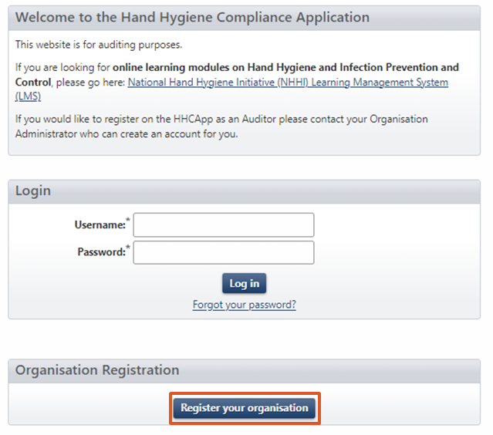

1. Follow the steps to complete the application.

Once the application is submitted for review, the applicant will be contacted via the email address provided in the application within five business days regarding the status of the application.

# User profiles

A HHCApp user profile is created either by the [NHHI LMS[6]](https://nhhi.southrock.com/) after a user completes the [*Hygiene Auditor Training Pathway[7]*](https://www.safetyandquality.gov.au/our-work/infection-prevention-and-control/national-hand-hygiene-initiative/auditor-training-and-validation-nhhi/hand-hygiene-auditor-training-nhhi) or by their Region, Group or Organisation Administrator. Region, Group or Organisation Administrators only need to create a HHCApp user profile for learners who completed the general auditor training in the old training format before 1 October 2023.

If a learner has an existing profile in the HHCApp, they must contact the [NHHI Help Desk](https://www.safetyandquality.gov.au/our-work/infection-prevention-and-control/national-hand-hygiene-initiative/national-hand-hygiene-initiative-contact-details)[8] to link their profile in the NHHI LMS and the HHCApp before enrolling in the *Hand Hygiene Auditor Training Pathway*.

When a learner enrols in the *Hand Hygiene Auditor Training Pathway* in the NHHI LMS and they do not have an existing profile in the HHCApp, they will be asked to nominate one organisation where they will conduct audits. If the learner cannot find their organisation name, they will be directed to the NHHI Help Desk for assistance in linking their profiles in the NHHI LMS and the HHCApp.

When a learner completes the *Hand Hygiene Auditor Training Pathway*, one of the following actions occur:

* If the learner does not have a user profile, a profile with an Auditor role will automatically be created and assigned to the organisation nominated at the time of enrolment. The new auditor will receive a pop-up message with their HHCApp login details once they complete the whole training pathway. They will also receive an email with the login details. The new auditor can log into the HHCApp to collect and report hand hygiene audit data for their organisation
* If the learner has an existing profile, their profile will be assigned an Auditor role. They can log into the HHCApp using the same login details and select the “Auditor” role to collect and report hand hygiene audit date.

As the learner can only nominate one organisation, their Region, Group or Organisation Administrator can assign them to more organisations after their auditor profile has created by the NHHI LMS, if needed.

# Entering audit data using the HHCApp

Only trained and validated hand hygiene auditors are authorised to collect and enter data using the HHCApp. Hand hygiene audit data can be entered by users with an Auditor or Data entry roles.

A user with an Auditor role can enter hand hygiene audit data that they collect. A user with a Data entry role can enter data on the hand hygiene audit data collection forms that are recorded by their department or organisation’s auditors for their department or organisation.

There are three main methods for entering hand hygiene data. These are:

* using the [HHCApp mobile site](https://nhhi.safetyandquality.gov.au/mobile/)[9]
* directly using the [HHCApp desktop site](https://nhhi.safetyandquality.gov.au/)[10]
* recording audit observations using a hand hygiene [audit data collection form](https://www.safetyandquality.gov.au/publications-and-resources/resource-library/audit-data-collection-form)[11] and then entering the hand hygiene data into the HHCApp later using the HHCApp desktop site.

## How to enter data using the mobile site

The HHCApp mobile site uses the internet browser on a mobile device. The mobile site works best with the most recent versions of these internet browsers: Google Chrome, Microsoft Edge, Apple Safari/iOS and Mozilla Firefox. Before accessing the mobile site, ensure the device is connected to the internet via a local wireless network or a carrier’s network (3G/4G/5G enabled).

The mobile site does not automatically send data to the HHCApp on completion of auditing. When using the mobile site, ensure audit sessions are synced before closing the audit to avoid data loss.

To access the mobile site, log in to: <https://nhhi.safetyandquality.gov.au/mobile/>.

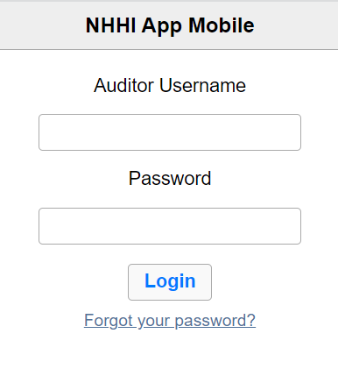

Once logged in, you will see the Sessions screen.

On the Sessions screen, you will see that there are no sessions stored on the device, or that there are previous audit sessions stored on your device that are waiting to be uploaded to the HHCApp database:

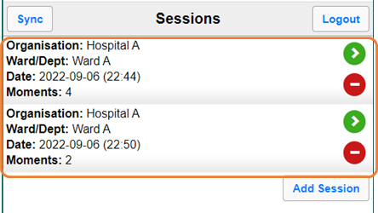

If you have sessions stored, use ‘Sync’ button in the upper left corner to upload the sessions to the HHCApp database. Sync your sessions regularly, preferably after each session and before logging out of the HHCApp Mobile. If you don’t sync, the audit data will remain on your device and won’t be added to the HHCApp database. This means your data won’t be visible to anyone in your organisation.

To enter data for a new session:

1. Click ‘Add Session’

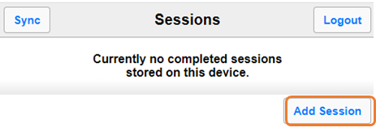

1. Select the appropriate Organisation, Audit, Ward/Dept name and Session (optional)

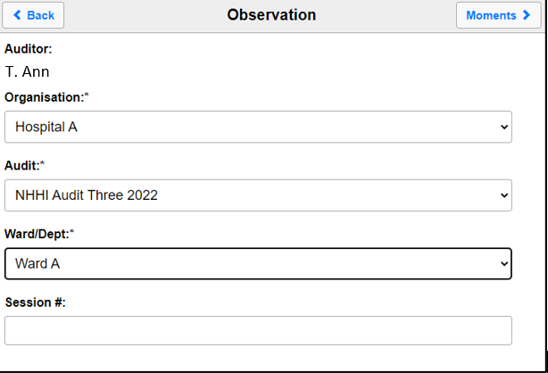

Please note that the date and time are automatically added to the session information. Make sure these settings are correct on your device.

1. Select ‘Moments’ button to move to the Moments screen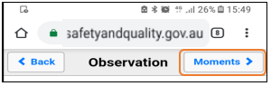
2. To enter moment data into the Healthcare worker (HCW), Action (Act), Moment type (M), or Glove (Glv) fields, select the required field and then select the appropriate value

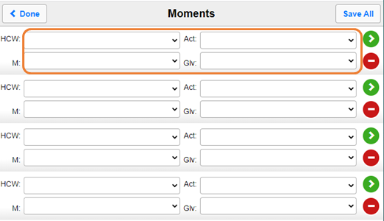

1. To save a moment, you can:
2. save each moment individually – select the green arrow to save the individual moment

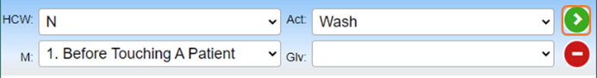

1. save all data on the page at the same time – after entering all moments, select ‘Save All’ to save all moments on the page

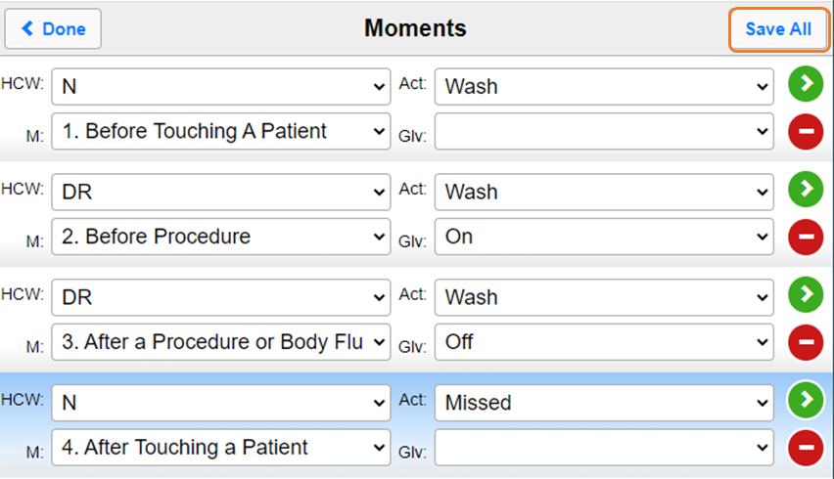

1. You can delete a moment that has been entered incorrectly by selecting the red circle next to the moment you wish to delete

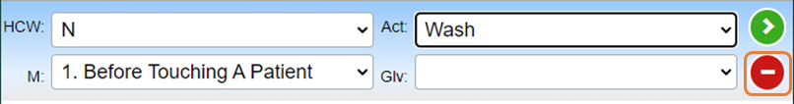

1. When you have completed a session, select ‘Done’; you will be returned to the Sessions page, where you will see a summary of the session data

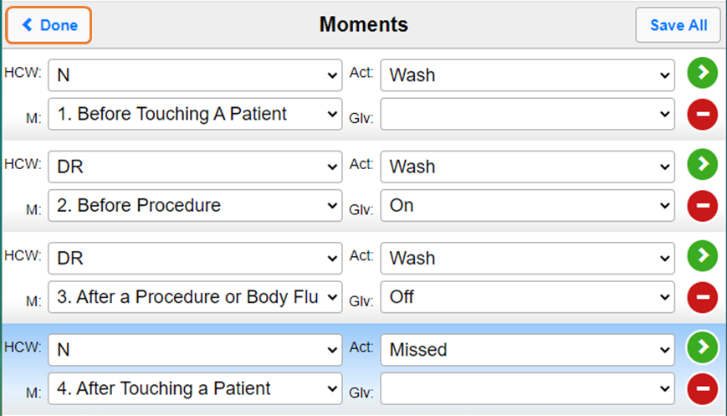

Invalid entry

If the moment breaches a revalidation rule (for example, the moment is not possible), you will get an error message when you try to save it. Select ‘OK’ and make the required changes to the moment field highlighted in red.

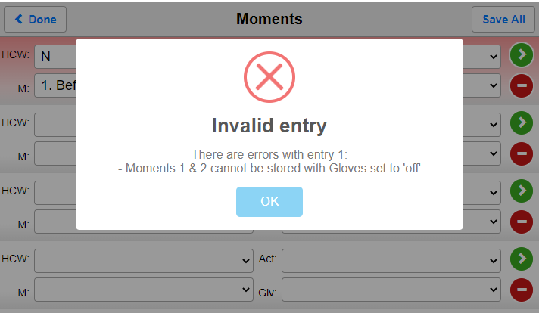

1. After selecting ‘Done’, a pop-up message will ask if you have finished the session. Select ‘Cancel’ if you have not finished the session. Select ‘Yes’ if you have completed entering data for the session

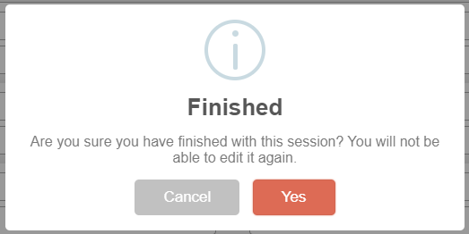

1. Synchronise all sessions stored on your device. To do this, select the ‘Sync’ to submit your data to the database. Synchronising a session sends the hand hygiene data directly to the database and clears the session data from your device. You must be connected to the internet to synchronise your data

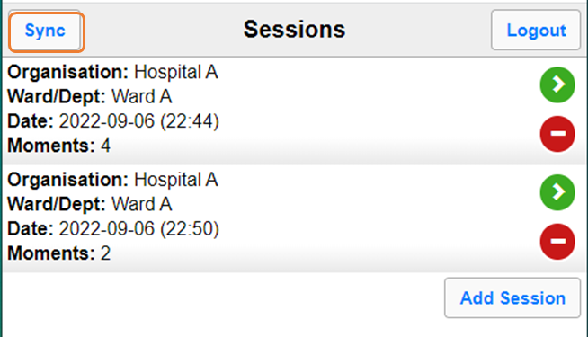

To synchronise an individual session, select the green arrow next to the session you want to synchronise.

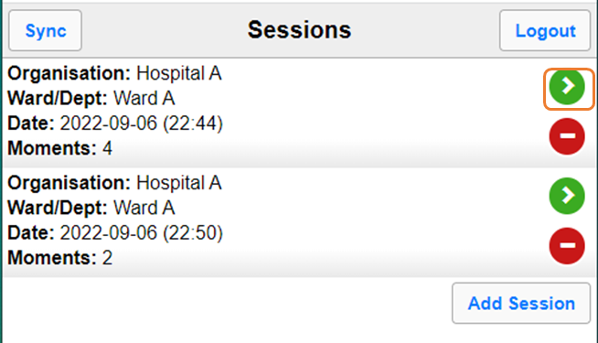

Click ‘Yes’ in the pop-up message to sync the session.

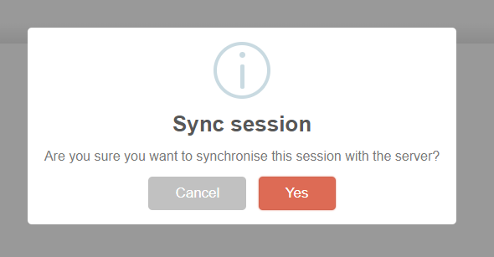

To delete a session without syncing, select the red circle next to the session you wish to delete and then confirm deletion. You cannot recover a session after it has been deleted.

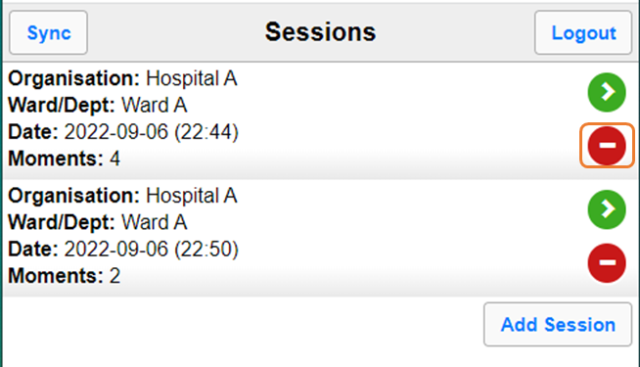

1. After collecting data, log out of the HHCApp mobile. To log out, select ‘Logout’ on the Sessions screen.

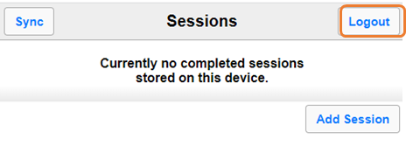

See [the instruction video on how to enter hand hygiene data using the HHCApp mobile site](https://www.safetyandquality.gov.au/sites/default/files/2023-05/NHHI%20-%20How%20to%20enter%20hand%20hygiene%20data%20using%20HHCApp%20mobile%20May%202023.mp4).[12]

The following resources can be downloaded from the Commission’s website:

* [Mobile device troubleshooting guide (Android)](https://www.safetyandquality.gov.au/publications-and-resources/resource-library/mobile-device-troubleshooting-guide-android)[13]
* [Mobile device troubleshooting guide (Apple)](https://www.safetyandquality.gov.au/publications-and-resources/resource-library/mobile-device-troubleshooting-guide-apple).[14]

## How to enter data using the desktop site

Log in to the HHCApp desktop at <https://nhhi.safetyandquality.gov.au/>.

The HHCApp desktop site can be used to audit in real time or to enter hand hygiene data that has been collected using a hand hygiene [audit data collection form](https://www.safetyandquality.gov.au/publications-and-resources/resource-library/audit-data-collection-form). HHCApp desktop site works best with the most recent versions of the following internet browsers: Google Chrome, Microsoft Edge, Apple Safari and Mozilla Firefox.

If you have multiple roles in the HHCApp, you must change your role to Auditor.



1. Click ‘Sessions’ on the home screen

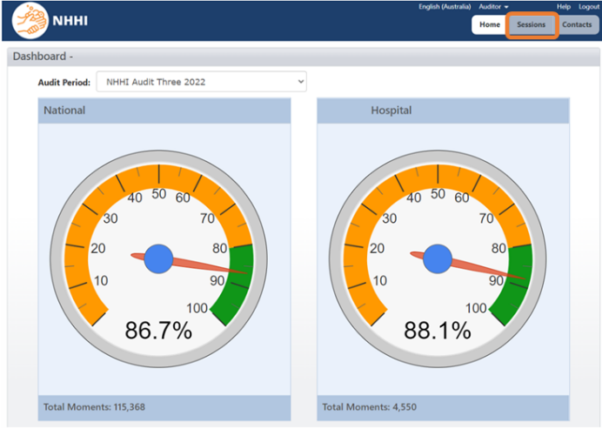

1. To add a new session, click ‘Add Session +’

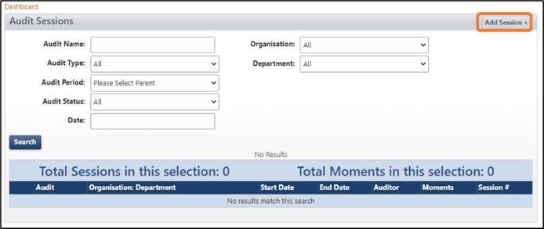

1. Select the relevant demographic details and then click ‘Save’

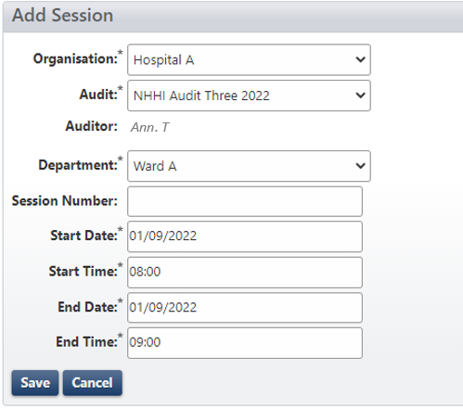

If you cannot see the current audit period in the **Audit** dropdown menu, you will need to contact your Organisation Administrator. Their contact email can be found under the ‘Contacts’ tab on the HHCApp homepage.

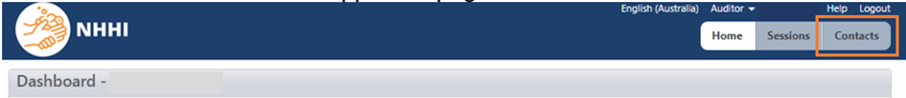

If you are entering data from a hand hygiene observation data collection form, you will need to enter the relevant information from the form into the required fields on the Add Session screen.

. 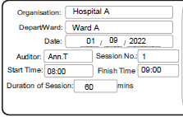 

 

1. Select the correct Healthcare worker type, Moment, Action and Glove use from the dropdown list and then click ‘save’

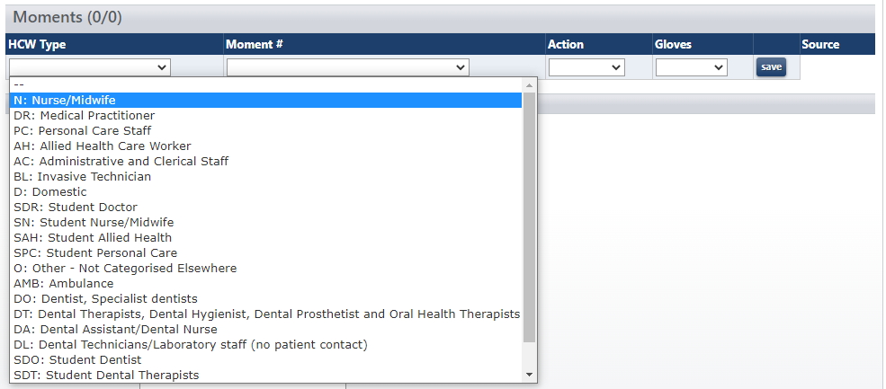

If you are entering data from a hand hygiene audit data collection form, you will need to input the relevant Healthcare worker, Action, and Glove use in accordance with what is recorded on the form.

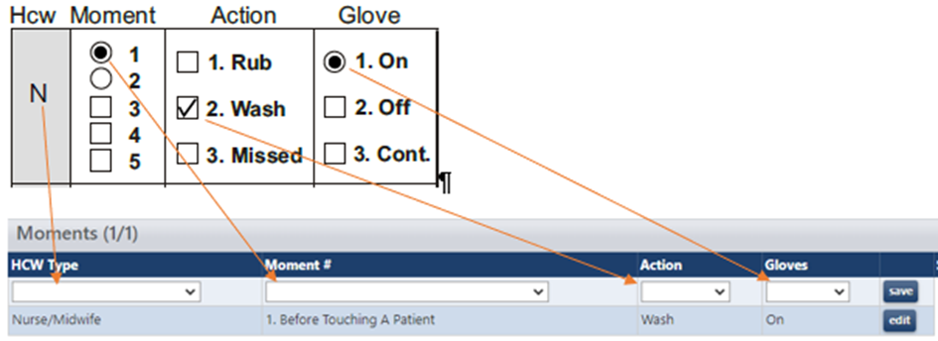

1. A new row will be added to the screen so that you can enter the next moment you have audited

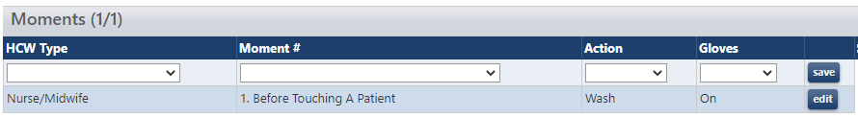

1. You can change the values in a previously saved moment by clicking the ‘edit’ button at the end of the row

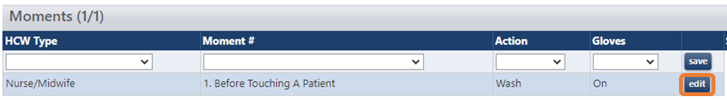

1. If you enter the moment incorrectly, you can delete the moment by clicking the ‘del’ button at the end of the row

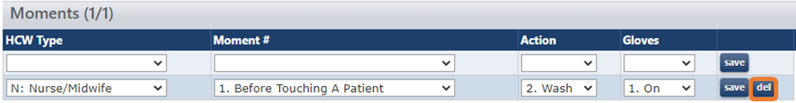

If you enter hand hygiene audit data directly into the HHCApp Desktop as you audit, make sure you update the End Time field under the session details and click ‘Save’.

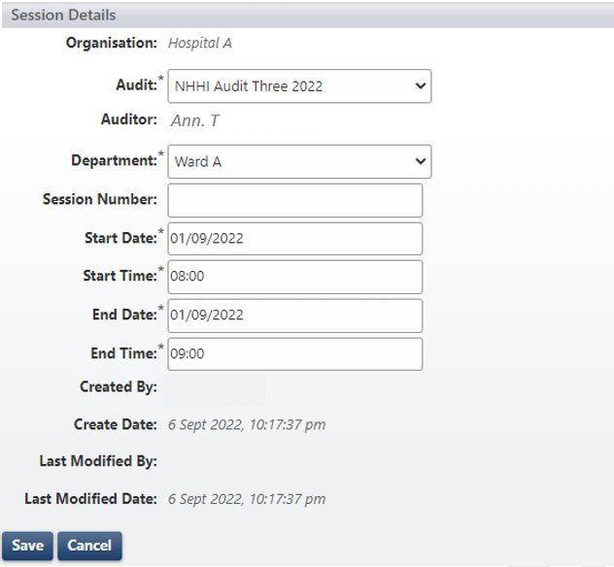

1. When you have completed entering data for a session, you can either repeat steps 1 to 7 to add more hand hygiene auditing sessions or click ‘Logout’ button on the top right corner to log out.

See [the instruction video on how to enter hand hygiene data using the HHCApp desktop site](https://www.safetyandquality.gov.au/sites/default/files/2023-05/NHHI%20-%20How%20to%20enter%20hand%20hygiene%20data%20using%20HHCApp%20desktop%20May%202023.mp4).[15]

## How to use the hand hygiene observation data collection form

The hand hygiene [audit data collection form](https://www.safetyandquality.gov.au/publications-and-resources/resource-library/audit-data-collection-form) can be used for auditing if this is the preferred data collection method of your organisation or if a mobile device is unavailable during auditing.

If the hand hygiene observation data collection form is used for auditing, follow these steps:

1. At the beginning of each hand hygiene audit session, fill in the demographic details on the data collection form. These details must be filled out on each data collection form. A new form should be used for each session of hand hygiene auditing

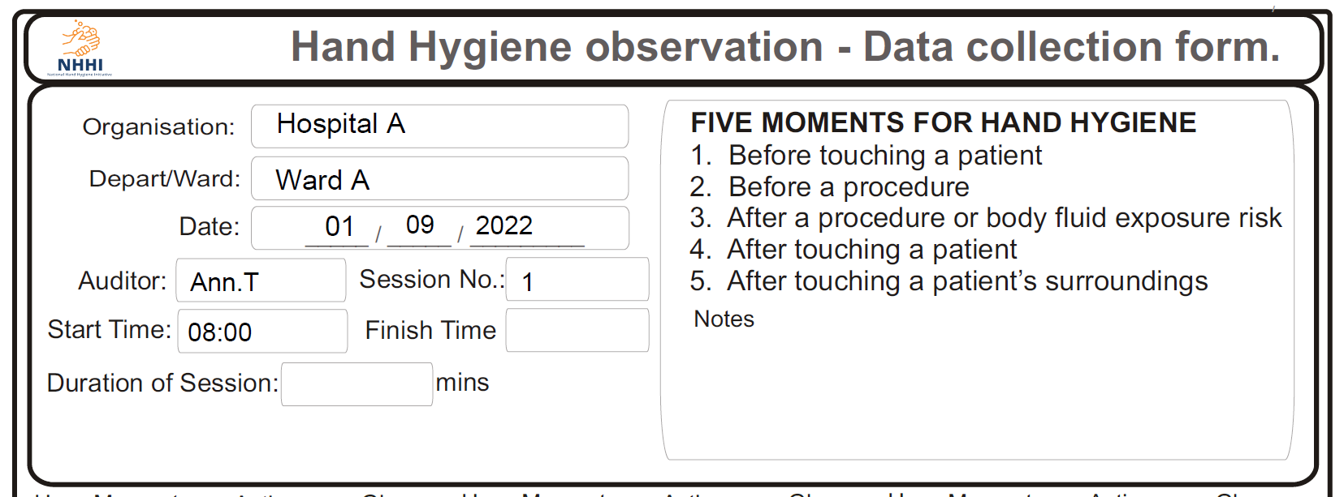

1. Record the type of healthcare worker you audited using a correct HCW code

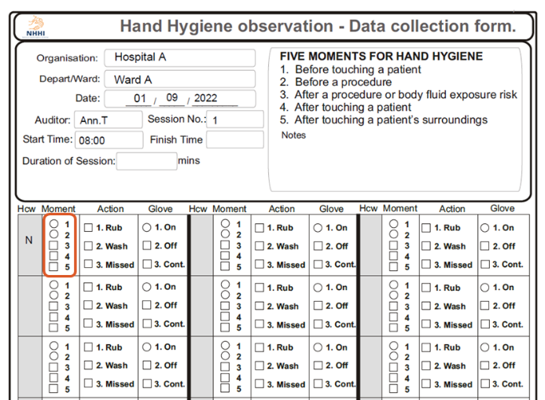

1. Record the hand hygiene moment you observed (only one moment per box)

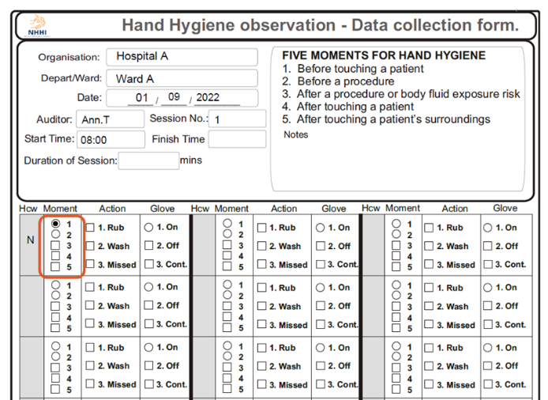

1. Record the hand hygiene action that you observed

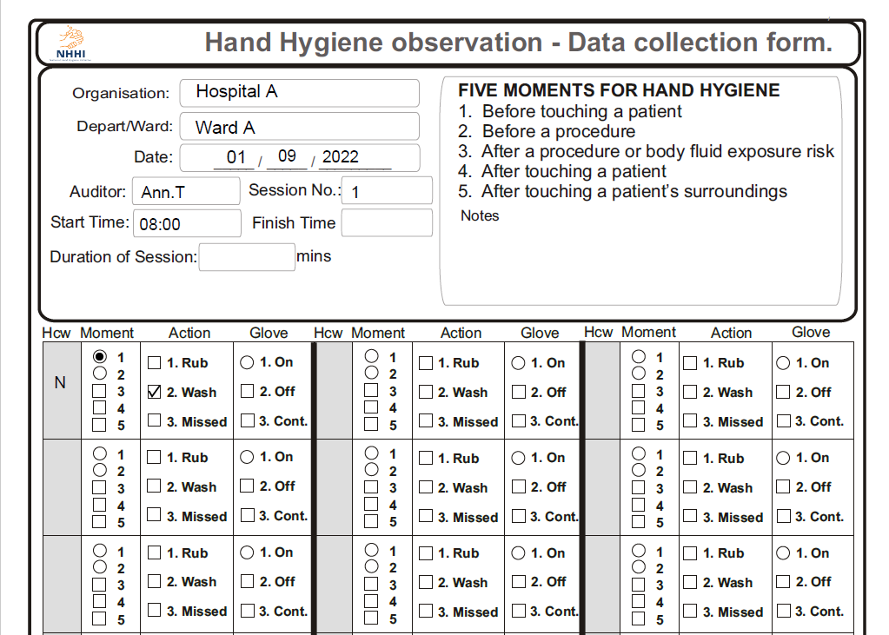

1. Record the glove use you observed

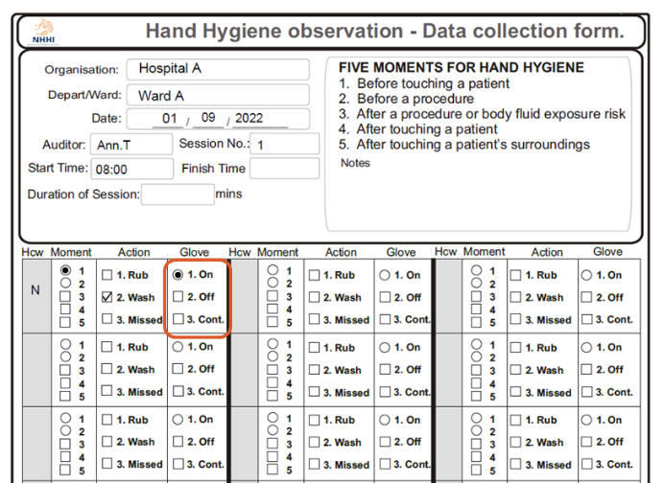

1. If you have made an error on the audit data collection form, cross it out

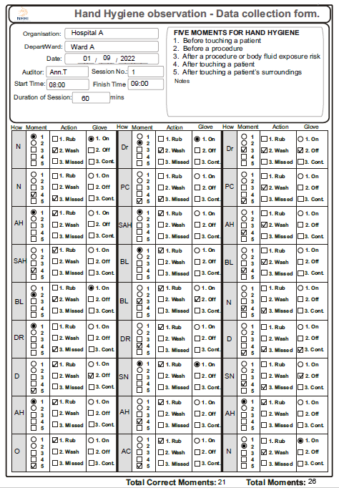

Record all hand hygiene moments that you have observed. Once you finish the hand hygiene audit or all boxes on the data collection form have been filled, record the finish time, duration of the auditing session, the total correct moments observed, and the number of moments observed.

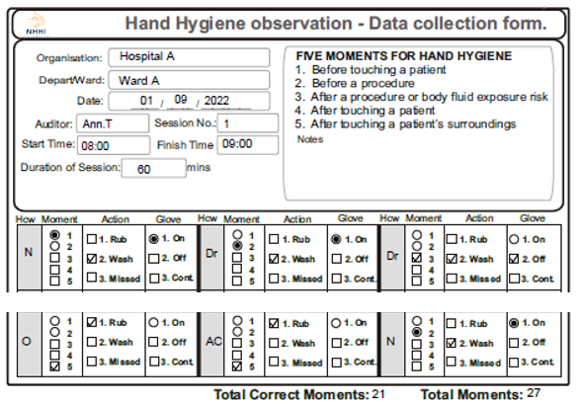

1. If you are continuing the hand hygiene audit, please use a new data collection form and repeat steps 1 to 7 until you finish the audit.

**The hand hygiene data on the hand hygiene observation data collection form must be entered into the HHCApp database (using HHCApp Desktop) before the last day of each national audit period.**

## Automated data validation

The automated data validation process is only for data that is being submitted to the national audit. It is not available for local audits. The validation rules enable administrators (Region/Group/Organisation Administrators) to check if the health service facility’s audit data is accurate. The current set of validation rules were developed based on trends observed in data collected over time from the National Hand Hygiene Initiative.

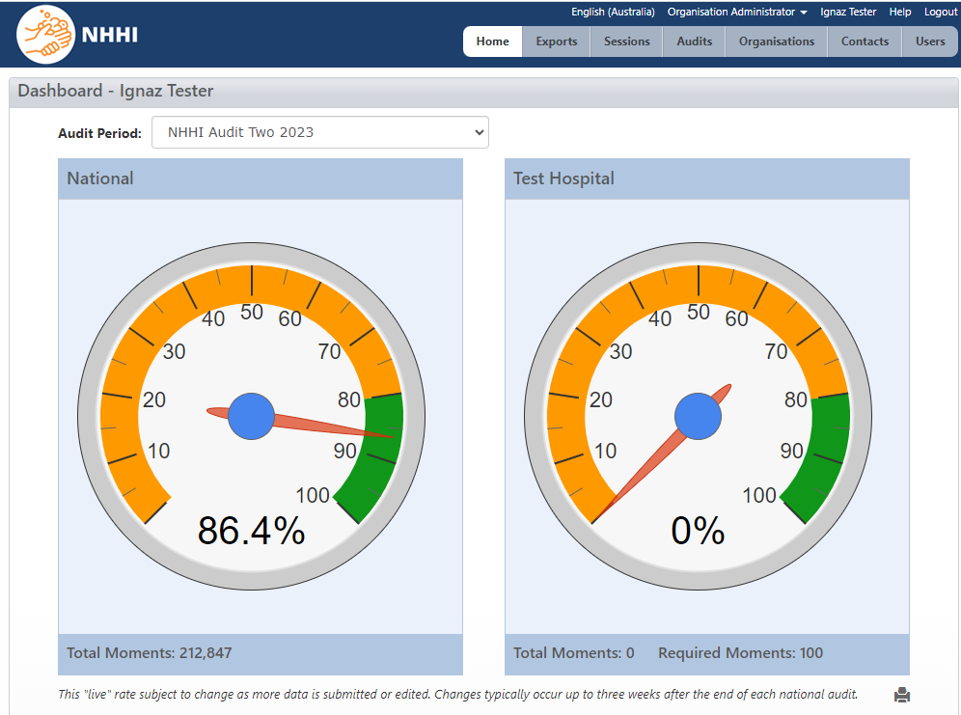On the dashboard page you will see required moments for your organisation under your organisation’s speedometer. If it says ‘update’, it means that there is no value in the number of beds/ number of chairs/ number of procedures per year field on the ‘Organisation details’ page.

On the ‘Organisation Details’ page, you will see a required moments field which is auto calculated based on the number of beds /number of chairs/ number of procedures per year field.

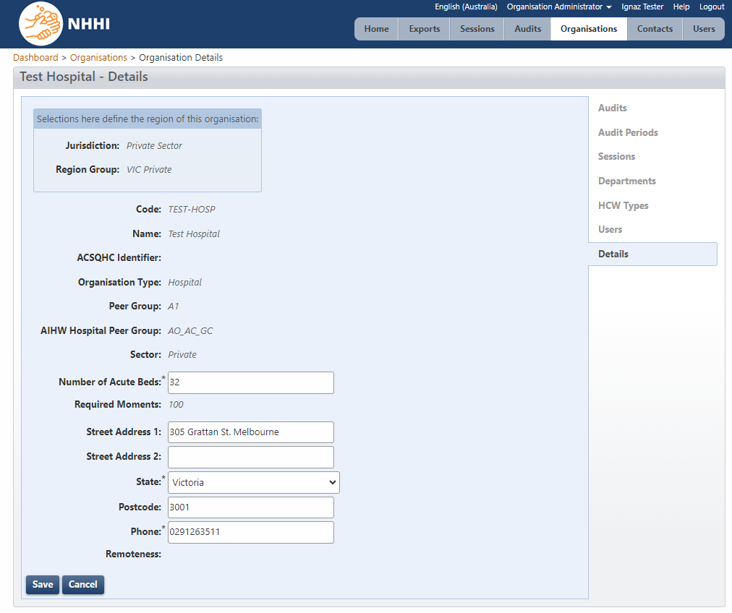

# Generating reports

HHCApp users with a **Jurisdictional**, **Region or Organisation Administrator or Reporter** role can access all data and generate reports for their region, organisation, or department.

The HHCApp users with reporting access can choose to report by national audit period, local audit period, or by a specific date range, for example, monthly.

## Standard Reports

The following reports are available to all users with reporting access:

Table 2. HHCApp reports: Standard

| **Report** | **Description** |
| --- | --- |
| Compliance rate by: |  |
| * State | Only available to users with access to a jurisdiction. |
| * Region Group | Only available to users with access to a Region Group; for example, health service level within a jurisdiction. |
| * Region | Only available to users with access to a Region; for example, a specific group of organisations within a Region Group. |
| * Organisation Group | Only available to users with access to an Organisation Group; for example, a specific group of organisations that are across more than one jurisdiction. |
| * Organisation | Only available if you have access to multiple organisations. |
| * Department | an organisation report with hand hygiene compliance for all departments on one report. This report can be filtered for ‘Department Type’. |
| * HCW Type | a report with hand hygiene compliance for each HCW type on one report. Can be run at an organisation level, or for a specific department. |
| * Moment | Report with hand hygiene compliance for each of the 5 Moments on one report. This can be run at an organisation level, or for a specific department. This report can also be filtered for ‘HCW type’. |
| * Department Type | Groups hand hygiene compliance data by department type, rather than individual departments; for example, all medical department hand hygiene compliance combined. |
| * Peer Group | Groups hand hygiene data by peer group. |
| * Combined Moment and HCW type | Includes both the HCW type report and the 5 Moments report into one file. |
| Auditor and sessions | This report provides details on the data collected by each auditor at an organisation, including number of moments collected and compliance rate collected by an individual auditor. |
| Action by Moment | A report detailing which hand hygiene action was used for each moment, rub, wash, missed. Can be run at an organisation level, or for a specific department. |
| Export CSV Line Data | This report provides a file of the raw line data for each moment. |
| Required Moments | This report provides a one-line summary for each organisation including the number of moments required, the number submitted and the difference between the two. |
| Poster report | This report provides a one-page summary of hand hygiene for the selected region/organisation/department relevant to the user’s level of access. The report details overall hand hygiene compliance, hand hygiene compliance by moment, and hand hygiene compliance by HCW in the selected area. This report is useful as a summary report for management, or as a poster to display hand hygiene results for the public. |
| Auditor and Session CSV Extract | This report exports auditor and sessions data as a CSV extract. |

## Custom reports

If the standard reports do not provide the hand hygiene data in a format that you require, you may be able to create custom reports.

The following flexible reports are available to all users with reporting access:

Table 3. HHCApp reports: Custom

| Report | Details |
| --- | --- |
| Snapshot report | Allows reporting performance during a single period. |
| Trend report | Allows reporting change in performance over time. |

The following preset reports for the current audit period are available to all users with reporting access:

Table 4. HHCApp reports: Preset

| Report |
| --- |
| * Compliance by Department |
| * Compliance by HCW Type |
| * Compliance by Organisation and HCW Type |
| * Compliance by Moment |
| * Compliance by Department Type |
| * Compliance by Moment and HCW Type |
| * Compliance by Glove Use |

For instructions on generating reports in the HHCApp, see [How to generate reports](https://safetyandquality.gov.au/publications-and-resources/resource-library/how-generate-reports).[16]

# Local audits

Organisation Administrators can also define their own local audit periods for which they can create audits. Moments collected against a local audit are not included in the national program.

This is a 2-step process. The audit period must be defined before adding the audit. Organisations can create local audit periods for audits that an organisation does not want to be included in a national program.

### Step 1. Defining a local audit period

1. Click the ‘Organisations’ button in the top-level menu
2. Click an organisation’s name to select it

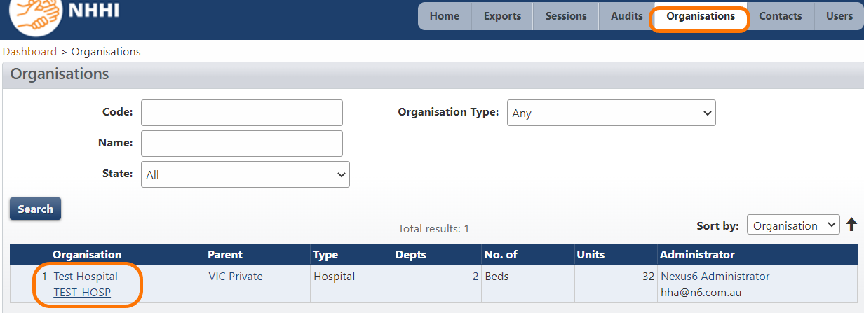

1. Click ‘Audit Periods’ in the Organisation Menu
2. Click ‘Add Audit Period +.’

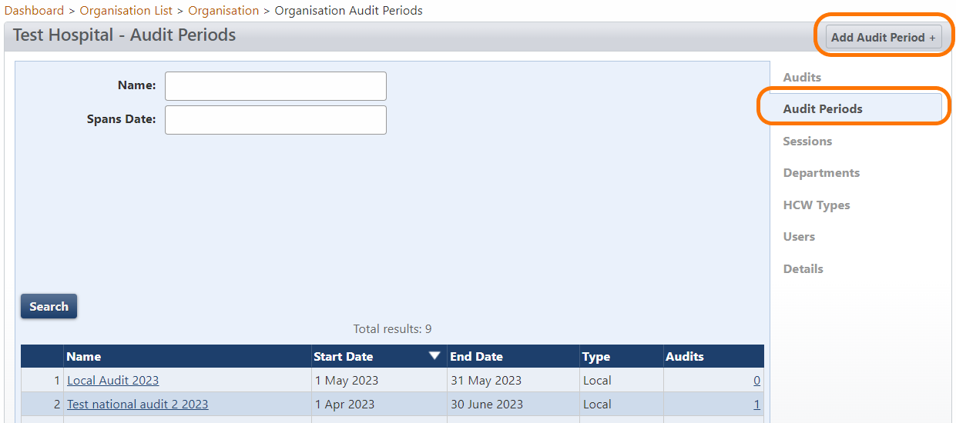

1. Enter a name, start date and end date. Click ‘Save’.

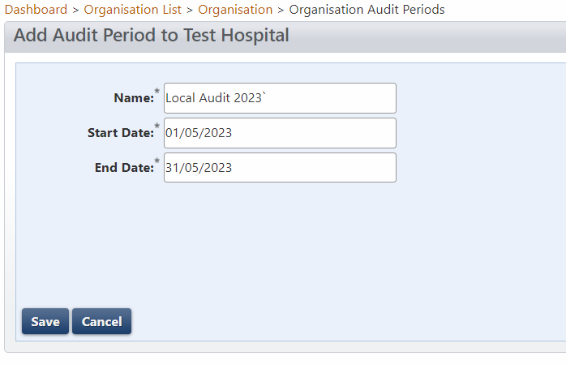

The new audit period will be added to the list of audit periods for the organisation.

Note: The end date cannot be in the past. However, you can amend the end date after creating the local audit.

### Step 2. Adding a local audit

1. Click ‘Audits’ in the Organisation Menu
2. Click ‘Add Audit +’

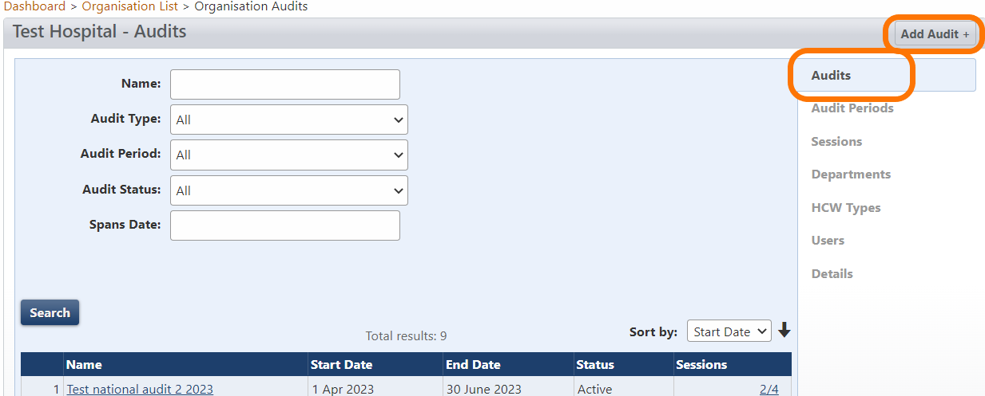

1. Select audit type ‘Local’

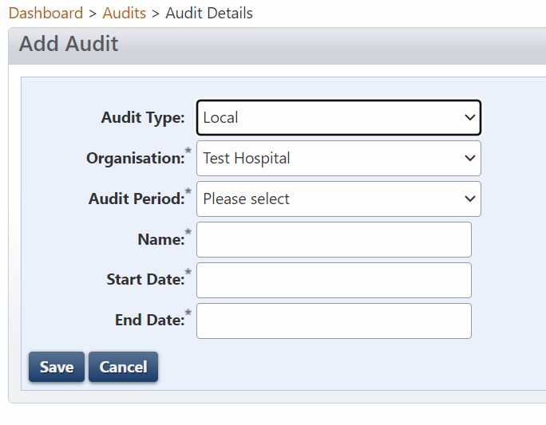

1. Select audit period created in Step 1

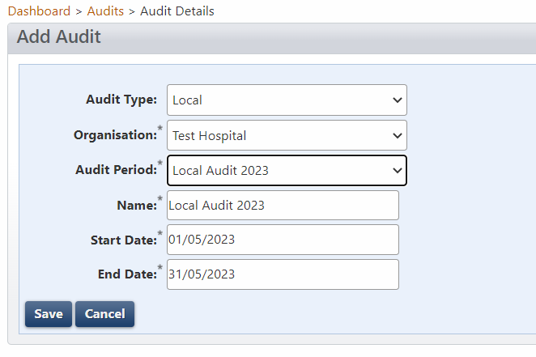

1. Click ‘Save’.



For more information, please see [How to create new audits – National and local](https://www.safetyandquality.gov.au/sites/default/files/2019-09/d19-29333_how_to_add_an_audit_to_a_national_audit_period.pdf).[17]

## More information

For more information, please visit: [National Hand Hygiene Initiative](https://www.safetyandquality.gov.au/our-work/infection-prevention-and-control/national-hand-hygiene-initiative/auditor-training-and-validation-nhhi/hand-hygiene-auditor-training-nhhi)[18] or [NHHI HHCApp - frequently asked questions and instructions](https://www.safetyandquality.gov.au/our-work/infection-prevention-and-control/national-hand-hygiene-initiative/national-audits-and-hhcapp/nhhi-hhcapp-frequently-asked-questions-and-instructions).[19]

You can also contact the project team by email at [handhygiene@nhhi.safetyandquality.gov.au](mailto:handhygiene@nhhi.safetyandquality.gov.au).

Level 5, 255 Elizabeth Street, Sydney NSW 2000  
GPO Box 5480, Sydney NSW 2001

Phone: (02) 9126 3600

Email: [mail@safetyandquality.gov.au](mailto:mail@safetyandquality.gov.au)   
Website: [www.safetyandquality.gov.au](http://www.safetyandquality.gov.au)



1. https://youtu.be/jd5o8LGgZcE
2. https://www.safetyandquality.gov.au/publications-and-resources/resource-library/national-hand-hygiene-initiative-learning-management-system-lms-instructions-region-administrators
3. https://www.safetyandquality.gov.au/publications-and-resources/resource-library/national-hand-hygiene-initiative-learning-management-system-lms-instructions-organisation-administrators
4. https://www.safetyandquality.gov.au/publications-and-resources/resource-library/national-hand-hygiene-initiative-learning-management-system-lms-instructions-learners
5. https://www.safetyandquality.gov.au/publications-and-resources/resource-library/quick-start-hhcapp-guide
6. https://nhhi.southrock.com/
7. https://www.safetyandquality.gov.au/our-work/infection-prevention-and-control/national-hand-hygiene-initiative/auditor-training-and-validation-nhhi/hand-hygiene-auditor-training-nhhi
8. https://www.safetyandquality.gov.au/our-work/infection-prevention-and-control/national-hand-hygiene-initiative/national-hand-hygiene-initiative-contact-details
9. https://nhhi.safetyandquality.gov.au/mobile/
10. https://nhhi.safetyandquality.gov.au/
11. https://www.safetyandquality.gov.au/publications-and-resources/resource-library/audit-data-collection-form
12. https://www.safetyandquality.gov.au/sites/default/files/2023-05/NHHI%20-%20How%20to%20enter%20hand%20hygiene%20data%20using%20HHCApp%20mobile%20May%202023.mp4
13. https://www.safetyandquality.gov.au/publications-and-resources/resource-library/mobile-device-troubleshooting-guide-android
14. https://www.safetyandquality.gov.au/publications-and-resources/resource-library/mobile-device-troubleshooting-guide-apple
15. https://www.safetyandquality.gov.au/sites/default/files/2023-05/NHHI%20-%20How%20to%20enter%20hand%20hygiene%20data%20using%20HHCApp%20desktop%20May%202023.mp4
16. https://www.safetyandquality.gov.au/publications-and-resources/resource-library/how-generate-reports
17. https://www.safetyandquality.gov.au/sites/default/files/2019-09/d19-29333_how_to_add_an_audit_to_a_national_audit_period.pdf
18. https://www.safetyandquality.gov.au/our-work/infection-prevention-and-control/national-hand-hygiene-initiative
19. https://www.safetyandquality.gov.au/our-work/infection-prevention-and-control/national-hand-hygiene-initiative/national-audits-and-hhcapp/nhhi-hhcapp-frequently-asked-questions-and-instructions