# Australian Commission on Safety and Quality logotypeOn the Radar

Issue 610

10 July 2023

*On the Radar* is a summary of some of the recent publications in the areas of safety and quality in health care. Inclusion in this document is not an endorsement or recommendation of any publication or provider. Access to particular documents may depend on whether they are Open Access or not, and/or your individual or institutional access to subscription sites/services. Material that may require subscription is included as it is considered relevant.

*On the Radar* is available online, via email or as a PDF or Word document from <https://www.safetyandquality.gov.au/newsroom/subscribe-news/radar>

If you would like to receive *On the Radar* via email, you can subscribe on our website <https://www.safetyandquality.gov.au/newsroom/subscribe-news>  
or by emailing us at H[Umail@safetyandquality.gov.auU](mailto:mail@safetyandquality.gov.au).   
You can also send feedback and comments to H[Umail@safetyandquality.gov.auU](mailto:mail@safetyandquality.gov.au).

For information about the Commission and its programs and publications, please visit <https://www.safetyandquality.gov.au>

You can also follow us on Twitter @ACSQHC.

**On the Radar**

Editor: Dr Niall Johnson [niall.johnson@safetyandquality.gov.au](mailto:niall.johnson@safetyandquality.gov.au)

Contributors: Niall Johnson, Dr Rashin Namivandi-Zangeneh

**Reports**

*How does the NHS compare to the health care systems of other countries?*

Anandaciva S

London: The King's Fund; 2023. p. 120.

|  |  |
| --- | --- |
| DOI | <https://www.kingsfund.org.uk/publications/nhs-compare-health-care-systems-other-countries> |
| Notes | While focused on the UK’s NHS, as the title suggests, this report allows for comparisons across the 19 national health systems discussed. As is often the case, Australia performs quite well in these in terms of people rating their health status, life expectancy, cancer survival, etc., but perhaps less well on costs to patients, avoidable hospitalisations, etc.  Figure 26 from How does the NHS compare to the health care systems of other countries? Showing percentage of lower and higher income adults reporting missed appointment over the past year, 2020.  Figure 28 from How does the NHS compare to the health care systems of other countries? Showing mortality rates from avoidable causes, 2019 in a number of nations.  Figure 30 from How does the NHS compare to the health care systems of other countries? Showing Breast cancer five-year net survival in a number of nations. |

*Prioritising carers’ health and wellbeing in the healthcare system*

Deeble Institute for Health Policy Research Issues Brief No. 50

Winter N, Haddock R

Canberra: Australian Healthcare and Hospitals Association; 2023. p. 46.

|  |  |
| --- | --- |
| DOI | <https://ahha.asn.au/publication/health-policy-issue-briefs/deeble-issues-brief-no-50-prioritising-carers%E2%80%99-health-and> |
| Notes | This issues brief from the Australian Healthcare and Hospitals Association’s Deeble Institute looks at the role of carers and how the healthcare system could better support the health and wellbeing of carers. The author observes that ‘Approximately 13% of Australians provide unpaid care to family members or friends living with chronic illness or disability and have no formal healthcare training. In 2020 carers saved the government $77.9 billion in healthcare expenditure.’ However, carers ‘experience negative impacts on their physical, mental, social and financial status as a result of their caring role.’ The brief examines ways to better identify carers and their needs and how they may be addressed. |

**Journal articles**

*The impact of safety culture, quality of care, missed care and nurse staffing on patient falls: A multisource association study*

Alanazi FK, Lapkin S, Molloy L, Sim J

Journal of Clinical Nursing. 2023 [epub].

|  |  |
| --- | --- |
| DOI | <https://doi.org/10.1111/jocn.16792> |
| Notes | Paper reporting on an Australian study that sought to ‘examine the association between nursing unit safety culture, quality of care, missed care and nurse staffing levels, and inpatient falls’. The study examined the incidence of falls and the perceptions of nurses on falls in their units, with 619 nurses from 33 units in 5 hospitals surveyed. From the analyses of the survey responses and the falls incidence data, the authors conclude that ‘Nursing units with a strong safety climate and better collaborations between nurses and other professionals, including physicians and pharmacists, were associated with lower incidents of patient falls.’ |

*Patient navigation across the cancer care continuum: An overview of systematic reviews and emerging literature*

Chan RJ, Milch VE, Crawford-Williams F, Agbejule OA, Joseph R, Johal J, et al

CA: A Cancer Journal for Clinicians. 2023.

|  |  |
| --- | --- |
| DOI | <https://doi.org/10.3322/caac.21788> |
| Notes | Patient navigation is an approach to address obstacles and minimize inequalities in healthcare. This paper provides an examination of available literature and highlights the benefits of patient navigation within the cancer care process. The findings reveal that patient navigation enhances rates of cancer screening while also reducing the duration of diagnosis and treatment. Moreover, patient navigation contributes to improved quality of life, enhanced patient satisfaction during survivorship, and lower rates of hospital readmissions. The authors also provide suggestions for enhancing the uniformity and efficiency of patient navigation in cancer care on a global scale. |

*The Australian Delirium Clinical Care Standard: not just another brick in the wall*

Teodorczuk A, Reade MC, Graham FA

Age and Ageing. 2023;52(6):afad078.

|  |  |
| --- | --- |
| DOI | <https://doi.org/10.1093/ageing/afad078> |
| Notes | This piece in the British Geriatrics Society’s journal *Age and Ageing* is a commentary on the Commission’s *Delirium Clinical Care Standard* (CCS). The *Delirium Clinical Care Standard* is available at <https://www.safetyandquality.gov.au/our-work/clinical-care-standards/delirium-clinical-care-standard>  The authors consider the CCS ‘an important step forward for delirium knowledge translation and are particularly relevant for patients in the geriatric setting’. |

*Journal for Healthcare Quality (JHQ)*

Volume 45, Number 4, July/August 2023

|  |  |
| --- | --- |
| URL | <https://journals.lww.com/jhqonline/toc/2023/08000> |
| Notes | A new issue of the *Journal for Healthcare Quality* (JHQ) has been published. Content in this issue of the *Journal for Healthcare Quality* includes:   * Experience and Hospital Context Influence **Fall Prevention Practice by Physical Therapists**: A Survey Study (James P Crick Jr, Lisa Juckett, Marka Salsberry, Carmen Quatman, Catherine C Quatman-Yates) * A Cross-Sectional Study of the Characteristics Associated With **Chronic Pain Documentation** on the Problem List (Tina L Rylee, David Copenhaver, Christiana Drake, Jill Joseph) * Assessing Factors Influencing Commitment to a **Disparities Reduction Intervention**: Social Justice Attitudes and Organizational Mission (Jill A Marsteller, Yea-Jen Hsu, Kristina Weeks, Modupe Oduwole, Romsai T Boonyasai, Gideon D Avornu, Katherine B Dietz, Zehui Zhou, Deven Brown, Anika Hines, Suna Chung, Lisa Lubomski, Kathryn A. Carson, Chidinma Ibe, Lisa A Cooper, for the RICH LIFE Project Investigators) * Value of Using a **Structured Improvement Approach**: A Dedicated Education Unit Exemplar (Shea Polancich, Elizabeth Byrd, Rebecca S Miltner, Greg Eagerton, Michele Talley, L Moneyham, J Stewart, C White-Williams) * Meta-Analysis of **Medication Administration Errors** in African Hospitals (Wudma Alemu, Jeannie P Cimiotti) * **Delays in Care During the COVID-19 Pandemic** in the Veterans Health Administration (Peter Mills, Robin Pendley Louis, Edward Yackel) |

*International Journal for Quality in Health Care*

Volume 35, Number 2, 2023

|  |  |
| --- | --- |
| URL | <https://academic.oup.com/intqhc/issue/35/2> |
| Notes | A new issue of the *International Journal for Quality in Health Care* has been published. Articles in this issue of the *International Journal for Quality in Health Care* include:   * Associations between **clinical pathway concordance, cost, and survival outcomes** for stage II colon cancer: a population-based study (Shannon Milroy; Judith Wong; Maria Eberg; Luciano Ieraci; Katharina Forster, Claire M B Holloway, Jason M Sutherland) * Adjuvant zoledronic acid therapy for postmenopausal women with **early breast cancer** in China: a cost-effectiveness analysis (Xiaoting Huang; Yiwei Liu; Shen Lin; Hang Wang; Yujie Deng , Xin Rao, Xianzhong Guo, Xinchan Jiang, Xiuhua Weng, Pinfang Huang) * A prospective randomized controlled study of the effect of standardized nursing intervention for **cancer pain** on the quality of life of patients (Bing Wang; Xiangjun Tao; Jing Zhao; Xiaojuan Liu) * Effect analysis of multi-department cooperation in improving **etiological submission rates before antibiotic treatment** (YiQun Lao; QiJiang Tang; Juan Zeng; WeiWei Gong; YuYing Shen) * **Is primary care a patient-safe setting?** Prevalence, severity, nature, and causes of adverse events: numerous and mostly avoidable (Gerardo Garzón González; Tamara Alonso Safont; Ester Zamarrón Fraile; Asunción Cañada Dorado; Arancha Luaces Gayan, Dolores Conejos Míquel, Cristina Villanueva Sanz, Oscar Aguado Arroyo, Juan José Jurado Balbuena, Marta Castelo Jurado, Purificación Magán Tapia, Aurora Barberá Martín, María José Toribio Vicente, Mercedes Drake Canela, Diego San José Saras, Inmaculada Mediavilla Herrera) * Appropriateness of **lumbar spine radiography** and factors influencing imaging ordering patterns: paving the path toward value-driven health care (Yi Xiang Tay; Ling Ling Chan; Shin Ru Than; Gek Hsiang Lim; Mark Bangwei Tan, May San Mak, Wenlu Hou, Jeremy Choon Peng Wee, Yeong Huei Ng, Robert Chun Chen) * Changes in cervical dysplasia, carcinoma *in situ*, and cervical cancer after expanding the **National Cancer Screening Program** to younger women in Korea (Woorim Kim; Sungyoun Chun; Sang Ah Lee) * International approaches for **implementing accreditation programmes** in different healthcare facilities: a comparative case study in Australia, Botswana, Denmark, and Jordan (Ellen Joan van Vliet; Jorien Soethout; Kate Churruca; Jeffrey Braithwaite; Karen Luxford Jacqui Stewart, Salma Jaouni, Carsten Engel, Mitchell N Sarkies) * **COVID-19 pandemic and the quality of antibiotic use in primary care**: an interrupted time-series study (Mariana Domingues; Carla Torre; José Pedro Guerreiro; Pedro Barata; Margarida Correia-Neves , João Rocha, Bruno Sepodes, António Teixeira Rodrigues) * The **LACE index** and risk factors of 14-day versus 30-day **readmissions in children** (Chaohsin Lin; Shuofen Hsu; Yu-Hua Yan) * Impact of **COVID-19 pandemic early response measures on myocardial infarctions and acute cardiac care** in Singapore (Shan Yin Audry Lee; Poay Huan Loh; Yee How Lau; Yilin Jiang; Boon Wah Liew , Patrick Zhan Yun Lim, Saurabh Rastogi, Wei Chieh Jack Tan, Hee Hwa Ho, Khung Keong Yeo) * Developing **online medical service quality indicators** in China from the perspective of online and offline integration: a modified Delphi–analytic hierarchy process study (Zhenlin Li; Rui Guo) * Leaving the hospital on time: hospital bed utilization and reasons for **discharge delay** in the Netherlands (Eva van den Ende; Bo Schouten; Lara Pladet; Hanneke Merten; Louise van Galen, Milka Marinova, Michiel Schinkel, Anneroos W Boerman, Rishi Nannan Panday, Cees Rustemeijer, Muhammad Dulaimy, Derek Bell, Prabath Wb Nanayakkara) * Measuring **health system responsiveness** in a national community health worker primary care programme in rural Liberia (Savior Flomo Mendin; Julie A Krause; Andrew Gweh; Massaboi Baysah; Joseph Nyumah h, Chris J Gaye, T- Max Zorh, John D Kraemer, Marion Subah, Lisa R Hirschhorn) * **High satisfaction among patients at HIV clinics** in Harare, Zimbabwe: a time and motion evaluation and patient satisfaction study (bigail Link; Mufuta Tshimanga; Barbara Cochrane; Danuta Kasprzyk) * The impact of the COVID-19 pandemic on emergency care of **acute myocardial infarction**: findings from the Taiwan Clinical Performance Indicator (Chia-Ling Hsu; Sheng-Hui Hung; Dulmaa Munkhtogoo; Pa-Chun Wang) * Improving **low-value clinical practices** in Murcia: a healthcare management area in Spain (Julio J Lopez-Picazo; Ana B Moreno; Inmaculada Vidal-Abarca; Mercedes López-Ibáñez) * **Clinical resilience**: toward a unified definition (Edwin Krogh; Ronald Epstein; Álvaro I Langer; Christoph Steinebach) * Editorial: **Health system resilience, accreditation, high-quality care, and continuous quality improvement**: what is the destination and how do we get there? (Wendy Nicklin; David Greenfield) * Editorial: **Patient-reported outcomes for quality of care among pediatric patients** (Mio Sakuma; Takeshi Morimoto) * **COVID-19 response**: a perspective from Pakistan (Zafar Mirza) * With much of England’s NHS under severe pressure, should **health inequalities** be a priority? (Richard M Wood) |

*Public Health Research & Practice*

Volume 33, Issue 2, July 2023

|  |  |
| --- | --- |
| URL | <https://www.phrp.com.au/issues/july-2023-volume-33-issue-2/> |
|  | A special issue of *Public Health Research & Practice* has been published with a theme of ‘Public health, wellbeing and future generations’. Articles in this issue of *Public Health Research & Practice* include:   * Editorial: **Why ‘wellbeing’?** The opportunities and challenges of a new public health approach (Julie Boulton , Tony Capon , Colin Sindall) * **How to measure progress towards a wellbeing economy**: distinguishing genuine advances from ‘window dressing’ (Gerry McCartney, Martin Hensher, Katherine Trebeck) * **Creating ‘wellbeing societies’**: moving from rhetoric to action (Faten Ben Abdelaziz, Carmel Williams, Yasmine J Anwar, Vivian Lin, Ruediger Krech) * Acting locally, thinking nationally: layering **Indigenous ontology within wellbeing frameworks** (Kate Harriden, Eunice Yu, Mandy Yap) * **Aboriginal and Torres Strait Islander Human Research Ethics Committees** (HRECs) are essential in promoting our health and wellbeing (Summer May Finlay, Michael Doyle, Michelle Kennedy) * **Interview with inaugural Future Generations Commissioner for Wales**, Sophie Howe: embedding a wellbeing approach in government (Sophie Howe, Don Nutbeam) * Developing a systems thinking guide for enhancing knowledge mobilisation in **prevention research** (Michelle J Irving, Melanie Pescud, Eloise Howse, Abby Haynes, Lucie Rychetnik) * A rapid review of initiatives to address **financial strain and wellbeing in high-income contexts** (Aryati Yashadhana, Nicole M Glenn, Karla Jaques, Ana Paula Belon, Patrick Harris, Evelyne de Leeuw, Candace IJ Nykiforuk) * Universal healthcare reform for **community treatment of eating disorders** in Australia: report of the first 2 years of operation (Sarah Maguire, Emma Bryant, Lorraine Ivancic, MAINSTREAM Research Collective , Natasha Nassar) * Views of the Australian public on the delivery of **risk-stratified cancer screening** in the population: a qualitative study (Kate LA Dunlop, Nicole M Rankin, Amelia K Smit, Ainsley J Newson, Louise A Keogh, Anne E Cust) * Hearing what matters: a case study of **meaningful community engagement as a model to inform wellbeing initiatives** (Miriam Sved, Ben Latham, Lyndsey Bateman, Libby Buckingham) * Beyond growth: a **wellbeing economy for the textile and garment sector** (Samantha Sharpe, Monique Retamal, Taylor Brydges) * Addressing Dementia Through Analysis of Population Traits and Risk Factors (ADAPTOR) project: **dementia incidence in an Australian cohort** (Smriti Nepal, Xenia Dolja-Gore, Dominic Cavenagh, Catherine D'Este, Kaarin J Anstey, Henry Brodaty, Heidi J Welberry, Anita MY Goh, Martin McNamara) * An audit assessing regulatory compliance of businesses that perform **colonic lavage** (Sinead A Flanigan, Toni J Cains, Leigh N McIndoe, Mark J Ferson) * The **World Health Organization’s post-pandemic stance**: what does it mean for global health? (Bashar Haruna Gulumbe, Zaharadeen Muhammad Yusuf) |

*Health Affairs*

Volume 42, Number 7, July 2023

|  |  |
| --- | --- |
| URL | <https://www.healthaffairs.org/toc/hlthaff/42/7> |
| Notes | A new issue of *Health Affairs* has been published with the themes ‘Medicare, Cancer Care And More’. Articles in this issue of *Health Affairs* include:   * **National Health Expenditure Projections**, 2022–31: Growth To Stabilize Once The COVID-19 Public Health Emergency Ends (P Keehan, J A Fiore, J A Poisal, G A Cuckler, A M Sisko, S D Smith, A J Madison, and K E Rennie) * **Burden Of Health-Related Social Needs** Among Dual- And Non-Dual-Eligible Medicare Advantage Beneficiaries (Deborah N Peikes, Kaylyn E Swankoski, Jeremiah S Rastegar, Stephanie M Franklin, and Danielle J Pavliv) * **Psychiatrist Networks In Medicare Advantage Plans** Are Substantially Narrower Than In Medicaid And ACA Markets (Jane M Zhu, Mark Katz Meiselbach, Coleman Drake, and Daniel Polsky) * Rapid Enrollment Growth In ‘Look-Alike’ **Dual-Eligible Special Needs Plans**: A Threat To Integrated Care (Yanlei Ma, Austin B Frakt, Eric T Roberts, Kenton J Johnston, Jessica Phelan, and José F Figueroa) * **CMS Hospital Value-Based Programs**: Refinements Are Needed To Reduce Health Disparities And Improve Outcomes (Charles N Kahn, Kimberly Rhodes, S Pal, T J McBride, D May, J E DaVanzo, and A Dobson) * Many **Intensive Care Units Were Overloaded** While Nearby Hospitals Had Excess Capacity During The COVID-19 Pandemic (Adam S Vohra, Dhruv Khullar, Rainu Kaushal, and William L Schpero) * Adopting **Weight-Based Dosing With Pharmacy-Level Stewardship** Strategies Could Reduce Cancer Drug Spending By Millions (Alex K Bryant, Zoey Chopra, Donna M Edwards, Adam S Whalley, Brian G Bazzell, Julie A Moeller, Michael J Kelley, A Mark Fendrick, Eve A Kerr, Nithya Ramnath, Michael DGreen, , Timothy P Hofer, and Garth W Strohbehn) * Medicaid Expansion Associated With Increase In **Palliative Care For People With Advanced-Stage Cancers** (Xuesong Han, Kewei Sylvia Shi, Jingxuan Zhao, Leticia Nogueira, R B Parikh, A H Kamal, A Jemal, and K R Yabroff) * **Late Postpartum Coverage Loss** Before COVID-19: Implications For Medicaid Unwinding (E Eliason, L K Admon, M W Steenland, and J R Daw) * **Antipsychotic Medication Use** In Medicaid-Insured Children Decreased Substantially Between 2008 And 2016 (Greta Bushnell, James Lloyd, Mark Olfson, Sharon Cook, Himshikha Das, and Stephen Crystal) * State Funding For **Substance Use Disorder Treatment** Declined In The Wake Of Medicaid Expansion (Christina M Andrews, Olivia M Hinds, Felipe Lozano-Rojas, W L Besmann, A J Abraham, C M Grogan, and A F Silverman) * Changes In County-Level Access To Medications For **Opioid Use Disorder** After Medicare Coverage Of Methadone Treatment Began (Samantha J Harris, Courtney R Yarbrough, and Amanda J Abraham) * Documenting **Latino Representation In The US Health Workforce** (Indira G Islas, E Brantley, M P Martinez, E Salsberg, F Dobkin, and B K Frogner) * Comparing The Effects Of Nudges And Automatic Plan Switching On **Choice Errors** Among Low-Income Marketplace Enrollees (Emory Wolf, Andrew Feher, Katie Ravel, and Isaac Menashe) * The Affordability Of **Individual-Market Health Insurance** In California Under The American Rescue Plan Act, 2021 (Vicki Fung, Mary Price, Emory Wolf, Joseph P Newhouse, and John Hsu) * **Helping Cancer Patients Through Difficult Decisions** (Tom A. Doyle) |

*International Journal for Quality in Health Care* online first articles

|  |  |
| --- | --- |
| URL | <https://academic.oup.com/intqhc/advance-articles> |
| Notes | *International Journal for Quality in Health Care* has published a number of ‘online first’ articles, including:   * **Governance and management** in healthcare organisations: their different roles in **driving safety and quality** (Ana Maria Malik and Ezequiel Garcia Elorrio) * Development and validation of a **patient satisfaction survey for pharmaceutical service** at primary care settings (Ruijian Huang et al) |

*BMJ Quality & Safety* online first articles

|  |  |
| --- | --- |
| URL | <https://qualitysafety.bmj.com/content/early/recent> |
| Notes | *BMJ Quality &Safety* has published a number of ‘online first’ articles, including:   * Did the Acute Frailty Network improve **outcomes for older people living with frailty**? A staggered difference-in-difference panel event study (Andrew Street, Laia Maynou, Simon Conroy) * Editorial: Moving upstream to address **diagnostic disparities** (Denise M Connor, Gurpreet Dhaliwal) * Editorial: Meeting external demands to **improve quality and safety of care**: learning systematically from the literature (Jack Needleman) * Initial opioid prescription characteristics and risk of **opioid misuse, poisoning and dependence**: retrospective cohort study (Aníbal García-Sempere, Isabel Hurtado, Celia Robles, Fran Llopis-Cardona, Francisco Sánchez-Saez, Clara Rodriguez-Bernal, Salvador Peiró-Moreno, Gabriel Sanfélix-Gimeno) * Editorial: Imperfection in **adverse event detection**: is this the opportunity to mature our focus on preventing harm in paediatrics? (Chris Wong, Charles Macias, Marlene Miller) |

**Online resources**

***UK] NICE Guidelines and Quality Standards***

<https://www.nice.org.uk/guidance>

The UK’s National Institute for Health and Care Excellence (NICE) has published new (or updated) guidelines and quality standards. The latest reviews or updates include:

* NICE Guideline NG83 ***Oesophago-gastric cancer****: assessment and management in adults* <https://www.nice.org.uk/guidance/ng83>
* Quality Standard QS11 ***Alcohol-use disorders****: diagnosis and management* <https://www.nice.org.uk/guidance/qs11>

***[UK] NIHR Evidence alerts***

<https://evidence.nihr.ac.uk/>

The UK’s National Institute for Health Research (NIHR) has posted new evidence alerts on its site. Evidence alerts are short, accessible summaries of health and care research which is funded or supported by NIHR. This is research which could influence practice and each Alert has a message for people commissioning, providing or receiving care. The latest alerts include:

* How can mental healthcare services meet the needs of people from ethnically diverse groups?
* Hospice at home can enable people to have a good death in the place of their choosing
* Helping people cope with the changing nature of Parkinson’s
* Young people who have a long wait for a cancer diagnosis have reduced quality of life
* Intervention helped office workers to spend less time sitting.

**COVID-19 resources**

https://www.safetyandquality.gov.au/covid-19

The Australian Commission on Safety and Quality in Health Care has developed a number of resources to assist healthcare organisations, facilities and clinicians. These and other material on COVID-19 are available at <https://www.safetyandquality.gov.au/covid-19>

These resources include:

* ***OVID-19 infection prevention and control risk management*** This primer provides an overview of three widely used tools for investigating and responding to patient safety events and near misses. Tools covered in this primer include incident reporting systems, Root Cause Analysis (RCA), and Failure Modes and Effects Analysis (FMEA).   
  <https://www.safetyandquality.gov.au/publications-and-resources/resource-library/covid-19-infection-prevention-and-control-risk-management-guidance>
* ***Poster – Combined contact and droplet precautions*** <https://www.safetyandquality.gov.au/publications-and-resources/resource-library/infection-prevention-and-control-poster-combined-contact-and-droplet-precautions>  
  [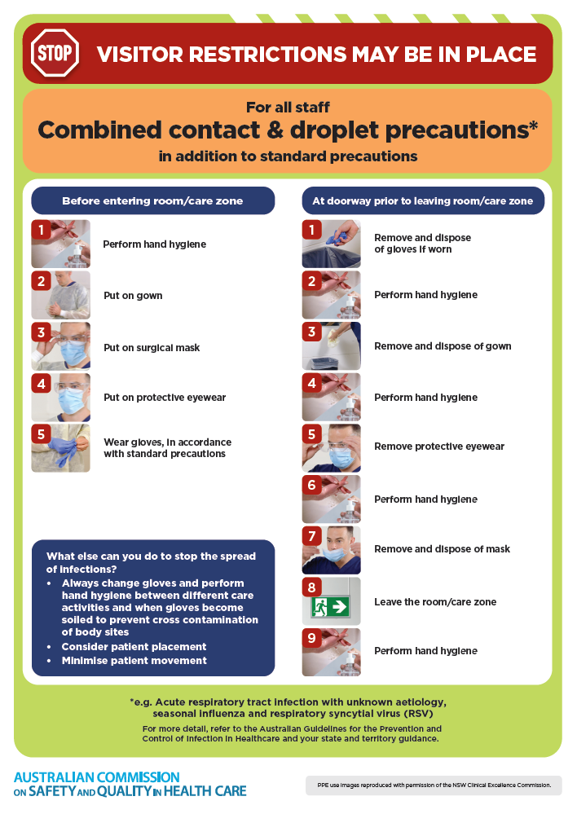](https://www.safetyandquality.gov.au/publications-and-resources/resource-library/infection-prevention-and-control-poster-combined-contact-and-droplet-precautions)
* ***Poster – Combined airborne and contact precautions*** <https://www.safetyandquality.gov.au/publications-and-resources/resource-library/poster-combined-airborne-and-contact-precautions>   
  [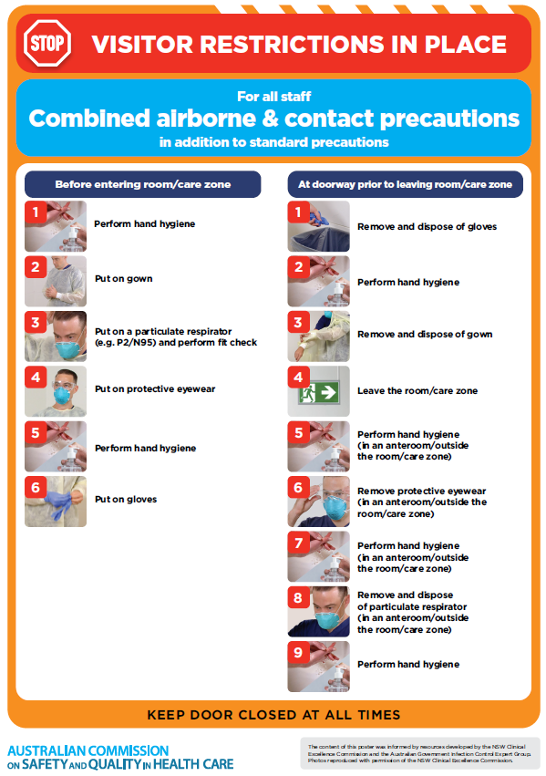](https://www.safetyandquality.gov.au/publications-and-resources/resource-library/poster-combined-airborne-and-contact-precautions)
* ***Environmental Cleaning and Infection Prevention and Control*** [www.safetyandquality.gov.au/environmental-cleaning](http://www.safetyandquality.gov.au/environmental-cleaning)
* ***COVID-19 infection prevention and control risk management – Guidance*** <https://www.safetyandquality.gov.au/publications-and-resources/resource-library/covid-19-infection-prevention-and-control-risk-management-guidance>
* ***Safe care for people with cognitive impairment during COVID-19***<https://www.safetyandquality.gov.au/our-work/cognitive-impairment/cognitive-impairment-and-covid-19>
* ***Stop COVID-19: Break the chain of infection*** posterhttps://www.safetyandquality.gov.au/publications-and-resources/resource-library/break-chain-infection-poster-a3  
  **[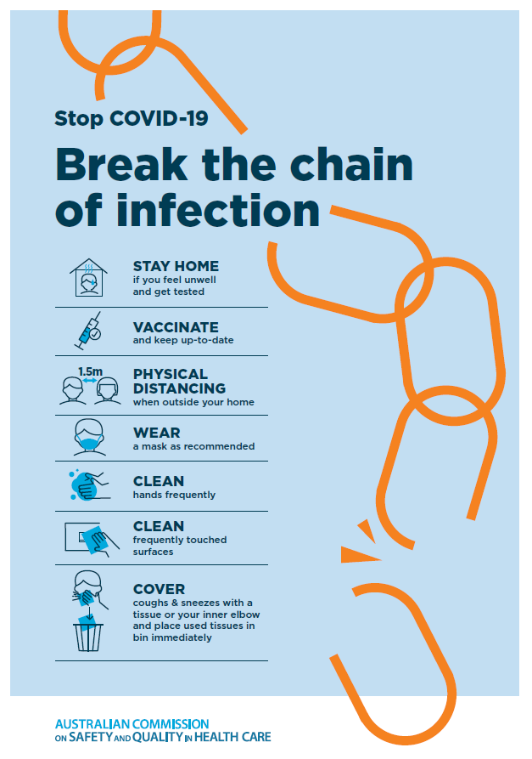](https://www.safetyandquality.gov.au/publications-and-resources/resource-library/break-chain-poster-a3https:/www.safetyandquality.gov.au/publications-and-resources/resource-library/break-chain-poster-a3)**
* ***COVID-19 and face masks – Information for consumers*** <https://www.safetyandquality.gov.au/publications-and-resources/resource-library/covid-19-and-face-masks-information-consumers>

[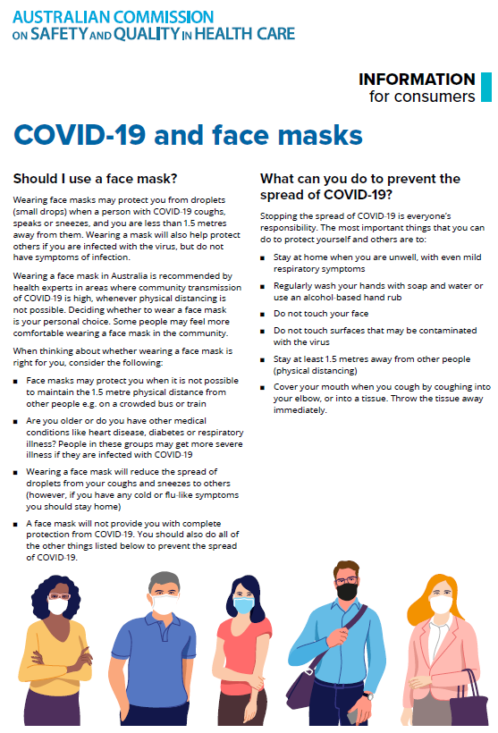](https://www.safetyandquality.gov.au/sites/default/files/2020-07/covid-19_and_face_masks_-_information_for_consumers.pdf)

*National COVID-19 Clinical Evidence Taskforce*

<https://covid19evidence.net.au/>

The National COVID-19 Clinical Evidence Taskforce is a collaboration of peak health professional bodies across Australia whose members are providing clinical care to people with COVID-19. The taskforce is undertaking continuous evidence surveillance to identify and rapidly synthesise emerging research in order to provide national, **evidence-based guidelines and clinical flowcharts for the clinical care of people with COVID-19**. The guidelines address questions that are specific to managing COVID-19 and cover the full disease course across mild, moderate, severe and critical illness. These are ‘living’ guidelines, updated with new research in near real-time in order to give reliable, up-to-the minute advice to clinicians providing frontline care in this unprecedented global health crisis.

*COVID-19 Critical Intelligence Unit*

<https://www.aci.health.nsw.gov.au/covid-19/critical-intelligence-unit>

The Agency for Clinical Innovation (ACI) in New South Wales has developed this page summarising rapid, evidence-based advice during the COVID-19 pandemic. Its operations focus on systems intelligence, clinical intelligence and evidence integration. The content includes a daily evidence digest, a COVID status monitor, a risk monitoring dashboard and evidence checks on a discrete topic or question relating to the current COVID-19 pandemic. There is also a ‘Living evidence’ section summarising key studies and emerging evidence on **COVID-19 vaccines** and **SARS-CoV-2 variants**. The most recent updates include:

* ***SARS-CoV-2 variants - retired living evidence*** – What is the evidence on SARS-CoV-2 variants that are under monitoring by the World Health Organization?
* ***COVID-19 vaccines - retired living evidence*** – What is the evidence on COVID-19 vaccine effectiveness and safety?
* ***Current and emerging patient safety issues during COVID-19*** – What is the evidence on the current and emerging patient safety issues arising from the COVID-19 pandemic?
* ***Bivalent COVID-19 vaccines*** – What is the available regulatory and research evidence for bivalent COVID-19 vaccines?
* ***Surgery post COVID-19*** – What is the evidence for the timing of surgery, and outcomes following surgery, for people who have recovered from COVID-19?
* ***Paxlovid*** – What is the evidence for Paxlovid for treatment of COVID-19?
* ***Molnupiravir*** –What is the evidence for and regulatory context of molnupiravir for treatment of COVID-19?
* ***Eating disorders and COVID-19*** – What is the impact of the COVID-19 pandemic on the prevalence of eating disorders?
* ***Long COVID –*** What is the evidence on the prevalence, presentation and management of long-COVID?
* ***Oseltamivir (Tamiflu) use in healthcare settings*** – What is the evidence that use of oseltamivir in healthcare workers with a symptomatic influenza diagnosis result in an earlier return to work and reduced absenteeism? What is the evidence that use of oseltamivir in adults and children with symptomatic influenza reduces influenza transmission in health care settings?
* ***Alternative models of care for acute medical conditions*** – What is the evidence on alternative models of care for managing patients with acute medical conditions outside of emergency or inpatient hospital settings?
* ***Exercise and long COVID*** – Is exercise helpful in individuals with long COVID? Is post-exertional symptom exacerbation a risk in long COVID?
* ***Influenza and seasonal prophylaxis with oseltamivir*** – What is the place or evidence for seasonal influenza prophylaxis (such as taking oseltamivir for 10 to 12 weeks continuously) in healthcare and aged care settings?
* ***Rapid access models of care for respiratory illnesses*** – What is the evidence for rapid access models of care for respiratory illnesses, especially during winter seasons, in emergency departments?
* ***Post-acute sequelae of COVID-19*** – What is the evidence on the post-acute sequelae of COVID-19?
* ***Emerging variants*** – What is the available evidence for emerging variants?
* ***Chest pain or dyspnoea following COVID-19 vaccination*** – What is evidence for chest pain or dyspnoea following COVID-19 vaccination?
* ***Cardiac investigations and elective surgery post-COVID-19*** – What is evidence for cardiac investigations and elective surgery post-COVID-19?
* ***Breathlessness post COVID-19*** – How to determine those patients who present with ongoing breathlessness in need of urgent review or intervention due to suspected pulmonary embolus?
* ***COVID-19 pandemic and influenza*** – What is the evidence for COVID-19 pandemic and influenza?
* ***Budesonide and aspirin for pregnant women with COVID-19 –*** What is the evidence for the use of Budesonide for pregnant women with COVID-19? What is the evidence for aspirin prophylaxis for pre-eclampsia in pregnant women with a COVID-19 infection?
* ***COVID-19 vaccines in Australia*** – What is the evidence on COVID-19 vaccines in Australia?
* ***COVID-19 pandemic and wellbeing of critical care and other healthcare workers*** – Evidence in brief on the impact of the COVID-19 pandemic on the wellbeing of critical care and other healthcare workers.
* ***Disease modifying treatments for COVID-19 in children*** – What is the evidence for disease modifying treatments for COVID-19 in children?
* ***Mask type for COVID-19 positive wearer*** – What is the evidence for different mask types for COVID-19 positive wearers?
* ***Post acute and subacute COVID-19 care*** – What published advice and models of care are available regarding post-acute and subacute care for COVID-19 patients?
* ***Hospital visitor policies*** – What is the evidence for hospital visitor policies during and outside of the COVID-19 pandemic?
* ***Surgical masks, eye protection and PPE guidance*** –What is the evidence for surgical masks in the endemic phase in hospitals and for eyewear to protect against COVID-19?

**Disclaimer**

On the Radar is an information resource of the Australian Commission on Safety and Quality in Health Care. The Commission is not responsible for the content of, nor does it endorse, any articles or sites listed. The Commission accepts no liability for the information or advice provided by these external links. Links are provided on the basis that users make their own decisions about the accuracy, currency and reliability of the information contained therein. Any opinions expressed are not necessarily those of the Australian Commission on Safety and Quality in Health Care.