# Australian Commission on Safety and Quality logotypeOn the Radar

Issue 611

17 July 2023

*On the Radar* is a summary of some of the recent publications in the areas of safety and quality in health care. Inclusion in this document is not an endorsement or recommendation of any publication or provider. Access to particular documents may depend on whether they are Open Access or not, and/or your individual or institutional access to subscription sites/services. Material that may require subscription is included as it is considered relevant.

*On the Radar* is available online, via email or as a PDF or Word document from <https://www.safetyandquality.gov.au/newsroom/subscribe-news/radar>

If you would like to receive *On the Radar* via email, you can subscribe on our website <https://www.safetyandquality.gov.au/newsroom/subscribe-news>  
or by emailing us at H[Umail@safetyandquality.gov.auU](mailto:mail@safetyandquality.gov.au).   
You can also send feedback and comments to H[Umail@safetyandquality.gov.auU](mailto:mail@safetyandquality.gov.au).

For information about the Commission and its programs and publications, please visit <https://www.safetyandquality.gov.au>

You can also follow us on Twitter @ACSQHC.

**On the Radar**

Editor: Dr Niall Johnson [niall.johnson@safetyandquality.gov.au](mailto:niall.johnson@safetyandquality.gov.au)

Contributors: Niall Johnson, Kristin Xenos

***Antimicrobial Stewardship and Outpatient Parenteral Antimicrobial Therapy (OPAT) in Hospital in the Home (HITH) and other settings***

*Antimicrobial Stewardship in Australian Health Care.*

Australian Commission on Safety and Quality in Health Care

Sydney: ACSQHC

<https://www.safetyandquality.gov.au/publications-and-resources/resource-library/antimicrobial-stewardship-australian-health-care>

Chapter 20 of *Antimicrobial Stewardship in Australian Health Care* (the AMS Book) is now available on the Commission’s website. This chapter *Antimicrobial Stewardship and Outpatient Parenteral Antimicrobial Therapy (OPAT) in Hospital in the Home (HITH) and other settings* focuses on outpatient antimicrobial use and appropriateness of use in hospital in the home and other settings. The chapter describes the importance of governance, partnering with consumers, the role of a multidisciplinary team for service delivery and considerations for de-escalation of therapy and transitions of care.

**Reports**

*Improving patient safety culture – a practical guide*

NHS England

2023. p. 40.

|  |  |
| --- | --- |
| URL | <https://www.england.nhs.uk/publication/improving-patient-safety-culture-a-practical-guide/> |
| Notes | NHS England has produced this guide ‘as a resource to support teams to understand their safety culture and how to approach improving it.’ This short guide includes sections on:   * Safety culture * Teamwork and communication * Just and restorative culture * Psychological safety * Promoting diversity & inclusive behaviours * Civility. |

*Six Steps to Better Care for Older People in Acute Hospitals*

Getting It Right First time (GIRFT) and British Geriatrics Society

Getting It Right First time (GIRFT), 2023. p. 7.

|  |  |
| --- | --- |
| URL | <https://gettingitrightfirsttime.co.uk/wp-content/uploads/2023/06/GIRFT-BGS-Six-Steps-to-Better-Care-for-Older-People-FINAL-V1-June-2023-1.pdf> |
| Notes | This resource is aimed at supporting (UK) hospital teams to improve the care of older people living with frailty. The resource was developed in a collaboration between Getting It Right First Time (GIRFT) and the British Geriatrics Society (BGS). This resource accompanies the GIRFT *Hospital Acute Care Frailty Pathway*.  The six steps include:   1. **Assess for frailty**: Systematically identify frailty in all settings using the Clinical Frailty Scale. 2. **Prevent complications**: Prevent, identify and effectively manage delirium and reduce hospital-acquired deconditioning. 3. **Home First**: Start discharge planning for older people with frailty and/or dementia as soon as possible after admission using a Home First principle. 4. **Surgical Liaison**: Provide evidence-based surgical specialty liaison that improves individual and service-level outcomes for older people. 5. **Rehabilitation**: Ensure there is effective recuperative rehabilitation for older people on all wards in hospital and linked community services. 6. **Primary and Community Care**: Develop effective primary and community care services that support older people to remain in or return to their usual residence. |

*Broken trust: making patient safety more than just a promise*

Parliamentary and Health Service Ombudsman

London: His Majesty’s Stationery Office; 2023. p. 44.

|  |  |
| --- | --- |
| URL | <https://www.ombudsman.org.uk/publications/broken-trust-making-patient-safety-more-just-promise> |
| Notes | The Parliamentary and Health Service Ombudsman in England has produced this report, *Broken trust: making patient safety more than just a promise*, stating that the UK’s National Health Service must do more to accept accountability and learn from mistakes, particularly when there is serious harm or, worse, loss of life.  The Ombudsman considered over 400 serious health complaints from the last 3 years and found 22 cases of avoidable death. The report offers recommendations to improve patient safety, including:   * better support for families affected by harm * embedding cultures that promote honesty and learning from mistakes * getting the right oversight and regulatory structures to prioritise patient safety * and an evidence-based and long-term workforce strategy that has cross-party support. |

**Journal articles**

*Patient safety and sense of security when telemonitoring chronic conditions at home: the views of patients and healthcare professionals - a qualitative study*

Ekstedt M, Nordheim ES, Hellström A, Strandberg S, Hagerman H

BMC Health Services Research. 2023;23(1):581.

|  |  |
| --- | --- |
| DOI | <https://doi.org/10.1186/s12913-023-09428-1> |
| Notes | The COVID-19 pandemic brought many changes to health care. One was increasing interest in remote patient monitoring (RPM). The paper reports on a Swedish study that sought to ‘explore patients’ and healthcare professionals’ experiences of safety and sense of security when using telemonitoring of chronic conditions at home.’ The authors report that ‘T**elemonitoring was perceived to increase symptom awareness and promote early detection of deterioration** promoting patient safety’ with clinicians and patients both reporting positive perceptions. |

*Systematic review of the impact of physician work schedules on patient safety with meta-analyses of mortality risk*

Weaver MD, Sullivan JP, Landrigan CP, Barger LK

The Joint Commission Journal on Quality and Patient Safety. 2023 [epub].

|  |  |
| --- | --- |
| DOI | <https://doi.org/10.1016/j.jcjq.2023.06.014> |
| Notes | The issue of (excessive) working hours and the impact on safety and quality of care has been debated for many years. This paper reports on a US study using ‘meta-analyses to evaluate the impact of work hour policies and work schedules on patient safety’. Based on 68 studies that ‘provided enough information for consideration in meta-analyses’, the authors report ‘We found that patient safety improved following implementation of the Accreditation Council for Graduate Medical Education's 2003 and 2011 resident physicians work hour guidelines. Limiting all resident physicians to 80-hour work weeks and 28-hour shifts in 2003 was associated with an 11% reduction in mortality (p < 0.001). Limited shift durations and shorter work weeks were also associated with improved patient safety in clinical trials and observational studies not specifically tied to policy changes.’ |

*The Additional Cost of Perioperative Medication Errors*

Langlieb ME, Sharma P, Hocevar M, Nanji KC

Journal of Patient Safety. 2023 [epub].

|  |  |
| --- | --- |
| DOI | <https://doi.org/10.1097/pts.0000000000001136> |
| Notes | Paper reporting on an attempt to ‘estimate the additional annual cost to the U.S. healthcare system attributable to preventable medication errors (MEs) in the operating room’. With estimates of the incidence of the MEs and the likelihood of downstream patient harm and additional costs, the researchers estimated that the **total additional annual cost of care due to perioperative medication errors was $5.33 billion US. dollars**. |

For information on the Commission’s work on medication safety, see <https://www.safetyandquality.gov.au/our-work/medication-safety>

*What makes an effective Quality Improvement Manager? A qualitative study in the New Zealand Health System*

Akmal A, Podgorodnichenko N, Stokes T, Foote J, Greatbanks R, Gauld R

BMC Health Services Research. 2022;22(1):50.

|  |  |
| --- | --- |
| DOI | <https://doi.org/10.1186/s12913-021-07433-w> |
| Notes | Paper examining the views on quality improvement managers in New Zealand on the competencies and qualities required ‘to achieve day-to-day and long-term quality improvement objectives.’ Based on interviews with 56 quality improvement managers from across New Zealand, the study identified two groups ‘traditional and clinical quality improvement managers’ with the traditional group being ‘those with formal quality improvement education’ while the clinical group ‘was represented by clinical staff—physicians and nurses—who received on-the-job training.’ The authors report three major themes emerged from the interviews: **quality improvement expertise, leadership competencies and interpersonal competencies**. The ‘traditional quality improvement managers emphasising leadership competencies and interpersonal skills more than clinical quality improvement managers’. |

*Workplace interventions to improve well-being and reduce burnout for nurses, physicians and allied healthcare professionals: a systematic review*

Catherine C, Silvia P, Eva B, Mark T, Jessie C  
BMJ Open. 2023;13(6):e071203.

|  |  |
| --- | --- |
| DOI | <https://doi.org/10.1136/bmjopen-2022-071203> |
| Notes | Paper reporting the result of a systematic literature review that sought to draw together the recent evidence on ‘the impact of interventions designed to address well-being and burnout in physicians, nurses and allied healthcare professionals.’ Based on 33 studies published since 2015, the study found that most studies had used ‘individually focused interventions’, including mindfulness-based practices, meditation, yoga, acupuncture, and positive mindset interventions (gratitude journaling, choirs, coaching). Organisational interventions focused on workload reduction, job crafting and peer networks. Overall,, the review ‘that interventions benefitted healthcare workers by increasing well-being, engagement and resilience, and reducing burnout. It is noted that the outcomes of numerous studies were impacted by design limitations that is, no control/waitlist control, and/or no post intervention follow-up.’ |

*Mapping Health Disparities in 11 High-Income Nations*

MacKinnon NJ, Emery V, Waller J, Ange B, Ambade P, Gunja M, et al

JAMA Network Open. 2023;6(7):e2322310-e2322310.

|  |  |
| --- | --- |
| DOI | <https://doi.org/10.1001/jamanetworkopen.2023.22310> |
| Notes | Article reporting on the US Commonwealth Fund’s latest survey into health care in a group of eleven high-income nations, including Australia and the USA. This study sought to examine ‘geographic health disparities as measured by differences in respondents living in urban and rural settings in 10 health indicators across 3 domains.’ The study found that ‘using self-reported data from 22 402 participants across 11 countries, the mean number of geographic health disparities across 10 indicators and 3 domains (health status and socioeconomic risk factors, affordability of care, access to care) was 1.9, although there was wide variation among the nations. The US had significant geographic health disparities in 5 indicators, the most of any country, while Canada, Norway, and the Netherlands had no significant geographic health disparities.’ For Australia, it was observed that there statistically significant geographic health disparities in 3 of the 10 indicators, including skipping medical and dental care because of cost. |

For information on the Commission’s work on healthcare variation, including the *Australian Atlas of Healthcare Variation* series, see <https://www.safetyandquality.gov.au/our-work/healthcare-variation>

*Australian Journal of Primary Health*

Volume 29, Number 3, July 2023

|  |  |
| --- | --- |
| URL | <https://www.publish.csiro.au/py/issue/11378> |
| Notes | A new issue of the *Australian Journal of Primary Health* has been published. This is a special issue with a theme of ‘Optimising Women’s Sexual and Reproductive Health in Australia: The Role of Primary Health Care’. Content in this issue of the *Australian Journal of Primary Health* includes:   * The role of **primary care in optimising women’s sexual and reproductive health** (Danielle Mazza and Jessica R. Botfield) * Scoping review into **models of interconception care** delivered at well-child visits for the Australian context (Morgan Thomas, Kate Cheney and K I Black) * Are we overlooking the obvious? Addressing social determinants of health that contribute to **perinatal depression** (Meital Simhi and Aviva Yoselis) * Improving the **provision of preconception care in Australian general practice** through task-sharing with practice nurses (Nishadi N Withanage, Jessica R Botfield, Kirsten I Black and Danielle Mazza) * Pathways to **IUD and implant insertion in general practice**: a secondary analysis of the ACCORd study (Danielle Mazza, Cathy J Watson, Angela Taft, Jayne Lucke, Kevin McGeechan, Marion Haas, Kathleen McNamee, Jeffrey F Peipert and Kirsten I Black) * Women’s experiences of, and preferences for, **postpartum contraception counselling** (Ching Kay Li, Jessica Botfield, Natalie Amos and D Mazza) * Women’s perspectives of **direct pharmacy access to oral contraception** (Tara Dev, Pip Buckingham and Danielle Mazza) * What women want from local **primary care services for unintended pregnancy** in rural Australia: a qualitative study from rural New South Wales (Anna Noonan, Kirsten I Black, Georgina M. Luscombe and Jane Tomnay) * How can we encourage the provision of **early medical abortion in primary care**? Results of a best–worst scaling survey (Marion Haas, Jody Church, Deborah J Street, Deborah Bateson and Danielle Mazza) * Utilising HealthPathways to understand the **availability of public abortion** in Australia (Sonia Srinivasan, Jessica R Botfield and Danielle Mazza) * **Acceptability and usability of ‘One Key Question’®** in Australian primary health care (Jessica Fitch, Edwina Dorney, Marguerite Tracy and K I Black) * Mapping the delivery of interventions for **vaccine-preventable infections in pregnancy** in Victoria, Australia (Nafisa Yussf, Nicole Allard, Nicole Romero, Ann Wilson, Jack Wallace, Meg Perrier, Stacey Rowe, Rosemary Morey, Neylan Aykut and Benjamin Cowie) * A qualitative exploration of obtaining **informed consent in medical consultations with Burma-born women** (Anna Power, Amita Tuteja, Lester Mascarenhas and Meredith Temple-Smith) |

*Nursing Leadership*

Volume 36, Number 1, April 2023

|  |  |
| --- | --- |
| URL | <https://www.longwoods.com/publications/nursing-leadership/27121/1/vol.-36-no.-1-2023> |
| Notes | A new issue of *Nursing Leadership* has been published with a ‘Focus on Nursing Retention’. Articles in this issue of *Nursing Leadership* include:   * Editorial: Rising Up to Embrace **Multi-Faceted and Dynamic Retention Challenges** (Ruth Martin-Misener) * Increasing the **Visibility and Influence of Canadian Nurses** within the United Nations System (Patrick Chiu) * **Retention of Canadian Advanced Practice Nurses**: What Will It Take? (Jennifer Splane, Samantha Horvath, Erin Ziegler, Isabelle Savard, Nancy Carter, Kelley Kilpatrick, Denise Bryant-Lukosius and Ruth Martin-Misener) * **Sustaining and Inspiring the Capacity of the Nursing Profession**: The Case for Transformative Practice Education Models (Susan M Duncan, Diane Sawchuck, Lenora Marcellus and Joanne Maclaren) * Do Not Wait Until It Is Too Late: Using **Stay Interviews to Engage and Retain Nursing Staff** (Angel Wang, Christine Devine, Lorrie Hamilton and Mikki Layton) * Differentiating **Specialized and Advanced Nursing Roles**: The Pathway to Role Optimization (Krista Jokiniemi, Denise Bryant-Lukosius, Josette Roussel, Kelley Kilpatrick, Ruth Martin-Misener, Joan Tranmer, Sarah Rietkoetter, Marcia Carr and Gregory R Pond) * Shifts in **Homecare Nursing Practices** and Their Implications for Families and Clients Receiving Palliative Care at Home (Kelli Stajduhar, Richard Sawatzky, Laura Funk, S. Robin Cohen, Ami Bitschy, Erin Donald and Kristine Votova) |

*BMJ Quality & Safety* online first articles

|  |  |
| --- | --- |
| URL | <https://qualitysafety.bmj.com/content/early/recent> |
| Notes | *BMJ Quality &Safety* has published a number of ‘online first’ articles, including:   * Initial opioid prescription characteristics and **risk of opioid misuse, poisoning and dependence**: retrospective cohort study (Aníbal García-Sempere, Isabel Hurtado, Celia Robles, Fran Llopis-Cardona, Francisco Sánchez-Saez, Clara Rodriguez-Bernal, Salvador Peiró-Moreno, Gabriel Sanfélix-Gimeno) |

*International Journal for Quality in Health Care* online first articles

|  |  |
| --- | --- |
| URL | <https://academic.oup.com/intqhc/advance-articles> |
| Notes | *International Journal for Quality in Health Care* has published a number of ‘online first’ articles, including:   * Effect of China’s **Long-term Care Insurance on Health Outcomes of Older Disabled People**: Role of Institutional Care (Jin-Qiu Zhou et al) |

**Online resources**

***Clinical Communiqué***

<https://www.thecommuniques.com/post/clinical-communiqu%C3%A9-volume-10-issue-2-june-2023>

Volume 10, Issue 2, June 2023

This issue of *Clinical Communiqué* examines two cases of extubation crises in post-operative patients who had upper airway signs and symptoms from dental pathology. In each case, the patient’s original condition had been surgically managed but ‘a series of decisions and actions led to the loss of airway protection, a failure to recognise the severity of the situation, and an inability to salvage the situation.’ The expert commentary provides a ‘synopsis on when and how to perform a safe extubation.’

**COVID-19 resources**

https://www.safetyandquality.gov.au/covid-19

The Australian Commission on Safety and Quality in Health Care has developed a number of resources to assist healthcare organisations, facilities and clinicians. These and other material on COVID-19 are available at <https://www.safetyandquality.gov.au/covid-19>

These resources include:

* ***OVID-19 infection prevention and control risk management*** This primer provides an overview of three widely used tools for investigating and responding to patient safety events and near misses. Tools covered in this primer include incident reporting systems, Root Cause Analysis (RCA), and Failure Modes and Effects Analysis (FMEA).   
  <https://www.safetyandquality.gov.au/publications-and-resources/resource-library/covid-19-infection-prevention-and-control-risk-management-guidance>
* ***Poster – Combined contact and droplet precautions*** <https://www.safetyandquality.gov.au/publications-and-resources/resource-library/infection-prevention-and-control-poster-combined-contact-and-droplet-precautions>  
  [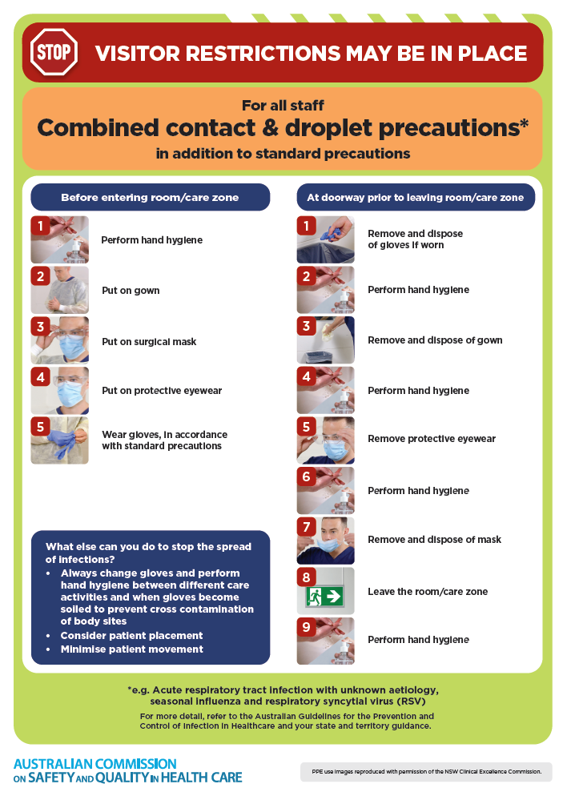](https://www.safetyandquality.gov.au/publications-and-resources/resource-library/infection-prevention-and-control-poster-combined-contact-and-droplet-precautions)
* ***Poster – Combined airborne and contact precautions*** <https://www.safetyandquality.gov.au/publications-and-resources/resource-library/poster-combined-airborne-and-contact-precautions>   
  [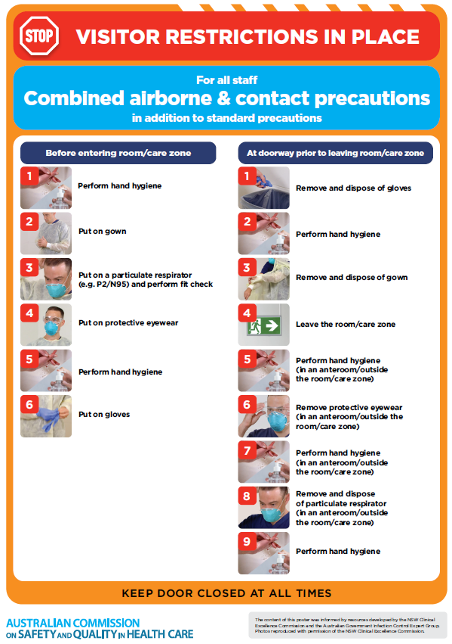](https://www.safetyandquality.gov.au/publications-and-resources/resource-library/poster-combined-airborne-and-contact-precautions)
* ***Environmental Cleaning and Infection Prevention and Control*** [www.safetyandquality.gov.au/environmental-cleaning](http://www.safetyandquality.gov.au/environmental-cleaning)
* ***COVID-19 infection prevention and control risk management – Guidance*** <https://www.safetyandquality.gov.au/publications-and-resources/resource-library/covid-19-infection-prevention-and-control-risk-management-guidance>
* ***Safe care for people with cognitive impairment during COVID-19***<https://www.safetyandquality.gov.au/our-work/cognitive-impairment/cognitive-impairment-and-covid-19>
* ***Stop COVID-19: Break the chain of infection*** posterhttps://www.safetyandquality.gov.au/publications-and-resources/resource-library/break-chain-infection-poster-a3  
  **[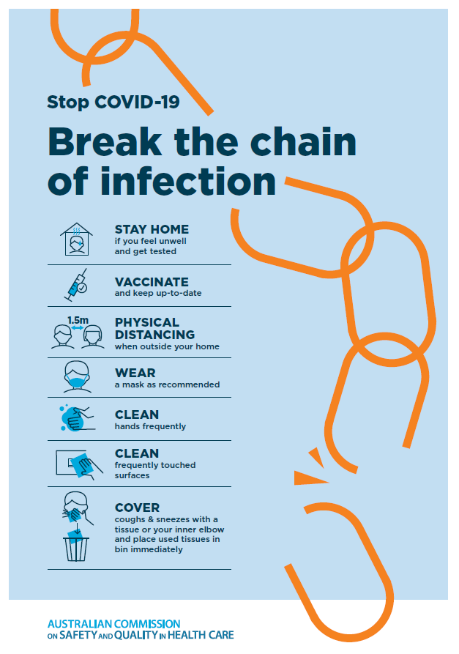](https://www.safetyandquality.gov.au/publications-and-resources/resource-library/break-chain-poster-a3https:/www.safetyandquality.gov.au/publications-and-resources/resource-library/break-chain-poster-a3)**
* ***COVID-19 and face masks – Information for consumers*** <https://www.safetyandquality.gov.au/publications-and-resources/resource-library/covid-19-and-face-masks-information-consumers>

[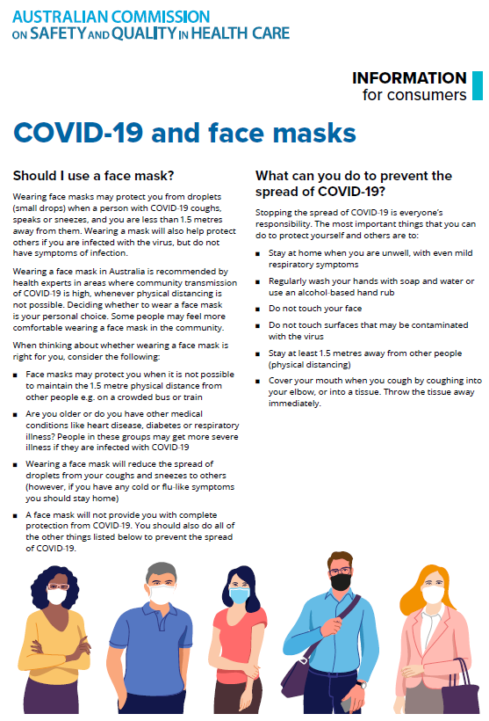](https://www.safetyandquality.gov.au/sites/default/files/2020-07/covid-19_and_face_masks_-_information_for_consumers.pdf)

*National COVID-19 Clinical Evidence Taskforce*

<https://covid19evidence.net.au/>

The National COVID-19 Clinical Evidence Taskforce is a collaboration of peak health professional bodies across Australia whose members are providing clinical care to people with COVID-19. The taskforce is undertaking continuous evidence surveillance to identify and rapidly synthesise emerging research in order to provide national, **evidence-based guidelines and clinical flowcharts for the clinical care of people with COVID-19**. The guidelines address questions that are specific to managing COVID-19 and cover the full disease course across mild, moderate, severe and critical illness. These are ‘living’ guidelines, updated with new research in near real-time in order to give reliable, up-to-the minute advice to clinicians providing frontline care in this unprecedented global health crisis.

*COVID-19 Critical Intelligence Unit*

<https://www.aci.health.nsw.gov.au/covid-19/critical-intelligence-unit>

The Agency for Clinical Innovation (ACI) in New South Wales has developed this page summarising rapid, evidence-based advice during the COVID-19 pandemic. Its operations focus on systems intelligence, clinical intelligence and evidence integration. The content includes a daily evidence digest, a COVID status monitor, a risk monitoring dashboard and evidence checks on a discrete topic or question relating to the current COVID-19 pandemic. There is also a ‘Living evidence’ section summarising key studies and emerging evidence on **COVID-19 vaccines** and **SARS-CoV-2 variants**. The most recent updates include:

* ***SARS-CoV-2 variants - retired living evidence*** – What is the evidence on SARS-CoV-2 variants that are under monitoring by the World Health Organization?
* ***COVID-19 vaccines - retired living evidence*** – What is the evidence on COVID-19 vaccine effectiveness and safety?
* ***Current and emerging patient safety issues during COVID-19*** – What is the evidence on the current and emerging patient safety issues arising from the COVID-19 pandemic?
* ***Bivalent COVID-19 vaccines*** – What is the available regulatory and research evidence for bivalent COVID-19 vaccines?
* ***Surgery post COVID-19*** – What is the evidence for the timing of surgery, and outcomes following surgery, for people who have recovered from COVID-19?
* ***Paxlovid*** – What is the evidence for Paxlovid for treatment of COVID-19?
* ***Molnupiravir*** –What is the evidence for and regulatory context of molnupiravir for treatment of COVID-19?
* ***Eating disorders and COVID-19*** – What is the impact of the COVID-19 pandemic on the prevalence of eating disorders?
* ***Long COVID –*** What is the evidence on the prevalence, presentation and management of long-COVID?
* ***Oseltamivir (Tamiflu) use in healthcare settings*** – What is the evidence that use of oseltamivir in healthcare workers with a symptomatic influenza diagnosis result in an earlier return to work and reduced absenteeism? What is the evidence that use of oseltamivir in adults and children with symptomatic influenza reduces influenza transmission in health care settings?
* ***Alternative models of care for acute medical conditions*** – What is the evidence on alternative models of care for managing patients with acute medical conditions outside of emergency or inpatient hospital settings?
* ***Exercise and long COVID*** – Is exercise helpful in individuals with long COVID? Is post-exertional symptom exacerbation a risk in long COVID?
* ***Influenza and seasonal prophylaxis with oseltamivir*** – What is the place or evidence for seasonal influenza prophylaxis (such as taking oseltamivir for 10 to 12 weeks continuously) in healthcare and aged care settings?
* ***Rapid access models of care for respiratory illnesses*** – What is the evidence for rapid access models of care for respiratory illnesses, especially during winter seasons, in emergency departments?
* ***Post-acute sequelae of COVID-19*** – What is the evidence on the post-acute sequelae of COVID-19?
* ***Emerging variants*** – What is the available evidence for emerging variants?
* ***Chest pain or dyspnoea following COVID-19 vaccination*** – What is evidence for chest pain or dyspnoea following COVID-19 vaccination?
* ***Cardiac investigations and elective surgery post-COVID-19*** – What is evidence for cardiac investigations and elective surgery post-COVID-19?
* ***Breathlessness post COVID-19*** – How to determine those patients who present with ongoing breathlessness in need of urgent review or intervention due to suspected pulmonary embolus?
* ***COVID-19 pandemic and influenza*** – What is the evidence for COVID-19 pandemic and influenza?
* ***Budesonide and aspirin for pregnant women with COVID-19 –*** What is the evidence for the use of Budesonide for pregnant women with COVID-19? What is the evidence for aspirin prophylaxis for pre-eclampsia in pregnant women with a COVID-19 infection?
* ***COVID-19 vaccines in Australia*** – What is the evidence on COVID-19 vaccines in Australia?
* ***COVID-19 pandemic and wellbeing of critical care and other healthcare workers*** – Evidence in brief on the impact of the COVID-19 pandemic on the wellbeing of critical care and other healthcare workers.
* ***Disease modifying treatments for COVID-19 in children*** – What is the evidence for disease modifying treatments for COVID-19 in children?
* ***Mask type for COVID-19 positive wearer*** – What is the evidence for different mask types for COVID-19 positive wearers?
* ***Post acute and subacute COVID-19 care*** – What published advice and models of care are available regarding post-acute and subacute care for COVID-19 patients?
* ***Hospital visitor policies*** – What is the evidence for hospital visitor policies during and outside of the COVID-19 pandemic?
* ***Surgical masks, eye protection and PPE guidance*** –What is the evidence for surgical masks in the endemic phase in hospitals and for eyewear to protect against COVID-19?

**Disclaimer**

On the Radar is an information resource of the Australian Commission on Safety and Quality in Health Care. The Commission is not responsible for the content of, nor does it endorse, any articles or sites listed. The Commission accepts no liability for the information or advice provided by these external links. Links are provided on the basis that users make their own decisions about the accuracy, currency and reliability of the information contained therein. Any opinions expressed are not necessarily those of the Australian Commission on Safety and Quality in Health Care.