# Australian Commission on Safety and Quality logotypeOn the Radar

Issue 613

31 July 2023

*On the Radar* is a summary of some of the recent publications in the areas of safety and quality in health care. Inclusion in this document is not an endorsement or recommendation of any publication or provider. Access to particular documents may depend on whether they are Open Access or not, and/or your individual or institutional access to subscription sites/services. Material that may require subscription is included as it is considered relevant.

*On the Radar* is available online, via email or as a PDF or Word document from <https://www.safetyandquality.gov.au/newsroom/subscribe-news/radar>

If you would like to receive *On the Radar* via email, you can subscribe on our website <https://www.safetyandquality.gov.au/newsroom/subscribe-news>  
or by emailing us at H[Umail@safetyandquality.gov.auU](mailto:mail@safetyandquality.gov.au).   
You can also send feedback and comments to H[Umail@safetyandquality.gov.auU](mailto:mail@safetyandquality.gov.au).

For information about the Commission and its programs and publications, please visit <https://www.safetyandquality.gov.au>

You can also follow us on Twitter @ACSQHC.

**On the Radar**

Editor: Dr Niall Johnson [niall.johnson@safetyandquality.gov.au](mailto:niall.johnson@safetyandquality.gov.au)

Contributors: Niall Johnson, Kristin Xenos

**Antimicrobial stewardship in primary care factsheets**

<https://www.safetyandquality.gov.au/our-work/antimicrobial-stewardship/antimicrobial-stewardship-primary-care>

The National Safety and Quality Primary and Community Healthcare Standards have actions relating to antimicrobial stewardship. To support these the Commission has developed factsheets for

* General Practice
* Community Pharmacy
* Dental Practice
* Allied Health including Optometry and Podiatry
* Community Health services
* Aboriginal Community Controlled Health Services

The factsheets have practical examples of how these services can promote antimicrobial stewardship and meet the standards.

**Reports**

*Optimising antimicrobial stewardship in Australian primary care*

Deeble Institute for Health Policy Research Issues Brief no: 52

Saha SK, Haddock R

Canberra: Australian Healthcare and Hospitals Association; 2023. p. 45.

|  |  |
| --- | --- |
| URL | <https://ahha.asn.au/publication/health-policy-issue-briefs/deeble-issues-brief-no-52-optimising-antimicrobial> |
| Notes | This issues brief from the Australian Healthcare and Hospitals Association’s Deeble Institute examines antimicrobial stewardship in primary care. Observing that ‘80% of antibiotics are consumed within primary care’, the notes argue that ‘concept of antimicrobial stewardship (AMS) in primary care will play an important role in improving the appropriate use of antibiotics and reducing the risk of antimicrobial resistance.’ The authors of this issues brief provide a number of recommendations, including:   1. Models of care to support best practice AMS 2. GP-community pharmacy practice agreements 3. AMS training 4. Collaborative GP-pharmacist prescribing models. 5. Guidelines to support delayed prescribing strategies. 6. Point-of-care testing for microbial infection 7. A digital platform to support AMS in primary care 8. Program evaluation 9. Audit and feedback through real-time monitoring for antibiotic prescribing 10. Clinical decision support tools for antibiotic prescribing 11. GP-Community pharmacy governance framework for AMS. |

For information on the Commission’s work on antimicrobial stewardship, see <https://www.safetyandquality.gov.au/our-work/antimicrobial-stewardship>

*Risk based cancer screening: the role of primary care*

Deeble Institute for Health Policy Research Perspectives Brief no: 27

Koa C, Emery J, Saya S

Canberra: Australian Healthcare and Hospitals Association; 2023. p. 14.

|  |  |
| --- | --- |
| URL | <https://ahha.asn.au/sites/default/files/docs/policy-issue/perspectives_brief_no_27_risk_based_cancer_screening_final.pdf> |
| Notes | This perspectives brief from the Australian Healthcare and Hospitals Association’s Deeble Institute is authored by researchers from the Primary Care Collaborative Cancer Clinical Trials Group. The authors examine how a move to risk-based cancer screening, particularly for bowel and breast cancer screening, may be approached and identify how primary care could be called upon to play a greater role and how that may be achieved. |

*Clinical quality registries – Four key benefits for your health*

Department of Health and Aged Care

Canberra: DoHAC; 2023.

|  |  |
| --- | --- |
| DOI | <https://www.health.gov.au/resources/publications/clinical-quality-registries-four-key-benefits-for-your-health> |
| Notes | Brief publication describing clinical quality registries that includes material on what registries are and how they provide information to improve health care. This publication draws upon the Commission’s work on clinical quality registries. |

For information on the Commission’s work on clinical quality registries, see <https://www.safetyandquality.gov.au/our-work/health-and-human-research/national-arrangements-clinical-quality-registries>

**Journal articles**

*Contributory factors and patient harm including deaths associated direct acting oral anticoagulants (DOACs) medication incidents: evaluation of real world data reported to the National Reporting and Learning System*

Rowily AA, Jalal Z, Paudyal V

Expert Opinion on Drug Safety. 2023 [epub].

|  |  |
| --- | --- |
| DOI | <https://doi.org/10.1080/14740338.2023.2223947> |
| Notes | Paper reporting a study using the UK’s National Reporting and Learning System to examine harms related to direct acting oral anticoagulants (DOACs).  The study examined nearly 16 thousand incident reports and found 25 deaths and a ‘a further 270 and 55 incidents leading to moderate and severe harm, respectively’ and 1381 incidents associated with low degree of harm. The authors report that ‘The majority of the incidents involved active failures (n = 13776; 87.58) including duplication of anticoagulant therapies, patients being discharged without DOACs, non-consideration of renal function, and lack of commencement of DOACs post-surgery suggesting preventability of such reported incidents.’ |

For information on the Commission’s work on medication safety, see <https://www.safetyandquality.gov.au/our-work/medication-safety>

*‘When a patient chooses to die at home, that's what they want… comfort, home’: Brilliance in community-based palliative care nursing*

Dadich A, Hodgins M, Womsley K, Collier A

Health Expectations. 2023;26(4):1716-1725.

|  |  |
| --- | --- |
| DOI | <https://doi.org/10.1111/hex.13780> |
| Notes | Paper from an Australian study that sought to examine ‘what constitutes brilliant palliative care to ask what brilliant nursing practices are supported and promoted.’ Working with nurses, patients and carers the study had ‘a particular focus on the practices and experiences that exceeded expectations and brought joy and delight’. The authors report that ‘Brilliant community-based palliative care nursing largely involved maintaining normality in patients’ and carers’ lives. The nurses demonstrated this by masking the clinical aspects of their role, normalising these aspects, and appreciating alternative ‘normals’.’ |

For information on the Commission’s work on end-of-life care, see <https://www.safetyandquality.gov.au/our-work/end-life-care>

*Remote consultations in primary care across low-, middle- and high-income countries: Implications for policy and care delivery*

Williams S, Barnard A, Collis P, Correia de Sousa J, Ghimire S, Habib M, et al

Journal of Health Services Research & Policy. 2022;28(3):181-189.

|  |  |
| --- | --- |
| DOI | <https://doi.org/10.1177/13558196221140318> |
| Notes | The COVID-19 pandemic saw many changes in health care, including the rapid increase in the use of remote consultations. Stemming from a group of primary care clinicians convened by the International Primary Care Respiratory Group, this piece reflects on the strengths and limitations of remote consultations in primary care at various levels. Recognising the remote consultations are now a routine approach to primary care delivery the authors make some observations on the implications for clinicians, training, provisioning, funding and policy. |

*The Joint Commission Journal on Quality and Patient Safety*

Volume 49, Issue 8, August 2023

|  |  |
| --- | --- |
| URL | <https://www.sciencedirect.com/journal/the-joint-commission-journal-on-quality-and-patient-safety/vol/49/issue/8> |
| Notes | A new issue of *The Joint Commission Journal on Quality and Patient Safety* has been published. Articles in this issue of *The Joint Commission Journal on Quality and Patient Safety* include:   * Editorial: Improving **Perioperative Handoffs**: Moving Beyond Standardized Checklists and Protocols (Joanna Abraham, Michael Rosen, Philip E. Greilich) * Bringing a Multiteam Systems Perspective to the Perioperative Context: Considerations for Future Research of **Perioperative Handoffs** (Annamaria V Wolf, Allison M Traylor, Marissa L Shuffler, Donald W Wiper) * Patient- and Team-Level Characteristics Associated with **Handoff Protocol Fidelity** in a Hybrid Implementation Study: Results from a Qualitative Comparative Analysis (Meghan B Lane-Fall, Christopher B Koilor, Kathleen Givan, Tamar Klaiman, Frances K Barg) * So Many Ways to Be Wrong: Completeness and Accuracy in a Prospective Study of **OR-to-ICU Handoff Standardization** (Julian Conn Busch, Jasmine Wu, Evanie Anglade, Hannah G Peifer, Meghan B Lane-Fall) * Leveraging the Science of Teamwork to Sustain **Handoff Improvements** in Cardiovascular Surgery (Joseph R Keebler, Isaac Lynch, Fallon Ngo, Eleanor Phelps, Philip E Greilich) * **Improving Handoffs in the Perioperative Environment**: A Conceptual Framework of Key Theories, System Factors, Methods, and Core Interventions to Ensure Success (Amy J Starmer, Meghan M Michael, Nancy D Spector, Lee Ann Riesenberg) * **Anesthesiology Patient Handoff Education Interventions**: A Systematic Review (Lee Ann Riesenberg, Robyn Davis, Allyson Heng, Clementino Vong do Rosario, Meghan Lane-Fall) * **Perioperative Handoff Enhancement Opportunities** Through Technology and Artificial Intelligence: A Narrative Review (Jamie L Sparling, Bommy Hong Mershon, Joanna Abraham) * Taking a **Resilience Engineering Approach to Perioperative Handoffs** (Aubrey Samost-Williams, Connor Lusk, Ken Catchpole) |

*Journal of Health Services Research & Policy*

Volume 28, Issue 3, July 2023

|  |  |
| --- | --- |
| URL | <https://journals.sagepub.com/toc/hsrb/28/3> |
| Notes | A new issue of the *Journal of Health Services Research & Policy* has been published. Articles in this issue of the *Journal of Health Services Research & Policy* include:   * Editorial: **Remote care** – good for some, but not for all? (Catherine Pope) * The role of knowledge, primary care and community engagement to improve **breast-screening access** for Pakistani women in the United Kingdom: A secondary analysis of a qualitative study (Hooran M Khattak, Victoria G Woof, David P French, Louise S Donnelly, Helen Ruane, Fiona Ulph, Nadeem Qureshi, Nasaim Khan, D Gareth Evans, and Kathryn A Robb) * Substitution or addition: An observational study of a new **primary care initiative in the Netherlands** (Esther HA van den Bogaart, Marieke D Spreeuwenberg, Mariëlle EAL Kroese, and Dirk Ruwaard) * **Family physician services and blood pressure control** in China: A population-based retrospective cohort study (Rize Jing, Karen Eggleston, Xiaozhen Lai, and Hai Fang) * Staff experiences of training and delivery of **remote home monitoring services** for patients diagnosed with COVID-19 in England: A mixed-methods study (Manbinder Sidhu, Holly Walton, Nadia Crellin, Jo Ellins, Lauren Herlitz, Ian Litchfield, Efthalia Massou, Sonila M Tomini, Cecilia Vindrola-Padros, and Naomi J Fulop) * **Remote consultations in primary care** across low-, middle- and high-income countries: Implications for policy and care delivery (Siân Williams, Amanda Barnard, Phil Collis, Jaime Correia de Sousa, Suraj Ghimire, Monsur Habib, Tessa Jelen, Frank Kanniess, Vince Mak, Sonia Martins, Ema Paulino, Hilary Pinnock, Miguel Roman, Hanna Sandelowsky, Ioanna Tsiligianni, Laurine van der Steen, and Fabio Weber Donatelli) * Using **arts-based research in applied health care**: An example from an evaluation of NHS dental contract reform in Wales (Ellie Overs, Chris Woods, Lorelei Jones, Lynne Williams, Sion Williams, C Burton, and P R Brocklehurst) * Enablers and barriers to **military veterans seeking help for mental health and alcohol difficulties**: A systematic review of the quantitative evidence (Catherine Hitch, Paul Toner, and Cherie Armour) |

*BMJ Quality & Safety* online first articles

|  |  |
| --- | --- |
| URL | <https://qualitysafety.bmj.com/content/early/recent> |
| Notes | *BMJ Quality &Safety* has published a number of ‘online first’ articles, including:   * Editorial: **Work addiction and quality of care** in healthcare: Working long hours should not be confused with addiction to work (Mark D Griffiths) * Editorial: Moving the needle: using quality improvement to address gaps in **sickle cell care** (Seethal A Jacob, Jennifer C Yui) * Editorial: Contextualising **opioid-related risk factors** before an initial opioid prescription (Scott G Weiner, Jason A Hoppe) * The Ethical Complexity of **Restricting Visitors during the COVID-19** Pandemic (Louise Campbell, Georgina Morley) * It’s time for the field of **geriatrics to invest in implementation science** (Beth Prusaczyk, Robert E Burke) * Comparing **secondary prevention for patients with coronary heart disease and stroke** attending Australian general practices: a cross-sectional study using nationwide electronic database (Jason Yue, Samia Kazi, Tu Nguyen, Clara Kayei Chow) |

**Online resources**

***[UK] NICE Guidelines and Quality Standards***

<https://www.nice.org.uk/guidance>

The UK’s National Institute for Health and Care Excellence (NICE) has published new (or updated) guidelines and quality standards. The latest reviews or updates include:

* NICE Guideline NG122 ***Lung cancer****: diagnosis and management* <https://www.nice.org.uk/guidance/ng122>
* Clinical Guideline CG189 ***Obesity****: identification, assessment and management* <https://www.nice.org.uk/guidance/cg189>

**COVID-19 resources**

https://www.safetyandquality.gov.au/covid-19

The Australian Commission on Safety and Quality in Health Care has developed a number of resources to assist healthcare organisations, facilities and clinicians. These and other material on COVID-19 are available at <https://www.safetyandquality.gov.au/covid-19>

These resources include:

* ***OVID-19 infection prevention and control risk management*** This primer provides an overview of three widely used tools for investigating and responding to patient safety events and near misses. Tools covered in this primer include incident reporting systems, Root Cause Analysis (RCA), and Failure Modes and Effects Analysis (FMEA).   
  <https://www.safetyandquality.gov.au/publications-and-resources/resource-library/covid-19-infection-prevention-and-control-risk-management-guidance>
* ***Poster – Combined contact and droplet precautions*** <https://www.safetyandquality.gov.au/publications-and-resources/resource-library/infection-prevention-and-control-poster-combined-contact-and-droplet-precautions>  
  [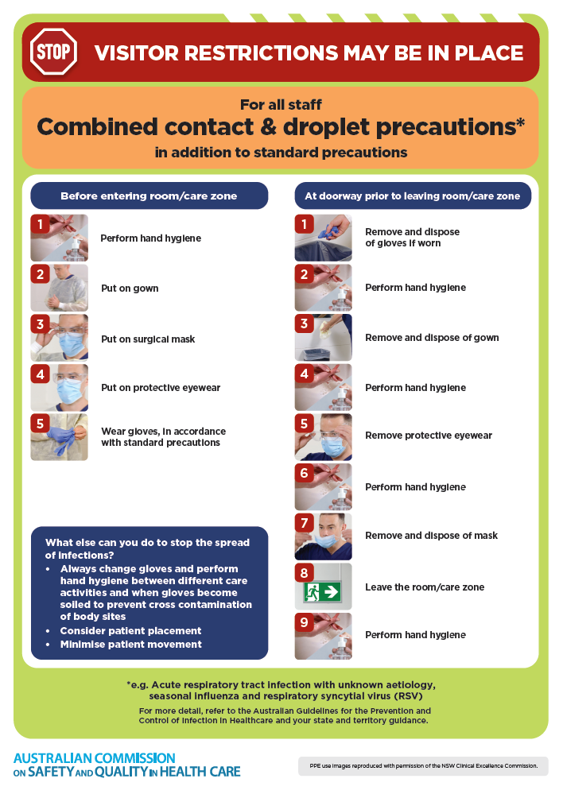](https://www.safetyandquality.gov.au/publications-and-resources/resource-library/infection-prevention-and-control-poster-combined-contact-and-droplet-precautions)
* ***Poster – Combined airborne and contact precautions*** <https://www.safetyandquality.gov.au/publications-and-resources/resource-library/poster-combined-airborne-and-contact-precautions>   
  [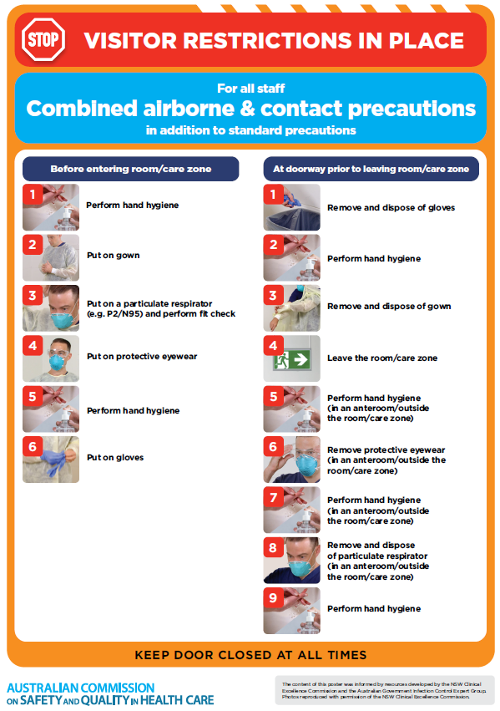](https://www.safetyandquality.gov.au/publications-and-resources/resource-library/poster-combined-airborne-and-contact-precautions)
* ***Environmental Cleaning and Infection Prevention and Control*** [www.safetyandquality.gov.au/environmental-cleaning](http://www.safetyandquality.gov.au/environmental-cleaning)
* ***COVID-19 infection prevention and control risk management – Guidance*** <https://www.safetyandquality.gov.au/publications-and-resources/resource-library/covid-19-infection-prevention-and-control-risk-management-guidance>
* ***Safe care for people with cognitive impairment during COVID-19***<https://www.safetyandquality.gov.au/our-work/cognitive-impairment/cognitive-impairment-and-covid-19>
* ***Stop COVID-19: Break the chain of infection*** posterhttps://www.safetyandquality.gov.au/publications-and-resources/resource-library/break-chain-infection-poster-a3  
  **[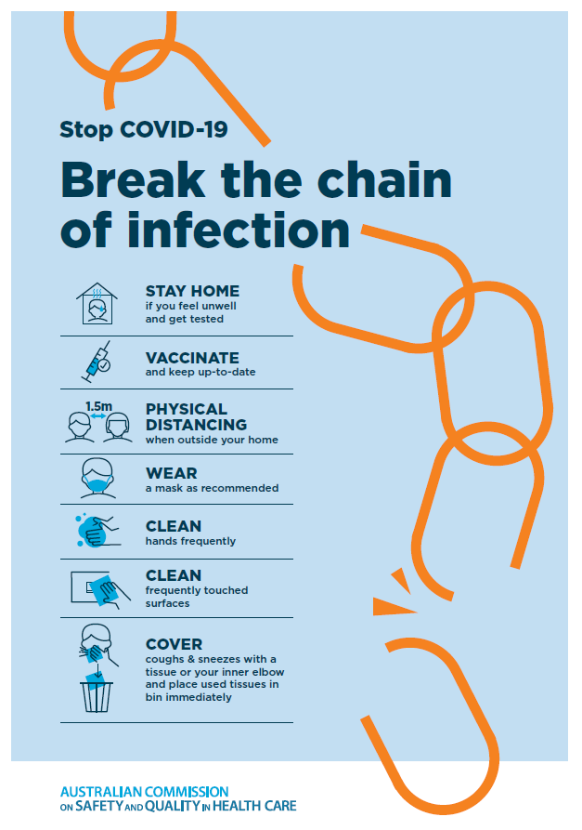](https://www.safetyandquality.gov.au/publications-and-resources/resource-library/break-chain-poster-a3https:/www.safetyandquality.gov.au/publications-and-resources/resource-library/break-chain-poster-a3)**
* ***COVID-19 and face masks – Information for consumers*** <https://www.safetyandquality.gov.au/publications-and-resources/resource-library/covid-19-and-face-masks-information-consumers>

[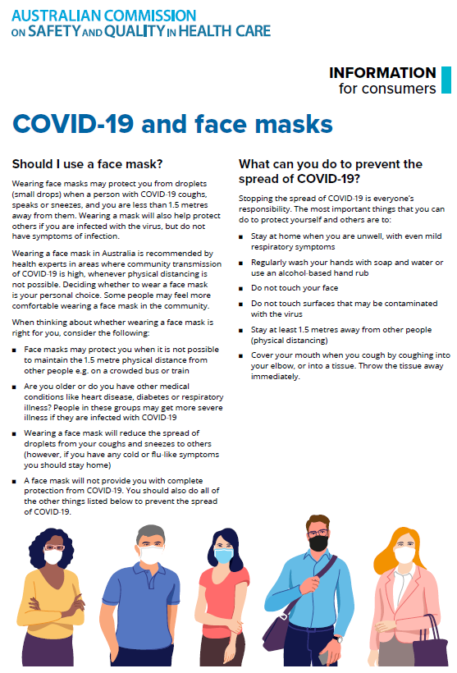](https://www.safetyandquality.gov.au/sites/default/files/2020-07/covid-19_and_face_masks_-_information_for_consumers.pdf)

*National Clinical Evidence Taskforce*

<https://clinicalevidence.net.au/>

The National Clinical Evidence Taskforce is a multi-disciplinary collaboration of 35 member organisations – Australia’s medical colleges and peak health organisations – who share a commitment to provide national evidence-based treatment guidelines for urgent and emerging diseases.

This alliance established the world’s first ‘living guidelines’ for the care of people with COVID-19 and MPX.

Funding has now been discontinued for the National Clinical Evidence Taskforce and the COVID-19 guidelines as of 30 June 2023.

These guidelines are no longer continually updated but will remain online until the guidance becomes inaccurate and/or no longer reflects the evidence or recommended practice.

*COVID-19 Critical Intelligence Unit*

<https://www.aci.health.nsw.gov.au/covid-19/critical-intelligence-unit>

The Agency for Clinical Innovation (ACI) in New South Wales has developed this page summarising rapid, evidence-based advice during the COVID-19 pandemic. Its operations focus on systems intelligence, clinical intelligence and evidence integration. The content includes a daily evidence digest, a COVID status monitor, a risk monitoring dashboard and evidence checks on a discrete topic or question relating to the current COVID-19 pandemic. There is also a ‘Living evidence’ section summarising key studies and emerging evidence on **COVID-19 vaccines** and **SARS-CoV-2 variants**. The most recent updates include:

* ***SARS-CoV-2 variants - retired living evidence*** – What is the evidence on SARS-CoV-2 variants that are under monitoring by the World Health Organization?
* ***COVID-19 vaccines - retired living evidence*** – What is the evidence on COVID-19 vaccine effectiveness and safety?
* ***Current and emerging patient safety issues during COVID-19*** – What is the evidence on the current and emerging patient safety issues arising from the COVID-19 pandemic?
* ***Bivalent COVID-19 vaccines*** – What is the available regulatory and research evidence for bivalent COVID-19 vaccines?
* ***Surgery post COVID-19*** – What is the evidence for the timing of surgery, and outcomes following surgery, for people who have recovered from COVID-19?
* ***Paxlovid*** – What is the evidence for Paxlovid for treatment of COVID-19?
* ***Molnupiravir*** –What is the evidence for and regulatory context of molnupiravir for treatment of COVID-19?
* ***Eating disorders and COVID-19*** – What is the impact of the COVID-19 pandemic on the prevalence of eating disorders?
* ***Long COVID –*** What is the evidence on the prevalence, presentation and management of long-COVID?
* ***Oseltamivir (Tamiflu) use in healthcare settings*** – What is the evidence that use of oseltamivir in healthcare workers with a symptomatic influenza diagnosis result in an earlier return to work and reduced absenteeism? What is the evidence that use of oseltamivir in adults and children with symptomatic influenza reduces influenza transmission in health care settings?
* ***Alternative models of care for acute medical conditions*** – What is the evidence on alternative models of care for managing patients with acute medical conditions outside of emergency or inpatient hospital settings?
* ***Exercise and long COVID*** – Is exercise helpful in individuals with long COVID? Is post-exertional symptom exacerbation a risk in long COVID?
* ***Influenza and seasonal prophylaxis with oseltamivir*** – What is the place or evidence for seasonal influenza prophylaxis (such as taking oseltamivir for 10 to 12 weeks continuously) in healthcare and aged care settings?
* ***Rapid access models of care for respiratory illnesses*** – What is the evidence for rapid access models of care for respiratory illnesses, especially during winter seasons, in emergency departments?
* ***Post-acute sequelae of COVID-19*** – What is the evidence on the post-acute sequelae of COVID-19?
* ***Emerging variants*** – What is the available evidence for emerging variants?
* ***Chest pain or dyspnoea following COVID-19 vaccination*** – What is evidence for chest pain or dyspnoea following COVID-19 vaccination?
* ***Cardiac investigations and elective surgery post-COVID-19*** – What is evidence for cardiac investigations and elective surgery post-COVID-19?
* ***Breathlessness post COVID-19*** – How to determine those patients who present with ongoing breathlessness in need of urgent review or intervention due to suspected pulmonary embolus?
* ***COVID-19 pandemic and influenza*** – What is the evidence for COVID-19 pandemic and influenza?
* ***Budesonide and aspirin for pregnant women with COVID-19 –*** What is the evidence for the use of Budesonide for pregnant women with COVID-19? What is the evidence for aspirin prophylaxis for pre-eclampsia in pregnant women with a COVID-19 infection?
* ***COVID-19 vaccines in Australia*** – What is the evidence on COVID-19 vaccines in Australia?
* ***COVID-19 pandemic and wellbeing of critical care and other healthcare workers*** – Evidence in brief on the impact of the COVID-19 pandemic on the wellbeing of critical care and other healthcare workers.
* ***Disease modifying treatments for COVID-19 in children*** – What is the evidence for disease modifying treatments for COVID-19 in children?
* ***Mask type for COVID-19 positive wearer*** – What is the evidence for different mask types for COVID-19 positive wearers?
* ***Post acute and subacute COVID-19 care*** – What published advice and models of care are available regarding post-acute and subacute care for COVID-19 patients?
* ***Hospital visitor policies*** – What is the evidence for hospital visitor policies during and outside of the COVID-19 pandemic?
* ***Surgical masks, eye protection and PPE guidance*** –What is the evidence for surgical masks in the endemic phase in hospitals and for eyewear to protect against COVID-19?

**Disclaimer**

On the Radar is an information resource of the Australian Commission on Safety and Quality in Health Care. The Commission is not responsible for the content of, nor does it endorse, any articles or sites listed. The Commission accepts no liability for the information or advice provided by these external links. Links are provided on the basis that users make their own decisions about the accuracy, currency and reliability of the information contained therein. Any opinions expressed are not necessarily those of the Australian Commission on Safety and Quality in Health Care.