# Australian Commission on Safety and Quality logotype On the Radar

Issue 616

21 August 2023

*On the Radar* is a summary of some of the recent publications in the areas of safety and quality in health care. Inclusion in this document is not an endorsement or recommendation of any publication or provider. Access to particular documents may depend on whether they are Open Access or not, and/or your individual or institutional access to subscription sites/services. Material that may require subscription is included as it is considered relevant.

*On the Radar* is available online, via email or as a PDF or Word document from <https://www.safetyandquality.gov.au/newsroom/subscribe-news/radar>

If you would like to receive *On the Radar* via email, you can subscribe on our website <https://www.safetyandquality.gov.au/newsroom/subscribe-news>  
or by emailing us at H[Umail@safetyandquality.gov.auU](mailto:mail@safetyandquality.gov.au).   
You can also send feedback and comments to H[Umail@safetyandquality.gov.auU](mailto:mail@safetyandquality.gov.au).

For information about the Commission and its programs and publications, please visit <https://www.safetyandquality.gov.au>

You can also follow us on Twitter @ACSQHC.

**On the Radar**

Editor: Dr Niall Johnson [niall.johnson@safetyandquality.gov.au](mailto:niall.johnson@safetyandquality.gov.au)

Contributors: Niall Johnson

**Reports**

*Overworked and Undervalued: Unmasking Primary Care Physicians’ Dissatisfaction in 10 High-Income Countries — Findings from the 2022 International Health Policy Survey*

Issue Briefs

Gumas ED, Gunja MZ, Shah A, Williams RD II

New York: Commonwealth Fund; 2023.

*Responding to Burnout and Moral Injury Among Clinicians*

Hostetter M, Klein S

New York: Commonwealth Fund; 2023.

|  |  |
| --- | --- |
| URL | Gumas et al <https://doi.org/10.26099/t0y2-6k44>  Hostetter and Klein <https://doi.org/10.26099/k72x-t469> |
| Notes | Two reports from the Commonwealth Fund in the USA that both touch on the experiences and pressures on clinicians.  Gumas et al is the latest in their regular comparisons of aspects health systems in a group of high income nations, including the USA and Australia. This report looks at ‘primary care physician work satisfaction in the first year of the pandemic — 2020 to 2021’. During this time, many primary care physicians were not satisfied with their work and were concerned with the quality of the work, the time that they could spend with patients, the time spent on administrative tasks and their own work-life balance. In many of these surveys Australia tends to do somewhat better than some of the other nations, but in this survey while a lesser proportion of Australian respondents felt care had worsened, there was still much in common across the primary care physicians in the 10 nations studied.  Also from the Commonwealth Fund is a report on burnout and moral injury (Hostetter and Klein)). Burnout is relatively well-recognised and can’ can be defined as having too much work and not enough time or resources to do it’. However, this piece observes that ‘increasingly, clinicians are rejecting the term “burnout.” They say they’re not overworked or frustrated, but are instead demoralized by a health care system that puts profits ahead of patients.’ The term “moral injury” has been applied and this piece examines burnout and moral injury and some response. |

**Journal articles**

*The burden of antimicrobial resistance in the Americas in 2019: a cross-country systematic analysis*

Aguilar GR, Swetschinski LR, Weaver ND, Ikuta KS, Mestrovic T, Gray AP, et al

The Lancet Regional Health – Americas. 2023 [epub].

|  |  |
| --- | --- |
| DOI | <https://doi.org/10.1016/j.lana.2023.100561> |
| Notes | The prospect of antimicrobial resistance leading to significant morbidity and mortality has been raised for many years. This piece in *The Lancet Regional Health – Americas* demonstrates that these are already occurring. This study ‘estimated 569,000 deaths (95% UI 406,000–771,000) associated with bacterial AMR and 141,000 deaths (99,900–196,000) attributable to bacterial AMR among the 35 countries in the WHO Region of the Americas in 2019.’ |

For information on the Commission’s work on antimicrobial resistance, see <https://www.safetyandquality.gov.au/our-work/antimicrobial-resistance>

*The changing landscape of clinical trials in Australia*

Seidler AL, Willson ML, Aberoumand M, Williams JG, Hunter KE, Barba A, et al.

Medical Journal of Australia. 2023 [epub].

|  |  |
| --- | --- |
| DOI | <https://doi.org/10.5694/mja2.52059> |
| Notes | Perspective piece in the *Medical Journal of Australia* describing the environment around clinical trials in Australia, including trends and significant changes. Among the aspects noted is that ‘Australian trial activity (number of trials per capita) compares favourably with other OECD countries, with more activity in Australia than in France, Germany, and the United States’. The authors suggest that ‘An even further improvement of Australia's trial activity could be achieved by better integration of trial research in routine health care’ and that the ‘implementation of the Australian Commission on Safety and Quality in Health Care National Clinical Trials Governance Framework in public and private health services is expected to address this need’. Further, ‘Streamlining of approval processes for trial start-up is anticipated through the proposed National One Stop Shop platform.’ |

For information on the *National Clinical Trials Governance Framework*, see <https://www.safetyandquality.gov.au/standards/national-clinical-trials-governance-framework>

For information on The National One Stop Shop - a national cross government platform for health-related human research, see <https://www.safetyandquality.gov.au/our-work/health-and-human-research/national-one-stop-shop-national-platform-health-related-human-research>

*The impact of transition to a digital hospital on medication errors (TIME study)*

Engstrom T, McCourt E, Canning M, Dekker K, Voussoughi P, Bennett O, et al

npj Digital Medicine. 2023 2023/07/25;6(1):133.

|  |  |
| --- | --- |
| DOI | <https://doi.org/10.1038/s41746-023-00877-w> |
| Notes | Paper reporting on the experience of a Queensland heath service where ‘a new digital hospital has been established and two wards from a neighbouring paper-based hospital transitioned into the new digital hospital’. The authors examine the ‘impact of transition from a paper-based to digital hospital on voluntarily reported medication incidents and prescribing errors’. The authors report that:   * The average monthly number of errors reduces from 12.5 pre- to 7.5 post-transition. * From a chart audit, 5072 medication orders are reviewed pre-transition and 3699 reviewed post-transition. The rates of orders with one or more error reduces significantly after transition (52.8% pre- vs. 15.7% post-, p < 0.001). * There are significant reductions in procedural (32.1% pre- vs. 1.3% post-, p < 0.001), and dosing errors (32.3% pre- vs. 14% post-, p < 0.001), but not therapeutic errors (0.6% pre- vs. 0.7% post-, p = 0.478). * Transition to a digital hospital is associated with reductions in voluntarily reported medication incidents and prescribing errors. |

For information on the Commission’s work on medication safety, see <https://www.safetyandquality.gov.au/our-work/medication-safety>

*Hiding in plain sight: Inconvenient facts for patient safety in non-24/7 theatre on-site staffed obstetric units*

McGurgan P

Australian and New Zealand Journal of Obstetrics and Gynaecology. 2023;63(4):606-611.

|  |  |
| --- | --- |
| DOI | <https://doi.org/10.1111/ajo.13701> |
| Notes | Opinion piece written by a consultant obstetrician reflecting on patient safety issues facing smaller obstetric units. The authors observes that such units ‘are resourced and staffed, such that depending on the time of day, the risk for the women we care for can dramatically alter’. Among the features the author suggests that obstetric services ‘in high population density areas, or with more than 50 woman per year attempting VBAC’ [vaginal birth after a caesarean section] should have include on-site 24/7 staffed operating theatres, on-site high dependency units or intensive care units and co-located acute medical/surgical/paediatric/mental health services. |

*Assessment of a wearable fall prevention system at a Veterans Health Administration hospital*

Osborne TF, Veigulis ZP, Arreola DM, Vrublevskiy I, Suarez P, Curtin C, et al

DIGITAL HEALTH. 2023;9.

*Interventions to reduce falls in hospitals: a systematic review and meta-analysis*

Morris ME, Webster K, Jones C, Hill A-M, Haines T, McPhail S, et al

Age and Ageing. 2022;51(5):afac077.

|  |  |
| --- | --- |
| DOI | Osborne et al <https://doi.org/10.1177/20552076231187727>  Morris et al <https://doi.org/10.1093/ageing/afac077> |
| Notes | Osborne et al report on a study in a US Veterans Health Administration hospital that examined a technological intervention for preventing falls. The intervention involved a ‘integrated sensor-enabled wearable SmartSock system’ provided to patients considered to be at high risk of falling. The authors report that across the almost nine month study period, ‘There were 20.7 falls per 1000 ward days of care (WDOC) for those not using the SmartSocks compared to 9.2 falls per 1000 WDOC for patients using the SmartSocks.’  A 2022 systematic review and meta-analysis of interventions aimed at reducing falls in hospitals (Morris et al) was more sanguine about technological fixes, observing that ‘Chair alarms, bed alarms, wearable sensors and use of scored risk assessment tools were not associated with significant fall reductions.’ The study authors reported that ‘The only intervention that yielded a significant result in the meta-analysis was education, with a reduction in falls rates (RaR = 0.70 [0.51–0.96], P = 0.03) and the odds of falling (OR = 0.62 [0.47–0.83], P = 0.001).’ |

For information on the Commission’s work on falls prevention, see <https://www.safetyandquality.gov.au/our-work/comprehensive-care/related-topics/falls-prevention>

*Healthcare-associated infections in adult intensive care units: A multisource study examining nurses’ safety attitudes, quality of care, missed care, and nurse staffing*

Alanazi FK, Lapkin S, Molloy L, Sim J

Intensive and Critical Care Nursing. 2023;78:103480.

|  |  |
| --- | --- |
| DOI | <https://doi.org/10.1016/j.iccn.2023.103480> |
| Notes | Paper reporting on an Australian study that sought to examine ‘the association between safety attitudes, quality of care, missed care, nurse staffing levels, and the rate of healthcare-associated infection (HAI) in adult intensive care units (ICUs).’ Survey data from 314 nurses across eight ICUs was combined with infection incidence data. The authors report that ‘CUs with strong job satisfaction had lower incidence and nurse-reported frequency of CLABSI, CAUTI, and VAP. Missed care was common, with 73.11% of nurses reporting missing at least one required care activity on their last shift.’ The authors asset that ‘Positive safety culture and better nurse staffing levels can lower the rates of HAIs in ICUs. Improvements to nurse staffing will reduce nursing workloads, which may reduce missed care, increase job satisfaction, and, ultimately, reduce HAIs.’  A previous paper from the same authors had made a similar finding between safety culture and falls incidence (<https://doi.org/10.1111/jocn.16792>) |

For information on the Commission’s work on healthcare-associated infection, see <https://www.safetyandquality.gov.au/our-work/healthcare-associated-infection-program>

*BMJ Quality & Safety*

Volume 32, Issue 9, September 2023

|  |  |
| --- | --- |
| URL | <https://qualitysafety.bmj.com/content/32/9> |
| Notes | A new issue of *BMJ Quality & Safety* has been published. Many of the papers in this issue have been referred to in previous editions of *On the Radar* (when they were released online). Articles in this issue of *BMJ Quality & Safety* include:   * Editorial: **Clinical decision-making and algorithmic inequality** (Robert Challen, Leon Danon) * Editorial: How can we finally reduce **repetitive routine laboratory tests for hospitalised patients**? (Christopher Moriates) * Evaluating equity in performance of an electronic health record-based 6-month **mortality risk model to trigger palliative care consultation**: a retrospective model validation analysis (Stephanie Teeple, Corey Chivers, Kristin A Linn, Scott D Halpern, Nwamaka Eneanya, Michael Draugelis, Katherine Courtright) * Repurposing the Ordering of **Routine Laboratory Tests in Hospitalised Medical Patients** (RePORT): results of a cluster randomised stepped-wedge quality improvement study (Anshula Ambasta, Onyebuchi Omodon, Alyssa Herring, Leah Ferrie, Surakshya Pokharel, Ashi Mehta, Liberty Liu, Julia Hews-Girard, Cheuk Tam, Simon Taylor, Kevin Lonergan, Peter Faris, Diane Duncan, Douglas Woodhouse) * Effect of a health system **payment and quality improvement programme for tonsillectomy** in Ontario, Canada: an interrupted time series analysis (Sanjay Mahant, Jun Guan, Jessie Zhang, Sima Gandhi, Evan Jon Propst, Astrid Guttmann) * **Patient-centred outcomes of imaging tests**: recommendations for patients, clinicians and researchers (Matthew J Thompson, Monica Zigman Suchsland, Victoria Hardy, Danielle C Lavallee, Sally Lord, Emily Beth Devine, Jeffrey G Jarvik, Steven Findlay, Thomas A Trikalinos, Fiona M Walter, Roger Chou, Beverly B Green, Karen J Wernli, Annette L Fitzpatrick, Patrick M Bossuyt) * **Days alive and at home after hip fracture**: a cross-sectional validation of a patient-centred outcome measure using routinely collected data (Daniel I McIsaac, Robert Talarico, Angela Jerath, Duminda N Wijeysundera) |

*Australian Journal of Primary Health*

Volume 29, Number 4, August 2023

|  |  |
| --- | --- |
| URL | <https://www.publish.csiro.au/py/issue/11380> |
| Notes | A new issue of the *Australian Journal of Primary Health* has been published. Articles in this issue of the *Australian Journal of Primary Health* include:   * **Post-acute COVID-19 condition (PACC)**: a perspective on collaborative Australian research imperatives and primary health models of care (Emma Tippett, Danielle Hitch, Louis Irving and David Watters) * The acceptability and utility of **Indigenous youth health assessments**: a narrative systematic review (Jed Fraser, Deborah Askew, Ray Mahoney and Geoffrey Spurling) * Supporting **LGBTIQA+ communities in small rural settings**: a case study of health promotion in a community health service (Dianne Couch and Sherene Clow) * Curious thing, an **artificial intelligence (AI)-based conversational agent for COVID-19 patient management** (Josephine Sau Fan Chow, Victoria Blight, Marian Brown, Vanessa Glynn, Brian Lane, Amanda Larkin, Sonia Marshall, Prue Matthews, Mick Rowles and Bradley Warner) * Experience of **telehealth for receipt of primary health care**: an online survey of young people in a geographic region of Aotearoa New Zealand (Sally B Rose, Susan M Garrett and Eileen McKinlay) * Addressing **security threats affecting primary healthcare service delivery and uptake** in Nigeria (Prince Agwu and Obinna Onwujekwe) * Do medical alliances truly work? Perspectives on **health service utilisation among outpatients with chronic diseases** in Shanghai, China (Wanju Sun, Haiyan Zhu, Linyi Zhang, Zhaoxin Wang, Li Luo, Weigang Qi, Hualin Qi, Yingxue Hua, Xiang Gao, Ling Yuan and Jianwei Shi) * Allied health professionals’ contribution to care at **end of life in aged care settings** (Jennifer Tieman, Deidre Morgan, Kelly Jones, Sue Gordon and Amal Chakraborty) * Educational models, participant experience and outcomes of a diploma course in **practice management for Aboriginal Medical Services**: a qualitative study (Parker Magin, Anthony Paulson, Christopher O’Brien, Irena Patsan, Alison Fielding, Mieke van Driel and Linda Klein) * Experiences of overweight and obese patients with diabetes and practice nurses during implementation of a brief **weight management intervention in general practice** settings serving Culturally and Linguistically Diverse disadvantaged populations (Sumathi Govindasamy, Kristen Beek, Ken Yates, Rohan Jayasuriya, Rebecca Reynolds, John B F de Wit and Mark Harris) * **Chronic non-cancer pain management** – insights from Australian general practitioners: a qualitative descriptive study (Lucy Gilkes, Caroline Bulsara and Nahal Mavaddat) * Management of **chronic breathlessness in primary care**: what do GPs, non-GP specialists, and allied health professionals think? (Anthony Sunjaya, Allison Martin, Clare Arnott and Christine Jenkins0 * **Disruption caused by the COVID-19 pandemic** response from a Western Australian metropolitan general practice perspective: a qualitative descriptive study (Diane E Arnold-Reed, Caroline E Bulsara and Lucy Gilkes) * Reflections of **Australian general practitioners during the first year of the COVID-19 pandemic**: a qualitative study (Seren Ovington, Katrina Anderson, Melinda Choy and Emily Haesler) |

*BMJ Quality & Safety* online first articles

|  |  |
| --- | --- |
| URL | <https://qualitysafety.bmj.com/content/early/recent> |
| Notes | *BMJ Quality &Safety* has published a number of ‘online first’ articles, including:   * Editorial: **Education and educational interventions**: moving beyond information provision (Karen Mattick, Christy Noble) |

*International Journal for Quality in Health Care* online first articles

|  |  |
| --- | --- |
| URL | <https://academic.oup.com/intqhc/advance-articles> |
| Notes | *International Journal for Quality in Health Care* has published a number of ‘online first’ articles, including:   * Quality improvement collaborative to optimize **heart failure care** in patients from a network of clinics in Argentina during COVID-19 pandemic (Facundo Jorro Barón et al) * **Harnessing Patient Complaints** to Systematically Monitoring Healthcare Concerns through Disproportionality Analysis (Søren Bie Bogh et al) * **Patient-Centered Care**: the North Star to guide us during uncertainty into a better day (Susan B Frampton and Michael Giuliano) |

**Online resources**

***Health Innovation Series - e-Medication Safety***

<https://www.mq.edu.au/research/research-centres-groups-and-facilities/healthy-people/centres/australian-institute-of-health-innovation/our-projects/Health-Innovation-Series/health-innovation-series-e-medication-safety>

The Health Innovation Series from the Australian Institute of Health Innovation at Macquarie University has had a number of recent issues, including:

* Default first dose times can cause deadly double doses
* How free-text fields can lead to medication errors
* First in line: optimising order sentence display reduces selection errors
* Making order sentences work for you: search tips for prescribers
* Keeping staff safe when handling hazardous medication: it’s not only cytotoxics that are risky
* Stop! Is that weight out-of-date? preventing dose errors in children.

**COVID-19 resources**

https://www.safetyandquality.gov.au/covid-19

The Australian Commission on Safety and Quality in Health Care has developed a number of resources to assist healthcare organisations, facilities and clinicians. These and other material on COVID-19 are available at <https://www.safetyandquality.gov.au/covid-19>

These resources include:

* ***OVID-19 infection prevention and control risk management*** This primer provides an overview of three widely used tools for investigating and responding to patient safety events and near misses. Tools covered in this primer include incident reporting systems, Root Cause Analysis (RCA), and Failure Modes and Effects Analysis (FMEA).   
  <https://www.safetyandquality.gov.au/publications-and-resources/resource-library/covid-19-infection-prevention-and-control-risk-management-guidance>
* ***Poster – Combined contact and droplet precautions*** <https://www.safetyandquality.gov.au/publications-and-resources/resource-library/infection-prevention-and-control-poster-combined-contact-and-droplet-precautions>  
  [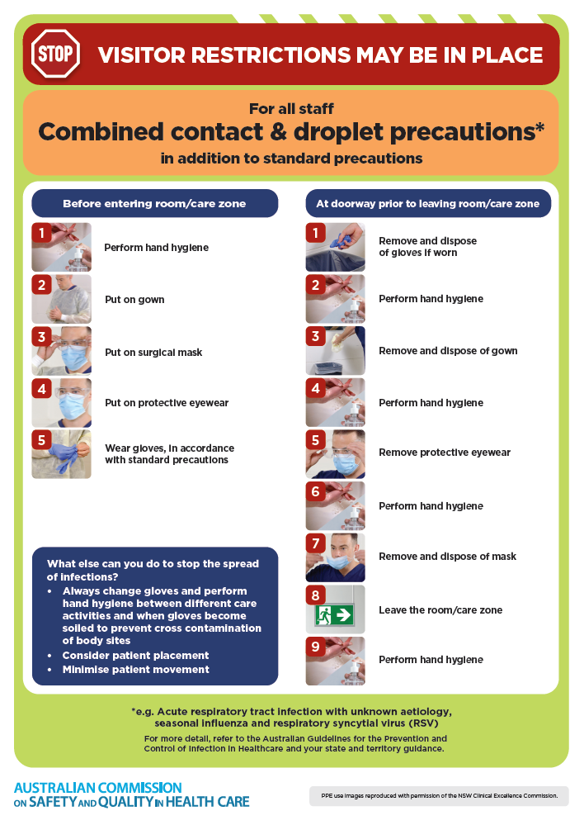](https://www.safetyandquality.gov.au/publications-and-resources/resource-library/infection-prevention-and-control-poster-combined-contact-and-droplet-precautions)
* ***Poster – Combined airborne and contact precautions*** <https://www.safetyandquality.gov.au/publications-and-resources/resource-library/poster-combined-airborne-and-contact-precautions>   
  [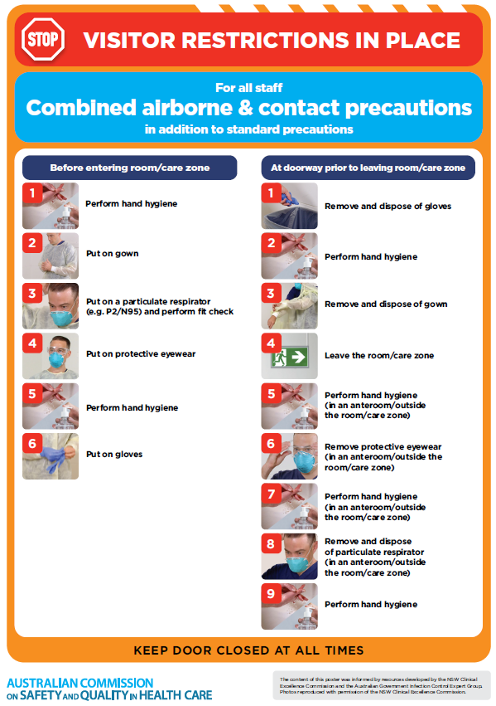](https://www.safetyandquality.gov.au/publications-and-resources/resource-library/poster-combined-airborne-and-contact-precautions)
* ***Environmental Cleaning and Infection Prevention and Control*** [www.safetyandquality.gov.au/environmental-cleaning](http://www.safetyandquality.gov.au/environmental-cleaning)
* ***COVID-19 infection prevention and control risk management – Guidance*** <https://www.safetyandquality.gov.au/publications-and-resources/resource-library/covid-19-infection-prevention-and-control-risk-management-guidance>
* ***Safe care for people with cognitive impairment during COVID-19***<https://www.safetyandquality.gov.au/our-work/cognitive-impairment/cognitive-impairment-and-covid-19>
* ***Stop COVID-19: Break the chain of infection*** posterhttps://www.safetyandquality.gov.au/publications-and-resources/resource-library/break-chain-infection-poster-a3  
  **[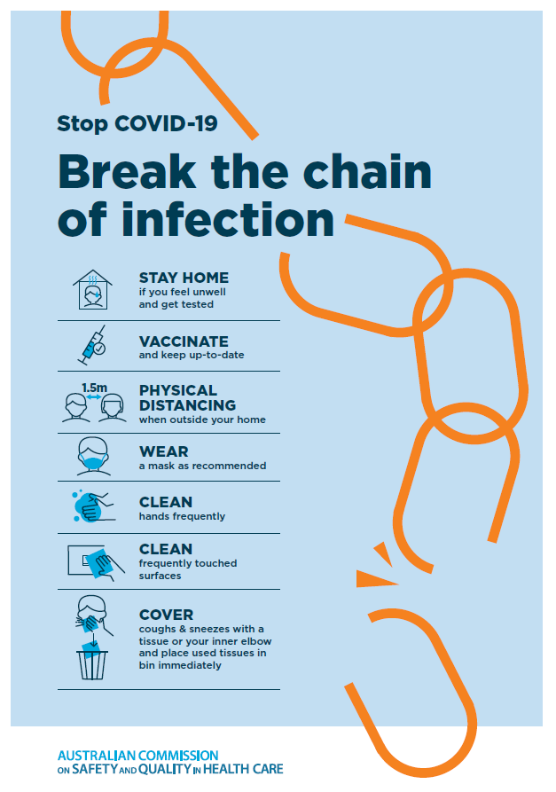](https://www.safetyandquality.gov.au/publications-and-resources/resource-library/break-chain-poster-a3https:/www.safetyandquality.gov.au/publications-and-resources/resource-library/break-chain-poster-a3)**
* ***COVID-19 and face masks – Information for consumers*** <https://www.safetyandquality.gov.au/publications-and-resources/resource-library/covid-19-and-face-masks-information-consumers>

[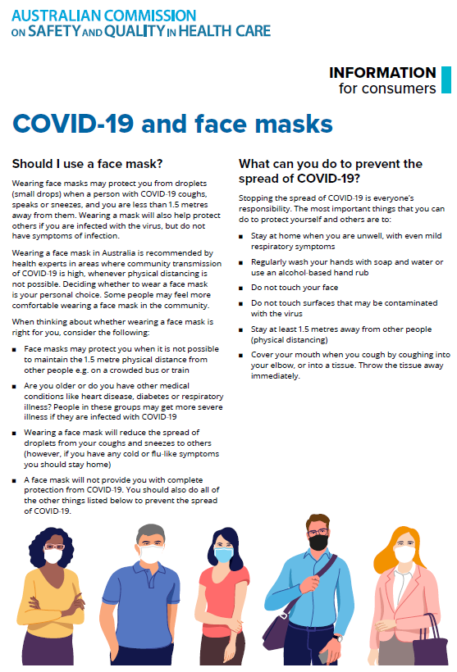](https://www.safetyandquality.gov.au/sites/default/files/2020-07/covid-19_and_face_masks_-_information_for_consumers.pdf)

*National Clinical Evidence Taskforce*

<https://clinicalevidence.net.au/>

The National Clinical Evidence Taskforce is a multi-disciplinary collaboration of 35 member organisations – Australia’s medical colleges and peak health organisations – who share a commitment to provide national evidence-based treatment guidelines for urgent and emerging diseases.

This alliance established the world’s first ‘living guidelines’ for the care of people with COVID-19 and MPX.

Funding has now been discontinued for the National Clinical Evidence Taskforce and the COVID-19 guidelines as of 30 June 2023.

These guidelines are no longer continually updated but will remain online until the guidance becomes inaccurate and/or no longer reflects the evidence or recommended practice.

*COVID-19 Critical Intelligence Unit*

<https://www.aci.health.nsw.gov.au/covid-19/critical-intelligence-unit>

The Agency for Clinical Innovation (ACI) in New South Wales has developed this page summarising rapid, evidence-based advice during the COVID-19 pandemic. Its operations focus on systems intelligence, clinical intelligence and evidence integration. The content includes a daily evidence digest, a COVID status monitor, a risk monitoring dashboard and evidence checks on a discrete topic or question relating to the current COVID-19 pandemic. There is also a ‘Living evidence’ section summarising key studies and emerging evidence on **COVID-19 vaccines** and **SARS-CoV-2 variants**. The most recent updates include:

* ***SARS-CoV-2 variants - retired living evidence*** – What is the evidence on SARS-CoV-2 variants that are under monitoring by the World Health Organization?
* ***COVID-19 vaccines - retired living evidence*** – What is the evidence on COVID-19 vaccine effectiveness and safety?
* ***Current and emerging patient safety issues during COVID-19*** – What is the evidence on the current and emerging patient safety issues arising from the COVID-19 pandemic?
* ***Bivalent COVID-19 vaccines*** – What is the available regulatory and research evidence for bivalent COVID-19 vaccines?
* ***Surgery post COVID-19*** – What is the evidence for the timing of surgery, and outcomes following surgery, for people who have recovered from COVID-19?
* ***Paxlovid*** – What is the evidence for Paxlovid for treatment of COVID-19?
* ***Molnupiravir*** –What is the evidence for and regulatory context of molnupiravir for treatment of COVID-19?
* ***Eating disorders and COVID-19*** – What is the impact of the COVID-19 pandemic on the prevalence of eating disorders?
* ***Long COVID –*** What is the evidence on the prevalence, presentation and management of long-COVID?
* ***Oseltamivir (Tamiflu) use in healthcare settings*** – What is the evidence that use of oseltamivir in healthcare workers with a symptomatic influenza diagnosis result in an earlier return to work and reduced absenteeism? What is the evidence that use of oseltamivir in adults and children with symptomatic influenza reduces influenza transmission in health care settings?
* ***Alternative models of care for acute medical conditions*** – What is the evidence on alternative models of care for managing patients with acute medical conditions outside of emergency or inpatient hospital settings?
* ***Exercise and long COVID*** – Is exercise helpful in individuals with long COVID? Is post-exertional symptom exacerbation a risk in long COVID?
* ***Influenza and seasonal prophylaxis with oseltamivir*** – What is the place or evidence for seasonal influenza prophylaxis (such as taking oseltamivir for 10 to 12 weeks continuously) in healthcare and aged care settings?
* ***Rapid access models of care for respiratory illnesses*** – What is the evidence for rapid access models of care for respiratory illnesses, especially during winter seasons, in emergency departments?
* ***Post-acute sequelae of COVID-19*** – What is the evidence on the post-acute sequelae of COVID-19?
* ***Emerging variants*** – What is the available evidence for emerging variants?
* ***Chest pain or dyspnoea following COVID-19 vaccination*** – What is evidence for chest pain or dyspnoea following COVID-19 vaccination?
* ***Cardiac investigations and elective surgery post-COVID-19*** – What is evidence for cardiac investigations and elective surgery post-COVID-19?
* ***Breathlessness post COVID-19*** – How to determine those patients who present with ongoing breathlessness in need of urgent review or intervention due to suspected pulmonary embolus?
* ***COVID-19 pandemic and influenza*** – What is the evidence for COVID-19 pandemic and influenza?
* ***Budesonide and aspirin for pregnant women with COVID-19 –*** What is the evidence for the use of Budesonide for pregnant women with COVID-19? What is the evidence for aspirin prophylaxis for pre-eclampsia in pregnant women with a COVID-19 infection?
* ***COVID-19 vaccines in Australia*** – What is the evidence on COVID-19 vaccines in Australia?
* ***COVID-19 pandemic and wellbeing of critical care and other healthcare workers*** – Evidence in brief on the impact of the COVID-19 pandemic on the wellbeing of critical care and other healthcare workers.
* ***Disease modifying treatments for COVID-19 in children*** – What is the evidence for disease modifying treatments for COVID-19 in children?
* ***Mask type for COVID-19 positive wearer*** – What is the evidence for different mask types for COVID-19 positive wearers?
* ***Post acute and subacute COVID-19 care*** – What published advice and models of care are available regarding post-acute and subacute care for COVID-19 patients?
* ***Hospital visitor policies*** – What is the evidence for hospital visitor policies during and outside of the COVID-19 pandemic?
* ***Surgical masks, eye protection and PPE guidance*** –What is the evidence for surgical masks in the endemic phase in hospitals and for eyewear to protect against COVID-19?

**Disclaimer**

On the Radar is an information resource of the Australian Commission on Safety and Quality in Health Care. The Commission is not responsible for the content of, nor does it endorse, any articles or sites listed. The Commission accepts no liability for the information or advice provided by these external links. Links are provided on the basis that users make their own decisions about the accuracy, currency and reliability of the information contained therein. Any opinions expressed are not necessarily those of the Australian Commission on Safety and Quality in Health Care.