# Australian Commission on Safety and Quality logotypeOn the Radar

Issue 617

28 August 2023

*On the Radar* is a summary of some of the recent publications in the areas of safety and quality in health care. Inclusion in this document is not an endorsement or recommendation of any publication or provider. Access to particular documents may depend on whether they are Open Access or not, and/or your individual or institutional access to subscription sites/services. Material that may require subscription is included as it is considered relevant.

*On the Radar* is available online, via email or as a PDF or Word document from <https://www.safetyandquality.gov.au/newsroom/subscribe-news/radar>

If you would like to receive *On the Radar* via email, you can subscribe on our website <https://www.safetyandquality.gov.au/newsroom/subscribe-news>  
or by emailing us at H[Umail@safetyandquality.gov.auU](mailto:mail@safetyandquality.gov.au).   
You can also send feedback and comments to H[Umail@safetyandquality.gov.auU](mailto:mail@safetyandquality.gov.au).

For information about the Commission and its programs and publications, please visit <https://www.safetyandquality.gov.au>

You can also follow us on Twitter @ACSQHC.

**On the Radar**

Editor: Dr Niall Johnson [niall.johnson@safetyandquality.gov.au](mailto:niall.johnson@safetyandquality.gov.au)

Contributors: Niall Johnson, Ashutosh Todkar

**Reports**

*Cambridge Elements: Improving Quality and Safety in Healthcare*

THIS Institute, Cambridge

|  |  |
| --- | --- |
| URL | <https://www.cambridge.org/core/publications/elements/elements-of-improving-quality-and-safety-in-healthcare> |
| Notes | The THIS Institute (The Healthcare Improvement Studies Institute) at the University of Cambridge has developed this series of open access publications. The series seeks to offer ‘a comprehensive and authoritative set of overviews of the different improvement approaches available, exploring the thinking behind them, examining evidence for each approach, and identifying areas of debate’.  Elements that have been published include:   * Workplace Conditions * Simulation as an Improvement Technique * Reducing Overuse * Implementation Science * Making Culture Change Happen * Co-Producing and Co-Designing * Collaboration-Based Approaches * The Positive Deviance Approach   Forthcoming Elements include:   * Approaches to Spread, Scale-Up, and Sustainability * Health Economics * Governance and Leadership |

*Harm caused by delays in transferring patients to the right place of care*

Independent report by the Healthcare Safety Investigation Branch NI-004133

Healthcare Safety Investigation Branch

Reading: HSIB; 2023. p. 42.

|  |  |
| --- | --- |
| URL | <https://www.hsib.org.uk/investigations-and-reports/harm-caused-by-delays-in-transferring-patients-to-the-right-place-of-care/> |
| Notes | The Healthcare Safety Investigation Branch in England has published their final report of an investigation examining the systems that are in place to manage the flow of patients through and out of hospitals and the interactions between the health and social care systems. The report observes that ‘Issues relating to patient flow affect ambulance crews’ ability to hand over patient care to ED [emergency department] staff. EDs are routinely at, or exceeding, their maximum capacity and this has an impact on their ability to provide safe care. The management of patient flow has further impacts across the healthcare system; these include delayed responses to …emergency calls and to calls that require an ambulance response, cancellation of elective (planned) surgery, and people staying in hospital longer than they need to.’  Among the finding of this and the interim reports are:   * The movement of patients into, through and out of hospitals has a direct impact on ambulances queuing at emergency departments and creates patient safety risks and issues throughout the healthcare system * Patient safety is managed differently across the UK healthcare system and does not consider the ‘air gap’ between health and social care * There is not a patient safety accountability framework which identifies individuals accountable and responsible for patient safety * Poor staff wellbeing due to stress, moral injury, incivility and burnout * Health services not being able to accept new patients because their hospital is full despite a significant number of patients being medically ft for discharge. This means patients in hospital who no longer need to be there but are unable to be safely discharged to the right place of care. * When hospitals are unable to accept new patients, this has a direct impact on flow on other hospitals who will see these patients in addition to their own. * Planned procedures may be delayed and/or cancelled due to the number of emergency procedures. * Initiatives to improve patient flow have focussed on performance targets in Eds rather than changes to the whole system to facilitate patient flow * The criteria to reside tool (a tool that helps clinicians determine appropriate discharge pathways) expects that patients on general wards should be reviewed twice daily to determine suitability for discharge (or need for care in hospital). This has not been consistently implemented across healthcare settings in England. |

**Journal articles**

*Reducing low value care: opportunities and challenges for Choosing Wisely campaigns*

Grimshaw JM, Levinson W

BMJ Evidence-Based Medicine 2023.

|  |  |
| --- | --- |
| DOI | <https://doi.org/10.1136/bmjebm-2023-112271> |
| Notes | Choosing Wisely (CW) campaigns in many countries have achieved remarkable penetration in healthcare organisations and professionals as well as citizens and patients. However, it’s difficult to quantify specific benefit at a population level leading to criticisms that Choosing Wisely campaigns have not achieved their goals. To address this criticism and maintain momentum, the authors of this article suggest, it is essential that CW campaigns focus on de-implementation of low value care to achieve the population and healthcare system benefits.  The authors of this piece occupy senior roles with Choosing Wisely Canada.  In Australia, Choosing Wisely has come under the auspices of the Australian Commission on Safety and Quality in Health Care. For further information about Choosing Wisely and the other Quality Use of Medicines (QUM) functions, see <https://www.safetyandquality.gov.au/our-work/transition-quality-use-medicines-programs> |

*The Joint Commission Journal on Quality and Patient Safety*

Volume 49, Issue 9, September 2023

|  |  |
| --- | --- |
| URL | <https://www.sciencedirect.com/journal/the-joint-commission-journal-on-quality-and-patient-safety/vol/49/issue/9> |
| Notes | A new issue of *The Joint Commission Journal on Quality and Patient Safety* has been published. Articles in this issue of *The Joint Commission Journal on Quality and Patient Safety* include:   * **Anesthesia Risk Alert Program**: A Proactive Safety Initiative (Brent Lee, Julie Marhalik-Helms, Leo Penzi) * **Virtual Multidisciplinary Rounds** to Reduce Length of Stay, Decrease Variation, and Promote Accountability (Krishna Nimmagadda, Susan Pancrazi, Anthony Martino, Eric Coleman, Narasa Madam, Nicole Goekler, Claudia Rodriguez, Sarah Kramer, Bharat Magu, Deb Aders) * Longitudinal Patterns in **Testosterone Prescribing** After US FDA Safety Communication in 2014 (Ashwini Sankar, Alexander O Everhart, Anupam B Jena, Molly M Jeffery, Joseph S Ross, Nilay D Shah, Pinar Karaca-Mandic) * The Positive Predictive Value of Hospital Discharge Data for Identifying **Severe Maternal Morbidity** With and Without Blood Transfusion (Sonya P Fabricant, Karen N Opara, Julianna V Paul, Gabriella Blissett, Alesandra R Rau, Jessica D White, Alodia Girma, I Sriprasert, L M Korst, E N Mitchell) * Optimizing **PROM Implementation** in Orthopedic Clinics for Longitudinal Outcome Monitoring: Lessons from a Multisite Study (Christina Pavetto, Martha Burla, Danielle C Lavallee, Timothy J Levison, Anthony M DiGioia, Patricia D Franklin) * Sociotechnical Work System Approach to **Occupational Fatigue** (Taylor L Watterson, Linsey M Steege, David A Mott, James H ord, Edward C Portillo, Michelle A Chui) * A Novel Web-Based and Mobile Application to Measure Real-Time **Moral Distress**: An Initial Pilot and Feasibility Study (Vanessa Amos, Nicholas Phair, Kevin Sullivan, Lucia D Wocial, Beth Epstein) * Preventing **Light Source-Related Burns** from Laparoscopy and Arthroscopy |

*Journal of Patient Safety*

Volume 19, Number 6, October 2023

|  |  |
| --- | --- |
| URL | <https://journals.lww.com/journalpatientsafety/toc/2023/10000> |
| Notes | A new issue of the *Journal of Patient Safety* has been published. Articles in this issue of the *Journal of Patient Safety* include:   * Status of **Patient Safety Culture in Community Pharmacy Settings**: A Systematic Review (Kyoung-Eun Kwon, Dal Ri Nam, Mo-Se Lee, Su-Jin Kim, Jae-Eun Lee, Sun-Young Jung) * Using **Failure Mode and Effect Analysis** to Identify Potential Failures in a Psychiatric Hospital Emergency Department (Sharon Gur-Arieh, Shlomo Mendlovic, Ronen Rozenblum, Racheli Magnezi) * **Patient Safety Perception Within Hospitals**: An Examination of Job Type, Handoffs and Information Exchange, and Hospital Management Support (Yue Ming, Rebecca Meehan) * The Additional Cost of **Perioperative Medication Errors** (Marin E Langlieb, Pranav Sharma, Mark Hocevar, Karen C Nanji) * Risk Factors for **Opioid-Related Adverse Drug Events** Among Older Adults After Hospitalization for Major Orthopedic Procedures (Shoshana J Herzig, Timothy S Anderson, Richard D Urman, Yoojin Jung, Long H Ngo, Ellen P McCarthy) * The Impact of a Patient Participating in **Evaluating Patient Safety** by Using the Patient Measure of Safety in Saudi Arabia: A Cross-Sectional Study (Amani K Al Zahrani, Yasser A Alaska, Nawaf M Alqahtani, Faisal Alotaibi, Mecciya Majrashi, Lamya Alhazani, Samar Binkheder, Fatemah Alghadheeb, Ghadah Alkhaldi, Abdullah B Hamdan, Rabab B Alkutbe) * **Patient Safety 2.0**: Slaying Dragons, Not Just Investigating Them (Alan J Card) * A Comprehensive Analysis of Risk Factors Associated With **Inpatient Falls** (Carley Warren, Eduardo Rizo, Edward Decker, Adam Hasse) * **Patient Safety Climate, Quality of Care, and Intention of Nursing Professionals to Remain in Their Job** During the COVID-19 Pandemic (Claire Nierva Herrera, Edinêis de Brito Guirardello) * Incorporating **Patient Safety and Quality Course Into the Nursing Curriculum:** An Assessment of Student Gains (Fasih Ali Ahmed, Roha Ahmad Choudhary, Hamza Khan, Farwa Ayub, Syed Sabih ul Hassan, Tahir Munir, Fozia Asif, Khairulnissa Ajani, Mehtab Jaffer, Zahra Tharani, Hanan J Aboumatar, Adil Haider, Asad Latif) |

*BMJ Quality & Safety* online first articles

|  |  |
| --- | --- |
| URL | <https://qualitysafety.bmj.com/content/early/recent> |
| Notes | *BMJ Quality &Safety* has published a number of ‘online first’ articles, including:   * Patient and family contributions to improve the diagnostic process through the **OurDX electronic health record tool**: a mixed method analysis (Sigall K Bell, Kendall Harcourt, Joe Dong, Catherine DesRoches, Nicholas J Hart, Stephen K Liu, Long Ngo, Eric J Thomas, Fabienne C. Bourgeois) |

*International Journal for Quality in Health Care* online first articles

|  |  |
| --- | --- |
| URL | <https://academic.oup.com/intqhc/advance-articles> |
| Notes | *International Journal for Quality in Health Care* has published a number of ‘online first’ articles, including:   * A scoping review of **clinical handover** mnemonic devices (Amos Yung et al) * A comparison of end-of-shift reports to an incident reporting system for **reporting incidents in the Intensive Care Unit** (Ishita Gupta et al) * **Barcode and radio-frequency identification utilization** varied across Korean hospitals (Noor Afif Mahmudah et al) * Leveraging collaborative learning for improved **heart failure care**: Insights from Argentina (Mohummad Hassan Raza Raja et al) |

**Online resources**

***[UK] NICE Guidelines and Quality Standards***

<https://www.nice.org.uk/guidance>

The UK’s National Institute for Health and Care Excellence (NICE) has published new (or updated) guidelines and quality standards. The latest reviews or updates include:

* NICE Guideline NG12 ***Suspected cancer****: recognition and referral* <https://www.nice.org.uk/guidance/ng12>
* NICE Guideline NG192 ***Caesarean birth*** <https://www.nice.org.uk/guidance/ng192>
* NICE Guideline NG126 ***Ectopic pregnancy and miscarriage****: diagnosis and initial management* <https://www.nice.org.uk/guidance/ng126>

**COVID-19 resources**

https://www.safetyandquality.gov.au/covid-19

The Australian Commission on Safety and Quality in Health Care has developed a number of resources to assist healthcare organisations, facilities and clinicians. These and other material on COVID-19 are available at <https://www.safetyandquality.gov.au/covid-19>

These resources include:

* ***OVID-19 infection prevention and control risk management*** This primer provides an overview of three widely used tools for investigating and responding to patient safety events and near misses. Tools covered in this primer include incident reporting systems, Root Cause Analysis (RCA), and Failure Modes and Effects Analysis (FMEA).   
  <https://www.safetyandquality.gov.au/publications-and-resources/resource-library/covid-19-infection-prevention-and-control-risk-management-guidance>
* ***Poster – Combined contact and droplet precautions*** <https://www.safetyandquality.gov.au/publications-and-resources/resource-library/infection-prevention-and-control-poster-combined-contact-and-droplet-precautions>  
  [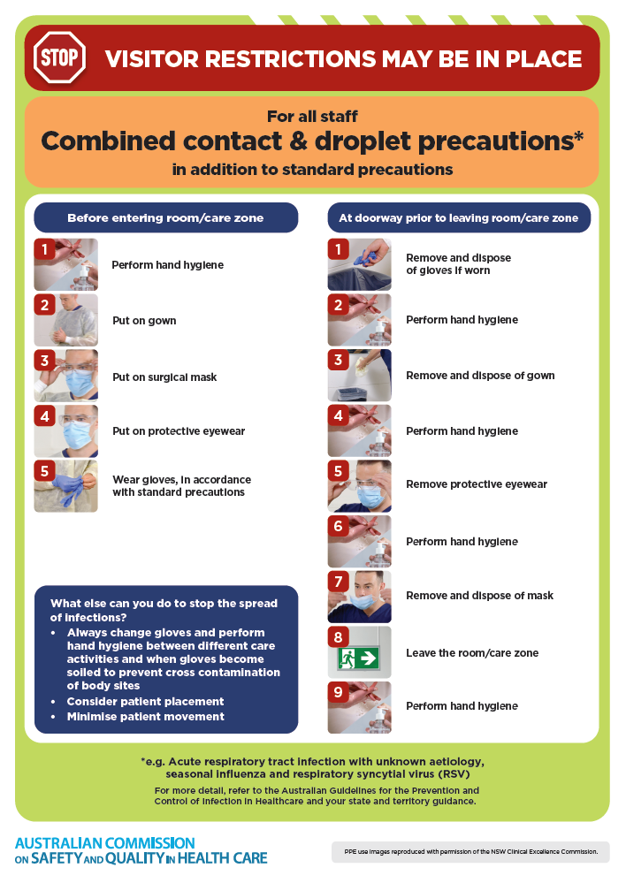](https://www.safetyandquality.gov.au/publications-and-resources/resource-library/infection-prevention-and-control-poster-combined-contact-and-droplet-precautions)
* ***Poster – Combined airborne and contact precautions*** <https://www.safetyandquality.gov.au/publications-and-resources/resource-library/poster-combined-airborne-and-contact-precautions>   
  [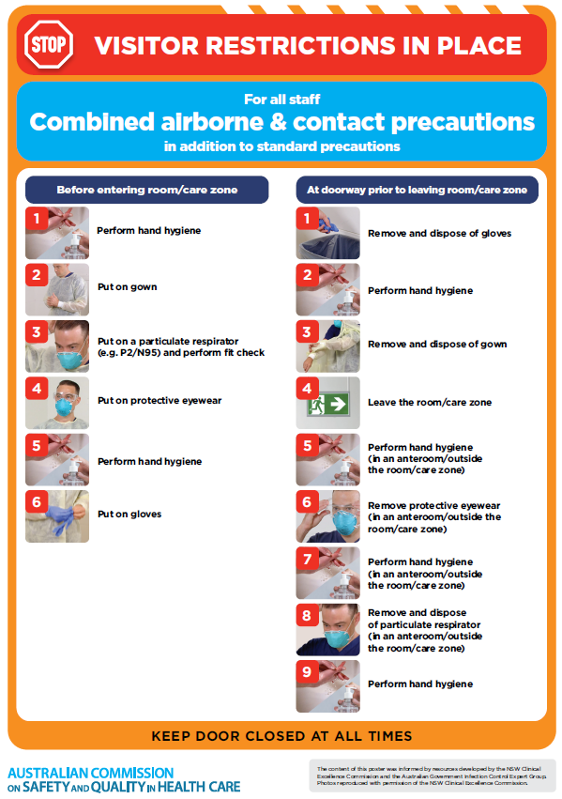](https://www.safetyandquality.gov.au/publications-and-resources/resource-library/poster-combined-airborne-and-contact-precautions)
* ***Environmental Cleaning and Infection Prevention and Control*** [www.safetyandquality.gov.au/environmental-cleaning](http://www.safetyandquality.gov.au/environmental-cleaning)
* ***COVID-19 infection prevention and control risk management – Guidance*** <https://www.safetyandquality.gov.au/publications-and-resources/resource-library/covid-19-infection-prevention-and-control-risk-management-guidance>
* ***Safe care for people with cognitive impairment during COVID-19***<https://www.safetyandquality.gov.au/our-work/cognitive-impairment/cognitive-impairment-and-covid-19>
* ***Stop COVID-19: Break the chain of infection*** posterhttps://www.safetyandquality.gov.au/publications-and-resources/resource-library/break-chain-infection-poster-a3  
  **[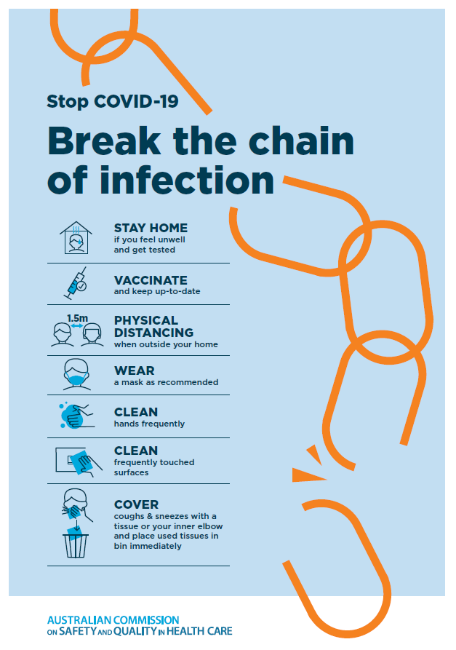](https://www.safetyandquality.gov.au/publications-and-resources/resource-library/break-chain-poster-a3https:/www.safetyandquality.gov.au/publications-and-resources/resource-library/break-chain-poster-a3)**
* ***COVID-19 and face masks – Information for consumers*** <https://www.safetyandquality.gov.au/publications-and-resources/resource-library/covid-19-and-face-masks-information-consumers>

[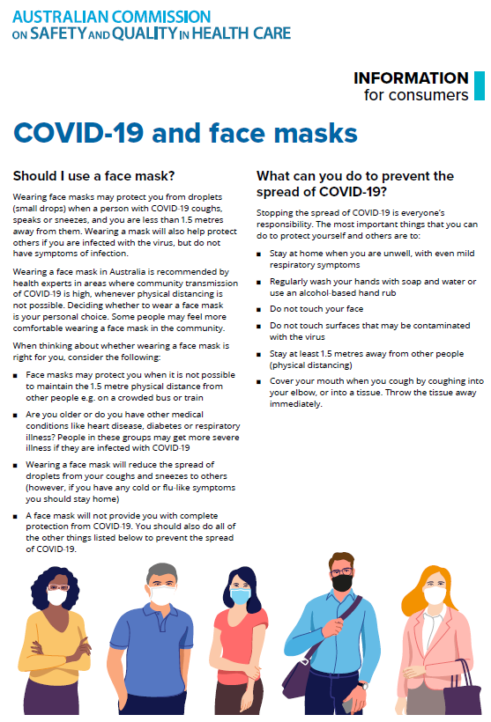](https://www.safetyandquality.gov.au/sites/default/files/2020-07/covid-19_and_face_masks_-_information_for_consumers.pdf)

*National Clinical Evidence Taskforce*

<https://clinicalevidence.net.au/>

The National Clinical Evidence Taskforce is a multi-disciplinary collaboration of 35 member organisations – Australia’s medical colleges and peak health organisations – who share a commitment to provide national evidence-based treatment guidelines for urgent and emerging diseases.

This alliance established the world’s first ‘living guidelines’ for the care of people with COVID-19 and MPX.

Funding has now been discontinued for the National Clinical Evidence Taskforce and the COVID-19 guidelines as of 30 June 2023.

These guidelines are no longer continually updated but will remain online until the guidance becomes inaccurate and/or no longer reflects the evidence or recommended practice.

*COVID-19 Critical Intelligence Unit*

<https://www.aci.health.nsw.gov.au/covid-19/critical-intelligence-unit>

The Agency for Clinical Innovation (ACI) in New South Wales has developed this page summarising rapid, evidence-based advice during the COVID-19 pandemic. Its operations focus on systems intelligence, clinical intelligence and evidence integration. The content includes a daily evidence digest, a COVID status monitor, a risk monitoring dashboard and evidence checks on a discrete topic or question relating to the current COVID-19 pandemic. There is also a ‘Living evidence’ section summarising key studies and emerging evidence on **COVID-19 vaccines** and **SARS-CoV-2 variants**. The most recent updates include:

* ***SARS-CoV-2 variants - retired living evidence*** – What is the evidence on SARS-CoV-2 variants that are under monitoring by the World Health Organization?
* ***COVID-19 vaccines - retired living evidence*** – What is the evidence on COVID-19 vaccine effectiveness and safety?
* ***Current and emerging patient safety issues during COVID-19*** – What is the evidence on the current and emerging patient safety issues arising from the COVID-19 pandemic?
* ***Bivalent COVID-19 vaccines*** – What is the available regulatory and research evidence for bivalent COVID-19 vaccines?
* ***Surgery post COVID-19*** – What is the evidence for the timing of surgery, and outcomes following surgery, for people who have recovered from COVID-19?
* ***Paxlovid*** – What is the evidence for Paxlovid for treatment of COVID-19?
* ***Molnupiravir*** –What is the evidence for and regulatory context of molnupiravir for treatment of COVID-19?
* ***Eating disorders and COVID-19*** – What is the impact of the COVID-19 pandemic on the prevalence of eating disorders?
* ***Long COVID –*** What is the evidence on the prevalence, presentation and management of long-COVID?
* ***Oseltamivir (Tamiflu) use in healthcare settings*** – What is the evidence that use of oseltamivir in healthcare workers with a symptomatic influenza diagnosis result in an earlier return to work and reduced absenteeism? What is the evidence that use of oseltamivir in adults and children with symptomatic influenza reduces influenza transmission in health care settings?
* ***Alternative models of care for acute medical conditions*** – What is the evidence on alternative models of care for managing patients with acute medical conditions outside of emergency or inpatient hospital settings?
* ***Exercise and long COVID*** – Is exercise helpful in individuals with long COVID? Is post-exertional symptom exacerbation a risk in long COVID?
* ***Influenza and seasonal prophylaxis with oseltamivir*** – What is the place or evidence for seasonal influenza prophylaxis (such as taking oseltamivir for 10 to 12 weeks continuously) in healthcare and aged care settings?
* ***Rapid access models of care for respiratory illnesses*** – What is the evidence for rapid access models of care for respiratory illnesses, especially during winter seasons, in emergency departments?
* ***Post-acute sequelae of COVID-19*** – What is the evidence on the post-acute sequelae of COVID-19?
* ***Emerging variants*** – What is the available evidence for emerging variants?
* ***Chest pain or dyspnoea following COVID-19 vaccination*** – What is evidence for chest pain or dyspnoea following COVID-19 vaccination?
* ***Cardiac investigations and elective surgery post-COVID-19*** – What is evidence for cardiac investigations and elective surgery post-COVID-19?
* ***Breathlessness post COVID-19*** – How to determine those patients who present with ongoing breathlessness in need of urgent review or intervention due to suspected pulmonary embolus?
* ***COVID-19 pandemic and influenza*** – What is the evidence for COVID-19 pandemic and influenza?
* ***Budesonide and aspirin for pregnant women with COVID-19 –*** What is the evidence for the use of Budesonide for pregnant women with COVID-19? What is the evidence for aspirin prophylaxis for pre-eclampsia in pregnant women with a COVID-19 infection?
* ***COVID-19 vaccines in Australia*** – What is the evidence on COVID-19 vaccines in Australia?
* ***COVID-19 pandemic and wellbeing of critical care and other healthcare workers*** – Evidence in brief on the impact of the COVID-19 pandemic on the wellbeing of critical care and other healthcare workers.
* ***Disease modifying treatments for COVID-19 in children*** – What is the evidence for disease modifying treatments for COVID-19 in children?
* ***Mask type for COVID-19 positive wearer*** – What is the evidence for different mask types for COVID-19 positive wearers?
* ***Post acute and subacute COVID-19 care*** – What published advice and models of care are available regarding post-acute and subacute care for COVID-19 patients?
* ***Hospital visitor policies*** – What is the evidence for hospital visitor policies during and outside of the COVID-19 pandemic?
* ***Surgical masks, eye protection and PPE guidance*** –What is the evidence for surgical masks in the endemic phase in hospitals and for eyewear to protect against COVID-19?

**Disclaimer**

On the Radar is an information resource of the Australian Commission on Safety and Quality in Health Care. The Commission is not responsible for the content of, nor does it endorse, any articles or sites listed. The Commission accepts no liability for the information or advice provided by these external links. Links are provided on the basis that users make their own decisions about the accuracy, currency and reliability of the information contained therein. Any opinions expressed are not necessarily those of the Australian Commission on Safety and Quality in Health Care.