# Australian Commission on Safety and Quality logotypeOn the Radar

Issue 618

4 September 2023

*On the Radar* is a summary of some of the recent publications in the areas of safety and quality in health care. Inclusion in this document is not an endorsement or recommendation of any publication or provider. Access to particular documents may depend on whether they are Open Access or not, and/or your individual or institutional access to subscription sites/services. Material that may require subscription is included as it is considered relevant.

*On the Radar* is available online, via email or as a PDF or Word document from <https://www.safetyandquality.gov.au/newsroom/subscribe-news/radar>

If you would like to receive *On the Radar* via email, you can subscribe on our website <https://www.safetyandquality.gov.au/newsroom/subscribe-news>  
or by emailing us at H[Umail@safetyandquality.gov.auU](mailto:mail@safetyandquality.gov.au).   
You can also send feedback and comments to H[Umail@safetyandquality.gov.auU](mailto:mail@safetyandquality.gov.au).

For information about the Commission and its programs and publications, please visit <https://www.safetyandquality.gov.au>

You can also follow us on Twitter @ACSQHC.

**On the Radar**

Editor: Dr Niall Johnson [niall.johnson@safetyandquality.gov.au](mailto:niall.johnson@safetyandquality.gov.au)

Contributors: Niall Johnson

**Journal articles**

*A Systems-Level Evaluation Framework for Virtual Care*

Lunney M, Modayil MV, Krajnak J, Woo K, Amlani S, Gray K, et al

Healthcare Quarterly 2023 Jul;26(2):43-50.

|  |  |
| --- | --- |
| DOI | <https://doi.org/10.12927/hcq.2023.27147> |
| Notes | The COVID-19 pandemic saw the escalation of virtual care and has subsequently become a routine mode for some care. This piece describes the development and use of a ‘a systems-level evaluation framework to inform virtual care service design and evaluation to take a more comprehensive approach to planning and implementing virtual care.’ |

*Transforming Health Care from Volume to Value: Moving the Needle Through Population Health*

Conway SJ, Kuye IO, Yeatts J, Jaffery J, Berkowitz SA

The American Journal of Medicine 2023 2023/09/01/;136(9):874-877.

|  |  |
| --- | --- |
| DOI | <https://doi.org/10.1016/j.amjmed.2023.04.031> |
| Notes | Recent years has seen an interest in questions of value, often focused on reducing “low value care”, but also touching on questions of efficiency, variation and appropriateness. This piece looks at ‘challenges in transitioning from volume-based to value-based care’ particularly from the perspective of academic or teaching hospitals/health services in the USA. The authors suggest that health services will need ‘o advance and formalize infrastructure in 3 core areas: organizational capabilities; provider engagement; and engagement of the patient, family, and community.’ |

*Healthcare fragmentation, multimorbidity, potentially inappropriate medication, and mortality: a Danish nationwide cohort study*

Prior A, Vestergaard CH, Vedsted P, Smith SM, Virgilsen LF, Rasmussen LA, et al

BMC Medicine 2023 2023/08/15;21(1):305.

|  |  |
| --- | --- |
| DOI | <https://doi.org/10.1186/s12916-023-03021-3> |
| Notes | The continuity or integration of care, especially for those with chronic conditions, has been widely identified as a means for providing improved care and outcomes. This paper reports a Danish study that aimed at looking at the impact of fragmented care at a population level. The ‘. Clinical fragmentation indicators included number of healthcare contacts, involved providers, provider transitions, and hospital trajectories.’ Using data on 4.7 million adults that covered ‘All healthcare contacts to primary care and hospitals during 2018’, the authors report that ‘The number of involved healthcare providers, provider transitions, and hospital trajectories rose with increasing morbidity levels.’ They also report ‘Care fragmentation was associated with higher rates of potentially inappropriate medication and increased mortality even when adjusting for the most important confounders.’ More positively, they also found that ‘Frequent contact to the usual provider, fewer transitions, and better coordination were associated with better patient outcomes regardless of morbidity level.’ |

*BMJ Quality & Safety* online first articles

|  |  |
| --- | --- |
| URL | <https://qualitysafety.bmj.com/content/early/recent> |
| Notes | *BMJ Quality &Safety* has published a number of ‘online first’ articles, including:   * Development and validation of the **Overall Fidelity Enactment Scale for Complex Interventions (OFES-CI)** (Liane Ginsburg, Matthias Hoben, Whitney Berta, Malcolm Doupe, Carole A Estabrooks, Peter G Norton, Colin Reid, Ariane Geerts, Adrian Wagg) |

*International Journal for Quality in Health Care* online first articles

|  |  |
| --- | --- |
| URL | <https://academic.oup.com/intqhc/advance-articles> |
| Notes | *International Journal for Quality in Health Care* has published a number of ‘online first’ articles, including:   * **Suicide and Stigma**: Connections and Challenges (Yu Xiao et al) * **Provider-patient experiences and HIV care utilization** among people living with HIV who inject drugs in St. Petersburg, Russia (Anita Raj et al) |

**Online resources**

***[UK] NICE Guidelines and Quality Standards***

<https://www.nice.org.uk/guidance>

The UK’s National Institute for Health and Care Excellence (NICE) has published new (or updated) guidelines and quality standards. The latest reviews or updates include:

* NICE Guideline NG233 ***Otitis media*** *with effusion in under 12s* <https://www.nice.org.uk/guidance/ng233>

***[UK] NIHR Evidence***

<https://evidence.nihr.ac.uk/>

The UK’s National Institute for Health Research (NIHR) has posted new evidence alerts on its site. Evidence alerts are short, accessible summaries of health and care research which is funded or supported by NIHR. This is research which could influence practice and each Alert has a message for people commissioning, providing or receiving care. The latest alerts include:

* How to **identify dementia** in people with hearing loss
* Personalised risk assessments could reassure parents of children with a disorder caused by a **chance genetic mutation**
* Small amounts of **exercise** protect against early death, heart disease and cancer
* **Epilepsy**: what are the chances of having a second seizure?
* Do people with **severe gut problems** need emergency surgery?
* **Freedom to Speak Up Guardians** need more support, study finds.

***[USA] Effective Health Care Program reports***

<https://effectivehealthcare.ahrq.gov/>

The US Agency for Healthcare Research and Quality (AHRQ) has an Effective Health Care (EHC) Program. The EHC has released the following final reports and updates:

* *Radiation Therapy for* ***Metastatic Bone Disease****: Effectiveness and Harms. Systematic Review* <https://effectivehealthcare.ahrq.gov/products/radiation-therapy-bone-metastases/research>

**COVID-19 resources**

https://www.safetyandquality.gov.au/covid-19

The Australian Commission on Safety and Quality in Health Care has developed a number of resources to assist healthcare organisations, facilities and clinicians. These and other material on COVID-19 are available at <https://www.safetyandquality.gov.au/covid-19>

These resources include:

* ***OVID-19 infection prevention and control risk management*** This primer provides an overview of three widely used tools for investigating and responding to patient safety events and near misses. Tools covered in this primer include incident reporting systems, Root Cause Analysis (RCA), and Failure Modes and Effects Analysis (FMEA).   
  <https://www.safetyandquality.gov.au/publications-and-resources/resource-library/covid-19-infection-prevention-and-control-risk-management-guidance>
* ***Poster – Combined contact and droplet precautions*** <https://www.safetyandquality.gov.au/publications-and-resources/resource-library/infection-prevention-and-control-poster-combined-contact-and-droplet-precautions>  
  [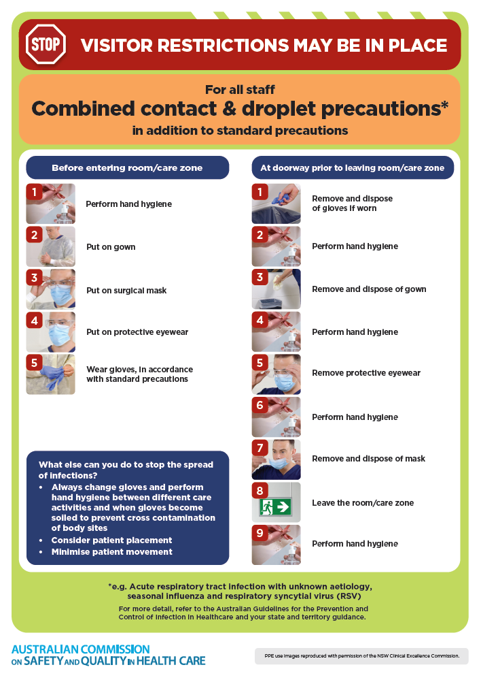](https://www.safetyandquality.gov.au/publications-and-resources/resource-library/infection-prevention-and-control-poster-combined-contact-and-droplet-precautions)
* ***Poster – Combined airborne and contact precautions*** <https://www.safetyandquality.gov.au/publications-and-resources/resource-library/poster-combined-airborne-and-contact-precautions>   
  [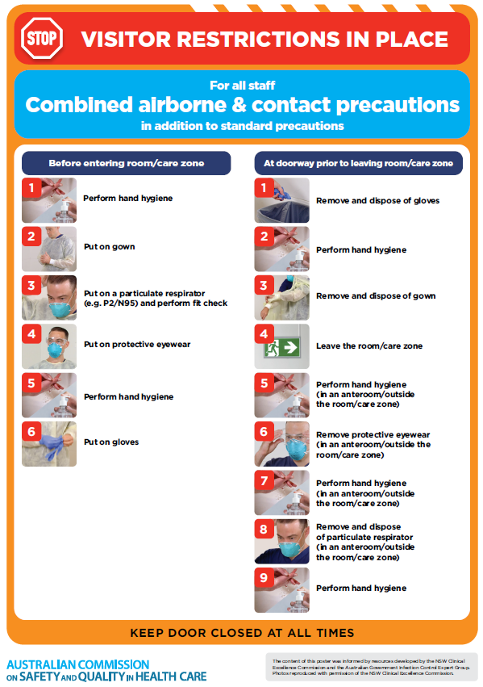](https://www.safetyandquality.gov.au/publications-and-resources/resource-library/poster-combined-airborne-and-contact-precautions)
* ***Environmental Cleaning and Infection Prevention and Control*** [www.safetyandquality.gov.au/environmental-cleaning](http://www.safetyandquality.gov.au/environmental-cleaning)
* ***COVID-19 infection prevention and control risk management – Guidance*** <https://www.safetyandquality.gov.au/publications-and-resources/resource-library/covid-19-infection-prevention-and-control-risk-management-guidance>
* ***Safe care for people with cognitive impairment during COVID-19***<https://www.safetyandquality.gov.au/our-work/cognitive-impairment/cognitive-impairment-and-covid-19>
* ***Stop COVID-19: Break the chain of infection*** posterhttps://www.safetyandquality.gov.au/publications-and-resources/resource-library/break-chain-infection-poster-a3  
  **[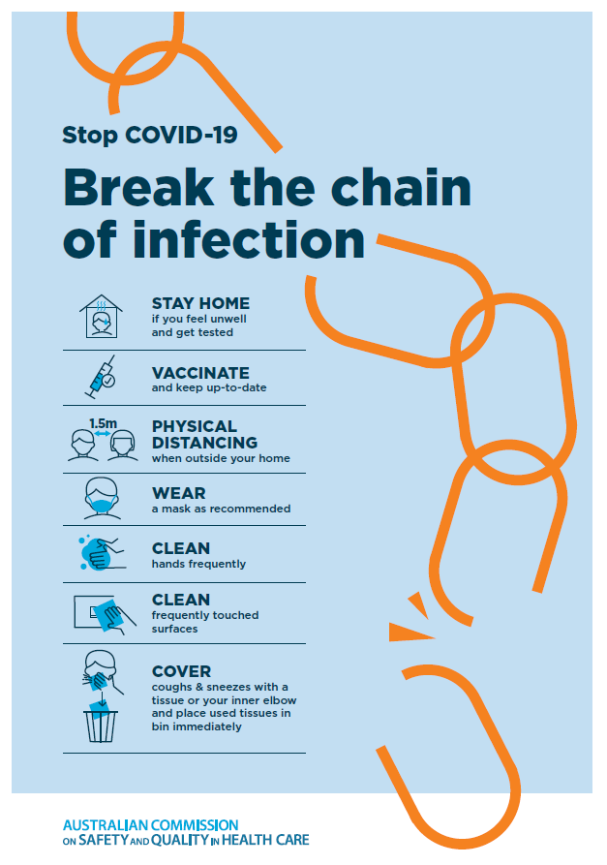](https://www.safetyandquality.gov.au/publications-and-resources/resource-library/break-chain-poster-a3https:/www.safetyandquality.gov.au/publications-and-resources/resource-library/break-chain-poster-a3)**
* ***COVID-19 and face masks – Information for consumers*** <https://www.safetyandquality.gov.au/publications-and-resources/resource-library/covid-19-and-face-masks-information-consumers>

[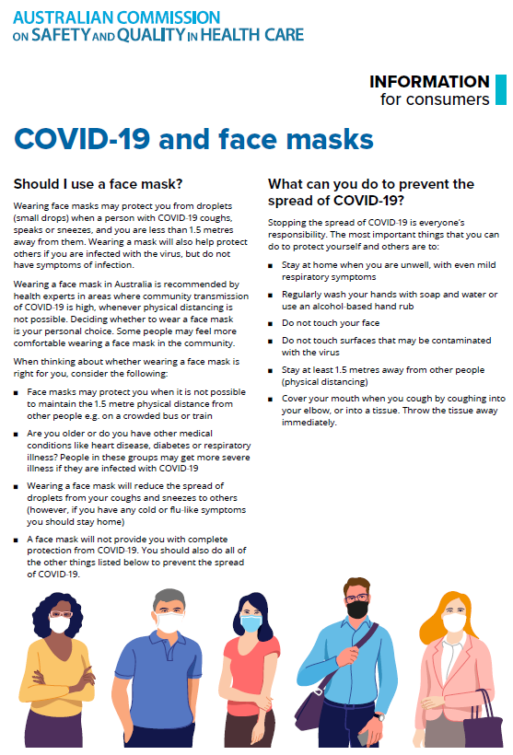](https://www.safetyandquality.gov.au/sites/default/files/2020-07/covid-19_and_face_masks_-_information_for_consumers.pdf)

*National Clinical Evidence Taskforce*

<https://clinicalevidence.net.au/>

The National Clinical Evidence Taskforce is a multi-disciplinary collaboration of 35 member organisations – Australia’s medical colleges and peak health organisations – who share a commitment to provide national evidence-based treatment guidelines for urgent and emerging diseases.

This alliance established the world’s first ‘living guidelines’ for the care of people with COVID-19 and MPX.

Funding has now been discontinued for the National Clinical Evidence Taskforce and the COVID-19 guidelines as of 30 June 2023.

These guidelines are no longer continually updated but will remain online until the guidance becomes inaccurate and/or no longer reflects the evidence or recommended practice.

*COVID-19 Critical Intelligence Unit*

<https://www.aci.health.nsw.gov.au/covid-19/critical-intelligence-unit>

The Agency for Clinical Innovation (ACI) in New South Wales has developed this page summarising rapid, evidence-based advice during the COVID-19 pandemic. Its operations focus on systems intelligence, clinical intelligence and evidence integration. The content includes a daily evidence digest, a COVID status monitor, a risk monitoring dashboard and evidence checks on a discrete topic or question relating to the current COVID-19 pandemic. There is also a ‘Living evidence’ section summarising key studies and emerging evidence on **COVID-19 vaccines** and **SARS-CoV-2 variants**. The most recent updates include:

* ***Surgery post COVID-19*** – What is the evidence for the timing of surgery, and outcomes following surgery, for people who have recovered from COVID-19?
* ***SARS-CoV-2 variants - retired living evidence*** – What is the evidence on SARS-CoV-2 variants that are under monitoring by the World Health Organization?
* ***COVID-19 vaccines - retired living evidence*** – What is the evidence on COVID-19 vaccine effectiveness and safety?
* ***Current and emerging patient safety issues during COVID-19*** – What is the evidence on the current and emerging patient safety issues arising from the COVID-19 pandemic?
* ***Bivalent COVID-19 vaccines*** – What is the available regulatory and research evidence for bivalent COVID-19 vaccines?
* ***Paxlovid*** – What is the evidence for Paxlovid for treatment of COVID-19?
* ***Molnupiravir*** –What is the evidence for and regulatory context of molnupiravir for treatment of COVID-19?
* ***Eating disorders and COVID-19*** – What is the impact of the COVID-19 pandemic on the prevalence of eating disorders?
* ***Long COVID –*** What is the evidence on the prevalence, presentation and management of long-COVID?
* ***Oseltamivir (Tamiflu) use in healthcare settings*** – What is the evidence that use of oseltamivir in healthcare workers with a symptomatic influenza diagnosis result in an earlier return to work and reduced absenteeism? What is the evidence that use of oseltamivir in adults and children with symptomatic influenza reduces influenza transmission in health care settings?
* ***Alternative models of care for acute medical conditions*** – What is the evidence on alternative models of care for managing patients with acute medical conditions outside of emergency or inpatient hospital settings?
* ***Exercise and long COVID*** – Is exercise helpful in individuals with long COVID? Is post-exertional symptom exacerbation a risk in long COVID?
* ***Influenza and seasonal prophylaxis with oseltamivir*** – What is the place or evidence for seasonal influenza prophylaxis (such as taking oseltamivir for 10 to 12 weeks continuously) in healthcare and aged care settings?
* ***Rapid access models of care for respiratory illnesses*** – What is the evidence for rapid access models of care for respiratory illnesses, especially during winter seasons, in emergency departments?
* ***Post-acute sequelae of COVID-19*** – What is the evidence on the post-acute sequelae of COVID-19?
* ***Emerging variants*** – What is the available evidence for emerging variants?
* ***Chest pain or dyspnoea following COVID-19 vaccination*** – What is evidence for chest pain or dyspnoea following COVID-19 vaccination?
* ***Cardiac investigations and elective surgery post-COVID-19*** – What is evidence for cardiac investigations and elective surgery post-COVID-19?
* ***Breathlessness post COVID-19*** – How to determine those patients who present with ongoing breathlessness in need of urgent review or intervention due to suspected pulmonary embolus?
* ***COVID-19 pandemic and influenza*** – What is the evidence for COVID-19 pandemic and influenza?
* ***Budesonide and aspirin for pregnant women with COVID-19 –*** What is the evidence for the use of Budesonide for pregnant women with COVID-19? What is the evidence for aspirin prophylaxis for pre-eclampsia in pregnant women with a COVID-19 infection?
* ***COVID-19 vaccines in Australia*** – What is the evidence on COVID-19 vaccines in Australia?
* ***COVID-19 pandemic and wellbeing of critical care and other healthcare workers*** – Evidence in brief on the impact of the COVID-19 pandemic on the wellbeing of critical care and other healthcare workers.
* ***Disease modifying treatments for COVID-19 in children*** – What is the evidence for disease modifying treatments for COVID-19 in children?
* ***Mask type for COVID-19 positive wearer*** – What is the evidence for different mask types for COVID-19 positive wearers?
* ***Post acute and subacute COVID-19 care*** – What published advice and models of care are available regarding post-acute and subacute care for COVID-19 patients?
* ***Hospital visitor policies*** – What is the evidence for hospital visitor policies during and outside of the COVID-19 pandemic?
* ***Surgical masks, eye protection and PPE guidance*** –What is the evidence for surgical masks in the endemic phase in hospitals and for eyewear to protect against COVID-19?

**Disclaimer**

On the Radar is an information resource of the Australian Commission on Safety and Quality in Health Care. The Commission is not responsible for the content of, nor does it endorse, any articles or sites listed. The Commission accepts no liability for the information or advice provided by these external links. Links are provided on the basis that users make their own decisions about the accuracy, currency and reliability of the information contained therein. Any opinions expressed are not necessarily those of the Australian Commission on Safety and Quality in Health Care.