# Australian Commission on Safety and Quality logotypeOn the Radar

Issue 619

11 September 2023

*On the Radar* is a summary of some of the recent publications in the areas of safety and quality in health care. Inclusion in this document is not an endorsement or recommendation of any publication or provider. Access to particular documents may depend on whether they are Open Access or not, and/or your individual or institutional access to subscription sites/services. Material that may require subscription is included as it is considered relevant.

*On the Radar* is available online, via email or as a PDF or Word document from <https://www.safetyandquality.gov.au/newsroom/subscribe-news/radar>

If you would like to receive *On the Radar* via email, you can subscribe on our website <https://www.safetyandquality.gov.au/newsroom/subscribe-news>  
or by emailing us at H[Umail@safetyandquality.gov.auU](mailto:mail@safetyandquality.gov.au).   
You can also send feedback and comments to H[Umail@safetyandquality.gov.auU](mailto:mail@safetyandquality.gov.au).

For information about the Commission and its programs and publications, please visit <https://www.safetyandquality.gov.au>

You can also follow us on Twitter @ACSQHC.

**On the Radar**

Editor: Dr Niall Johnson [niall.johnson@safetyandquality.gov.au](mailto:niall.johnson@safetyandquality.gov.au)

Contributors: Niall Johnson, Megan Ingman-Jones, Sarah Robertson, Amy Forysth

[](https://www.safetyandquality.gov.au/standards/clinical-care-standards/hip-fracture-care-clinical-care-standard)

**Launch of the updated Hip Fracture Clinical Care Standard**

<https://www.safetyandquality.gov.au/standards/clinical-care-standards/hip-fracture-care-clinical-care-standard>

The updated *Hip Fracture Clinical Care Standard* by the Australian Commission on Safety and Quality in Health care is released today at the Australian and New Zealand Hip Fracture Registry (ANZHFR) [Hip Fest 2023](https://anzhfr.org/hipfest2023/). It coincides with the release of the *ANZHFR Annual Report 2023*, which covers over 16,000 hip fracture records on care outcomes from 97 participating hospitals.

Each year 19,000 people present with a hip fracture. Amongst those, 1 in 4 people with a hip fracture die within a year. Hip fracture is a leading cause of death and morbidity in older people and the injury often leads to reduced mobility and a loss of the ability to live independently.

First released in 2016, the binational standard was developed by the Commission to improve how people with a hip fracture are assessed and managed to optimise the outcome and reduce their risk of another fracture.

Changes have been made to align the quality statements and indicators with the evidence base and current practice. Key updates in the 2023 standard include:

* Reducing time to surgery reduced from 48 to 36 hours of presenting at any hospital, including transfer times.
* The addition of cultural safety and equity considerations and better communication to ensure First Nations people receive safe and equitable care.
* An emphasis on identifying and managing malnutrition, fragility and delirium.
* Clarifying that nerve blocks should be provided early as part of pain management, including for transfer patients.

Learn more about the *Hip Fracture Clinical Care Standard* at <https://safetyandquality.gov.au/hipfracture-ccs>   
There is also a communications kit to help share the news with your networks available from <https://safetyandquality.gov.au/hipfracture-campaign>.

[](https://www.safetyandquality.gov.au/newsroom/consultations/consultation-draft-nsqhs-standards-guide-ambulance-health-services)

**Draft NSQHS Standards Guide for Ambulance Health Services**

<https://www.safetyandquality.gov.au/newsroom/consultations/consultation-draft-nsqhs-standards-guide-ambulance-health-services>

Consultation is now open on the draft *NSQHS Standards Guide for Ambulance Health Services*.

The draft Guide provides practical support and guidance for ambulance health services to implement the National Safety and Quality Health Service (NSQHS) Standards. It has been developed with the support of key stakeholders.

Your feedback will help ensure the draft Guide meets the needs of Ambulance Health Services implementing the NSQHS Standards.

Visit our website <https://www.safetyandquality.gov.au/newsroom/consultations/consultation-draft-nsqhs-standards-guide-ambulance-health-services> before 10 November 2023 to review the draft Guide.

[](https://safetyandquality.tv/national-medicines-symposium-2023/?utm_source=acsqh&utm_medium=signature&utm_campaign=nms23&utm_content=aug_reg)

**National Medicines Symposium 2023**

<https://safetyandquality.tv/national-medicines-symposium-2023/?utm_source=acsqh&utm_medium=signature&utm_campaign=nms23&utm_content=aug_reg>

*Join the conversation on the future of medicines and sustainability.*

Registrations are now open for the National Medicines Symposium 2023 on the future of medicines and sustainability, hosted by the Australian Commission on Safety and Quality in Health Care.

*Key highlights*

* Hear from experts, healthcare professionals, policymakers and thought leaders from around the world on how appropriate use of medicines can contribute to a sustainable healthcare system
* Gain insights into the significant impact of pharmaceutical waste and the role of medicines in contributing to greenhouse gases
* Explore innovative practices, initiatives, and success stories driving positive change in sustainable and quality use of medicines
* Join the conversation on fostering a culture of sustainability within health care, ensuring quality patient care while reducing waste

*Theme*: The future of medicines: good for people, good for the planet

*When*: Wednesday 8 November, 10.00 am - 4.30 pm (AEDT)

*Format*: Virtual event – featuring individual speakers and panel discussions

Register at <https://safetyandquality.tv/national-medicines-symposium-2023/?utm_source=acsqh&utm_medium=signature&utm_campaign=nms23&utm_content=aug_reg>

*Healthcare Policy*

Volume 19, Number 1, August 2023

|  |  |
| --- | --- |
| URL | <https://www.longwoods.com/publications/healthcare-policy/27151/1/vol.-19-no.-1-2023> |
| Notes | A new issue *Healthcare Policy* has been published. Articles in this issue of *Healthcare Policy* include:   * Editorial: Reversing the Stigma around Canada’s **Poor-Performing Healthcare Systems** (Jason M Sutherland) * Economic Evidence for **Home and Community Care Investment**: The Case for Ontario Personal Support Workers’ Wage Parity (Katherine A P Zagrodney, Emily C King, Deborah Simon, K A Nichol and S M McKay) * Commentary: Minding the Gap – Why Wage Parity Is Crucial for the **Care of Older Canadians** (Kristina M Kokorelias and Samir K Sinha) * **E-Mental Health Services** in Canada: Can They Close the Access Gap? (Evgenia Gatov, Gillian Strudwick, David Wiljer and Paul Kurdyak) * Commentary: Minding the Gap in **Access to Mental Health Services** – Calling for Smart Funding, Not Just More Funding (David Goldbloom and David Gratzer) * Reforming **Paediatric Drug Regulations** in Canada: A Clinical and an Access Imperative (Charlotte Moore Hepburn, A A Chang and D M Levy) * Commentary: The Injustice of **Paediatric Drug Labelling** in Canada – A Call to Action (Tamorah Lewis) * **Enterprise Healthcare Physician Services** in Canada: An Environmental Scan (Sheryl Spithoff and Lana Mogic) * How Timid or Bold Are Ministries of Health and Provincial Health Authorities in Canada in **Planning for Healthcare Quality**? (Benjamin T B Chan, Susmitha Rallabandi and Dan Florizone) * **COVID-19 Vaccine’s** Speed to Market and Vaccine Hesitancy: A Cross-Sectional Survey Study (Ally Memedovich, Brenlea Farkas, Aidan Hollis, Charleen Salmon, Jia Hu, Kate Zinszer, Tyler Williamsand Reed F Beall) * Productivity Decline or Administrative Avalanche? Examining Factors That Shape Changing **Workloads in Primary Care** (Ruth Lavergne, Sandra Peterson, David Rudoler, Ian Scott, Rita McCracken, G Mitra and A Katz) |

*Health Affairs*

Volume 42, Number 9, September 2023

|  |  |
| --- | --- |
| URL | <https://www.healthaffairs.org/toc/hlthaff/42/9> |
| Notes | A new issue of *Health Affairs* has been published with the themes ‘Medicare, Affordability And More’. Articles in this issue of *Health Affairs* include:   * Favorable Selection In **Medicare Advantage** Is Linked To Inflated Benchmarks And Billions In Overpayments To Plans (Andrew M Ryan, Zoey Chopra, David J Meyers, Erin C Fuse Brown, R C Murray, and T C Williams) * **Home-Based Medical Care Use** In Medicare Advantage And Traditional Medicare In 2018 (Jeffrey Marr, Christine Ritchie, B Leff, and K A Ornstein) * **Medicare Switching**: Patterns Of Enrollment Growth In Medicare Advantage, 2006–22 (Lanlan Xu, W. Pete Welch, Steven Sheingold, Nancy De Lew, and Benjamin D. Sommers) * Wide Variation In **Differences In Resource Use** Seen Across Conditions Between Medicare Advantage, Traditional Medicare (Jeah Jung, Caroline S Carlin, Roger Feldman, and Ge Song) * Growth In **Patient Cost Sharing** For Hospitalizations With And Without Intensive Care Among Commercially Insured Patients (Sneha Kannan, Jennifer Stevens, and Zirui Song) * **The Forgotten Middle**: Worsening Health And Economic Trends Extend To Americans With Modest Resources Nearing Retirement (Jack M Chapel, Bryan Tysinger, Dana P Goldman, John W Rowe, and The Research Network on an Aging Society) * **Health Care Service Price Comparison** Suggests That Employers Lack Leverage To Negotiate Lower Prices (Aditi . Sen, J Y Chang, and J Hargraves) * Health Care Costs Associated With **Hospice Use For People With Dementia** In The US (Melissa D Aldridge, Lauren J Hunt, Krista L Harrison, Karen McKendrick, Lihua Li, and R Sean Morrison) * The Effect Of Labor Unions On **Nursing Home Compliance With OSHA’s Workplace Injury And Illness Reporting** Requirement (Adam Dean, Jamie McCallum, Atheendar S Venkataramani, and David Michaels) * **Perinatal Care Measures** Are Incomplete If They Do Not Assess The Birth Parent–Infant Dyad As A Whole (S C Handley, B Formanowski, M Passarella, K B Kozhimannil, S A Leonard, E K Main, C S Phibbs, and S A Lorch) * Choosing Or Losing In **Behavioral Health**: A Study Of Patients’ Experiences Selecting **Telehealth Versus In-Person Care** (Jessica Sousa, Andrew Smith, Jessica Richard, Maya Rabinowitz, Pushpa Raja, Ateev Mehrotra, Alisa B Busch, Haiden A Huskamp, and Lori Uscher-Pines) * **Sexual Orientation, High-Deductible Health Plans, And Financial Barriers To Care** (Nathaniel M Tran, Samuel Mann, and Gilbert Gonzales) * Extramural US Federal Research Grants For **Health Outcomes Associated With Climate Change** Inadequate, Too Narrow In Focus (Cecilia Sorensen, Caleb Dresser, Arjun Balakumar, Stefan Wheat, Elizabeth Yates, James P Healy, Connor Brown, Nirali Butala, Eliyahu Y Lehmann, Giselle Malina, Robert J Redelmeier, Jeremy J Hess, and Renee N Salas) * The Revolving Door In **Health Care Regulation** (Genevieve P Kanter and Daniel Carpenter) * ‘Wow, That’s Me’: Uneven Access To **Gender-Affirming Care** (Meg Quint) |

*BMJ Quality & Safety* online first articles

|  |  |
| --- | --- |
| URL | <https://qualitysafety.bmj.com/content/early/recent> |
| Notes | *BMJ Quality &Safety* has published a number of ‘online first’ articles, including:   * Unintended consequences of the 18-week **referral to treatment standard in NHS England**: a threshold analysis (Laura Quinn, Paul Bird, Sandra Remsing, Katharine Reeves, Richard Lilford) * Editorial: **Targets: unintended and unanticipated effects** (Nigel Edwards, Steve Black) * Is targeting **healthcare’s carbon footprint** really the best we can do to help address the climate crisis? (Kaveh G Shojania) |

*International Journal for Quality in Health Care* online first articles

|  |  |
| --- | --- |
| URL | <https://academic.oup.com/intqhc/advance-articles> |
| Notes | *International Journal for Quality in Health Care* has published a number of ‘online first’ articles, including:   * The development of indicators to measure the **quality of care in geriatric rehabilitation** (B Veneberg et al) |

**Online resources**

***[UK] NICE Guidelines and Quality Standards***

<https://www.nice.org.uk/guidance>

The UK’s National Institute for Health and Care Excellence (NICE) has published new (or updated) guidelines and quality standards. The latest reviews or updates include:

* NICE Guideline NG192 ***Caesarean birth*** <https://www.nice.org.uk/guidance/ng192>
* NICE Guideline NG234 ***Spinal metastases*** *and metastatic spinal cord compression* <https://www.nice.org.uk/guidance/ng234>
* Quality Standard QS56 ***Spinal metastases*** *and metastatic spinal cord compression* <https://www.nice.org.uk/guidance/qs56>

***[USA] AHRQ Perspectives on Safety***

<https://psnet.ahrq.gov/psnet-collection/perspectives>

The US Agency for Healthcare Research and Quality (AHRQ) publishes occasional Perspectives on Safety essays. Recent essays include:

* *Beyond the Pandemic: Creating* ***Total Systems Safety*** *–* focuses on the importance of patient safety following the end of the public health emergency   
  <https://psnet.ahrq.gov/perspective/beyond-pandemic-creating-total-systems-safety>
* ***Virtual Nursing****: Improving Patient Care and Meeting Workforce Challenges – ,* discusses virtual nursing, an approach to care that incorporates an advanced practice nurse into hospital-based patient care through telehealth.<https://psnet.ahrq.gov/perspective/virtual-nursing-improving-patient-care-and-meeting-workforce-challenges>

***[USA] Patient Safety Primers***

<https://psnet.ahrq.gov/primers/>

The Patient Safety Primers from the (US) Agency for Healthcare Research and Quality (AHRQ) discuss key concepts in patient safety. Each primer defines a topic, offers background information on its epidemiology and context, and provides links to relevant materials.

* ***Personal Health Literacy*** <https://psnet.ahrq.gov/primer/personal-health-literacy>

**COVID-19 resources**

https://www.safetyandquality.gov.au/covid-19

The Australian Commission on Safety and Quality in Health Care has developed a number of resources to assist healthcare organisations, facilities and clinicians. These and other material on COVID-19 are available at <https://www.safetyandquality.gov.au/covid-19>

These resources include:

* ***OVID-19 infection prevention and control risk management***   
  <https://www.safetyandquality.gov.au/publications-and-resources/resource-library/covid-19-infection-prevention-and-control-risk-management-guidance>
* ***Poster – Combined contact and droplet precautions*** <https://www.safetyandquality.gov.au/publications-and-resources/resource-library/infection-prevention-and-control-poster-combined-contact-and-droplet-precautions>  
  [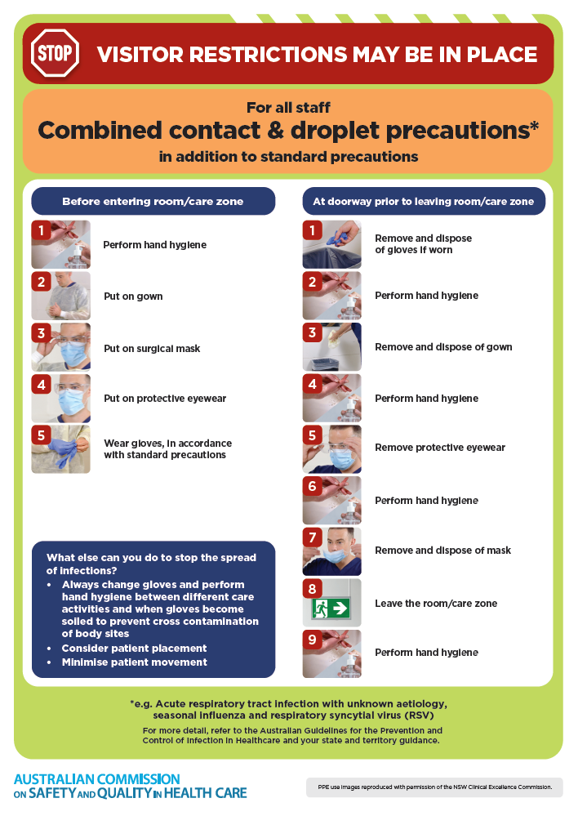](https://www.safetyandquality.gov.au/publications-and-resources/resource-library/infection-prevention-and-control-poster-combined-contact-and-droplet-precautions)
* ***Poster – Combined airborne and contact precautions*** <https://www.safetyandquality.gov.au/publications-and-resources/resource-library/poster-combined-airborne-and-contact-precautions>   
  [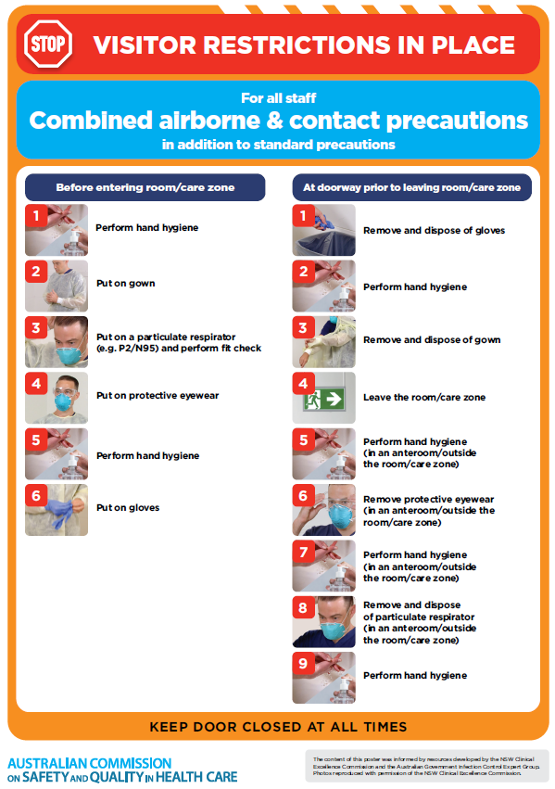](https://www.safetyandquality.gov.au/publications-and-resources/resource-library/poster-combined-airborne-and-contact-precautions)
* ***Environmental Cleaning and Infection Prevention and Control*** [www.safetyandquality.gov.au/environmental-cleaning](http://www.safetyandquality.gov.au/environmental-cleaning)
* ***COVID-19 infection prevention and control risk management – Guidance*** <https://www.safetyandquality.gov.au/publications-and-resources/resource-library/covid-19-infection-prevention-and-control-risk-management-guidance>
* ***Safe care for people with cognitive impairment during COVID-19***<https://www.safetyandquality.gov.au/our-work/cognitive-impairment/cognitive-impairment-and-covid-19>
* ***Stop COVID-19: Break the chain of infection*** posterhttps://www.safetyandquality.gov.au/publications-and-resources/resource-library/break-chain-infection-poster-a3  
  **[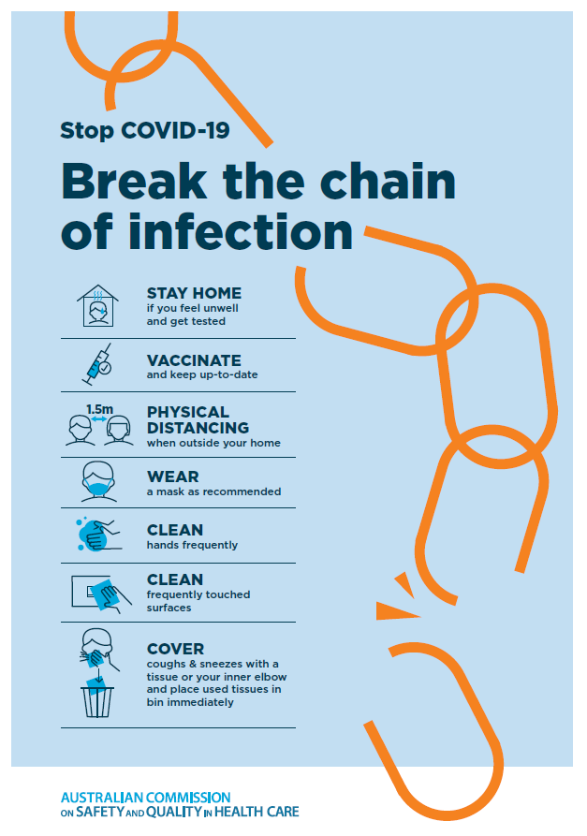](https://www.safetyandquality.gov.au/publications-and-resources/resource-library/break-chain-poster-a3https:/www.safetyandquality.gov.au/publications-and-resources/resource-library/break-chain-poster-a3)**
* ***COVID-19 and face masks – Information for consumers*** <https://www.safetyandquality.gov.au/publications-and-resources/resource-library/covid-19-and-face-masks-information-consumers>

[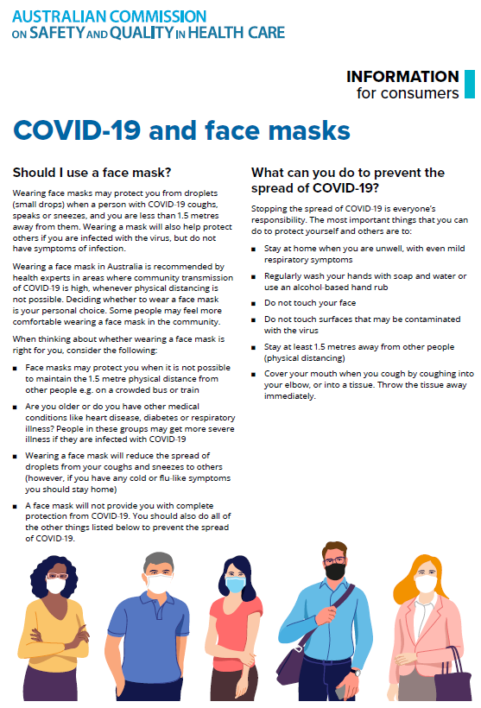](https://www.safetyandquality.gov.au/sites/default/files/2020-07/covid-19_and_face_masks_-_information_for_consumers.pdf)

*National Clinical Evidence Taskforce*

<https://clinicalevidence.net.au/>

The National Clinical Evidence Taskforce is a multi-disciplinary collaboration of 35 member organisations – Australia’s medical colleges and peak health organisations – who share a commitment to provide national evidence-based treatment guidelines for urgent and emerging diseases.

This alliance established the world’s first ‘living guidelines’ for the care of people with COVID-19 and MPX.

Funding has now been discontinued for the National Clinical Evidence Taskforce and the COVID-19 guidelines as of 30 June 2023.

These guidelines are no longer continually updated but will remain online until the guidance becomes inaccurate and/or no longer reflects the evidence or recommended practice.

*COVID-19 Critical Intelligence Unit*

<https://www.aci.health.nsw.gov.au/covid-19/critical-intelligence-unit>

The Agency for Clinical Innovation (ACI) in New South Wales has developed this page summarising rapid, evidence-based advice during the COVID-19 pandemic. Its operations focus on systems intelligence, clinical intelligence and evidence integration. The content includes a daily evidence digest, a COVID status monitor, a risk monitoring dashboard and evidence checks on a discrete topic or question relating to the current COVID-19 pandemic. There is also a ‘Living evidence’ section summarising key studies and emerging evidence on **COVID-19 vaccines** and **SARS-CoV-2 variants**. The most recent updates include:

* ***SARS-CoV-2 variants - retired living evidence*** – What is the evidence on SARS-CoV-2 variants that are under monitoring by the World Health Organization?
* ***COVID-19 vaccines - retired living evidence*** – What is the evidence on COVID-19 vaccine effectiveness and safety?
* ***Current and emerging patient safety issues during COVID-19*** – What is the evidence on the current and emerging patient safety issues arising from the COVID-19 pandemic?
* ***Bivalent COVID-19 vaccines*** – What is the available regulatory and research evidence for bivalent COVID-19 vaccines?
* ***Surgery post COVID-19*** – What is the evidence for the timing of surgery, and outcomes following surgery, for people who have recovered from COVID-19?
* ***Paxlovid*** – What is the evidence for Paxlovid for treatment of COVID-19?
* ***Molnupiravir*** –What is the evidence for and regulatory context of molnupiravir for treatment of COVID-19?
* ***Eating disorders and COVID-19*** – What is the impact of the COVID-19 pandemic on the prevalence of eating disorders?
* ***Long COVID –*** What is the evidence on the prevalence, presentation and management of long-COVID?
* ***Oseltamivir (Tamiflu) use in healthcare settings*** – What is the evidence that use of oseltamivir in healthcare workers with a symptomatic influenza diagnosis result in an earlier return to work and reduced absenteeism? What is the evidence that use of oseltamivir in adults and children with symptomatic influenza reduces influenza transmission in health care settings?
* ***Alternative models of care for acute medical conditions*** – What is the evidence on alternative models of care for managing patients with acute medical conditions outside of emergency or inpatient hospital settings?
* ***Exercise and long COVID*** – Is exercise helpful in individuals with long COVID? Is post-exertional symptom exacerbation a risk in long COVID?
* ***Influenza and seasonal prophylaxis with oseltamivir*** – What is the place or evidence for seasonal influenza prophylaxis (such as taking oseltamivir for 10 to 12 weeks continuously) in healthcare and aged care settings?
* ***Rapid access models of care for respiratory illnesses*** – What is the evidence for rapid access models of care for respiratory illnesses, especially during winter seasons, in emergency departments?
* ***Post-acute sequelae of COVID-19*** – What is the evidence on the post-acute sequelae of COVID-19?
* ***Emerging variants*** – What is the available evidence for emerging variants?
* ***Chest pain or dyspnoea following COVID-19 vaccination*** – What is evidence for chest pain or dyspnoea following COVID-19 vaccination?
* ***Cardiac investigations and elective surgery post-COVID-19*** – What is evidence for cardiac investigations and elective surgery post-COVID-19?
* ***Breathlessness post COVID-19*** – How to determine those patients who present with ongoing breathlessness in need of urgent review or intervention due to suspected pulmonary embolus?
* ***COVID-19 pandemic and influenza*** – What is the evidence for COVID-19 pandemic and influenza?
* ***Budesonide and aspirin for pregnant women with COVID-19 –*** What is the evidence for the use of Budesonide for pregnant women with COVID-19? What is the evidence for aspirin prophylaxis for pre-eclampsia in pregnant women with a COVID-19 infection?
* ***COVID-19 vaccines in Australia*** – What is the evidence on COVID-19 vaccines in Australia?
* ***COVID-19 pandemic and wellbeing of critical care and other healthcare workers*** – Evidence in brief on the impact of the COVID-19 pandemic on the wellbeing of critical care and other healthcare workers.
* ***Disease modifying treatments for COVID-19 in children*** – What is the evidence for disease modifying treatments for COVID-19 in children?
* ***Mask type for COVID-19 positive wearer*** – What is the evidence for different mask types for COVID-19 positive wearers?
* ***Post acute and subacute COVID-19 care*** – What published advice and models of care are available regarding post-acute and subacute care for COVID-19 patients?
* ***Hospital visitor policies*** – What is the evidence for hospital visitor policies during and outside of the COVID-19 pandemic?
* ***Surgical masks, eye protection and PPE guidance*** –What is the evidence for surgical masks in the endemic phase in hospitals and for eyewear to protect against COVID-19?

**Disclaimer**

On the Radar is an information resource of the Australian Commission on Safety and Quality in Health Care. The Commission is not responsible for the content of, nor does it endorse, any articles or sites listed. The Commission accepts no liability for the information or advice provided by these external links. Links are provided on the basis that users make their own decisions about the accuracy, currency and reliability of the information contained therein. Any opinions expressed are not necessarily those of the Australian Commission on Safety and Quality in Health Care.