# Australian Commission on Safety and Quality logotypeOn the Radar

Issue 620

18 September 2023

*On the Radar* is a summary of some of the recent publications in the areas of safety and quality in health care. Inclusion in this document is not an endorsement or recommendation of any publication or provider. Access to particular documents may depend on whether they are Open Access or not, and/or your individual or institutional access to subscription sites/services. Material that may require subscription is included as it is considered relevant.

*On the Radar* is available online, via email or as a PDF or Word document from <https://www.safetyandquality.gov.au/newsroom/subscribe-news/radar>

If you would like to receive *On the Radar* via email, you can subscribe on our website <https://www.safetyandquality.gov.au/newsroom/subscribe-news>  
or by emailing us at H[Umail@safetyandquality.gov.auU](mailto:mail@safetyandquality.gov.au).   
You can also send feedback and comments to H[Umail@safetyandquality.gov.auU](mailto:mail@safetyandquality.gov.au).

For information about the Commission and its programs and publications, please visit <https://www.safetyandquality.gov.au>

You can also follow us on Twitter @ACSQHC.

**On the Radar**

Editor: Dr Niall Johnson [niall.johnson@safetyandquality.gov.au](mailto:niall.johnson@safetyandquality.gov.au)

Contributors: Niall Johnson, Vannary Sar, Broni Smith

**Take part in the first national PaRIS Health Survey**

[www.safetyandquality.gov.au/paris-survey](http://www.safetyandquality.gov.au/paris-survey)

Are you an accredited GP practice?   
Help improve patient care in Australia and overseas. [Register for the PaRIS Health Survey](https://www.safetyandquality.gov.au/our-work/indicators-measurement-and-reporting/patient-reported-indicator-survey-paris), an international survey of adults with chronic conditions that assesses their outcomes and experiences with GPs.

More than 20 countries are involved in the OECD-led initiative. In Australia, the Commission is implementing the survey with ORIMA Research, on behalf of the Department of Health and Aged Care. The survey closes on 31 October 2023.

By taking part in the PaRIS survey, GP practices will be able to better understand their patients’ experiences, how they compare to other practices, and identify opportunities to improve patient care. Survey participation can also count towards CPD requirements.

The first 100 GP practices in Australia to fully complete the survey and invite participation from their patients will receive a $500 voucher. This incentive acknowledges your time to support evidence-based quality improvement in primary care.

Learn more at [www.safetyandquality.gov.au/paris-survey](http://www.safetyandquality.gov.au/paris-survey)

**Partnering with Consumers: A guide for consumers**

Australian Commission on Safety and Quality in Health Care

Sydney: ACSQHC; 2023. p. 48.

<https://www.safetyandquality.gov.au/our-work/partnering-consumers/partnering-consumers-guide-consumers>

The Commission has released *Partnering with Consumers: A guide for consumers* as part of our activities to mark World Patient Safety Day 2023, the theme of which is ‘engaging patients for patient safety’. Strong partnerships with consumers are essential for safe and high-quality health care. All health services need to partner with consumers under the National Safety and Quality Health Service (NSQHS) Standards.

The Guide has been developed by consumers for consumers, with Consumers Health Forum of Australia (CHF) engaged to undertake the co-design process. It explains how to build and strengthen consumer partnerships at all levels of the health system to support person-centred care and drive positive change.

Using the Guide, both consumers and health service organisations can improve their understanding of how to get the most from their partnerships, so there are better health outcomes for all consumers.

*Australian Prescriber*

Volume 46, Issue 2, August 2023

|  |  |
| --- | --- |
| URL | <https://australianprescriber.tg.org.au/> |
| Notes | A new issue of *Australian Prescriber* has been published. This is the second with its new publisher, Therapeutic Guidelines. Content in this issue of *Australian Prescriber* includes:   * Editorial: Limitations of **randomised controlled trials** as evidence of drug safety (TRJ Thynne, GM Gabb) * **Medicines stewardship** (E Su, DFL Liew, J Donnelly, RA Elliott) * An update on **wound management** (G Sussman) * **Chimeric antigen receptor T-cell therapy** (C Burge, V Vanguru, PJ Ho) * **New drugs**:  Brexucabtagene autoleucel for mantle cell lymphoma, B-cell precursor acute lymphoblastic leukaemia Opicapone for Parkinson’s disease |

*Public Health Research & Practice*

Volume 33, Issue 3, September 2023

|  |  |
| --- | --- |
| URL | <https://www.phrp.com.au/issues/september-2023-volume-33-issue-3/> |
|  | A new issue of *Public Health Research & Practice* has been published with a theme of ‘Moving on from COVID-19, communication and community engagement’. Articles in this issue of *Public Health Research & Practice* include:   * Editorial: **Moving on from COVID-19** – not so fast (Don Nutbeam) * Advancing **loneliness and social isolation** as global health challenges: taking three priority actions (Michelle H Lim, Pamela Qualter, Ding Ding, Julianne Holt-Lunstad, Christopher Mikton, Ben J Smith) * A cross-disciplinary view of **current and emerging COVID-19 developments** (Catherine M Bennett, Benjamin Riley, Susan Morpeth, Wen Shi Lee, Dean A Murphy, Krispin Hajkowicz, Edwina J Wright, on behalf of the ASHM C19 2023 Conference Organising Committee) * “We don’t want to run before we walk”: the attitudes of Australian stakeholders towards using **psychedelics for mental health conditions** (Breanne E Kunstler, Liam Smith, Christopher J Langmead, Denise M Goodwin, Breanna Wright, Melissa A Hatty) * A retrospective observational study of **telehealth utilisation for mental health consultations** during the COVID-19 pandemic in Australian general practice (Judith Thomas, Gorkem Sezgin, Precious McGuire, Rae-Anne Hardie, Guilherme S Franco, Margaret Williamson, Andrew Georgiou) * Testing campaign slogans designed to **motivate older people to be more physically active** (Simone Pettigrew, Michelle I Jongenelis, Liyuwork M Dana, Rajni Rai, Ben Jackson, Robert U Newton) * Enhanced **self-harm presentation reporting** using additional ICD-10 codes and free text in NSW emergency departments (Grant E Sara, Jianyun Wu) * The delivery of **safe and effective test result communication, management and follow-up** (Andrew Georgiou, Julie Li, Judith Thomas, Rita Horvath, Robert Lindeman, Johanna Westbrook) * Community engagement programs on **radiation and health**: addressing public concerns (Christopher Brzozek, Ken Karipidis) * Development and piloting of a Community of Practice to support learning and improvement in **health promotion practice** within NSW local health districts (Courtney Barnes, Rachel Sutherland, Gavin Jones, Nina Kingon, NCOIS Research Collaborative†, Luke Wolfenden) * **Engaging with culturally and linguistically diverse communities** during a COVID-19 outbreak: a NSW Health interagency public health campaign (Sally J Ioannides, Isabel Hess, Craig Lamberton, Barbara Luisi, Leena Gupta) * **Cancer care pathways** mapping and dissemination toolkit: lessons learnt from cancer services in NSW, Australia (Liz M Norsa, Isaac Y Addo, Tim Shaw, Stephen Manley, Sandy Avery, Lisa J Delaney, Nicole M Rankin, Deborah M McGregor, Kahren M White) * The impact of the 2020 **COVID-19-related suspension of BreastScreen NSW** on breast cancer tumour size and treatment (Amanda A Jayakody, Kan Ren, Richard J Walton, Matthew E Warner-Smith, Nicola Scott, Anthea M Temple, Chirag Mistry, Sarah J McGill) * Redressing **barriers to healthcare for Aboriginal and Torres Strait Islander Peoples**: preliminary findings from a mobile clinic in rural Victoria (Hannah Beks, Vincent L Versace, Fiona Mitchell, James A Charles, Tim Chatfield, Roman Zwolak) * **Industry to influence policymaking**: it takes two to tango, and the industry is not the leader (Alain Braillon) |

*Journal for Healthcare Quality*

Volume 45, Issue 5, September/October 2023

|  |  |
| --- | --- |
| URL | <https://journals.lww.com/jhqonline/toc/2023/10000> |
| Notes | A new issue of the *Journal for Healthcare Quality* (JHQ) has been published. Articles in this issue of the *Journal for Healthcare Quality* include:   * Should **Penicillin Allergy Testing** Be Included as Part of Preoperative Testing? (Svjetlana Lozo, Daniel Wagner, Nirav Shah, Roger Goldberg, Adam Gafni-Kane, Anthony Solomonides) * What are Effective Strategies to Reduce **Low-Value Care**? An Analysis of 121 Randomized Deimplementation Studies (Pauline Heus, Simone A van Dulmen, Jan-Willem Weenink, Christiana A Naaktgeboren, Toshihiko Takada, Eva W Verkerk, Isabelle Kamm, Maarten J van der Laan, L Hooft, R B Kool) * **Clinical Pharmacist Transition of Care Model** Improves Hospital System Practice by Reducing Readmissions (Nha Uyen Tuong Ngo, Soodtida Tangpraphaphorn, Deborah Kahaku, Catherine P. Canamar, Andrew Young) * The Use of Quality Improvement in the **Physical Therapy** Literature: A Scoping Review (James P Crick, Jr, Timothy J Rethorn, Tyler A Beauregard, Riley Summers, Zachary D Rethorn, Catherine C Quatman-Yates) * Development of Quality Measures for **Inpatient Diabetes Care and Education Specialists**: A Call to Action (Gwen Klinkner, Leigh Bak, Jennifer N Clements, Eva H Gonzales) * Improving **Operating Room Efficiency** Through Reducing First Start Delays in an Academic Center (Dylan Singh, Lawrence Cai, Dominique Watt, Elise Scoggins, Samuel Wald, Rahim Nazerali) |

*Health Expectations*

Volume 26, Issue 5, October 2023

|  |  |
| --- | --- |
| URL | <https://onlinelibrary.wiley.com/toc/13697625/2023/26/5> |
| Notes | A new issue of *Health Expectations* has been published. Articles in this issue of *Health Expectations* include:   * Editorial: **Reconsidering patient-centred care**: Authority, expertise and abandonment (Alison Pilnick) * The elephant in the room: **Family engagement in mental health and substance use research** (Lisa D Hawke, Connie Putterman, Nathan Dawthorne, Shannon Pascoe, Shaylene Pind) * Meaningful engagement through critical reflexivity: Engaging people with lived experience in **continuing mental health professional development** (Holly Harris, Chantalle Clarkin, Jordana Rovet, Allison Crawford, Andrew Johnson, Anne Kirvan, Sam Gruszecki, Stephanie Wang BKin, Sophie Soklaridis) * Conceptualising **community engagement** as an infinite game implemented through finite games of ‘research’, ‘community organising’ and ‘knowledge mobilisation’ (Tanvir C Turin, Mashrur Kazi, Nahid Rumana, Mohammad A A Lasker, Nashit Chowdhury) * Exploring the impact of **engagement in mental health and substance use research**: A scoping review and thematic analysis (Natasha Y Sheikhan, Kerry Kuluski, Shelby McKee, Melissa Hiebert, Lisa D Hawke) * Conceptualization of **patient-centered care** in Latin America: A scoping review (Anne Klimesch, Alejandra Martinez-Pereira, Cheyenne Topf, Martin Härter, Isabelle Scholl, Paulina Bravo) * Co-development of a school-based and primary care-based multicomponent intervention to improve **HPV vaccine coverage** amongst French adolescents (the PrevHPV Study) (Aurélie Bocquier, Sébastien Bruel, Morgane Michel, Anne-Sophie Le Duc-Banaszuk, Stéphanie Bonnay, Marion Branchereau, Karine Chevreul, Sandra Chyderiotis, Aurélie Gauchet, Bruno Giraudeau, D-P Hagiu, J E Mueller, A Gagneux-Brunon, N Thilly, PrevHPV Study Group) * **Patient engagement in health implementation research**: A logic model (Mathieu Bisson, Kris Aubrey-Bassler, Maud-Christine Chouinard, Shelley Doucet, Vivian R Ramsden, Olivier Dumont-Samson, Dana Howse, Mireille Lambert, Charlotte Schwarz, Alison Luke, Norma Rabbitskin, André Gaudreau, Jude Porter, Donna Rubenstein, J Taylor, M Warren, C Hudon) * **COVID-19 in Western Australia**: ‘The last straw’ and hopes for a ‘new normal’ for parents of children with long-term conditions (Stephanie Smith, Mary Tallon, James Smith, Lauren Jones, Evalotte Mörelius) * **Lived experiences of young adults facing a recent diagnosis of cancer**: A phenomenological study (Mehraban Shahmari, Alireza Nikbakht Nasrabadi, Elaheh Rezaie, Seemin Dashti, Elhameh Nasiri, Leily Zare) * ‘Just because we're younger doesn't mean our opinions should be any less valued’: A qualitative study of youth perspectives on a **Youth Advisory Council in a mental healthcare context** (Adrienne Young, Anthony Levitt, Sugy Kodeeswaran, Roula Markoulakis) * **Trauma-informed co-production**: Collaborating and combining expertise to improve access to primary care with women with complex needs (Helen McGeown, Lucy Potter, Tracey Stone, Julie Swede, H Cramer, Bridging Gaps Group, J Horwood, M Carvalho, F Connell, G Feder, M Farr) * The experiences of psychiatric patients, their caregivers and companions in upholding **patient dignity during hospitalization**: A qualitative study (Amirahmad Shojaei, Yosra Raziani, Colleen Bernstein, Ali Asgari, Farshid Alazmani-Noodeh, Mohammadreza Arab, Hadi Ranjbar) * How do **(false) positively screened patients** experience a screening programme for liver cirrhosis or fibrosis in Germany? A qualitative study (Urs A Fichtner, Anita Arslanow, Harald Binder, Peter R Galle, Christian Labenz, Frank Lammert, Julia Ortner, D Stelzer, L Velthuis, E Farin-Glattacker) * Parent's preferences for **unscheduled paediatric healthcare**: A discrete choice experiment (Emma Nicholson, Thérèse McDonnell, Ciara Conlon, Aoife De Brún, Edel Doherty, Eilish McAuliffe0 * Creating a **culturally competent pharmacy profession**: A qualitative exploration of pharmacy staff perspectives of cultural competence and its training in community pharmacy settings (Jessica McCann, Wing Man Lau, Andy Husband, Adam Todd, L Sile, A K Doll, S Varia, A Robinson-Barella) * Developing a **Women's Thought Collective methodology for health research**: The roles and responsibilities of researchers in the reflexive co-production of knowledge (Kristen Foley, Belinda Lunnay, C Kevin, P R Ward) * **Family caregiver roles and challenges** in assisting patients with cancer treatment decision-making: Analysis of data from a national survey (James N Dionne-Odom, Erin E Kent, Gabrielle B Rocque, Andres Azuero, Erin R Harrell, Shena Gazaway, Rhiannon D Reed, Reed W Bratches, Avery C Bechthold, Kyungmi Lee, Frank Puga, Ellen Miller-Sonet, K A Ornstein) * A Community of Practice to increase education and collaboration in dementia and ageing research and care: **The Liverpool Dementia & Ageing Research Forum** (Clarissa Giebel, Hilary Tetlow, Thomas Faulkner, Ruth Eley) * **#TreatmentResistantDepression:** A qualitative content analysis of Tweets about difficult-to-treat depression (Amelia Talbot, Tori Ford, Sara Ryan, Kamal R Mahtani, Charlotte Albury) * Towards an **Implementation-STakeholder Engagement Model (I-STEM)** for improving health and social care services (Sebastian Potthoff, Tracy Finch, Leah Bührmann, Anne Etzelmüller, Claire R van Genugten, Melissa Girling, Carl R May, Neil Perkins, Christiaan Vis, T Rapley, ImpleMentAll consortium) * Exploring the views and experiences of people recovering from a stroke about a new text message intervention to promote **physical activity after rehabilitation**—Keeping Active with Texting After Stroke: A qualitative study (Albert Farre, Jacqui H Morris, Linda Irvine, Stephan U Dombrowski, Jenna P Breckenridge, Gozde Ozakinci, Thérèse Lebedis, Claire Jones) * The impact of **adding cost information to a conversation aid** to support shared decision making about low-risk prostate cancer treatment: Results of a stepped-wedge cluster randomised trial (Mary C Politi, Rachel C Forcino, Katelyn Parrish, M-A Durand, A J O'Malley, R Moses, K Cooksey, G Elwyn) * Involving patients and caregivers to develop items for a new **patient-reported experience measure for older adults attending the emergency department**. Findings from a nominal group technique study (Blair Graham, Jason E Smith, Ffion Barham, Jos M Latour) * **Healthy Parent Carers**: Acceptability and practicability of online delivery and learning through implementation by delivery partner organisations (Alice Garrood, Gretchen Bjornstad, Aleksandra Borek, Annette Gillett, Jenny Lloyd, Sarah Brand, Mark Tarrant, Susan Ball, Annie Hawton, Annabel McDonald, Mary Fredlund, Fleur Boyle, Vashti Berry, Stuart Logan, Christopher Morris) * **Supporting carers to improve patient safety** and maintain their well-being in transitions from mental health hospitals to the community: A prioritisation nominal group technique (Sarah McMullen, Maria Panagioti, Claire Planner, Sally Giles, I Angelakis, R N Keers, C Robinson, Y Fu, J Johnson, N Tyler) * A qualitative exploration of the **psychosocial needs of people living with long-term conditions** and their perspectives on online peer support (Hannah Rowlands, Elly Aylwin-Foster, Matthew Hotopf, Lauren Rayner, Alan Simpson, Grace Lavelle, Vanessa Lawrence) * Is the **early identification and referral of suspected head and neck cancers by community pharmacists** feasible? A qualitative interview study exploring the views of patients in North East England (Susan M Bissett, Andrew Sturrock, Marco Carrozzo, Rachel Lish, Debora Howe, Susan Mountain, Michael Nugent, James O'Hara, A Todd, S Wilkes, P M Preshaw) * The impact of **expert by experience involvement** in teaching in a DClinPsych programme; for trainees and experts by experience (Ellie Kerry, Nicola Collett, Jason Gunn) |

*International Journal for Quality in Health Care* online first articles

|  |  |
| --- | --- |
| URL | <https://academic.oup.com/intqhc/advance-articles> |
| Notes | *International Journal for Quality in Health Care* has published a number of ‘online first’ articles, including:   * Improving care safety by characterizing **task interruptions during interactions between healthcare professionals**: an observational study (Delphine Teigné et al) * The Crisis of **Physician Well-being** in Nepal: A Multifaceted Dilemma Demanding Urgent Intervention (Bivek Singh) |

**Online resources**

***Palliative care toolkit for Aboriginal and Torres Strait Islander health professionals***

<https://pepaeducation.com/support-and-education/pepa-online-materials-and-learning-guides/>

This toolkit aims to enhance the capacity and confidence of the Aboriginal and Torres Strait Islander health workforce who provide care to those affected by life-limiting illness.

The toolkit provides a range of content, learning activities and resources for the following topic areas:

* understanding palliative care
* yarning about palliative care
* symptom management in palliative care
* loss, grief and healing
* looking after yourself.

**[NZ] Frailty care guides | Ngā aratohu maimoa hauwarea (2023 edition)**

<https://www.hqsc.govt.nz/resources/resource-library/frailty-care-guides-nga-aratohu-maimoa-hauwarea-2023-edition/>

The Health Quality and Safety Commission in New Zealand has recently launched the 2023 edition of their *Frailty care guides | Ngā aratohu maimoa hauwarea*. This set of 32 guides has a specific focus on aged residential care but the Commission says that they can be applied to other care settings for individuals living with frailty. The guides are available as PDFs and as accessible web pages.

***[UK] NICE Guidelines and Quality Standards***

<https://www.nice.org.uk/guidance>

The UK’s National Institute for Health and Care Excellence (NICE) has published new (or updated) guidelines and quality standards. The latest reviews or updates include:

* NICE Guideline NG50 ***Cirrhosis*** *in over 16s: assessment and management* <https://www.nice.org.uk/guidance/ng50>

**COVID-19 resources**

https://www.safetyandquality.gov.au/covid-19

The Australian Commission on Safety and Quality in Health Care has developed a number of resources to assist healthcare organisations, facilities and clinicians. These and other material on COVID-19 are available at <https://www.safetyandquality.gov.au/covid-19>

These resources include:

* ***OVID-19 infection prevention and control risk management*** This primer provides an overview of three widely used tools for investigating and responding to patient safety events and near misses. Tools covered in this primer include incident reporting systems, Root Cause Analysis (RCA), and Failure Modes and Effects Analysis (FMEA).   
  <https://www.safetyandquality.gov.au/publications-and-resources/resource-library/covid-19-infection-prevention-and-control-risk-management-guidance>
* ***Poster – Combined contact and droplet precautions*** <https://www.safetyandquality.gov.au/publications-and-resources/resource-library/infection-prevention-and-control-poster-combined-contact-and-droplet-precautions>  
  [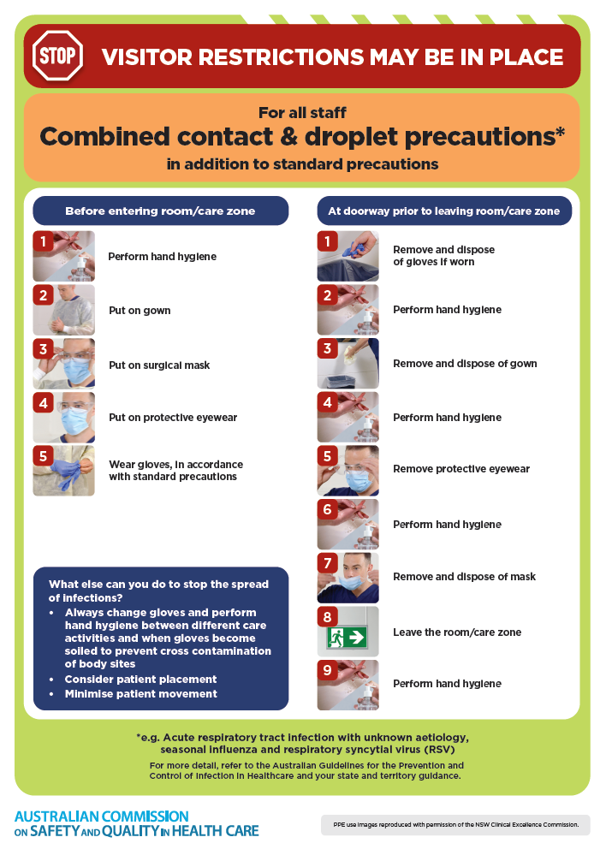](https://www.safetyandquality.gov.au/publications-and-resources/resource-library/infection-prevention-and-control-poster-combined-contact-and-droplet-precautions)
* ***Poster – Combined airborne and contact precautions*** <https://www.safetyandquality.gov.au/publications-and-resources/resource-library/poster-combined-airborne-and-contact-precautions>   
  [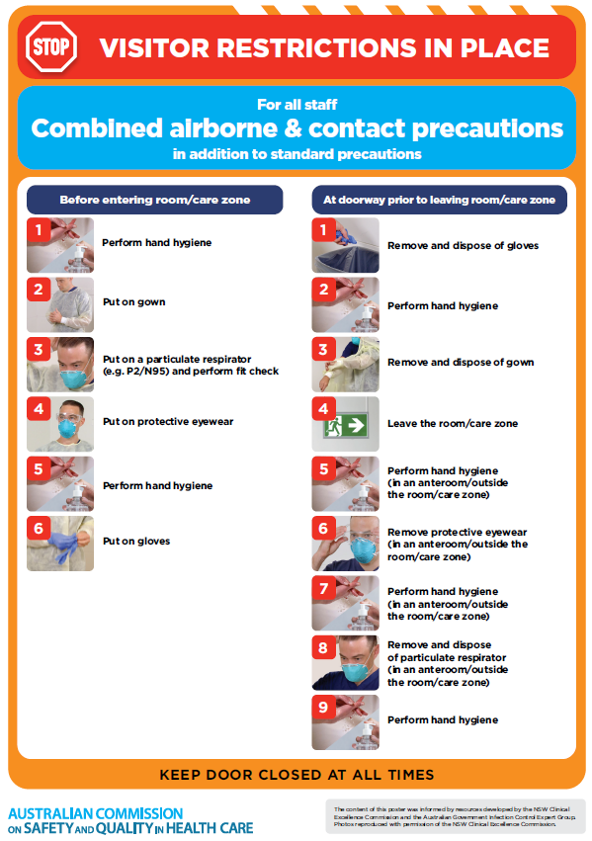](https://www.safetyandquality.gov.au/publications-and-resources/resource-library/poster-combined-airborne-and-contact-precautions)
* ***Environmental Cleaning and Infection Prevention and Control*** [www.safetyandquality.gov.au/environmental-cleaning](http://www.safetyandquality.gov.au/environmental-cleaning)
* ***COVID-19 infection prevention and control risk management – Guidance*** <https://www.safetyandquality.gov.au/publications-and-resources/resource-library/covid-19-infection-prevention-and-control-risk-management-guidance>
* ***Safe care for people with cognitive impairment during COVID-19***<https://www.safetyandquality.gov.au/our-work/cognitive-impairment/cognitive-impairment-and-covid-19>
* ***Stop COVID-19: Break the chain of infection*** posterhttps://www.safetyandquality.gov.au/publications-and-resources/resource-library/break-chain-infection-poster-a3  
  **[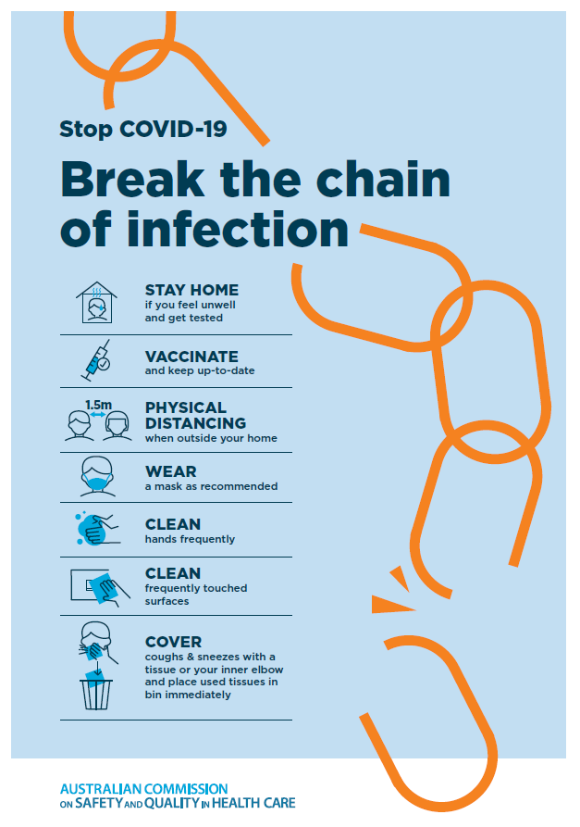](https://www.safetyandquality.gov.au/publications-and-resources/resource-library/break-chain-poster-a3https:/www.safetyandquality.gov.au/publications-and-resources/resource-library/break-chain-poster-a3)**
* ***COVID-19 and face masks – Information for consumers*** <https://www.safetyandquality.gov.au/publications-and-resources/resource-library/covid-19-and-face-masks-information-consumers>

[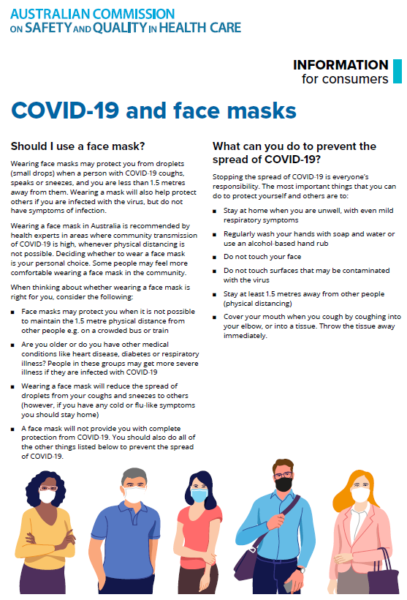](https://www.safetyandquality.gov.au/sites/default/files/2020-07/covid-19_and_face_masks_-_information_for_consumers.pdf)

*National Clinical Evidence Taskforce*

<https://clinicalevidence.net.au/>

The National Clinical Evidence Taskforce is a multi-disciplinary collaboration of 35 member organisations – Australia’s medical colleges and peak health organisations – who share a commitment to provide national evidence-based treatment guidelines for urgent and emerging diseases.

This alliance established the world’s first ‘living guidelines’ for the care of people with COVID-19 and MPX.

Funding has now been discontinued for the National Clinical Evidence Taskforce and the COVID-19 guidelines as of 30 June 2023.

These guidelines are no longer continually updated but will remain online until the guidance becomes inaccurate and/or no longer reflects the evidence or recommended practice.

*COVID-19 Critical Intelligence Unit*

<https://www.aci.health.nsw.gov.au/covid-19/critical-intelligence-unit>

The Agency for Clinical Innovation (ACI) in New South Wales has developed this page summarising rapid, evidence-based advice during the COVID-19 pandemic. Its operations focus on systems intelligence, clinical intelligence and evidence integration. The content includes a daily evidence digest, a COVID status monitor, a risk monitoring dashboard and evidence checks on a discrete topic or question relating to the current COVID-19 pandemic. There is also a ‘Living evidence’ section summarising key studies and emerging evidence on **COVID-19 vaccines** and **SARS-CoV-2 variants**. The most recent updates include:

* ***SARS-CoV-2 variants - retired living evidence*** – What is the evidence on SARS-CoV-2 variants that are under monitoring by the World Health Organization?
* ***COVID-19 vaccines - retired living evidence*** – What is the evidence on COVID-19 vaccine effectiveness and safety?
* ***Current and emerging patient safety issues during COVID-19*** – What is the evidence on the current and emerging patient safety issues arising from the COVID-19 pandemic?
* ***Bivalent COVID-19 vaccines*** – What is the available regulatory and research evidence for bivalent COVID-19 vaccines?
* ***Surgery post COVID-19*** – What is the evidence for the timing of surgery, and outcomes following surgery, for people who have recovered from COVID-19?
* ***Paxlovid*** – What is the evidence for Paxlovid for treatment of COVID-19?
* ***Molnupiravir*** –What is the evidence for and regulatory context of molnupiravir for treatment of COVID-19?
* ***Eating disorders and COVID-19*** – What is the impact of the COVID-19 pandemic on the prevalence of eating disorders?
* ***Long COVID –*** What is the evidence on the prevalence, presentation and management of long-COVID?
* ***Oseltamivir (Tamiflu) use in healthcare settings*** – What is the evidence that use of oseltamivir in healthcare workers with a symptomatic influenza diagnosis result in an earlier return to work and reduced absenteeism? What is the evidence that use of oseltamivir in adults and children with symptomatic influenza reduces influenza transmission in health care settings?
* ***Alternative models of care for acute medical conditions*** – What is the evidence on alternative models of care for managing patients with acute medical conditions outside of emergency or inpatient hospital settings?
* ***Exercise and long COVID*** – Is exercise helpful in individuals with long COVID? Is post-exertional symptom exacerbation a risk in long COVID?
* ***Influenza and seasonal prophylaxis with oseltamivir*** – What is the place or evidence for seasonal influenza prophylaxis (such as taking oseltamivir for 10 to 12 weeks continuously) in healthcare and aged care settings?
* ***Rapid access models of care for respiratory illnesses*** – What is the evidence for rapid access models of care for respiratory illnesses, especially during winter seasons, in emergency departments?
* ***Post-acute sequelae of COVID-19*** – What is the evidence on the post-acute sequelae of COVID-19?
* ***Emerging variants*** – What is the available evidence for emerging variants?
* ***Chest pain or dyspnoea following COVID-19 vaccination*** – What is evidence for chest pain or dyspnoea following COVID-19 vaccination?
* ***Cardiac investigations and elective surgery post-COVID-19*** – What is evidence for cardiac investigations and elective surgery post-COVID-19?
* ***Breathlessness post COVID-19*** – How to determine those patients who present with ongoing breathlessness in need of urgent review or intervention due to suspected pulmonary embolus?
* ***COVID-19 pandemic and influenza*** – What is the evidence for COVID-19 pandemic and influenza?
* ***Budesonide and aspirin for pregnant women with COVID-19 –*** What is the evidence for the use of Budesonide for pregnant women with COVID-19? What is the evidence for aspirin prophylaxis for pre-eclampsia in pregnant women with a COVID-19 infection?
* ***COVID-19 vaccines in Australia*** – What is the evidence on COVID-19 vaccines in Australia?
* ***COVID-19 pandemic and wellbeing of critical care and other healthcare workers*** – Evidence in brief on the impact of the COVID-19 pandemic on the wellbeing of critical care and other healthcare workers.
* ***Disease modifying treatments for COVID-19 in children*** – What is the evidence for disease modifying treatments for COVID-19 in children?
* ***Mask type for COVID-19 positive wearer*** – What is the evidence for different mask types for COVID-19 positive wearers?
* ***Post acute and subacute COVID-19 care*** – What published advice and models of care are available regarding post-acute and subacute care for COVID-19 patients?
* ***Hospital visitor policies*** – What is the evidence for hospital visitor policies during and outside of the COVID-19 pandemic?
* ***Surgical masks, eye protection and PPE guidance*** –What is the evidence for surgical masks in the endemic phase in hospitals and for eyewear to protect against COVID-19?

**Disclaimer**

On the Radar is an information resource of the Australian Commission on Safety and Quality in Health Care. The Commission is not responsible for the content of, nor does it endorse, any articles or sites listed. The Commission accepts no liability for the information or advice provided by these external links. Links are provided on the basis that users make their own decisions about the accuracy, currency and reliability of the information contained therein. Any opinions expressed are not necessarily those of the Australian Commission on Safety and Quality in Health Care.