# Australian Commission on Safety and Quality logotypeOn the Radar

Issue 624

16 October 2023

*On the Radar* is a summary of some of the recent publications in the areas of safety and quality in health care. Inclusion in this document is not an endorsement or recommendation of any publication or provider. Access to particular documents may depend on whether they are Open Access or not, and/or your individual or institutional access to subscription sites/services. Material that may require subscription is included as it is considered relevant.

*On the Radar* is available online, via email or as a PDF or Word document from <https://www.safetyandquality.gov.au/newsroom/subscribe-news/radar>

If you would like to receive *On the Radar* via email, you can subscribe on our website <https://www.safetyandquality.gov.au/newsroom/subscribe-news>  
or by emailing us at H[Umail@safetyandquality.gov.auU](mailto:mail@safetyandquality.gov.au).   
You can also send feedback and comments to H[Umail@safetyandquality.gov.auU](mailto:mail@safetyandquality.gov.au).

For information about the Commission and its programs and publications, please visit <https://www.safetyandquality.gov.au>

You can also follow us on Twitter @ACSQHC.

**On the Radar**

Editor: Dr Niall Johnson [niall.johnson@safetyandquality.gov.au](mailto:niall.johnson@safetyandquality.gov.au)

Contributors: Niall Johnson

**Reports**

*Closing the gap: Actions to reduce waiting times for children and young people*

Getting It Right First Time (GIRFT)

London: NHS England; 2023. p. 6.

|  |  |
| --- | --- |
| URL | <https://gettingitrightfirsttime.co.uk/concise-guide-offers-actions-for-reducing-waiting-times-for-children-and-young-peoples-surger>y/ |
| Notes | The Getting It Right First Time (GRIFT) initiative in the UK has produced this short guidance document listing ten actions which can help reduce waiting times for children, as well as quick links to data, resources and best practice case studies.  The actions include:  ‘Increase theatre capacity   1. Run dedicated paediatric lists or operating days 2. Add extra sessions or ‘super-days’ for children’s surgery 3. Share capacity across systems, including elective surgical hubs   Increase theatre utilisation   1. Book the recommended number of cases per list 2. Increase efficiency of flow with safe expedited discharge protocols 3. Stagger children’s admission times for surgery   Streamline pathways of care   1. Avoid procedures of limited medical benefit, such as circumcision, using clinical decision tools 2. Ensure all children go through preoperative assessment 3. Use holistic prioritisation tools 4. Provide ‘waiting well’ or self-care resources to children and parents’ |

*National Joint Registry 20th Annual Report*

NJR Editorial Committee

National Joint Registry (UK); 2023. p. 370.

*Hip, Knee and Shoulder Arthroplasty: 2023 Annual Report*

Smith PN, Gill DR, McAuliffe MJ, McDougall C, Stoney JD, Vertullo CJ, et al.

Adelaide: Australian Orthopaedic Association National Joint Replacement Registry, AOA; 2023. p. 482.

|  |  |
| --- | --- |
| URL | National Joint Registry (UK) <https://www.hqip.org.uk/resource/national-joint-registry-20th-annual-report-2023/>  Australian Orthopaedic Association National Joint Replacement Registry <https://aoanjrr.sahmri.com/>  <https://doi.org/10.25310/YWQZ9375> |
| Notes | The UK’s National Joint Registry has released its 20th annual report. The registry’s purpose ‘is to record patient information and provide data on the performance and longevity of replacement joint implants, the surgical outcomes for the hospitals where these operations are carried out, and on the performance outcomes of the surgeons who conduct the procedures’. The NJR is also looking at incorporating patient reported outcome measures (PROM) and issues around sustainability and environmental impact of orthopaedic surgery.  The Australian joint replacement registry, which is slightly older than it’s UK counterpart, also produces annual reports. The Australian Orthopaedic Association National Joint Replacement Registry (AOANJRR) (<https://aoanjrr.sahmri.com/>) has released its *2023 Annual Report Hip, Knee and Shoulder Arthroplasty* report. This is the registry's 24th Annual Report. The 2023 report is based on the analysis of 1,982,200 joint replacement procedures, including 850,603 hip replacements, 1,046,247 knee replacements, and 85,350 shoulder replacements. The AOANJRR identifies prostheses with higher than expected rates of revision. In the 2023 report, four total conventional hip prostheses, three total knee prostheses, and two total stemmed reverse shoulder prostheses have been newly identified. Over the years, the AOANJRR has played a significant role in shaping the market by identifying prostheses with higher revision rates. The 2023 report also ‘includes a separate chapter on infection, currently the most common reason for revision surgery and a PROMs section in a dedicated supplementary chapter’. |

For information on the Commission’s work on clinical quality registries, including the *Framework for Australian clinical quality registries*, see <https://www.safetyandquality.gov.au/our-work/health-and-human-research/national-arrangements-clinical-quality-registries>

**Journal articles**

*Building on value-based health care: Towards a health system perspective*

Smith PC, Sagan A, Siciliani L, Figueras J

Health Policy 2023;138:104918.

|  |  |
| --- | --- |
| DOI | <https://doi.org/10.1016/j.healthpol.2023.104918> |
| Notes | Recent years have seen interest in various aspects of value in health care. The authors of this paper propose ‘develop a framework to reconcile different approaches towards value-based health policies’. The framework comprises ‘five dimensions of value, embracing health improvement, health care responsiveness, financial protection, efficiency and equity’. The focus is on ‘value created by the health system as a whole’ while recognising that those within the system make varying contributions and that there may be a ‘range of policy levers promoting different aspects of value.’  Figure setting  out a framework that captures the concept of health system value. The health system is allocated funds that it is expected to convert into valued health-related outcomes, which in turn improve wellbeing. Health systems aim at providing health services that satisfy patients’ needs promptly (responsiveness) and improve health, and that are free of charge or involve small co-payments (financial protection). |

*BMJ Quality & Safety* online first articles

|  |  |
| --- | --- |
| URL | <https://qualitysafety.bmj.com/content/early/recent> |
| Notes | *BMJ Quality &Safety* has published a number of ‘online first’ articles, including:   * Informing understanding of c**oordination of care for patients with heart failure** with preserved ejection fraction: a secondary qualitative analysis (Rosalie Brooman-White, Thomas Blakeman, Duncan McNab, Christi Deaton) |

*International Journal for Quality in Health Care* online first articles

|  |  |
| --- | --- |
| URL | <https://academic.oup.com/intqhc/advance-articles> |
| Notes | *International Journal for Quality in Health Care* has published a number of ‘online first’ articles, including:   * Care in the future - reconciling **health system and individual resilience** (Siri Wiig et al) * **Unsafe care in residential settings for older adults**. A content analysis of accreditation reports (Peter D Hibbert et al) |

**Online resources**

***[UK] NICE Guidelines and Quality Standards***

<https://www.nice.org.uk/guidance>

The UK’s National Institute for Health and Care Excellence (NICE) has published new (or updated) guidelines and quality standards. The latest reviews or updates include:

* NICE Guideline NG145 ***Thyroid disease****: assessment and management* <https://www.nice.org.uk/guidance/ng145>

**COVID-19 resources**

https://www.safetyandquality.gov.au/covid-19

The Australian Commission on Safety and Quality in Health Care has developed a number of resources to assist healthcare organisations, facilities and clinicians. These and other material on COVID-19 are available at <https://www.safetyandquality.gov.au/covid-19>

These resources include:

* ***OVID-19 infection prevention and control risk management*** This primer provides an overview of three widely used tools for investigating and responding to patient safety events and near misses. Tools covered in this primer include incident reporting systems, Root Cause Analysis (RCA), and Failure Modes and Effects Analysis (FMEA).   
  <https://www.safetyandquality.gov.au/publications-and-resources/resource-library/covid-19-infection-prevention-and-control-risk-management-guidance>
* ***Poster – Combined contact and droplet precautions*** <https://www.safetyandquality.gov.au/publications-and-resources/resource-library/infection-prevention-and-control-poster-combined-contact-and-droplet-precautions>  
  [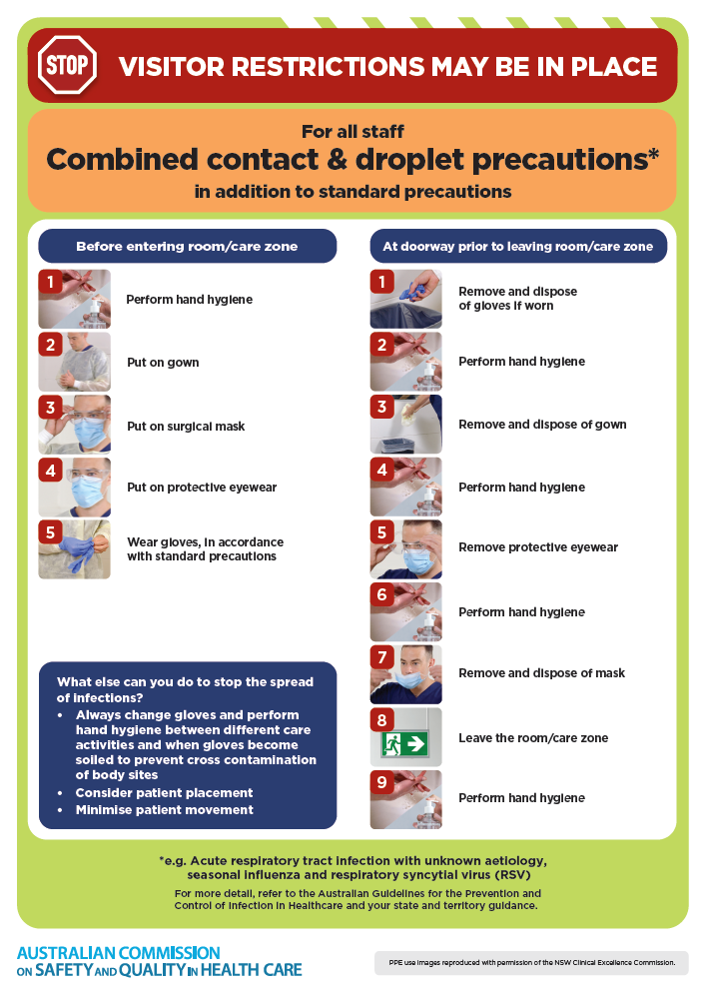](https://www.safetyandquality.gov.au/publications-and-resources/resource-library/infection-prevention-and-control-poster-combined-contact-and-droplet-precautions)
* ***Poster – Combined airborne and contact precautions*** <https://www.safetyandquality.gov.au/publications-and-resources/resource-library/poster-combined-airborne-and-contact-precautions>   
  [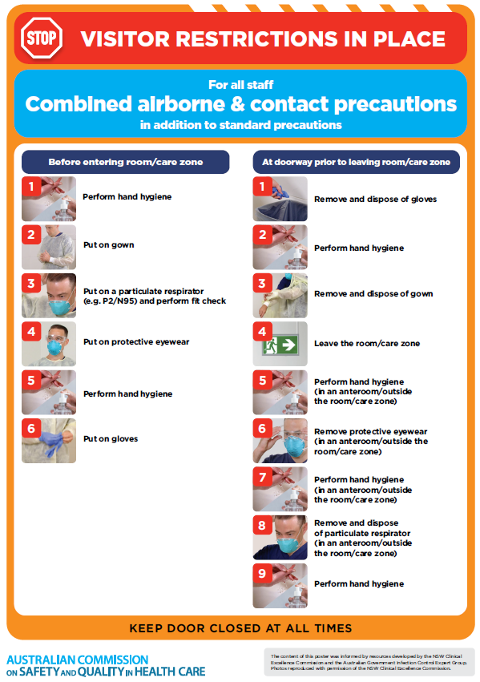](https://www.safetyandquality.gov.au/publications-and-resources/resource-library/poster-combined-airborne-and-contact-precautions)
* ***Environmental Cleaning and Infection Prevention and Control*** [www.safetyandquality.gov.au/environmental-cleaning](http://www.safetyandquality.gov.au/environmental-cleaning)
* ***COVID-19 infection prevention and control risk management – Guidance*** <https://www.safetyandquality.gov.au/publications-and-resources/resource-library/covid-19-infection-prevention-and-control-risk-management-guidance>
* ***Safe care for people with cognitive impairment during COVID-19***<https://www.safetyandquality.gov.au/our-work/cognitive-impairment/cognitive-impairment-and-covid-19>
* ***Stop COVID-19: Break the chain of infection*** posterhttps://www.safetyandquality.gov.au/publications-and-resources/resource-library/break-chain-infection-poster-a3  
  **[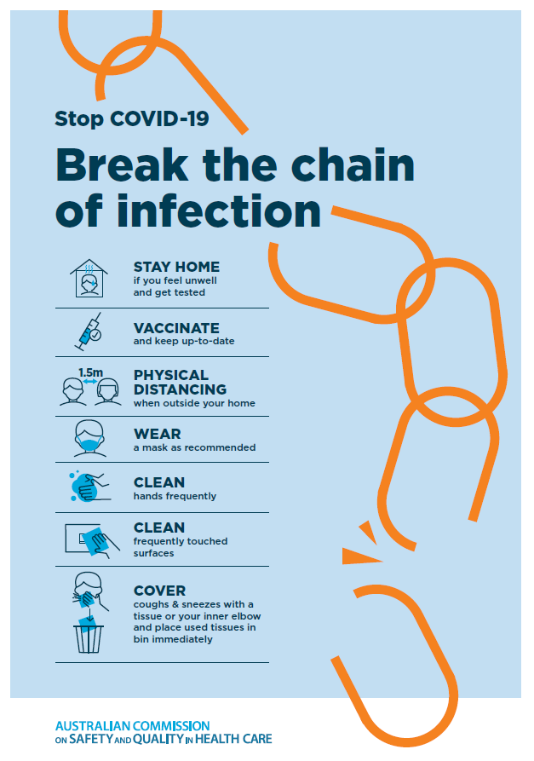](https://www.safetyandquality.gov.au/publications-and-resources/resource-library/break-chain-poster-a3https:/www.safetyandquality.gov.au/publications-and-resources/resource-library/break-chain-poster-a3)**
* ***COVID-19 and face masks – Information for consumers*** <https://www.safetyandquality.gov.au/publications-and-resources/resource-library/covid-19-and-face-masks-information-consumers>

[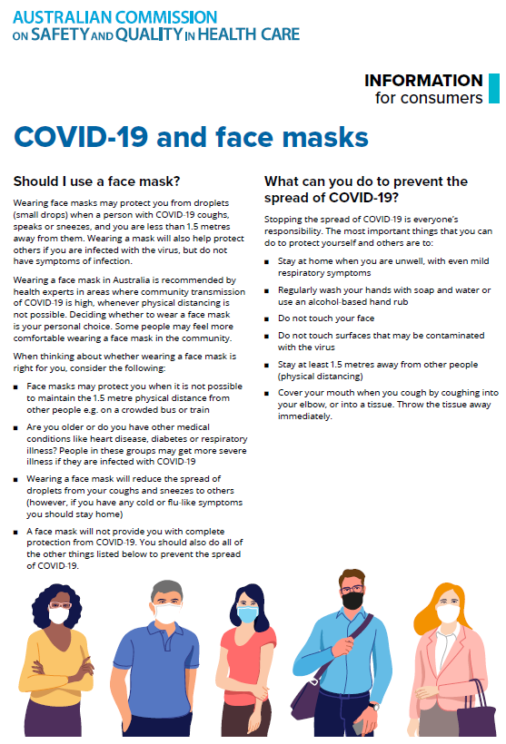](https://www.safetyandquality.gov.au/sites/default/files/2020-07/covid-19_and_face_masks_-_information_for_consumers.pdf)

*National Clinical Evidence Taskforce*

<https://clinicalevidence.net.au/>

The National Clinical Evidence Taskforce is a multi-disciplinary collaboration of 35 member organisations – Australia’s medical colleges and peak health organisations – who share a commitment to provide national evidence-based treatment guidelines for urgent and emerging diseases.

This alliance established the world’s first ‘living guidelines’ for the care of people with COVID-19 and MPX.

Funding has now been discontinued for the National Clinical Evidence Taskforce and the COVID-19 guidelines as of 30 June 2023.

These guidelines are no longer continually updated but will remain online until the guidance becomes inaccurate and/or no longer reflects the evidence or recommended practice.

*COVID-19 Critical Intelligence Unit*

<https://www.aci.health.nsw.gov.au/covid-19/critical-intelligence-unit>

The Agency for Clinical Innovation (ACI) in New South Wales has developed this page summarising rapid, evidence-based advice during the COVID-19 pandemic. Its operations focus on systems intelligence, clinical intelligence and evidence integration. The content includes a daily evidence digest, a COVID status monitor, a risk monitoring dashboard and evidence checks on a discrete topic or question relating to the current COVID-19 pandemic. There is also a ‘Living evidence’ section summarising key studies and emerging evidence on **COVID-19 vaccines** and **SARS-CoV-2 variants**. The most recent updates include:

* ***SARS-CoV-2 variants - retired living evidence*** – What is the evidence on SARS-CoV-2 variants that are under monitoring by the World Health Organization?
* ***COVID-19 vaccines - retired living evidence*** – What is the evidence on COVID-19 vaccine effectiveness and safety?
* ***Current and emerging patient safety issues during COVID-19*** – What is the evidence on the current and emerging patient safety issues arising from the COVID-19 pandemic?
* ***Bivalent COVID-19 vaccines*** – What is the available regulatory and research evidence for bivalent COVID-19 vaccines?
* ***Surgery post COVID-19*** – What is the evidence for the timing of surgery, and outcomes following surgery, for people who have recovered from COVID-19?
* ***Paxlovid*** – What is the evidence for Paxlovid for treatment of COVID-19?
* ***Molnupiravir*** –What is the evidence for and regulatory context of molnupiravir for treatment of COVID-19?
* ***Eating disorders and COVID-19*** – What is the impact of the COVID-19 pandemic on the prevalence of eating disorders?
* ***Long COVID –*** What is the evidence on the prevalence, presentation and management of long-COVID?
* ***Oseltamivir (Tamiflu) use in healthcare settings*** – What is the evidence that use of oseltamivir in healthcare workers with a symptomatic influenza diagnosis result in an earlier return to work and reduced absenteeism? What is the evidence that use of oseltamivir in adults and children with symptomatic influenza reduces influenza transmission in health care settings?
* ***Alternative models of care for acute medical conditions*** – What is the evidence on alternative models of care for managing patients with acute medical conditions outside of emergency or inpatient hospital settings?
* ***Exercise and long COVID*** – Is exercise helpful in individuals with long COVID? Is post-exertional symptom exacerbation a risk in long COVID?
* ***Influenza and seasonal prophylaxis with oseltamivir*** – What is the place or evidence for seasonal influenza prophylaxis (such as taking oseltamivir for 10 to 12 weeks continuously) in healthcare and aged care settings?
* ***Rapid access models of care for respiratory illnesses*** – What is the evidence for rapid access models of care for respiratory illnesses, especially during winter seasons, in emergency departments?
* ***Post-acute sequelae of COVID-19*** – What is the evidence on the post-acute sequelae of COVID-19?
* ***Emerging variants*** – What is the available evidence for emerging variants?
* ***Chest pain or dyspnoea following COVID-19 vaccination*** – What is evidence for chest pain or dyspnoea following COVID-19 vaccination?
* ***Cardiac investigations and elective surgery post-COVID-19*** – What is evidence for cardiac investigations and elective surgery post-COVID-19?
* ***Breathlessness post COVID-19*** – How to determine those patients who present with ongoing breathlessness in need of urgent review or intervention due to suspected pulmonary embolus?
* ***COVID-19 pandemic and influenza*** – What is the evidence for COVID-19 pandemic and influenza?
* ***Budesonide and aspirin for pregnant women with COVID-19 –*** What is the evidence for the use of Budesonide for pregnant women with COVID-19? What is the evidence for aspirin prophylaxis for pre-eclampsia in pregnant women with a COVID-19 infection?
* ***COVID-19 vaccines in Australia*** – What is the evidence on COVID-19 vaccines in Australia?
* ***COVID-19 pandemic and wellbeing of critical care and other healthcare workers*** – Evidence in brief on the impact of the COVID-19 pandemic on the wellbeing of critical care and other healthcare workers.
* ***Disease modifying treatments for COVID-19 in children*** – What is the evidence for disease modifying treatments for COVID-19 in children?
* ***Mask type for COVID-19 positive wearer*** – What is the evidence for different mask types for COVID-19 positive wearers?
* ***Post acute and subacute COVID-19 care*** – What published advice and models of care are available regarding post-acute and subacute care for COVID-19 patients?
* ***Hospital visitor policies*** – What is the evidence for hospital visitor policies during and outside of the COVID-19 pandemic?
* ***Surgical masks, eye protection and PPE guidance*** –What is the evidence for surgical masks in the endemic phase in hospitals and for eyewear to protect against COVID-19?

**Disclaimer**

On the Radar is an information resource of the Australian Commission on Safety and Quality in Health Care. The Commission is not responsible for the content of, nor does it endorse, any articles or sites listed. The Commission accepts no liability for the information or advice provided by these external links. Links are provided on the basis that users make their own decisions about the accuracy, currency and reliability of the information contained therein. Any opinions expressed are not necessarily those of the Australian Commission on Safety and Quality in Health Care.