# Australian Commission on Safety and Quality logotypeOn the Radar

Issue 626

30 October 2023

*On the Radar* is a summary of some of the recent publications in the areas of safety and quality in health care. Inclusion in this document is not an endorsement or recommendation of any publication or provider. Access to particular documents may depend on whether they are Open Access or not, and/or your individual or institutional access to subscription sites/services. Material that may require subscription is included as it is considered relevant.

*On the Radar* is available online, via email or as a PDF or Word document from <https://www.safetyandquality.gov.au/newsroom/subscribe-news/radar>

If you would like to receive *On the Radar* via email, you can subscribe on our website <https://www.safetyandquality.gov.au/newsroom/subscribe-news>  
or by emailing us at H[Umail@safetyandquality.gov.auU](mailto:mail@safetyandquality.gov.au).   
You can also send feedback and comments to H[Umail@safetyandquality.gov.auU](mailto:mail@safetyandquality.gov.au).

For information about the Commission and its programs and publications, please visit <https://www.safetyandquality.gov.au>

You can also follow us on Twitter @ACSQHC.

**On the Radar**

Editor: Dr Niall Johnson [niall.johnson@safetyandquality.gov.au](mailto:niall.johnson@safetyandquality.gov.au)

Contributors: Niall Johnson

**Reports**

*People-centred approach to addressing antimicrobial resistance in human health. WHO core package of interventions to support national action plans*

World Health Organization

Geneva: WHO; 2023. p. 63.

|  |  |
| --- | --- |
| URL | <https://www.who.int/news/item/19-10-2023-13-critical-interventions-that-support-countries-to-address-antimicrobial-resistance-in-human-health>  <https://www.who.int/publications/i/item/9789240082496> |
| Notes | The World Health Organization (WHO) has produced this document outlining ‘the concept and content of the WHO people-centred approach to addressing antimicrobial resistance (AMR) in the human health sector. The proposed approach recognizes and aims to address the challenges and health system barriers people face when accessing health services to prevent, diagnose and treat (drug-resistant) infections.’ The document outlines a number of ‘core interventions’ that ‘promote equitable and affordable access to quality health services for the prevention, diagnosis and treatment of infections, including drug-resistant infections, at all levels of health care within a country.’  [Graphic describing the four pillars and two foundational steps that are critical to overcome barriers faced by people and health systems in addressing AMR.](https://www.who.int/news/item/19-10-2023-13-critical-interventions-that-support-countries-to-address-antimicrobial-resistance-in-human-health) |

For information on the Commission’s work on antimicrobial resistance, see <https://www.safetyandquality.gov.au/our-work/antimicrobial-resistance>

*Rethinking Patient Safety. A Discussion Guide for Patients Healthcare Providers and Leaders*

Gilbert R, Asselbergs M, Davis D, MacLaurin A, Popescu I, Fancott C

Ottawa: Healthcare Excellence Canada; 2023. p. 11.

|  |  |
| --- | --- |
| URL | <https://www.healthcareexcellence.ca/media/gx4l3idd/rethinking-patient-safety.pdf> |
| Notes | Healthcare Excellence Canada and Patients for Patient Safety Canada have collaborated to produce this short resource. Release during Canadian Patient Safety Week (23–27 October) this resource prompts conversations around patient safety, including the roles of patients, families, and everyone working in healthcare in improving safety.  Pull quote from Rethinking Patient Safety. A Discussion Guide for Patients Healthcare Providers and Leaders document. Quote reads "Everyone contributes to patient safety. Together we must learn and act to create safer care and reduce all forms of healthcare harm." |

For information on the Commission’s work on partnering with consumers, see <https://www.safetyandquality.gov.au/our-work/partnering-consumers>

**Journal articles**

*Vital Signs: Health Worker–Perceived Working Conditions and Symptoms of Poor Mental Health — Quality of Worklife Survey, United States, 2018–2022*

Nigam JAS, Barker RM, Cunningham TR, Swanson NG, Chosewood LC

Morbidity and Mortality Weekly Report.24 October 2023

|  |  |
| --- | --- |
| DOI | <https://dx.doi.org/10.15585/mmwr.mm7244e1> |
| Notes | This piece in the *Morbidity and Mortality Weekly Report* reports the findings of a survey of health workers in the USA looking at issues including burnout and mental health impacts in 2018 and 2022. The respondents reported more days of poor mental health and were more likely to report burnout in 2022 than in 2018. Positive working conditions, such as trust in management and supervisor help, were associated with lower odds of poor mental health symptoms and burnout.  Infographic from Morbidity and Mortality Weekly Report titled What can employers do? https://www.cdc.gov/mmwr/index.html |

*Predictors of fatal and nonfatal overdose after prescription of opioids for chronic pain: a systematic review and meta-analysis of observational studies*

Wang L, Hong PJ, Jiang W, Rehman Y, Hong BY, Couban RJ, et al

Canadian Medical Association Journal 2023;195:E1399.

|  |  |
| --- | --- |
| DOI | <https://doi.org/10.1503/cmaj.230459> |
| Notes | This paper summarises a systematic review and meta-analysis of observational studies on opioid overdose after prescription for chronic pain. The project examined 28 unique studies in the analyses (21 cohort studies and 7 case-control studies). The authors report that ‘In this meta-analysis of observational studies of patients prescribed opioids for chronic pain, moderate- to high-certainty evidence showed large associations of fatal and nonfatal overdose with a history of opioid overdose, depression, bipolar disorder, a mental health diagnosis, current substance use disorder, pancreatitis, multiple opioid prescribers or dispensing pharmacies, prescription of 90-mg morphine equivalents or higher and prescription of fentanyl.’ |

For information on the *Opioid Analgesic Stewardship in Acute Pain Clinical Care Standard*, see <https://www.safetyandquality.gov.au/standards/clinical-care-standards/opioid-analgesic-stewardship-acute-pain-clinical-care-standard>

For information on the Commission’s work on medication safety, see <https://www.safetyandquality.gov.au/our-work/medication-safety>

*Factors Associated with Acute Injurious Falls in Elderly Hospitalized Patients: A Multicenter Descriptive Study*

Geskey JM, Yuksel JM, Snead JA, Noviasky JA, Brummel G, Shippey E.

The Joint Commission Journal on Quality and Patient Safety 2023;49(11):604-12.

*NSPD Data Spotlight: Patterns of Fall Interventions, 2023*

Agency for Healthcare Research and Quality

Rockville, MD: Agency for Healthcare Research and Quality; 2023. p. 22.

|  |  |
| --- | --- |
| DOI | Geskey et al <https://doi.org/10.1016/j.jcjq.2023.06.016>  AHRQ <https://www.ahrq.gov/sites/default/files/wysiwyg/npsd/data/spotlights/spotlight-patterns-fall-interventions.pdf> |
| Notes | Geskey et al examined data of patient falls from 835 US hospitals for a two-year period. The authors report that ‘Among 11,064,024 patient encounters, 5,978 met the …definition of a serious fall. **Patients who experienced a serious fall** were significantly more **likely** to be **>79 years** of age (p < 0.001, odds ratio [OR] 1.30, 95% confidence interval [CI] 1.23–1.37), have a **history of prior falls** (p < 0.001, OR 2.30, 95% CI 2.11–2.50), have a code for **dementia** (p < 0.001, OR 1.50, 95% CI 1.40–1.60), and have higher **anticholinergic cognitive burden** (ACB) scores (p < 0.001, OR 1.14, 95% CI 1.13–1.14).’  The *NSPD Data Spotlight: Patterns of Fall Interventions* draws together data on patient safety events from many US healthcare providers into the Network of Patient Safety Databases (NPSD). This Spotlight ‘focuses on falls within the NPSD since they are one of the most frequently reported patient safety events in the NPSD, second only to Medication or Other Substance events, making up approximately 10% of all events.’ The authors highlight a number of findings that echo the findings of the Geskey et al paper:   * Seniors experienced harm almost twice as often as adults (16.7% vs. 9.5%). * Patients with sensory impairment had a 15.9% higher rate of injury compared to patients without sensory impairment (24.8% vs. 21.4%). * Patients on medication known to increase their risk of falls had a 10.0% higher rate of injury (22.2% vs. 20.1%) compared with patients not on any medication known to increase risk of falls. * Patients with a history of falls had a 10.7% higher rate of injury compared to patients with no history of falls (24.1% vs. 21.8%).’ |

*Impact of leadership walkarounds on operational, cultural and clinical outcomes: a systematic review*

Foster M, Shultz B, Mazur L

BMJ Open Quality 2023;12:e002284.

*Toxic leadership and its relationship with outcomes on the nursing workforce and patient safety: a systematic review*

Labrague LJ

Leadership in Health Services 2023 [epub].

|  |  |
| --- | --- |
| DOI | Foster et al <https://doi.org/10.1136/bmjoq-2023-002284>  Labrague <https://doi.org/10.1108/lhs-06-2023-0047> |
| Notes | A pair of papers that focus on the importance and impact of leadership, both positive and negative.  Foster et al report on a systematic review examining the impact of leadership walkarounds. The authors observe that ‘In healthcare, patient safety leadership walkarounds (PSLWs) were introduced to increase clinicians’ awareness of safety hazards, demonstrate senior leaders’ engagement with safety and educate employees on patient safety concepts and active or impending safety hazards’. Focussing on 12 studies, they found only one study evaluated clinical outcomes. That study found a decrease in catheter-associated urinary tract infections after implementation of leadership walkarounds. Most studies had examined organisational outcomes and the authors note that ‘evidence exists to suggest a positive association of LWs on operational and cultural outcomes’.  Labrague reviewed the literature on the impact of toxic leadership on the nursing workforce and patient safety outcomes. Focused on 16 studies, content analysis clustered outcomes into 5 themes: satisfaction with work; relationship with organization; psychological state and well-being; productivity and performance; and patient safety outcomes. Under the patient safety theme, toxic leadership was associated with increased rates of falls, infections and medication errors. |

*Australian Prescriber*

Volume 46, Issue 3, October 2023

|  |  |
| --- | --- |
| URL | <https://australianprescriber.tg.org.au/> |
| Notes | A new issue of *Australian Prescriber* has been published. This is the third with its new publisher, Therapeutic Guidelines. Content in this issue of *Australian Prescriber* includes:   * Editorial: **Digital health and prescribing**: declare the past, diagnose the present, foretell the future (Jodie A Austin, Michael A Barras, Clair M Sullivan) * Management of **menopause** (Karen Magraith, Christina Jang) * **Blood glucose monitoring devices**: current considerations (Benjamin Sly, Janet Taylor) * **COVID-19 vaccines** in 2023 (Ketaki Sharma, Jean Li-Kim-Moy) * Update on changing Australian **medicine names** * **New drugs**:  Elasomeran+davesomeran for prevention of COVID-19 Tozinameran+riltozinameran and tozinameran+famtozinameran for prevention of COVID-19 Finerenone for chronic kidney disease associated with type 2 diabetes with albuminuria |

*The Joint Commission Journal on Quality and Patient Safety*

Volume 49, Issue 11, November 2023

|  |  |
| --- | --- |
| URL | <https://www.sciencedirect.com/journal/the-joint-commission-journal-on-quality-and-patient-safety/vol/49/issue/11> |
| Notes | A new issue of *The Joint Commission Journal on Quality and Patient Safety* has been published. Articles in this issue of *The Joint Commission Journal on Quality and Patient Safety* include:   * Editorial: Hungry for Change: How Best to Implement and Sustain Reduced **Fasting Times in Hospitalized Surgical Patients**? (Jamie L Sparling, Daniel Dante Yeh) * Editorial: **Repatriation of Transferred Patients**: A Solution for Hospital Capacity Concerns? (Stephanie K Mueller) * Reducing **Preoperative Fasting** Through Technology and Education in an Acute General Surgical Adult Cohort (Alexandra Jolley, Wallace Jin, Kristy Mansour, David Moore, Ned Douglas, Benjamin P T Loveday) * Impact of a **Repatriation Program Between Quaternary and Community Hospitals** (Kyan C Safavi, Allison Koehler, Nancy Mathews, Rachael McKenzie, Christina Stone, Patricia R Masson, Michael Hu, Peter F Dunn) * A Data-Driven Approach to Evaluate **Barcode-Assisted Medication Preparation Alerts** at a Large Academic Medical Center (Rutvik N Joshi, Samuel Kalaminsky, A-A Feemster, J Hill, J Leiman, D Evelyn, R Duncan) * Factors Associated with **Acute Injurious Falls in Elderly Hospitalized Patients**: A Multicenter Descriptive Study (Joseph M Geskey, Jaylan M Yuksel, Jessica A Snead, John A Noviasky, Gretchen Brummel, Ernie Shippey) * Readmission Reduction for **Hyperbilirubinemia in Infants** ≥ 35 Weeks Estimated Gestational Age Using a Standardized Protocol (Dakota K Tomasini, Michael G Guindon, R J Vereen, C M Drumm, A P Ponnapakkam) * Lessons Learned About System-Level Improvement in **Serious Illness Communication**: A Qualitative Study of Serious Illness Care Program Implementation in Five Health Systems (Joanna Paladino, Erik K Fromme, Laurel Kilpatrick, Laura Dingfield, Winifred Teuteberg, Rachelle Bernacki, Vicki Jackson, Justin J Sanders, Juliet Jacobsen, Christine Ritchie, S Mitchell) * Systematic Review of the **Impact of Physician Work Schedules on Patient Safety** with Meta-Analyses of Mortality Risk (Matthew D Weaver, Jason P Sullivan, Christopher P Landrigan, Laura K Barger) * Improving Judicious Use of **Heparin-Induced Thrombocytopenia Testing** Through Electronic Health Record–Based Intervention (Rushad Machhi, Paul F Lindholm, David Cooke, Matthew Groth, Karlyn A Martin) |

*BMJ Quality & Safety* online first articles

|  |  |
| --- | --- |
| URL | <https://qualitysafety.bmj.com/content/early/recent> |
| Notes | *BMJ Quality &Safety* has published a number of ‘online first’ articles, including:   * Editorial: Time to treat **the climate and nature crisis as one indivisible global health emergency** (Chris Zielinski on behalf of the authorship group) |

**COVID-19 resources**

https://www.safetyandquality.gov.au/covid-19

The Australian Commission on Safety and Quality in Health Care has developed a number of resources to assist healthcare organisations, facilities and clinicians. These and other material on COVID-19 are available at <https://www.safetyandquality.gov.au/covid-19>

These resources include:

* ***OVID-19 infection prevention and control risk management*** This primer provides an overview of three widely used tools for investigating and responding to patient safety events and near misses. Tools covered in this primer include incident reporting systems, Root Cause Analysis (RCA), and Failure Modes and Effects Analysis (FMEA).   
  <https://www.safetyandquality.gov.au/publications-and-resources/resource-library/covid-19-infection-prevention-and-control-risk-management-guidance>
* ***Poster – Combined contact and droplet precautions*** <https://www.safetyandquality.gov.au/publications-and-resources/resource-library/infection-prevention-and-control-poster-combined-contact-and-droplet-precautions>  
  [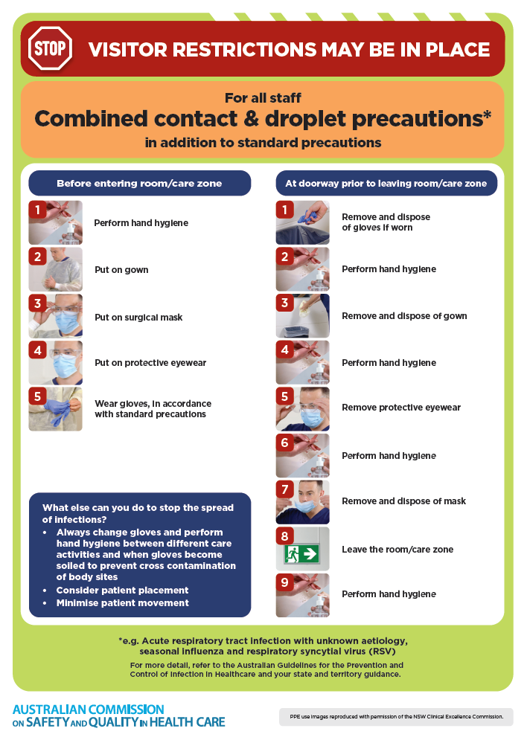](https://www.safetyandquality.gov.au/publications-and-resources/resource-library/infection-prevention-and-control-poster-combined-contact-and-droplet-precautions)
* ***Poster – Combined airborne and contact precautions*** <https://www.safetyandquality.gov.au/publications-and-resources/resource-library/poster-combined-airborne-and-contact-precautions>   
  [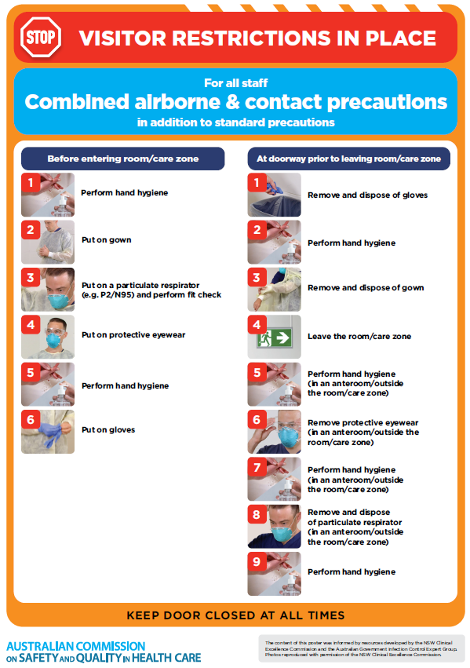](https://www.safetyandquality.gov.au/publications-and-resources/resource-library/poster-combined-airborne-and-contact-precautions)
* ***Environmental Cleaning and Infection Prevention and Control*** [www.safetyandquality.gov.au/environmental-cleaning](http://www.safetyandquality.gov.au/environmental-cleaning)
* ***COVID-19 infection prevention and control risk management – Guidance*** <https://www.safetyandquality.gov.au/publications-and-resources/resource-library/covid-19-infection-prevention-and-control-risk-management-guidance>
* ***Safe care for people with cognitive impairment during COVID-19***<https://www.safetyandquality.gov.au/our-work/cognitive-impairment/cognitive-impairment-and-covid-19>
* ***Stop COVID-19: Break the chain of infection*** posterhttps://www.safetyandquality.gov.au/publications-and-resources/resource-library/break-chain-infection-poster-a3  
  **[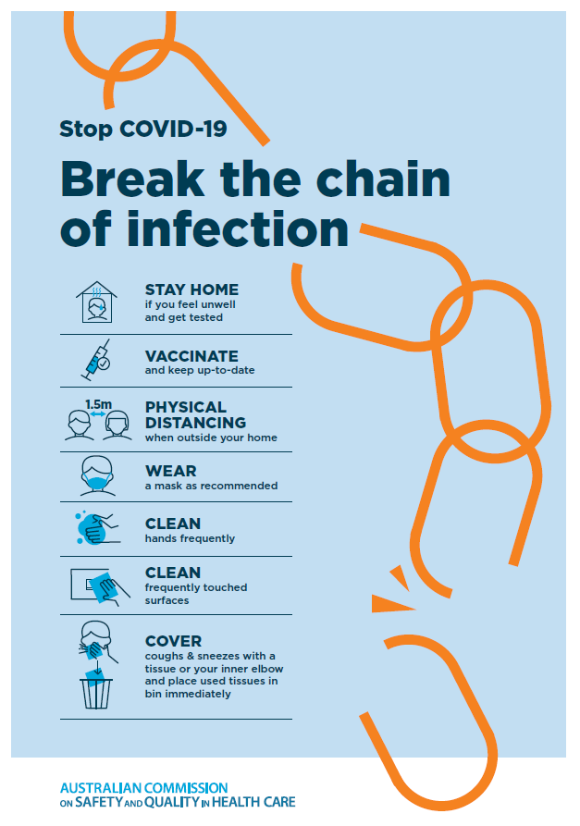](https://www.safetyandquality.gov.au/publications-and-resources/resource-library/break-chain-poster-a3https:/www.safetyandquality.gov.au/publications-and-resources/resource-library/break-chain-poster-a3)**
* ***COVID-19 and face masks – Information for consumers*** <https://www.safetyandquality.gov.au/publications-and-resources/resource-library/covid-19-and-face-masks-information-consumers>

[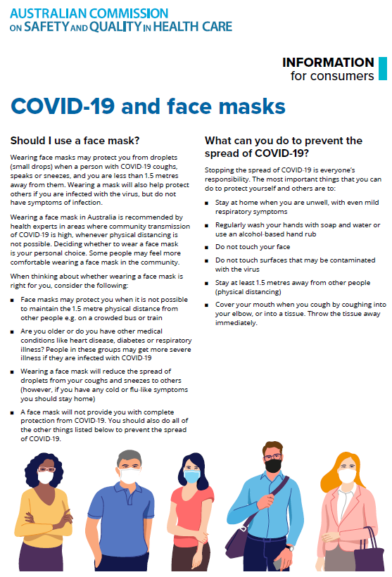](https://www.safetyandquality.gov.au/sites/default/files/2020-07/covid-19_and_face_masks_-_information_for_consumers.pdf)

*National Clinical Evidence Taskforce*

<https://clinicalevidence.net.au/>

The National Clinical Evidence Taskforce is a multi-disciplinary collaboration of 35 member organisations – Australia’s medical colleges and peak health organisations – who share a commitment to provide national evidence-based treatment guidelines for urgent and emerging diseases.

This alliance established the world’s first ‘living guidelines’ for the care of people with COVID-19 and MPX.

Funding has now been discontinued for the National Clinical Evidence Taskforce and the COVID-19 guidelines as of 30 June 2023.

These guidelines are no longer continually updated but will remain online until the guidance becomes inaccurate and/or no longer reflects the evidence or recommended practice.

**Disclaimer**

On the Radar is an information resource of the Australian Commission on Safety and Quality in Health Care. The Commission is not responsible for the content of, nor does it endorse, any articles or sites listed. The Commission accepts no liability for the information or advice provided by these external links. Links are provided on the basis that users make their own decisions about the accuracy, currency and reliability of the information contained therein. Any opinions expressed are not necessarily those of the Australian Commission on Safety and Quality in Health Care.