# Australian Commission on Safety and Quality logotypeOn the Radar

Issue 627

6 November 2023

*On the Radar* is a summary of some of the recent publications in the areas of safety and quality in health care. Inclusion in this document is not an endorsement or recommendation of any publication or provider. Access to particular documents may depend on whether they are Open Access or not, and/or your individual or institutional access to subscription sites/services. Material that may require subscription is included as it is considered relevant.

*On the Radar* is available online, via email or as a PDF or Word document from <https://www.safetyandquality.gov.au/newsroom/subscribe-news/radar>

If you would like to receive *On the Radar* via email, you can subscribe on our website <https://www.safetyandquality.gov.au/newsroom/subscribe-news>  
or by emailing us at H[Umail@safetyandquality.gov.auU](mailto:mail@safetyandquality.gov.au).   
You can also send feedback and comments to H[Umail@safetyandquality.gov.auU](mailto:mail@safetyandquality.gov.au).

For information about the Commission and its programs and publications, please visit <https://www.safetyandquality.gov.au>

You can also follow us on Twitter @ACSQHC.

**On the Radar**

Editor: Dr Niall Johnson [niall.johnson@safetyandquality.gov.au](mailto:niall.johnson@safetyandquality.gov.au)

Contributors: Niall Johnson, Alex Humphreys, Amy Forsyth, Lilly Crino

**Draft COPD Clinical Care Standard consultation**

<https://www.safetyandquality.gov.au/standards/clinical-care-standards/chronic-obstructive-pulmonary-disease-clinical-care-standard>

The Australian Commission on Safety and Quality in Health Care (the Commission) has released the draft *Chronic Obstructive Pulmonary Disease (COPD) Clinical Care Standard* for public consultation.

This new clinical care standard aims to reduce potentially preventable hospitalisations and improve overall outcomes for people with COPD by supporting best practice in the assessment and management of the condition, including COPD exacerbations. It also aims to increase consideration of the palliative care needs of people with COPD to support symptom management and improve quality of life.

Public consultation is open from **Monday 6 November** until **Monday 18 December 2023**. The draft Standard and instructions for submitting comments are available at <https://www.safetyandquality.gov.au/ccs-consultations>

[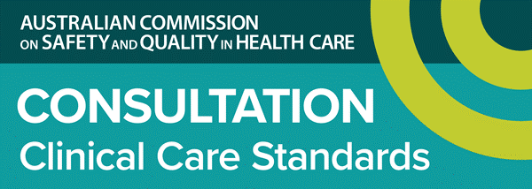](https://www.safetyandquality.gov.au/ccs-consultations)

**Register now National Medicines Symposium 2023**

<https://safetyandquality.gov.au/nms23>

Healthcare leaders, experts and policymakers will come together at the free virtual National Medicines Symposium this week, on 8 November to explore sustainable and quality use of medicines while maintaining appropriate care.

Hear from local and international experts, including:

* Hon Mark Butler, Minister for Health and Aged Care
* Professor Faye McMillan AM, Deputy National Rural Health Commissioner and Professor in Indigenous Health, UTS
* Dr Kate Charlesworth, Medical Director, Climate Risk and Net Zero Unit, NSW Health
* Dr Valeria Stoynova and Dr Celia Culley, CASCADES, Canada

Discover practical insights to reduce the carbon footprint of medicines and improve sustainable practice. Register today at <https://safetyandquality.gov.au/NMS23>

[](http://safetyandquality.gov.au/nms23)

**Reports**

*Investigation report: Caring for adults with a learning disability in acute hospitals*

Health Services Safety Investigations Body

Poole: HSIB; 2023.

|  |  |
| --- | --- |
| URL | <https://www.hssib.org.uk/patient-safety-investigations/caring-for-adults-with-learning-disabilities-in-acute-hospitals/> |
| Notes | The Health Services Safety Investigations Body in the UK has released their latest report which has the intention of improving the inpatient care of adults with a known learning disability in acute hospital settings. The investigation report provides a number of findings, recommendations and safety observations. While the report is focused on the UK, many of these issues exist elsewhere. |

*Briefing: Improvement as mainstream business. The strategic case*

Jones B, Pereira P

London: The Health Foundation; 2023. p. 20.

|  |  |
| --- | --- |
| URL | <https://www.health.org.uk/publications/reports/briefing-improvement-as-mainstream-business> |
| Notes | This briefing from The Health Foundation in the UK makes the point that (quality) improvement should be mainstream or core business for health care organisations and systems. The authors assert that ‘Improvement approaches are not just a mechanism for improving care processes and pathways and tackling variation. They are indispensable when it comes to tackling the biggest delivery and transformation challenges that health care faces, such as the need to make greater use of technology and tackle waiting times and winter pressures. They provide a systematic, collaborative and inclusive approach capable of delivering sustained improvement at scale.’  In the briefing the authors also examine approaches to improvement, the benefits of improvement, some of the barries to uptake and effectiveness of improvement and what may be done to help embed improvement. |

**Journal articles**

*Second victim syndrome in intensive care unit healthcare workers: A systematic review and meta-analysis on types, prevalence, risk factors, and recovery time*

Naya K, Aikawa G, Ouchi A, Ikeda M, Fukushima A, Yamada S, et al

PLOS ONE 2023;18(10):e0292108.

|  |  |
| --- | --- |
| DOI | <https://doi.org/10.1371/journal.pone.0292108> |
| Notes | Patient safety incidents can have profound impacts on both the patient and those involved. This piece reports on a systematic review and meta-analysis that examined the impacts on healthcare workers (‘second victims’) of incidents in the intensive care unit (ICU) setting. While there is a literature on ‘second victims’, the literature focussing on this in ICUs is less extensive with this review focused on 5 studies. From these, the review reported ‘that 58% of intensive care unit healthcare workers experienced second victim syndrome. Frequent symptoms included guilt (12–68%), anxiety (38–63%), anger at self (25–58%), and lower self-confidence (7–58%).’ They also found that ‘approximately 20% of individuals took more than a year to recover or did not recover at all from the second victim syndrome.’ |

*Patient Experience Journal*

Volume 10, Issue 3, 2023

|  |  |
| --- | --- |
| URL | <https://pxjournal.org/journal/vol10/iss3/> |
| Notes | A new issue of the *Patient Experience Journal (PXJ)* has been published. Articles in this issue of the *Patient Experience Journal* include:   * Editorial: Four commitments for **the future of healthcare**: Reflecting on a decade of Patient Experience Journal (Jason A Wolf) * Breaking the transactional mindset: A new path for **healthcare leadership built on a commitment to human experience** (Kirsten Krull, Jerry Mansfield, Jennifer Gentry, Karen Grimley, Barbara Jacobs, and Jason Wolf) * The case for **patient-reported pleasure** (Preston Long and Tanja Stamm) * Transforming the American **experience of death**: What dreams may come? (Melinda Xu; Geoffrey A Silvera; Lyle Walton; and Jane Banaszak-Holl) * Medicine and kindness, a glorious concurrence? (Araya Gautam) * The silence of **mitotic figures** (Hope K Haefner) * **“You Are the Key”: A co-design project** to reduce disparities in Black veterans’ communication with healthcare providers (Anna M Barker, Renda S Wiener, Dave Crocker, Makayla Dones, Oluwabunmi Emidio, Abigail N Herbst, Jenesse Kaitz, Lauren Kearney, Danielle Miano, and Gemmae M Fix) * Patient perspectives of **health-related social needs screening** in an urban academic adult primary care practice (Antony Nguyen, Joselvin Galeas, and Jane Jih) * **Informed consent** in surgical practice with patients’ experiences: A cross-sectional study (Seda Kumru, Pakize Yiğit, Meryem Demirtaş, and Hüseyin Fındık) * Informative material for **patient empowerment in sensitive situations** (Iris Reychav, Lin Zhu, Avi Parush, Roger McHaney, Daphne R. Raban, Amy Lauren Shapira, and Rami Moshonov) * Meaningful engagement of patients and families in a complex trial of **advance care planning in primary care** (Angela K Combe, Deborah L Dokken, Mary M Minniti, and Annette M Totten) * Implementing a **patient engagement framework in the primary healthcare system** in Qatar (Nawal Khattabi, Mohammed Abdalla, Amal Al Ali, and Mariam Abdul Malik) |

*Nursing Leadership*

Volume 36, Number 2, 2023

|  |  |
| --- | --- |
| URL | <https://www.longwoods.com/publications/nursing-leadership/27201/1/vol.-36-no.-2-2023> |
| Notes | A new issue of *Nursing Leadership* has been published. Articles in this issue of *Nursing Leadership* include:   * Editorial: **Leading to Learn and Learning to Lead** in Post-COVID Healthcare Systems (Ruth Martin-Misener) * **Sharing Nurses’ Voices** in Challenging Times (Gail J Donner and Mary M Wheeler) * Easing the Nursing Shortage: Tools for **Retaining Nurses through Mentorship** (Élisabeth Bélanger-Hardy, Karen S Palmer, Kristina M Kokorelias, Christine Chan and Susan Law) * **Organizational Supports for Nurse Managers** in a North American Context: A Scoping Review (Janelle Cave, Noelle Rohatinsky and Lois Berry) * Evaluation Findings on Lessons Learned from the Implementation of the **Public Health Leadership Program** during the COVID-19 Pandemic (Hamida Bhimani, Julia Roitenberg and Dorothy Dziunikowski) * Interventions to Improve the **Nursing Care of People with Dementia** in Canadian Hospitals: An Environmental Scan (Elaine Moody, S. Hannah Jamieson, Kelly Bradbury, Melissa Rothfus, Ishani Khanna, Lori E. Weeks, Ann Belliveau, Trish Bilski and Gianisa Adisaputri) |

*International Journal for Quality in Health Care* online first articles

|  |  |
| --- | --- |
| URL | <https://academic.oup.com/intqhc/advance-articles> |
| Notes | *International Journal for Quality in Health Care* has published a number of ‘online first’ articles, including:   * Design and validation of indicators for the comprehensive measurement of **quality of care for type 2 diabetes and acute respiratory infections**, in ambulatory health services (Hortensia Reyes-Morales et al) |

**Online resources**

***End of Life Essentials***

<https://www.endoflifeessentials.com.au/>

The End of Life Essentials has added an additional video titled *Patient’s Perspective*.

Health service staff can use the video for various purposes, such as team-building activities, in-service education sessions, as part of the onboarding process for new staff members, and as an informative tool to shape terms of reference related to integrating the patient perspective into discussions of quality and safety. They may incorporate the video into their in-house resources, making it readily accessible for ongoing reference and guidance in their daily roles and interactions with patients.

Through the personal story presented, viewers are encouraged to find the courage to view and interact with patients as individuals, not just as their diagnosis. It shows the power of healthcare professionals who take the time to connect on a personal level, showing empathy and compassion. Ultimately, the video highlights the transformative effect of recognising patients as people, fostering a more patient-centered and empathetic healthcare environment.

End-of-Life Essentials is funded by the Australian Government Department of Health and Aged Care.

***[UK] NICE Guidelines and Quality Standards***

<https://www.nice.org.uk/guidance>

The UK’s National Institute for Health and Care Excellence (NICE) has published new (or updated) guidelines and quality standards. The latest reviews or updates include:

* NICE Guideline NG237 *Suspected* ***acute respiratory infection*** *in over 16s: assessment at first presentation and initial management* <https://www.nice.org.uk/guidance/ng237>
* Quality Standard QS210 ***Acute respiratory infection*** *in over 16s: initial assessment and management including virtual wards (hospital at home)* <https://www.nice.org.uk/guidance/qs210>
* Clinical Guideline CG191 ***Pneumonia*** *in adults: diagnosis and management* <https://www.nice.org.uk/guidance/cg191>
* Clinical Guideline CG98 ***Jaundice*** *in newborn babies under 28 days* <https://www.nice.org.uk/guidance/cg98>

***[UK] NIHR Evidence***

https://evidence.nihr.ac.uk/

The UK’s National Institute for Health Research (NIHR) has posted new evidence alerts on its site. Evidence alerts are short, accessible summaries of health and care research which is funded or supported by NIHR. This is research which could influence practice and each Alert has a message for people commissioning, providing or receiving care. The latest alerts include:

* How to **share decision-making** about major surgery for people at high risk of complications
* Mindfulness-based cognitive therapy, delivered as supported self-help, can help people with **depression**
* Which **attachment interventions** are supported by research?
* **Blood pressure treatment**: the risks may be as great as the benefits in older people with frailty
* Can we improve discussions with **pregnant women** about previous trauma?

The NIHR has also produced a new Collection: **Why we need to understand breast cancer risk.** <https://evidence.nihr.ac.uk/collection/breast-cancer-risk-why-we-need-to-understand-it/>This Collection provides insights into breast cancer risk and screening. The Collection brings together a selection of studies that have investigated breast cancer risk and screening, including how:

* Risk-based approach could increase benefits of breast screening
* Healthy weight would prevent some breast cancers
* Family history increases some women’s risk but extra screening can help.

***[USA] AHRQ Perspectives on Safety***

<https://psnet.ahrq.gov/psnet-collection/perspectives>

The US Agency for Healthcare Research and Quality (AHRQ) publishes occasional Perspectives on Safety essays. Recent essays include:

* *Addressing* ***Workplace Violence*** *and Creating a Safer Workplace* – focuses on workplace violence trends in healthcare settings and strategies for creating a safer healthcare environment.<https://psnet.ahrq.gov/perspective/addressing-workplace-violence-and-creating-safer-workplace>

***[USA] Patient Safety Primers***

<https://psnet.ahrq.gov/primers/>

The Patient Safety Primers from the (US) Agency for Healthcare Research and Quality (AHRQ) discuss key concepts in patient safety. Each primer defines a topic, offers background information on its epidemiology and context, and provides links to relevant materials.

* ***Digital Health Literacy*** <https://psnet.ahrq.gov/primer/digital-health-literacy>

**COVID-19 resources**

https://www.safetyandquality.gov.au/covid-19

The Australian Commission on Safety and Quality in Health Care has developed a number of resources to assist healthcare organisations, facilities and clinicians. These and other material on COVID-19 are available at <https://www.safetyandquality.gov.au/covid-19>

These resources include:

* ***OVID-19 infection prevention and control risk management*** This primer provides an overview of three widely used tools for investigating and responding to patient safety events and near misses. Tools covered in this primer include incident reporting systems, Root Cause Analysis (RCA), and Failure Modes and Effects Analysis (FMEA).   
  <https://www.safetyandquality.gov.au/publications-and-resources/resource-library/covid-19-infection-prevention-and-control-risk-management-guidance>
* ***Poster – Combined contact and droplet precautions*** <https://www.safetyandquality.gov.au/publications-and-resources/resource-library/infection-prevention-and-control-poster-combined-contact-and-droplet-precautions>  
  [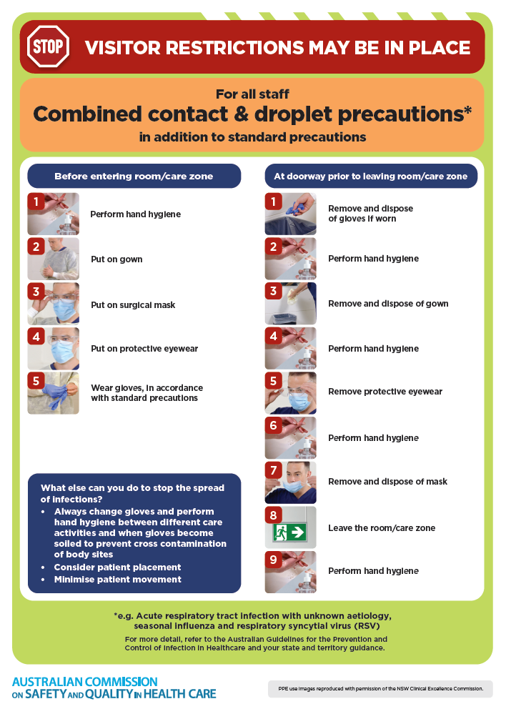](https://www.safetyandquality.gov.au/publications-and-resources/resource-library/infection-prevention-and-control-poster-combined-contact-and-droplet-precautions)
* ***Poster – Combined airborne and contact precautions*** <https://www.safetyandquality.gov.au/publications-and-resources/resource-library/poster-combined-airborne-and-contact-precautions>   
  [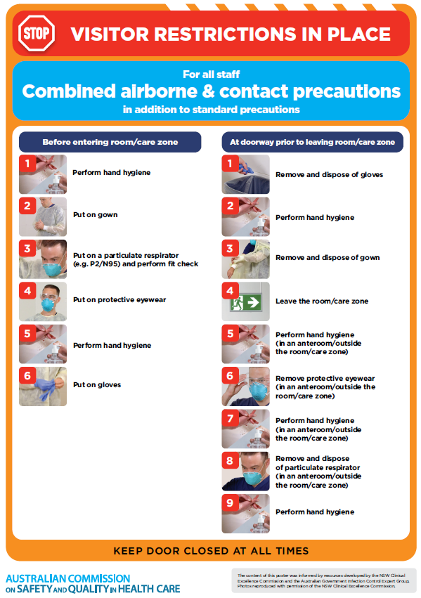](https://www.safetyandquality.gov.au/publications-and-resources/resource-library/poster-combined-airborne-and-contact-precautions)
* ***Environmental Cleaning and Infection Prevention and Control*** [www.safetyandquality.gov.au/environmental-cleaning](http://www.safetyandquality.gov.au/environmental-cleaning)
* ***COVID-19 infection prevention and control risk management – Guidance*** <https://www.safetyandquality.gov.au/publications-and-resources/resource-library/covid-19-infection-prevention-and-control-risk-management-guidance>
* ***Safe care for people with cognitive impairment during COVID-19***<https://www.safetyandquality.gov.au/our-work/cognitive-impairment/cognitive-impairment-and-covid-19>
* ***Stop COVID-19: Break the chain of infection*** posterhttps://www.safetyandquality.gov.au/publications-and-resources/resource-library/break-chain-infection-poster-a3  
  **[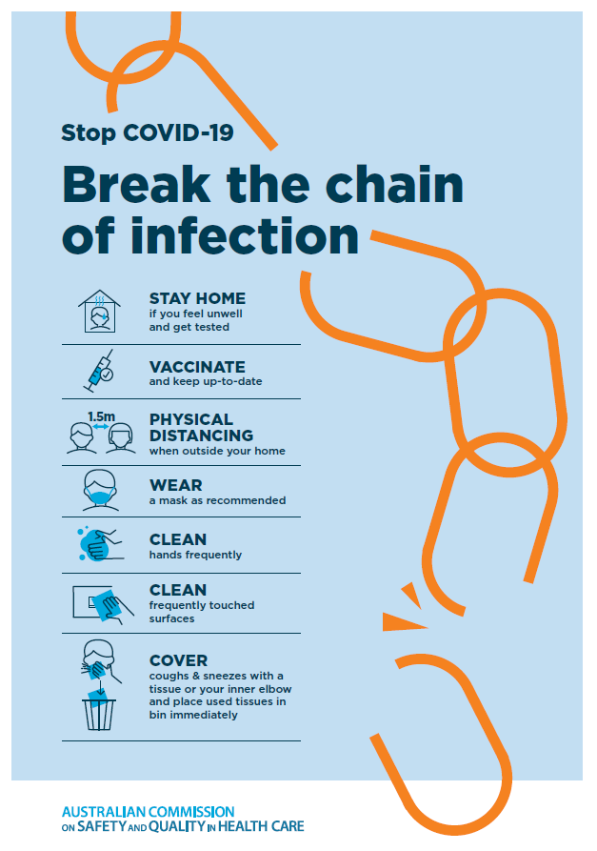](https://www.safetyandquality.gov.au/publications-and-resources/resource-library/break-chain-poster-a3https:/www.safetyandquality.gov.au/publications-and-resources/resource-library/break-chain-poster-a3)**
* ***COVID-19 and face masks – Information for consumers*** <https://www.safetyandquality.gov.au/publications-and-resources/resource-library/covid-19-and-face-masks-information-consumers>

[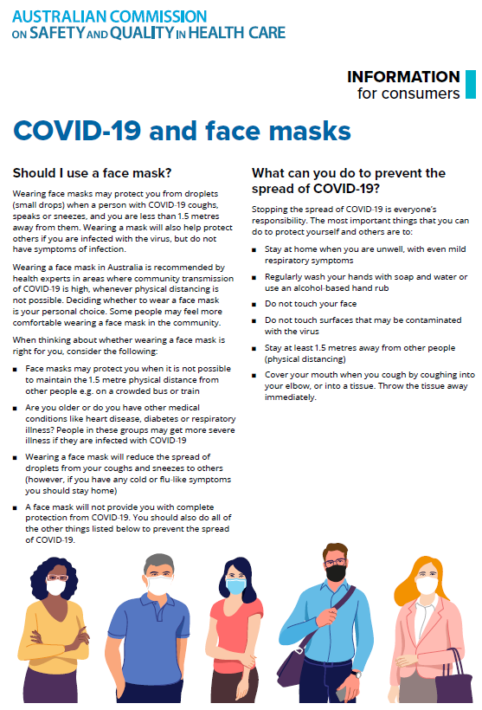](https://www.safetyandquality.gov.au/sites/default/files/2020-07/covid-19_and_face_masks_-_information_for_consumers.pdf)

*National Clinical Evidence Taskforce*

<https://clinicalevidence.net.au/>

The National Clinical Evidence Taskforce is a multi-disciplinary collaboration of 35 member organisations – Australia’s medical colleges and peak health organisations – who share a commitment to provide national evidence-based treatment guidelines for urgent and emerging diseases.

This alliance established the world’s first ‘living guidelines’ for the care of people with COVID-19 and MPX.

Funding has now been discontinued for the National Clinical Evidence Taskforce and the COVID-19 guidelines as of 30 June 2023.

These guidelines are no longer continually updated but will remain online until the guidance becomes inaccurate and/or no longer reflects the evidence or recommended practice.

**Disclaimer**

On the Radar is an information resource of the Australian Commission on Safety and Quality in Health Care. The Commission is not responsible for the content of, nor does it endorse, any articles or sites listed. The Commission accepts no liability for the information or advice provided by these external links. Links are provided on the basis that users make their own decisions about the accuracy, currency and reliability of the information contained therein. Any opinions expressed are not necessarily those of the Australian Commission on Safety and Quality in Health Care.