# Australian Commission on Safety and Quality logotypeOn the Radar

Issue 628

13 November 2023

*On the Radar* is a summary of some of the recent publications in the areas of safety and quality in health care. Inclusion in this document is not an endorsement or recommendation of any publication or provider. Access to particular documents may depend on whether they are Open Access or not, and/or your individual or institutional access to subscription sites/services. Material that may require subscription is included as it is considered relevant.

*On the Radar* is available online, via email or as a PDF or Word document from <https://www.safetyandquality.gov.au/newsroom/subscribe-news/radar>

If you would like to receive *On the Radar* via email, you can subscribe on our website <https://www.safetyandquality.gov.au/newsroom/subscribe-news>  
or by emailing us at H[Umail@safetyandquality.gov.auU](mailto:mail@safetyandquality.gov.au).   
You can also send feedback and comments to H[Umail@safetyandquality.gov.auU](mailto:mail@safetyandquality.gov.au).

For information about the Commission and its programs and publications, please visit <https://www.safetyandquality.gov.au>

You can also follow us on Twitter @ACSQHC.

**On the Radar**

Editor: Dr Niall Johnson [niall.johnson@safetyandquality.gov.au](mailto:niall.johnson@safetyandquality.gov.au)

Contributors: Niall Johnson

**Books**

*Governance and Leadership*

Elements of Improving Quality and Safety in Healthcare

Fulop NJ, Ramsay AIG

Cambridge: Cambridge University Press; 2023

|  |  |
| --- | --- |
| DOI / URL | <https://doi.org/10.1017/9781009309578>  <https://www.cambridge.org/core/elements/governance-and-leadership/9FBFA3C48A57CCB5B97F5899895D011D> |
| Notes | This is the latest release in the Elements of Improving Quality and Safety in Healthcare series from The Healthcare Improvement Studies Institute (the THIS Institute) in Cambridge. This volume examines the evidence on how governance and leadership influence quality and safety in healthcare. It also describes behaviours that may help boards and governing bodies focus on improving quality and how different leadership approaches may contribute to delivering system change and improvement. |

**Reports**

*Nursing Care Needs Standard*

Professional Record Standards Body

London. 2023.

|  |  |
| --- | --- |
| URL | <https://theprsb.org/standards/nursingcareneeds/> |
| Notes | The Professional Record Standards Body (PRSB) in the UK has published this new nursing standard for use across different health and social care settings in the UK. The standard seeks to reduce that documentation burden on nurses and support them in providing quality care. According to the PRSB, the standard ‘reflects best practice and standardises documentation across different nursing settings, helping free nurses from the administrative burden of repetitive data entry and giving them more time to provide care. It also helps people and their families avoid having to ‘tell their story’ repeatedly.’ |

**Journal articles**

Digital Health and Technology Adoption

Ng FSF, Brommeyer M, Liang Z

In: Fong BYF, Wong WCW, editors

Gaps and Actions in Health Improvement from Hong Kong and Beyond: All for Health

Singapore: Springer Nature Singapore; 2023. p. 281-294.

|  |  |
| --- | --- |
| DOI | <https://doi.org/10.1007/978-981-99-4491-0_19> |
| Notes | The potential for digital technologies to enhance health care and contribute to the safety and quality of care has been regularly asserted. Using case studies from Australia and Hong Kong this piece examines how digital technologies and models of care have changed health car delivery. The authors also identify the importance of the digital health workforce and how competent health service and health information managers support the move to digital health. |

*The Journal for Healthcare Quality*

Volume 45, Number 6, November/December 2023

|  |  |
| --- | --- |
| URL | <https://journals.lww.com/jhqonline/toc/2023/12000> |
| Notes | A new issue of *The Journal for Healthcare Quality (JHQ)* has been published. Articles in this issue of *The Journal for Healthcare Quality (JHQ)* include:   * Implementing a **Discharge Follow-up Phone Call Program Reduces Readmission Rates** in an Integrated Health System (Lukanski, Amy; Watters, Shelley; Bilderback, Andrew L; Buchanan, Dan; Hodges, Jacob C; Burwell, D; Triola, A; Marroquin, O C; Martin, S C; Zapf, R L; Kip, P L; Minnier, T E) * Applying the **Urgent Maternal Warning Signs Initiative** in a Novel Setting (Jenkins, Katherine; Quarshie, Evelyn; Phommasathit, Crystal; Menegay, Michelle; Lorenz, Allison; Schneider, Patrick; Oza-Frank, Reena; Haviland, Breanne; Kristofzski-Raizor, Heather; Gogan Turner, Dyane) * Interventions to Reduce **Inappropriate Physical Therapy Consultation in the Inpatient Setting**: A Quality Improvement Initiative (Patel, Moksha; Gardner, Tiffany A; White, C; Keniston, A; Maassen, B; Gottenborg, E) * Diagnostic Accuracy of a **Trauma Risk Assessment Tool** Among Geriatric Patients With Crash Injuries (Adeyemi, Oluwaseun John; Gibbons, Kester; Schwartz, Luke B; Meltzer-Bruhn, Ariana T; Esper, Garrett W.; Grudzen, Corita; DiMaggio, Charles; Chodosh, Joshua; Egol, Kenneth A; Konda, S R) * Barriers to **Health Information Exchange Among Ambulatory Physicians**: Results From a Nationally Representative Sample (Matthews, Elizabeth B; Stanhope, Victoria; Hu, Yuanyuan) * Comparison of **Clinical, Economic, and Humanistic Outcomes Between Blood Collection Approaches**: A Systematic Literature Review (Perry, Cathy; Alsbrooks, Kimberly; Mares, Alicia; Hoerauf, Klaus0 * An Initiative to **Stop Antibiotics Prescribed for Urinary Symptoms** When Urine Culture Is Negative (Kofoed, Benjamin; Morris, Jacob; Rich, Jennifer) |

*Health Affairs Scholar*

Volume 1, Issue 4, October 2023

|  |  |
| --- | --- |
| URL | <https://academic.oup.com/healthaffairsscholar/issue/1/4> |
| Notes | A new issue of *Health Affairs Scholar* has been published. Articles in this issue of *Health Affairs Scholar* include:   * Paid care among **older adults with long-term care needs** declined in the first year of COVID-19 while families stepped in (Yulya Truskinovsky and Emily E Wiemers) * The impact of **parental involvement laws on minors seeking abortion services**: a systematic review (Alisha Kramer et al) * Project Respect: **experiences of seriously ill LGBTQ+ patients** and partners with their health care providers (Gary L Stein et al) * **Public perceptions of US for-profit, nonprofit, and public hospitals** (Lauren A Taylor et al) * Evolving availability and standardization of **patient attributes for matching** (Yu Deng et al) * The potential impact of clinical decision support on nonwaivered **primary care clinicians’ prescribing of buprenorphine** (Anthony W Olson et al) * Is employment group **insurance financing of expensive gene therapies** threatened in the United States? (Jalpa A Doshi et al) * Social media users’ perceptions about **health mis- and disinformation on social media** (Jim P Stimpson and Alexander N Ortega) * Why the United States needs a multifaceted **definition of health** (Kevin Fiscella and Ronald M Epstein) |

*Health Affairs*

Volume 42, Number 11, November 2023

|  |  |
| --- | --- |
| URL | <https://www.healthaffairs.org/toc/hlthaff/42/11> |
| Notes | A new issue of *Health Affairs* has been published with the themes ‘Care Models, Physicians, Affordability & more’. Articles in this issue of *Health Affairs* include:   * No Improvement In Mental Health Treatment Or Patient-Reported Outcomes At Medicare ACOs For **Depression And Anxiety Disorders** (Jason M Hockenberry, Hefei Wen, B G Druss, T Loux, and K J Johnston) * Medicare Care Choices Model Improved **End-Of-Life Care**, Lowered Medicare Expenditures, And Increased Hospice Use (Keith Kranker, Matthew J Niedzwiecki, R Vincent Pohl, Tonya L Saffer, Arnold Chen, Jonathan Gellar, Lauren Vollmer Forrow, and Lynn Miescier) * Proportion Of **Preventive Primary Care Visits** Nearly Doubled, Especially Among Medicare Beneficiaries, 2001–19 (Lisa S Rotenstein, John N Mafi, and Bruce E Landon) * After 50 Years, **Health Professional Shortage Areas** Had No Significant Impact On Mortality Or Physician Density (Justin H Markowski, Jacob Wallace, and Chima D Ndumele) * The Joint Distribution Of **High Out-Of-Pocket Burdens, Medical Debt, And Financial Barriers** To Needed Care (Didem M Bernard, Thomas M Selden, and Zhengyi Fang) * Confronting High Costs And Clinical Uncertainty: Innovative **Payment Models For Gene Therapies** (Caroline Horrow and Aaron S Kesselheim) * **Firearm Injuries In Children And Adolescents:** Health And Economic Consequences Among Survivors And Family Members (Zirui Song, José R Zubizarreta, Mia Giuriato, Katherine A Koh, and Chana A Sacks) * Age Trends And State Disparities In **Firearm-Related Suicide** In The US, 1999–2020 (Nathaniel J Glasser, Nabil Abou Baker, Harold A Pollack, Sohail S Hussaini, and Elizabeth L Tung) * Studies Of **Prescription Digital Therapeutics** Often Lack Rigor And Inclusivity (Anika Kumar, Joseph S Ross, Nisarg A Patel, Vinay Rathi, Rita F Redberg, and Sanket S Dhruva) * Minnesota Data Sharing May Be Model For **Near-Real-Time Tracking Of Drug Overdose Hospital And ED Trends** (Riley D. Shearer, Rebecca Rossom, Paul J. Christine, Madison Hoover, J Bauch, P Bodurtha, N K Rai, M Clegg, B C Westgard, K R Ehresmann, A L Bennett, and T N A Winkelman) * The Health And Social Needs Of Medicaid Beneficiaries In The **Postpartum Year**: Evidence From A Multistate Survey (Jamie R Daw, Kristen Underhill, Chen Liu, and Heidi L Allen) * Medicaid Expansion And **Outpatient Cardiovascular Care** Use Among Low-Income Nonelderly Adults, 2012–15 (Sameed Ahmed M Khatana, Lin Yang, L A Eberly, A S Nathan, R Gupta, S A Lorch, and P W Groeneveld) * The Impact Of Provincial Proof- Of-Vaccination Policies On Age-Specific First-Dose **Uptake Of COVID-19 Vaccines** In Canada (Tiffany Fitzpatrick, Cheryl A. Camillo, S Hillis, M Habbick, M Roerig, N Muhajarine, and S Allin) * **Health Benefits In 2023**: Premiums Increase With Inflation And Employer Coverage In The Wake Of Dobbs (Gary Claxton, Matthew Rae, Anthony Damico, Emma Wager, Aubrey Winger, and Michelle Long) * **To Profit Or Not?** Lessons From The Insurance Front Lines (P A Steiner) |

*Health Expectations*

Volume 26, Issue 6, December 2023

|  |  |
| --- | --- |
| URL | <https://onlinelibrary.wiley.com/toc/13697625/2023/26/6> |
| Notes | A new issue of *Health Expectations* has been published. Articles in this issue of *Health Expectations* include:   * Understanding how **shared decision-**making approaches and patient aids influence patients with advanced cancer when deciding on palliative treatments and care: A realist review (Michelle Edwards, Daniella Holland-Hart, Mala Mann, Kathy Seddon, Peter Buckle, Mirella Longo, Anthony Byrne, A Nelson) * Patient, carer and family experiences of seeking **redress and reconciliation following a life-changing event**: Systematic review of qualitative evidence (Liz Shaw, Hassanat M Lawal, Simon Briscoe, Ruth Garside, Jo Thompson Coon, Morwenna Rogers, G J Melendez-Torres) * Involvement of people who use alcohol and other drug services in the development of **patient-reported measures of experience**: A scoping review (Anke E van der Sterren, Sally Nathan, Patrick Rawstorne, Elisabeth Yarbakhsh, Chris Gough, Devin Bowles) * **Self-directed self-management interventions** to prevent or address distress in young people with long-term physical conditions: A rapid review (Nadia Corp, Lucy Bray, Carolyn A Chew-Graham, Kay Polidano, Tamsin Fisher, Adam D Farmer, Megan McDermott-Hughes, Benjamin Saunders) * Patient engagement during the **transition from nondialysis-dependent chronic kidney disease to dialysis**: A meta-ethnography (Jinjie Liu, Yujun Zhou, Yanyao Tang, Jieling Chen, Jianying Li) * Experiences of **goal planning in Australian community pharmacy settings** for people experiencing mental illness: A qualitative study (Victoria Stewart, S S McMillan, J Hu, J C Collins, S El-Den, C O'Reilly, A J Wheeler) * Why do people **choose not to take part in screening**? Qualitative interview study of atrial fibrillation screening nonparticipation (Sarah Hoare, Gwilym P A Thomas, Alison Powell, Natalie Armstrong, Jonathan, Jenni Burt) * **Transition readiness of youth** with co-occurring chronic health and mental health conditions: A mixed methods study (Brooke Allemang, Susan Samuel, Katelyn Greer, Keighley Schofield, Karina Pintson, Megan Patton, Marcela Farias, Kathleen C Sitter, Scott B Patten, Andrew S Mackie, G Dimitropoulos) * **Trust and distrust** in low-income Michigan residents during the early **COVID-19** pandemic: A qualitative study (Gavisha Waidyaratne Eric Steinbrook, Shalini Roy, Annabella Opoku, Kaitlyn Jaffe, Susan Dorr Goold) * Beyond dry eye: The greater extent of **Sjögren's systemic disease symptoms**, the impact of COVID-19 and perceptions towards telemedicine identified through a patient co-designed study (Emily Greenan, Gráinne Tynan, Deirdre Collins, C C Murphy, M Flood, Joan Ní Gabhann-Dromgoole) * Young people's perspectives on **addressing UK health inequalities**: utopian visions and preferences for action (Gillian Fergie, Caroline Vaczy, Katherine Smith, Mhairi Mackenzie, Thu Thuy Phan, Shona Hilton) * Impact of **postmenopausal osteoporosis** on the lives of Omani women and the use of cultural and religious practises to relieve pain: A hermeneutic phenomenological study (F Al Zadjali, J Brooks, T W O'Neill, E Stanmore) * **Haemochromatosis** patients' research priorities: Towards an improved quality of life (Lídia Romero-Cortadellas, Veronica Venturi, Juan Carlos Martín-Sánchez, Ketil Toska, Dianne Prince, Barbara Butzeck, Graça Porto, Nils Thorm Milman, HI/EFAPH Survey Committee, Mayka Sánchez) * **Family carers'** experiences and perceived roles in interprofessional collaborative practice in primary care: A constructivist grounded theory study (Alexandra R Davidson, Bekhinkosi D Zigori, Lauren Ball, Mark Morgan, Devanshi Gala, Dianne P Reidlinger) * ‘I became more aware of my actions’—A qualitative longitudinal study of a health psychological group intervention for patients with **myalgic encephalomyelitis/chronic fatigue syndrome** (Meeri Keurulainen, Juha Holma, Elina Wallenius Lic. Med, Mikko Pänkäläinen, J Hintikka, M Partinen) * The dyadic self-care experience of **stroke survivors and their caregivers**: A qualitative descriptive study (Wenna Wang, Gianluca Pucciarelli, Yongxia Mei, Zhenxiang Zhang, Ercole Vellone) * The silent world of **assisted reproduction**: A qualitative account of communication between doctors and patients undergoing in vitro fertilisation in Australia (Louis Taffs, Ian Kerridge, Wendy Lipworth) * Sleep hygiene behaviours mediate the association between **health/e-health literacy and mental wellbeing** (Mehran Alijanzadeh, Rafat Yahaghi, Jalal Rahmani, Nahid Yazdi, Elahe Jafari, Hashem Alijani, Narges Zamani, Razie Fotuhi, Elham Taherkhani, Zeinab Buchali, Masoume Zarenejad, Narges Mahmoudi, Najmeh Shahmahdi, Leila Poorzolfaghar, Safie Ahmadizade, Azam Shahbazkhania, David Gozal, Chung-Ying Lin, Amir H Pakpour) * Exploring the sources of **cervical cancer screening** self-efficacy among rural females: A qualitative study (Mengyue Zhang, Janet W H Sit, Tingxuan Wang, Carmen W H Chan) * Emergency department **patient-centred care perspectives from deaf and hard-of-hearing patients** (Tyler G James, Meagan K Sullivan, Michael M McKee, Jason Rotoli, David Maruca, R Stachowiak, JW Cheong, J R Varnes) * **Peer supporters' mental health and emotional wellbeing** needs: Key factors and opportunities for co-produced training (Laura Kane, Robert M Portman, Judith Eberhardt, L Walker, E-L Proctor, H Poulter, C O'Neill) * Barriers to and enablers of the promotion of **patient and family participation in primary healthcare nursing** in Brazil, Germany and Spain: A qualitative study (Marcus Heumann, Gundula Röhnsch, Edurne Zabaleta-del-Olmo, Beatriz R Gonçalves de Oliveira Toso, L Giovanella, K Hämel) * The engagement of older people living with **chronic lung disease** in a peer support community-based exercise programme: A qualitative study (Rebekkah Middleton, C Metusela, K Marriott-Statham, C Ferguson, P M Davidson) * Patient research priority setting partnership in **human T-cell lymphotropic virus** type I (Adine Adonis, Anne-Marie Russell, Graham P Taylor, Melanie Preston, A Shields, S Strachan, S Young, H Diallo, S Ashford, E Cassidy) * Collaborative evaluation of a pilot involvement opportunity: **Cochrane Common Mental Disorders Voice of Experience College** (Sarah Knowles, Karen Morley, Rob Foster, Amy Middleton, Semra Pinar, Fiona Rose, Emma Williams, Jessica Hendon, Rachel Churchill) * Acceptability of a **shared cancer follow-up model of care** between general practitioners and radiation oncologists: A qualitative evaluation (Tiffany Sandell, Heike Schütze, Andrew Miller BMed) * Patients' requests for **radiological imaging**: A qualitative study on general practitioners' perspectives (Lizzie De Silva, Melissa Baysari, Melanie Keep, Peter Kench, Jillian Clarke) * Conversation Analysis Based Simulation (CABS): A method for improving **communication skills training for healthcare practitioners** (Alison Pilnick, Rebecca O'Brien, Suzanne Beeke, Sarah Goldberg, M Murray, R H Harwood) * Women's experiences of **care after stillbirth and obstetric fistula**: A phenomenological study in Kenya (Anne Nendela, Sarah Farrell, Sabina Wakasiaka, Tracey Mills, Weston Khisa, Grace Omoni, Tina Lavender) * **Volunteering on Heritage at Risk sites and wellbeing**: A qualitative interview study (Julie Pattinson, Despina Laparidou, Joseph Akanuwe, Anna Scott, Claudia Sima, Carenza Lewis, Niro Siriwardena) * The burden of global outbreaks: Photos of the daily lives of children with congenital **Zika syndrome during the COVID-19 pandemic** (D L de Lima Nascimento Coutinho, H Feldner, M L G Coelho, K S Monteiro, E Longo) * A **virtuous cycle of co-production**: Reflections from a community priority-setting exercise (Deborah Ikhile, Devyn Glass, Kat Frere-Smith, Sam Fraser, Keith Turner, Hasu Ramji, Georgie Gremesty, E Ford, H van Marwijk) * **Patient and public involvement in health research** from researchers' perspective (Toril B Røssvoll, Jan H Rosenvinge, Kristin Liabo, Tove A Hanssen, Gunn Pettersen) * **How to make mental health services more youth-friendly**? A Delphi study involving young adults, parents and professionals (Eline Wittevrongel, Ruud van Winkel, Maarten Jackers, Laura Colman, Melina Versyck, Eline Camp, Geert Everaert, May Vrijens, Dieter Baeyens, Marina Danckaerts) * Supporting patients to prepare for **total knee replacement**: Evidence-, theory- and person-based development of a ‘Virtual Knee School’ digital intervention (Anna M Anderson, Gretl A McHugh, Christine Comer, Judith Joseph, Toby O Smith, Lucy Yardley, Anthony C Redmond) * Development and validation of educational multimedia to promote public health literacy about **healthy cognitive aging** (Aysha Rooha, Shreya Shetty, Gagan Bajaj, Nidhi L Jacob, Vinitha M George, Jayashree S Bhat,) * A **codesigned integrated kidney and diabetes model of care** improves patient activation among patients from culturally and linguistically diverse backgrounds (Edward Zimbudzi, Clement Lo, Sanjeeva Ranasinha, Tim Usherwood, Kevan R Polkinghorne, Gregory Fulcher, Martin Gallagher, Stephen Jan, A Cass, R Walker, G Russell, G Johnson, P G Kerr, S Zoungas) * Facilitated telemedicine for **hepatitis C virus**: Addressing challenges for improving health and life for people with opioid use disorder (Andrew H Talal, Urmo Jaanimägi, Arpan Dharia, Suzanne S Dickerson) * **User satisfaction in child and adolescent mental health service**: Comparison of background, clinical and service predictors for adolescent and parent satisfaction (Yngvild Arnesen, Kjersti R Lillevoll, Børge Mathiassen) * Staying safe, feeling welcome, being seen: How spatio-temporal configurations affect **relations of care** at an inclusive health and wellness centre (Stefanie Plage, Kirsten Baker, Cameron Parsell, R-M Stambe, E Kuskoff, A Mansuri) * Knowledge and acceptance of **malaria vaccine** among parents of under-five children of malaria endemic areas in Bangladesh: A cross-sectional study (Mohammad Ashraful Amin, Sadia Afrin, Atia S Bonna, Md Faisal K Rozars, Mohammad Hayatun Nabi, Mohammad Delwer H Hawlader) * Who cares for the carer? **Codesigning a carer health and wellbeing clinic for older care partners** of older people in Australia (Natasha Layton, Aislinn Lalor, Susan Slatyer, Den-Ching A Lee, Christina Bryant, Moira Watson, Anjali Khushu, Elissa Burton, Déborah Oliveira, Natasha L Brusco, Alessandro Jacinto, Elizabeth Tiller, Keith D Hill) * Patient and healthcare professionals' perceptions of a combined blood and faecal immunochemical test for **excluding colorectal cancer diagnosis** in primary care (Kayleigh Nelson, Kym Carter, Julie Hepburn, Ian Hill, Claire Hurlow, Claire O'Neill, Alethea Tang, Dean A Harris) * Enablers and barriers for **hearing parents with deaf children**: Experiences of parents and workers in Wales, UK (Julia Terry) * **Implementing patient–public engagement for improved health**: Lessons from three Ghanaian community-based programmes (Samuel E Ankomah, Adam Fusheini, Sarah Derrett) * Barriers to connecting with the **voluntary assisted dying** system in Victoria, Australia: A qualitative mixed method study (Ben P White, Ruthie Jeanneret, Lindy Willmott) |

*BMJ Quality & Safety* online first articles

|  |  |
| --- | --- |
| URL | <https://qualitysafety.bmj.com/content/early/recent> |
| Notes | *BMJ Quality &Safety* has published a number of ‘online first’ articles, including:   * Why is safety in **intrapartum electronic fetal monitoring** so hard? A qualitative study combining human factors/ergonomics and social science analysis (Guillaume Lamé, Elisa Giulia Liberati, Aneurin Canham, Jenni Burt, Lisa Hinton, Tim Draycott, Cathy Winter, Francesca Helen Dakin, Natalie Richards, Lucy Miller, Janet Willars, Mary Dixon-Woods) * Talking about falls: a qualitative exploration of spoken communication of **patients’ fall risks in hospitals** and implications for multifactorial approaches to fall prevention (Lynn McVey, Natasha Alvarado, Frances Healey, Jane Montague, Chris Todd, Hadar Zaman, Dawn Dowding, Alison Lynch, Basma Issa, Rebecca Randell) * Identifying and mapping measures of **medication safety during transfer of care in a digital era**: a scoping literature review (Catherine Leon, Helen Hogan, Yogini H Jani) * Effect of implementing a **heart failure admission care bundle** on hospital readmission and mortality rates: interrupted time series study (Thomas Woodcock, Dionne Matthew, Raffaele Palladino, Mable Nakubulwa, Trish Winn, Hugh Bethell, Stephen Hiles, Susan Moggan, Jackie Dowell, Paul Sullivan, Derek Bell, Martin R Cowie) |

*International Journal for Quality in Health Care* online first articles

|  |  |
| --- | --- |
| URL | <https://academic.oup.com/intqhc/advance-articles> |
| Notes | *International Journal for Quality in Health Care* has published a number of ‘online first’ articles, including:   * Validity of 16 AHRQ Patient Safety Indicators to identify in-**hospital complications**: A medical record review across nine Swiss hospitals (Michael M Havranek et al) |

**Online resources**

***[USA] Impact Wellbeing***

<https://www.cdc.gov/niosh/impactwellbeing/>

The US Centers for Disease Control and Prevention’s (CDC) National Institute for Occupational Safety and Health (NIOSH) has launched Impact Wellbeing. This campaign provides hospital leaders with evidence-informed resources to improve workplace policies and practices that reduce burnout, normalize help-seeking, and strengthen professional wellbeing.

***[USA] Effective Health Care Program reports***

<https://effectivehealthcare.ahrq.gov/>

The US Agency for Healthcare Research and Quality (AHRQ) has an Effective Health Care (EHC) Program. The EHC has released the following final reports and updates:

* *Pharmacotherapy for Adults With* ***Alcohol Use Disorder*** *in Outpatient Settings: Systematic Review* <https://effectivehealthcare.ahrq.gov/products/alcohol-use-disorders/research>

**COVID-19 resources**

https://www.safetyandquality.gov.au/covid-19

The Australian Commission on Safety and Quality in Health Care has developed a number of resources to assist healthcare organisations, facilities and clinicians. These and other material on COVID-19 are available at <https://www.safetyandquality.gov.au/covid-19>

These resources include:

* ***OVID-19 infection prevention and control risk management*** This primer provides an overview of three widely used tools for investigating and responding to patient safety events and near misses. Tools covered in this primer include incident reporting systems, Root Cause Analysis (RCA), and Failure Modes and Effects Analysis (FMEA).   
  <https://www.safetyandquality.gov.au/publications-and-resources/resource-library/covid-19-infection-prevention-and-control-risk-management-guidance>
* ***Poster – Combined contact and droplet precautions*** <https://www.safetyandquality.gov.au/publications-and-resources/resource-library/infection-prevention-and-control-poster-combined-contact-and-droplet-precautions>  
  [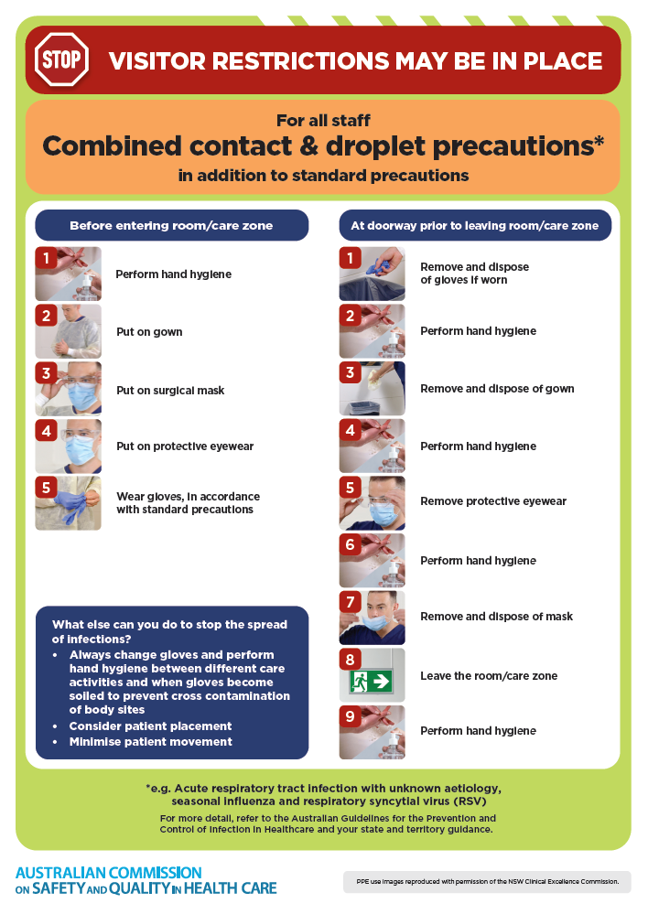](https://www.safetyandquality.gov.au/publications-and-resources/resource-library/infection-prevention-and-control-poster-combined-contact-and-droplet-precautions)
* ***Poster – Combined airborne and contact precautions*** <https://www.safetyandquality.gov.au/publications-and-resources/resource-library/poster-combined-airborne-and-contact-precautions>   
  [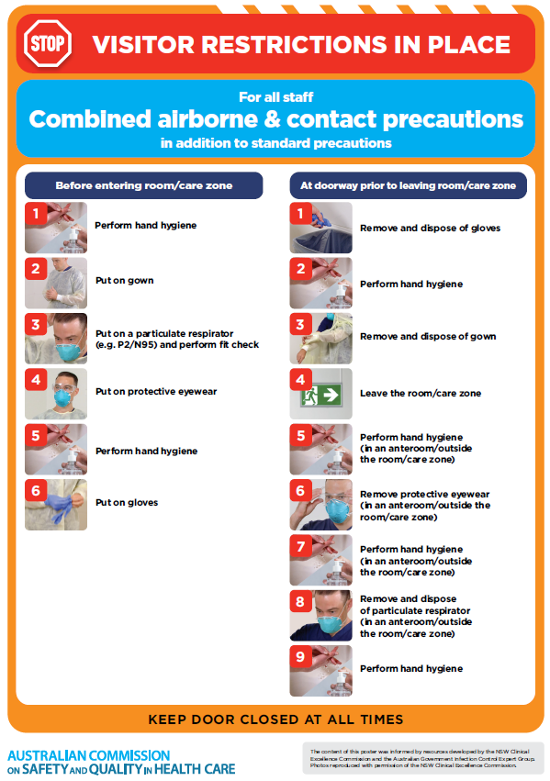](https://www.safetyandquality.gov.au/publications-and-resources/resource-library/poster-combined-airborne-and-contact-precautions)
* ***Environmental Cleaning and Infection Prevention and Control*** [www.safetyandquality.gov.au/environmental-cleaning](http://www.safetyandquality.gov.au/environmental-cleaning)
* ***COVID-19 infection prevention and control risk management – Guidance*** <https://www.safetyandquality.gov.au/publications-and-resources/resource-library/covid-19-infection-prevention-and-control-risk-management-guidance>
* ***Safe care for people with cognitive impairment during COVID-19***<https://www.safetyandquality.gov.au/our-work/cognitive-impairment/cognitive-impairment-and-covid-19>
* ***Stop COVID-19: Break the chain of infection*** posterhttps://www.safetyandquality.gov.au/publications-and-resources/resource-library/break-chain-infection-poster-a3  
  **[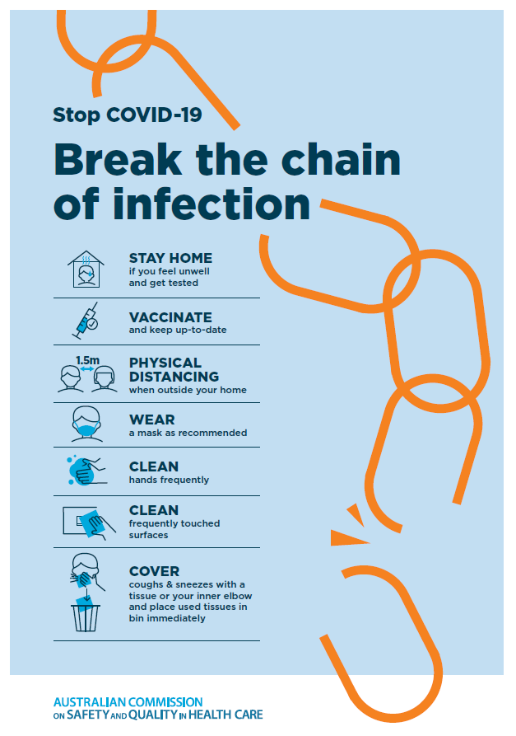](https://www.safetyandquality.gov.au/publications-and-resources/resource-library/break-chain-poster-a3https:/www.safetyandquality.gov.au/publications-and-resources/resource-library/break-chain-poster-a3)**
* ***COVID-19 and face masks – Information for consumers*** <https://www.safetyandquality.gov.au/publications-and-resources/resource-library/covid-19-and-face-masks-information-consumers>

[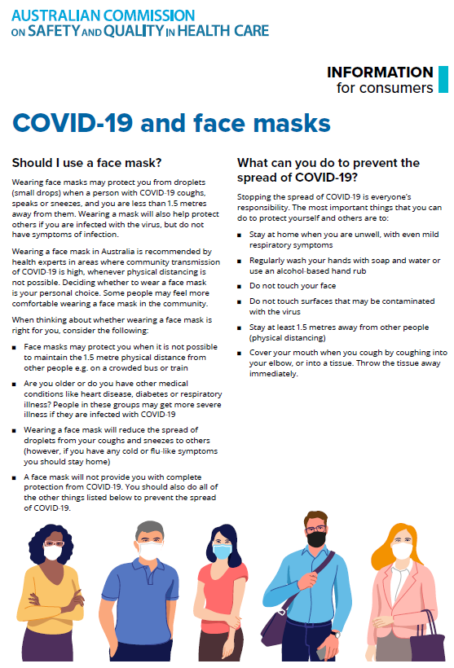](https://www.safetyandquality.gov.au/sites/default/files/2020-07/covid-19_and_face_masks_-_information_for_consumers.pdf)

*National Clinical Evidence Taskforce*

<https://clinicalevidence.net.au/>

The National Clinical Evidence Taskforce is a multi-disciplinary collaboration of 35 member organisations – Australia’s medical colleges and peak health organisations – who share a commitment to provide national evidence-based treatment guidelines for urgent and emerging diseases.

This alliance established the world’s first ‘living guidelines’ for the care of people with COVID-19 and MPX.

Funding has now been discontinued for the National Clinical Evidence Taskforce and the COVID-19 guidelines as of 30 June 2023.

These guidelines are no longer continually updated but will remain online until the guidance becomes inaccurate and/or no longer reflects the evidence or recommended practice.

**Disclaimer**

On the Radar is an information resource of the Australian Commission on Safety and Quality in Health Care. The Commission is not responsible for the content of, nor does it endorse, any articles or sites listed. The Commission accepts no liability for the information or advice provided by these external links. Links are provided on the basis that users make their own decisions about the accuracy, currency and reliability of the information contained therein. Any opinions expressed are not necessarily those of the Australian Commission on Safety and Quality in Health Care.