# Australian Commission on Safety and Quality logotypeOn the Radar

Issue 630

27 November 2023

*On the Radar* is a summary of some of the recent publications in the areas of safety and quality in health care. Inclusion in this document is not an endorsement or recommendation of any publication or provider. Access to particular documents may depend on whether they are Open Access or not, and/or your individual or institutional access to subscription sites/services. Material that may require subscription is included as it is considered relevant.

*On the Radar* is available online, via email or as a PDF or Word document from <https://www.safetyandquality.gov.au/newsroom/subscribe-news/radar>

If you would like to receive *On the Radar* via email, you can subscribe on our website <https://www.safetyandquality.gov.au/newsroom/subscribe-news>  
or by emailing us at H[Umail@safetyandquality.gov.auU](mailto:mail@safetyandquality.gov.au).   
You can also send feedback and comments to H[Umail@safetyandquality.gov.auU](mailto:mail@safetyandquality.gov.au).

For information about the Commission and its programs and publications, please visit <https://www.safetyandquality.gov.au>

You can also follow us on Twitter @ACSQHC.

**On the Radar**

Editor: Dr Niall Johnson [niall.johnson@safetyandquality.gov.au](mailto:niall.johnson@safetyandquality.gov.au)

Contributors: Niall Johnson

**Reports**

*A National Policy Roadmap for Artificial Intelligence in Healthcare*

Australian Alliance for Artificial Intelligence in Healthcare

North Ryde: Australian Alliance for Artificial Intelligence in Healthcare, ; 2021. p. 24.

|  |  |
| --- | --- |
| URL | <https://aihealthalliance.org/2023/11/16/ai-can-revolutionise-healthcare-but-only-with-a-national-plan/> |
| Notes | The Australian Alliance for Artificial Intelligence in Healthcare has developed this updated ‘roadmap’ to provide ‘a policy agenda for AI in Healthcare’ that is ‘designed to assist all levels of government, industry and civil society’ in developing the policy and regulatory environment to ‘help industry exploit AI, and support healthcare services to be effective adopters of AI.’  The report’s 16 recommendations fall into five areas:   * **AI safety, quality, ethics and security** – ensuring the safe use of AI in healthcare. * **Workforce** – enabling essential training and development of the healthcare and AI workforce. * **Consumers** – ensuring health AI literacy. * **Industry** – supporting industry to thrive and be competitive. * **Research** – guiding the research that will protect Australia’s national interest. |

*The health of people in Australia's prisons 2022*

Australian Institute for Health and Welfare

Canberra: AIHW; 2023.

|  |  |
| --- | --- |
| URL | <https://www.aihw.gov.au/reports/prisoners/the-health-of-people-in-australias-prisons-2022/contents/about> |
| Notes | The Australian Institute of Health and Welfare (AIHW) has released this report on the health of people in prisons in Australia. As the report notes, ‘People in prison are among the most vulnerable groups in society. They are more likely to have been homeless and unemployed than people in the general community and often come from socioeconomically disadvantaged backgrounds’ They tend to have, as the web page state, they also tend to ‘poorer physical and mental health outcomes than the general population. They are less likely to have accessed health-care services, and more likely to have a history of risk behaviours that can affect health and wellbeing. Most people in prison are there for short periods, and many enter and exit the system multiple times. The health of people in prison is public health. The safety and quality issues of delivering care in these settings may differ from other settings. |

*Medicine safety: mental health care*

Pharmaceutical Society of Australia

Canberra: PSA; 2023. p. 48.

|  |  |
| --- | --- |
| URL | <https://www.psa.org.au/advocacy/working-for-our-profession/medicine-safety/mental_health/> |
| Notes | The Pharmaceutical Society of Australia has released this report highlighting opportunities for pharmacists to better support Australians using medicines to treat mental health conditions, including improving access to care and investing in quality use of medicines services at critical points of care. Written by academics at the Quality Use of Medicines and Pharmacy Research Centre, University of South Australia the report includes sections on the extent of mental health issues, medicine use for mental health and the role of pharmacists. The authors write: ‘The evidence from the literature shows a myriad of difficulties that people with mental health conditions may face in using medicines, including:   * inappropriate therapeutic selection * lack of recognition of side effects of the medicines * lack of understanding and appreciation of the impact of side effects on daily life * frequent changes in therapy * lack of documentation of past therapeutic failures and outcomes * lack of information to use medicines safely * difficulty in complying with medicine regimens * lack of access to mental health services and pharmacists' expertise.   Pharmacists, as active members of the multidisciplinary healthcare team, have an important role to support patients and health professionals to understand and resolve many of these medicine-related challenges.’  The report also includes a number of recommendations from the Pharmaceutical Society of Australia. |

For information on the Commission’s work on medication safety, see <https://www.safetyandquality.gov.au/our-work/medication-safety>

*The Cost of Not Getting Care: Income Disparities in the Affordability of Health Services Across High-Income Countries. Findings from the Commonwealth Fund 2023 International Health Policy Survey*

Gunja MZ, Gumas ED, Williams RDI, Doty MM, Shah A, Fields K

New York: Commonwealth Fund; 2023.

|  |  |
| --- | --- |
| DOI | <https://doi.org/10.26099/jbe9-c870> |
| Notes | The Commonwealth Fund in the USA conducts regular surveys of the health systems in a group of high-income nations, including Australia. This Issue Brief provides the ‘the first findings from the Commonwealth Fund 2023 International Health Policy Survey, which engaged adults age 18 and older in 10 countries to explore how financial barriers affect their health care decisions.’ Australia tends to compare quite well in these surveys, particularly on outcomes. However, one area where Australia tends to do less well is that of cost barriers. Most of the nations in the comparison have universal healthcare, excluding the USA, but ‘the out-of-pocket expenses patients pay for health services can greatly vary based on health needs, geographic location, and income.’  Graph showing the Percentage of adults who had a cost-related access problem in the past 12 months in 9 high income nations. |

*Therapeutic patient education: an introductory guide*

World Health Organization

Copenhagen: WHO Regional Office for Europe; 2023. p. 92.

|  |  |
| --- | --- |
| URL | <https://www.who.int/europe/news/item/14-11-2023-improving-patient-education--a-new-guide-for-policy-makers-and-health-professionals-to-support-self-management-of-chronic-conditions> |
| Notes | The World health Organization’s Regional Office for Europe has produced guide for policy-makers, health professionals, and education and training bodies on therapeutic patient education (TPE). Therapeutic patient education is ‘a structured person-centred learning process that supports individuals living with chronic conditions to self-manage their own health by drawing on their own resources, supported by their carers and families’. The guide covers ‘commissioning, designing and delivering TPE services and training programmes for health professionals. It also looks at the evidence and theory underpinning patient education, outlines key components for delivering a high-quality service and identifies implementation opportunities and barriers.’ |

**Journal articles**

*Managing unwarranted variation in hospital care – findings from a regional audit in Norway*

Eide HP, Barach P, Søreide E, Thoresen C, Tjomsland O

Research in Health Services & Regions 2023 2023/11/15;2(1):16.

|  |  |
| --- | --- |
| DOI | <https://doi.org/10.1007/s43999-023-00033-7> |
| Notes | Recent years has seen interest in the issue of unwarranted variation in care and various efforts to address it. This paper reports on a study that examined the response to a regional strategy aimed at reducing unwarranted variation in outcomes and utilization rates. The study involved 75 hospital leaders from eight hospital trusts in South-Eastern Norway Regional Trust (HSO). The authors report that their ‘audit revealed that the aim of reducing unwanted variation was not clearly communicated by senior HSO management. There was varying use of data from the national quality registers and health atlases for quality improvement. One third of the clinical leaders reported a lack of scrutiny of their work and were insufficiently aware of the HSO’s top-management and the hospital’s Boards strategic expectations about the importance of reducing unwarranted variation in their hospital utilization.’ The authors observe ‘that the strategic aim of reducing unwanted clinical variation was not clearly communicated by senior HSO management to hospital boards and senior management’ and that ‘hospitals could benefit from a better understanding of causes of variation by strengthening their efforts to reduce unwarranted variation in utilization rates as a key element in improving health care quality and patient safety.’ |

For information on the Commission’s work on healthcare variation, including the *Australian Atlas of Healthcare Variation* series, see <https://www.safetyandquality.gov.au/our-work/healthcare-variation>

*Overnight Stay in the Emergency Department and Mortality in Older Patients*

Roussel M, Teissandier D, Yordanov Y, Balen F, Noizet M, Tazarourte K, et al

JAMA Internal Medicine 2023.

|  |  |
| --- | --- |
| DOI | <https://doi.org/10.1001/jamainternmed.2023.5961> |
| Notes | French study that sought to examine the impact of staying overnight in the emergency department (ED) had an impact on older patients. This prospective cohort study included 1598 older patients (≥75 years) ‘who visited the ED and were admitted to the hospital on December 12 to 14, 2022, at 97 EDs across France’. The study compared: ‘those who stayed in the ED from midnight until 8:00 am (ED group) and those who were admitted to a ward before midnight (ward group)’. Those who spent the night in the ED ‘had a higher in-hospital mortality rate of 15.7% vs 11.1% (adjusted risk ratio [aRR], 1.39; 95% CI, 1.07-1.81). They also had a higher risk of adverse events compared with the ward group (aRR, 1.24; 95% CI, 1.04-1.49) and increased median length of stay (9 vs 8 days; rate ratio, 1.20; 95% CI, 1.11-1.31).’ The authors suggest that ‘Older adults should be prioritized for admission to a ward.’ |

*BMJ Quality & Safety*

Volume 32, Issue 12, December 2023

|  |  |
| --- | --- |
| URL | <https://qualitysafety.bmj.com/content/32/12> |
| Notes | A new issue of *BMJ Quality & Safety* has been published. Many of the papers in this issue have been referred to in previous editions of *On the Radar* (when they were released online). Articles in this issue of *BMJ Quality & Safety* include:   * Editorial: The Ethical Complexity of **Restricting Visitors during the COVID-19 Pandemic** (Louise Campbell, Georgina Morley) * Editorial: Meeting **external demands to improve quality and safety of care**: learning systematically from the literature (Jack Needleman) * Editorial: **Targets: unintended and unanticipated effects** (Nigel Edwards, Steve Black) * Editorial: It’s time for the field of **geriatrics to invest in implementation science** (Beth Prusaczyk, Robert E Burke) * **Patient safety and hospital visiting at the end of life during COVID-19** restrictions in Aotearoa New Zealand: a qualitative study (Aileen Collier, Deborah Balmer, Eileen Gilder, Rachael Parke) * Unintended consequences of the **18-week referral to treatment standard** in NHS England: a threshold analysis (Laura Quinn, Paul Bird, Sandra Remsing, Katharine Reeves, Richard Lilford) * Did the **Acute Frailty Network** improve outcomes for older people living with frailty? A staggered difference-in-difference panel event study (Andrew Street, Laia Maynou, Simon Conroy) * Safety implications of **remote assessments for suspected COVID-19**: qualitative study in UK primary care (Sietse Wieringa, Ana Luisa Neves, Alexander Rushforth, Emma Ladds, Laiba Husain, Teresa Finlay, Catherine Pope, Trisha Greenhalgh) * Handling missing values in the **analysis of between-hospital differences in ordinal and dichotomous outcomes**: a simulation study (Reinier C A van Linschoten, Marzyeh Amini, Nikki van Leeuwen, Frank Eijkenaar, Sanne J den Hartog, Paul J Nederkoorn, Jeannette Hofmeijer, Bart J Emmer, Alida A Postma, Wim van Zwam, Bob Roozenbeek, Diederik Dippel, Hester F Lingsma) * Factors that influence the **implementation of (inter)nationally endorsed health and social care standards**: a systematic review and meta-summary (Yvonne Kelly, Niamh O'Rourke, Rachel Flynn, Laura O’Connor, J Hegarty) |

*Journal of Patient Safety*

Volume 19, Issue 8, December 2023

|  |  |
| --- | --- |
| URL | <https://journals.lww.com/journalpatientsafety/toc/2023/12000> |
| Notes | A new issue of *Journal of Patient Safety* has been published. Articles in this issue of *Journal of Patient Safety* include:   * A Clinical Data Warehouse Analysis of **Risk Factors for Inpatient Falls in a Tertiary Hospital**: A Case-Control Study (E Kwon, S J Chang, M Kwon) * Validation of a Reduced Set of High-Performance Triggers for Identifying **Patient Safety Incidents with Harm in Primary Care**: TriggerPrim Project (Gerardo Garzón González, Tamara Alonso Safont, Dolores Conejos Míquel, Marta Castelo Jurado, Oscar Aguado Arroyo, Juan José Jurado Balbuena, Cristina Villanueva Sanz, Ester Zamarrón Fraile, Arancha Luaces Gayán, Asunción Cañada Dorado, Dolores Martínez Patiño, Purificación Magán Tapia, Aurora Barberá Martín, María José Toribio Vicente, Mercedes Drake Canela, Inmaculada Mediavilla Herrera) * What Do We Know About **Patient Safety Culture** in Saudi Arabia? A Descriptive Study (Yasser A Alaska, Rabab B Alkutbe) * Impact of a Decision Support System on **Fall-Prevention Nursing Practices** (Hyesil Jung, Hyeoun-Ae Park, Ho-Young Lee) * Diagnostic Yield, Radiation Exposure, and the Role of Clinical Decision Rules to Limit **Computed Tomographic Pulmonary Angiography–Associated Complications** (Apostolos Perelas, Jason Kirincich, Ruchi Yadav, Sravanti Ennala, Xiaofeng Wang, Divyajot Sadana, Abhijit Duggal, Sudhir Krishnan) * Cost Savings Associated With Implementing 4 **Total Joint Replacement Electronic Clinical Quality Measures** Nationally: 2020–2040 (Patricia C Dykes, Mica Curtin-Bowen, Calvin Franz, Ania Syrowatka, Stuart Lipsitz, Michael Sainlaire, Alexandra Businger, Tien Thai, Antonia F Chen, Andrew J Schoenfeld, Jay R Lieberman, Richard Iorio, Todd O’Brien, Bonnie Blanchfield, Jeffrey N Katz, William A Jiranek, C Melnic, D W Bates) * Experiences and Perceptions of Healthcare Stakeholders in **Disclosing Errors and Adverse Events to Historically Marginalized Patients** (Kristan Olazo, Thomas H Gallagher, Urmimala Sarkar) * Exploring the “Black Box” of Recommendation Generation in **Local Health Care Incident Investigations**: A Scoping Review (William Lea, Rebecca Lawton, Charles Vincent, Jane O’Hara) * Development of a Psychological Scale for Measuring **Disruptive Clinician Behavior** (Manabu Fujimoto, Mika Shimamura, Hiroaki Miyazaki, Kazuto Inaba) * The Nature, Causes, and Clinical Impact of **Errors in the Clinical Laboratory Testing Process** Leading to Diagnostic Error: A Voluntary Incident Report Analysis (Christel van Moll, Toine Egberts, Cordula Wagner, Laura Zwaan, Maarten ten Berg) * Uncovering the Risks of Anticancer Therapy Through Incident Report Analysis Using a Newly Developed **Medical Oncology Incident Taxonomy** (Joseph O Jacobson, Jessica A Zerillo, James Doolin, Sherri O Stuver, Anna Revette, Therese Mulvey) |

*BMJ Quality & Safety* online first articles

|  |  |
| --- | --- |
| URL | <https://qualitysafety.bmj.com/content/early/recent> |
| Notes | *BMJ Quality &Safety* has published a number of ‘online first’ articles, including:   * Grand rounds in methodology: key considerations for implementing **machine learning solutions in quality improvement initiatives** (Amol A Verma, Patricia Trbovich, Muhammad Mamdani, Kaveh G Shojania) |

*International Journal for Quality in Health Care* online first articles

|  |  |
| --- | --- |
| URL | <https://academic.oup.com/intqhc/advance-articles> |
| Notes | *International Journal for Quality in Health Care* has published a number of ‘online first’ articles, including:   * Monitoring for **adverse drug events of high-risk medications** with a computerized clinical decision support system: A prospective cohort study (Mari Nezu, Mio Sakuma, Tsukasa Nakamura, Tomohiro Sonoyama, Chisa Matsumoto, Jiro Takeuchi, Yoshinori Ohta, Shinji Kosaka, Takeshi Morimoto) |

**Online resources**

***[UK] NICE Guidelines and Quality Standards***

<https://www.nice.org.uk/guidance>

The UK’s National Institute for Health and Care Excellence (NICE) has published new (or updated) guidelines and quality standards. The latest reviews or updates include:

* Clinical Guideline CG109 ***Transient loss of consciousness ('blackouts')*** *in over 16s* <https://www.nice.org.uk/guidance/cg109>

**COVID-19 resources**

https://www.safetyandquality.gov.au/covid-19

The Australian Commission on Safety and Quality in Health Care has developed a number of resources to assist healthcare organisations, facilities and clinicians. These and other material on COVID-19 are available at <https://www.safetyandquality.gov.au/covid-19>

These resources include:

* ***OVID-19 infection prevention and control risk management*** This primer provides an overview of three widely used tools for investigating and responding to patient safety events and near misses. Tools covered in this primer include incident reporting systems, Root Cause Analysis (RCA), and Failure Modes and Effects Analysis (FMEA).   
  <https://www.safetyandquality.gov.au/publications-and-resources/resource-library/covid-19-infection-prevention-and-control-risk-management-guidance>
* ***Poster – Combined contact and droplet precautions*** <https://www.safetyandquality.gov.au/publications-and-resources/resource-library/infection-prevention-and-control-poster-combined-contact-and-droplet-precautions>  
  [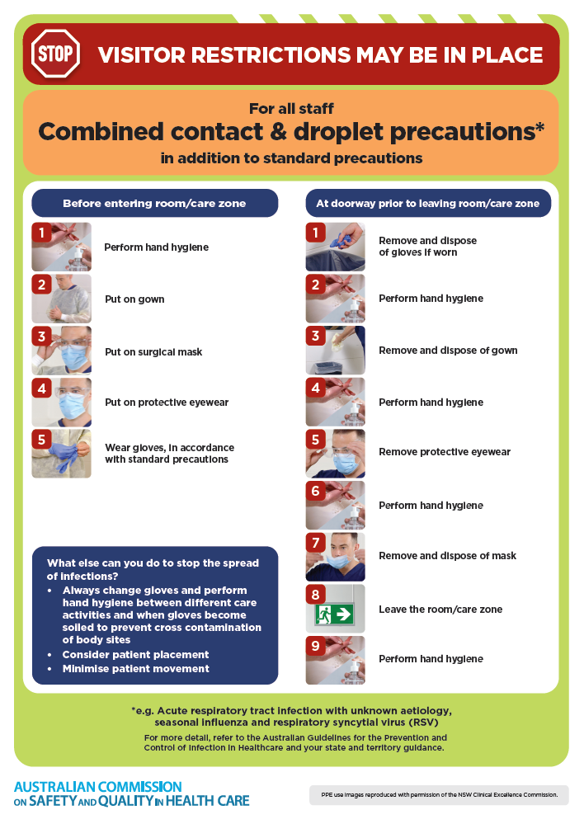](https://www.safetyandquality.gov.au/publications-and-resources/resource-library/infection-prevention-and-control-poster-combined-contact-and-droplet-precautions)
* ***Poster – Combined airborne and contact precautions*** <https://www.safetyandquality.gov.au/publications-and-resources/resource-library/poster-combined-airborne-and-contact-precautions>   
  [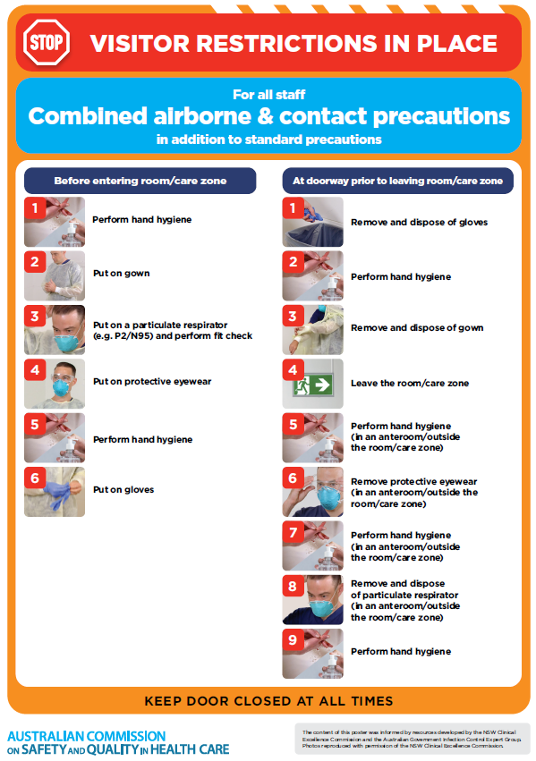](https://www.safetyandquality.gov.au/publications-and-resources/resource-library/poster-combined-airborne-and-contact-precautions)
* ***Environmental Cleaning and Infection Prevention and Control*** [www.safetyandquality.gov.au/environmental-cleaning](http://www.safetyandquality.gov.au/environmental-cleaning)
* ***COVID-19 infection prevention and control risk management – Guidance*** <https://www.safetyandquality.gov.au/publications-and-resources/resource-library/covid-19-infection-prevention-and-control-risk-management-guidance>
* ***Safe care for people with cognitive impairment during COVID-19***<https://www.safetyandquality.gov.au/our-work/cognitive-impairment/cognitive-impairment-and-covid-19>
* ***Stop COVID-19: Break the chain of infection*** posterhttps://www.safetyandquality.gov.au/publications-and-resources/resource-library/break-chain-infection-poster-a3  
  **[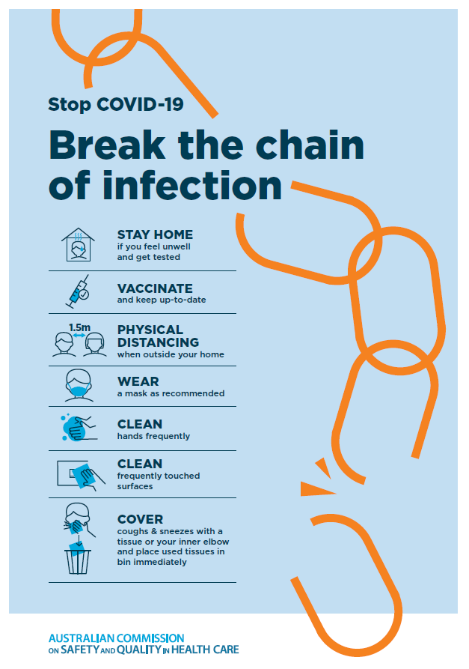](https://www.safetyandquality.gov.au/publications-and-resources/resource-library/break-chain-poster-a3https:/www.safetyandquality.gov.au/publications-and-resources/resource-library/break-chain-poster-a3)**
* ***COVID-19 and face masks – Information for consumers*** <https://www.safetyandquality.gov.au/publications-and-resources/resource-library/covid-19-and-face-masks-information-consumers>

[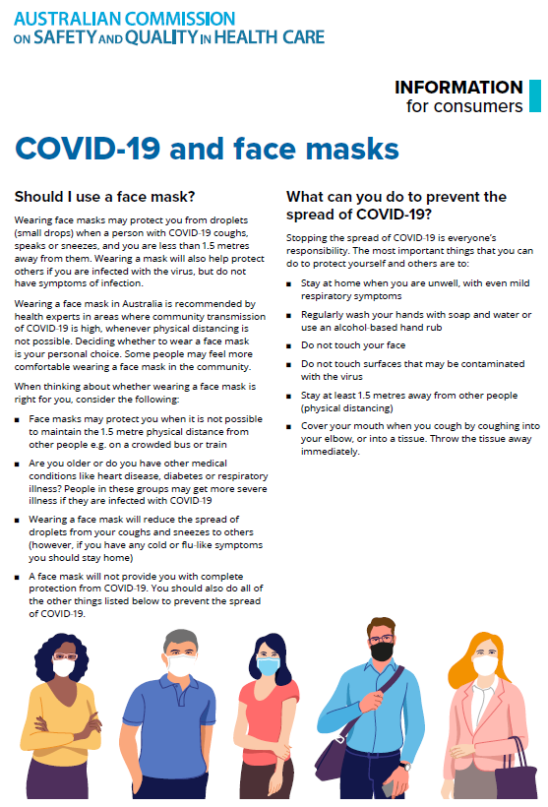](https://www.safetyandquality.gov.au/sites/default/files/2020-07/covid-19_and_face_masks_-_information_for_consumers.pdf)

*National Clinical Evidence Taskforce*

<https://clinicalevidence.net.au/>

The National Clinical Evidence Taskforce is a multi-disciplinary collaboration of 35 member organisations – Australia’s medical colleges and peak health organisations – who share a commitment to provide national evidence-based treatment guidelines for urgent and emerging diseases.

This alliance established the world’s first ‘living guidelines’ for the care of people with COVID-19 and MPX.

Funding has now been discontinued for the National Clinical Evidence Taskforce and the COVID-19 guidelines as of 30 June 2023.

These guidelines are no longer continually updated but will remain online until the guidance becomes inaccurate and/or no longer reflects the evidence or recommended practice.

**Disclaimer**

On the Radar is an information resource of the Australian Commission on Safety and Quality in Health Care. The Commission is not responsible for the content of, nor does it endorse, any articles or sites listed. The Commission accepts no liability for the information or advice provided by these external links. Links are provided on the basis that users make their own decisions about the accuracy, currency and reliability of the information contained therein. Any opinions expressed are not necessarily those of the Australian Commission on Safety and Quality in Health Care.