# Australian Commission on Safety and Quality logotypeOn the Radar

Issue 631

4 December 2023

*On the Radar* is a summary of some of the recent publications in the areas of safety and quality in health care. Inclusion in this document is not an endorsement or recommendation of any publication or provider. Access to particular documents may depend on whether they are Open Access or not, and/or your individual or institutional access to subscription sites/services. Material that may require subscription is included as it is considered relevant.

*On the Radar* is available online, via email or as a PDF or Word document from <https://www.safetyandquality.gov.au/newsroom/subscribe-news/radar>

If you would like to receive *On the Radar* via email, you can subscribe on our website <https://www.safetyandquality.gov.au/newsroom/subscribe-news>  
or by emailing us at H[Umail@safetyandquality.gov.auU](mailto:mail@safetyandquality.gov.au).   
You can also send feedback and comments to H[Umail@safetyandquality.gov.auU](mailto:mail@safetyandquality.gov.au).

For information about the Commission and its programs and publications, please visit <https://www.safetyandquality.gov.au>

You can also follow us on Twitter @ACSQHC.

**On the Radar**

Editor: Dr Niall Johnson [niall.johnson@safetyandquality.gov.au](mailto:niall.johnson@safetyandquality.gov.au)

Contributors: Niall Johnson, Kristin Xenos

**Antibiotic shortages - Clinicians working in the Aboriginal and Torres Strait Islander health sector**

<https://www.safetyandquality.gov.au/publications-and-resources/resource-library/antibiotic-shortages-clinicians-working-aboriginal-and-torres-strait-islander-health-sector>

**Antibiotic Shortages - Aboriginal and Torres Strait Islander – Consumer**

<https://www.safetyandquality.gov.au/publications-and-resources/resource-library/antibiotic-shortages-aboriginal-and-torres-strait-islander-consumer>

The Commission and the National Aboriginal Community Controlled Health Organisation (NACCHO) have developed resources to assist managing antibiotic shortages for Aboriginal and Torres Strait Islander people.

The Clinician resource and the Consumer resource are now available on the Commission’s website.

The Clinician resource has information on where to find out more about shortages, general advice for managing a shortage, details about serious scarcity substitution instruments (SSSIs), the NACCHO Medicines Network and advice for patients.

The Consumer resource has general advice on what may happen if an antibiotic you are prescribed is unavailable and advise for how to take crushed or dispersed medicine.

**Reports**

*Describing the Primary Care Journey for People with Musculoskeletal Pain*

Deeble Institute for Health Policy Research Perspectives Brief no: 28

Beal H, Howard K, Goldston L, Thompson D, Finch J, Clarke K, et al

Canberra: Australian Healthcare and Hospitals Association; 2023. p. 9.

|  |  |
| --- | --- |
| URL | <https://ahha.asn.au/sites/default/files/docs/policy-issue/perpectives_brief_no_28_msk_patient_journeys_final.pdf> |
| Notes | This Perspectives Brief from the Australian Healthcare and Hospitals Association’s Deeble Institute ‘describes findings from a review of patient care journeys and experiences within a musculoskeletal physiotherapy screening clinic … and highlights the dissonance between patient experiences and care pathways, best practice guidelines and the delivery of value-based, holistic, and person-centred primary health care.’ |

*Investigation report: Continuity of care: delayed diagnosis in GP practices*

Health Services Safety Investigation Body

Poole: HSSIB; 2023.

|  |  |
| --- | --- |
| DOI | <https://www.hssib.org.uk/patient-safety-investigations/continuity-of-care-delayed-diagnosis-in-gp-practices/> |
| Notes | The Health Services Safety Investigation Body in the UK has released their latest investigation report. This investigation explored the safety risk associated with the lack of a system of continuity of care within GP practices in the UK. The report includes a number of findings, observations and recommendations that seek to prevent the delayed diagnosis of serious health conditions caused by a lack of continuity of care. |

**Journal articles**

*Reducing unwarranted variation: can a ‘clinical dashboard’ be helpful for hospital executive boards and top-level leaders?* Tjomsland O, Thoresen C, Ingebrigtsen T, Søreide E, Frich JC.

BMJ Leader 2023:leader-2023-000749.

|  |  |
| --- | --- |
| DOI | <http://dx.doi.org/10.1136/leader-2023-000749> |
| Notes | Further to a recent piece on how unwarranted variation was communicated in health organisations is this piece on how a "dashboard" approach may be used. The authors describe how they developed ‘a safety, quality and utilisation rate dashboard (‘clinical dashboard’) based on a selection of data routinely reported to executive boards and top-level leaders in Norwegian specialist healthcare.’ They ‘argue that selecting quality indicators of patient safety, quality and utilisation rates and presenting them in a dashboard may help executive hospital boards and top-level leaders to focus on unwarranted variation.’ |

For information on the Commission’s work on healthcare variation, including the *Australian Atlas of Healthcare Variation* series, see <https://www.safetyandquality.gov.au/our-work/healthcare-variation>

*Surgical leadership in a culture of safety: An inter-professional study of metrics and tools for improving clinical practice*

Gogalniceanu P, Kunduzi B, Ruckley C, Kaafarani H, Sevdalis N, Mamode N

The American Journal of Surgery 2023 [epub].

|  |  |
| --- | --- |
| DOI | <https://doi.org/10.1016/j.amjsurg.2023.09.002> |
| Notes | There have been various attempts to learn from other industries, particularly aviation, when it comes to safety and leadership in health care. This paper reports on a study that used interviews with ‘leadership experts from safety-critical professions’ to inform the development of ‘a framework, metrics and tools to improve surgical leadership and safety outcomes.’ From the analysis of the interviews, the authors report that “Leaders were identified as ‘threat and error managers’ who placed safety first. Their core attribute was humble confidence. This allowed them to set the tone for high standards of practice, whilst empowering individuals to speak up about safety issues.”  Graphical abstract from Surgical leadership in a culture of safety: An inter-professional study of metrics and tools for improving clinical practice article. |

*Patient safety incidents in endoscopy: a human factors analysis of nonprocedural significant harm incidents from the National Reporting and Learning System (NRLS)*

Ravindran S, Matharoo M, Rutter MD, Ashrafian H, Darzi A, Healey C, et al

Endoscopy 2023 [epub].

|  |  |
| --- | --- |
| DOI | <https://doi.org/10.1055/a-2177-4130> |
| Notes | Paper reporting on a study that used information on endoscopy-related patient safety incidents in the UK’s National Reporting and Learning System (NRLS) to then conduct a human factors analysis of these incidents. From this analysis, the most common factor was ‘decision-based errors’ with other contributing factors identified included resourcing issues, patient factors, ineffective team communication along with lack of staffing, standard operating procedures, effective systems, and clinical pathways.  Graphical abstract from Patient safety incidents in endoscopy: a human factors analysis of nonprocedural significant harm incidents from the National Reporting and Learning System (NRLS) article. |

*The Joint Commission Journal on Quality and Patient Safety*

Volume 49, Issue 12, December 2023

|  |  |
| --- | --- |
| URL | <https://www.sciencedirect.com/journal/the-joint-commission-journal-on-quality-and-patient-safety/vol/49/issue/12> |
| Notes | A new issue of *The Joint Commission Journal on Quality and Patient Safety* has been published. Articles in this issue of *The Joint Commission Journal on Quality and Patient Safety* include:   * Editorial: No More Useless Band-aids that Fail to Solve America's **Emergency Department Boarding** Crisis (Richelle J Cooper, D L Schriger) * Editorial: **Screening for Suicide Risk** Is Predicting the Future, Not Diagnosing the Present (Rebecca C Rossom, Gregory E Simon) * Clinicians’ Insights on **Emergency Department Boarding**: An Explanatory Mixed Methods Study Evaluating Patient Care and Clinician Well-Being (Dana E Loke, Kelsey A Green, Emily G Wessling, Elizabeth T Stulpin, Abra L Fant) * A Proposed Approach to Allegations of **Sexual Boundary Violation in Health Care** (William O Cooper, Jody J Foster, Gerald B Hickson, A J Reid Finlayson, Karin Rice, Sonya Sanchez, Joshua C Smith, Isabel Dees, J Adler) * Does **Suicide Risk Screening** Improve the Identification of Primary Care Patients Who Will Attempt Suicide Versus Depression Screening Alone? (Craig J Bryan, Michael H Allen, AnnaBelle O Bryan, Cynthia J Thomsen, Justin C Baker, Alexis M May) * Long-Term Sustainability and Adaptation of **I-PASS Handovers** (Sophia L Ryan, Merranda Logan, Xiu Liu, David M Shahian, Elizabeth Mort) * Improving **Diabetes Screening in the Primary Care Clinic** (Eva Tseng, Yea-Jen Hsu, Candace Nigrin, Jeanne M Clark, J A Marsteller, N M Maruthur) * Key Strategies to **Publishing Your Quality Improvement Work** (Rebecca Suttle, Gail Armstrong, Linda Headrick, Rebecca Miltner, Greg Ogrinc) * Improving the Format, Content, and Writing Process of **Outpatient Clinic Letters** Within a Musculoskeletal Therapy Department (Christopher Horler, Emma Eve, Rachel Turner) * Learning from **Latent Safety Threats Identified During Simulation** to Improve Patient Safety (Kari Congenie, Linda Bartjen, Dikera Gutierrez, Lauren Knepper, Katherine McPartlin, A Pack, K Sava, L Smith, H Watts) * Sentinel Event Alert 67: Preserving **Patient Safety After a Cyberattack** * Survey of Perioperative Nurses Regarding Their Experience with **Operating Room Fires** (Eli Mlaver, Jyotirmay Sharma) |

*Healthcare Quarterly*

Volume 26, Number 3, October 2023

|  |  |
| --- | --- |
| URL | <https://www.longwoods.com/publications/healthcare-quarterly/27214/1/vol.-26-no.3-2023> |
| Notes | A new issue of *Healthcare Quarterly* has been published. Articles in this issue of *Healthcare Quarterly* include:   * The Importance of **Race and Ethnicity Data on Cardiovascular Health** Research (Javal Sheth, Maneesh Sud and Dennis Ko) * The Commonwealth Fund Survey of Primary Care Physicians Reveals **Challenges Experienced by Family Doctors and Emphasizes the Need for Interoperability of Health Information Technologies** (Winnie Chan, Masud Hussain, Lyricy Francis, Farzana Haq, Laura Douglas and Liudmila Husak) * Intergenerational Civics Programs to Combat **Structural Ageism** in Canada (Neil Seeman) * A Case Study Implementing a **Social Needs Screening Process** and a Family Navigation Hub at Holland Bloorview Kids Rehabilitation Hospital (Joanne Maxwell, Stephanie McFarland, Stephanie Moynagh, Jessica Reid, Shauna Kingsnorth and C J Curran) * Oshkibiimaates Wiidoogakewin: A **Partnership between Matawa First Nations Management and St. Joseph’s Care Group** (Ashley Palmer and Brad Battiston) * It Is Time for **Health Quality 5.0**: Are You Ready? (Leslee J Thompson) * **Was Virtual Care as Safe as In-Person Care?** Analyzing Patient Outcomes at Seven and Thirty Days in Ontario during the COVID-19 Pandemic (Shawn Mondoux, Frank Battaglia, Anastasia Gayowsky, Natasha Clayton, Caillin Langmann, Paul Miller, Alim Pardhan, Julie Mathews, Alex Drossos and Keerat Grewal) * **Inspiring Leadership**: How a Community Hospital Is Tackling Healthcare’s Most Difficult Problems (Daniel P. Edgcumbe, Krista Ieraci, Elaine Do Rosario and Michele Leroux) * **Advance Care Planning in Primary Care**: A Step toward Normalizing the Conversation (Shannon L. Roberts, Susan Joyce, Anita Greig, Fereshte Nurdin Lalani, Liad Salz, Gili Rosen and Rosanna Macri) |

*Health Affairs Scholar*

Volume 1, Issue 5, November 2023

|  |  |
| --- | --- |
| URL | <https://academic.oup.com/healthaffairsscholar/issue/1/5> |
| Notes | A new issue of *Health Affairs Scholar* has been published. Articles in this issue of *Health Affairs Scholar* include:   * Time to treat the **climate and nature crisis as** **one indivisible global health emergency** (Kamran Abbasi et al) * **Continuous Medicaid coverage during the COVID-19** public health emergency reduced churning, but did not eliminate it (Daniel B Nelson et al) * Involuntary and patient-initiated **delays in medical care during the COVID-19** pandemic (Erin T Bronchetti et al) * “More than just checking the box”: community-based organizations on their role in **Medicaid redesigns** (Dolma Tsering et al) * **Methadone prescribing** by addiction specialists likely to leave communities without available methadone treatment (Paul J Joudrey et al) * Pre-pandemic assessment: a decade of progress in **electronic health record adoption** among U.S. hospitals (John (Xuefeng) Jiang et al) * Deciphering the **Neighborhood Atlas Area Deprivation Index**: the consequences of not standardizing (Stephen Petterson * Active steps to reduce **administrative spending** associated with financial transactions in US health care (Nikhil R Sahni et al) * Urgent need for **substance use disorder research** among understudied populations: examining the Asian-American experience (Sugy Choi et al) |

*BMJ Quality & Safety* online first articles

|  |  |
| --- | --- |
| URL | <https://qualitysafety.bmj.com/content/early/recent> |
| Notes | *BMJ Quality &Safety* has published a number of ‘online first’ articles, including:   * Editorial: Changing the **patient safety mindset**: can safety cases help? (Mark Sujan, Ibrahim Habli) * Health services under pressure: a scoping review and development of a taxonomy of **adaptive strategies** (Bethan Page, Dulcie Irving, Rene Amalberti, Charles Vincent) * Connecting pathogen transmission and healthcare worker cognition: a cognitive task analysis of **infection prevention and control practices** during simulated patient care (Joel M Mumma, Bradley W Weaver, Jill S Morgan, Golpar Ghassemian, Paige R Gannon, Kylie B Burke, Brandon A Berryhill, Rebecca E MacKay, Lindsay Lee, Colleen S Kraft) |

*International Journal for Quality in Health Care* online first articles

|  |  |
| --- | --- |
| URL | <https://academic.oup.com/intqhc/advance-articles> |
| Notes | *International Journal for Quality in Health Care* has published a number of ‘online first’ articles, including:   * Monitoring for **adverse drug events of high-risk medications** with a computerized clinical decision support system: A prospective cohort study (Mari Nezu, Mio Sakuma, Tsukasa Nakamura, Tomohiro Sonoyama, Chisa Matsumoto, Jiro Takeuchi, Yoshinori Ohta, Shinji Kosaka, Takeshi Morimoto) |

**Online resources**

***Health Innovation Series - e-Medication Safety***

<https://www.mq.edu.au/research/research-centres-groups-and-facilities/healthy-people/centres/australian-institute-of-health-innovation/our-projects/Health-Innovation-Series/health-innovation-series-e-medication-safety>

The Health Innovation Series from the Australian Institute of Health Innovation at Macquarie University has had a number of recent issues, including:

* Is your administration documentation accurate? Check fields that auto-populate!
* A mix of prescribing systems may be a recipe for disaster
* Default first dose times can cause deadly double doses
* How free-text fields can lead to medication errors

***[UK] NICE Guidelines and Quality Standards***

<https://www.nice.org.uk/guidance>

The UK’s National Institute for Health and Care Excellence (NICE) has published new (or updated) guidelines and quality standards. The latest reviews or updates include:

* NICE Guideline NG191 ***COVID-19*** *rapid guideline: managing COVID-19* <https://www.nice.org.uk/guidance/ng191>

***[UK] NIHR Evidence***

https://evidence.nihr.ac.uk/

The UK’s National Institute for Health Research (NIHR) has posted new evidence alerts on its site. Evidence alerts are short, accessible summaries of health and care research which is funded or supported by NIHR. This is research which could influence practice and each Alert has a message for people commissioning, providing or receiving care. The latest alerts include:

* What could reduce aggressive behaviour in **adults with learning disabilities**?
* Prevention of **cervical cancer**: what are the risks and benefits of different treatments?
* **Cervical cancer**: women with HPV may benefit from more intense screening
* **Pregnancy complications** increase the risk of heart attacks and stroke in women with high blood pressure
* **Long COVID**: fatigue predicts poor everyday functioning
* **AI** detects thickened heart muscle using routine measurements
* **Antibiotics** make little difference to children’s chest infections
* **Pelvic floor and bladder problems** can make people feel embarrassed, and have an impact on everyday life.

The NIHR has also produced a new Collection: **8 findings to help you stay healthy as you age** <https://evidence.nihr.ac.uk/collection/8-findings-to-help-you-stay-healthy-as-you-age/>

**COVID-19 resources**

https://www.safetyandquality.gov.au/covid-19

The Australian Commission on Safety and Quality in Health Care has developed a number of resources to assist healthcare organisations, facilities and clinicians. These and other material on COVID-19 are available at <https://www.safetyandquality.gov.au/covid-19>

These resources include:

* ***OVID-19 infection prevention and control risk management*** This primer provides an overview of three widely used tools for investigating and responding to patient safety events and near misses. Tools covered in this primer include incident reporting systems, Root Cause Analysis (RCA), and Failure Modes and Effects Analysis (FMEA).   
  <https://www.safetyandquality.gov.au/publications-and-resources/resource-library/covid-19-infection-prevention-and-control-risk-management-guidance>
* ***Poster – Combined contact and droplet precautions*** <https://www.safetyandquality.gov.au/publications-and-resources/resource-library/infection-prevention-and-control-poster-combined-contact-and-droplet-precautions>  
  [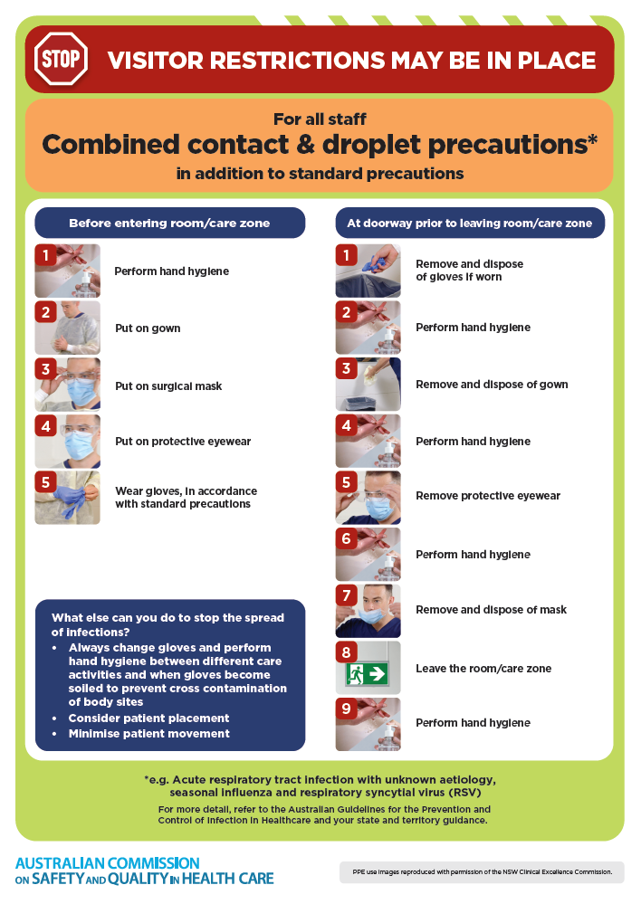](https://www.safetyandquality.gov.au/publications-and-resources/resource-library/infection-prevention-and-control-poster-combined-contact-and-droplet-precautions)
* ***Poster – Combined airborne and contact precautions*** <https://www.safetyandquality.gov.au/publications-and-resources/resource-library/poster-combined-airborne-and-contact-precautions>   
  [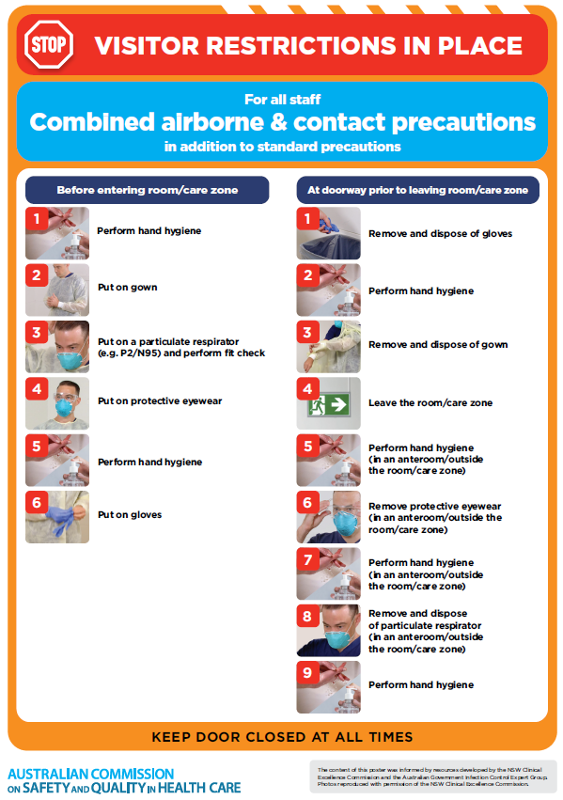](https://www.safetyandquality.gov.au/publications-and-resources/resource-library/poster-combined-airborne-and-contact-precautions)
* ***Environmental Cleaning and Infection Prevention and Control*** [www.safetyandquality.gov.au/environmental-cleaning](http://www.safetyandquality.gov.au/environmental-cleaning)
* ***COVID-19 infection prevention and control risk management – Guidance*** <https://www.safetyandquality.gov.au/publications-and-resources/resource-library/covid-19-infection-prevention-and-control-risk-management-guidance>
* ***Safe care for people with cognitive impairment during COVID-19***<https://www.safetyandquality.gov.au/our-work/cognitive-impairment/cognitive-impairment-and-covid-19>
* ***Stop COVID-19: Break the chain of infection*** posterhttps://www.safetyandquality.gov.au/publications-and-resources/resource-library/break-chain-infection-poster-a3  
  **[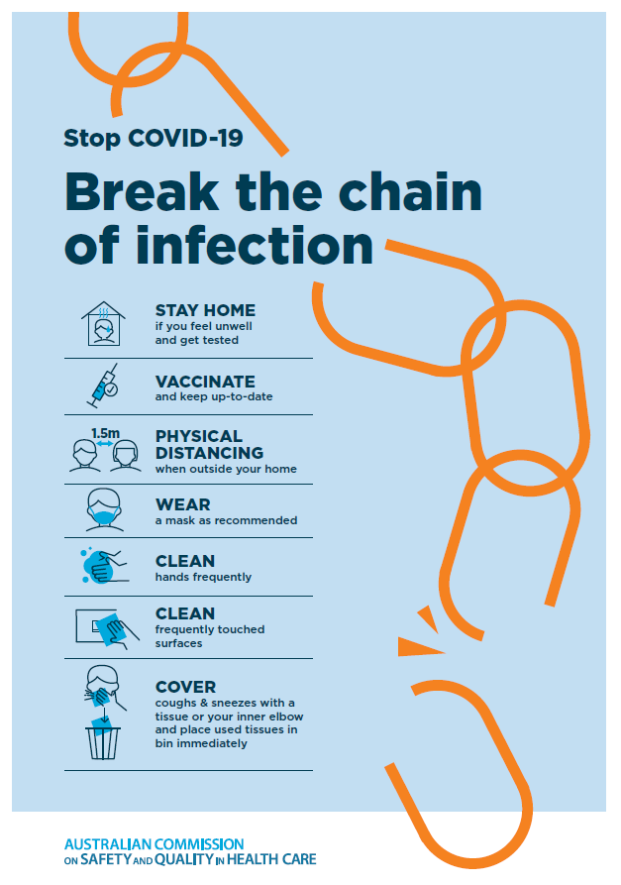](https://www.safetyandquality.gov.au/publications-and-resources/resource-library/break-chain-poster-a3https:/www.safetyandquality.gov.au/publications-and-resources/resource-library/break-chain-poster-a3)**
* ***COVID-19 and face masks – Information for consumers*** <https://www.safetyandquality.gov.au/publications-and-resources/resource-library/covid-19-and-face-masks-information-consumers>

[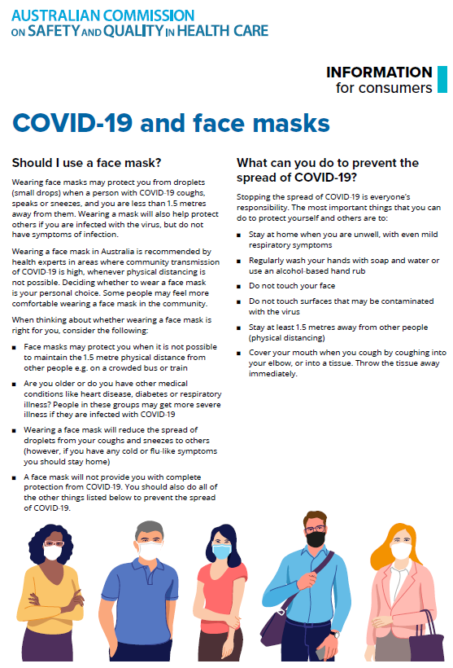](https://www.safetyandquality.gov.au/sites/default/files/2020-07/covid-19_and_face_masks_-_information_for_consumers.pdf)

*National Clinical Evidence Taskforce*

<https://clinicalevidence.net.au/>

The National Clinical Evidence Taskforce is a multi-disciplinary collaboration of 35 member organisations – Australia’s medical colleges and peak health organisations – who share a commitment to provide national evidence-based treatment guidelines for urgent and emerging diseases.

This alliance established the world’s first ‘living guidelines’ for the care of people with COVID-19 and MPX.

Funding has now been discontinued for the National Clinical Evidence Taskforce and the COVID-19 guidelines as of 30 June 2023.

These guidelines are no longer continually updated but will remain online until the guidance becomes inaccurate and/or no longer reflects the evidence or recommended practice.

**Disclaimer**

On the Radar is an information resource of the Australian Commission on Safety and Quality in Health Care. The Commission is not responsible for the content of, nor does it endorse, any articles or sites listed. The Commission accepts no liability for the information or advice provided by these external links. Links are provided on the basis that users make their own decisions about the accuracy, currency and reliability of the information contained therein. Any opinions expressed are not necessarily those of the Australian Commission on Safety and Quality in Health Care.