# Australian Commission on Safety and Quality logotypeOn the Radar

Issue 634

22 January 2024

*On the Radar* is a summary of some of the recent publications in the areas of safety and quality in health care. Inclusion in this document is not an endorsement or recommendation of any publication or provider. Access to particular documents may depend on whether they are Open Access or not, and/or your individual or institutional access to subscription sites/services. Material that may require subscription is included as it is considered relevant.

*On the Radar* is available online, via email or as a PDF or Word document from <https://www.safetyandquality.gov.au/newsroom/subscribe-news/radar>

If you would like to receive *On the Radar* via email, you can subscribe on our website <https://www.safetyandquality.gov.au/newsroom/subscribe-news>  
or by emailing us at H[Umail@safetyandquality.gov.auU](mailto:mail@safetyandquality.gov.au).   
You can also send feedback and comments to H[Umail@safetyandquality.gov.auU](mailto:mail@safetyandquality.gov.au).

For information about the Commission and its programs and publications, please visit <https://www.safetyandquality.gov.au>

w

**On the Radar**

Editor: Dr Niall Johnson [niall.johnson@safetyandquality.gov.au](mailto:niall.johnson@safetyandquality.gov.au)

Contributors: Niall Johnson

**Books**

*Approaches to Spread, Scale-Up, and Sustainability*

Elements of Improving Quality and Safety in Healthcare

Papoutsi C, Greenhalgh T, Marjanovic S

Cambridge: Cambridge University Press; 2024

|  |  |
| --- | --- |
| DOI | <https://doi.org/10.1017/9781009326049> |
| Notes | This is the latest release in the Elements of Improving Quality and Safety in Healthcare series from The Healthcare Improvement Studies Institute (the THIS Institute) in Cambridge. This volume examines the challenges of spreading and scaling up improvements in health care. The authors provide:   * Definitions of spread, scale-up, and sustainability in the context of healthcare improvement. * An overview of different approaches, noting their strengths and limitations. * Case studies highlighting how different ways of viewing spread and scale-up can make a difference in practice. * A summary of key practical lessons for improvement practitioners and researchers. |

**Journal articles**

*Impact of pharmacist-led admission medication reconciliation on patient outcomes in a large health system*

Kramer J, Hayley Burgess L, Warren C, Schlosser M, Fraker S, Hamilton M

Journal of Patient Safety and Risk Management 2023;28(6):260-267.

|  |  |
| --- | --- |
| DOI | <https://doi.org/10.1177/25160435231193584> |
| Notes | Paper describing the implementation and evaluation of a ‘pharmacy-led admission medication reconciliation program’ in 16 hospitals across a single health system. The program targeted high-risk, complex inpatients admitted through the emergency department [ED] and directly to the hospital with 311,473 patients admitted during the pre- and postimplementation time period. The authors report that ‘After implementation of pharmacy-led admission medication reconciliation, patient ADEs [Adverse Drug Events] and complications decreased during hospitalization, and physician, nurse, and pharmacist satisfaction significantly improved.’ |

For information on the Commission’s work on medication safety, see <https://www.safetyandquality.gov.au/our-work/medication-safety>

*Audit and feedback to reduce unwarranted clinical variation at scale: a realist study of implementation strategy mechanisms*

Sarkies M, Francis-Auton E, Long J, Roberts N, Westbrook J, Levesque J-F, et al.

Implementation Science 2023 18(1):71.

*Four System Enablers of Large-System Transformation in Health Care: A Mixed Methods Realist Evaluation*

Francis-Auton E, Long JC, Sarkies M, Roberts N, Westbrook J, Levesque J-F, et al.

The Milbank Quarterly 2023.

|  |  |
| --- | --- |
| DOI | <https://doi.org/10.1186/s13012-023-01324-w>  <https://doi.org/10.1111/1468-0009.12684> |
| Notes | A pair of papers from the same cluster of authors describing approaches to transformation or reform in large health care systems, in this case, the implementation of a valued-based health care program New South Wales.  Sarkies et al focuses on using audit and feedback as a mechanism for addressing clinical variation within NSW Health as ‘a state-wide value-based healthcare program implemented between 2017 and 2021 in New South Wales, Australia.’ The paper describes the strategies used in development, implementation and evaluation. The authors report that ‘Audit and feedback strategies may help reduce unwarranted clinical variation in care where there is engagement between auditors and local clinicians, meaningful audit indicators, clear improvement plans, and respect for clinical expertise’. They also offer a Model for Audit and Feedback Implementation at Scale. Recommendations.  Francis-Auton et al focuses more on how to enable such a ‘large-system transformation’. They recognise that while ‘Large-scale transformative initiatives have the potential to improve the quality, efficiency, and safety of health care’ they can also be ‘expensive, complex, and difficult to implement and sustain.’ The authors identified four system enablers:   1. build an authorizing environment; 2. provide relevant, authentic, timely, and meaningful data; 3. designate and distribute leadership and decision making; and 4. support the emergence of a learning culture. |

For information on the Commission’s work on healthcare variation, including the *Australian Atlas of Healthcare Variation* series and the *User Guide for Reviewing Clinical Variation*, see <https://www.safetyandquality.gov.au/our-work/healthcare-variation>

*First do no harm in responding to incidental imaging findings*

Scott IA, Slavotinek J, Glasziou PP

Medical Journal of Australia 2024;220(1):7-9.

|  |  |
| --- | --- |
| DOI | <https://doi.org/10.5694/mja2.52177> |
| Notes | This Perspectives piece in the *Medical Journal of Australia* reflects on the issue of incidental findings, particularly “incidentalomas” The authors note that ‘Incidentalomas are lesions, usually asymptomatic, serendipitously detected in patients undergoing imaging for an unrelated reason.’ and that they ‘occur in about 15–30% of all diagnostic imaging tests and 20–40% of computed tomography (CT) and magnetic resonance imaging (MRI) scans. The piece examines ‘the benefits and harms of detecting incidentalomas, examine current management guidelines, and propose recommendations for radiologists and referring clinicians in minimising incidentaloma-induced low value care.’ It illustrates how intertwined low value care, clinical variation, appropriateness and sustainability are. The authors offer a number of ‘Recommendations for reducing incidentaloma-induced low value care’, including:   * Avoid unwarranted imaging * Raise awareness of potential for harm * Improve incidentaloma characterisation and risk stratification * Optimise management recommendations * Adopt conservative, specific reporting * Include incidentaloma outcome reporting in clinical trials. |

*Association Between Daily Toothbrushing and Hospital-Acquired Pneumonia: A Systematic Review and Meta-Analysis*Ehrenzeller S, Klompas M  
JAMA Internal Medicine 2023.

|  |  |
| --- | --- |
| DOI | <https://doi.org/10.1001/jamainternmed.2023.6638> |
| Notes | Systematic review and meta-analysis of 15 randomized clinical trials covering 2786 patients that sought to answer the question ‘Is daily toothbrushing among hospitalized patients associated with prevention of hospital-acquired pneumonia and improved objective outcomes?’ From the analysis, the authors consider that ‘daily toothbrushing may be associated with lower rates of pneumonia and ICU mortality, particularly among patients undergoing invasive mechanical ventilation’ |

For information on the Commission’s work on healthcare-associated infection, see <https://www.safetyandquality.gov.au/our-work/healthcare-associated-infection-program>

*International Journal for Quality in Health Care*

Volume 35, Issue 4, 2023

|  |  |
| --- | --- |
| URL | <https://academic.oup.com/intqhc/issue/35/4> |
| Notes | A new issue of the *International Journal for Quality in Health Care* has been published. Articles in this issue of the *International Journal for Quality in Health Care* include:   * Monitoring for **adverse drug events of high-risk medications** with a computerized clinical decision support system: a prospective cohort study (Mari Nezu, Mio Sakuma, T Nakamura, T Sonoyama, C Matsumoto et al) * Prevalence and determinants of **defensive medicine** among physicians: a systematic review and meta-analysis (Junyao Zheng, Yongbo Lu, Wenjie Li, Bin Zhu, Fan Yang et al) * Developing **quality measures for non-pharmacological prevention and rehabilitation** in primary health care for chronic conditions: a consensus study (Marie Louise Svendsen, Tina Veje Andersen, Hanne Soendergaard) * Nurses’ perception of **medication administration errors** and factors associated with their reporting in the neonatal intensive care unit (Josephine Henry Basil, Chandini Menon Premakumar, Adliah Mhd Ali, Nurul Ain Mohd Tahir, Zamtira Seman et al) * **Delayed discharges** at a tertiary rehabilitation centre in Saudi Arabia: contributing factors and cost impact (Bayan Adam Gudal, Salwa Ali Ahmed, Ahmad Zaheer Qureshi, Grace Almacen, Ghassan Azhari et al) * Using **patient-reported outcome measures and patient-reported experience measures** to elevate the quality of healthcare (Pedro Casaca, Willemijn Schäfer, Ana Beatriz Nunes, Paulo Sousa) * **Patient- and family-centred care transition interventions** for adults: a systematic review and meta-analysis of RCTs (Julie Chartrand, Beverley Shea, Brian Hutton, Orvie Dingwall, Anupriya Kakkar et al) * Adapting lean management to prevent **healthcare-associated infections**: a low-cost strategy involving Kamishibai cards to sustain bundles’ compliance (Marco Antonio Saavedra Bravo, Guilherme Cesar Silva Dias Santos, Ademir Jose Petenate, Patrick Jacobsen Westphal, L G de Albuquerque Souza et al) * Effects of the care given to intensive care patients using an evidence model on the prevention of **central line-associated bloodstream infections** (Deniz Şanlı, Aklime Sarıkaya, Peter J Pronovost) * Provider–patient experiences and **HIV care** utilization among people living with HIV who inject drugs in St. Petersburg, Russia (Anita Raj, Natalia Gnatienko, Debbie M Cheng, Elena Blokhina, Arnab K Dey et al) * Can guidelines rein in **oxygen use**? A retrospective cross-sectional study using routinely collected data (Usman Talat, Kelly A Schmidtke, Saval Khanal, Alice M Turner, Ivo Vlaev) * The impact of hospital command centre on **patient flow and data quality**: findings from the UK National Health Service (Teumzghi F Mebrahtu, Ciaran D McInerney, Jonathan Benn, Carolyn McCrorie, Josh Granger et al) * Outcomes of completed **quality activities in an Australian tertiary hospital**, 2015–2019 (Qun Catherine Li, Jonathan Karnon, Jim Codde) * EPERCAS study (Strategies for Preventing Medication Administration Errors in Nursing Homes). Preparation of a list of strategies to prevent the most frequent **medication administration errors in the residential care environment** (Esther Laso Lucas, Alex Ferro Uriguen, Adriana E San Juan Muñoz, Borja Ollo Tejero, Idoia Beobide Telleria) * ‘Virtually daily grief’—understanding distress in **health practitioners involved in a regulatory complaints process**: a qualitative study in Australia (Susan Biggar, Anna van der Gaag, Pat Maher, Jacinta Evans, L Bondu et al) * **Burden of ischemic stroke** in mainland China and Taiwan province from 1990 to 2019: with forecast for the next 11 years (Jia Yu, Fude Liu, Yawen Cheng, Jianyi Wang, Wenlong Ma et al) * Improving the quality of **hospital sterilization process** using failure modes and effects analysis, fuzzy logic, and machine learning: experience in tertiary dental centre (Amine En-Naaoui, Aicha Aguezzoul, Mohammed Kaicer) * Innovative approaches to analysing **aged care falls incident data**: international classification for patient safety and correspondence analysis (Karla Seaman, Isabelle Meulenbroeks, Amy Nguyen, S Silva, N Wabe et al) * **Unsafe care in residential settings for older adults**: a content analysis of accreditation reports (Peter D Hibbert, Ruby Ash, Charlotte J Molloy, Johanna Westbrook, Ian D Cameron et al) * Improving **patient safety governance and systems** through learning from successes and failures: qualitative surveys and interviews with international experts (Peter D Hibbert, Sasha Stewart, Louise K Wiles, Jeffrey Braithwaite, William B Runciman et al) * Single-use negative pressure wound therapy to prevent **surgical site complications** in high-risk patients undergoing caesarean sections: a real-world study (Mendinaro Imcha, Nyan Chin Liew, Arthur McNally, Davor Zibar, Mairead O’Riordan et al) * Design and validation of indicators for the comprehensive measurement of **quality of care for type 2 diabetes and acute respiratory infections** in ambulatory health services (Hortensia Reyes-Morales, Sergio Flores-Hernández, Sandra Patricia Díaz-Portillo, Edson Serván-Mori, André Escalante-Castañón et al) * Validity of 16 AHRQ Patient Safety Indicators to identify **in-hospital complications**: a medical record review across nine Swiss hospitals (Michael M Havranek, Florian Rüter, Selina Bilger, Yuliya Dahlem, L Oliveira et al) * **Are adverse events related to the completeness of clinical records?** Results from a retrospective records review using the Global Trigger Tool (Enrico Scarpis, Peter Cautero, Annarita Tullio, Flavio Mellace, F Farneti et al) * Association between **patient choice of provider and patient-reported experience** (Do Hee Kim, Bomgyeol Kim, Suk-Yong Jang, Sang Gyu Lee, Tae Hyun Kim) * The use of natural language processing in **detecting and predicting falls** within the healthcare setting: a systematic review (Vincent Quoc-Nam Trinh, Steven Zhang, Joshua Kovoor, Aashray Gupta, Weng Onn Chan et al) * Facilitators and barriers to the implementation of **surgical safety checklist**: an integrative review (Petrina Jia Hui Lim, Lin Chen, S Siow, S Hoon Lim) * **Measuring quality of care for universal health coverage** in the Western Pacific (Arianna Maever Loreche, Veincent Christian F Pepito, Kenneth Y Hartigan-Go, Manuel M Dayrit) |

*Journal of Health Services Research & Policy*

Volume: 29, Number 1, January 2024

|  |  |
| --- | --- |
| URL | <https://journals.sagepub.com/toc/hsrb/29/1> |
| Notes | A new issue of the *Journal of Health Services Research & Policy* has been published. Articles in this issue of the *Journal of Health Services Research & Policy* include:   * Editorial: **Disrespect in health care**: An epistemic injustice (Mary C Beach) * Measuring the value of solidarity: The *abem* **financial assistance program for out-of-pocket payments on pharmacy medicines** in Portugal (Miguel Gouveia, Margarida Borges, João Costa, Francisco Lourençol, F Fiorentino) * Fostering **equitable change in health services**: Using critical reflexivity to challenge dominant discourses in low back pain care in Australia (Karime Mescouto, Rebecca E Olson, Nathalia Costa, Kerrie Evans, Miriam Dillon) * A patienthood that transcends the patient: An analysis of **patient research partners’ narratives of involvement** in a Canadian arthritis patient advisory board (Graham G Macdonald, J Leese, A M Hoens, S Kerr, W Lum, L Gulka) * Patient and multidisciplinary health professional perceptions of an Australian **geriatric evaluation and management and rehabilitation hospital in the home service** (Ruth Cox, Greg Kyle, Anya Suzuki, L Wishart, M McCusker) * **Tackling disrespect in health care**: The relevance of socio-relational equality (Vikki A Entwistle, Alan Cribb, Polly Mitchell) * **Think tanks and health policy** in the United Kingdom: The role of the King’s Fund (Chris Ham) * Integration and impact of **pharmacists in general practice** internationally: A rapid review (Georgios Dimitrios Karampatakis, N Patel, G Stretch, K Ryan) |

*Journal of Patient Safety*

Volume 20, Number 1, January 2024

|  |  |
| --- | --- |
| URL | <https://journals.lww.com/journalpatientsafety/toc/2024/01000> |
| Notes | A new issue of the *Journal of Patient Safety* has been published. Articles in this issue of the *Journal of Patient Safety* include:   * Sky-High Safety? A Qualitative Study of Physicians’ Experiences of **Patient Safety in Norwegian Helicopter Emergency Services** (Kristen Rasmussen, Stephen JM Sollid, Marit Kvangarsnes) * **Medication Safety Gaps in English Pediatric Inpatient Units**: An Exploration Using Work Domain Analysis (Adam Sutherland, Denham L Phipps, Andrea Gill, Stephen Morris, Darren M Ashcroft) * Factors Affecting **Medical Residents’ Decisions to Work After Call** (Michele M Carr, Anne M Foreman, J E Friedel, D C O’Brien, O Wirth) * Evaluating the Effects of a General Anesthesia and Prone Position Nursing Checklist and Training Course on **Posterior Lumbar Surgery**: A Randomized Controlled Trial (Jianshu Cai, Miaomiao Jiang, Haiou Qi) * Rapid Expansion of the Healing Emotional Lives of Peers Program During COVID-19: A **Second Victim Peer Support Program for Healthcare Professionals** (Enid Y Rivera-Chiauzzi, Lily Huang, Alayna K Osborne, Ashley A Musch, Bridget E Berkland, Anne T Meyer, Sairey M Vitek, Kaisa C Wieneke, Megan A Allyse, Kirsten A Riggan, Robyn E Finney) * **Adverse Events in Pediatric Inpatients**: The Japan Adverse Event Study (Mio Sakuma, Yoshinori Ohta, Jiro Takeuchi, Yuki Yuza, Hiroyuki Ida, David W. Bates, Takeshi Morimoto) * Taking Up the Challenge to Improve **Name and Role Recognition in the Operating Room** (Bhavana Thota, Anna Rabinowitz, Oren Guttman) * Interventions to Promote **Safety Culture in Cancer Care**: A Systematic Review (Dan Le, Charles H Lim, Rouhi Fazelzad, Lyndon Morley, Jean-Pierre Bissonnette, Melanie Powis, Monika K Krzyzanowska) * **Interprofessional Learning in Multidisciplinary Healthcare Teams** Is Associated With Reduced Patient Mortality: A Quantitative Systematic Review and Meta-analysis (Craig S Webster, Ties Coomber, S Liu, K Allen, T Jowsey) * **Second Victim Symptoms and Desired Support Strategies** Among Italian Health Care Workers in Friuli-Venezia Giulia: Cross-Sectional Survey and Latent Profile Analysis (Enrico Scarpis, Yvonne Beorchia, Valentina Moretti, Beatrice Favero, Federico Farneti, Roberto Cocconi, R Quattrin, L Castriotta) |

*Pediatric Quality & Safety*

Volume 8, Number 6, November/December 2023

|  |  |
| --- | --- |
| URL | <https://journals.lww.com/pqs/toc/2023/11000> |
| Notes | A new issue of *Pediatric Quality & Safety* has been published. Articles in this issue of *Pediatric Quality & Safety* include:   * Improving **Asthma Action Plan Completion Rates** across Five Divisions in an Academic Children’s Hospital (Maria G Alfieri, Katie Catalano, Tregony Simoneau, Linda Haynes, Patricia Glidden, Sachin N Baxi, Ramy Yim, Benjamin Ethier, Faye F Holder-Niles, Kendall McCarty, Frinny Polanco Walters, Eli Sprecher, Amy Starmer, Jonathan M Gaffin, Jeffrey Durney, Elizabeth Klements, Brittany Esty) * Decreasing ICU and Hospital Length of Stay through a Standardized Respiratory Therapist-driven **Electronic Clinical Care Pathway for Status Asthmaticus** (Merrick Lopez, Michele Wilson, Ekua Cobbina, Danny Kaufman, Julie Fluitt, Michele Grainger, Robert Ruiz, Gulixian Abudukadier, Michael Tiras, Bronwyn Carlson, Jeane Spaid, Kim Falsone, Invest Cocjin, Anthony Moretti, Chad Vercio, Cynthia Tinsley, Harsha K Chandnani, Carlos Samayoa, Carissa Cianci, James Pappas, Nancy Y Chang) * Increasing **COVID-19 Immunization Rates** through a Vaccination Program for Hospitalized Children (Victoria Mattick, Katelyn Cappotelli Nevin, Anne Fallon, Stephanie Northwood Darrow, Suzanne Ramazani, T Dick, T Sosa) * **Decreasing Blood Culture Collection in Hospitalized Patients** with CAP, SSTI, and UTI (Monica D Combs, Danica B Liberman, Vivian Lee) * Promoting a **Sleep-friendly Environment** by Minimizing Overnight Room Entries (Lauren M McDaniel, Nilesh Seshadri, Elizabeth A Harkins, Megan Keydash, Alice Pan, Laura M Sterni, Shawn L Ralston) * Establishing a Quality Improvement Program for **Pediatric In-hospital Cardiac Arrest** (Anya J Freedman, Erik C Madsen, Lia Lowrie) * A Quality Improvement Project to Improve the Utilization of an **Intraoperative Rapid Response System** (Asheen Rama, Daniel Qian, Ty Forbes, Ellen Wang, Lynda Knight, Marc Berg, Thomas J Caruso) * Reducing the **Time to Action on Bilirubin Results** Overnight in a Newborn Nursery (Andrew M Beverstock, Lily Rubin, Meredith Akerman, E Noyola) * Sustainability Standards in Pediatric Anesthesia: Quality Initiative to Reduce **Costly Environmentally Harmful Volatile Anesthetics** (Andrew T Waberski, Sophie R Pestieau, Caroll Vazquez-Colon, J Cronin, B H Braffett) * Improving **Pediatric Ovarian Torsion Evaluation** in the Pediatric Emergency Department: A Quality Improvement Initiative (Brian L Park, Sara Fenstermacher, A Luana Stanescu, Lori Rutman, Lauren Kinneman, P Solari) * Multidisciplinary Initiative to Increase Guideline-concordant **Antibiotic Prescription at Discharge** for Hospitalized Children with Uncomplicated Community-acquired Pneumonia (Alexandra B Yonts, Laura B O’Neill, Matthew A Magyar, Michael J Bozzella) |

*The Joint Commission Journal on Quality and Patient Safety*

Volume 50, Issue 1, January 2024

|  |  |
| --- | --- |
| URL | <https://www.sciencedirect.com/journal/the-joint-commission-journal-on-quality-and-patient-safety/vol/50/issue/1> |
| Notes | A new issue of *The Joint Commission Journal on Quality and Patient Safety* has been published. Articles in this issue of *The Joint Commission Journal on Quality and Patient Safety* include:   * Editorial: Achieving **Health Care Equity** Requires a Systems Approach (David W Baker) * Investigating **Racial and Ethnic Disparities in Maternal Care** at the System Level Using Patient Safety Incident Reports (Myrtede C Alfred, Dulaney Wilson, Elise DeForest, Sam Lawton, Amartha Gore, Jeffrey T Howard, Christine Morton, Latha Hebbar, Chris Goodier) * Documentation of **Disability Status and Accommodation Needs in the Electronic Health Record**: A Qualitative Study of Health Care Organizations’ Current Practices (Megan A Morris, C Sarmiento, K Eberle) * Leveraging Technology and Workflow Optimization for **Health-Related Social Needs Screening**: An Improvement Project at a Large Health System (Nelly Angah, Bridget Meedzan, Natacha Pruzinsky, Andrew O'Connell, Louis Hart, Darcey Cobbs-Lomax, Polly Vanderwoude) * Addressing **Veteran Health-Related Social Needs**: How Joint Commission Standards Accelerated Integration and Expansion of Tools and Services in the Veterans Health Administration (Justin M List, Lauren E Russell, Leslie R M Hausmann, Kristine Groves, Benjamin Kligler, J Koget, E Moy, C Clancy) * **Disparities in Patient Safety Voluntary Event Reporting**: A Scoping Review (Katherine Hoops, Ellen Pittman, David C Stockwell) * Embedding Equity into the **Hospital Incident Command System**: A Narrative Review (Rachel Moyal-Smith, Daniel J Barnett, Eric S Toner, Jill A Marsteller, Christina T Yuan) * Self-Reported **Accommodation Needs for Patients with Disabilities** in Primary Care (Grayson E Buning, Tyler G James, B Richards, M M McKee) * Multisite Quality Improvement Program Within the **Project ECHO Diabetes Remote Network** (C Jason Wang, Eugene M Lewit, Catherine L Clark, Fu-Shiuan Whitney Lee, David M Maahs, Michael James Haller, Ananta Addala, Rayhan A Lal, Nicolas Cuttriss, Linda G Baer, Lauren E Figg, Claudia Añez-Zabala, Eleni P Sheehan, Sarah C Westen, Angelina V Bernier, William Troy Donahoo, Ashby Farmer Walker) * **Equity and Performance Improvement**: A Novel Toolkit That Makes Using an Equity Lens the Default (Fran A Ganz-Lord, Paul Beechner, Mark Wnorowksi, Dennis Asante, K Johnson, J Bianco, S Gazivoda, S K Forest) * Improving Communication with Patients with Limited English Proficiency: **Non-English Language Proficiency Assessment for Clinicians** (Lizzeth N Alarcon, Alana M Ewen, Elida Acuña-Martinez, Christine C Cheston) * Bringing the Equity Lens to **Patient Safety Event Reporting** (Tejal K Gandhi, Lucy B Schulson, Angela D. Thomas) |

*The Journal for Healthcare Quality*

Volume 46, Number 1, January/February 2024

|  |  |
| --- | --- |
| URL | <https://journals.lww.com/jhqonline/toc/2024/02000> |
| Notes | A new issue of *The Journal for Healthcare Quality (JHQ)* has been published. Articles in this issue of *The Journal for Healthcare Quality* include:   * Hospital Adaptions to Mitigate the COVID-19 Pandemic Effects on **MARQUIS Toolkit** Implementation and Sustainability (Bethany Rhoten, Abigail C Jones, Cathy Maxwell, Deonni P Stolldorf) * **Does Rounding Order Bias Discharge Efficiency?** Predictors of Discharge Timing on an Academic Urology Service (Charles J Paul, Bradley A Erickson, Kenneth G Nepple, Chad R Tracy) * **Surgical Site Infection Prevention** Using “Strike Teams”: The Experience of an Academic Colorectal Surgical Department (Buddhi Hatharaliyadda, Michelle Schmitz, Anne Mork, F Osman, C Heise, N Safdar, A Pop-Vicas) * Development of **Diagnostic Quality Metrics for Prosthetic Joint Infection** (Andy O Miller, Alberto V Carli, Amy Chin, D Chee, S Simon, C H MacLean) * Increasing **Hospital at Home** Enrollment Through Decentralization With Agile Science (Erin Shadbolt, Margaret Paulson, Lorin T Divine, Julie Ellis, Lucas Myers, Karly Mucks, Malaz Boustani, I Dumic, M Maniaci, H Lindroth) * Identifying **Obstructive Sleep Apnea Risk** Using the STOP-BANG Questionnaire in a Cardiology Clinic (Megan Rogel, Lindsay Iverson, A Hall) * Improving Utilization of a **Nursing-Initiated Supportive Medication Order Panel** in the Inpatient Setting (Alexandra W. Tatara, Samuel D. Lipten) |

*Health Affairs*

Volume 43, Number 1, January 2024

|  |  |
| --- | --- |
| URL | <https://www.healthaffairs.org/toc/hlthaff/43/1> |
| Notes | A new issue of *Health Affairs* has been published with the themes ‘Pharmaceuticals, Opioid Use, Health Spending & More’. Articles in this issue of *Health Affairs* include:   * National Health Care Spending In 2022: Growth Similar To Prepandemic Rates (Micah Hartman, Anne B. Martin, Lekha Whittle, Aaron Catlin) * **Orphan Drug Label Expansions**: Analysis Of Subsequent Rare And Common Indication Approvals (Kathleen L Miller and Michael Lanthier) * Physicians’ Perspectives On **FDA Regulation Of Drugs And Medical Devices**: A National Survey (Sanket S Dhruva, Aaron S Kesselheim, Steven Woloshin, Robin Z Ji, Zhigang Lu, Jonathan J Darrow, and Rita F Redberg) * Estimating The Impact Of Out-Of-Pocket Cost Changes On Abandonment Of **HIV Pre-Exposure Prophylaxis** (Lorraine T Dean, Amy S Nunn, H-Y Chang, S Bakre, W C Goedel, R Dawit, P Saberi, P A Chan, and J A Doshi) * Medications For **Opioid Use Disorder** Increased Among Louisiana Medicaid Enrollees During Policy Reforms, 2018–21 (Olivia K Sugarman, Wenshu Li, and Brendan Saloner) * Medicaid Managed Care Prior Authorization For **Buprenorphine** Tied To State Partisanship And Health Plan Profit Status, 2018 (Christina M Andrews, Melissa A Westlake, A J Abraham, C M Grogan, S J Harris, and S Jehan) * **Adolescent Residential Addiction Treatment** In The US: Uneven Access, Waitlists, And High Costs (Caroline A King, Tamara Beetham, Natashia Smith, Honora Englander, Dana Button, Patrick C M Brown, Scott E Hadland, Sarah M Bagley, Olivia Rae Wright, P Todd Korthuis, and R Cook) * Insights From Implementation Of A **Community-Based Model For Collaborative Public Good Investing** (Lauren A Taylor, and L M Nichols) * **Small Marketplace Premiums** Pose Financial And Administrative Burdens: Evidence From Massachusetts, 2016–17 (Adrianna McIntyre, Mark Shepard, and Timothy J Layton) * Enrollment Trends In **Self-Funded Employer-Sponsored Insurance**, 2015 And 2021 (Mark Katz Meiselbach, Jeffrey Marr, and Yang Wang) * **Contraceptive Use** Among Traditional Medicare And Medicare Advantage Enrollees (Jacqueline Ellison, Sabnum Pudasainy, Meghan Bellerose, Deirdre Quinn, Sonya Borrero, Iris Olson, Q Chen, T I Shireman, and M P Jarlenski) * **Nursing Home Staffing**: Share Of Immigrant Certified Nursing Assistants Grew As US-Born Staff Numbers Fell, 2010–21 (Hankyung Jun, and David C Grabowski) * Medicare’s **Value-Based Purchasing** And 30-Day Mortality At Hospitals Caring For High Proportions Of Black Adults (Ashley N. Kyalwazi, Prihatha Narasimmaraj, Jiaman Xu, Yang Song, and Rishi K Wadhera) * US **Cancer Detection** Decreased Nearly 9 Percent During The First Year Of The COVID-19 Pandemic (Uriel Kim, Siran Koroukian, Johnie Rose, Richard S Hoehn, and Bryan T Carroll) * The Camden Coalition Care Management Program Improved **Intermediate Care Coordination**: A Randomized Controlled Trial (Amy Finkelstein, Joel C Cantor, Jesse Gubb, Margaret Koller, Aaron Truchil, R A Zhou, and J Doyle) * Finding **A Voice For The Terminally Ill** (Richey Piiparinen) |

*BMJ Quality & Safety* online first articles

|  |  |
| --- | --- |
| URL | <https://qualitysafety.bmj.com/content/early/recent> |
| Notes | *BMJ Quality &Safety* has published a number of ‘online first’ articles, including:   * Interrupting false narratives: **applying a racial equity lens to healthcare quality data** (Lauren Anita Arrington, Briana Kramer, Serena Michelle Ogunwole, Tanay L Harris, L Dankwa, S Knight, A A Creanga, K M Bower) * Editorial: Elusive but hopefully not illusive: coordinating care for **patients with heart failure with preserved ejection fraction** (Carol Sinnott, Rajesh Vedanthan, Josefien van Olmen) * Editorial: Lost in translation: does measuring ‘adherence’ to the **Surgical Safety Checklist** indicate true implementation fidelity? (Brigid M Gillespie, Justin Bradley Ziemba) * **What and when to debrief**: a scoping review examining (Julia Paxino, Rebecca A Szabo, Stuart Marshall, David Story, Elizabeth Molloy) * Association between **language discordance and unplanned hospital readmissions or emergency department revisits**: a systematic review and meta-analysis (Janet N Chu, Jeanette Wong, Naomi S Bardach, Isabel Elaine Allen, Jill Barr-Walker, Maribel Sierra, Urmimala Sarkar, Elaine C Khoong) * **Surgical informed consent practices** and influencing factors in sub-Saharan Africa: a scoping review of the literature (Chiara Pittalis, Cherie Sackey, Paul Okeny, Bip Nandi, Jakub Gajewski) * Editorial: **Identifying patients with additional needs isn’t enough** to improve care: harnessing the benefits and avoiding the pitfalls of classification (Natalie Armstrong, Elizabeth Sutton, Sarah Chew, Carolyn Tarrant) |

*International Journal for Quality in Health Care* online first articles

|  |  |
| --- | --- |
| URL | <https://academic.oup.com/intqhc/advance-articles> |
| Notes | *International Journal for Quality in Health Care* has published a number of ‘online first’ articles, including:   * Constructing **nursing quality indicators for intraoperative acquired pressure injury** in cancer patients based on guidelines (Yu Zhou et al) * The **global, regional, and national burden and quality of care index (QCI) of kidney cancer**; a Global Burden of Disease systematic analysis 1990–2019 (Mohamad Mehdi Khadembashiri et al) * Engaging healthcare professionals and patient representatives in the development of a **quality model for hospitals**: A mixed-method study (Kathleen Bogaert et al) * The **Care Needs of the Elderly** in China’s Elderly Care Institutions: A Narrative Synthesis (Rong Tan et al) * Process reengineering using DMAIC framework for reduction of **waiting time in daycare infusion therapy** for better patient experience (Gopinath Mamballikalam et al) * Variations in Surgical Practice and Short-term Outcomes for **Degenerative Lumbar Scoliosis and Spondylolisthesis**: Do Surgeon Training and Experience Matter? (Kanaka D Shetty et al) * Multidisciplinary perspectives on **roles of hospital pharmacists** in tertiary settings: a qualitative study (Kyung Min Kirsten Lee et al) * Best practice: Quality assessment outcomes of the **Practice Enhancement Program among family physicians** in Saskatchewan, Canada (James Macaskill et al) * Risk identification and prediction of **complaints and misconduct against health practitioners**: A scoping review (Yufeng Wang et al) * Implementing **co-production to enhance patient safety**: the introduction of the Patient Safety Consent tool, an example of a simple local solution to a common challenge (Abdulelah Alhawsawi and David Greenfield) * Effects of a team QI method in a **national clinical audit programme of four clinical specialties** in Ministry of Health hospitals in Saudi Arabia (Saleh Alghamdi et al) |

**Online resources**

***[UK] NICE Guidelines and Quality Standards***

<https://www.nice.org.uk/guidance>

The UK’s National Institute for Health and Care Excellence (NICE) has published new (or updated) guidelines and quality standards. The latest reviews or updates include:

* Clinical Guideline CG185 ***Bipolar disorder****: assessment and management* <https://www.nice.org.uk/guidance/cg185>
* Quality Standard QS211 ***Epilepsies*** *in children, young people and adults* <https://www.nice.org.uk/guidance/qs211>
* NICE Guideline NG101 *Early and locally advanced* ***breast cancer****: diagnosis and management* <https://www.nice.org.uk/guidance/ng101>

***Clinical Communiqué***

<https://www.thecommuniques.com/post/clinical-communiqu%C3%A9-volume-10-issue-4-december-2023>

Volume 10, Issue 4, December 2023

This issue of *Clinical Communiqué* examines **thunderstorm asthma events**.

***[UK] NIHR Evidence***

https://evidence.nihr.ac.uk/

The UK’s National Institute for Health Research (NIHR) has posted new evidence alerts on its site. Evidence alerts are short, accessible summaries of health and care research which is funded or supported by NIHR. This is research which could influence practice and each Alert has a message for people commissioning, providing or receiving care. The latest alerts include:

* How can we improve **partnerships between healthcare providers**?
* How effective are referrals to the **NHS Diabetes Prevention Programme**?
* New biological treatments for **lupus** do not increase the risk of serious infections
* Women need support to improve their health before **pregnancy**
* **Arterial blockages** below the knee: which treatment is best at restoring blood flow?
* People with **high genetic risk of heart disease** benefit most from switching sitting for physical activity
* Tool could reduce blood test monitoring for most people on **methotrexate**.

The NIHR has also produced a new Collection: *Who’s who in General Practice? Research can help practices introduce new roles* <https://doi.org/10.3310/nihrevidence_61223>

***[USA] Effective Health Care Program reports***

<https://effectivehealthcare.ahrq.gov/>

The US Agency for Healthcare Research and Quality (AHRQ) has an Effective Health Care (EHC) Program. The EHC has released the following final reports and updates:

* ***Respectful Maternity Care***   
  <https://effectivehealthcare.ahrq.gov/products/respectful-maternity-care/research>
* *Social and Structural Determinants of* ***Maternal Morbidity and Mortality****: An Evidence Map* <https://effectivehealthcare.ahrq.gov/products/maternal-morbidity-mortality/research>

***[USA] AHRQ Perspectives on Safety***

<https://psnet.ahrq.gov/psnet-collection/perspectives>

The US Agency for Healthcare Research and Quality (AHRQ) publishes occasional Perspectives on Safety essays. Recent essays include:

* *The Relationship Between* ***Climate Change and Healthcare Quality and Safety***<https://psnet.ahrq.gov/perspective/relationship-between-climate-change-and-healthcare-quality-and-safety>

***[USA] Patient Safety Primers***

<https://psnet.ahrq.gov/primers/>

The Patient Safety Primers from the (US) Agency for Healthcare Research and Quality (AHRQ) discuss key concepts in patient safety. Each primer defines a topic, offers background information on its epidemiology and context, and provides links to relevant materials.

* ***Retained Surgical Items****: Definition and Epidemiology*   
  <https://psnet.ahrq.gov/primer/retained-surgical-items-definition-and-epidemiology>

**COVID-19 resources**

https://www.safetyandquality.gov.au/covid-19

The Australian Commission on Safety and Quality in Health Care has developed a number of resources to assist healthcare organisations, facilities and clinicians. These and other material on COVID-19 are available at <https://www.safetyandquality.gov.au/covid-19>

These resources include:

* ***OVID-19 infection prevention and control risk management*** This primer provides an overview of three widely used tools for investigating and responding to patient safety events and near misses. Tools covered in this primer include incident reporting systems, Root Cause Analysis (RCA), and Failure Modes and Effects Analysis (FMEA).   
  <https://www.safetyandquality.gov.au/publications-and-resources/resource-library/covid-19-infection-prevention-and-control-risk-management-guidance>
* ***Poster – Combined contact and droplet precautions*** <https://www.safetyandquality.gov.au/publications-and-resources/resource-library/infection-prevention-and-control-poster-combined-contact-and-droplet-precautions>  
  [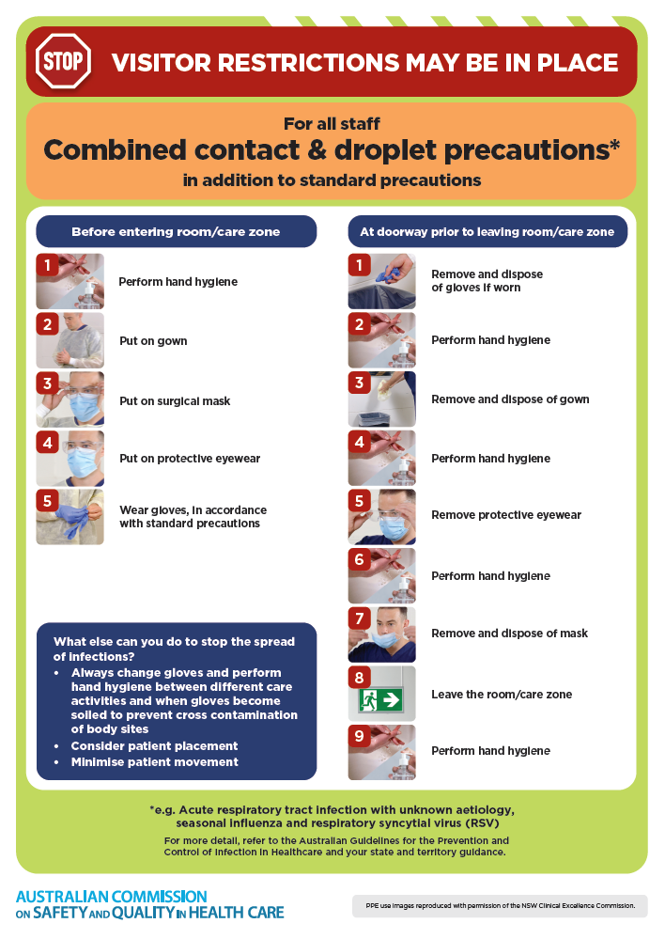](https://www.safetyandquality.gov.au/publications-and-resources/resource-library/infection-prevention-and-control-poster-combined-contact-and-droplet-precautions)
* ***Poster – Combined airborne and contact precautions*** <https://www.safetyandquality.gov.au/publications-and-resources/resource-library/poster-combined-airborne-and-contact-precautions>   
  [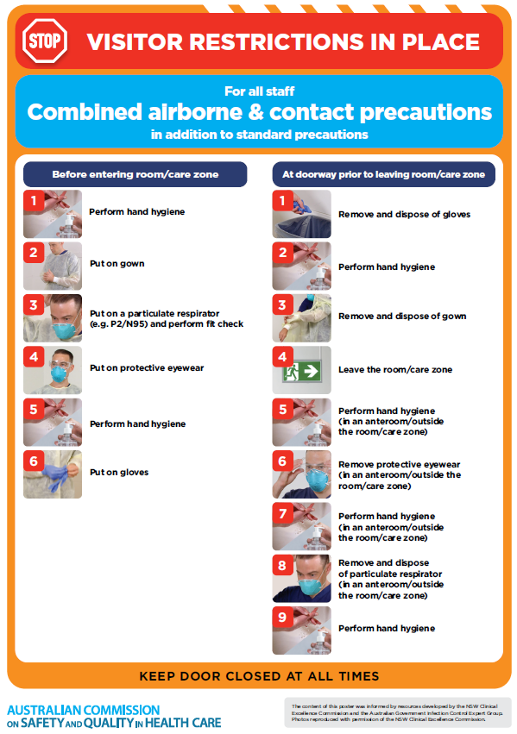](https://www.safetyandquality.gov.au/publications-and-resources/resource-library/poster-combined-airborne-and-contact-precautions)
* ***Environmental Cleaning and Infection Prevention and Control*** [www.safetyandquality.gov.au/environmental-cleaning](http://www.safetyandquality.gov.au/environmental-cleaning)
* ***COVID-19 infection prevention and control risk management – Guidance*** <https://www.safetyandquality.gov.au/publications-and-resources/resource-library/covid-19-infection-prevention-and-control-risk-management-guidance>
* ***Safe care for people with cognitive impairment during COVID-19***<https://www.safetyandquality.gov.au/our-work/cognitive-impairment/cognitive-impairment-and-covid-19>
* ***Stop COVID-19: Break the chain of infection*** posterhttps://www.safetyandquality.gov.au/publications-and-resources/resource-library/break-chain-infection-poster-a3  
  **[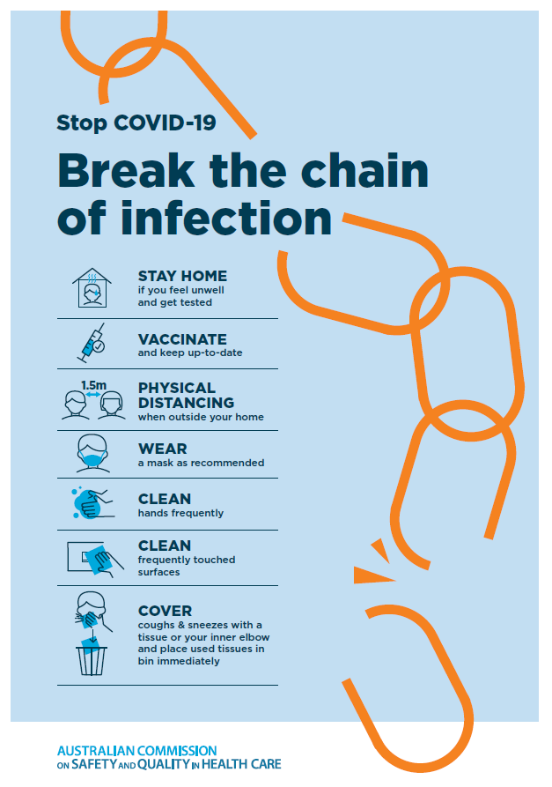](https://www.safetyandquality.gov.au/publications-and-resources/resource-library/break-chain-poster-a3https:/www.safetyandquality.gov.au/publications-and-resources/resource-library/break-chain-poster-a3)**
* ***COVID-19 and face masks – Information for consumers*** <https://www.safetyandquality.gov.au/publications-and-resources/resource-library/covid-19-and-face-masks-information-consumers>

[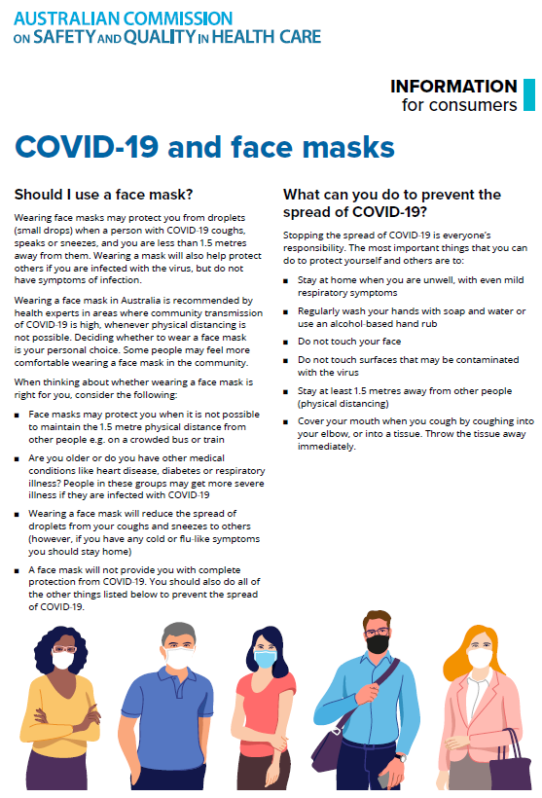](https://www.safetyandquality.gov.au/sites/default/files/2020-07/covid-19_and_face_masks_-_information_for_consumers.pdf)

*National Clinical Evidence Taskforce*

<https://clinicalevidence.net.au/>

The National Clinical Evidence Taskforce is a multi-disciplinary collaboration of 35 member organisations – Australia’s medical colleges and peak health organisations – who share a commitment to provide national evidence-based treatment guidelines for urgent and emerging diseases.

This alliance established the world’s first ‘living guidelines’ for the care of people with COVID-19 and MPX.

Funding has now been discontinued for the National Clinical Evidence Taskforce and the COVID-19 guidelines as of 30 June 2023.

These guidelines are no longer continually updated but will remain online until the guidance becomes inaccurate and/or no longer reflects the evidence or recommended practice.

**Disclaimer**

On the Radar is an information resource of the Australian Commission on Safety and Quality in Health Care. The Commission is not responsible for the content of, nor does it endorse, any articles or sites listed. The Commission accepts no liability for the information or advice provided by these external links. Links are provided on the basis that users make their own decisions about the accuracy, currency and reliability of the information contained therein. Any opinions expressed are not necessarily those of the Australian Commission on Safety and Quality in Health Care.