# Australian Commission on Safety and Quality logotypeOn the Radar

Issue 635

29 January 2024

*On the Radar* is a summary of some of the recent publications in the areas of safety and quality in health care. Inclusion in this document is not an endorsement or recommendation of any publication or provider. Access to particular documents may depend on whether they are Open Access or not, and/or your individual or institutional access to subscription sites/services. Material that may require subscription is included as it is considered relevant.

*On the Radar* is available online, via email or as a PDF or Word document from <https://www.safetyandquality.gov.au/newsroom/subscribe-news/radar>

If you would like to receive *On the Radar* via email, you can subscribe on our website <https://www.safetyandquality.gov.au/newsroom/subscribe-news>  
or by emailing us at H[Umail@safetyandquality.gov.auU](mailto:mail@safetyandquality.gov.au).   
You can also send feedback and comments to H[Umail@safetyandquality.gov.auU](mailto:mail@safetyandquality.gov.au).

For information about the Commission and its programs and publications, please visit <https://www.safetyandquality.gov.au>

w

**On the Radar**

Editor: Dr Niall Johnson [niall.johnson@safetyandquality.gov.au](mailto:niall.johnson@safetyandquality.gov.au)

Contributors: Niall Johnson

**Journal articles**

*The quality of care delivered to residents in long-term care in Australia: an indicator-based review of resident records (CareTrack Aged study)*

Hibbert PD, Molloy CJ, Cameron ID, Gray LC, Reed RL, Wiles LK, et al

BMC Medicine 2024;22(1):22.

|  |  |
| --- | --- |
| DOI | <https://doi.org/10.1186/s12916-023-03224-8> |
| Notes | The latest CareTrack study has focused on aged care in Australia. The paper reports on a study that sought to estimate the prevalence of evidence-based care received by a sample of long-term care (LTC) residents aged ≥ 65 years in 2021. The study examined the care received by 294 residents across 27,585 care encounters in 25 LTC facilities. The authors report that ‘Adherence to evidence-based care indicators was estimated at 53.2% (95% CI: 48.6, 57.7) ranging from a high of 81.3% (95% CI: 75.6, 86.3) for Bladder and Bowel to a low of 12.2% (95% CI: 1.6, 36.8) for Depression. Six conditions (skin integrity, end-of-life care, infection, sleep, medication, and depression) had less than 50% adherence with indicators.’ |

*Effect of chair placement on physicians’ behavior and patients’ satisfaction: randomized deception trial*

Iyer R, Park D, Kim J, Newman C, Young A, Sumarsono A.

BMJ 2023;383: e076309.

|  |  |
| --- | --- |
| DOI | <https://doi.org/10.1136/bmj-2023-076309> |
| Notes | Piece in the *BMJ* (British Medical Journal) reporting on an intervention that observed patient encounters in which a chair was either ≤3 feet (0.9 m) of the patient’s bedside and facing the bed or the usual chair location. This small study in one US hospital observed 125 encounters (randomized with 60 to chair placement and 65 control). The authors report that ‘Chair placement is a simple, no cost, low tech intervention that increases a physician’s likelihood of sitting during a bedside consultation and resulted in higher patients’ scores for both satisfaction and communication’.  [Visual abstract for Effect of chair placement on physicians’ behavior and patients’ satisfaction: randomized deception trial article](https://doi.org/10.1136/bmj-2023-076309) |

*Impact of hospital accreditation on quality improvement in healthcare: A systematic review*

Alhawajreh MJ, Paterson AS, Jackson WJ

PLOS ONE 2023;18(12): e0294180.

|  |  |
| --- | --- |
| DOI | <https://doi.org/10.1371/journal.pone.0294180> |
| Notes | Paper reporting on a systematic review that sought to examine the ‘evidence for the impact of accreditation on quality improvement of healthcare services’. Ultimately based on 21 articles, the review authors observe that ‘While there are contradictory findings about the impact of accreditation on improving the quality of healthcare services, accreditation continues to gain acceptance internationally as a quality assurance tool to support best practices in evaluating the quality outcomes of healthcare delivered.’ |

*Diagnostic Errors in Hospitalized Adults Who Died or Were Transferred to Intensive Care*

Auerbach AD, Lee TM, Hubbard CC, Ranji SR, Raffel K, Valdes G, et al

JAMA Internal Medicine 2024.

|  |  |
| --- | --- |
| DOI | <https://doi.org/10.1001/jamainternmed.2023.7347> |
| Notes | There has been increasing interest in issues around diagnosis, including delayed diagnosis or diagnostic error. This cohort study sought to examine ‘How often do diagnostic errors happen in adult patients who are transferred to the intensive care unit (ICU) or die in the hospital, what causes the errors, and what are the associated harms?’ The study examined 2428 patient records from 29 US hospitals of adult patients ‘hospitalized with general medical conditions and who were transferred to an ICU, died, or both from January 1 to December 31, 2019’. The authors report that in the sample, ‘a missed or delayed diagnosis took place in 23%, with 17% of these errors causing temporary or permanent harm to patients. The underlying diagnostic process problems with greatest effect sizes associated with diagnostic errors, and which might be an initial focus for safety improvement efforts, were faults in testing and clinical assessment.’ |

*BMJ Quality & Safety*

Volume 33, Issue 2, February 2024

|  |  |
| --- | --- |
| URL | <https://qualitysafety.bmj.com/content/33/2> |
| Notes | A new issue of *BMJ Quality & Safety* has been published. Many of the papers in this issue have been referred to in previous editions of *On the Radar* (when they were released online). Articles in this issue of *BMJ Quality & Safety* include:   * Editorial: Time to treat the climate and nature crisis as one indivisible **global health emergency** (Chris Zielinski) * Editorial: Making lemonade out of lemons: an approach to **combining variable race and ethnicity data from hospitals** for quality and safety efforts (Kayla L Karvonen, Naomi S Bardach) * Editorial: Towards comprehensive fidelity evaluations: consideration of **enactment measures in quality improvement interventions** (Holly Walton) * Editorial: **How safe is the diagnostic process in healthcare?** (Perla J Marang-van de Mheen, Eric J Thomas, Mark L Graber) * **Racial and ethnic disparities in common inpatient safety outcomes** in a children’s hospital cohort (Anne Lyren, Elizabeth Haines, Meghan Fanta, Michael Gutzeit, Katherine Staubach, Pavan Chundi, Valerie Ward, Lakshmi Srinivasan, Megan Mackey, Michelle Vonderhaar, Patricia Sisson, Ursula Sheffield-Bradshaw, Bonnie Fryzlewicz, Maitreya Coffey, John D Cowden) * Development and validation of the **Overall Fidelity Enactment Scale for Complex Interventions (OFES-CI)** (Liane Ginsburg, Matthias Hoben, Whitney Berta, Malcolm Doupe, Carole A Estabrooks, Peter G Norton, Colin Reid, Ariane Geerts, Adrian Wagg) * Burden of **serious harms from diagnostic error** in the USA (David E Newman-Toker, Najlla Nassery, Adam C Schaffer, Chihwen Winnie Yu-Moe, Gwendolyn D Clemens, Zheyu Wang, Yuxin Zhu, Ali S. Saber Tehrani, Mehdi Fanai, Ahmed Hassoon, Dana Siegal) * Grand rounds in methodology: key considerations for implementing **machine learning solutions in quality improvement initiatives** (Amol A Verma, Patricia Trbovich, Muhammad Mamdani, Kaveh G Shojania) * Retrospective cohort study of **wrong-patient imaging order errors**: how many reach the patient? (Jerard Z Kneifati-Hayek, Elias Geist, Jo R Applebaum, Alexis K Dal Col, Hojjat Salmasian, Clyde B Schechter, Noémie Elhadad, Joshua Weintraub, Jason S Adelman) |

*Milbank Quarterly*

Volume 101, December 2023

|  |  |
| --- | --- |
| URL | <https://www.milbank.org/quarterly/issues/december-2023/> |
| Notes | A new issue of the *Milbank Quarterly* has been published. Articles in this issue of the *Milbank Quarterly* include:   * Moving Toward Inclusion: **Access to Care Models for Uninsured Immigrant Children** (Katelyn Girtain, Sural Shah, Ana C Monterrey, J Raul Gutierrez, Mark Kuczewski, Julie M. Linton) * Advancing Dialogue About **Consent and Molecular HIV Surveillance** in the United States: Four Proposals Following a Federal Advisory Panel's Call for Major Reforms (Stephen Molldrem, Anthony Smith, A McClelland) * Improving Food and Drug Administration–Centers for Medicare and Medicaid Services Coordination for **Drugs Granted Accelerated Approval** (Peter J Neumann, Elliott Crummer, James D Chambers, Sean R Tunis) * The Role of Place in **Person- and Family-Oriented Long-Term Services and Supports** (Chanee D Fabius, Safiyyah M Okoye, Mingche M J Wu, Andrew D Jopson, L C Chyr, J Burgdorf, J Ballreich, D Scerpella, J L Wolff) * Building **High-Performing Primary Care Systems**: After a Decade of Policy Change, Is Canada "Walking the Talk?" (Monica Aggarwal, Brian Hutchison, Reham Abdelhalim, Ross Baker) * Association Between **Partisan Affiliation of State Governments and State Mortality Rates** Before and During the COVID-19 Pandemic (Steven H Woolf, Roy T Sabo, Derek A Chapman, Jong Hyung Lee) * Unrealized Cross-System Opportunities to Improve **Employment and Employment-Related Services Among Autistic Individuals** (Anne M Roux, Kaitlin K Miller, Sha Tao, Jessica E Rast, Jonas Ventimiglia, Paul t Shattuck, Lindsay L Shea) * Trade-Related Aspects of Intellectual Property Rights Flexibilities and Public Health: Implementation of **Compulsory Licensing Provisions into National Patent Legislation** (Lauren McGivern) * Community Health Center Staff Perspectives on Financial **Payments for Social Care** (J M Lopez, H Wing, S L Ackerman, D Hessler, L M Gottlieb) * Dual Barriers: Examining Digital Access and Travel Burdens to Hospital **Maternity Care Access** in the United States, 2020 (Peiyin Hung, Marion Granger, Nansi Boghossian, Jiani Yu, Sayward Harrison, Jihong Liu, Berry A Campbell, Bo Cai, Chen Liang, Xiaoming Li) * Caught Between a Well-Intentioned State and a Hostile Federal System: Local Implementation of **Inclusive Immigrant Policies** (Maria-Elena de Trinidad Young, Sharon Tafolla, Fabiola M. Perez-Lua) |

*BMJ Leader*

Volume 7, Issue 4, December 2023

|  |  |
| --- | --- |
| URL | <https://bmjleader.bmj.com/content/7/4> |
| Notes | A new issue of *BMJ Leader* has been published. Articles in this issue of *BMJ Leader* include:   * Editorial: Time to treat the climate and nature crisis as one indivisible **global health emergency** (Chris Zielinski) * Framework analysis: Tony Ghaye’s and Christopher Johns’ **reflective practice models** (Jye Gard) * Message to junior and less junior clinicians: **let the core values of care guide your leadership**! (Kris Vanhaecht) * **Trajectory of a medical career**: a perspective regarding a proposed model (James KStoller) * Facilitating **workplace grief** through an organic office ‘Last Office’ session for bereaved employees (Paul Victor Patinadan, Winnie Teo) * Is it time for a paradigmatic shift in relation to **healthcare in the UK**? A reflection (Karen Saunders, Mohamed Sakel, Cary L Cooper) * **Stretch goals** have enduring appeal, but are the right organisations using them? (Kelly E See, C Chet Miller, Sim B Sitkin) * Roadmap for embedding **health equity research** into learning health systems (Antoinette Schoenthaler, Fritz Francois, Ilseung Cho, Gbenga Ogedegbe) * **Clinical academics’ experiences during the COVID-19 pandemic**: a qualitative study of challenges and opportunities when working at the clinical frontline (Diane Trusson, Emma Rowley, Louise Bramley) * Role of leader member exchange on **nurse’s organisational citizenship behaviour** from the Bugis tribe cultural perspective in Indonesia (Andi Indahwaty AS, Irwandy Irwandy, Rifa’ah Mahmudah Bulu) * What can clinical leaders contribute to the **governance of integrated care systems**? (Justin Waring, Simon Bishop, Georgia Black, Jenelle Clarke, B Roe) * Exploring the implementation and evaluation of a **distributed leadership model** within a Scottish, integrated health and care context (Calum F Leask, Sandra Macleod) * Let’s **reconnect healthcare with its mission and purpose** by bringing humanity to the point of care (Mathieu Louiset, Dominique Allwood, Suzie Bailey, Robert Klaber, Maureen Bisognano) * Moving towards **people-centred healthcare systems**: Using discrete choice experiments to improve leadership decision making (Adi Ghosh, Oguz A Acar, Aneesh Banerjee, Caroline Wiertz) * Keeping the frogs in the wheelbarrow: how **virtual onboarding** creates positive team-enabling cultures (Rick Varma, Bradley Hastings) * **Psychologically informed leadership coaching** positively impacts the mental well-being of 80 senior doctors, medical and public health leaders (Fiona Jane Day) * Innovative approach to **medical leadership and management development**: clinician secondment to a management consulting firm (Francesco Papalia, Kenneth Fung, Yang Chen, George D Thornton, Nick Geatches, Frances Cousins, Karen Kirkham, Mark Westwood) * Capturing what and why in **healthcare innovation** (Benet Reid, Lori Leigh Davis, Lisi Gordon) * Paradigm lost? Reflections on the effectiveness of NHS approaches to **improving employment relations** (Roger Kline) |

*BMJ Quality & Safety* online first articles

|  |  |
| --- | --- |
| URL | <https://qualitysafety.bmj.com/content/early/recent> |
| Notes | *BMJ Quality &Safety* has published a number of ‘online first’ articles, including:   * Editorial: **Intrapartum electronic fetal monitoring**: imperfect technologies and clinical uncertainties—what can a human factors and social science approach add? (Jane Sandall) |

*International Journal for Quality in Health Care* online first articles

|  |  |
| --- | --- |
| URL | <https://academic.oup.com/intqhc/advance-articles> |
| Notes | *International Journal for Quality in Health Care* has published a number of ‘online first’ articles, including:   * **Reduction in use of MRI and arthroscopy among patients with degenerative knee disease** in independent treatment centers versus general hospitals – a time series analysis (Laurien S Kuhrij et al) * Foundations of safety – Realistic Medicine, **trust and respect between professionals and patients** (Siri Wiig et al) * **Resilience and regulation** – antithesis or a smart combination for future healthcare service improvement? (Sina Furnes Øyri et al) * **Reform of mental health systems**: what does the future look like and how to get there? (Michael Gorton and David Greenfield * Improving Compliance with **Personal Protective Equipment** among anaesthetists through behaviour changing interventions during the COVID-19 Pandemic (P Chia et al) |

**Online resources**

**Critical Intelligence Unit**

<https://aci.health.nsw.gov.au/statewide-programs/critical-intelligence-unit>

The Critical Intelligence Unit (CIU) of the Agency for Clinical Innovation (ACI) in New South Wales provides evidence-based insights for clinical innovation. Their site offers ‘Living evidence’ summaries and rapid review ‘Evidence checks’.

The CIU is now also offering an *Artificial intelligence living evidence* page at <https://aci.health.nsw.gov.au/statewide-programs/critical-intelligence-unit/artificial>. This has been added to their existing Living evidence pages on Surgical waiting time and waitlist and Post acute sequelae (long COVID).

***[UK] NICE Guidelines and Quality Standards***

<https://www.nice.org.uk/guidance>

The UK’s National Institute for Health and Care Excellence (NICE) has published new (or updated) guidelines and quality standards. The latest reviews or updates include:

* Quality Standard QS75 ***Neonatal infection*** <https://www.nice.org.uk/guidance/qs75>
* Diagnostics Guideline DG57 *Artificial intelligence (AI)-derived software to help clinical decision making in* ***stroke*** <https://www.nice.org.uk/guidance/dg57>

***[USA] Effective Health Care Program reports***

<https://effectivehealthcare.ahrq.gov/>

The US Agency for Healthcare Research and Quality (AHRQ) has an Effective Health Care (EHC) Program. The EHC has released the following final reports and updates:

* *Reducing Adverse Drug Events Related to* ***Anticoagulant*** *Use in Adults* <https://effectivehealthcare.ahrq.gov/products/high-risk-drugs/rapid-research>

**COVID-19 resources**

https://www.safetyandquality.gov.au/covid-19

The Australian Commission on Safety and Quality in Health Care has developed a number of resources to assist healthcare organisations, facilities and clinicians. These and other material on COVID-19 are available at <https://www.safetyandquality.gov.au/covid-19>

These resources include:

* ***OVID-19 infection prevention and control risk management*** This primer provides an overview of three widely used tools for investigating and responding to patient safety events and near misses. Tools covered in this primer include incident reporting systems, Root Cause Analysis (RCA), and Failure Modes and Effects Analysis (FMEA).   
  <https://www.safetyandquality.gov.au/publications-and-resources/resource-library/covid-19-infection-prevention-and-control-risk-management-guidance>
* ***Poster – Combined contact and droplet precautions*** <https://www.safetyandquality.gov.au/publications-and-resources/resource-library/infection-prevention-and-control-poster-combined-contact-and-droplet-precautions>  
  [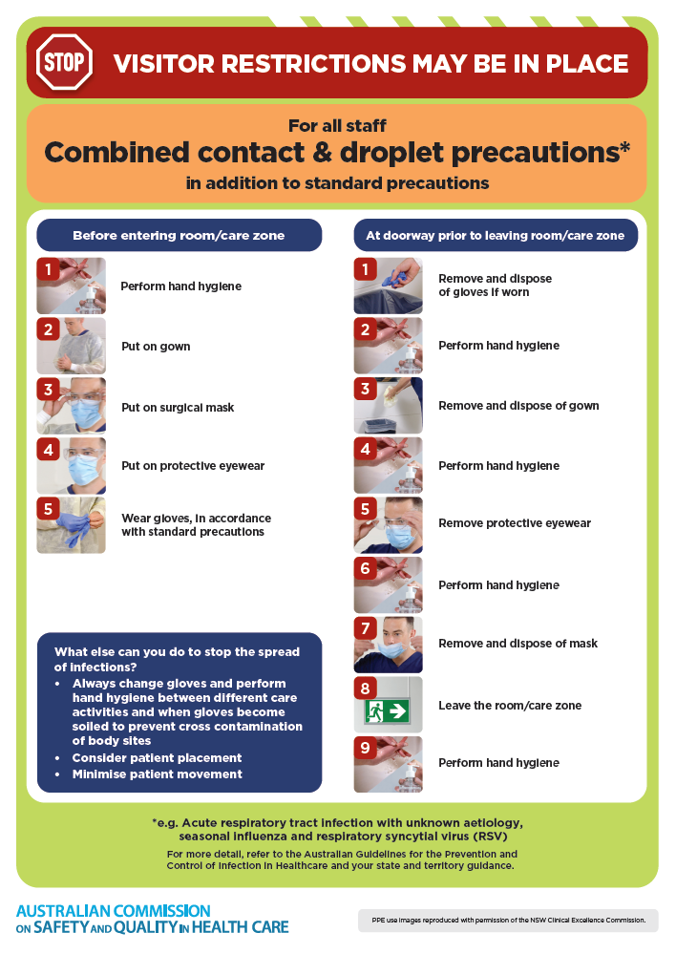](https://www.safetyandquality.gov.au/publications-and-resources/resource-library/infection-prevention-and-control-poster-combined-contact-and-droplet-precautions)
* ***Poster – Combined airborne and contact precautions*** <https://www.safetyandquality.gov.au/publications-and-resources/resource-library/poster-combined-airborne-and-contact-precautions>   
  [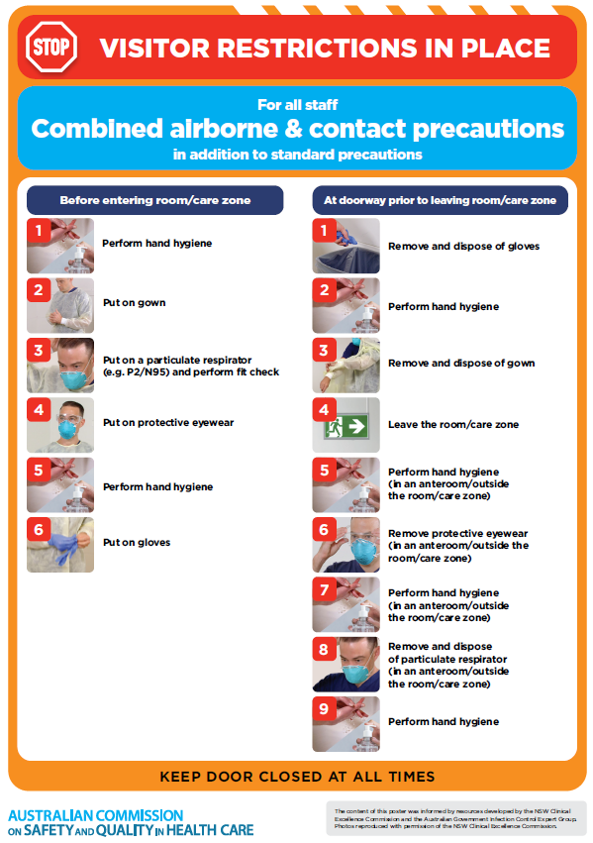](https://www.safetyandquality.gov.au/publications-and-resources/resource-library/poster-combined-airborne-and-contact-precautions)
* ***Environmental Cleaning and Infection Prevention and Control*** [www.safetyandquality.gov.au/environmental-cleaning](http://www.safetyandquality.gov.au/environmental-cleaning)
* ***COVID-19 infection prevention and control risk management – Guidance*** <https://www.safetyandquality.gov.au/publications-and-resources/resource-library/covid-19-infection-prevention-and-control-risk-management-guidance>
* ***Safe care for people with cognitive impairment during COVID-19***<https://www.safetyandquality.gov.au/our-work/cognitive-impairment/cognitive-impairment-and-covid-19>
* ***Stop COVID-19: Break the chain of infection*** posterhttps://www.safetyandquality.gov.au/publications-and-resources/resource-library/break-chain-infection-poster-a3  
  **[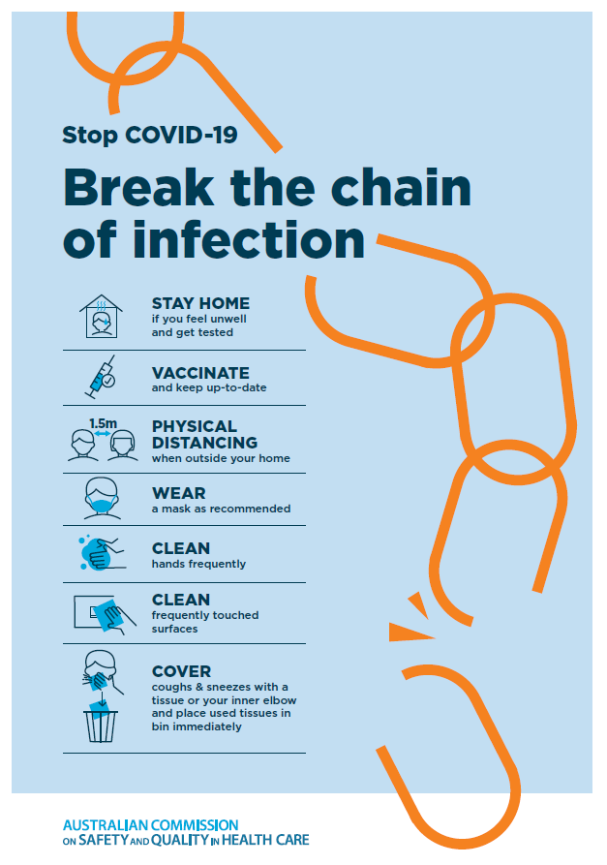](https://www.safetyandquality.gov.au/publications-and-resources/resource-library/break-chain-poster-a3https:/www.safetyandquality.gov.au/publications-and-resources/resource-library/break-chain-poster-a3)**
* ***COVID-19 and face masks – Information for consumers*** <https://www.safetyandquality.gov.au/publications-and-resources/resource-library/covid-19-and-face-masks-information-consumers>

[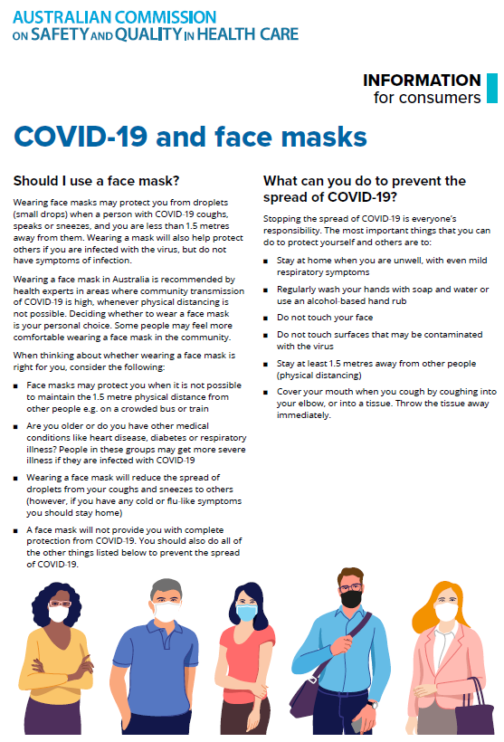](https://www.safetyandquality.gov.au/sites/default/files/2020-07/covid-19_and_face_masks_-_information_for_consumers.pdf)

*National Clinical Evidence Taskforce*

<https://clinicalevidence.net.au/>

The National Clinical Evidence Taskforce is a multi-disciplinary collaboration of 35 member organisations – Australia’s medical colleges and peak health organisations – who share a commitment to provide national evidence-based treatment guidelines for urgent and emerging diseases.

This alliance established the world’s first ‘living guidelines’ for the care of people with COVID-19 and MPX.

Funding has now been discontinued for the National Clinical Evidence Taskforce and the COVID-19 guidelines as of 30 June 2023.

These guidelines are no longer continually updated but will remain online until the guidance becomes inaccurate and/or no longer reflects the evidence or recommended practice.

**Disclaimer**

On the Radar is an information resource of the Australian Commission on Safety and Quality in Health Care. The Commission is not responsible for the content of, nor does it endorse, any articles or sites listed. The Commission accepts no liability for the information or advice provided by these external links. Links are provided on the basis that users make their own decisions about the accuracy, currency and reliability of the information contained therein. Any opinions expressed are not necessarily those of the Australian Commission on Safety and Quality in Health Care.