 

# What are the National Safety and Quality Mental Health Standards for Community Managed Organisations and why should they matter to me?

SCAN ME



FOR MORE INFO

The National Safety and Quality Mental Health Standards for Community Managed Organisations (the NSQMHCMO Standards) have been introduced to make sure that you are receiving quality care from the community service provider that cares for your mental health.

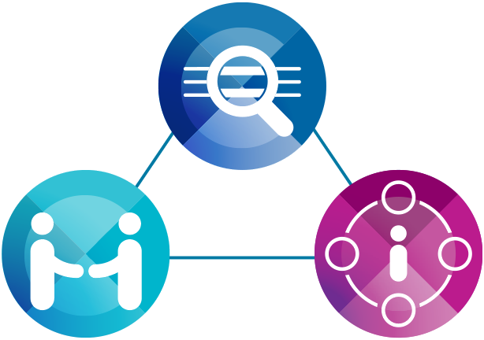

## What are the Standards?



### Practice governance

How your service provider makes sure you receive safe and reliable high-quality care that meets your needs.



### Partnering with consumers and carers

How your service provider involves and includes you and your loved ones in your care and works with you to improve the service for others.



### Model of care

How your service supports you when you are well and if you become unwell, and how this is communicated with those who need to know.

## How do I know if my service is accredited?

An accreditation logo will be displayed at their entrance and on their website.

To find out more, please talk to a staff member or call the Australian Commission on Safety and Quality in Health Care Advice Centre on

1800 304 056. You can also send an email to [advicecentre@safetyandquality.gov.au](mailto:advicecentre%40safetyandquality.gov.au?subject=)

## What this looks like:

You will know when your service meets these standards because you will:

* Be matched with the right care for your needs
* Be treated as a valued partner in your own care
* Be supported to guide your recovery in a meaningful way
* Feel respected and listened to
* Know that your family members or carers are respected and listened to
* Be involved in giving feedback and evaluating service quality.

The NSQMHCMO Standards have an action plan to guide service providers. Every three years, your service will be assessed to ensure it is:

* Safe and reliable
* Focused on your needs
* Involving you, your family members and carers in continually creating a better service
* Communicating with you effectively and putting your safety first
* Responding in the right way if you or your loved one is becoming unwell.

 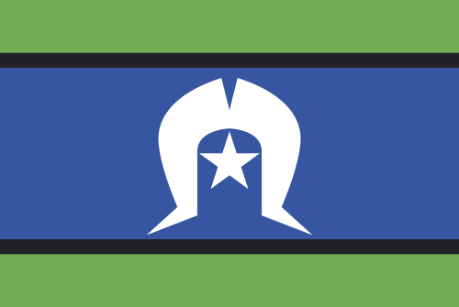 

This Fact Sheet has been informed by the valued perspectives of consumers, families, carers and kin. We acknowledge the Traditional Owners and Custodians of Country throughout Australia, and their continuing connection to land, waters and community. We pay our respects to them and their cultures, and to elders both past and present.