# Australian Commission on Safety and Quality logotypeOn the Radar

Issue 637

12 February 2024

*On the Radar* is a summary of some of the recent publications in the areas of safety and quality in health care. Inclusion in this document is not an endorsement or recommendation of any publication or provider. Access to particular documents may depend on whether they are Open Access or not, and/or your individual or institutional access to subscription sites/services. Material that may require subscription is included as it is considered relevant.

*On the Radar* is available online, via email or as a PDF or Word document from <https://www.safetyandquality.gov.au/newsroom/subscribe-news/radar>

If you would like to receive *On the Radar* via email, you can subscribe on our website <https://www.safetyandquality.gov.au/newsroom/subscribe-news>  
or by emailing us at H[Umail@safetyandquality.gov.auU](mailto:mail@safetyandquality.gov.au).   
You can also send feedback and comments to H[Umail@safetyandquality.gov.auU](mailto:mail@safetyandquality.gov.au).

For information about the Commission and its programs and publications, please visit <https://www.safetyandquality.gov.au>

w

**On the Radar**

Editor: Dr Niall Johnson [niall.johnson@safetyandquality.gov.au](mailto:niall.johnson@safetyandquality.gov.au)

Contributors: Niall Johnson, Rozanna Alameddine

**Consultation on updating the National Guidelines for On-Screen Presentation of Discharge Summaries**

<https://www.safetyandquality.gov.au/newsroom/consultations/updating-national-guidelines-screen-presentation-discharge-summaries>

The Australian Commission on Safety and Quality in Health Care has developed a couple of short surveys as part of consultation for the revised *National Guidelines for On-Screen Presentation of Discharge Summaries* (the Guidelines).

The Guidelines aim to improve the presentation of discharge summaries that are prepared and communicated electronically. They provide recommendations on the clinical content and layout of discharge summary information to improve overall safety and quality of patients' continuity of care. The revised Guidelines have been informed by findings from a literature review and environmental scan as well as consultation with states and territories. Two surveys have been developed for this consultation round to gather feedback from:

1. Healthcare professionals that prepare discharge summaries in hospital settings
2. Healthcare professionals that receive discharge summaries in primary care (primarily in general practice settings)

Healthcare professionals are invited provide feedback on the revised discharge summary template by completing the [survey](https://www.safetyandquality.gov.au/newsroom/consultations/updating-national-guidelines-screen-presentation-discharge-summaries) most applicable to their practice setting. Consultation is open until **20 February 2024** 11:59 PM AEDT.

**Reports**

*Top 10 Health Technology Hazards for 2024: Executive Brief*

ECRI

Plymouth Meeting, PA: ECRI; 2024.

|  |  |
| --- | --- |
| URL | <https://www.ecri.org/2024hazards> |
| Notes | ECRI ((originally the Emergency Care Research Institute) in the USA produces an annual list of hazards. Their list of the top 10 health technology hazards for 2024 is:   1. Medical Devices May Pose Usability Challenges for Home Users, Risking Misuse and Patient Harm 2. Inadequate or Onerous Device Cleaning Instructions Endanger Patients 3. Sterile Drug Compounding without the Use of Technological Safeguards Increases the Risk of Medication Errors 4. Overlooked Environmental Impacts of Patient Care Endanger Public Health 5. Insufficient Governance of AI Used in Medical Technologies Risks Inappropriate Care Decisions 6. Ransomware Targeting the Healthcare Sector Remains a Critical Threat 7. Increased Burn Risk with Single-Foil Electrosurgical Return Electrodes 8. Infusion Pump Damage Remains a Medication Safety Concern 9. Poor QC of Implantable Orthopedic Products Can Lead to Surgical Delays and Patient Harm 10. Third-Party Web Analytics Software Can Compromise Patient Confidentiality. |

*Making Healthcare Safer IV: Deprescribing To Reduce Medication Harms in Older Adults. Rapid Response*

Linsky AM, Motala A, Lawson E, Shekelle P.

Rockville, MD: Agency for Healthcare Research and Quality; 2024.

|  |  |
| --- | --- |
| DOI | <https://doi.org/10.23970/AHRQEPC_MHS4DEPRESCRIBING> |
| Notes | As part of the Making Healthcare Safer IV initiative, the US Agency for Healthcare Research and Quality (AHRQ) commissioned this rapid review examining recent literature on the use of deprescribing to improve the safety of medication use among older adults (age ≥ 65 years). The literature search identified 15 systematic reviews and 7 original research studies published since 2019 to add to the existing evidence base. The authors write that ‘Deprescribing as an explicit, specific intervention is a relatively newer practice with the objective of reducing harms associated with polypharmacy and inappropriate medication use. Numerous systematic reviews continue to support the effectiveness of this practice to reduce proximal outcomes related to medications: medication count and number of potentially inappropriate medications. The evidence also indicates that deprescribing reduced medication-related costs, a conclusion also reached in MHS III [the earlier Making Healthcare Safer III]. Importantly, deprescribing was associated with few adverse drug withdrawal events.’ |

For information on the Commission’s work on medication safety, see <https://www.safetyandquality.gov.au/our-work/medication-safety>

*Current State of Diagnostic Safety: Implications for Research, Practice, and Policy. Issues Brief 16*

Khan S, Cholankeril R, Sloane J, Offner A, Sittig DF, Bradford A, et al

Rockville, MD: Agency for Healthcare Research and Quality; 2024. p. 53.

|  |  |
| --- | --- |
| URL | <https://www.ahrq.gov/patient-safety/reports/issue-briefs/dxsafety-current-state.html> |
| Notes | Issues Brief produced for the US Agency for Healthcare Research and Quality (AHRQ) the describes the results of rapid narrative review and interviews with subject matter experts in order ‘to identify major themes related to the current state of diagnostic safety and highlight key gaps in knowledge’. The authors observe that there has been progress, however ‘Despite progress in various domains of diagnostic safety, several research gaps remain’. |

*National learning report: Positive patient identification*

Health Services Safety Investigation Body

Poole: HSSIB; 2024.

|  |  |
| --- | --- |
| URL | <https://www.hssib.org.uk/patient-safety-investigations/positive-patient-identification/> |
| Notes | Correct identification of the patient was recognised as a key safety issue many years ago. This latest report from the UK’s Health Services Safety Investigation Body (HSSIB) draws together evidence from previous investigations and broader sources to examine factors that contribute to patients being misidentified within the healthcare systems. The report observes ‘Positive patient identification’ is correctly identifying a patient to ensure that the right person receives their intended care’ and ‘Patient misidentification is where a patient is identified as someone else. This may mean that a patient does not receive the care meant for them, or that they receive the care meant for someone else.’ The report includes findings, safety observations and recommendations.  Among the findings are:   * Patient misidentification is challenging to address and previous efforts to reduce the risk have not been as successful as hoped. There may be a benefit in proactively ensuring that processes for identifying patients are safe, rather than reacting to incidents of harm. * Positive patient identification is seen as a routine task, but is common, complex and critical for patient safety. It relies on staff following instructions described in policies and procedures, which might not always be fully appropriate to the circumstances within which staff are identifying patients. * Patients are at higher risk of being misidentified in certain situations and settings. Examples include handovers and when care is transferred between different healthcare organisations. * The risk of patient misidentification is underestimated and patient misidentification can result in significant harm to patients. Under-recognition of the risk is preventing allocation of already limited safety resources to further mitigate the risk. * Technology alone is unlikely to reduce the risk of patient misidentification. Work systems involving people, technology and tools need to be designed to improve identification processes. * It is not yet possible to eliminate the risk of patient misidentification. However, a series of interventions – including using new technologies and optimising workplaces – may help to reduce the risk. * When a patient is misidentified, it is difficult to correct the misidentification and ensure their records are made accurate.   The safety observations include:   * Future improvement programmes considering the risk of patient misidentification can improve patient safety by prioritising high-risk situations and settings, such as handovers and transfers of patient care. Multiple controls may need to be introduced, including new technologies and standardising of processes. * Healthcare organisations can improve patient safety through the use of principles of ‘user-centred design’ to help them understand and optimise clinical work settings for positive patient identification. * Those designing patient identification processes, including related software, can improve patient safety by undertaking effective equality impact assessments and by considering the needs of specific patient groups that are at high risk of being misidentified.   Patient identification is part of the *Communicating for Safety Standard* within the *National Safety and Quality Health Service (NSQHS) Standards*.  <https://www.safetyandquality.gov.au/standards/nsqhs-standards/communicating-safety-standard> |

**Journal articles**

*A 7-year analysis of attributable costs of healthcare-associated infections in a network of community hospitals in the southeastern United States*

Zhang HL, Crane L, Cromer AL, Green A, Padgette P, Payne VC, et al

Infection Control & Hospital Epidemiology 2024;45(1):103-105.

|  |  |
| --- | --- |
| DOI | <https://doi.org/10.1017/ice.2023.160> |
| Notes | The authors of this study sought to calculate ‘the attributable cost of several healthcare-associated infections [HAIs] in a community hospital network’ of more than 40 US hospitals in the period 2016–2022. The HAIs included central line-associated bloodstream infections (CLABSI), catheter-associated urinary tract infections (CAUTI), hospital-onset Clostridioides difficile infection (CDI-HO), and surgical site infections (SSI). The authors report that ‘From 2016 to 2022, the total cost of CLABSIs, CAUTIs, CDI-HOs, and SSIs was [USD] $420,012,025’. |

For information on the Commission’s work on healthcare-associated infections, see <https://www.safetyandquality.gov.au/our-work/healthcare-associated-infection-program>

*Preventing hospital falls: feasibility of care workforce redesign to optimise patient falls education*

Morris ME, Thwaites C, Lui R, McPhail SM, Haines T, Kiegaldie D, et al

Age and Ageing 2024;53(1):afad250.

|  |  |
| --- | --- |
| DOI | <https://doi.org/10.1093/ageing/afad250> |
| Notes | Paper reporting on an Australian study that examined the potential for allied health assistants to deliver patient falls prevention education. The study involved 541 patients (median age 81 years) with 270 in a control group and 271 in the experimental group over a 20-week period. The authors report that ‘There were 32 falls in the control group and 22 in the experimental group. The falls rate was 8.07 falls per 1,000 bed days in the control group and 5.69 falls per 1,000 bed days for the experimental group’. |

*Decision aids for people facing health treatment or screening decisions*

Stacey D, Lewis KB, Smith M, Carley M, Volk R, Douglas EE, et al.

Cochrane Database of Systematic Reviews 2024.

*Decision aids: challenges for practice when we have confidence in effectiveness*

Ryan RE, Hill S

Cochrane Database of Systematic Reviews 2024

|  |  |
| --- | --- |
| DOI | Stacey et al <https://doi.org/10.1002/14651858.CD001431.pub6>  Ryan and Hill <https://doi.org/10.1002/14651858.ED000164> |
| Notes | Stacey et al is an update to a Cochrane review that examines the effects of patient decision aids in adults considering treatment or screening decisions. This review is apparently the Cochrane Consumers and Communication's most highly cited review, having been cited in more than 90 clinical guidelines globally. This update added 104 new studies for a total of 209 studies covering 107,698 participants and describes evidence of the benefits of the use of decision aids over usual care across a range of health decisions. An accompanying editorial (Ryan and Hill) and podcast (with the lead author Professor Dawn Stacey) have also been published with the review and are available at <https://www.cochrane.org/news/decision-aids-people-facing-health-treatment-or-screening-decisions> |

For information on the Commission’s work on shared decision making, see <https://www.safetyandquality.gov.au/our-work/partnering-consumers/shared-decision-making>

For information on the Commission’s work on decision support tools, see <https://www.safetyandquality.gov.au/our-work/partnering-consumers/shared-decision-making/decision-support-tools-specific-conditions>

For information on the Commission’s work on person-centred care, see <https://www.safetyandquality.gov.au/our-work/partnering-consumers/person-centred-care>

*Hospital staff reports of coworker positive and unprofessional behaviours across eight hospitals: who reports what about whom?*

Urwin R, Pavithra A, McMullan RD, Churruca K, Loh E, Moore C, et al

BMJ Open Quality 2023;12(4):e002413.

|  |  |
| --- | --- |
| DOI | <https://doi.org/10.1136/bmjoq-2023-002413> |
| Notes | Australian study examining the impact of ‘A whole-of-hospital culture change programme, Ethos, … implemented by St. Vincent’s Health Australia across eight hospitals’. The Ethos programme ‘includes a secure online submission system that allows staff across all professional groups to report positive (Feedback for Recognition) and negative (Feedback for Reflection) coworker behaviours.’ In the period 2017–2020 there were a total of 2504 submissions, including 1194 (47.7%) positive and 1310 (52.3% negative. The authors note that:   * ‘Frequently reported positive coworker behaviours were non-technical skills (79.3%, N=947); values-driven behaviours (72.5%, N=866); and actions that enhanced patient care (51.3%, N=612).’ * ‘Overall, the most frequently reported unprofessional behaviours were being rude (53.8%, N=705); humiliating or ridiculing others (26%, N=346); and ignoring others’ opinions (24.6%, N=322).’ |

*Society of Critical Care Medicine Guidelines on Recognizing and Responding to Clinical Deterioration Outside the ICU: 2023*

Honarmand K, Wax RS, Penoyer D, Lighthall G, Danesh V, Rochwerg B, et al

Critical Care Medicine 2024;52(2):314-330.

|  |  |
| --- | --- |
| DOI | <https://doi.org/10.1097/ccm.0000000000006072> |
| Notes | Piece offering ‘evidence-based recommendations for hospital clinicians and administrators to optimize recognition and response to clinical deterioration in non-ICU patients.’ This guidance stems from a 25-member panel convened by the Society Of Critical Care Medicine. The recommendations relate to both recognizing and responding to clinical deterioration. |

For information on the Commission’s work on Recognising and responding to deterioration, see <https://www.safetyandquality.gov.au/our-work/recognising-and-responding-deterioration>

*Association between surgeon volume and patient outcomes after elective shoulder replacement surgery using data from the National Joint Registry and Hospital Episode Statistics for England: population based cohort study*

Valsamis EM, Collins GS, Pinedo-Villanueva R, Whitehouse MR, Rangan A, Sayers A, et al.

BMJ 2023;381:e075355.

|  |  |
| --- | --- |
| DOI | <https://doi.org/10.1136/bmj-2023-075355> |
| Notes | This piece is a recent addition to the literature on the surgical volume quality relationship. The study used UK national registry data on elective shoulder replacement surgery that included ‘39 281 shoulder replacement procedures undertaken by 638 consultant surgeons at 416 surgical units’ in the period 2021–2020. The authors concluded ‘In the healthcare system represented by these registry data, an association was found between surgeons who averaged more than 10.4 shoulder replacements yearly and lower rates of revision surgery and reoperation, lower risk of serious adverse events, and shorter hospital stays.’ |

*Health Affairs*

Volume 43, Number 2, February 2024

|  |  |
| --- | --- |
| URL | <https://www.healthaffairs.org/toc/hlthaff/43/2> |
| Notes | A new issue of *Health Affairs* has been published with the themes ‘Housing & Health. Articles in this issue of *Health Affairs* include:   * For Some Patients, **Better Health Starts With Finding A Home** (Michele Cohen Marill) * **Neighborhoods And Health**: Interventions At The Neighborhood Level Could Help Advance Health Equity (Mariana C. Arcaya, Ingrid Gould Ellen, and Justin Steil) * **Homelessness And Health**: Factors, Evidence, Innovations That Work, And Policy Recommendations (Cheyenne Garcia, Kelly Doran, and Margot Kushel) * **Gentrification** Yields Racial And Ethnic Disparities In Exposure To Contextual Determinants Of Health (Arthur Acolin, Kyle Crowder, A Decter-Frain, A Hajat, M Hall, L Homandberg, P MHurvitz, and L Woyczynski) * A History Of The **Impacts Of Discriminatory Policies On Housing And Maternal And Infant Health** In An Ohio Neighborhood (Kierra S Barnett, Jason Reece, Brittany M Mosley, Mikyung Baek, Ayaz Hyder, Kelly Kelleher, Shawnita Sealy-Jefferson, and Deena J Chisolm) * **Addressing Housing-Related Social Needs** Through Medicaid: Lessons From North Carolina’s Healthy Opportunities Pilots Program (Katie Huber, Raman Nohria, Vibhav Nandagiri, Rebecca Whitaker, Yolande Pokam Tchuisseu, Nicholas Pylypiw, Meaghan Dennison, Brianna Van Stekelenburg, Amanda Van Vleet, Maria Ramirez Perez, Madlyn C Morreale, Andrea Thoumi, Michelle Lyn, Robert S Saunders, and William K Bleser) * **Primary Care–Based Housing Program** Reduced Outpatient Visits; Patients Reported Mental And Physical Health Benefits (MaryCatherine Arbour, Placidina Fico, Sidney Atwood, Na Yu, Lynn Hur, Maahika Srinivasan, and Richard Gitomer) * **‘Housing First’** Increased Psychiatric Care Office Visits And Prescriptions While Reducing Emergency Visits (Devlin Hanson, and Sarah Gillespie) * **Encampment Clearings And Transitional Housing**: A Qualitative Analysis Of Resident Perspectives (Michael Mayer, Yesenia Mejia Urieta, Linda S. Martinez, Miriam Komaromy, Ursel Hughes, and Avik Chatterjee) * **Mortal Systemic Exclusion** Yielded Steep Mortality-Rate Increases In People Experiencing Homelessness, 2011–20 (M Z Fowle, and G Routhier) * **Housing Status** Changes Are Associated With **Cancer Outcomes** Among US Veterans (Hannah C Decker, Laura A Graham, Ashley Titan, Mary T Hawn, Hemal K Kanzaria, Elizabeth Wick, and Margot B Kushel) * Higher Rates Of **Homelessness** Are Associated With Increases In Mortality From Accidental **Drug And Alcohol Poisonings** (W David Bradford, and Felipe Lozano-Rojas) * Temporary Financial Assistance Reduced The Probability Of **Unstable Housing Among Veterans** For More Than 1 Year (Alec B Chapman, Daniel Scharfstein, Thomas H Byrne, Ann Elizabeth Montgomery, Ying Suo, Atim Effiong, Tania Velasquez, W Pettey, R Dalrymple, J Tsai, and R E Nelson) * **Energy Insecurity** Indicators Associated With Increased Odds Of Respiratory, Mental Health, And Cardiovascular Conditions (Eva Laura Siegel, K Lane, A Yuan, L A Smalls-Mantey, J Laird, C Olson, and D Hernández) * **TennCare Disenrollment** Led To Increased Eviction Filings And Evictions In Tennessee Relative To Other Southern States (Mir M Ali, Ashley C Bradford, and Johanna Catherine Maclean) * Experimental Evidence Shows That **Housing Vouchers** Provided Measurable Benefits, Including Parent Stress Reduction (Sandra Newman, Tama Leventhal, C Scott Holupka, and Fei Tan) * Exposing Pittsburgh Landlords To Asset-Framing Narratives: An Experiment To Increase **Housing Voucher Participation** (Selena E Ortiz, Andrew Fenelon, and Yousef Chavehpour) * **Housing-Sensitive Health Conditions** Can Predict Poor-Quality Housing (Ougni Chakraborty, Kacie L Dragan, Ingrid Gould Ellen, Sherry A Glied, Renata E Howland, Daniel B Neill, and Scarlett Wang) * Finding **A Place To Be Somebody** (Lawrence Lincoln) |

*BMJ Quality & Safety* online first articles

|  |  |
| --- | --- |
| URL | <https://qualitysafety.bmj.com/content/early/recent> |
| Notes | *BMJ Quality &Safety* has published a number of ‘online first’ articles, including:   * Editorial: Routine versus prompted **clinical debriefing**: aligning aims, mechanisms and implementation (Emma Claire Phillips, Victoria Tallentire) |

**Online resources**

***[USA] Effective Health Care Program reports***

<https://effectivehealthcare.ahrq.gov/>

The US Agency for Healthcare Research and Quality (AHRQ) has an Effective Health Care (EHC) Program. The EHC has released the following final reports and updates:

* ***Deprescribing*** *To Reduce Medication Harms in Older Adults* <https://effectivehealthcare.ahrq.gov/products/deprescribing-mhs4/rapid-research>

**COVID-19 resources**

https://www.safetyandquality.gov.au/covid-19

The Australian Commission on Safety and Quality in Health Care has developed a number of resources to assist healthcare organisations, facilities and clinicians. These and other material on COVID-19 are available at <https://www.safetyandquality.gov.au/covid-19>

These resources include:

* ***OVID-19 infection prevention and control risk management*** This primer provides an overview of three widely used tools for investigating and responding to patient safety events and near misses. Tools covered in this primer include incident reporting systems, Root Cause Analysis (RCA), and Failure Modes and Effects Analysis (FMEA).   
  <https://www.safetyandquality.gov.au/publications-and-resources/resource-library/covid-19-infection-prevention-and-control-risk-management-guidance>
* ***Poster – Combined contact and droplet precautions*** <https://www.safetyandquality.gov.au/publications-and-resources/resource-library/infection-prevention-and-control-poster-combined-contact-and-droplet-precautions>  
  [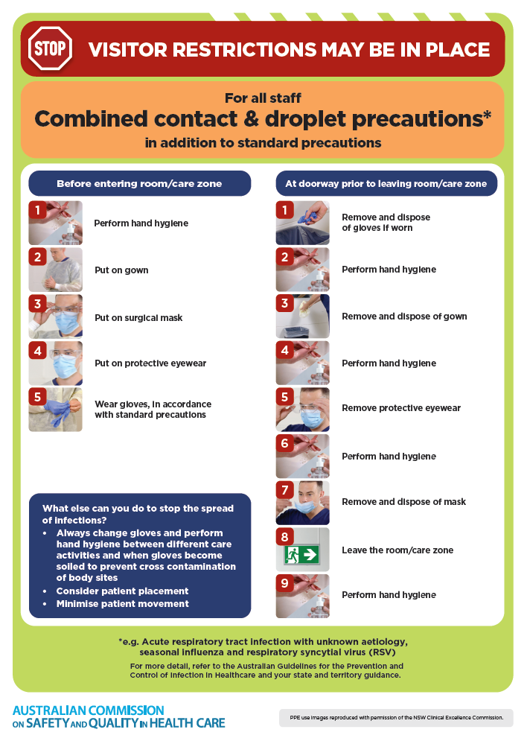](https://www.safetyandquality.gov.au/publications-and-resources/resource-library/infection-prevention-and-control-poster-combined-contact-and-droplet-precautions)
* ***Poster – Combined airborne and contact precautions*** <https://www.safetyandquality.gov.au/publications-and-resources/resource-library/poster-combined-airborne-and-contact-precautions>   
  [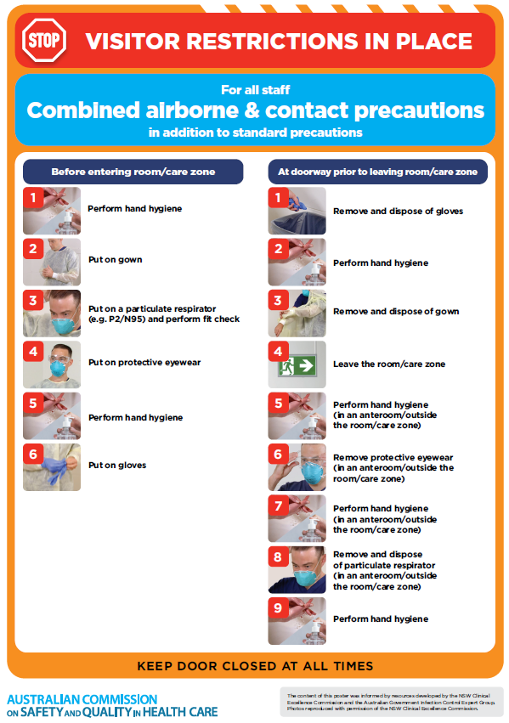](https://www.safetyandquality.gov.au/publications-and-resources/resource-library/poster-combined-airborne-and-contact-precautions)
* ***Environmental Cleaning and Infection Prevention and Control*** [www.safetyandquality.gov.au/environmental-cleaning](http://www.safetyandquality.gov.au/environmental-cleaning)
* ***COVID-19 infection prevention and control risk management – Guidance*** <https://www.safetyandquality.gov.au/publications-and-resources/resource-library/covid-19-infection-prevention-and-control-risk-management-guidance>
* ***Safe care for people with cognitive impairment during COVID-19***<https://www.safetyandquality.gov.au/our-work/cognitive-impairment/cognitive-impairment-and-covid-19>
* ***Stop COVID-19: Break the chain of infection*** posterhttps://www.safetyandquality.gov.au/publications-and-resources/resource-library/break-chain-infection-poster-a3  
  **[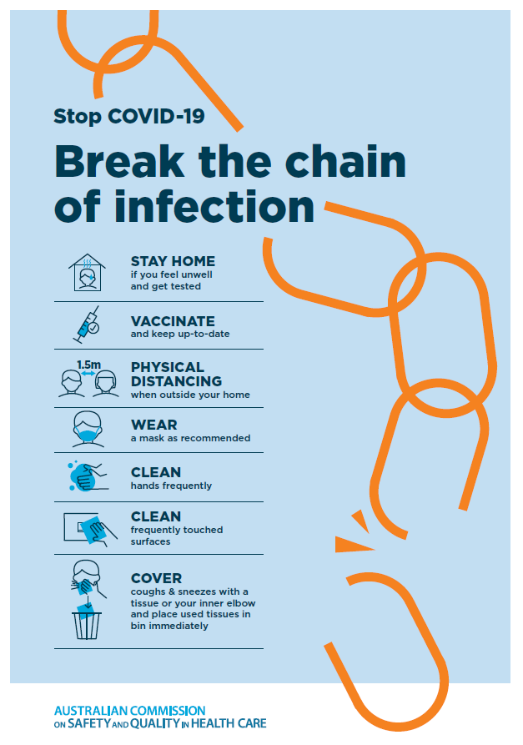](https://www.safetyandquality.gov.au/publications-and-resources/resource-library/break-chain-poster-a3https:/www.safetyandquality.gov.au/publications-and-resources/resource-library/break-chain-poster-a3)**
* ***COVID-19 and face masks – Information for consumers*** <https://www.safetyandquality.gov.au/publications-and-resources/resource-library/covid-19-and-face-masks-information-consumers>

[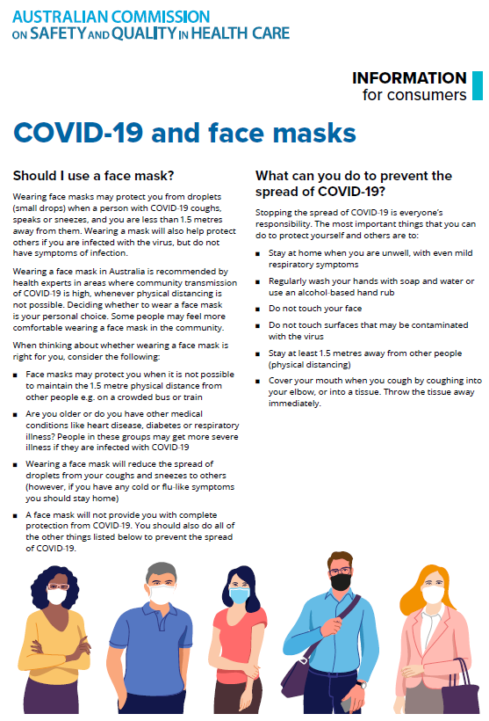](https://www.safetyandquality.gov.au/sites/default/files/2020-07/covid-19_and_face_masks_-_information_for_consumers.pdf)

*National Clinical Evidence Taskforce*

<https://clinicalevidence.net.au/>

The National Clinical Evidence Taskforce is a multi-disciplinary collaboration of 35 member organisations – Australia’s medical colleges and peak health organisations – who share a commitment to provide national evidence-based treatment guidelines for urgent and emerging diseases.

This alliance established the world’s first ‘living guidelines’ for the care of people with COVID-19 and MPX.

Funding has now been discontinued for the National Clinical Evidence Taskforce and the COVID-19 guidelines as of 30 June 2023.

These guidelines are no longer continually updated but will remain online until the guidance becomes inaccurate and/or no longer reflects the evidence or recommended practice.

**Disclaimer**

On the Radar is an information resource of the Australian Commission on Safety and Quality in Health Care. The Commission is not responsible for the content of, nor does it endorse, any articles or sites listed. The Commission accepts no liability for the information or advice provided by these external links. Links are provided on the basis that users make their own decisions about the accuracy, currency and reliability of the information contained therein. Any opinions expressed are not necessarily those of the Australian Commission on Safety and Quality in Health Care.