# Australian Commission on Safety and Quality logotypeOn the Radar

Issue 639

26 February 2024

*On the Radar* is a summary of some of the recent publications in the areas of safety and quality in health care. Inclusion in this document is not an endorsement or recommendation of any publication or provider. Access to particular documents may depend on whether they are Open Access or not, and/or your individual or institutional access to subscription sites/services. Material that may require subscription is included as it is considered relevant.

*On the Radar* is available online, via email or as a PDF or Word document from <https://www.safetyandquality.gov.au/newsroom/subscribe-news/radar>

If you would like to receive *On the Radar* via email, you can subscribe on our website <https://www.safetyandquality.gov.au/newsroom/subscribe-news>  
or by emailing us at H[Umail@safetyandquality.gov.auU](mailto:mail@safetyandquality.gov.au).  
You can also send feedback and comments to H[Umail@safetyandquality.gov.auU](mailto:mail@safetyandquality.gov.au).

For information about the Commission and its programs and publications, please visit <https://www.safetyandquality.gov.au>

w

**On the Radar**

Editor: Dr Niall Johnson [niall.johnson@safetyandquality.gov.au](mailto:niall.johnson@safetyandquality.gov.au)

Contributors: Niall Johnson

**Reports**

*Rethinking Health System Performance Assessment: A Renewed Framework*

OECD

Paris: OECD Publishing; 2024.

|  |  |
| --- | --- |
| DOI | <https://doi.org/https://doi.org/10.1787/107182c8-en> |
| Notes | The OECD has revised or renewed their framework for assessing health system performance. According to the OECD, ‘t incorporates new performance dimensions, notably people-centredness, resilience, and environmental sustainability, and places increased emphasis on addressing inequalities, including those related to gender. This framework expands on existing OECD efforts in these domains and integrates the most recent advancements in health system performance assessment.’  [Diagrammatic illustration of the renewed OECD Health System Performance Assessment Framework.](https://doi.org/https:/doi.org/10.1787/107182c8-en) |

**Journal articles**

*Effect of exercise for depression: systematic review and network meta-analysis of randomised controlled trials*

Noetel M, Sanders T, Gallardo-Gómez D, Taylor P, del Pozo Cruz B, van den Hoek D, et al

BMJ. 2024;384:e075847.

|  |  |
| --- | --- |
| DOI | <https://doi.org/10.1136/bmj-2023-075847> |
| Notes | Paper reporting on a systematic review and network meta-analysis of randomised controlled trials that sought to ‘identify the optimal dose and modality of exercise for treating major depressive disorder’. Based on 218 studies, the authors conclude ‘Exercise is an effective treatment for depression, with walking or jogging, yoga, and strength training more effective than other exercises, particularly when intense. Yoga and strength training were well tolerated compared with other treatments. Exercise appeared equally effective for people with and without comorbidities and with different baseline levels of depression.’ |

*Prevalence, contributing factors, and interventions to reduce medication errors in outpatient and ambulatory settings: a systematic review*

Naseralallah L, Stewart D, Price M, Paudyal V

International Journal of Clinical Pharmacy. 2023;45(6):1359-1377.

|  |  |
| --- | --- |
| DOI | <https://doi.org/10.1007/s11096-023-01626-5> |
| Notes | This review examined the ‘peer-reviewed literature on the prevalence, nature, contributory factors, and interventions to minimize medication errors in outpatient and ambulatory settings’. Focusing on 24 studies, the authors report that while the studies reported prevalence range was wide, ‘Medication errors (particularly prescribing errors and dosing errors) in outpatient settings are prevalent’. |

For information on the Commission’s work on medication safety, see <https://www.safetyandquality.gov.au/our-work/medication-safety>

*Australian Prescriber*

Volume 47, Issue 1, February 2024

|  |  |
| --- | --- |
| URL | <https://australianprescriber.tg.org.au/> |
| Notes | A new issue of *Australian Prescriber* has been published. Content in this issue of *Australian Prescriber* includes:   * Managing pre-existing **diabetes prior to and during pregnancy** (Leonie K Callaway, Fiona Britten) * Managing **hypercholesterolaemia** (Adam J Nelson, Stephen J Nicholls) * **Therapeutic inertia** (Tim Usherwood) * Diagnosis and management of **eosinophilic oesophagitis** (Varan Perananthan, Rebecca Burgell) * Severe liver injury following use of RAD-140, a **selective androgen receptor modulator**, for body building (Varan Perananthan, Jacob George) * **TGA Medicines Safety Update** and Australian Prescriber * **Morphine oral liquid** availability * TGA Medicines Safety Update summary: Use caution when prescribing **baclofen** off label * TGA Medicines Safety Update summary: New warnings of **romosozumab (Evenity)** cardiovascular risks * **New drugs**: Andexanet alfa for reversal of direct factor Xa inhibitor anticoagulant |

*Australian Journal of Primary Health*

|  |  |
| --- | --- |
| URL | <https://www.publish.csiro.au/py/#Latest> |
| Notes | The *Australian Journal of Primary Health* has moved to a continuous publication model. In the continuous publication model, once an article is ready for publication, it is immediately published online with final citation details (<https://www.publish.csiro.au/PY/Continuouspublication>).  The latest articles from *Australian Journal of Primary Health* include:   * Child health nurses’ perceptions of the **Family Community-based Assistance Resourcing and Education program** in contemporary practice: a qualitative study (Nicole Latham, Jeanine Young, Josephine Wilson, Michelle Gray and Kendall George) * ‘Can a relative override a patient’s Advance Care Directive?’: **end-of-life legal worries of general practitioners and nurses working in aged care** (Ben White, Rachel Feeney, Marcus Sellars, Penny Neller, P Yates and L Willmott * Exploring the feasibility of a **gambling harm screening model** in general practice and community service settings in Fairfield: a pilot study (Andrew Reid, Nick McGhie, Thi Huyen Linh Nguyen, Uday Yadav, Patricia Cullen, Leon Booth and Amy Bestman) * What do parents think about **child’s routine height and weight measures**? A qualitative study (Slavica Krstic, Sarah Dennis, Faye Southcombe and Elizabeth Denney-Wilson) * Exploring organisational readiness to implement a preventive intervention in Australian general practice for **overweight and obese patients**: key learnings from the HeLP-GP trial (Sharon Parker, An Tran, Shoko Saito, C McNamara, E Denney-Wilson, D Nutbeam, M F Harris and and on behalf of the Health e-Literacy for Prevention in General Practice (HeLP-GP) Trial Group) * An integrative review of **missed nursing care** and the general practice nurse (Eileen Willis, Claire Verrall, Susan McInnes and Elyce Pate) * Promoting effective **interprofessional collaborative practice in the primary care setting**: recommendations from Queensland physiotherapy private practitioners (Jack Seaton, Anne Jones, Catherine Johnston and Karen Francis) * **Leading primary care under the weight of COVID-19**: how leadership was enacted in six australian general practices during 2020 (Kathleen Wisbey, Riki Lane, Jennifer Neil, Jenny Advocat, Karyn Alexander, Benjamin F Crabtree, William L. Miller and Grant Russell) * **Healthy ageing** in remote Cape York: a co-designed Integrated Allied Health Service Model (Alice Cairns, Danielle Rodda, Frances Wymarra and K Bird) * Aboriginal Health Practitioners obtaining, possessing and administering fluoride varnish: self-determination driven regulation amendment for **integrated oral health care for Aboriginal children** (Rahila Ummer-Christian, Dallas Widdicombe, Anil Raichur and Danielle Couch) * A systematic search and narrative review of **Aboriginal and Torres Strait Islander women and men pelvic health care**: demonstrated need for improvement (Emma M Wise, Marilyn A Morgan, Emily D Biggs, Bronte H Ellis, Marissa C Joseph, Melanie L Say, Lea T Yanitsas, Jonathan C Bullen, Brooke R Conley, Ivan B Lin, Leo Ng and Darren J Beales) * Access to general practice for **preventive health care for people who experience severe mental illness** in Sydney, Australia: a qualitative study (Catherine Spooner, Peri O’Shea, Karen R Fisher, Ben Harris-Roxas, Jane Taggart, Patrick Bolton and Mark F Harris) * Building workforce capacity to **address substance use in primary health care**: preliminary results from a mixed-methods pilot program (Matthew W R Stevens, Rowena Ivers, Joanne Telenta and Robert L Ali) * Empowering our **First Nations workforce**: evaluation of a First Nations COVID-19 vaccination training program (Sean Cowley, Karina Baigrie, Katie Panaretto, Kelly Trudgen, Vanessa Clements, Oscar Whitehead and Rica Lacey) * Australian health professionals’ perspectives on **discussing sexual activity and intimacy** with people who have had a heart attack: a qualitative study (Claire Moran, Kara Lilly, Anthony Leo Walsh, R Foreman and J Taylor) * Quantitative analysis on **dental utilisation in culturally and linguistically diverse mothers** (Kanchan Marcus, Madhan Balasubramanian, Stephanie D. Short and Woosung Sohn) * Lessons from the Netherlands for Australia: cross-country comparison of trends in **antidepressant dispensing** 2013–2021 and contextual factors influencing prescribing (Katharine A Wallis, Pieter J S Dikken, Piumika Sooriyaarachchi, Arthur M Bohnen and Maria Donald) * The evaluation of the Plan–Do–Study–Act cycles for a healthcare **quality improvement intervention in primary care** (Deborah Manandi, Qiang Tu, Nashid Hafiz, Rebecca Raeside, Julie Redfern and Karice Hyun) * ‘A sense of self, empowerment and purposefulness’: professional **diversification and wellbeing in Australian general practitioners** (Jill Benson, Shaun Prentice, Penny Need, Michelle Pitot and Taryn Elliott) * The client and family experience of attending a **nurse-led clinic for chronic wounds** (Anusuya Dhar, Judith Needham, Michelle Gibb and E Coyne) * **Postpartum contraception** in Australia: opportunities for increasing access in the primary care setting (Rhea Singh and Jessica R Botfield) * **Reducing antibiotic prescribing** in general practice in Australia: a cluster randomised controlled trial of a multimodal intervention (Minyon L Avent, Lisa Hall, Mieke van Driel, Annette Dobson, Laura Deckx, Mahmoud Galal, Malene Plejdrup Hansen and Charles Gilks) * **GP perspectives on a** **psychiatry phone line** in Western Australia’s Great Southern region: implications for addressing rural GP workload (Beatriz Cuesta-Briand, D Rock, L Tayba, J Hoimes, H Ngo, M Taran and M Coleman) * The **impact of COVID-19 on community mental health**: lessons learned from Tasmania, Australia (Melissa Savaglio, R O’Donnell and H Skouteris) * **Communicating medical information with Aboriginal patients**: lessons learned from GPs and GP registrars in Aboriginal primary health care (Wissam Ghamrawi, Jill Benson and Emma Kennedy) * **E-prescription: views and acceptance** of general practitioners and pharmacists in Greater Sydney (Phyllis Lau, Minh Thuan Tran, Ricky Yong Kim, Alsayed Hashem Alrefae, Sangwoo Ryu and Jim Chyuan The) * Identification and nutritional management of **malnutrition and frailty in the community**: the process used to develop an Australian and New Zealand guide (Megan Rattray and Shelley Roberts) * **Capacity building for mental health services**: methodology and lessons learned from the Partners in Recovery initiative (Tania Shelby-James, Megan Rattray, Garry Raymond and Richard Reed) * Barriers and facilitators to adherence to Optimal Care Pathways for **diagnosis and treatment of cancer for Aboriginal and Torres Strait Islander people** (Rowena Ivers, Michelle Dickson, Kathleen Taylor, Trish Levett, Kyla Wynn, Janelle Trees, Emma Webster, G Garvey, J Cunningham, L Whop and A Diaz) * ‘Being in a place where it matters’: **GPs who do and do not work in Aboriginal Health Services** (Shaun Prentice, Alexandra Barrett, Jill Benson and Taryn Elliott) * The influence of care continuity and disclosure of sexual orientation in general practice on **lesbian, bi+ and queer cisgender women’s engagement with mental health services** (Pip Buckingham, Adam Bourne, Ruth McNair, Adam O. Hill, Anthony Lyons, Marina Carman and Natalie Amos) |

*BMJ Quality & Safety*

Volume 33, Issue 3, March 2024

|  |  |
| --- | --- |
| URL | <https://qualitysafety.bmj.com/content/33/3> |
| Notes | A new issue of *BMJ Quality & Safety* has been published. Many of the papers in this issue have been referred to in previous editions of *On the Radar* (when they were released online). Articles in this issue of *BMJ Quality & Safety* include:   * Editorial: Our mission and how we hope to move the field forward: statement from the **BMJ Quality & Safety senior editorial team** 2023 (John Browne, Bryony Dean Franklin, Eric J Thomas, Perla J Marang-van de Mheen) * Editorial: Changing the **patient safety mindset**: can safety cases help? (Mark Sujan, Ibrahim Habli) * Editorial: Using patient and carer perspectives to improve **medication safety at transitions of care** (Sara Garfield, Mike Etkind, Bryony Dean Franklin) * Editorial: **Identifying patients with additional needs** isn’t enough to improve care: harnessing the benefits and avoiding the pitfalls of classification (Natalie Armstrong, Elizabeth Sutton, Sarah Chew, Carolyn Tarrant) * What can **Safety Cases** offer for patient safety? A multisite case study (Elisa Giulia Liberati, Graham P Martin, Guillaume Lamé, Justin Waring, Carolyn Tarrant, Janet Willars, Mary Dixon-Woods) * Talking about falls: a qualitative exploration of spoken communication of patients’ fall risks in hospitals and implications for multifactorial approaches to **fall prevention** (Lynn McVey, Natasha Alvarado, Frances Healey, Jane Montague, Chris Todd, Hadar Zaman, Dawn Dowding, Alison Lynch, Basma Issa, Rebecca Randell) * Identifying and mapping measures of **medication safety during transfer of care** in a digital era: a scoping literature review (Catherine Leon, Helen Hogan, Yogini H Jani) * Systematic review of **clinical debriefing tools**: attributes and evidence for use (Emma Claire Phillips, Samantha Eve Smith, Victoria Tallentire, Sheena Blair) * **Choosing Wisely and the climate crisis**: a role for clinicians (Karen B Born, Wendy Levinson, Emma Vaux) * Is targeting healthcare’s carbon footprint really the best we can do to help address the **climate crisis**? (Kaveh G Shojania) |

*Journal of Patient Safety*

Volume 20, Number 2, March 2024

|  |  |
| --- | --- |
| URL | <https://journals.lww.com/journalpatientsafety/toc/2024/03000> |
| Notes | A new issue of the *Journal of Patient Safety* has been published. Articles in this issue of the *Journal of Patient Safety* include:   * **Patient Safety in Nursing Homes** From an Ecological Perspective: An Integrated Review (Deulle Min, Seungmi Park, Suhee Kim, Hye Ok Park) * **Dentists’ Attitudes to the Preprocedural Safety Checklist** “Time-Out” in Saudi Arabia (Davide Rocchettta, Syed Sirajul Hassan, Jenny Gray) * Nomogram for Predicting the Risk of Complications in Hospitalized Children With **Peripheral Intravenous Catheters** (Xin Zhang, Shuhui Xu, Jing Sun, Ying Yang, Meihua Piao, Shih-Yu Lee) * Examining the Relationship Between Nurses’ **Fear of COVID-19 and Nursing Care Behavior** (Burcu Ceylan, Gul Gunes Aktan, Simge C Palaz) * The Influence of Preoperative Waiting Time on Anxiety and Pain Levels in **Outpatient Surgery for Breast Diseases** (Bei Wu, Han-Jin Wang, Xiu-Pin Yang, Zhen-Hua Zhong) * Why Simulation Matters: A Systematic Review on **Medical Errors Occurring During Simulated Health Care** (Leshya Bokka, F Ciuffo, T C Clapper) * Enhancing **Pressure Injury Surveillance** Using Natural Language Processing (Carly E Milliren, Al Ozonoff, Kerri A Fournier, Jennifer Welcher, Assaf Landschaft, Amir A Kimia) * Systematic Review of **Morbidity and Mortality Meeting Standardization**: Does It Lead to Improved Professional Development, System Improvements, Clinician Engagement, and Enhanced Patient Safety Culture? (Emily J Steel, Monika Janda, Shayaun Jamali, Michelle Winning, Bryan Dai, Kylie Sellwood) * The Association of Organizational, Environmental, and Staffing Characteristics of **Residential Care Facilities** and the Risk Rating of Statutory Notifications: A Cross-Sectional Study in Ireland (Paul Dunbar, Niall McGrane, Laura M Keyes) * Implementation of **Hospital Mortality Reviews**: A Systematic Review (Moritz Sebastian Schönfeld, Martin Härter, Ann Sophie Schröder, Katrin Kokartis, Hans-Jürgen Bartz, Levente Kriston) * A Novel Role to Manage **Capacity and Flow** in Hospital Medicine (Gabrielle Kis Bromberg, Marjory A Bravard, Kimiyoshi J Kobayashi, Amber Moore) |

*Pediatric Quality & Safety*

Volume 9, Number 1, January/February 2024

|  |  |
| --- | --- |
| URL | <https://journals.lww.com/pqs/toc/2024/01000> |
| Notes | A new issue of *Pediatric Quality & Safety* has been published.This issue of *Pediatric Quality & Safety* includes:   * **Antimicrobial Stewardship** and Improved Antibiotic Utilization in the Pediatric Cardiac Intensive Care Unit (Margot M Hillyer, Preeti Jaggi, Nikhil K Chanani, Alfred J Fernandez, Hania Zaki, Michael P Fundora) * Impact of a Clinical Decision Support Alert on **Informed Consent Documentation** in the Neonatal Intensive Care Unit (Emily Sangillo, Neena Jube-Desai, Dina El-Metwally, Colleen Hughes Driscoll) * Impact of a **Bronchiolitis Clinical Pathway** on Management Decisions by Preferred Language (Robert H Rosen, Michael C Monuteaux, Anne M Stack, Kenneth A Michelson, Andrew M Fine) * Implementation of an **Anterior Mediastinal Mass Pathway** to Improve Time to Biopsy and Multidisciplinary Communication (Rachel E Gahagen, William C Gaylord, M D D Jackson, A E McCallister, R Lutfi, J A Belsky) * Improving **Anticoagulation Care for Pediatric Oncology Patients**: A Quality Improvement Initiative (Vilmarie Rodriguez, Brockton S Mitchell, Joseph Stanek, K Vasko, J Giver, K Monda, J Canini, A A Dunn, R Kumar) * A Quality Improvement Initiative to Transform **Seasonal Immunization Processes** Using Learning from the Coronavirus 2019 Pandemic (Eric D Robinette, Pamela M Nelly, Laurie J Engler, Michael T Bigham) |

*BMJ Quality & Safety* online first articles

|  |  |
| --- | --- |
| URL | <https://qualitysafety.bmj.com/content/early/recent> |
| Notes | *BMJ Quality &Safety* has published a number of ‘online first’ articles, including:   * Role of knowledge and reasoning processes as predictors of resident physicians’ susceptibility to **anchoring bias in diagnostic reasoning**: a randomised controlled experiment (Sílvia Mamede, Adrienne Zandbergen, Marco Antonio de Carvalho-Filho, Goda Choi, Marco Goeijenbier, Joost van Ginkel, Laura Zwaan, Fred Paas, Henk G Schmidt) |

**Online resources**

***Australian Concussion Guidelines for Youth and Community Sport***

<https://www.concussioninsport.gov.au/>

<https://www.concussioninsport.gov.au/__data/assets/pdf_file/0003/1133994/37382_Concussion-Guidelines-for-community-and-youth-FA-acc.pdf>

A collaboration between the Australian Institute of Sport, Australasian College of Sport & Exercise Physicians, Sports Medicine Australia and Australian Physiotherapy Association.

*“In in doubt, sit them out.”*

***[UK] NICE Guidelines and Quality Standards***

<https://www.nice.org.uk/guidance>

The UK’s National Institute for Health and Care Excellence (NICE) has published new (or updated) guidelines and quality standards. The latest reviews or updates include:

* NICE Guideline NG33 ***Tuberculosis*** <https://www.nice.org.uk/guidance/ng33>

**COVID-19 resources**

https://www.safetyandquality.gov.au/covid-19

The Australian Commission on Safety and Quality in Health Care has developed a number of resources to assist healthcare organisations, facilities and clinicians. These and other material on COVID-19 are available at <https://www.safetyandquality.gov.au/covid-19>

These resources include:

* ***OVID-19 infection prevention and control risk management*** This primer provides an overview of three widely used tools for investigating and responding to patient safety events and near misses. Tools covered in this primer include incident reporting systems, Root Cause Analysis (RCA), and Failure Modes and Effects Analysis (FMEA).   
  <https://www.safetyandquality.gov.au/publications-and-resources/resource-library/covid-19-infection-prevention-and-control-risk-management-guidance>
* ***Poster – Combined contact and droplet precautions*** <https://www.safetyandquality.gov.au/publications-and-resources/resource-library/infection-prevention-and-control-poster-combined-contact-and-droplet-precautions>  
  [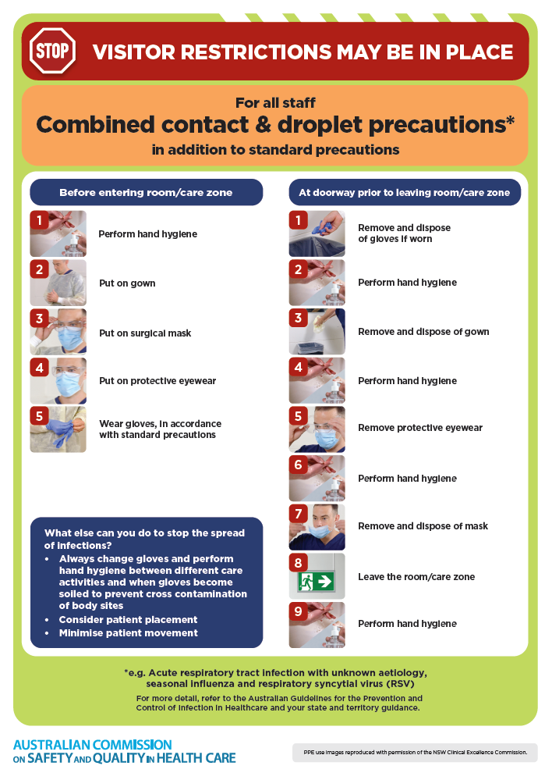](https://www.safetyandquality.gov.au/publications-and-resources/resource-library/infection-prevention-and-control-poster-combined-contact-and-droplet-precautions)
* ***Poster – Combined airborne and contact precautions*** <https://www.safetyandquality.gov.au/publications-and-resources/resource-library/poster-combined-airborne-and-contact-precautions>   
  [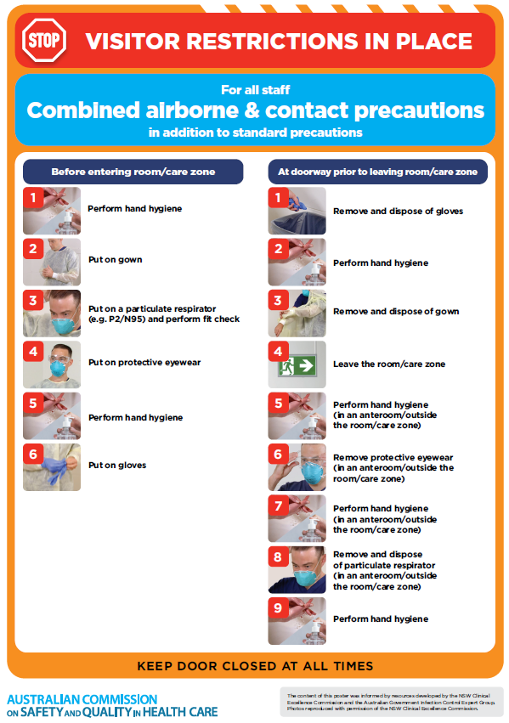](https://www.safetyandquality.gov.au/publications-and-resources/resource-library/poster-combined-airborne-and-contact-precautions)
* ***Environmental Cleaning and Infection Prevention and Control*** [www.safetyandquality.gov.au/environmental-cleaning](http://www.safetyandquality.gov.au/environmental-cleaning)
* ***COVID-19 infection prevention and control risk management – Guidance*** <https://www.safetyandquality.gov.au/publications-and-resources/resource-library/covid-19-infection-prevention-and-control-risk-management-guidance>
* ***Safe care for people with cognitive impairment during COVID-19***<https://www.safetyandquality.gov.au/our-work/cognitive-impairment/cognitive-impairment-and-covid-19>
* ***Stop COVID-19: Break the chain of infection*** posterhttps://www.safetyandquality.gov.au/publications-and-resources/resource-library/break-chain-infection-poster-a3  
  **[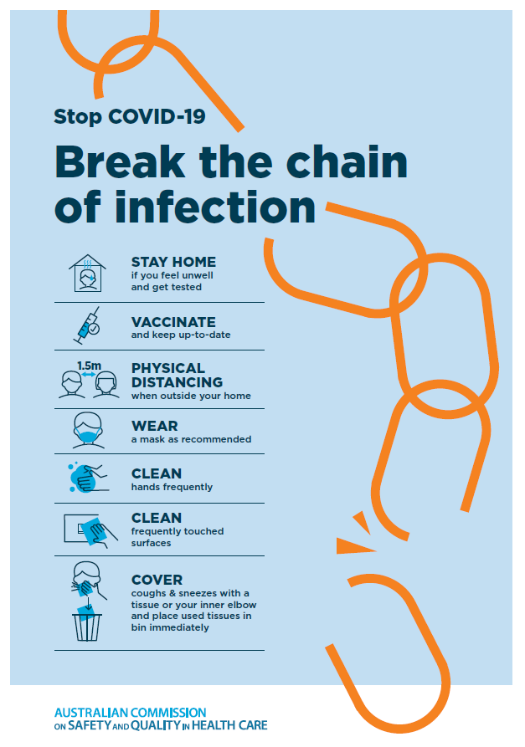](https://www.safetyandquality.gov.au/publications-and-resources/resource-library/break-chain-poster-a3https:/www.safetyandquality.gov.au/publications-and-resources/resource-library/break-chain-poster-a3)**
* ***COVID-19 and face masks – Information for consumers*** <https://www.safetyandquality.gov.au/publications-and-resources/resource-library/covid-19-and-face-masks-information-consumers>

[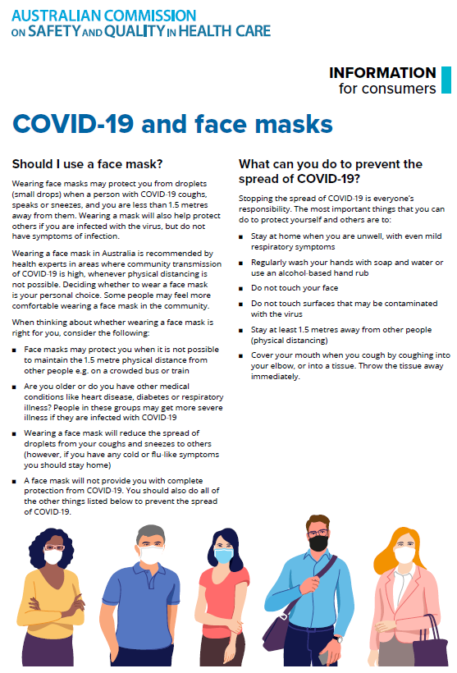](https://www.safetyandquality.gov.au/sites/default/files/2020-07/covid-19_and_face_masks_-_information_for_consumers.pdf)

*National Clinical Evidence Taskforce*

<https://clinicalevidence.net.au/>

The National Clinical Evidence Taskforce is a multi-disciplinary collaboration of 35 member organisations – Australia’s medical colleges and peak health organisations – who share a commitment to provide national evidence-based treatment guidelines for urgent and emerging diseases.

This alliance established the world’s first ‘living guidelines’ for the care of people with COVID-19 and MPX.

Funding has now been discontinued for the National Clinical Evidence Taskforce and the COVID-19 guidelines as of 30 June 2023.

These guidelines are no longer continually updated but will remain online until the guidance becomes inaccurate and/or no longer reflects the evidence or recommended practice.

**Disclaimer**

On the Radar is an information resource of the Australian Commission on Safety and Quality in Health Care. The Commission is not responsible for the content of, nor does it endorse, any articles or sites listed. The Commission accepts no liability for the information or advice provided by these external links. Links are provided on the basis that users make their own decisions about the accuracy, currency and reliability of the information contained therein. Any opinions expressed are not necessarily those of the Australian Commission on Safety and Quality in Health Care.