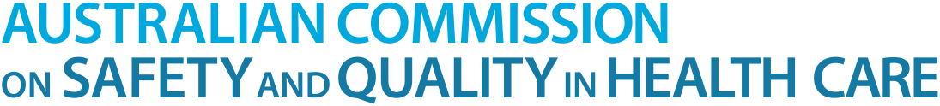 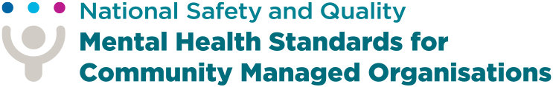

SCAN ME



For more information about the National Safety and Quality Mental Health Standards for Community Managed Organisations and what they mean for you.

# WHAT HAVING STANDARDS FEELS LIKE TO ME

## WELCOME

At this service, I feel welcome, comfortable, safe, and listened to.

## RECOVERY PLANNING

I am respected by staff and peer workers. I have options and choice over my recovery plan.

## PARTNERSHIP

If something is not working for me, I am listened to. I am also invited to help improve services for myself and others.

## ACCREDITATION

Assessors will ask me about my experience. They will listen, help me feel safe. The feedback I give is kept private and only used for improving services.

## ASSESSMENT REPORT

The service will get an assessment report on what they are doing well and what they could do better.

## IMPROVEMENT

The service will keep making improvements to provide better services for me and my loved ones.

 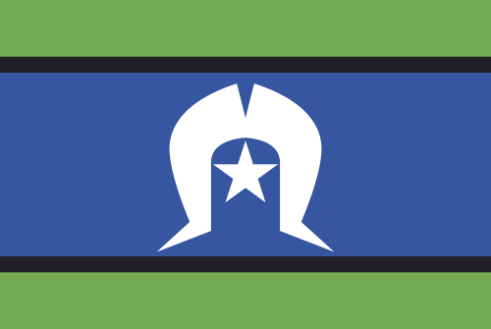 

This document has been informed by the valued perspectives of consumers, families, carers and kin. We acknowledge the Traditional Owners and Custodians of Country throughout Australia, and their continuing connection to land, waters and community. We pay our respects to them and their cultures, and to elders both past and present.