DECISION AID

for consumers

Sore throat:   
Should I take antibiotics?

## What is this decision aid for?

* This decision aid can help you decide whether to use antibiotics when **you or your child** has a sore throat.
* It is designed to be used with your doctor to help you make a **shared decision** about what is best for you or your child.

## What causes a sore throat?

It can be caused by a viral or bacterial infection. It is hard for your doctor to tell which it is.

## How long does a sore throat last?

Symptoms will usually get better in **2–7 days**, without taking antibiotics.

## What are the treatment options?

There are two options that you can discuss with your doctor:

1. **Not taking antibiotics**. This means letting the infection get better by itself.
2. **Taking antibiotics**.

Symptoms, such as fever, can be treated with over-the-counter medicines which can be used with either option. See below for some examples.

## What are the likely benefits and harms of each option?

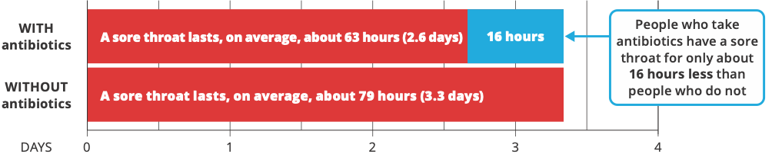

These figures show what is likely to happen to people with sore throats who **do not** take antibiotics and those who **do**. Each circle is one person. We cannot predict who will get better sooner or who will have problems.

## Possible benefits

100 people who DO NOT take antibiotics: 34 will be better (no sore throat) at 3 days; 66 not better.  100 people who DO take antibiotics: 54 will be better (no sore throat) at 3 days; 46 not better. 

With antibiotics, **20 more people** will be better by 3 days.

Without taking antibiotics, **most** people will be better after about **4–7 days** anyway.

## Possible harms

100 people who DO NOT take antibiotics: 20 will have problems such as vomiting, diarrhoea or rash; 80 no problems.100 people who DO take antibiotics: 27 will have problems such as vomiting, diarrhoea or rash; 73 no problems.

With antibiotics, **7 more people** will have problems such as vomiting, diarrhoea or rash. Other **antibiotic downsides** are:

* The **cost** of buying them
* **Remembering** to take them
* The risk of **antibiotic resistance** (see below).

## Where do these estimates of benefits and harms come from?

* They are from the most up-to-date medical evidence of benefits and harms about what works best.1-3 This is a review of 29 studies, and over 15,000 people, that looked at antibiotic use in people with sore throat.
* The quality of this research evidence is ranked as moderate. This means that further research may change these estimates.

## Why might antibiotics be used?

There are a few special reasons why your doctor might suggest antibiotics. This might be if the sore throat is caused by a dangerous, but rare, type of bacterium, or in people who are at a high risk of complications, such as Aboriginal and Torres Strait Islander peoples.

## What is antibiotic resistance?

* Using antibiotics means the bacteria, including the healthy ones in your body, can develop resistance to the antibiotic.
* This means that **antibiotics may not work if you or your child needs them in the future** to treat a bacterial infection.
* A person who has recently used antibiotics is more likely to have resistant bacteria in their body.

## Are there other things I can do to manage a sore throat?

* Pain and fever are best treated with over-the-counter **paracetamol or ibuprofen**. Do not give more than the maximum recommended dose. Read the dose information on the packet.
* Aspirin should NOT be used with children who are younger than 16 years.
* Gargle with warm salty water.
* Suck an ice cube or throat lozenge.

## When should you see a doctor and get further help?

If the person with the sore throat has any of these signs:

* Very drowsy
* Fast, noisy, or difficult breathing, or shortness of breath
* Cold or discoloured hands and/or feet with a warm body
* Pain in the arms and/or legs
* Unusual skin colour (pale or blue) around the lips
* A rash that does not fade when the skin is pressed.

## Questions to consider when talking with your doctor

* Do I need antibiotics?
* What happens if I do not take antibiotics?
* Do I know enough about the benefits and harms of:
  + taking antibiotics?
  + not taking antibiotics?
* Am I clear about which benefits and harms matter most to me?
* Do I have enough information and support to decide?

## ****References****

1. Spinks A, Glasziou P, & Del Mar C. Antibiotics for treatment of sore throat in children and adults. Cochrane Database of Systematic Reviews 2021. 12: CD000023. DOI: 10.1002/14651858.CD000023.pub5. [www.cochranelibrary.com](http://www.cochranelibrary.com)
2. Spinks A, Glasziou P, & Del Mar C. Antibiotics for sore throat. Cochrane Database of Systematic Reviews, 2013. 11: CD000023.
3. Gillies M, Ranakusuma A, Hoffmann T, Thorning S, McGuire T, Glasziou P, & Del Mar C. Common harms from amoxicillin: a systematic review and meta-analysis of randomized placebo-controlled trials for any indication. Canadian Medical Association Journal, 2015, 187; doi:10.1503/cmaj.140848.

The information in this decision aid is provided for general information only. It is not intended as medical advice and should not be relied upon as a substitute for consultations with a qualified health professional who can determine you or your child’s individual medical needs.

Last reviewed: June 2023. Update due: July 2025. Decision Aids funded by the Australian Commission on Safety and Quality in Health Care and developed by Professor Tammy Hoffmann, Professor Chris Del Mar, and Mr Peter Coxeter – Institute for Evidence-Based Healthcare, Bond University.

[**safetyandquality.gov.au**](http://www.safetyandquality.gov.au)

Creative Commons Licence© Australian Commission on   
Safety and­­ ­Quality in Health Care 2023