# Australian Commission on Safety and Quality logotypeOn the Radar

Issue 640

4 March 2024

*On the Radar* is a summary of some of the recent publications in the areas of safety and quality in health care. Inclusion in this document is not an endorsement or recommendation of any publication or provider. Access to particular documents may depend on whether they are Open Access or not, and/or your individual or institutional access to subscription sites/services. Material that may require subscription is included as it is considered relevant.

*On the Radar* is available online, via email or as a PDF or Word document from <https://www.safetyandquality.gov.au/newsroom/subscribe-news/radar>

If you would like to receive *On the Radar* via email, you can subscribe on our website <https://www.safetyandquality.gov.au/newsroom/subscribe-news>  
or by emailing us at H[Umail@safetyandquality.gov.auU](mailto:mail@safetyandquality.gov.au).  
You can also send feedback and comments to H[Umail@safetyandquality.gov.auU](mailto:mail@safetyandquality.gov.au).

For information about the Commission and its programs and publications, please visit <https://www.safetyandquality.gov.au>

**On the Radar**

Editor: Dr Niall Johnson [niall.johnson@safetyandquality.gov.au](mailto:niall.johnson@safetyandquality.gov.au)

Contributors: Niall Johnson

**Books**

*Statistical Process Control*

Elements of Improving Quality and Safety in Healthcare

Mohammed AM

Cambridge: Cambridge University Press; 2024

|  |  |
| --- | --- |
| DOI | <https://doi.org/10.1017/9781009326834> |
| Notes | This is the latest release in the Elements of Improving Quality and Safety in Healthcare series from The Healthcare Improvement Studies Institute (the THIS Institute) in Cambridge. This volume examines the use of statistical process control in health care. The abstract notes that ‘Using case studies, this Element shows that statistical process control methodology is widely used in healthcare because it offers an intuitive, practical, and robust approach to supporting efforts to monitor and improve healthcare.’ The author examines various approaches to analysing and visualising statistical data, including run charts, control charts, CUSUM charts, funnel plots, etc. with examples of uses of each. |

**Journal articles**

*Physician and nurse well-being, patient safety and recommendations for interventions: cross-sectional survey in hospitals in six European countries*

Aiken LH, Sermeus W, McKee M, Lasater KB, Sloane D, Pogue CA, et al.

BMJ Open. 2024;14(2):e079931.

|  |  |
| --- | --- |
| DOI | <https://doi.org/10.1136/bmjopen-2023-079931> |
| Notes | Report on a study that sought to ‘determine the well-being of physicians and nurses in hospital practice’ and then to ‘identify interventions that hold promise for reducing adverse clinician outcomes and improving patient safety’.  This study surveyed 2187 physicians and 6643 nurses practicing in 64 acute general hospitals in six European countries. The authors found that ‘Burnout, mental health morbidities, job dissatisfaction and concerns about patient safety and care quality are prevalent among European hospital physicians and nurses.’ The authors also concluded that ‘Interventions to improve hospital work environments and staffing are more important to clinicians than mental health interventions to improve personal resilience.’ |

*Exploring the Role of Guidelines in Contributing to Medication Errors: A Descriptive Analysis of National Patient Safety Incident Data*

Jones MD, Liu S, Powell F, Samsor A, Ting FCR, Veliotis N, et al

Drug Safety. 2024.

|  |  |
| --- | --- |
| DOI | <https://doi.org/10.1007/s40264-024-01396-7> |
| Notes | Guidelines are often developed in order to standardise practices. However, as this study reveals, this is not always achieved. The study sought to identify guideline-related medication errors reported to the National Reporting and Learning System (NRLS) for England and Wales and then ‘describe types of error, stages of medication use, guidelines, drugs, specialties and clinical locations most commonly associated with such errors’. Using 28,217 reports, the authors found issues around ‘finding guidelines (n = 300 reports), finding information within guidelines (n = 166) and using information (n = 176). Discrepancies were most frequently identified for guidelines produced by a local organisation (n = 405), and most occurred during prescribing (n = 277) or medication administration (n = 241).’ |

For information on the Commission’s work on medication safety, see <https://www.safetyandquality.gov.au/our-work/medication-safety>

*The Joint Commission Journal on Quality and Patient Safety*

Volume 50, Issue 3, March 2024

|  |  |
| --- | --- |
| URL | <https://www.sciencedirect.com/journal/the-joint-commission-journal-on-quality-and-patient-safety/vol/50/issue/3> |
| Notes | A new issue of *The Joint Commission Journal on Quality and Patient Safety* has been published. Articles in this issue of *The Joint Commission Journal on Quality and Patient Safety* include:   * Editorial: Measuring **Healthcare Workplace Violence** in Real Time: Measuring Healthcare Workplace Violence (James P Phillips) * The **Aggressive Incidents in Medical Settings (AIMS) Study**: Advancing Measurement to Promote Prevention of Workplace Violence (Joanne DeSanto Iennaco, Elizabeth Molle, Mary Allegra, David Depukat, Janet Parkosewich) * **Low Rate of Completion of Recommended Tests and Referrals** in an Academic Primary Care Practice with Resident Trainees (Maelys J Amat, Timothy S Anderson, Umber Shafiq, Scot B Sternberg, ... Russell S. Phillips) * Internal Medicine Virtual Specialist Assessment Program Reduces **Emergency Department Transfers from Long-Term Care** (Amanda Mac, Nazia Sharfuddin, Shaan Chugh, Alison Freeland, ... Tony Campbell) * Contextual Factors Influencing the Implementation of a Multifaceted Intervention to Improve **Teamwork and Quality for Hospitalized Patients**: A Multisite Qualitative Comparative Case Study (Iva A. Terwilliger, Julie K. Johnson, Milisa Manojlovich, Gopi J. Astik, ... Kevin J. O'Leary) * Creating a Statewide Assessment and Support Service to Prevent **Infections in Patients Receiving Hemodialysis** (Chelsea M Ludington, Renee E Brum, Denise I Parr) * Improving Supervisor Confidence in Responding to **Distressed Health Care Employees** (Gregory P Couser, Allyssa M Stevens, Heidi D Arndt, Jody L Nation, ... Craig N. Sawchuk * A **Combined Assessment Tool of Teamwork, Communication, and Workload** in Hospital Procedural Units (Bradley W Weaver, David J Murphy) * **Digital Stockpiling**: An Innovative Strategy for Preparedness and Medical Supply Chain Resilience (Beth Ripley, Susan R. Kirsh, Kenneth W. Kizer) |

*Health Policy*

Volume 20, Number 2, March 2024

|  |  |
| --- | --- |
| URL | <https://www.sciencedirect.com/journal/health-policy/vol/141/> |
| Notes | A new issue of *Health Policy* has been published. Articles in this issue of *Health Policy* include:   * **Vaccine nationalism** is not unethical from a political ethics perspective: Learning from the global COVID-19 vaccine distribution failure (Qi Shao) * Theories, models and frameworks for **health systems integration**. A scoping review (Celia Piquer-Martinez, Amaia Urionagüena, Shalom I Benrimoj, Begoña Calvo, Sarah Dineen-Griffin, Victoria Garcia-Cardenas, Fernando Fernandez-Llimos, Fernando Martinez-Martinez, Miguel Angel Gastelurrutia) * Financial incentives for **integrated care**: A scoping review and lessons for evidence-based design (Dimitar Yordanov, Anne Sophie Oxholm, Thim Prætorius, Søren Rud Kristensen) * The end of an era? **Activity-based funding based on diagnosis-related groups**: A review of payment reforms in the inpatient sector in 10 high-income countries (Ricarda Milstein, Jonas Schreyögg) * An international comparative policy analysis of **opioid use disorder treatment in primary care** across nine high-income jurisdictions (Kellia Chiu, Saloni Pandya, Manu Sharma, Ashleigh Hooimeyer, Alexandra de Souza, Abhimanyu Sud) * Financing **COVID-19-related health care costs** in the Dutch competitive health system during 2020 and 2021: Overall experiences and policy recommendations for improving health system resilience (Frederik T Schut, Frédérique M.E. Franken, Stéphanie A. van der Geest, Marco Varkevisser) * How did European countries set **health priorities in response to the COVID-19** threat? A comparative document analysis of 24 pandemic preparedness plans across the EURO region (Iestyn Williams, Lydia Kapiriri, Claudia-Marcela Vélez, Bernardo Aguilera, Marion Danis, Beverley Essue, Susan Goold, Mariam Noorulhuda, Elysee Nouvet, Donya Razavi, Lars Sandman) * A global comparative analysis of the inclusion of **priority setting in national COVID-19 pandemic plans**: A reflection on the methods and the accessibility of the plans (Lydia Kapiriri, Claudia-Marcela Vélez, Bernardo Aguilera, Beverley M. Essue, Elysee Nouvet, Razavi s Donya, Williams Ieystn, Danis Marion, Goold Susan, Julia Abelson, Kiwanuka Suzanne) * The role of **health and health systems in promoting social capital, political participation and peace**: A narrative review (Giacomo Davide De Luca, Xi Lin) |

*BMJ Quality & Safety* online first articles

|  |  |
| --- | --- |
| URL | <https://qualitysafety.bmj.com/content/early/recent> |
| Notes | *BMJ Quality &Safety* has published a number of ‘online first’ articles, including:   * Between-**hospital variation in indicators of quality** of care: a systematic review (Margrietha van der Linde, Nèwel Salet, Nikki van Leeuwen, Hester F Lingsma, Frank Eijkenaar) * Implementation of an **enhanced recovery after surgery protocol** for colorectal cancer in a regional hospital network supported by audit and feedback: a stepped wedge, cluster randomised trial (Eva Pagano, Luca Pellegrino, Manuela Robella, Anna Castiglione, Francesco Brunetti, Lisa Giacometti, Monica Rolfo, Alessio Rizzo, Sarah Palmisano, Maurizio Meineri, Ilaria Bachini, Mario Morino, Marco Ettore Allaix, Alfredo Mellano, Paolo Massucco, Paola Bellomo, Roberto Polastri, Giovannino Ciccone, Felice Borghi ERAS-colorectal Piemonte group) |

**Online resources**

***[UK] NIHR Evidence***

https://evidence.nihr.ac.uk/

The UK’s National Institute for Health Research (NIHR) has posted new evidence alerts on its site. Evidence alerts are short, accessible summaries of health and care research which is funded or supported by NIHR. This is research which could influence practice and each Alert has a message for people commissioning, providing or receiving care. The latest alerts include:

* What influences **young people’s food choices**?
* Blog: Housing support services in hospitals may speed up **discharge**
* Podcast: How to improve **leadership in surgery**
* Weights, resistance bands and rest days are best for **tendinopathy**
* Even short periods of **diabetes remission** are linked to lower risk of heart attack and stroke
* How common are side-effects of treatment to prevent **gout** flares when starting allopurinol?
* **Alcohol dependence**: telephone support plus financial incentives helped people take acamprosate
* Blog: How can we help older people experiencing **memory problems and homelessness**?
* **Women with cancer in one breast** who opt to have both removed report satisfaction with their decision.

The NIHR has also produced a new Collection ***How to reduce antibiotic use in primary care*** <https://evidence.nihr.ac.uk/collection/how-to-reduce-antibiotic-use-in-primary-care/>

***[USA] AHRQ Perspectives on Safety***

<https://psnet.ahrq.gov/psnet-collection/perspectives>

The US Agency for Healthcare Research and Quality (AHRQ) publishes occasional Perspectives on Safety essays. Recent essays include:

* *Revising TeamSTEPPS: The Evolution of* ***Patient Safety Teamwork Training***<https://psnet.ahrq.gov/perspective/revising-teamstepps-evolution-patient-safety-teamwork-training>

**COVID-19 resources**

https://www.safetyandquality.gov.au/covid-19

The Australian Commission on Safety and Quality in Health Care has developed a number of resources to assist healthcare organisations, facilities and clinicians. These and other material on COVID-19 are available at <https://www.safetyandquality.gov.au/covid-19>

These resources include:

* ***OVID-19 infection prevention and control risk management*** This primer provides an overview of three widely used tools for investigating and responding to patient safety events and near misses. Tools covered in this primer include incident reporting systems, Root Cause Analysis (RCA), and Failure Modes and Effects Analysis (FMEA).   
  <https://www.safetyandquality.gov.au/publications-and-resources/resource-library/covid-19-infection-prevention-and-control-risk-management-guidance>
* ***Poster – Combined contact and droplet precautions*** <https://www.safetyandquality.gov.au/publications-and-resources/resource-library/infection-prevention-and-control-poster-combined-contact-and-droplet-precautions>  
  [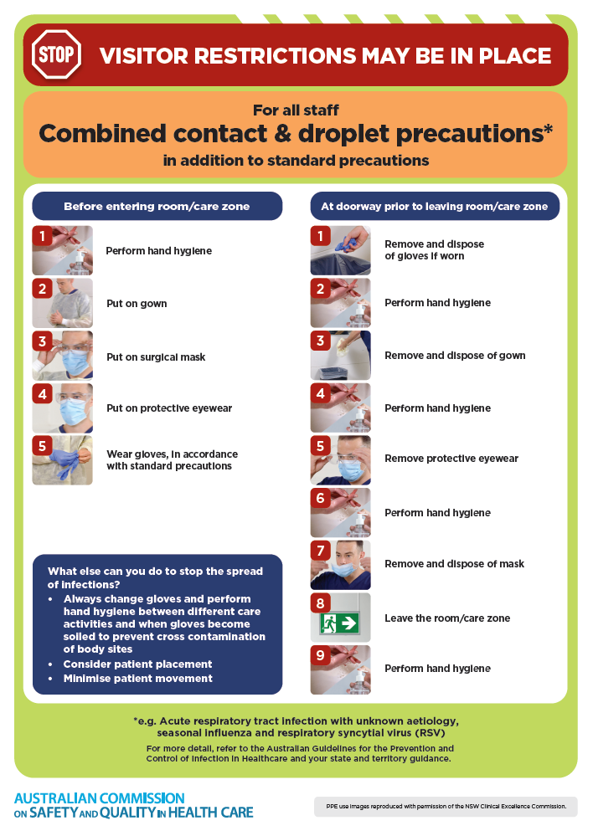](https://www.safetyandquality.gov.au/publications-and-resources/resource-library/infection-prevention-and-control-poster-combined-contact-and-droplet-precautions)
* ***Poster – Combined airborne and contact precautions*** <https://www.safetyandquality.gov.au/publications-and-resources/resource-library/poster-combined-airborne-and-contact-precautions>   
  [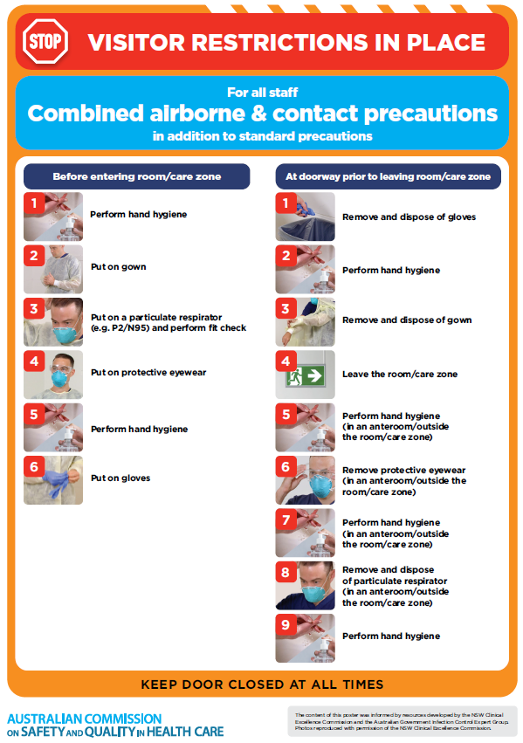](https://www.safetyandquality.gov.au/publications-and-resources/resource-library/poster-combined-airborne-and-contact-precautions)
* ***Environmental Cleaning and Infection Prevention and Control*** [www.safetyandquality.gov.au/environmental-cleaning](http://www.safetyandquality.gov.au/environmental-cleaning)
* ***COVID-19 infection prevention and control risk management – Guidance*** <https://www.safetyandquality.gov.au/publications-and-resources/resource-library/covid-19-infection-prevention-and-control-risk-management-guidance>
* ***Safe care for people with cognitive impairment during COVID-19***<https://www.safetyandquality.gov.au/our-work/cognitive-impairment/cognitive-impairment-and-covid-19>
* ***Stop COVID-19: Break the chain of infection*** posterhttps://www.safetyandquality.gov.au/publications-and-resources/resource-library/break-chain-infection-poster-a3  
  **[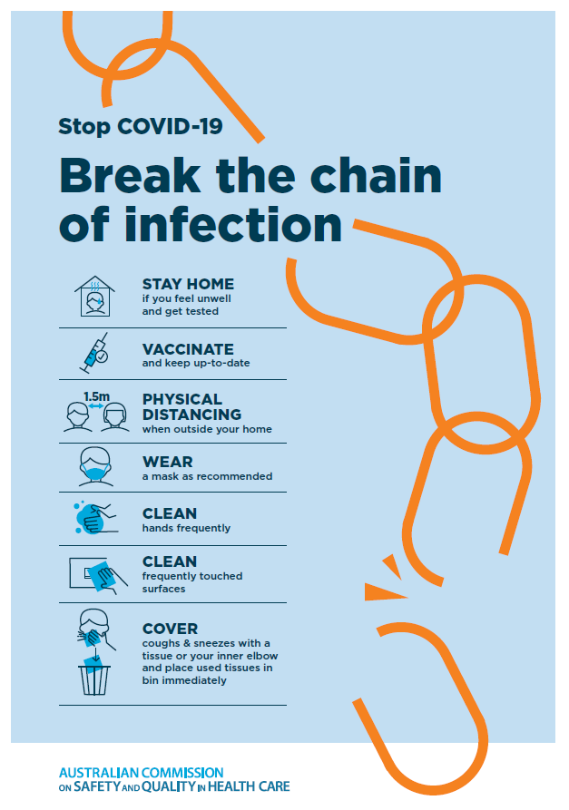](https://www.safetyandquality.gov.au/publications-and-resources/resource-library/break-chain-poster-a3https:/www.safetyandquality.gov.au/publications-and-resources/resource-library/break-chain-poster-a3)**
* ***COVID-19 and face masks – Information for consumers*** <https://www.safetyandquality.gov.au/publications-and-resources/resource-library/covid-19-and-face-masks-information-consumers>

[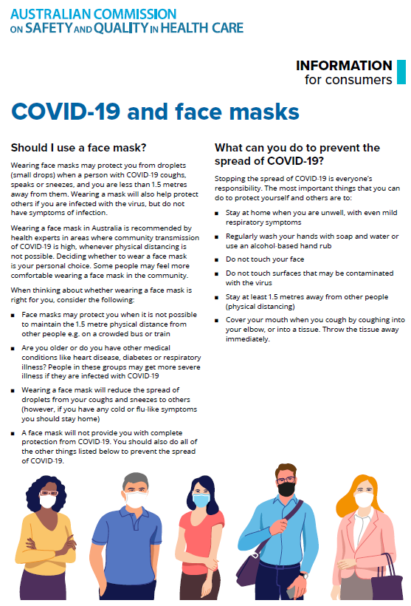](https://www.safetyandquality.gov.au/sites/default/files/2020-07/covid-19_and_face_masks_-_information_for_consumers.pdf)

*National Clinical Evidence Taskforce*

<https://clinicalevidence.net.au/>

The National Clinical Evidence Taskforce is a multi-disciplinary collaboration of 35 member organisations – Australia’s medical colleges and peak health organisations – who share a commitment to provide national evidence-based treatment guidelines for urgent and emerging diseases.

This alliance established the world’s first ‘living guidelines’ for the care of people with COVID-19 and MPX.

Funding has now been discontinued for the National Clinical Evidence Taskforce and the COVID-19 guidelines as of 30 June 2023.

These guidelines are no longer continually updated but will remain online until the guidance becomes inaccurate and/or no longer reflects the evidence or recommended practice.

**Disclaimer**

On the Radar is an information resource of the Australian Commission on Safety and Quality in Health Care. The Commission is not responsible for the content of, nor does it endorse, any articles or sites listed. The Commission accepts no liability for the information or advice provided by these external links. Links are provided on the basis that users make their own decisions about the accuracy, currency and reliability of the information contained therein. Any opinions expressed are not necessarily those of the Australian Commission on Safety and Quality in Health Care.