# Australian Commission on Safety and Quality logotypeOn the Radar

Issue 641

11 March 2024

*On the Radar* is a summary of some of the recent publications in the areas of safety and quality in health care. Inclusion in this document is not an endorsement or recommendation of any publication or provider. Access to particular documents may depend on whether they are Open Access or not, and/or your individual or institutional access to subscription sites/services. Material that may require subscription is included as it is considered relevant.

*On the Radar* is available online, via email or as a PDF or Word document from <https://www.safetyandquality.gov.au/newsroom/subscribe-news/radar>

If you would like to receive *On the Radar* via email, you can subscribe on our website <https://www.safetyandquality.gov.au/newsroom/subscribe-news>  
or by emailing us at H[Umail@safetyandquality.gov.auU](mailto:mail@safetyandquality.gov.au).  
You can also send feedback and comments to H[Umail@safetyandquality.gov.auU](mailto:mail@safetyandquality.gov.au).

For information about the Commission and its programs and publications, please visit <https://www.safetyandquality.gov.au>

w

**On the Radar**

Editor: Dr Niall Johnson [niall.johnson@safetyandquality.gov.au](mailto:niall.johnson@safetyandquality.gov.au)

Contributors: Niall Johnson

**Reports**

*Transforming for value-based health care: Lessons from NHS Wales*

Deeble Institute for Health Policy Research Perspectives Brief no: 30

Hoban E, Lewis S, Woolcock K, Haddock R

Canberra: Australian Healthcare and Hospitals Association; 2024. p. 42.

|  |  |
| --- | --- |
| URL | <https://ahha.asn.au/sites/default/files/docs/policy-issue/deeble_perspectives_brief_30._transforming_for_valued-based_health_care.pdf> |
| Notes | This Perspectives Brief recently published by the Australian Healthcare and Hospitals Association’s Deeble Institute uses examples from NHS Wales to examine value-based health care (VBHC), including the how VBHC has evolved and lessons that can be learned from to inform how it may be applied in Australia. |

*Translating policy into practice by engaging older persons and their carers as co-researchers*

Deeble Institute for Health Policy Research Perspectives Brief no: 29

Beks H, Clayden S, West E, King O, Alston L, Williams S, et al

Canberra: Australian Healthcare and Hospitals Association; 2024. p. 29.

|  |  |
| --- | --- |
| URL | <https://ahha.asn.au/sites/default/files/docs/policy-issue/perspectives_brief_no_29._engaging_older_persons_as_co-researchers.pdf> |
| Notes | This Perspectives Brief from the Australian Healthcare and Hospitals Association’s Deeble Institute examines approaches to observations of the Royal Commission into Aged Care Quality and Safety. The authors of this Perspectives Brief note that the Royal Commission ‘identified the need to improve the delivery of health care to meet the needs of older persons and their carers’ and that the ‘greater involvement of older persons and their carers in research to develop solutions was recommended.’ This brief examines mechanisms for engaging older persons and their carers as co-researchers in participatory health research. |

For information on the Commission’s work on partnering with consumers, see <https://www.safetyandquality.gov.au/our-work/partnering-consumers>

**Journal articles**

*Supported decision-making interventions in mental healthcare: A systematic review of current evidence and implementation barriers*

Francis CJ, Johnson A, Wilson RL

Health Expectations. 2024;27(2):e14001.

|  |  |
| --- | --- |
| DOI | <https://doi.org/10.1111/hex.14001> |
| Notes | Paper from a group of Australian researchers reporting on a systematic review of the literature on shared-decision making in mental health. Based on 140 articles, the authors report that ‘Overarching **barriers to shared and supported decision-making in mental health** treatment planning were (1) **Organisational** (resource limitations, culture barriers, risk management priorities and structure); (2) **Process** (lack of knowledge, time constraints, health-related concerns, problems completing and using plans); and (3) **Relationship** barriers (fear and distrust for both service users and clinicians).’ The authors observe that ‘Central to and underlying all three of these barriers were the common and intertwined threads of fear and distrust’. Furthermore, ‘minimising these barriers and providing the right organisational, process and relationship assistance are key to successful shared and supported decision-making in mental health treatment planning. With the need to develop trust at the heart of the actions to be taken.’ |

For information on the Commission’s work on mental health, see <https://www.safetyandquality.gov.au/our-work/mental-health>

For information on the Commission’s work on shared decisions making, see <https://www.safetyandquality.gov.au/our-work/partnering-consumers/shared-decision-making>

*Care Fragmentation, Care Continuity, and Care Coordination—How They Differ and Why It Matters*

Kern LM, Bynum JPW, Pincus HA

JAMA Internal Medicine. 2024;184(3):236-237.

|  |  |
| --- | --- |
| DOI | <https://doi.org/10.1001/jamainternmed.2023.7628> |
| Notes | Viewpoint piece in *JAMA Internal Medicine* that examines fragmentation, continuity, and coordination of care. The authors define these:  ‘Care fragmentation is care that is diffusely spread across many physicians, such that no single physician accounts for a substantial proportion of visits.’  ‘Care continuity is the use of the same ambulatory physician repeatedly over time, such that the usual physician (who can be a primary care physician or specialist) accounts for a substantial proportion of visits.’  It’s observed that ‘fragmentation and continuity are measures of utilization. They can both be measured with numerical indices’  ‘By contrast, care coordination cannot simply be assessed by a quantitative measure of ambulatory utilization. It involves a more qualitative assessment of the extent to which physicians are collectively operating in a teamlike manner to develop and implement an overall care plan to meet the patient’s goals’  In their conclusion the authors suggest ‘Even though continuity and fragmentation are the mathematical inverses of each other, improving continuity (ie, increasing the number of visits with one physician) would not necessarily decrease the total number of physicians involved in a person’s care, nor would it necessarily improve coordination among all of those physicians.’ However, the issue may be more that ‘Patients are experiencing avoidable harm from fragmented care, and they deserve better.’ |

*Complication Rates of Central Venous Catheters: A Systematic Review and Meta-Analysis*

Teja B, Bosch NA, Diep C, Pereira TV, Mauricio P, Sklar MC, et al

JAMA Internal Medicine. 2024.

*Enhancing Quality and Safety in Critical Care—Challenges and Strategies for Central Venous Catheters*

Saade EA, Lytle FT, Pronovost PJ

JAMA Internal Medicine. 2024.

|  |  |
| --- | --- |
| DOI | Teja et al <https://doi.org/10.1001/jamainternmed.2023.8232>  Saade et al <https://doi.org/10.1001/jamainternmed.2023.8243> |
| Notes | Teja et al report on a systematic review and meta-analysis that sought to examine the rates of complications from central venous catheter (CVC) use. Based on 130 studies published in the period 2015 to 2023, the authors found ‘rates of complications varied substantially across studies, but on average, the rate of serious complications (arterial cannulation, pneumothorax, infection, or deep vein thrombosis) from a CVC placed for 3 days was estimated to be 30 events per 1000 catheters placed (3%). Use of ultrasonography was associated with lower rates of immediate insertion-related complications.’  In an invited commentary, Saade et al canvas a number of issues around CVCs including how the reliance on CVCs is being re-evaluated, practices to lower the risks of CVC use, and the use of process measures as ‘a proactive approach to infection control by promoting the standardization of practices known to reduce infection risk’. |

*What's going well: a qualitative analysis of positive patient and family feedback in the context of the diagnostic process.*

Liu SK, Bourgeois F, Dong J, Harcourt K, Lowe E, Salmi L, et al

Diagnosis 2024;11(1):63-72.

|  |  |
| --- | --- |
| DOI | <https://doi.org/10.1515/dx-2023-0075> |
| Notes | Paper reporting on a study that sought to understand patient perspectives ‘on what constitutes a “good” diagnostic process (DxP).’ Using surveys conducted with ‘Patients/families living with chronic conditions with visits in three urban pediatric subspecialty clinics (site 1) and one rural adult primary care clinic (site 2)’ with ‘7,075 surveys were completed before 18,129 visits (39 %) at site 1, and 460 surveys were completed prior to 706 (65 %) visits at site 2.’ 1,578 of these ‘volunteered positive feedback’ with analysis of the longer responses leading the authors to the conclusion that ‘Patients/families valued relationships with clinicians above all else in the DxP, emphasizing the importance of supporting clinicians to nurture effective relationships and relationship-centered care in the DxP.’ |

*Journal of Patient Safety and Risk Management*

Volume 29, Number 1, February 2024

|  |  |
| --- | --- |
| URL | <https://journals.sagepub.com/toc/cric/29/1> |
| Notes | A new issue of the *Journal of Patient Safety and Risk Management* has been published. Articles in this issue of the *Journal of Patient Safety and Risk Management* include:   * Editorial: **Making a career in patient safety**: How I got hooked (Albert W Wu, Charles Vincent, Shin Ushiro, Anupam Sibal, Pa-Chun Wang, and Ezequiel Garcia Elorrio) * **Lucy Letby inquiry** could be a missed opportunity if it does not look at the wider issue (Paul Whiteing) * Challenges of **integrating patient safety into nursing curricula**: An integrative literature review (D M Ashoka Priyadarshani Dissanayake, Kumudini Paba Dharmasena, and Sudath Shirley Pathmasiri Warnakulasuriya) * How deep is a problem of **second victims** for medical staff? A pilot study in Croatia (Anatoliy G Goncharuk, Bojana Knežević, Sandra C Buttigieg, and José Joaquín Mira) * **Patient safety near misses** – Still missing opportunities to learn (Nick Woodier, Charlotte Burnett, Paul Sampson, and Iain Moppett) * **Patient safety competence of nursing students** and affecting factors (Ayşegül Yılmaz and Özlem Erdem) * A five-step approach to **safer skin surgery** (Hayley Smith, Raman Bhutani, Angana Mitra, Victoria Goulden, Walayat Hussain, Rajib Rahim, Claire Machin, and Graeme I Stables) |

*Healthcare Papers*

Volume 21, Number 4, 2024

|  |  |
| --- | --- |
| URL | <https://www.longwoods.com/publications/healthcarepapers/27267/1/vol.-21-no.-4-2024-defining-essential-digital-health-for-the-underserved-> |
| Notes | A new issue of *Healthcare Papers* has been published with a focus on **Defining “Essential Digital Health for the Underserved”**. Articles in this issue of *Healthcare Papers* include:   * Defining “**Essential Digital Health for the Underserved**” (Kendall Ho, Owen Adams, Ambreen Sayani and Gurleen Cheema) * Consolidated Principles for **Equitable and Inclusive Digital Health and Virtual Care Co-Design** (Paula Voorheis, Jennifer Major, Jennifer Stinson, Ron Beleno, Colleen Ferris and Carolyn Steele Gray) * Relational Work Is the Work: **Virtual Healthcare Transformation for Rural, Remote and First Nations Communities** in British Columbia (John Mah, John Pawlovich, Terri Aldred, Scott Graham, Ray Markham, Kim Williams, Bob Woollard, John Grogan, Dee Taylor, Nelly D Oelke, Alison James, Melissa Stewart, Sonya Cressman, Arianna Hogan and Daniel Harper) * Can Answers to the **Health Workforce Crisis** Be Found in Equity-Informed Digital Health? (Helen Novak Lauscher, Chad Kim Sing, Chantz Strong, Anita Palepu, Jason Jaswal, Dietrich Fürstenburg, Nelly D Oelke, P K Pearce, K Ho) * **Human Factor Health Data Interoperability** (Ewan Affleck, Eric Sutherland, Cliff Lindeman, Richard Golonka, Teri Price, Tim Murphy, Tyler Williamson, Ann Chapman, Anita Layton and Cassie Fraser) * **Enabling Connected Care** with a Person-Centred Data Foundation (Anne Forsyth, Ann Chapman, Shannon Malovec, Michael Tatto, Mauree Aki Matsusaka, Jennifer Cordeiro and Meagan Mark) * Trustworthy Evidence to Support Quality **Digital Healthcare Policy for Underserved Communities**: What Needs to Happen to Translate Evidence into Policy? (Clare L Ardern, Alex Haagaard, Megan MacPherson, Jessica Nadigel, Bahar Kasaai, Sonya Cressman, Jennifer Cordeiro and Kendall Ho) * **Learning Health Systems**: A Paradigm Shift in What We Can Do about Digital Health Inequities (Sonya Cressman, Ibukun-Oluwa Omolade Abejirinde, Joan Assali, Mavis B Dennis, Alies Maybee, Michele Strom, Kendall Ho, Clare L. Ardern, A Sayani, R Markham and O Bhattacharyya) * From Today to Tomorrow: **Leveraging Digital Health to Move toward Health for All** (Kendall Ho, Onil Bhattacharyya and Owen Adams) |

*Journal for Healthcare Quality*

Volume 46, Number 2, March/April 2024

|  |  |
| --- | --- |
| URL | <https://journals.lww.com/jhqonline/toc/2024/04000> |
| Notes | A new issue of the *Journal for Healthcare Quality* has been published. Articles in this issue of the *Journal for Healthcare Quality* include:   * **Improving Interdisciplinary Communication** on an Academic Hospitalist Service: A Quality Improvement Project (Stephen Biederman, Nargiza Sadr, Rehan Qayyum) * **Team-Based Care Model** Improves Timely Access to Care and Patient Satisfaction in General Cardiology (Christa M Sharpe, Linda Eastham) * Quality Improvement Interventions to Enhance **Vaccine Uptake in Cancer Patients**: A Systematic Review (Basil Kazi, Zain Talukdar, Janice Schrieffer) * Improving Quality Care and Patient Safety With Implementation of an Oversew Stitch in **Lumbar Drains** (Erik C Brown, Samantha Fay, Ahmed M Raslan, Christina M Sayama) * Organizational Learning in the **Morbidity and Mortality Conference** (Michelle Batthish, Ayelet Kuper, Claire Fine, Ronald M Laxer, G Ross Baker) * **Self-Measured Blood Pressure Monitoring** During the COVID-19 Pandemic: Perspectives From Community Health Center Clinicians (Margaret Meador, Neha Sachdev, Eboni Anderson, Debosree Roy, R Curtis Bay, Lauren H Becker, Joy H Lewis) * Redesigning the **First Prenatal Visit**: A Quality Improvement Initiative (Diane Christopher, Joellen Fresia, Jennifer Alexander, Kristin Krenz, Heather Aldrich, Karen Hampanda) |

*Journal of Health Services Research & Policy*

Volume 29, Number 2, April 2024

|  |  |
| --- | --- |
| URL | <https://journals.sagepub.com/toc/hsrb/29/2> |
| Notes | A new issue of the *Journal of Health Services Research & Policy* has been published. Articles in this issue of the *Journal of Health Services Research & Policy* include:   * **Expected wait times** for access to a disease-modifying Alzheimer’s treatment in England: A modelling study (Soeren Mattke, Yu Tang, and Mark Hanson) * **Demand and willingness to pay** for human papilloma virus vaccine for their daughters among mothers in Haryana, India: A contingent valuation study (Shomik Ray, Rubina Mulchandani, and Pankaj Patel) * **Job preferences of Chinese primary health care workers**: A discrete choice experiment (Yingxi Lin, Jinfeng Xie, Dan Wu, Yingyu Wang, Yiyuan Cai, Qing Zhao, Lanping Zhang, Jiaqi Li, Wenjun He, and Dong (Roman) Xu) * **High health care use prior to elective surgery for osteoarthritis** is associated with poor postoperative outcomes: A Canadian population-based cohort study (Mayilee Canizares, J Denise Power, Anthony V Perruccio, Michael Paterson, Nizar N Mahomed, and Y Raja Rampersaud) * Experiences of online group support for engaging and supporting participants in the National Health Service **Digital Diabetes Prevention Programme**: A qualitative interview study (Wang Chun Cheung, Lisa M Miles, Rhiannon E Hawkes, and David P French) * What is the best way to **evaluate social prescribing**? A qualitative feasibility assessment for a national impact evaluation study in England (Abimbola Ayorinde, Amy Grove, Iman Ghosh, Jenny Harlock, Edward Meehan, Natalie Tyldesley-Marshall, Adam Briggs, Aileen Clarke, and Lena Al-Khudairy) * Assessing progress in managing and improving **quality in nascent integrated care systems** in England (Mirza Lalani, Priya Sugavanam, James Caiels, Helen Crocker, Sarah Gunn, Harriet Hay, Helen Hogan, Bethan Page, Michele Peters, and Ray Fitzpatrick) * **Innovative domestic financing mechanisms for health** in Africa: An evidence review (Nouria Brikci) |

*Health Affairs*

Volume 43, Number 3, March 2024

|  |  |
| --- | --- |
| URL | <https://www.healthaffairs.org/toc/hlthaff/43/3> |
| Notes | A new issue of *Health Affairs* has been published with the themes ‘Nursing Homes, Medicaid, Physicians & Health. Articles in this issue of *Health Affairs* include:   * New CMS **Nursing Home Ownership Data**: Major Gaps And Discrepancies (Amanda C Chen, Robert J Skinner, Robert Tyler Braun, R Tamara Konetzka, David G Stevenson, and David C Grabowski) * **Nursing Homes Increasingly Rely On Staffing Agencies** For Direct Care Nursing (John R Bowblis, Christopher S Brunt, Huiwen Xu, Robert Applebaum, and David C Grabowski) * COVID-19 Medicaid Continuous Enrollment Provision Yielded Gains In **Postpartum Continuity Of Coverage** (Sarah H Gordon, Lucy Chen, Nancy DeLew, and Benjamin D Sommers) * Effects Of Medicaid Expansions On **Coverage, Prenatal Care, And Health Among American Indian/Alaska Native Women** (Kate W Strully, Pinka Chatterji, Han Liu, Soojin Han, and Lawrence Schell) * **Private Equity–Acquired Physician Practices** And Market Penetration Increased Substantially, 2012–21 (Ola Abdelhadi, Brent D Fulton, Laura Alexander, and Richard M Scheffler) * Higher Rates Of Emergency Surgery, Serious Complications, And Readmissions In **Primary Care Shortage Areas**, 2015–19 (Sara L Schaefer, Shukri H A Dualeh, Nicholas Kunnath, John W Scott, and A M Ibrahim) * **Primary Care Physicians In Medicare Advantage** Were Less Costly, Provided Similar Quality Versus Regional Average (Eran Politzer, Timothy S Anderson, John Z Ayanian, Vilsa Curto, John A Graves, Laura A Hatfield, Jeffrey Souza, Alan M Zaslavsky, and Bruce E Landon) * Gaps In Quality Of Care Not Consistent Between **Traditional Medicare, Medicare Advantage** For Racial And Ethnic Groups (Jeah Jung, Hansoo Ko, Roger Feldman, Caroline S Carlin, and Ge Song) * Medicare Part D Plans Greatly Increased **Utilization Restrictions On Prescription Drugs**, 2011–20 (Geoffrey Joyce, Barbara Blaylock, Jiafan Chen, and Karen Van Nuys) * Georgia’s **Reinsurance Waiver** Associated With Decreased Premium Affordability And Enrollment (D M Anderson, E Golberstein, and C Drake) * **Meals On Wheels Clients**: Measurable Differences In The Likelihood Of Aging In Place Or Being Hospitalized (Sarah E Walsh, France Marie Weaver, and Jennifer Chubinski) * **Trauma Center Hospitals** Charged Higher Prices For Some Nontrauma Care Than Non–Trauma Center Hospitals, 2012–18 (Daniel P Kessler, Richard Sweeney, and Glenn A Melnick) * **Hospital Facility Prices** Declined As A Result Of Oregon’s Hospital Payment Cap (Roslyn C Murray, Zach Y Brown, Sarah Miller, Edward C Norton, and Andrew M Ryan) * County-Level Mandates Were Generally Effective At Slowing **COVID-19 Transmission** (Courtney E Baird, D Lake, O A Panagiotou, and P Gozalo) * **PrEP Discontinuation** In A US National Cohort Of Sexual And Gender Minority Populations, 2017–22 (Yan Guo, Drew A Westmoreland, Alexa D’Angelo, Chloe Mirzayi, Michelle Dearolf, Pedro B Carneiro, Meredith Ray, David W Pantalone, Adam W Carrico, Viraj V Patel, Sarit A Golub, Sabina Hirshfield, Donald Hoover, Denis Nash, and Christian Grov) * Losing Our Way In A **Rare Disease Diagnostic Odyssey** (Kara A. Ayik) |

*BMJ Quality & Safety* online first articles

|  |  |
| --- | --- |
| URL | <https://qualitysafety.bmj.com/content/early/recent> |
| Notes | *BMJ Quality &Safety* has published a number of ‘online first’ articles, including:   * Editorial: Effective use of **interdisciplinary approaches in healthcare quality**: drawing on operations and visual management (Nicola Bateman) * Editorial: Can **virtual reality simulations** improve macrocognition? (Michelle Aebersold, Laura Gonzalez) * Editorial: Pragmatic trials are needed to assess the effectiveness of **enhanced recovery after surgery protocols** on patient safety (Antoine Duclos) |

**Online resources**

***[UK] NICE Guidelines and Quality Standards***

<https://www.nice.org.uk/guidance>

The UK’s National Institute for Health and Care Excellence (NICE) has published new (or updated) guidelines and quality standards. The latest reviews or updates include:

* NICE Guideline NG239 ***Vitamin B12 deficiency*** *in over 16s: diagnosis and management* <https://www.nice.org.uk/guidance/ng239>

**COVID-19 resources**

https://www.safetyandquality.gov.au/covid-19

The Australian Commission on Safety and Quality in Health Care has developed a number of resources to assist healthcare organisations, facilities and clinicians. These and other material on COVID-19 are available at <https://www.safetyandquality.gov.au/covid-19>

These resources include:

* ***OVID-19 infection prevention and control risk management*** This primer provides an overview of three widely used tools for investigating and responding to patient safety events and near misses. Tools covered in this primer include incident reporting systems, Root Cause Analysis (RCA), and Failure Modes and Effects Analysis (FMEA).   
  <https://www.safetyandquality.gov.au/publications-and-resources/resource-library/covid-19-infection-prevention-and-control-risk-management-guidance>
* ***Poster – Combined contact and droplet precautions*** <https://www.safetyandquality.gov.au/publications-and-resources/resource-library/infection-prevention-and-control-poster-combined-contact-and-droplet-precautions>  
  [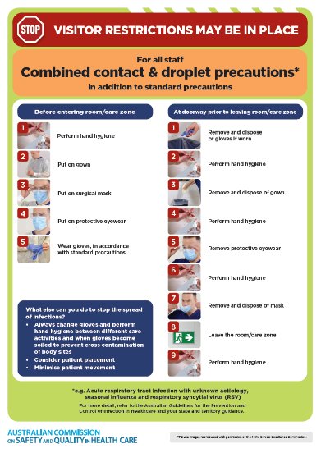](https://www.safetyandquality.gov.au/publications-and-resources/resource-library/infection-prevention-and-control-poster-combined-contact-and-droplet-precautions)
* ***Poster – Combined airborne and contact precautions*** <https://www.safetyandquality.gov.au/publications-and-resources/resource-library/poster-combined-airborne-and-contact-precautions>   
  [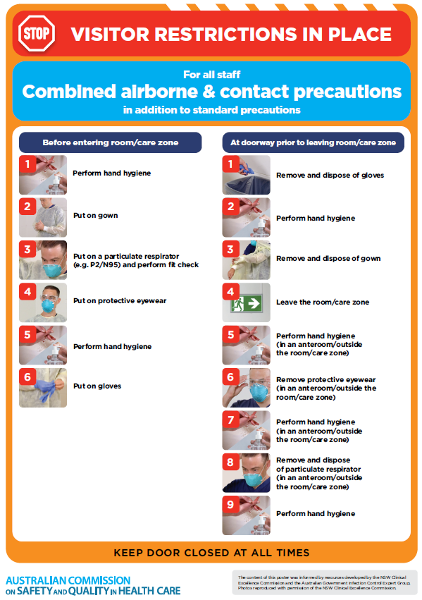](https://www.safetyandquality.gov.au/publications-and-resources/resource-library/poster-combined-airborne-and-contact-precautions)
* ***Environmental Cleaning and Infection Prevention and Control*** [www.safetyandquality.gov.au/environmental-cleaning](http://www.safetyandquality.gov.au/environmental-cleaning)
* ***COVID-19 infection prevention and control risk management – Guidance*** <https://www.safetyandquality.gov.au/publications-and-resources/resource-library/covid-19-infection-prevention-and-control-risk-management-guidance>
* ***Safe care for people with cognitive impairment during COVID-19***<https://www.safetyandquality.gov.au/our-work/cognitive-impairment/cognitive-impairment-and-covid-19>
* ***Stop COVID-19: Break the chain of infection*** posterhttps://www.safetyandquality.gov.au/publications-and-resources/resource-library/break-chain-infection-poster-a3  
  **[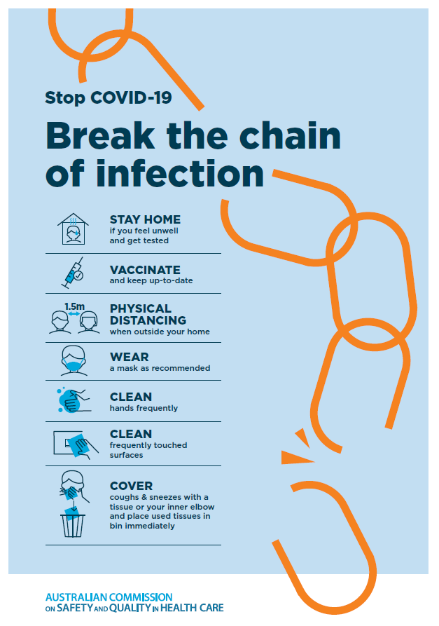](https://www.safetyandquality.gov.au/publications-and-resources/resource-library/break-chain-poster-a3https:/www.safetyandquality.gov.au/publications-and-resources/resource-library/break-chain-poster-a3)**
* ***COVID-19 and face masks – Information for consumers*** <https://www.safetyandquality.gov.au/publications-and-resources/resource-library/covid-19-and-face-masks-information-consumers>

[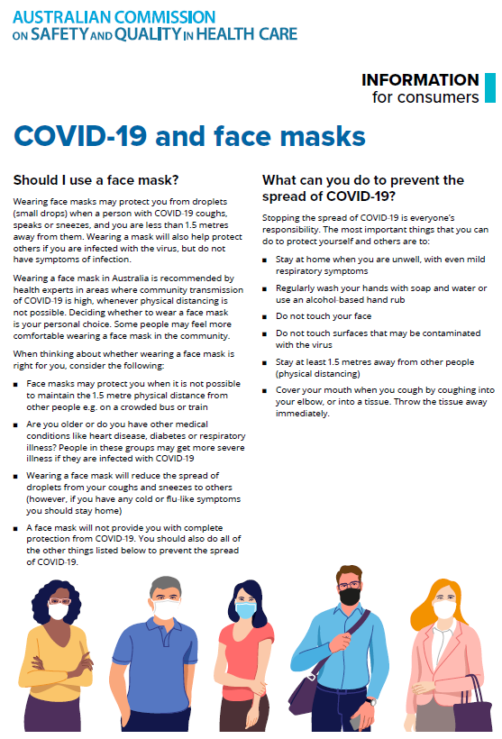](https://www.safetyandquality.gov.au/sites/default/files/2020-07/covid-19_and_face_masks_-_information_for_consumers.pdf)

*National Clinical Evidence Taskforce*

<https://clinicalevidence.net.au/>

The National Clinical Evidence Taskforce is a multi-disciplinary collaboration of 35 member organisations – Australia’s medical colleges and peak health organisations – who share a commitment to provide national evidence-based treatment guidelines for urgent and emerging diseases.

This alliance established the world’s first ‘living guidelines’ for the care of people with COVID-19 and MPX.

Funding has now been discontinued for the National Clinical Evidence Taskforce and the COVID-19 guidelines as of 30 June 2023.

These guidelines are no longer continually updated but will remain online until the guidance becomes inaccurate and/or no longer reflects the evidence or recommended practice.

**Disclaimer**

On the Radar is an information resource of the Australian Commission on Safety and Quality in Health Care. The Commission is not responsible for the content of, nor does it endorse, any articles or sites listed. The Commission accepts no liability for the information or advice provided by these external links. Links are provided on the basis that users make their own decisions about the accuracy, currency and reliability of the information contained therein. Any opinions expressed are not necessarily those of the Australian Commission on Safety and Quality in Health Care.