# Australian Commission on Safety and Quality logotypeOn the Radar

Issue 643

25 March 2024

*On the Radar* is a summary of some of the recent publications in the areas of safety and quality in health care. Inclusion in this document is not an endorsement or recommendation of any publication or provider. Access to particular documents may depend on whether they are Open Access or not, and/or your individual or institutional access to subscription sites/services. Material that may require subscription is included as it is considered relevant.

*On the Radar* is available online, via email or as a PDF or Word document from <https://www.safetyandquality.gov.au/newsroom/subscribe-news/radar>

If you would like to receive *On the Radar* via email, you can subscribe on our website <https://www.safetyandquality.gov.au/newsroom/subscribe-news>  
or by emailing us at H[Umail@safetyandquality.gov.auU](mailto:mail@safetyandquality.gov.au).  
You can also send feedback and comments to H[Umail@safetyandquality.gov.auU](mailto:mail@safetyandquality.gov.au).

For information about the Commission and its programs and publications, please visit <https://www.safetyandquality.gov.au>

w

**On the Radar**

Editor: Dr Niall Johnson [niall.johnson@safetyandquality.gov.au](mailto:niall.johnson@safetyandquality.gov.au)

Contributors: Niall Johnson

**Reports**

*Telehealth quality of care tool*

World Health Organization, Regional Office for Europe

Copenhagen: WHO, Regional Office for Europe; 2024. p. 57.

|  |  |
| --- | --- |
| URL | <https://www.who.int/europe/publications/i/item/WHO-EURO-2024-9475-49247-73556> |
| Notes | The World Health Organization (WHO) have released this first version of their Telehealth quality of care tool (‎TQoCT)‎. The WHO Regional Office for Europe have developed this ‘tool that serves as both a guidance and self-assessment instrument for telehealth services quality improvement’. improvement that is useful at local, regional and national levels’. The WHO ‘envision that using the tool requires gathering a group of stakeholders to agree on the maturity level of a telehealth system through three components of quality of care – people centricity, clinical effectiveness, and safety – be it at the national, regional or organizational level.’ A Microsoft Excel version of the tool is available. |

*Notifiable data breaches report July to December 2023*

Office of the Australian Information Commissioner

Sydney: OAIC; 2024. p. 44.

|  |  |
| --- | --- |
| URL | <https://www.oaic.gov.au/privacy/notifiable-data-breaches/notifiable-data-breaches-publications/notifiable-data-breaches-report-july-to-december-2023> |
| Notes | The Office of the Australian Information Commissioner (OAIC) has released their latest Notifiable data breaches report. This report captures notifications received under the notifiable data breaches (NDB) scheme from 1 July to 31 December 2023. The OAIC noted that health and finance sectors remained the top reporters of data breaches. Health reported 104 breaches (22% of all notifications) and finance 49 breaches (10%). For health service providers, 55 breaches were due to malicious or criminal attack, 46 human errors, and 3 system fault.  Chart showing Source of breaches – Top 5 sectors. For health service providers, 55 breaches were due to malicious or criminal attack, 46 human errors, and 3 system fault. |

*The Top Five: A Review of Post-Pandemic Patient Safety Priorities*

Health Quality Institute

Sacramento CA: HQI; 24. p. 17.

|  |  |
| --- | --- |
| URL | <https://hqinstitute.org/file/hqi-top-five-paper-on-post-pandemic-patient-safety/> |
| Notes | The Hospital Quality Institute (HQI) in the USA has produced this document having ‘assessed hospital discharge and incident reports [in California] for the year prior to, during, and after the COVID-19 pandemic (2019 to 2021).’ The HQI’s top five include:   * Falls * Medications * CAUTIs (catheter-associated urinary tract infections) * CLABSIs (central line-associated bloodstream infections) * Pressure injuries. |

**Journal articles**

*Teamwork Climate, Safety Climate, and Physician Burnout: A National, Cross-Sectional Study*

Rotenstein L, Wang H, West CP, Dyrbye LN, Trockel M, Sinsky C, et al

The Joint Commission Journal on Quality and Patient Safety. 2024 2024/03/14/.

|  |  |
| --- | --- |
| DOI | <https://doi.org/10.1016/j.jcjq.2024.03.007> |
| Notes | The COVID-19 pandemic saw burnout rise to greater prominence and it remains a significant issue in many health systems and organisations. This paper reports on a survey of US physicians that ‘assessed US physicians’ perceptions of team-based care delivery and safety climate within their institutions and the associations of these domains with burnout.’ Based on the analysis of survey responses from 968 physicians, the authors report that ‘higher ratings of both teamwork climate and safety climate were associated with lower odds of emotional exhaustion, depersonalization, and burnout.’ |

*Progress towards cultural safety in Indigenous cardiovascular health care and research*

Burchill L, Dos Santos A

The Lancet Global Health. 2024;12(4):e541-e542.

*Effects of a culturally informed model of care for Aboriginal and Torres Strait Islander patients with acute coronary syndrome in a tertiary hospital in Australia: a pre-post, quasi-experimental, interventional study*

Harrop DL, Bryce V, Kitchener T, Grugan S, Renouf S, Mitchell S, et al

The Lancet Global Health. 2024;12(4):e623-e630.

|  |  |
| --- | --- |
| DOI | Burchill and Dos Santos <https://doi.org/10.1016/S2214-109X(24)00080-9>  Harrop et al <https://doi.org/10.1016/S2214-109X(23)00601-0> |
| Notes | A pair of articles in this issue of *The Lancet Global Health* examining Indigenous cardiovascular health. Burchill and Dos Santos observe that ‘Aboriginal and Torres Strait Islander Indigenous Australians are not adequately screened or treated for cardiovascular disease, and Indigenous Australians are less likely to receive guideline-recommended treatment after being hospitalised for a severe heart attack than non-Indigenous Australians. Although cardiovascular-disease mortality has improved, it is still substantially higher than for non-Indigenous Australians.’ The paper describes work undertaken and suggests further work, stressing the need to ‘changes the focus from deficit narratives to solutions that consider Indigenous culture as a strength of Indigenous people and the most effective way to advance our health’. There is also a distinction between culturally informed and culturally safe care.  Harrop et al report on the development and implementation of ‘a culturally informed model of care for Indigenous patients hospitalised with acute coronary syndrome (ACS)’ at a tertiary hospital in metropolitan Brisbane. The Indigenous cohorts in the study included 199 patients admitted with ACS before the model of care was implemented and 119 admitted post-implementation. The authors report that ‘Clinical outcomes for Indigenous patients admitted to a tertiary hospital in Australia improved after implementation of a culturally informed model of care, with a reduction in the disparity in incidence of primary endpoints that existed between Indigenous and non-Indigenous patients before implementation.’ The reduction in the primary outcome ‘was driven by a reduction in unplanned cardiac readmissions’. |

*Incidence of hospital-acquired pressure injuries and predictors of severity in a paediatric hospital*

Dimanopoulos T, Chaboyer W, Campbell J, Ullman AJ, Battley C, Ware RS, et al

Journal of Advanced Nursing. 2024.

|  |  |
| --- | --- |
| DOI | <https://doi.org/10.1111/jan.16140> |
| Notes | Paper reporting on a retrospective cohort study examining hospital-acquired pressure injuries (HAPIs) in a large Australian children's hospital between January 2020 and December 2021. Among the results reported were:   * The HAPI incidence rate was 6.96 per 1000 patient admissions. * Of the age groups, neonates had the highest HAPI incidence (15.5 per 1000 admissions). * Critically ill children had the highest rate for admission location (12.8 per 1000 patient admissions). * Aboriginal and/or Torres Strait Islander patients had a higher HAPI severity risk.. |

*BMJ Leader*

Volume 8, Issue 1, March2024

|  |  |
| --- | --- |
| URL | <https://bmjleader.bmj.com/content/8/1> |
| Notes | A new issue of *BMJ Leader* has been published. Articles in this issue of *BMJ Leader* include:   * Editorial: **Kindness in healthcare**: why it matters and why BMJ Leader will focus on it (Robert Klaber, James Mountford, Dominique Allwood) * **Leadership and resilience**: a viewpoint of Ukrainian doctors (Yaroslav Diakunchak, Andrii Bazylevych, Olesya Vynnyk, Rustam Zhurayev) * **Navigating role conflict**: one professional’s journey as a new clinician leader (Christopher Wiedman) * Five hats of **effective leaders**: teacher, mentor, coach, supervisor and sponsor (Richard C Winters, Teresa M Chan, Bradley E Barth) * Workplace-based **knowledge exchange programmes** between academics, policy-makers and providers of healthcare: a qualitative study (Stephanie Kumpunen, Jake Matthews, Thuvarahan Amuthalingam, Greg Irving, Bernadeta Bridgwood, Luisa M Pettigrew) * **Effective clinical nursing leadership** in hospitals: barriers from the perspectives of nurse managers (Abdullah Algunmeeyn, Majd T Mrayyan, Wafika A Suliman, Hamzeh Y Abunab, Saleem Al-Rjoub) * **Integrating health leadership and management perspectives**: the MESH framework for culturally informed food design thinking and well-being promotion (Jack S Tillotson, Vito Tassiello, Shona Bettany, Benjamin Laker) * Thematic analysis of tools for health innovators and organisation leaders to develop **digital health solutions fit for climate change** (Lysanne Rivard, Pascale Lehoux, Robson Rocha de Oliveira, Hassane Alami) * **What makes for a ‘Top Doc’?** An analysis of UK press portrayals of so-called top doctors (Paul Keeley, Mark Taubert, Emma Wardle, Simon Tavabie, Ollie Minton) * Vital role of clinicians in reducing the NHS **carbon footprint** through smarter procurement decisions (Nada Al-Hadithy, Katie Knight, Anya Gopfert, Maria Van Hove, Xana Villa Garcia) * **Empathy** in the age of science disinformation: implications for healthcare quality (Yash B Shah, Nicholas W Kieran, Stephen K Klasko) * **ChatGPT and generative AI chatbots**: challenges and opportunities for science, medicine and medical leaders (Erwin Loh) * **What is medicine for?** (Kristin M Collier) * When work harms: how better understanding of avoidable **employee harm** can improve employee safety, patient safety and healthcare quality (Aled Jones, Adrian Neal, Suzie Bailey, Andrew Cooper) * ‘No one can actually see us in positions of power’: the intersectionality between **gender and culture for women in leadership** (Helen Skouteris, Michelle Ananda-Rajah, Claire Blewitt, Darshini Ayton) * Examining the **differences between physician and administrative leaders** at Cleveland Clinic and the implications for leadership development programming (Gina Phelps Thoebes, Gary Logan Rife, Tracy Hopkins Porter) * Primary care doctors’ perceived needs for **physician leadership development** in rural and remote settings of Aceh province, Indonesia (Fury Maulina, Mubasysyir Hasanbasri, Jamiu O Busari, Fedde Scheele) * Method to **share learning in real time at scientific meetings**: lessons from the IHI-BMJ International Conference on Quality and Safety (Johanna Figueroa, Marianne E McPherson, Göran Henriks, James Mountford, Pierre Barker) * Listening campaigns: engaging clinicians to assess system factors contributing to **burnout** (Sarah E Richards, Victoria Kennel, Jana Wardian, Kristy Carlson, Bethany Lowndes) * **Incivility in healthcare**: the impact of poor communication (Joseph H Guppy, Hedda Widlund, Ross Munro, Jim Price) * Evidence behind the exhortation? A rapid review of **servant leadership’s influence and claims in healthcare** over the last decade (Lee Yung Wong, Sen Sendjaya, Samuel Wilson, Andrew Rixon) |

*Health Policy*

Volume 142, April 2024

|  |  |
| --- | --- |
| URL | <https://www.sciencedirect.com/journal/health-policy/vol/142/suppl/C> |
| Notes | A new issue of *Health Policy* has been published. Articles in this issue of *Health Policy* include:   * Marginal cost per **QALY estimates**: What are they good for? (Chris Sampson, Graham Cookson) * Barriers and best practices to improving **clinical trials transparency** at UK public research institutions: A qualitative interview study (Nicholas J DeVito, Jessica Morley, Ben Goldacre) * **Moral obligations towards human persons’ wellbeing versus their suffering**: An analysis of perspectives of moral philosophy (Bjørn Hofmann) * A comparison of **social prescribing** approaches across twelve high-income countries (Giada Scarpetti, Hannah Shadowen, Gemma A. Williams, Juliane Winkelmann, et al) * **Immigration**, policies of integration and healthcare expenditure: A longitudinal analysis of the INHS (2002‒2018) (Antonio D'Andreamatteo, Francesca Neri, Gianluca Antonucci, Massimo Sargiacomo) * Factors influencing the effects of policies and interventions to promote the **appropriate use of medicines in high-income countries**: A rapid realist review (Mathieu Charbonneau, Steven G. Morgan, Camille Gagnon, Cheryl A. Sadowski, et al) * The association of **hospital profitability and digital maturity** – An explorative study using data from the German DigitalRadar project (Justus Vogel, Johannes Hollenbach, Alexander Haering, Boris Augurzky, Alexander Geissler) * Associations between **corporate ownership of primary care providers and doctor wellbeing**, workload, access, organizational efficiency, and service quality (Anthony Scott, Tamara Taylor, Grant Russell, Matt Sutton) * **Priority setting in times of crises**: an analysis of priority setting for the COVID-19 response in the Western Pacific Region (Beverley M. Essue, Lydia Kapiriri, Hodan Mohamud, Claudia-Marcela Vélez, et al) * **Stakeholder participation in the COVID-19 pandemic preparedness and response plans**: A synthesis of findings from 70 countries (Bernardo Aguilera, Razavi s. Donya, Claudia-Marcela Vélez, Lydia Kapiriri, et al) * **Health and health system effects on poverty**: A narrative review of global evidence (Owen O'Donnell) * Co-benefits from health and health systems to education (Ines Lee) |

*BMJ Quality & Safety* online first articles

|  |  |
| --- | --- |
| URL | <https://qualitysafety.bmj.com/content/early/recent> |
| Notes | *BMJ Quality &Safety* has published a number of ‘online first’ articles, including:   * **Crowdsourcing a diagnosis?** Exploring the accuracy of the size and type of group diagnosis: an experimental study (Jonathan Sherbino, Matt Sibbald, Geoffrey Norman, Andrew LoGiudice, Amy Keuhl, Mark Lee, Sandra Monteiro) |

*International Journal for Quality in Health Care* online first articles

|  |  |
| --- | --- |
| URL | <https://academic.oup.com/intqhc/advance-articles> |
| Notes | *International Journal for Quality in Health Care* has published a number of ‘online first’ articles, including:   * The Impact of **Elective Surgery Postponement during COVID-19** on Emergency Bellwether Procedures in a large tertiary centre in Singapore (Sze Ling Chan, Alwin Yaoxian Zhang, Sean ShaoWei Lam, Vijaya Rao, Devendra Kanagalingam et al) |

**Online resources**

***[UK] NICE Guidelines and Quality Standards***

<https://www.nice.org.uk/guidance>

The UK’s National Institute for Health and Care Excellence (NICE) has published new (or updated) guidelines and quality standards. The latest reviews or updates include:

* NICE Guideline NG51 ***Suspected sepsis****: recognition, diagnosis and early management* <https://www.nice.org.uk/guidance/ng51>
* NICE Guideline NG195 ***Neonatal infection****: antibiotics for prevention and treatment* <https://www.nice.org.uk/guidance/ng195>
* NICE Guideline NG240 ***Meningitis (bacterial) and meningococcal disease****: recognition, diagnosis and management* <https://www.nice.org.uk/guidance/ng240>
* NICE Guideline NG241 ***Ovarian cancer****: identifying and managing familial and genetic risk* <https://www.nice.org.uk/guidance/ng241>

***Chronic Kidney Disease Management in Primary Care handbook***

<https://kidney.org.au/health-professionals/ckd-management-handbook>

Kidney Health Australia have released the 5th edition of their CKD handbook. Available as both hardcopy and electronic handbooks, the handbook offers guidance and clinical tips to help primary care practitioners to detect, manage and refer patients with CKD in their practice.

**COVID-19 resources**

https://www.safetyandquality.gov.au/covid-19

The Australian Commission on Safety and Quality in Health Care has developed a number of resources to assist healthcare organisations, facilities and clinicians. These and other material on COVID-19 are available at <https://www.safetyandquality.gov.au/covid-19>

These resources include:

* ***OVID-19 infection prevention and control risk management*** This primer provides an overview of three widely used tools for investigating and responding to patient safety events and near misses. Tools covered in this primer include incident reporting systems, Root Cause Analysis (RCA), and Failure Modes and Effects Analysis (FMEA).   
  <https://www.safetyandquality.gov.au/publications-and-resources/resource-library/covid-19-infection-prevention-and-control-risk-management-guidance>
* ***Poster – Combined contact and droplet precautions*** <https://www.safetyandquality.gov.au/publications-and-resources/resource-library/infection-prevention-and-control-poster-combined-contact-and-droplet-precautions>  
  [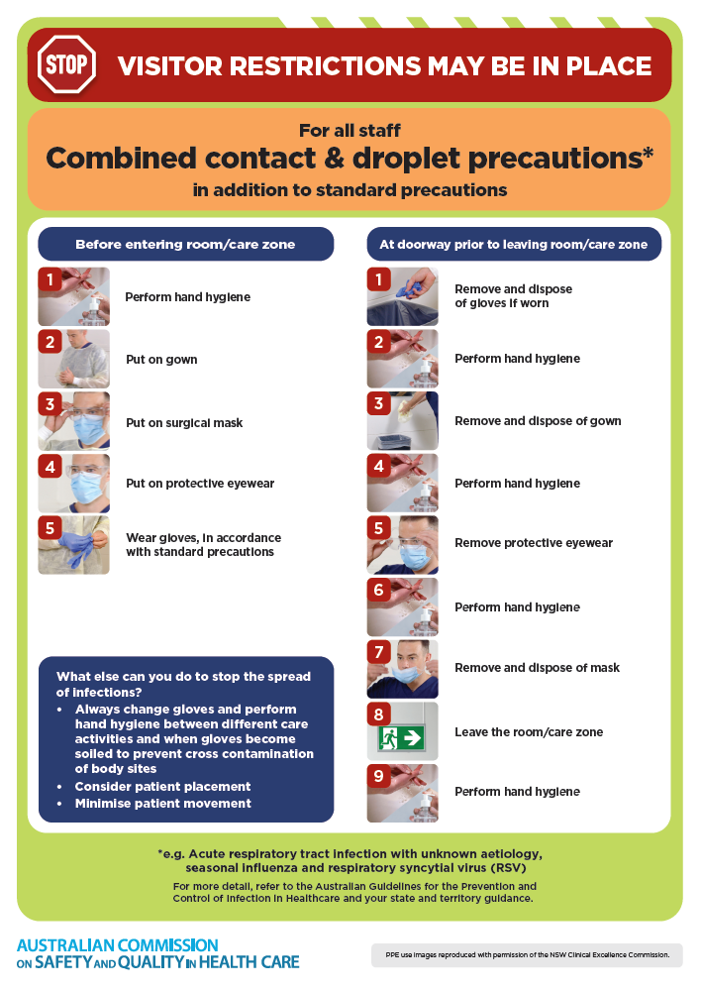](https://www.safetyandquality.gov.au/publications-and-resources/resource-library/infection-prevention-and-control-poster-combined-contact-and-droplet-precautions)
* ***Poster – Combined airborne and contact precautions*** <https://www.safetyandquality.gov.au/publications-and-resources/resource-library/poster-combined-airborne-and-contact-precautions>   
  [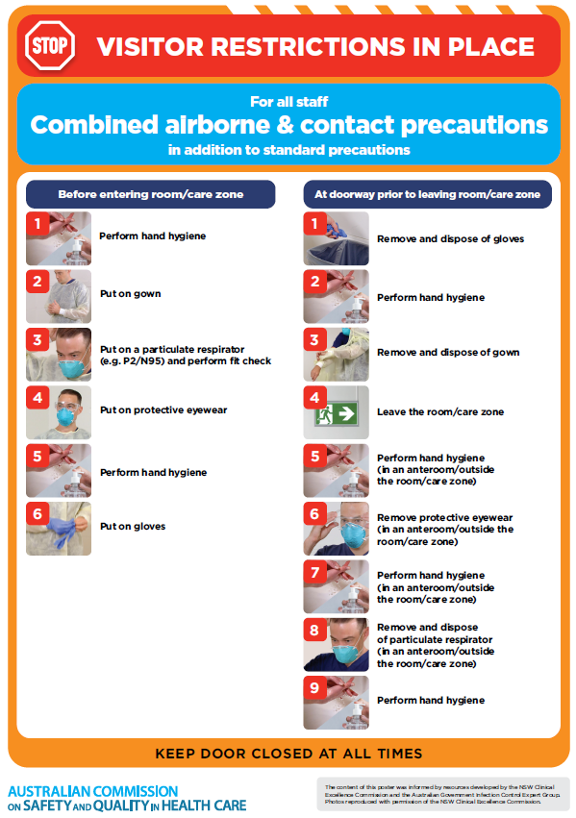](https://www.safetyandquality.gov.au/publications-and-resources/resource-library/poster-combined-airborne-and-contact-precautions)
* ***Environmental Cleaning and Infection Prevention and Control*** [www.safetyandquality.gov.au/environmental-cleaning](http://www.safetyandquality.gov.au/environmental-cleaning)
* ***COVID-19 infection prevention and control risk management – Guidance*** <https://www.safetyandquality.gov.au/publications-and-resources/resource-library/covid-19-infection-prevention-and-control-risk-management-guidance>
* ***Safe care for people with cognitive impairment during COVID-19***<https://www.safetyandquality.gov.au/our-work/cognitive-impairment/cognitive-impairment-and-covid-19>
* ***Stop COVID-19: Break the chain of infection*** posterhttps://www.safetyandquality.gov.au/publications-and-resources/resource-library/break-chain-infection-poster-a3  
  **[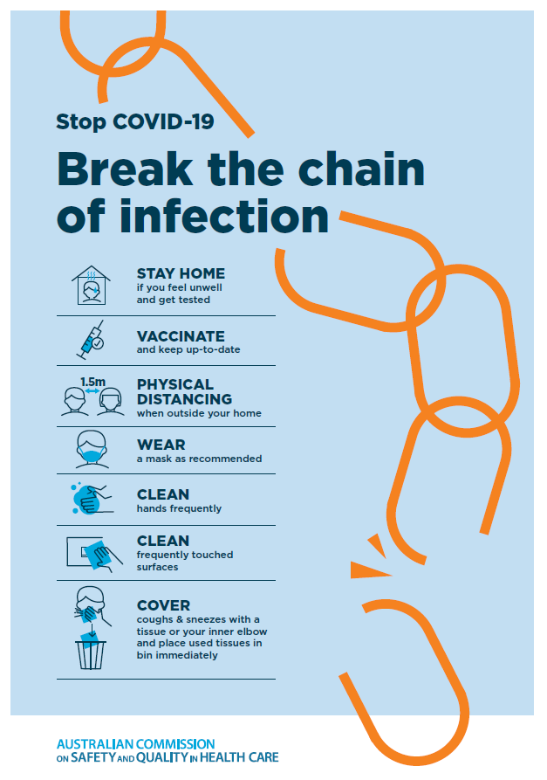](https://www.safetyandquality.gov.au/publications-and-resources/resource-library/break-chain-poster-a3https:/www.safetyandquality.gov.au/publications-and-resources/resource-library/break-chain-poster-a3)**
* ***COVID-19 and face masks – Information for consumers*** <https://www.safetyandquality.gov.au/publications-and-resources/resource-library/covid-19-and-face-masks-information-consumers>

[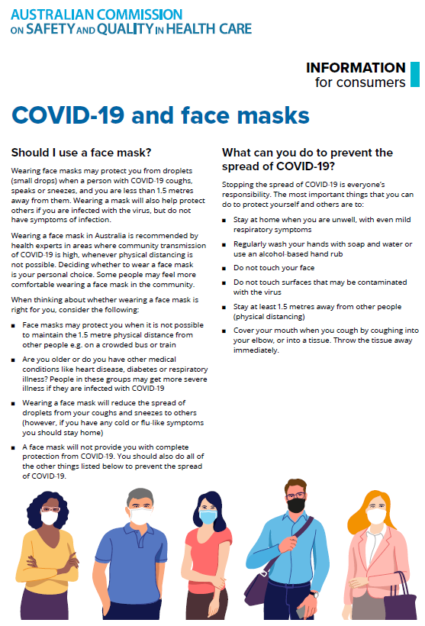](https://www.safetyandquality.gov.au/sites/default/files/2020-07/covid-19_and_face_masks_-_information_for_consumers.pdf)

*National Clinical Evidence Taskforce*

<https://clinicalevidence.net.au/>

The National Clinical Evidence Taskforce is a multi-disciplinary collaboration of 35 member organisations – Australia’s medical colleges and peak health organisations – who share a commitment to provide national evidence-based treatment guidelines for urgent and emerging diseases.

This alliance established the world’s first ‘living guidelines’ for the care of people with COVID-19 and MPX.

Funding has now been discontinued for the National Clinical Evidence Taskforce and the COVID-19 guidelines as of 30 June 2023.

These guidelines are no longer continually updated but will remain online until the guidance becomes inaccurate and/or no longer reflects the evidence or recommended practice.

**Disclaimer**

On the Radar is an information resource of the Australian Commission on Safety and Quality in Health Care. The Commission is not responsible for the content of, nor does it endorse, any articles or sites listed. The Commission accepts no liability for the information or advice provided by these external links. Links are provided on the basis that users make their own decisions about the accuracy, currency and reliability of the information contained therein. Any opinions expressed are not necessarily those of the Australian Commission on Safety and Quality in Health Care.