# Australian Commission on Safety and Quality logotypeOn the Radar

Issue 644

8 April 2024

*On the Radar* is a summary of some of the recent publications in the areas of safety and quality in health care. Inclusion in this document is not an endorsement or recommendation of any publication or provider. Access to particular documents may depend on whether they are Open Access or not, and/or your individual or institutional access to subscription sites/services. Material that may require subscription is included as it is considered relevant.

*On the Radar* is available online, via email or as a PDF or Word document from <https://www.safetyandquality.gov.au/newsroom/subscribe-news/radar>

If you would like to receive *On the Radar* via email, you can subscribe on our website <https://www.safetyandquality.gov.au/newsroom/subscribe-news>  
or by emailing us at H[Umail@safetyandquality.gov.auU](mailto:mail@safetyandquality.gov.au).  
You can also send feedback and comments to H[Umail@safetyandquality.gov.auU](mailto:mail@safetyandquality.gov.au).

For information about the Commission and its programs and publications, please visit <https://www.safetyandquality.gov.au>

w

**On the Radar**

Editor: Dr Niall Johnson [niall.johnson@safetyandquality.gov.au](mailto:niall.johnson@safetyandquality.gov.au)

Contributors: Niall Johnson, Amy Forsyth, Jeff Elliott

[](https://safetyandquality.tv/psychotropics-ccs/)

**Launch of Clinical Care Standard for psychotropic medicines**

Join our webcast to hear experts discuss informed consent, adequate assessment, best use of non-medication strategies and how to optimise safety when psychotropic medicines are considered necessary.

Psychotropic medications are frequently prescribed to people who live with cognitive disability or impairment – and are often used to manage behaviours of concern, despite the lack of evidence that they are effective for this purpose.

**When**: Thursday 9 May 12:00 – 1:00 pm AEST

**Register Now** <https://safetyandquality.tv/psychotropics-ccs/>

**Expert panellists**

Award-winning ABC journalist Tegan Taylor will host an expert panel including:

* Conjoint Associate Professor Carolyn Hullick – Chief Medical Officer, Australian Commission on Safety and Quality in Health Care
* Associate Professor Juanita Breen – Dementia Research, University of Tasmania
* Professor Eddy Strivens AM PSM – Geriatrician and Clinical Director, Cairns and Hinterland Hospital and Health Service
* Professor Julian Trollor – Chair, Intellectual Disability Mental Health, University of New South Wales.

This event is relevant to all healthcare workers involved in providing care to people with cognitive disability or impairment.

The standard was developed following a [Joint Statement](https://www.safetyandquality.gov.au/publications-and-resources/resource-library/joint-statement-inappropriate-use-psychotropic-medicines-manage-behaviours-people-disability-and-older-people) between the Australian Commission on Safety and Quality in Health Care, the Aged Care Quality and Safety Commission and the NDIS Quality and Safeguards Commission, outlining their commitment to working together to reduce the inappropriate use of psychotropic medicines.

For more information visit <https://www.safetyandquality.gov.au/psychotropics-ccs>

**Reports**

*Impact Wellbeing™ Guide: Taking Action to Improve Healthcare Worker Wellbeing*

National Institute for Occupational Safety and Health (NIOSH)

Washington DC: U.S. Department of Health and Human Services, Centers for Disease Control and Prevention, National Institute for Occupational Safety and Health,; 2024. p. 95.

|  |  |
| --- | --- |
| DOI | <https://doi.org/10.26616/NIOSHPUB2024109> |
| Notes | The US Centers for Disease Control and Prevention’s (CDC) National Institute for Occupational Safety and Health (NIOSH) have released this evidence-informed and actionable guide for the nation’s hospital leaders to improve healthcare worker wellbeing. The Guide includes six evidence-informed Actions designed to improve the professional wellbeing of healthcare workers and strengthen hospital operations. Each Action offers useful background information and tools to equip hospital leaders to complete all steps. The activities culminate in a long-term wellbeing plan.  The Guide's Six Actions include:   1. Review Your Hospital’s Operations 2. Build Your Professional Wellbeing Team 3. Break Down Barriers for Help-Seeking 4. Communicate Your Commitment to Professional Wellbeing 5. Integrate Professional Wellbeing into Quality Improvement 6. Develop Your Long-Term Professional Wellbeing Plan. |

*Osteoporosis prevention, diagnosis and management postmenopausal women and men over 50 years of age. 3rd ed*

The Royal Australian College of General Practitioners and Healthy Bones Australia

East Melbourne: RACGP; 2024. p. 160.

|  |  |
| --- | --- |
| URL | <https://www.racgp.org.au/clinical-resources/clinical-guidelines/key-racgp-guidelines/view-all-racgp-guidelines/osteoporosis/executive-summary> |
| Notes | The Royal Australian College of General Practitioners (RACGP) and Healthy Bones Australia have produced this evidence update prompted by the accumulation of high-quality evidence supporting changes to clinical practice over the past five years, the need for expert consensus and opinion, and new developments in the pharmacological management of osteoporosis, especially the role of osteoanabolic therapies. The guide is designed to provide clear, evidence-based recommendations to assist Australian general practitioners (GPs) in managing patients over 50 years of age with poor bone health, including osteopenia and osteoporosis. |

*Finger on the Pulse: The State of Primary Care in the U.S. and Nine Other Countries*

Gumas ED, Lewis C, Horstman C, Gunja MZ

New York: Commonwealth Fund; 2024.

|  |  |
| --- | --- |
| DOI | <https://doi.org/10.26099/p3y4-5g38> |
| Notes | The Commonwealth Fund in the USA conducts regular surveys of the health systems in a group of high-income nations, including Australia. This Issue Brief provides a comparative view of the primary care landscape in 10 high-income nations.  The findings on Australia include:   * 94% of adults reported having a regular doctor or place to go for care * 45% of adults reported having a longstanding relationship with a primary care provider * 67% of adults reported they “always” or “often” have their regular doctor helps coordinate or arrange care received from other doctors and places * 53% of primary care providers report they “usually” receive information from the specialist about changes to their patient’s medication or care plan * 2% of primary care physicians reporting having ‘high telehealth use’ * 78% of of primary care providers report making home visits “frequently” or “occasionally” * 82% of primary care providers report having after-hours arrangements * 13% of primary care providers report screening their patients for social needs * 82% of primary care providers reported at least one “major” challenge in coordinating their patients’ care with social services * 99% of primary care providers said their practice was “well” or “somewhat” prepared to manage care for patients with behavioural health needs. |

*Strengthening Health Systems: A Practical Handbook for Resilience Testing*

Zimmermann J, McKee C, Karanikolos M, Cylus J and members of the OECD Health Division. Strengthening Health

Copenhagen: WHO Regional Office for Europe (on behalf of the European Observatory on Health Systems and Policies,

OECD Publishing, Paris; 2024.

|  |  |
| --- | --- |
| DOI | <https://doi.org/10.1787/3a39921e-en> |
| Notes | In the foreword to this handbook it is observed that ‘The COVID-19 pandemic taught us a hard lesson about the importance of resilient and responsive health systems. This handbook was born out of necessity and urgency to improve our health systems’ capacity to respond to adverse events: not just pandemics, but also other “shocks” or crises that may be related to societal challenges, economic downturns, antimicrobial resistance or climate change.’  The WHO, European Observatory on Health Systems and Policies and OECD have produced this handbook to provide health policy makers with tools to assess and enhance their systems' resilience. This is intended to foster policy dialogues and the identification of structural weaknesses as the starting point for targeted investments and remedial policies that will allow health systems to withstand the impact of future shocks more effectively. |

**Journal articles**

*Medication Errors in Pediatric Emergency Departments: A Systematic Review and Recommendations for Enhancing Medication Safety*

Alsabri M, Eapen D, Sabesan V, Tarek Hassan Z, Amin M, Elshanbary AA, et al

Pediatric Emergency Care. 2024;40(1):58-67.

|  |  |
| --- | --- |
| DOI | <https://doi.org/10.1097/PEC.0000000000003108> |
| Notes | Paper on a systematic review that identified six studies of medication errors in paediatric emergency care. Focused on 6 studies, the authors report finding: ‘**Medication errors in P-EDs are prevalent**, ranging from **10% to 15%,** with **dosing errors being the most common**, accounting for 39% to 49% of reported errors. These errors primarily stem from **inaccurate weight estimations or dosage miscalculations**.  Inadequate dosing frequency and documentation also contribute significantly to medication errors.  Commonly implicated medications include acetaminophen, analgesics, corticosteroids, antibiotics, bronchodilators, and intravenous fluids.  Most errors are categorized as insignificant/mild (51.7% to 94.5%) or moderate (47.5%).  Risk factors associated with medication errors in P-EDs include less experienced physicians, severely ill patients, and weekend/specific-hour ordering.’ |

For information on the Commission’s work on medication safety, see <https://www.safetyandquality.gov.au/our-work/medication-safety>

*A multicentre observational study to investigate feasibility of a direct oral penicillin challenge in de-labelling ‘low risk’ patients with penicillin allergy by non-allergy healthcare professionals (SPACE study): Implications for healthcare systems*

Krishna MT, Bhogal R, Ng BY, Kildonaviciute K, Jani YH, Williams I, et al

Journal of Infection. 2024;88(3):106116.

|  |  |
| --- | --- |
| DOI | <https://doi.org/10.1016/j.jinf.2024.01.015> |
| Notes | Penicillin allergy is commonly reported but may not always be present. The authors of this piece note that ‘The huge burden of inaccurate penicillin allergy labels (PALs) is an important driver of antimicrobial resistance’ and this ‘s is magnified by insufficient allergy specialists and lack of ‘point-of-care’ tests’. This paper reports on a study into the ‘feasibility of non-allergy healthcare professionals (HCPs) delivering direct oral penicillin challenges (DPCs) for penicillin allergy de-labelling.’ Of the patients approached in the study, 126 ‘low risk patients underwent DPC, 122 (96.8%) were de-labelled with no serious allergic reactions.’ The authors state the DPCs can be delivered by non-allergy healthcare professionals and that the safety and simplicity of DPCs lends itself to adoption, even in settings with limited resources. |

*Pay-for-performance and patient safety in acute care: a systematic review*

Slawomirski L, Hensher M, Campbell J, deGraaff B

Health Policy. 2024:105051.

|  |  |
| --- | --- |
| DOI | <https://doi.org/10.1016/j.healthpol.2024.105051> |
| Notes | Paper reporting on a systematic review undertaken by an Australian team that sought to examine pay-for-performance (p4p) and patient safety in acute (hospital) care. The review team sifted 6122 potential titles to foce on 53 from which they identified only five system-wide p4p initiatives targeting hospital patient safety had been implemented. Of these, only one initiative was observed to improve patient outcomes, this was ‘the Fragility Hip Fracture Best Practice Tariff (BPT) in England, where sustained improvement was observed across various evaluations.’ Further, they observe that ‘All policies had a miniscule impact on total hospital revenue’ and that ‘Our findings suggest the importance of simplicity and transparency in policy design, involvement of the clinical community, explicit links to other quality improvement initiatives, and gradual implementation.’ |

*Inter-Hospital Transfer Is an Independent Risk Factor for Hospital-Associated Infection*

Gardner C, Rubinfeld I, Gupta AH, Johnson JL

Surgical Infections. 2023;25(2):125-132.

|  |  |
| --- | --- |
| DOI | <https://doi.org/10.1089/sur.2023.077> |
| Notes | Transitions of care are recognised as having potential for various forms of lapse, miscommunication and harm. This US study examined the role of inter-hospital transfer on hospital-associated infections (HAI) rates in surgical patients. The study used data on adult surgical inpatients ‘from a five-hospital health system administration registry containing encounters from 2014 to 2021’. The rate of cohort of 92,832 patients included 3,232 (3.5%) who were transfers. The authors report an increased risk-adjusted rate for HAI in transferred surgical patients compared with non-transferred patients. These infections then contribute to an increased financial burden. |

For information on the Commission’s work on health-association infection, see <https://www.safetyandquality.gov.au/our-work/healthcare-associated-infection-program>

*The association between nurse staffing and quality of care in emergency departments: A systematic review*

Drennan J, Murphy A, McCarthy VJC, Ball J, Duffield C, Crouch R, et al

International Journal of Nursing Studies. 2024;153:104706.

|  |  |
| --- | --- |
| DOI | <https://doi.org/10.1016/j.ijnurstu.2024.104706> |
| Notes | The issue of nursing staffing levels and any relationship to care and outcomes has been debated. This paper reports on a systematic review that sought to examine the relationship between nurse staffing, skill-mix and quality of care in emergency departments (EDs). Focussed on 16 studies, the authors that, while limited, ‘The evidence reviewed identified that poorer staffing levels within emergency departments are associated with increased patient wait times, a higher proportion of patients who leave without being seen and an increased length of stay. Lower levels of nurse staffing are also associated with an increase in time to medications and therapeutic interventions, and increased risk of cardiac arrest within the emergency department.’ |

*BMJ Quality & Safety*

Volume 33, Issue 4, April 2024

|  |  |
| --- | --- |
| URL | <https://qualitysafety.bmj.com/content/33/4> |
| Notes | A new issue of *BMJ Quality & Safety* has been published. Many of the papers in this issue have been referred to in previous editions of *On the Radar* (when they were released online). Articles in this issue of *BMJ Quality & Safety* include:   * Editorial: Lost in translation: does measuring ‘adherence’ to the **Surgical Safety Checklist** indicate true implementation fidelity? (Brigid M Gillespie, Justin Bradley Ziemba) * Editorial: Elusive but hopefully not illusive: **coordinating care for patients with heart failure** with preserved ejection fraction (Carol Sinnott, Rajesh Vedanthan, Josefien van Olmen) * Editorial: Effective use of **interdisciplinary approaches in healthcare quality**: drawing on operations and visual management (Nicola Bateman) * Editorial: **Intrapartum electronic fetal monitoring**: imperfect technologies and clinical uncertainties—what can a human factors and social science approach add? (Jane Sandall) * CheckPOINT: a simple tool to measure **Surgical Safety Checklist** implementation fidelity (Rachel Moyal-Smith, James C Etheridge, Nathan Turley, Shu Rong Lim, Yves Sonnay, Sarah Payne, Henriette Smid-Nanninga, Rishabh Kothari, William Berry, Joaquim Havens, Mary E Brindle) * Informing understanding of **coordination of care for patients with heart failure** with preserved ejection fraction: a secondary qualitative analysis (Rosalie Brooman-White, Thomas Blakeman, Duncan McNab, C Deaton) * Why is safety in **intrapartum electronic fetal monitoring** so hard? A qualitative study combining human factors/ergonomics and social science analysisEditor's Choice (Guillaume Lamé, Elisa Giulia Liberati, Aneurin Canham, Jenni Burt, Lisa Hinton, Tim Draycott, Cathy Winter, Francesca Helen Dakin, Natalie Richards, Lucy Miller, Janet Willars, M Dixon-Woods) * How to **co-design a prototype of a clinical practice tool**: a framework with practical guidance and a case study (Matthew Woodward, Mary Dixon-Woods, Wendy Randall, Caroline Walker, Chloe Hughes, Sarah Blackwell, Louise Dewick, Rachna Bahl, Tim Draycott, Cathy Winter, Akbar Ansari, Alison Powell, Janet Willars, Imogen A F Brown, Annabelle Olsson, Natalie Richards, Joann Leeding, Lisa Hinton, Jenni Burt, Giulia Maistrello, Charlotte Davies, Thiscovery Authorship Group, ABC Contributor Group, Jan W van der Scheer) * Practice or perfect? Coaching for a **growth mindset to improve the quality of healthcare** (Laura Desveaux, Noah Ivers) |

*The Joint Commission Journal on Quality and Patient Safety*

Volume 50, Issue 4, April 2024

|  |  |
| --- | --- |
| URL | <https://www.sciencedirect.com/journal/the-joint-commission-journal-on-quality-and-patient-safety/vol/50/issue/4> |
| Notes | A new issue of *The Joint Commission Journal on Quality and Patient Safety* has been published. Articles in this issue of *The Joint Commission Journal on Quality and Patient Safety* include:   * Editorial: **Implementing Multiple Digital Technologies in Health Care**: Seeing the Unintended Consequences for Patient Safety (James Shaw, Payal Agarwal, Onil Bhattacharyya) * Implementation of a **Continuous Patient Monitoring System** in the Hospital Setting: A Qualitative Study (Masha Kuznetsova, Alice Y. Kim, Darren A Scully, Paula Wolski, ... Patricia C. Dykes) * **Standardizing Patient Safety Event Reporting** between Care Delivered or Purchased by the Veterans Health Administration (VHA) (Amy K Rosen, Erin Beilstein-Wedel, Jeffrey Chan, Ann Borzecki, ... Michael Shwartz) * National Survey of **Patient Safety Experiences in Hospital Medicine** **During the COVID-19 Pandemic** (Danielle Carter, Amanda Rosen, Jo R Applebaum, William N Southern, ... Jason S Adelman) * Opinions of Nurses and Physicians on a **Patient, Family, and Visitor Activated Rapid Response System** in Use Across Two Hospital Settings (Lindy King, Stanislav Minyaev, Hugh Grantham, Robyn A Clark) * Harnessing **In Situ Simulation to Identify Human Errors and Latent Safety Threats** in Adult Tracheostomy Care (Brooke Hassan, Marc-Mina Tawfik, Elliot Schiff, Roxanna Mosavian, ... Christina J Yang) * Evaluation of Objective **Appropriateness Criteria for Daily Labs** in General Medicine Inpatients (Caleb J Murphy, Justin S Bauzon, Wilson Chan, Vishvaas Ravikumar, Sandhya Wahi-Gururaj) * Leveraging Health Systems to Expand and Enhance **Antibiotic Stewardship in Outpatient Settings** (Raphaelle H Rodzik, Whitney R Buckel, Adam L Hersh, Lauri A Hicks, ... Rachel M Zetts) |

*Journal of Patient Safety*

Volume 20, Number 3, April 2024

|  |  |
| --- | --- |
| URL | <https://journals.lww.com/journalpatientsafety/toc/2024/04000> |
| Notes | A new issue of the *Journal of Patient Safety* has been published. Articles in this issue of the *Journal of Patient Safety* include:   * The Effectiveness of Public Awareness Initiatives Aimed at Encouraging the **Use of Evidence-Based Recommendations by Health Professionals**: A Systematic Review (Esther Jie Tian, Cathy Nguyen, Lilian Chung, Chloe Morris, Saravana Kumar * **Vulnerability to Decubitus Ulcers** and Their Association With Healthcare Utilization: Evidence From Nationwide Inpatient Sample Dataset From 2016 to 2020 in US Hospitals (Sun Jung Kim, Mar Medina, Kaci Hotz, Juliy Kim, Jongwha Chang) * Trend Analysis of **Inpatient Medical Adverse Events in Taiwan** (2014–2020): Findings From Taiwan Patient Safety Reporting System (Dulmaa Munkhtogoo, Yueh-Ping Liu, Sheng-Hui Hung, Pi-Tuan Chan, Chih-Hung Ku, Chung-Liang Shih, Pa-Chun Wang) * Patients’ Experiences of **Dental Diagnostic Failures**: A Qualitative Study Using Social Media (Enihomo Obadan-Udoh, Rachel Howard, Luke Carmichael Valmadrid, Muhammad Walji, Elizabeth Mertz) * The Impact of Adding a 2-Way **Video Monitoring System on Falls** and Costs for High-Risk Inpatients (Marie Anne Sosa, Marcio Soares, Samira Patel, Kimberly Trujillo, Doreen Ashley, Elizabeth Smith, Bhavarth Shukla, Dipen Parekh, Tanira Ferreira, Hayley B. Gershengorn) * **Medication Management** Strategies by Community-Dwelling Older Adults: A Multisite Qualitative Analysis (Fatoumata Jallow, Elisa Stehling, Zara Sajwani-Merchant, Kathryn M Daniel, Kimberly G Fulda, Ayse P Gurses, Alicia I Arbaje, Yan Xiao) * Impact of Repeated Reimbursement Penalties on **Hospital Total Quality Scores** (Alice Brewer, M Courtney Hughes, Kunal N Patel) * An Analysis of Incident Reports Related to **Electronic Medication Management**: How They Change Over Time (Madaline Kinlay, Wu Yi Zheng, Rosemary Burke, Ilona Juraskova, Lai Mun (Rebecca) Ho, Hannah Turton, Jason Trinh, Melissa T Baysari) * Evaluating **Independent Double Checks** in the Pediatric Intensive Care Unit: A Human Factors Engineering Approach (Leah Konwinski, Caryn Steenland, Kayla Miller, Brian Boville, Robert Fitzgerald, Robert Connors, Elizabeth Sterling, Alicia Stowe, Surender Rajasekaran) * Multi-Institution Survey of Accepting Physicians’ Perception of Appropriate Reasons for **Interhospital Transfer**: A Mixed-Methods Evaluation (Khanh T Nguyen, Tiffany M Lee, Stephanie K Mueller) * Improving **Direct Admissions to Internal Medicine Services** (Seth Scheetz, Micah Prochaska, Rukmini Roy, Khanh T Nguyen) * Availability Bias: The Peril of Modern **Patient Safety Reviews** (Benjamin Vipler) |

*Public Health Research & Practice*

Volume 34, Issue 1, April 2024

|  |  |
| --- | --- |
| URL | <https://www.phrp.com.au/issues/april-2024-volume-34-issue-1/> |
|  | A new issue of *Public Health Research & Practice* has been published with a theme of ‘Collaborative partnerships for prevention: health determinants, systems and impact’. Articles in this issue of *Public Health Research & Practice* include:   * Editorial: Collaboration for advancing **chronic disease prevention** research, practice, and policy (Shaan S Naughton, Briony Hill, Cheryce L Harrison) * Supporting the next generation of **prevention research leaders** to conduct effective research-policy partnerships (Briony Hill, Lucie Rychetnik, Meghan Finch, Shaan Naughton, Alix Hall, Konsita Kuswara, Vicki Brown, Cheryce L Harrison, Helen Skouteris) * **Consumer and community involvement in preventive health**: current insights and considerations for future best practice (Bonnie R Brammall, Helena J Teede, Ashley H Ng, Rhonda M Garad, Sandy Reeder, Angela Jones, Cheryce L Harrison) * How much is invested in **obesity prevention** in Australia? An analysis of major research and Federal Government funding, 2013–2022 (Huong Ngoc Quynh Tran, Moosa Al Subhi, Nicole Ward, Phuong Nguyen, Marufa Sultana, Jaithri Ananthapavan, Vicki Brown) * A systems approach to assist **policy action to prevent falls** among community-dwelling older people in Australia (Nathalia Costa, Meghan Ambrens, Kim Delbaere, Louise Wilson, Ang Li, Catherine Sherrington) * **Australian healthy retail policies in hospital settings** – a policy analysis and scoping review of potential impacts on dietary behaviours (Huong Ngoc Quynh Tran, Shannon Krattli, Nicole Ward, Jaithri Ananthapavan) * **Tobacco control interventions** for populations living in subsidised, low-income housing: a scoping review (Germaine Lai, Kylie Morphett, Driss Ait Ouakrim, Kate E Mason, Samantha Howe, Vaughan W Rees, Stephen Li, Coral Gartner) * Evaluating **portable air cleaner effectiveness in residential settings** to reduce exposures to biomass smoke resulting from prescribed burns (Amanda J Wheeler, Fabienne Reisen, Christopher T Roulston, Martine Dennekamp, Nigel Goodman, Fay H Johnston) * Experiences of **research-policy engagement in policy-making** processes (Carmel Williams, Tahna Pettman, Ian Goodwin-Smith, Yonatal M Tefera, Somayya Hanifie, Katherine L Baldock) * Use of targeted SMS messaging to encourage **COVID-19 oral antiviral uptake** in South West Victoria (Naomi E Clarke, Jessica O'Keeffe, Arvind Yerramilli, Caroline Bartolo, Nomvuyo Mothobi, Michael Muleme, Bridgette J McNamara, Daniel P O'Brien, Eugene Athan, Mohammad Akhtar Hussain) * **Environmental assessments in the workplace:** an analysis of workplace wellbeing facilities for people of reproductive age (Seonad K Madden, Briony Hill, Andrew P Hills, Helen Skouteris, Claire Blewitt, Kiran DK Ahuja) * Building **prevention research science communication and knowledge translation** capacity through multidisciplinary collaboration (Shaan S Naughton, Konsita Kuswara, Ainsley E Burgess, Helen C Dinmore, Cindy Jones, Karen Metcalfe, Heidi Turon, Helen Signy) * Collaborating with end-users in evidence synthesis: case studies for **prevention in the first 2000 days** (Alexandra Chung, Konsita Kuswara, Brittany J Johnson, Anna Lene Seidler, Alix Hall, Vicki Brown) |

*Nursing Leadership*

Volume 36, Number 3, 2024

|  |  |
| --- | --- |
| URL | <https://www.longwoods.com/publications/nursing-leadership/27286/1/vol.-36-no.-3-2024> |
| Notes | A new issue of *Nursing Leadership* has been published. Articles in this issue of *Nursing Leadership* include:   * **Big Challenges Meet Big Leadership** in 2024 (Ruth Martin-Misener) * Creating a Dual Degree: **Nursing Education** Goes Global (Lorna Butler, Karen Ursel, Judith Angelitta Noronha, Jessica Webster, Linu Sara George and Stephen VanSluke) * Insights on a **National Safety Improvement Learning Collaborative**: Using the Consolidated Framework for Implementation Research (Lianne Jeffs, Rui Lin Zeng, Frances Bruno, Noah Schonewille, Marie Oliveira, Kim Kinder, Maryanne D'Arpino, Gina De Souza and Ross G. Baker) * Leaders’ Role in Fostering a **Just Culture** (Laura Danielle Pozzobon, Kim Sears and Aleksandra Zuk) * A Compendium of **Clinical Nurse Specialist Roles** in a Canadian Health Authority (Tannis Andersen, Shannon Paul-Jost, Allyson Thomas, Sherry Miyashita, Vicki Kennedy and Amanda Lavigne) * Moving Beyond Ignorance and Epistemic Violence: **Indigenous Health Nurses’ Response to Systems Transformation**\* (Colleen Seymour, Mona Lisa Bourque Bearskin, Liquaa Wazni, Rose Melnyk, Nikki Rose Hunter Porter and Michelle Padley) |

*Health Affairs*

Volume 43, Number 4, April 2024

|  |  |
| --- | --- |
| URL | <https://www.healthaffairs.org/toc/hlthaff/43/4> |
| Notes | A new issue of *Health Affairs* has been published with the theme ‘Perinatal Mental Health & Well-Being’. Articles in this issue of *Health Affairs* include:   * **Perinatal Mental Health**: The Need For Broader Understanding And Policies That Meet The Challenges (Emily C Dossett, Alison Stuebe, Twylla Dillion, and Karen M Tabb) * Cultivating **Vital Conditions For Perinatal Well-Being And A Sustained Commitment To Reproductive Justice** (Alison Stuebe, Anna Creegan, Francoise Knox-Kazimierczuk, Meredith C Smith, Sabia Wade, and K Tully) * **Perinatal Depression** Associated With Increased **Pediatric Emergency Department Use** And Charges In The First Year Of Life (Slawa Rokicki) * Racial And Ethnic Inequities In **Postpartum Depressive Symptoms, Diagnosis, And Care** In 7 US Jurisdictions (Sarah C Haight, Jamie R Daw, C L Martin, K Sheffield-Abdullah, S Verbiest, B W Pence, and J Maselko) * **Perinatal Mood And Anxiety Disorders** Rose Among Privately Insured People, 2008–20 (Kara Zivin, Andrea Pangori, Xiaosong Zhang, Anca Tilea, S V Hall, A Vance, V K Dalton, A Schroeder, A Courant, and K M Tabb) * **Perinatal Posttraumatic Stress Disorder Diagnoses** Among Commercially Insured People Increased, 2008–20 (Stephanie V Hall, Sarah Bell, Anna Courant, Lindsay K Admon, and Kara Zivin) * Antidepressant Prescriptions Increased For Privately Insured People With **Perinatal Mood And Anxiety Disorder**, 2008–20 (Stephanie V Hall, Andrea Pangori, Anca Tilea, Amy Schroeder, Lindsay K Admon, and Kara Zivin) * Extended Postpartum Medicaid In Colorado Associated With Increased Treatment For **Perinatal Mood And Anxiety Disorders** (Sarah H Gordon, Sobin Lee, Maria W Steenland, Nigel Deen, and Emily Feinberg) * Social Determinants Among **Pregnant Clients With Perinatal Depression, Anxiety, Or Serious Mental Illness** (Bridgette Blebu, Ashaki Jackson, Astrid Reina, Emily C. Dossett, and Erin Saleeby) * **Integrating Mental Health In Perinatal Care**: Perspectives Of Interprofessional Clinicians (Jessica M Harrison) * Text And Telephone Screening And Referral Improved Detection And Treatment Of **Maternal Mental Health Conditions** (Constance Guille, Courtney King, Kathryn King, Ryan Kruis, Dee Ford, Lizmarie Maldonado, Paul J. Nietert, Kathleen T Brady, and Roger B Newman) * Increasing **Access To Perinatal Mental Health Care**: The Perinatal Psychiatry Access Program Model (Ana J Schaefer, Thomas Mackie, Ekaanth S Veerakumar, Radley Christopher Sheldrick, Tiffany A Moore Simas, Jeanette Valentine, Deborah Cowley, Amritha Bhat, Wendy Davis, and Nancy Byatt) * A Strategy To Support **Perinatal Mental Health** By Collaborating With Tribal Communities In Montana (Amy Stiffarm, Stephanie Morton, Dawn Gunderson, B MacLaurin, N Redvers, M Shogren, T Wright, and A Williams) * **Solutions From Mexican-Descent Perinatal Women** To Pandemic-Related Food, Mental Health, And Health And Safety Stressors (Sandraluz Lara-Cinisomo, Mary Ellen Mendy, Amy L Non, Jessica Avalos, Jacqueline Marquez, and Kimberly D’Anna-Hernandez) * Addressing **Pregnancy And Parenting In Mental Health Care**: Perspectives Of Women With Serious Mental Illness (Karissa Fenwick, Emily C Dossett, Rebecca Gitlin, Kristina Cordasco, Alison B Hamilton, and N Goodsmith) * **Perinatal Mental Health: Father Inclusion** At The Local, State, And National Levels (Tova B Walsh, and Craig F Garfield) * My Story Of **Trauma And Reproductive Health** (Angelica L. Al Janabi) |

*BMJ Quality & Safety* online first articles

|  |  |
| --- | --- |
| URL | <https://qualitysafety.bmj.com/content/early/recent> |
| Notes | *BMJ Quality &Safety* has published a number of ‘online first’ articles, including:   * Care Under Pressure 2: a realist synthesis of causes and interventions to **mitigate psychological ill health in nurses, midwives and paramedics** (Cath Taylor, Jill Maben, Justin Jagosh, Daniele Carrieri, Simon Briscoe, Naomi Klepacz, Karen Mattick) * Grand rounds in methodology: designing for integration in **mixed methods research** (Timothy C Guetterman, Milisa Manojlovich) * **Diagnostic error in mental health**: a review (Andrea Bradford, Ashley Meyer, Sundas Khan, Traber D Giardina, Hardeep Singh) * Estimating the impact on patient safety of enabling the **digital transfer of patients’ prescription information** in the English NHS (Elizabeth M Camacho, Sean Gavan, Richard Neil Keers, Antony Chuter, Rachel Ann Elliott) |

**Online resources**

***[[UK] NIHR Evidence***

https://evidence.nihr.ac.uk/

The UK’s National Institute for Health Research (NIHR) has posted new evidence alerts on its site. Evidence alerts are short, accessible summaries of health and care research which is funded or supported by NIHR. This is research which could influence practice and each Alert has a message for people commissioning, providing or receiving care. The latest alerts include:

* Children in intensive care have better outcomes with lower **oxygen targets**
* The coil and medicines are both effective long-term treatments for **heavy periods**
* MRI screening for **prostate cancer** shows promise
* **Mental health support** in schools is well-received but challenges remain
* **Irritable bowel syndrome**: low-dose antidepressant improves symptoms.

The NIHR has also produced a new Collection ***Eczema in children: uncertainties addressed***

<https://evidence.nihr.ac.uk/collection/eczema-in-children-uncertainties-addressed/>

***USA] Effective Health Care Program reports***

<https://effectivehealthcare.ahrq.gov/>

The US Agency for Healthcare Research and Quality (AHRQ) has an Effective Health Care (EHC) Program. The EHC has released the following final reports and updates:

* ***ADHD Diagnosis and Treatment*** *in Children and Adolescents* *Systematic Review* <https://effectivehealthcare.ahrq.gov/products/attention-deficit-hyperactivity-disorder/research>
* *Failure To Rescue* ***– Rapid Response Systems*** <https://effectivehealthcare.ahrq.gov/products/mhs4-failure-rescue/rapid-research>

***[USA] AHRQ Perspectives on Safety***

<https://psnet.ahrq.gov/psnet-collection/perspectives>

The US Agency for Healthcare Research and Quality (AHRQ) publishes occasional Perspectives on Safety essays. Recent essays include:

* ***Equity in Patient Safety*** <https://psnet.ahrq.gov/perspective/equity-patient-safety>
* ***Communication During Transitions of*** Care <https://psnet.ahrq.gov/perspective/communication-during-transitions-care>
* ***Cybersecurity and How to Maintain Patient Safety*** <https://psnet.ahrq.gov/perspective/cybersecurity-and-how-maintain-patient-safety>
* ***Artificial Intelligence and Patient Safety: Promise and Challenges*** <https://psnet.ahrq.gov/perspective/artificial-intelligence-and-patient-safety-promise-and-challenges>
* ***Ensuring Patient and Workforce Safety Culture in Healthcare*** <https://psnet.ahrq.gov/perspective/ensuring-patient-and-workforce-safety-culture-healthcare>

***[USA] Patient Safety Primers***

<https://psnet.ahrq.gov/primers-0>

The Patient Safety Primers from the (US) Agency for Healthcare Research and Quality (AHRQ) discuss key concepts in patient safety. Each primer defines a topic, offers background information on its epidemiology and context, and provides links to relevant materials.

* ***Inpatient Transitions of Care: Challenges and Safety Practices*** – Transitions of care occur frequently during hospitalizations and present notable risks associated with communication, medication management, and caregiver preparedness.   
  <https://psnet.ahrq.gov/primer/inpatient-transitions-care-challenges-and-safety-practices>
* ***National Patient Safety Goals*** – The National Patient Safety Goals (NPSG) were developed in response to the high prevalence of preventable medical errors in the United States.  
  <https://psnet.ahrq.gov/primer/national-patient-safety-goals>

***[USA] Ventilation Can Reduce Exposure to Respiratory Viruses in Indoor Spaces***

<https://www.cdc.gov/ncird/whats-new/ventilation-respiratory-viruses.html>

The US Centers for Disease Control and Prevention (CDC) has updated their guidance on indoor ventilation in ameliorating the impact of respiratory viruses.

**COVID-19 resources**

https://www.safetyandquality.gov.au/covid-19

The Australian Commission on Safety and Quality in Health Care has developed a number of resources to assist healthcare organisations, facilities and clinicians. These and other material on COVID-19 are available at <https://www.safetyandquality.gov.au/covid-19>

These resources include:

* ***OVID-19 infection prevention and control risk management*** This primer provides an overview of three widely used tools for investigating and responding to patient safety events and near misses. Tools covered in this primer include incident reporting systems, Root Cause Analysis (RCA), and Failure Modes and Effects Analysis (FMEA).   
  <https://www.safetyandquality.gov.au/publications-and-resources/resource-library/covid-19-infection-prevention-and-control-risk-management-guidance>
* ***Poster – Combined contact and droplet precautions*** <https://www.safetyandquality.gov.au/publications-and-resources/resource-library/infection-prevention-and-control-poster-combined-contact-and-droplet-precautions>  
  [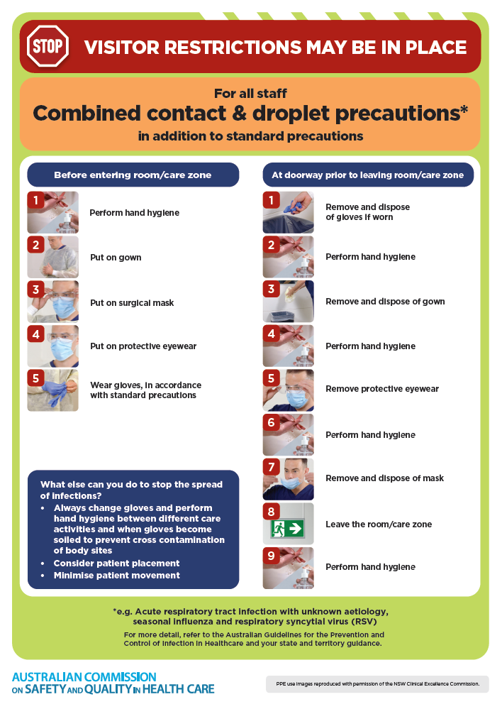](https://www.safetyandquality.gov.au/publications-and-resources/resource-library/infection-prevention-and-control-poster-combined-contact-and-droplet-precautions)
* ***Poster – Combined airborne and contact precautions*** <https://www.safetyandquality.gov.au/publications-and-resources/resource-library/poster-combined-airborne-and-contact-precautions>   
  [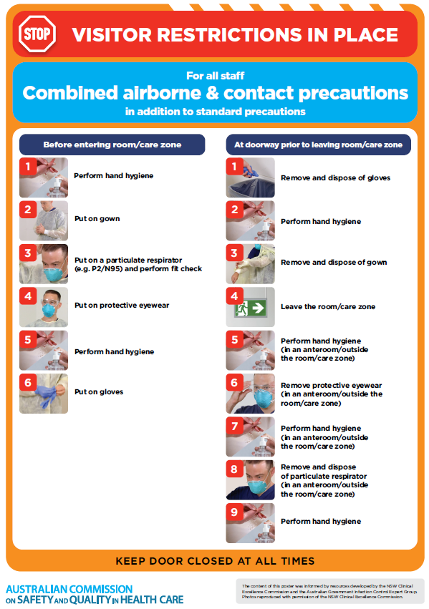](https://www.safetyandquality.gov.au/publications-and-resources/resource-library/poster-combined-airborne-and-contact-precautions)
* ***Environmental Cleaning and Infection Prevention and Control*** [www.safetyandquality.gov.au/environmental-cleaning](http://www.safetyandquality.gov.au/environmental-cleaning)
* ***COVID-19 infection prevention and control risk management – Guidance*** <https://www.safetyandquality.gov.au/publications-and-resources/resource-library/covid-19-infection-prevention-and-control-risk-management-guidance>
* ***Safe care for people with cognitive impairment during COVID-19***<https://www.safetyandquality.gov.au/our-work/cognitive-impairment/cognitive-impairment-and-covid-19>
* ***Stop COVID-19: Break the chain of infection*** posterhttps://www.safetyandquality.gov.au/publications-and-resources/resource-library/break-chain-infection-poster-a3  
  **[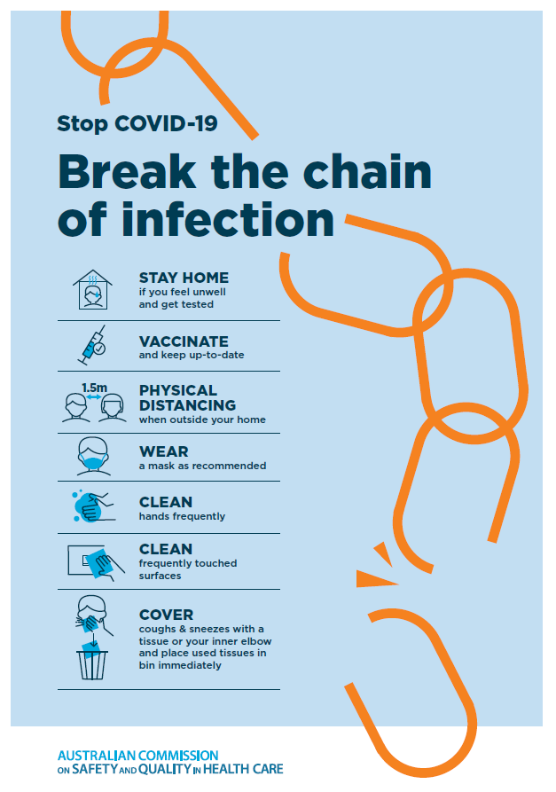](https://www.safetyandquality.gov.au/publications-and-resources/resource-library/break-chain-poster-a3https:/www.safetyandquality.gov.au/publications-and-resources/resource-library/break-chain-poster-a3)**
* ***COVID-19 and face masks – Information for consumers*** <https://www.safetyandquality.gov.au/publications-and-resources/resource-library/covid-19-and-face-masks-information-consumers>

[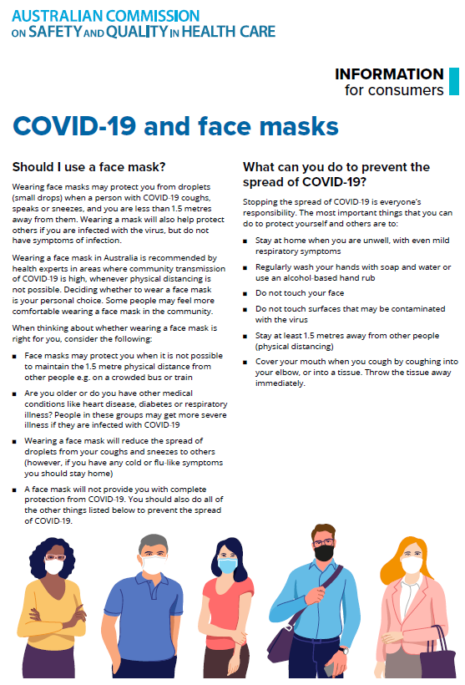](https://www.safetyandquality.gov.au/sites/default/files/2020-07/covid-19_and_face_masks_-_information_for_consumers.pdf)

*National Clinical Evidence Taskforce*

<https://clinicalevidence.net.au/>

The National Clinical Evidence Taskforce is a multi-disciplinary collaboration of 35 member organisations – Australia’s medical colleges and peak health organisations – who share a commitment to provide national evidence-based treatment guidelines for urgent and emerging diseases.

This alliance established the world’s first ‘living guidelines’ for the care of people with COVID-19 and MPX.

Funding has now been discontinued for the National Clinical Evidence Taskforce and the COVID-19 guidelines as of 30 June 2023.

These guidelines are no longer continually updated but will remain online until the guidance becomes inaccurate and/or no longer reflects the evidence or recommended practice.

**Disclaimer**

On the Radar is an information resource of the Australian Commission on Safety and Quality in Health Care. The Commission is not responsible for the content of, nor does it endorse, any articles or sites listed. The Commission accepts no liability for the information or advice provided by these external links. Links are provided on the basis that users make their own decisions about the accuracy, currency and reliability of the information contained therein. Any opinions expressed are not necessarily those of the Australian Commission on Safety and Quality in Health Care.