# Australian Commission on Safety and Quality logotypeOn the Radar

Issue 645

15 April 2024

*On the Radar* is a summary of some of the recent publications in the areas of safety and quality in health care. Inclusion in this document is not an endorsement or recommendation of any publication or provider. Access to particular documents may depend on whether they are Open Access or not, and/or your individual or institutional access to subscription sites/services. Material that may require subscription is included as it is considered relevant.

*On the Radar* is available online, via email or as a PDF or Word document from <https://www.safetyandquality.gov.au/newsroom/subscribe-news/radar>

If you would like to receive *On the Radar* via email, you can subscribe on our website <https://www.safetyandquality.gov.au/newsroom/subscribe-news>  
or by emailing us at H[Umail@safetyandquality.gov.auU](mailto:mail@safetyandquality.gov.au).  
You can also send feedback and comments to H[Umail@safetyandquality.gov.auU](mailto:mail@safetyandquality.gov.au).

For information about the Commission and its programs and publications, please visit <https://www.safetyandquality.gov.au>

w

**On the Radar**

Editor: Dr Niall Johnson [niall.johnson@safetyandquality.gov.au](mailto:niall.johnson@safetyandquality.gov.au)

Contributors: Niall Johnson

**Journal articles**

*Inappropriate Diagnosis of Pneumonia Among Hospitalized Adults*

Gupta AB, Flanders SA, Petty LA, Gandhi TN, Pulia MS, Horowitz JK, et al

JAMA Internal Medicine. 2024.

|  |  |
| --- | --- |
| DOI | <https://doi.org/10.1001/jamainternmed.2024.0077> |
| Notes | Paper reporting on a cohort study of 7 290 hospitalized adults treated for pneumonia in 48 Michigan hospitals. The study sought to examine he incidence of and factors associated with inappropriate diagnosis. The authors report finding that ‘12.0% were inappropriately diagnosed. Older patients, those with dementia, and those presenting with altered mental status had the highest risk of being inappropriately diagnosed, and for those inappropriately diagnosed, receipt of a full antibiotic duration was associated with antibiotic-associated adverse events.’ |

*Reducing Hospitalizations and Multidrug-Resistant Organisms via Regional Decolonization in Hospitals and Nursing Homes*

Gussin GM, McKinnell JA, Singh RD, Miller LG, Kleinman K, Saavedra R, et al

JAMA. 2024.

|  |  |
| --- | --- |
| DOI | <https://doi.org/10.1001/jama.2024.2759> |
| Notes | Paper reporting on a regional hospital and nursing home collaboration aimed at reducing the prevalence of multidrug-resistant organisms (MDROs) on patients' skin. The collaboration had more than 50,000 patients at 16 hospitals, 16 nursing homes, and 3 long-term acute care hospitals in California routinely undergoing chlorhexidine bathing and nasal iodophor antisepsis over a 25-month intervention period. The authors report that the collaboration ‘was associated with lower MDRO carriage, infections, hospitalizations, costs, and deaths.’ |

For information on the Commission’s work on infection prevention and control, see <https://www.safetyandquality.gov.au/our-work/infection-prevention-and-control>

*Care Under Pressure 2: a realist synthesis of causes and interventions to mitigate psychological ill health in nurses, midwives and paramedics*

Taylor C, Maben J, Jagosh J, Carrieri D, Briscoe S, Klepacz N, et al

BMJ Quality & Safety. 2024:bmjqs-2023-016468.

|  |  |
| --- | --- |
| DOI | <https://doi.org/10.1136/bmjqs-2023-016468> |
| Notes | The authors of this piece observe that ‘Nurses, midwives and paramedics comprise over half of the clinical workforce in the UK National Health Service’ and that they also ‘have some of the highest prevalence of psychological ill health’. The paper reports on a realist synthesis’ project that led to five key findings:   1. it is difficult to promote staff psychological wellness where there is a blame culture; 2. the needs of the system often over-ride staff psychological well-being at work; 3. there are unintended personal costs of upholding and implementing values at work; 4. interventions are fragmented, individual-focused and insufficiently recognise cumulative chronic stressors; and 5. it is challenging to design, identify and implement interventions.   These suggest that that there is ‘the need for healthcare organisations to rebalance the working environment to enable healthcare professionals to recover and thrive. This requires high standards for patient care to be balanced with high standards for staff psychological well-being; professional accountability to be balanced with having a listening, learning culture; reactive responsive interventions to be balanced by having proactive preventative interventions; and the individual focus balanced by an organisational focus.’ |

*Diagnostic error in mental health: a review*

Bradford A, Meyer A, Khan S, Giardina TD, Singh H

BMJ Quality & Safety. 2024.

|  |  |
| --- | --- |
| DOI | <https://doi.org/10.1136/bmjqs-2023-016996> |
| Notes | Recent years have seen increased interest in diagnosis, including diagnostic errors and harm. This review was prompted by the apparent lack of work on diagnosis in mental health and sought to summarise the current state of research and identify research opportunities. While finding that ‘diagnostic error is well understood to be a problem in mental healthcare’, the ‘lack of clear consensus on how to conceptualise, define and measure errors in diagnosis’ is a barrier. The authors suggest a focus on ‘identifying preventable missed opportunities in the diagnosis of mental disorders’. |

*Risk Assessment and Prevention of Falls in Older Community-Dwelling Adults: A Review*

Colón-Emeric CS, McDermott CL, Lee DS, Berry SD

JAMA. 2024.

*A systems approach to assist policy action to prevent falls among community-dwelling older people in Australia*

Costa N, Ambrens M, Delbaere K, Wilson L, Li A, Sherrington C

Public Health Research & Practice. 2024;34(1):e3412405.

|  |  |
| --- | --- |
| DOI | Colón-Emeric et al <https://doi.org/10.1001/jama.2024.1416>  Costa et al <https://doi.org/10.17061/phrp3412405> |
| Notes | Falls have long been – and remain – a significant cause of harm and acute admission.  Colón-Emeric et al provide a review on falls among older adults who reside in the community. The authors note that:   * More than 25% of older adults fall each year, and falls are the leading cause of injury-related death in persons aged 65 years or older. * Functional exercises to improve leg strength and balance are recommended for fall prevention in average-risk to high-risk populations. * Multifactorial risk reduction based on a systematic clinical assessment for modifiable risk factors may reduce fall rates among those at high risk.   Costa et al present a review of a selection of policy documents encompassing falls prevention among community-dwelling older adults in Australia. From their selection, the authors perceive ‘a need for a comprehensive national policy that draws upon insights from various disciplines, suggests intersectoral collaboration, addresses health inequities and involves meaningful engagement with key stakeholders.’ |

For information on the Commission’s work on falls prevention, including the *Preventing Falls and Harm from Falls in Older People: Best Practice Guidelines* 2009, see <https://www.safetyandquality.gov.au/our-work/comprehensive-care/related-topics/falls-prevention>

*Oxycodone initiation in Australia (2014–2018): Sociodemographic factors and preceding health service use*

Gillies MB, Camacho X, Bharat C, Buizen L, Blyth F, Currow D, et al

British Journal of Clinical Pharmacology. 2024.

|  |  |
| --- | --- |
| DOI | <https://doi.org/10.1111/bcp.16063> |
| Notes | The authors of this piece observe that ‘Oxycodone is the most commonly prescribed strong opioid in Australia.’ The study sought to examine oxycodone initiation in New South Wales. This was a ‘Population-based new user cohort study linking medicine dispensings, hospitalizations, emergency department visits, medical services and cancer notifications from New South Wales (NSW) for 2014–2018.’ Among the results reported were:   * Oxycodone accounted for 30% of opioid initiations. * Annually, 3% of the NSW population initiated oxycodone, and 5–6% were prevalent users; the new user cohort comprised 830 963 people. * Discharge from hospital (39.3%), therapeutic procedures (21.4%) and emergency department visits (19.7%) were common * A hospital admission for injury (6.0%) or a past-year history of cancer (7.2%) were less common. * At 1 year after initiation, 4.6% of people were using oxycodone * new use of oxycodone increased with age and was higher for people outside major cities. |

For information on the Commission’s work on medication safety, see <https://www.safetyandquality.gov.au/our-work/medication-safety>

*International Journal for Quality in Health Care*

Volume 36, Issue 1, 2024

|  |  |
| --- | --- |
| URL | <https://academic.oup.com/intqhc/issue/36/1> |
| Notes | A new issue of the *International Journal for Quality in Health Care* has been published. Articles in this issue of the *International Journal for Quality in Health Care* include:   * The development of indicators to measure the **quality of care in geriatric rehabilitation** (Bram Veneberg, Lian M J Tijsen, Maarten J Wirtz, Viola Zevenhuizen, Bianca I Buijck) * Variations in surgical practice and short-term outcomes for **degenerative lumbar scoliosis and spondylolisthesis**: do surgeon training and experience matter? (Kanaka D Shetty, Peggy G Chen, Harsimran S Brara, Neel Anand, David L Skaggs ...) * Implementing **co-production to enhance patient safety**: the introduction of the patient safety consent tool, an example of a simple local solution to a common challenge (Abdulelah Alhawsawi, David Greenfield) * Effects of gait adaptation training on augmented reality treadmill for **patients with stroke in community ambulation** (Hang Yang, Zhenzhen Gao, Ye Zhou, Zhenyi Liao, Caiping Song ...) * Are SMART goals fit-for-purpose? **Goal planning with mental health service-users** in Australian community pharmacies (Victoria Stewart, Sara S McMillan, Jie Hu, Jack C Collins, Sarira El-Den ...) * A beacon to guide others: **improving chronic disease management** through targeted, evidence-based primary healthcare quality measures (Elom Hillary Otchi, Reece Hinchcliff, David Greenfield) * Factors influencing the indication of **coronary angiography** in patients presenting with chest pain unspecified: an analysis of two decades (1994–2014) (Abel E Moreyra, Chirag Mehta, Nora M Cosgrove, Stavros Zinonos, Davit Sargsyan ...) * Co-design of an intervention to improve patient participation in **discharge medication communication** (Georgia Tobiano, Sharon Latimer, Elizabeth Manias, Andrea P Marshall, Megan Rattray ...) * The impact of **elective surgery postponement during COVID-19** on emergency bellwether procedures in a large tertiary centre in Singapore (Sze Ling Chan, Alwin Yaoxian Zhang, Sean Shao Wei Lam, Vijaya Rao, Devendra Kanagalingam ...) * **Making remote healthcare safer** (Trisha Greenhalgh, Rebecca Payne, Flora McCabe) * The care needs of the elderly in **China’s elderly care institutions**: a narrative synthesis (Rong Tan, Ruizhe Gao, Jiping Tan, Qunhui Zhu, Hua Liu ...) * Process reengineering using DMAIC framework for reduction of **waiting time in daycare infusion therapy** for better patient experience (Gopinath Mamballikalam, Deena Davis, K G Sabrish) * Multidisciplinary perspectives on **roles of hospital pharmacists in tertiary settings**: a qualitative study (Kyung Min Kirsten Lee, Ivanka Koeper, Michaela E Johnson, Amy Page, Debra Rowett ...) * Risk identification and prediction of **complaints and misconduct against health practitioners**: a scoping review (Yufeng Wang, Sanyogita (Sanya) Ram, Shane Scahill) * Best practice: quality assessment outcomes of the **Practice Enhancement Program** among family physicians in Saskatchewan, Canada (James Macaskill, Rhonda Bryce, Andries Muller) * Constructing **nursing quality indicators** for intraoperative acquired pressure injury in cancer patients based on guidelines (Yu Zhou, Lu Liu, Rong Rong, Li Guo, Yuquan Pei ...) * Engaging healthcare professionals and patient representatives in the development of a **quality model for hospitals**: a mixed-method study (Kathleen Bogaert, Melissa De Regge, Frank Vermassen, Kristof Eeckloo) * The global, regional, and national burden and quality of care index of **kidney cancer; a global burden of disease** systematic analysis 1990–2019 (Mohamad Mehdi Khadembashiri, Erfan Ghasemi, Mohammad Amin Khadembashiri, Sina Azadnajafabad, Sahar Saeedi Moghaddam ...) * Improving **compliance with personal protective equipment among anaesthetists** through behaviour-changing interventions during the coronavirus disease 2019(COVID-19) pandemic (Pamela Chia, Leonard Tang, Gerald Tse, Molly How, Loong Tat Wong ...) * Effects of a **team Quality Improvement method** in a national clinical audit programme of four clinical specialties in Ministry of Health hospitals in Saudi Arabia (Saleh Alghamdi, Nancy Dixon, Fahmi Al-Senani, Zohair Al Aseri, Shukri Al Saif ...) * Reduction in use of MRI and arthroscopy among patients with **degenerative knee disease** in independent treatment centers versus general hospitals: a time series analysis (Laurien S Kuhrij, Perla J Marang-van de Mheen, Lisanne van Lier, Razia Alimahomed, Rob G H H Nelissen ...) * Implications of absenteeism of health workers on achieving **universal health coverage in Nigeria**: exploring lived experiences in primary healthcare (Prince Agwu, Aloysius Odii, Charles Orjiakor, Pamela Ogbozor, Chinyere Mbachu ...) * Multiple case study of processes used by **hospitals to select performance indicators**: do they align with best practices? (Michael A Heenan, Glen E Randall, Jenna M Evans, Erin M Reid) * ‘The big value of it is getting the patient seen by the right person at the right time’: clinician perceptions of the value of **allied health primary contact models of care** (Caitlin Brandenburg, Elizabeth C Ward, Maria Schwarz, Michelle Palmer, Carina Hartley ...) * Increasing **venous thromboembolism risk assessment** through a whole hospital-based intervention: a pre-post service evaluation to demonstrate quality improvement (Juliana Abboud, Niaz Shaikh, Musthafa Moosa, Martin Dempster, Pauline Adair) * Editorial: **Reform of mental health systems**: what does the future look like and how to get there? (Michael Gorton, David Greenfield) * Editorial: **Resilience and regulation**—antithesis or a smart combination for future healthcare service improvement? (Sina Furnes Øyri, Jeffrey Braithwaite, David Greenfield, Siri Wiig) * Editorial: **Foundations of safety**—Realistic Medicine, t rust, and respect between professionals and patients (Siri Wiig, Hilda Bø Lyng, Jeffrey Braithwaite, David Greenfield, Catherine Calderwood) * **Health system performance assessment**: embedding resilience through performance intelligence (Dionne Kringos, Damir Ivanković, Erica Barbazza, Niek Klazinga, Óscar Brito Fernandes) |

*Australian Health Review*

Volume 48, Number 2, April 2024

|  |  |
| --- | --- |
| URL | <https://www.publish.csiro.au/ah/issue/11607> |
| Notes | A new issue of *Australian Health Review* has been published with a theme of **Value-Based Healthcare**. Articles in this issue of *Australian Health Review* include:   * From integrated care to **value-based healthcare in New South Wales** (Jillian Skinner) * The cultural shift towards **a value-based approach to healthcare** (Sally Lewis) * Is the strategy to fix **healthcare in shared value**? (Olivia Pantelidis) * An opportunity to transform **Australia’s neo-colonial health system** (Alicia E Veasey) * Poor policy and inadequate regulation of **medical technology is driving low-value** care in Australia’s private health system (Rachel David) * Creating a framework for change: transitioning to **value-based healthcare in Queensland** (Belinda Gavaghan, Jennifer Finch and Katelyn Clarke) * Driving **value-based healthcare** through a new vision for Queensland’s health system (Madeleine Wellington, Elizabeth Whiting, Damien Searle, Megan Kreis and Emily Cross) * Experiences and learnings from developing and implementing **a co-designed value-based healthcare framework** within Victorian public oral health sector (Shalika Hegde, Susan McKee, Deborah Cole and Zoe Wainer) * Designing and implementing a **bundle of care for patients with early-stage breast cancer**: lessons from a pilot program (Yvonne Zissiadis, Helen Ballal, Nicola Forsyth, Angela Ives, Lee Jackson, Anna Montgomery, Sarah Wise, Wen Chan Yeow and Christobel Saunders) * The development and implementation of the **Northern Health lung cancer digital care pathway**: a case study in service change (Rachel L Duckham, Tracey Webster and Katharine See) * Taking a **value based commissioning** approach to non-clinical and clinical support services (Trinette Kinsman, Samantha Reid and Hayley Arnott) * Measuring **clinician experience in value-based healthcare initiatives**: a 10-item core clinician experience measure (CEM-10) (Reema Harrison, Louise A Ellis, Maryam Sina, Ramya Walsan, Rebecca Mitchell, Ramesh Walpola, Glen Maberly, Catherine Chan and Liz Hay) * Marked variations in medical provider and out-of-pocket costs for **radical prostatectomy procedures** in Australia (Ramya Walsan, Rebecca J. Mitchell, Jeffrey Braithwaite, Johanna Westbrook, Peter Hibbert, Virginia Mumford and Reema Harrison) * The impact of management option on out-of-pocket costs and perceived financial burden among men with **localised prostate cancer** in Australia within 6 months of diagnosis (Daniel Lindsay, Penelope Schofield, Doreen Nabukalu, Matthew J. Roberts, John Yaxley, Stephen Quinn, Natalie Richards, Mark Frydenberg, Robert Gardiner, Nathan Lawrentschuk, Ilona Juraskova, Declan G Murphy and Louisa G Gordon) * **Hospitalisations and emergency department presentations** by older individuals accessing long-term aged care in Australia (Stephanie L Harrison, Catherine Lang, Tesfahun C Eshetie, Maria Crotty, Craig Whitehead, Keith Evans, Megan Corlis, Steve Wesselingh, Gillian E Caughey and Maria C Inacio) * Consumer perspectives of **allied health involvement in a public hospital setting**: cross-sectional survey and electronic health record review (Laura Jolliffe, Cylie M Williams, Natalie Bozyk, Taya A Collyer, Kirsten Caspers and David A Snowdon) * Development and implementation of the **Specialist Palliative Care in Aged Care (SPACE) Project** across Queensland (Rebecca Smith, Gregory Merlo, Andrew M Broadbent, Caitlin Lock, Sharon Mickan and Nicola Morgan) * **Clinical research imperatives**: principles and priorities from the perspective of Allied Health executives and managers (Susan Hillier, Duncan Lodge, Jo Nolan, Rosalie Yandell, Anna Chur-Hansen, Stacey George and Elizabeth Lynch) |

*International Journal for Quality in Health Care* online first articles

|  |  |
| --- | --- |
| URL | <https://academic.oup.com/intqhc/advance-articles> |
| Notes | *International Journal for Quality in Health Care* has published a number of ‘online first’ articles, including:   * **Co-worker unprofessional behaviour and patient safety risks**: An analysis of co-worker reports across eight Australian hospitals (Ryan D McMullan, Kate Churruca, Peter Hibbert, Ling Li, Ruby Ash, Rachel Urwin, Antoinette Pavithra, Johanna I Westbrook) * Key lessons to improve care - factors contributing to **delayed discharges** and cost implications: medical conditions and rehabilitation delays at a tertiary rehabilitation centre in Saudi Arabia (Poonam Gupta and David Greenfield) * Assessing **quality of critical care during an ongoing health emergency** in a resource-limited setting: A novel approach to evaluate the quality of care in Lebanese public ICUs during the COVID-19 pandemic. (Karim AbouNader) * **Cost-Effectiveness Evaluations** Should be Based on Trials, Not Models (Robert M Kaplan) * Integration of persistence in the **5P-Medicine Approach for age-related chronic diseases** (Joaquín Borrás-Blasco et al) |

**Online resources**

***Clinical Communiqué***

Volume 11, Issue 1, March 2024

<https://www.thecommuniques.com/post/clinical-communiqu%C3%A9-volume-11-issue-1-march-2024>

This edition of *Clinical Communiqué* examines the challenges ‘of determining **fitness to drive** in older drivers. Advancing age is associated with co-morbidities that cumulatively increase driving risk and will affect a person’s fitness to drive. Stroke, dementia, sleep disorders, mobility issues, hearing and vision impairment may warrant cessation of driving. The two cases in this edition demonstrate two main risk profiles in older drivers – the driving risks when a patient is bodily capable but easily disorientated, and the driving risks when a patient is mentally sharp but physically slow.’

***[UK] NICE Guidelines and Quality Standards***

<https://www.nice.org.uk/guidance>

The UK’s National Institute for Health and Care Excellence (NICE) has published new (or updated) guidelines and quality standards. The latest reviews or updates include:

* NICE Guideline NG137 ***Twin and triplet pregnancy*** <https://www.nice.org.uk/guidance/ng137>

***USA] Effective Health Care Program reports***

<https://effectivehealthcare.ahrq.gov/>

The US Agency for Healthcare Research and Quality (AHRQ) has an Effective Health Care (EHC) Program. The EHC has released the following final reports and updates:

* *Prevention in Adults of Transmission of* ***Infection With Multidrug-Resistant Organisms*** <https://effectivehealthcare.ahrq.gov/products/prevention-infection-mdro/rapid-research>
* *Patient Safety Practices Focused on* ***Sepsis*** *Prediction and Recognition* <https://effectivehealthcare.ahrq.gov/products/sepsis/rapid-research>

***[USA] Patient Safety Primers***

<https://psnet.ahrq.gov/primers-0>

The Patient Safety Primers from the (US) Agency for Healthcare Research and Quality (AHRQ) discuss key concepts in patient safety. Each primer defines a topic, offers background information on its epidemiology and context, and provides links to relevant materials.

* ***Long-term Care and Patient Safety***   
  <https://psnet.ahrq.gov/primer/long-term-care-and-patient-safety>

**COVID-19 resources**

https://www.safetyandquality.gov.au/covid-19

The Australian Commission on Safety and Quality in Health Care has developed a number of resources to assist healthcare organisations, facilities and clinicians. These and other material on COVID-19 are available at <https://www.safetyandquality.gov.au/covid-19>

These resources include:

* ***OVID-19 infection prevention and control risk management*** This primer provides an overview of three widely used tools for investigating and responding to patient safety events and near misses. Tools covered in this primer include incident reporting systems, Root Cause Analysis (RCA), and Failure Modes and Effects Analysis (FMEA).   
  <https://www.safetyandquality.gov.au/publications-and-resources/resource-library/covid-19-infection-prevention-and-control-risk-management-guidance>
* ***Poster – Combined contact and droplet precautions*** <https://www.safetyandquality.gov.au/publications-and-resources/resource-library/infection-prevention-and-control-poster-combined-contact-and-droplet-precautions>  
  [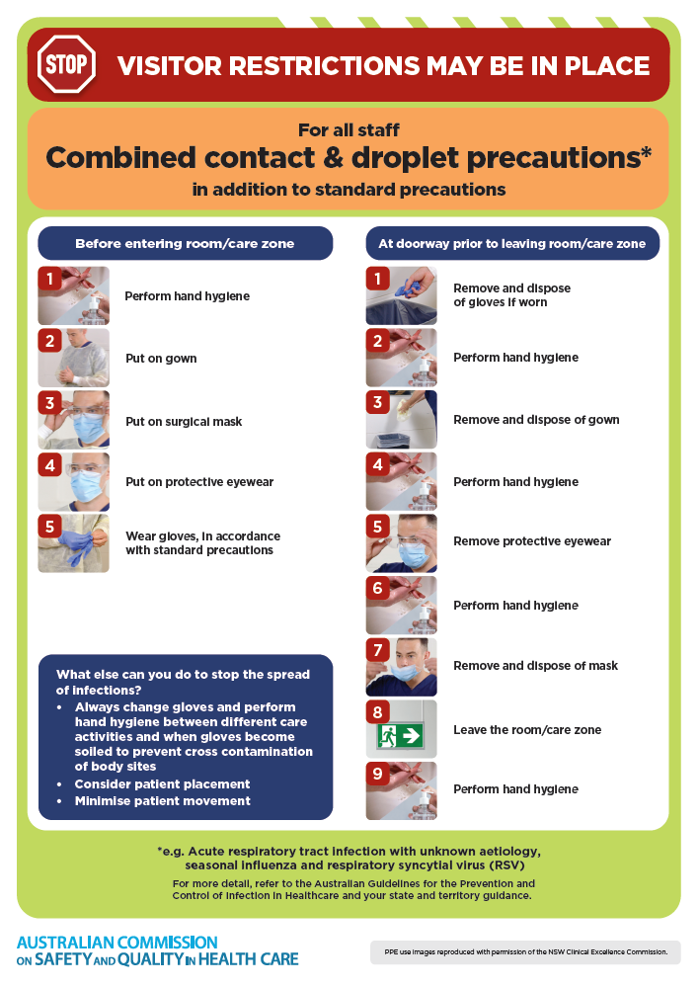](https://www.safetyandquality.gov.au/publications-and-resources/resource-library/infection-prevention-and-control-poster-combined-contact-and-droplet-precautions)
* ***Poster – Combined airborne and contact precautions*** <https://www.safetyandquality.gov.au/publications-and-resources/resource-library/poster-combined-airborne-and-contact-precautions>   
  [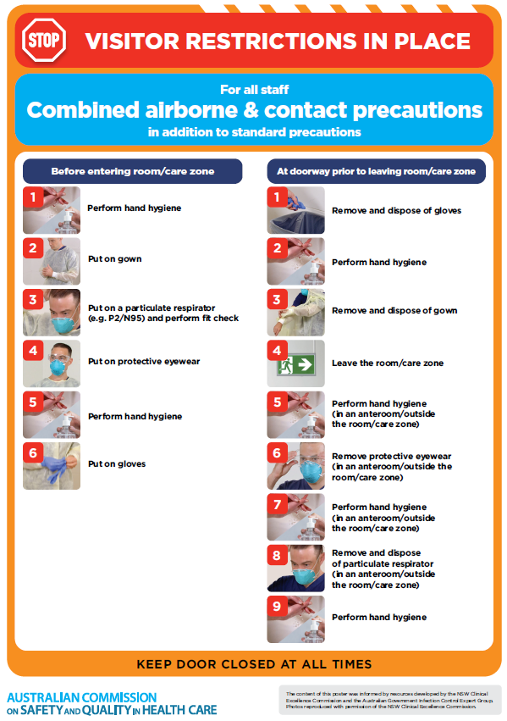](https://www.safetyandquality.gov.au/publications-and-resources/resource-library/poster-combined-airborne-and-contact-precautions)
* ***Environmental Cleaning and Infection Prevention and Control*** [www.safetyandquality.gov.au/environmental-cleaning](http://www.safetyandquality.gov.au/environmental-cleaning)
* ***COVID-19 infection prevention and control risk management – Guidance*** <https://www.safetyandquality.gov.au/publications-and-resources/resource-library/covid-19-infection-prevention-and-control-risk-management-guidance>
* ***Safe care for people with cognitive impairment during COVID-19***<https://www.safetyandquality.gov.au/our-work/cognitive-impairment/cognitive-impairment-and-covid-19>
* ***Stop COVID-19: Break the chain of infection*** posterhttps://www.safetyandquality.gov.au/publications-and-resources/resource-library/break-chain-infection-poster-a3  
  **[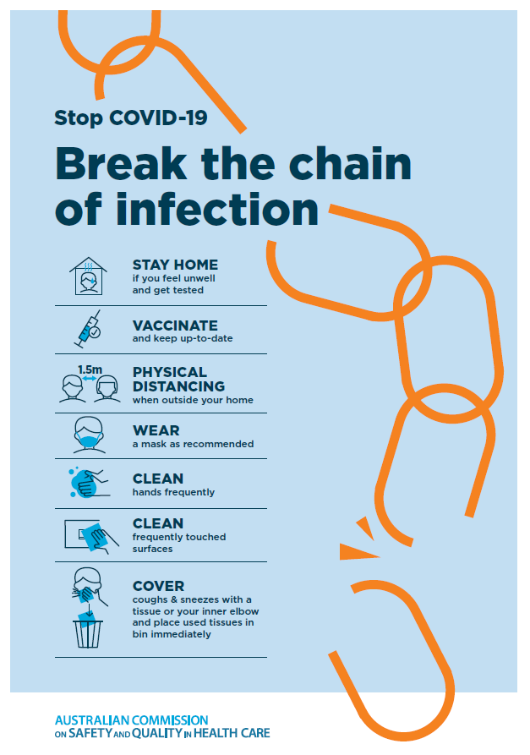](https://www.safetyandquality.gov.au/publications-and-resources/resource-library/break-chain-poster-a3https:/www.safetyandquality.gov.au/publications-and-resources/resource-library/break-chain-poster-a3)**
* ***COVID-19 and face masks – Information for consumers*** <https://www.safetyandquality.gov.au/publications-and-resources/resource-library/covid-19-and-face-masks-information-consumers>

[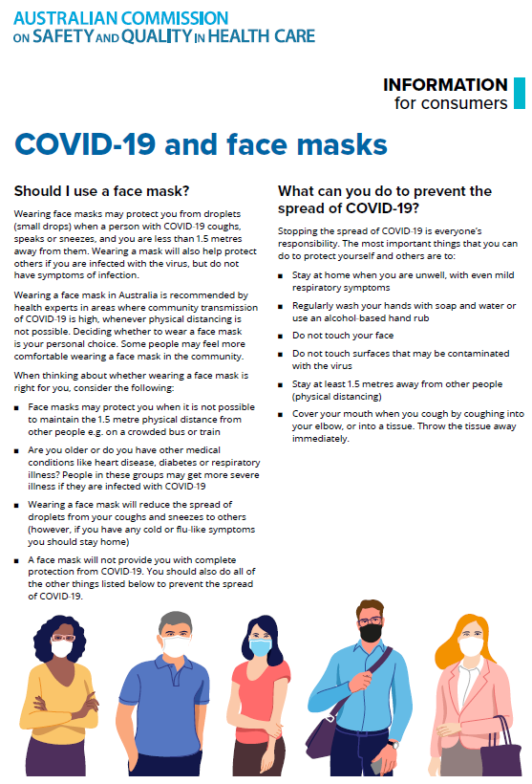](https://www.safetyandquality.gov.au/sites/default/files/2020-07/covid-19_and_face_masks_-_information_for_consumers.pdf)

*National Clinical Evidence Taskforce*

<https://clinicalevidence.net.au/>

The National Clinical Evidence Taskforce is a multi-disciplinary collaboration of 35 member organisations – Australia’s medical colleges and peak health organisations – who share a commitment to provide national evidence-based treatment guidelines for urgent and emerging diseases.

This alliance established the world’s first ‘living guidelines’ for the care of people with COVID-19 and MPX.

Funding has now been discontinued for the National Clinical Evidence Taskforce and the COVID-19 guidelines as of 30 June 2023.

These guidelines are no longer continually updated but will remain online until the guidance becomes inaccurate and/or no longer reflects the evidence or recommended practice.

**Disclaimer**

On the Radar is an information resource of the Australian Commission on Safety and Quality in Health Care. The Commission is not responsible for the content of, nor does it endorse, any articles or sites listed. The Commission accepts no liability for the information or advice provided by these external links. Links are provided on the basis that users make their own decisions about the accuracy, currency and reliability of the information contained therein. Any opinions expressed are not necessarily those of the Australian Commission on Safety and Quality in Health Care.