# Australian Commission on Safety and Quality logotypeOn the Radar

Issue 646

22 April 2024

*On the Radar* is a summary of some of the recent publications in the areas of safety and quality in health care. Inclusion in this document is not an endorsement or recommendation of any publication or provider. Access to particular documents may depend on whether they are Open Access or not, and/or your individual or institutional access to subscription sites/services. Material that may require subscription is included as it is considered relevant.

*On the Radar* is available online, via email or as a PDF or Word document from <https://www.safetyandquality.gov.au/newsroom/subscribe-news/radar>

If you would like to receive *On the Radar* via email, you can subscribe on our website <https://www.safetyandquality.gov.au/newsroom/subscribe-news>  
or by emailing us at H[Umail@safetyandquality.gov.auU](mailto:mail@safetyandquality.gov.au).  
You can also send feedback and comments to H[Umail@safetyandquality.gov.auU](mailto:mail@safetyandquality.gov.au).

For information about the Commission and its programs and publications, please visit <https://www.safetyandquality.gov.au>

w

**On the Radar**

Editor: Dr Niall Johnson [niall.johnson@safetyandquality.gov.au](mailto:niall.johnson@safetyandquality.gov.au)

Contributors: Niall Johnson, Helen Francombe, Paul Miles

**Emergency Triage Education Kit, 2nd edition**

Australian Commission on Safety and Quality in Health Care

Sydney: ACSQHC; 2024.

<https://www.safetyandquality.gov.au/publications-and-resources/resource-library/emergency-triage-education-kit-etek-second-edition>

Learning how to rapidly identify subtle signs of serious illness and gather the essential facts from a patient’s history will now be easier for emergency department nurses training for the triage role. The second edition of the *Emergency Triage Education Kit* (ETEK) is now available as an interactive PDF on the website of the Australian Commission on Safety and Quality in Health Care (the Commission).

Triage nurses determine each patient’s need for time-critical care and the order in which patients see the treating clinician. Designed for both independent learning and educator-led sessions, the ETEK includes a set of learning resources that support nationally consistent training for this role. Each chapter contains case studies to illustrate key points, and a set of validated triage scenarios is provided for self-test and consolidation of learning.

The Department of Health and Aged Care engaged the Commission to review and update the original ETEK, published in 2009. The project was underpinned by extensive engagement with key stakeholder groups: practising emergency clinicians to ensure the ETEK's currency; topic experts and academics to reference best practice and the evidence base; and consumers to incorporate their needs at triage. Their collective wisdom has been distilled into clear and practical guidance for nurses preparing for this critical role in the Australian health system.

For enquiries about the revised ETEK, please contact [mail@safetyandquality.gov.au](mailto:mail@safetyandquality.gov.au)

**Books**

*Values and Ethics*

Elements of Improving Quality and Safety in Healthcare

Cribb A, Entwistle VA, Mitchell P.

Cambridge: Cambridge University Press; 2024.

|  |  |
| --- | --- |
| DOI | <https://doi.org/10.1017/9781009325233> |
| Notes | This is the latest release in the Elements of Improving Quality and Safety in Healthcare series from The Healthcare Improvement Studies Institute (the THIS Institute) in Cambridge. This volume examines the role of values and ethical issues in healthcare improvement. As the authors note ‘Ethics involves examining values and identifying what is good, right, and justified – and why. Diverse values and ethical issues run through healthcare improvement, but they are not always recognised or given the attention they need.’ They suggest that this ‘Element demonstrates the ethical considerations and rich array of values that inevitably underpin both the goals of healthcare improvement (what aspects of quality or what kinds of good are pursued) and how improvement work is undertaken. It outlines an agenda for improvement ethics with the aim of helping those involved in healthcare improvement to reflect on and discuss ethical aspects of their work more explicitly and rigorously.’ |

**Reports**

*Investigation report: Retained swabs following invasive procedures*

Health Services Safety Investigation Body

Poole: HSSIB; 2024.

|  |  |
| --- | --- |
| URL | <https://www.hssib.org.uk/patient-safety-investigations/retained-surgical-swabs/investigation-report/#32-detectability-of-swabs-placed-in-the-cavity-during-surgery> |
| Notes | This latest report from the UK’s Health Services Safety Investigation Body (HSSIB) examines the patient safety risk of swabs being unintentionally retained following an invasive procedure such as surgery. This investigation was prompted by the case of patient undergoing surgery to treat coronary artery disease who was twice returned to the operating theatre to remove gauze swabs that had been inadvertently left in the patient’s chest after the surgery. The investigation report offers a number of findings and recommendations. |

**Journal articles**

*An Analysis of Incident Reports Related to Electronic Medication Management: How They Change Over Time*

Kinlay M, Zheng WY, Burke R, Juraskova I, Ho LM, Turton H, et al

Journal of Patient Safety. 2024;20(3):202-208

*Drug–Drug Interactions and Actual Harm to Hospitalized Patients: A Multicentre Study Examining the Prevalence Pre- and Post-Electronic Medication System Implementation*

Li L, Baker J, Quirk R, Deidun D, Moran M, Salem AA, et al

Drug Safety. 2024.

|  |  |
| --- | --- |
| DOI | Kinlay et al <https://doi.org/10.1097/PTS.0000000000001204>  Li et al <https://doi.org/10.1007/s40264-024-01412-w> |
| Notes | A pair of Australian studies examining the impacts of electronic medication management (EMM).  Kinlay et al examined incidents arising between 1 January 2010, and 31 December 2019 after the implementation of EMM systems at 3 Australian hospitals. The review found ‘444 incident reports were determined to be EMM related.’ The analysis of the incidents led the authors to conclude ‘Electronic medication management–related incidents continue to occur years after EMM implementation and are driven by design, user, and organizational conditions. Although factors contribute to reported incidents in varying degrees over time, some factors are persistent and highlight the importance of continuously improving the EMM system and its use.’  Li et al also examined EMM in 3 Australian hospitals, with a focus on the incidence of potential drug-drug interactions (pDDI) and clinically relevant drug-drug-interactions DDI (cDDI) before and after implementation of EMM systems. The authors report that ‘Of 1186 patient admissions, 70.1% (n = 831) experienced a pDDI, 42.6% (n = 505) a cDDI and 0.9% (n = 11) an actual harm in hospital. Of 15,860 pDDIs identified, 27.0% (n = 4285) were classified as cDDIs.’ The authors note that ‘less than one-third of pDDIs were clinically relevant’. They go on to suggest that this ‘low prevalence of harm identified raises questions about the value of incorporating DDI decision support into systems given the potential negative impacts of DDI alerts.’ |

For information on the Commission’s work on medication safety, including electronic medication management and the *Electronic Medication Management Systems – A guide to safe implementation* (third edition), see <https://www.safetyandquality.gov.au/our-work/medication-safety>

*Decreasing Prescribing Errors in Antimicrobial Stewardship Program-Restricted Medications*

Tang KM, Lee P, Anosike BI, Asas K, Cassel-Choudhury G, Devi T, et al..

Hospital Pediatrics. 2024;14(4):281-290.

|  |  |
| --- | --- |
| DOI | <https://doi.org/10.1542/hpeds.2023-007548> |
| Notes | Paper reporting on a quality improvement project that sought to reduce the rate of prescribing errors in antimicrobial stewardship programs (ASP) restricted medications by standardizing workflow in a US tertiary care children’s hospital. The changes to workflow included ‘standardizing communication and medication review, implementing protocols, and developing electronic health record safety nets’. From the analysis of the baseline and intervention periods, the authors report ‘The proportion of prescribing errors decreased from 10.9% to 4.6%’ and ‘Mean time between prescribing errors increased from 2.9 days to 8.5 days.’ |

For information on the Commission’s work on antimicrobial stewardship, see <https://www.safetyandquality.gov.au/our-work/antimicrobial-stewardship>

*Paediatric medication incident reporting: a multicentre comparison study of medication errors identified at audit, detected by staff and reported to an incident system*Li L, Badgery-Parker T, Merchant A, Fitzpatrick E, Raban MZ, Mumford V, et al  
BMJ Quality & Safety. 2024:bmjqs-2023-016711.

|  |  |
| --- | --- |
| DOI | <https://doi.org/10.1136/bmjqs-2023-016711> |
| Notes | Paper reporting on a comparison study at two tertiary referral paediatric hospitals between 2016 and 2020 in Australia that sought to ‘compare medication errors identified at audit and via direct observation with medication errors reported to an incident reporting system … and to investigate differences in types and severity of errors detected and reported by staff.’ The authors report finding that ‘Of 11 302 clinical prescribing errors identified at audit, 3.2 per 1000 errors (95% CI 2.3 to 4.4, n=36) had an incident report. Of 2224 potentially serious prescribing errors from audit, 26.1% (95% CI 24.3 to 27.9, n=580) were detected by staff and 11.2 per 1000 errors (95% CI 7.6 to 16.5, n=25) were reported to the incident system.’ Further, ‘None of the 2883 clinical medication administration errors observed, including 903 potentially serious errors and 144 errors associated with actual patient harm, had incident reports.’ These led to the conclusion that ‘Incident reporting data do not provide an accurate reflection of medication errors and related harm to children in hospitals. Failure to detect medication errors is likely to be a significant contributor to low error reporting rates.’ The authors suggest that ‘In an era of electronic health records, new automated approaches to monitor medication safety should be pursued to provide real-time monitoring.’ |

For information on the Commission’s work on medication safety, see <https://www.safetyandquality.gov.au/our-work/medication-safety>

*Managing workplace violence against health care workers: education alone is not enough*

Kynoch K, Liu X-L, Cabilan CJ, Ramis M-A

JBI Evidence Synthesis. 2024;22(4).

|  |  |
| --- | --- |
| DOI | <https://doi.org/10.11124/JBIES-24-00104> |
| Notes | Editorial reporting on and summarising a systematic review in the same journal issue (<https://doi.org/10.11124/JBIES-22-00409>) that examined the ‘evidence on the impact of educational programs and interventions for health care staff to prevent and manage aggressive behaviors in acute hospitals.’ While ‘Education programs aim to prepare health care workers to recognize and respond appropriately to potentially violent situation’, the review found ‘certainty regarding the most effective education intervention to prevent and manage aggressive behaviors is unclear.’ In the editorial the authors observe the review ‘highlights that education programs require careful consideration, and that a combination of approaches are needed to equip health care workers with the knowledge, skills, and confidence to manage aggressive situations’. It is also suggested that ‘health care policies, procedures, and processes for preventing and managing workplace violence are essential at local levels also, and should be informed by robust evidence, supporting the need for additional resources and funding for further multidisciplinary research.’ |

*Co-worker unprofessional behaviour and patient safety risks: An analysis of co-worker reports across eight Australian hospitals*McMullan RD, Churruca K, Hibbert P, Li L, Ash R, Urwin R, et al  
International Journal for Quality in Health Care. 2024:mzae030.

|  |  |
| --- | --- |
| DOI | <https://doi.org/10.1093/intqhc/mzae030> |
| Notes | This study used healthcare worker reports from ‘a whole-of-hospital professional accountability programme that includes an online messaging system’ at eight Australian hospitals. The authors report that ‘Of 1310 submissions about unprofessional behaviour, 395 (30.2%) indicated that there was a risk to patient safety.’ Among the results noted were:   * Nurses made the highest number of submissions that included a patient safety risk * Medical professionals had the highest rate as subjects of submissions for unprofessional behaviour * ‘Opinions being ignored’ and ‘someone withholding information which affects work performance’ were behaviours strongly associated with patient safety risk in the submissions * The two main types of risks to patient safety described were related to clinical process/procedure and clinical administration. * Commonly reported events included staff not following policy or protocol; doctors refusing to review a patient; and interruptions and inadequate information during handover.   The authors suggest that ‘Co-worker reports about unprofessional behaviour have significant value as they can be used by organizations to better understand how unprofessional behaviour can disrupt work practices and lead to risks to patient safety.’ |

*Locum doctor working and quality and safety: a qualitative study in English primary and secondary care*

Ferguson J, Stringer G, Walshe K, Allen T, Grigoroglou C, Ashcroft DM, et al

BMJ Quality & Safety 2024:bmjqs-2023-016699.

*Locums: threat or opportunity*

Lilford R

BMJ Quality & Safety 2024:bmjqs-2023-016951.

|  |  |
| --- | --- |
| DOI | Ferguson et al <https://doi.org/10.1136/bmjqs-2023-016699>  Lilford <https://doi.org/10.1136/bmjqs-2023-016951> |
| Notes | Ferguson et al conducted ‘semi-structured interviews and focus groups were conducted with 130 participants, including locums, patients, permanently employed doctors, nurses and other healthcare professionals with governance and recruitment responsibilities for locums across primary and secondary healthcare organisations in the English NHS’ as part of their investigation on ‘the implications of locum working for quality and safety’. Is the related editorial Lilford observes that this study ‘found that the life of the locum is a difficult and lonely one, opening up many pathways to unsafe practice.’  From these sources and the analyses Ferguson et al report ‘Locum working and how locums were integrated into organisations posed some significant challenges and opportunities for patient safety and quality of care. Organisations should take stock of how they work with the locum workforce to improve not only quality and safety but also locum experience and retention.’ |

*Telephone versus video consultations: A systematic review of comparative effectiveness studies and guidance for choosing the most appropriate modality*

Caffery LJ, Catapan SDC, Taylor ML, Kelly JT, Haydon HM, Smith AC, et al

Journal of Telemedicine and Telecare 2024:1357633X241232464.

*The Impact Of Telemedicine On Utilization, Spending, And Quality, 2019–22*

Nakamoto CH, Cutler DM, Beaulieu ND, Uscher-Pines L, Mehrotra A

Health Affairs 2024.

|  |  |
| --- | --- |
| DOI | Caffery et al <https://doi.org/10.1177/1357633X241232464>  Nakamoto et al <https://doi.org/10.1377/hlthaff.2023.01142> |
| Notes | Caffery et al report on a systematic review that sought to compare the clinical, service and cost effectiveness of telephone consultations (TC) to video consultations (VC). Based on 79 articles the review found ‘VC were superior or equivalent to TC for all clinical outcomes. When compared to TC, VC were likely to have better patient engagement and retention, to improve transfer decisions, and reduce downstream sub-acute care utilisation. The impact of telehealth modality on consultation time, completion rates, failure-to-attend rates and acute care utilisation was mixed. VC were consistently found to be more cost effective despite having a higher incremental cost than TC.’  Nakamoto et al examined the impact of telemedicine in the USA by seeking to ‘estimate association of greater telemedicine use across health systems with utilization, spending, and quality’. They report that ‘Patients receiving care from health systems in the highest quartile of telemedicine use had modest increases in office visits, care continuity, and medication adherence, as well as decreases in ED visits, relative to patients of health systems in the lowest quartile. We did not observe differences in testing or preventive service use. The relative increase in visits was larger among patients without chronic illness and among lower-income, non-White patients. However, these changes were accompanied by a 1.6 percent increase in health care spending, largely driven by inpatient and drug spending.’ |

*Health Policy*

Volume 143, May 2024

|  |  |
| --- | --- |
| URL | <https://www.sciencedirect.com/journal/health-policy/vol/143/> |
| Notes | A new issue of *Health Policy* has been published. Articles in this issue of *Health Policy* include:   * Health literacy, governance and systems leadership contribute to the implementation of the **One Health** approach: a virtuous circle (Carl Rudolf Blankart, Saskia Maria De Gani, H Crimlisk, M Desmedt, B Bauer, G Doyle) * The role of the **health sector in tackling climate change**: A narrative review (Zeynep Or, Anna-Veera Seppänen) * Variations and inequities in **access to cardiac diagnostic services** in Ontario Canada (Gavin Wardle, Anthony J. Sanfilippo, Ashrut Narula, Andriy Kolos, Kwan Chan, Howard Leong-Poi, Zion Sasson, Graham Woodward) * Understanding the legacies of shocks on **health system performance**: Exploring Ireland's management of recent crises and its implications for policy (Liz Farsaci, Padraic Fleming, A Almirall-Sanchez, C O'Donoghue, S Thomas) * Responsiveness of **inpatient care and provision of dignity**: Insights from a patient experience survey in Israel (Keren Semyonov-Tal) * Disentangling the impact of **alternative payment models and associated service delivery models on quality of chronic care**: A scoping review (Cassandra Simmons, Mirjam Pot, Klara Lorenz-Dant, Kai Leichsenring) * The dynamics of **international health system reforms**: Evidence of a new wave in response to the 2008 economic crisis and the COVID-19 pandemic? (Chiara Berardi, Frederik Schut, Francesco Paolucci) * New **paramedic scope of practice** in Poland based on the 2022 reform (Katarzyna Nowak-Zając, Alicja Domagała, I A Bielska, I Kowalska-Bobko) * The association between allostatic load and guaranteed annual income using the Canadian Longitudinal Study on Aging: A cross-sectional analysis of the **benefits of guaranteed public pensions** (Luke Duignan, Daniel J Dutton) * Tackling **medicine shortages** during and after the COVID-19 pandemic: Compilation of governmental policy measures and developments in 38 countries (Sabine Vogler) * Lessons learned from the Canadian Fabry Disease Initiative for **future risk-sharing and managed access agreements for pharmaceutical and advanced therapies** in Canada (Conor M.W. Douglas, Shir Grunebaum) * **Nurses’ intention to leave, nurse workload and in-hospital patient mortality** in Italy: A descriptive and regression study (Gianluca Catania, Milko Zanini, Marzia A. Cremona, Paolo Landa, Maria Emma Musio, Roger Watson, Giuseppe Aleo, Linda H. Aiken, Loredana Sasso, Annamaria Bagnasco) * **Pay-for-performance and patient safety in acute care**: A systematic review (Luke Slawomirski, Martin Hensher, Julie Campbell, Barbara deGraaff) * From symbiosis to independence: Investigating changes in the relationship between general practitioners’ presence and **pharmacies’ market size** in Slovakia (Richard Kališ) * Unlocking the genomic landscape: Results of the Beyond 1 Million Genomes (B1MG) pilot in Belgium towards **Genomic Data Infrastructure** (GDI) (Tugce Schmitt, Hélène A. Poirel, E Cauët, M Delnord, M Van den Bulcke) * The **hidden toll of the pandemic on nonrespiratory patients** (Simone Ferro, Andrea Riganti) * The association between **SARS-CoV-2 seroprevalence and cross-border mobility** for visiting family or friends among Dutch residents of a Euregional province (Demi ME Pagen, Daniëlle AT Hanssen, Inge HM van Loo, Stephanie Brinkhues, Casper DJ den Heijer, Nicole HTM Dukers-Muijrers, Christian JPA Hoebe) * The **impact of health on economic growth**: A narrative literature review (Elena Fumagalli, M Pinna Pintor, Marc Suhrcke) * Environmental co-benefits of health policies to reduce **meat consumption**: A narrative review (Céline Bonnet, Marine Coinon) * The **impact of health on labour market outcomes**: A rapid systematic review (Matteo Pinna Pintor, Elena Fumagalli, Marc Suhrcke) * Mitigating the regressivity of **private mechanisms of financing healthcare**: An Assessment of 29 countries (Ruth Waitzberg, Sara Allin, Michel Grignon, Åsa Ljungvall, Katharina Habimana, Marios Kantaris, Steve Thomas, T Rice) |

*BMJ Quality & Safety* online first articles

|  |  |
| --- | --- |
| URL | <https://qualitysafety.bmj.com/content/early/recent> |
| Notes | *BMJ Quality &Safety* has published a number of ‘online first’ articles, including:   * Editorial: Understanding **linguistic inequities in healthcare**: moving from the technical to the social (Christina Reppas-Rindlisbacher, Shail Rawal) * **Paediatric medication incident reporting**: a multicentre comparison study of medication errors identified at audit, detected by staff and reported to an incident system (Ling Li, Tim Badgery-Parker, Alison Merchant, Erin Fitzpatrick, Magdalena Z Raban, Virginia Mumford, Najwa-Joelle Metri, Peter Damian Hibbert, Cheryl Mccullagh, Michael Dickinson, Johanna I Westbrook) * **Ensuring safe and equitable discharge**: a quality improvement initiative for individuals with hypertensive disorders of pregnancy (Kathleen M. Zacherl, Emily Carper Sterrett, Brenna L. Hughes, Karley M Whelan, James Tyler-Walker, Samuel T Bauer, Heather C Talley, Laura J Havrilesky) * **General practitioners’ risk literacy and real-world prescribing of potentially hazardous drugs**: a cross-sectional study (Odette Wegwarth, Tammy C Hoffmann, Ben Goldacre, Claudia Spies, Helge A Giese) * Editorial: **Locums**: threat or opportunity (Richard Lilford) * **Locum doctor working and quality and safety**: a qualitative study in English primary and secondary care (Jane Ferguson, Gemma Stringer, Kieran Walshe, Thomas Allen, Christos Grigoroglou, Darren M Ashcroft, Evangelos Kontopantelis) |

*International Journal for Quality in Health Care* online first articles

|  |  |
| --- | --- |
| URL | <https://academic.oup.com/intqhc/advance-articles> |
| Notes | *International Journal for Quality in Health Care* has published a number of ‘online first’ articles, including:   * Primum non nocere: first, do no harm – determining the current, ongoing and future contribution of **smart health care** (Daniel Wu et al) * Implementation remains the biggest challenge to the **effective use of PROMs and PREMs**, so what can we do about it? (Claudia Bull and Jason D Pole) * Process management program to **prevent falls in hospitalized patients with neuropsychiatric disorders**: a quality improvement program (Hua XU et al) * A multi-phase, multi-centre development and validation of two maturity tools assessing the **implementation of the FlaQuM co-creation roadmap** (Fien Claessens et al) |

**Online resources**

***[UK] NICE Guidelines and Quality Standards***

<https://www.nice.org.uk/guidance>

The UK’s National Institute for Health and Care Excellence (NICE) has published new (or updated) guidelines and quality standards. The latest reviews or updates include:

* NICE Guideline NG73 ***Endometriosis****: diagnosis and management* <https://www.nice.org.uk/guidance/ng73>

***USA] Effective Health Care Program reports***

<https://effectivehealthcare.ahrq.gov/>

The US Agency for Healthcare Research and Quality (AHRQ) has an Effective Health Care (EHC) Program. The EHC has released the following final reports and updates:

* *Engaging Family Caregivers With Structured Communication for* ***Safe Care Transitions*** <https://effectivehealthcare.ahrq.gov/products/engaging-caregivers-mhs4/rapid-research>

**COVID-19 resources**

https://www.safetyandquality.gov.au/covid-19

The Australian Commission on Safety and Quality in Health Care has developed a number of resources to assist healthcare organisations, facilities and clinicians. These and other material on COVID-19 are available at <https://www.safetyandquality.gov.au/covid-19>

These resources include:

* ***OVID-19 infection prevention and control risk management*** This primer provides an overview of three widely used tools for investigating and responding to patient safety events and near misses. Tools covered in this primer include incident reporting systems, Root Cause Analysis (RCA), and Failure Modes and Effects Analysis (FMEA).   
  <https://www.safetyandquality.gov.au/publications-and-resources/resource-library/covid-19-infection-prevention-and-control-risk-management-guidance>
* ***Poster – Combined contact and droplet precautions*** <https://www.safetyandquality.gov.au/publications-and-resources/resource-library/infection-prevention-and-control-poster-combined-contact-and-droplet-precautions>  
  [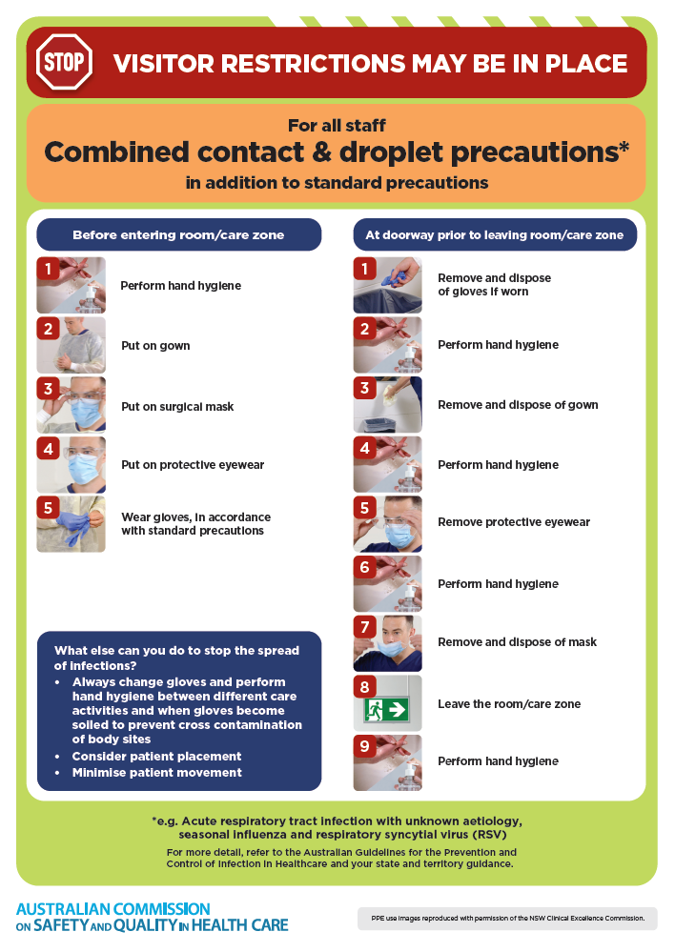](https://www.safetyandquality.gov.au/publications-and-resources/resource-library/infection-prevention-and-control-poster-combined-contact-and-droplet-precautions)
* ***Poster – Combined airborne and contact precautions*** <https://www.safetyandquality.gov.au/publications-and-resources/resource-library/poster-combined-airborne-and-contact-precautions>   
  [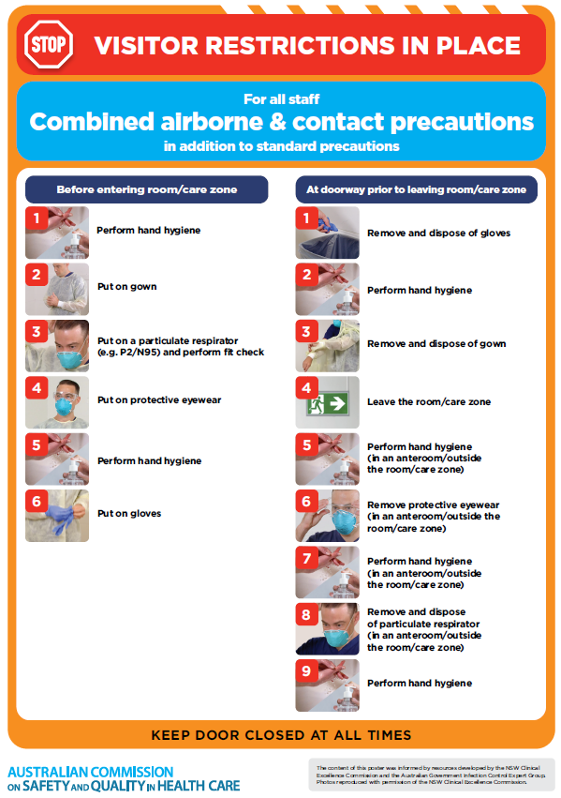](https://www.safetyandquality.gov.au/publications-and-resources/resource-library/poster-combined-airborne-and-contact-precautions)
* ***Environmental Cleaning and Infection Prevention and Control*** [www.safetyandquality.gov.au/environmental-cleaning](http://www.safetyandquality.gov.au/environmental-cleaning)
* ***COVID-19 infection prevention and control risk management – Guidance*** <https://www.safetyandquality.gov.au/publications-and-resources/resource-library/covid-19-infection-prevention-and-control-risk-management-guidance>
* ***Safe care for people with cognitive impairment during COVID-19***<https://www.safetyandquality.gov.au/our-work/cognitive-impairment/cognitive-impairment-and-covid-19>
* ***Stop COVID-19: Break the chain of infection*** posterhttps://www.safetyandquality.gov.au/publications-and-resources/resource-library/break-chain-infection-poster-a3  
  **[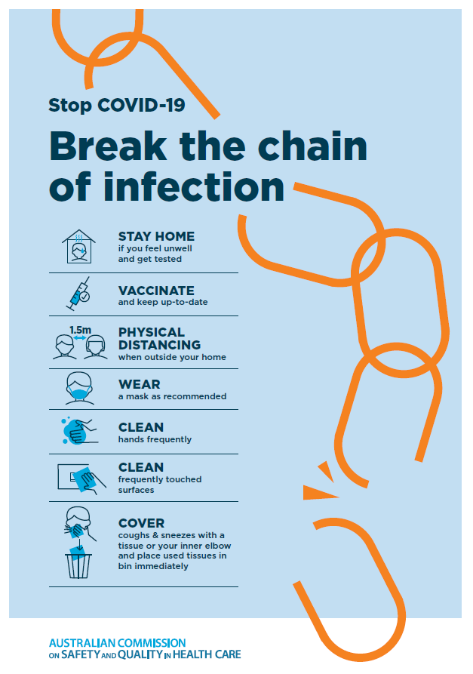](https://www.safetyandquality.gov.au/publications-and-resources/resource-library/break-chain-poster-a3https:/www.safetyandquality.gov.au/publications-and-resources/resource-library/break-chain-poster-a3)**
* ***COVID-19 and face masks – Information for consumers*** <https://www.safetyandquality.gov.au/publications-and-resources/resource-library/covid-19-and-face-masks-information-consumers>

[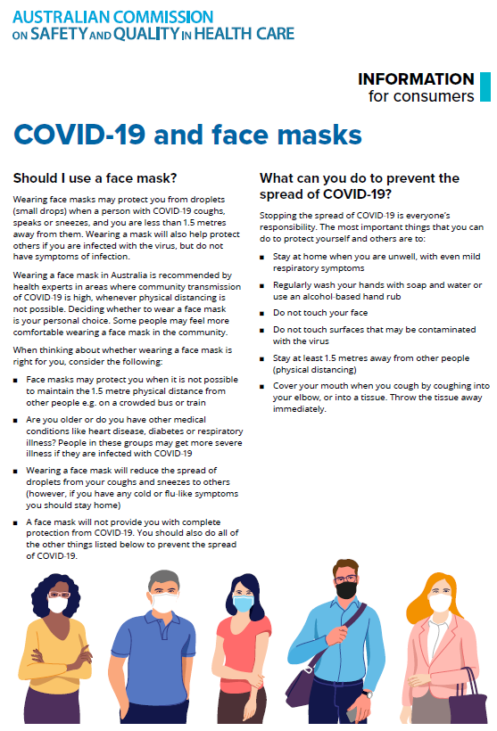](https://www.safetyandquality.gov.au/sites/default/files/2020-07/covid-19_and_face_masks_-_information_for_consumers.pdf)

*National Clinical Evidence Taskforce*

<https://clinicalevidence.net.au/>

The National Clinical Evidence Taskforce is a multi-disciplinary collaboration of 35 member organisations – Australia’s medical colleges and peak health organisations – who share a commitment to provide national evidence-based treatment guidelines for urgent and emerging diseases.

This alliance established the world’s first ‘living guidelines’ for the care of people with COVID-19 and MPX.

Funding has now been discontinued for the National Clinical Evidence Taskforce and the COVID-19 guidelines as of 30 June 2023.

These guidelines are no longer continually updated but will remain online until the guidance becomes inaccurate and/or no longer reflects the evidence or recommended practice.

**Disclaimer**

On the Radar is an information resource of the Australian Commission on Safety and Quality in Health Care. The Commission is not responsible for the content of, nor does it endorse, any articles or sites listed. The Commission accepts no liability for the information or advice provided by these external links. Links are provided on the basis that users make their own decisions about the accuracy, currency and reliability of the information contained therein. Any opinions expressed are not necessarily those of the Australian Commission on Safety and Quality in Health Care.