# Australian Commission on Safety and Quality logotypeOn the Radar

Issue 647

29 April 2024

*On the Radar* is a summary of some of the recent publications in the areas of safety and quality in health care. Inclusion in this document is not an endorsement or recommendation of any publication or provider. Access to particular documents may depend on whether they are Open Access or not, and/or your individual or institutional access to subscription sites/services. Material that may require subscription is included as it is considered relevant.

*On the Radar* is available online, via email or as a PDF or Word document from <https://www.safetyandquality.gov.au/newsroom/subscribe-news/radar>

If you would like to receive *On the Radar* via email, you can subscribe on our website <https://www.safetyandquality.gov.au/newsroom/subscribe-news>  
or by emailing us at H[Umail@safetyandquality.gov.auU](mailto:mail@safetyandquality.gov.au).  
You can also send feedback and comments to H[Umail@safetyandquality.gov.auU](mailto:mail@safetyandquality.gov.au).

For information about the Commission and its programs and publications, please visit <https://www.safetyandquality.gov.au>

w

**On the Radar**

Editor: Dr Niall Johnson [niall.johnson@safetyandquality.gov.au](mailto:niall.johnson@safetyandquality.gov.au)

Contributors: Niall Johnson, Jennifer Caldwell

***TGA transition to paperless (digital) access for unapproved therapeutic goods***

<https://www.tga.gov.au/resources/publication/publications/transition-paperless-digital-access-unapproved-therapeutic-goods>

The Therapeutic Goods Administration (TGA) is transitioning to a paperless model for Special Access Scheme (SAS) and Authorised Prescriber (AP) submissions for unapproved therapeutic goods.

They are implementing the changes in 2 phases, providing healthcare practitioners and organisations currently submitting paper-based notifications with sufficient time to register to use the online system.

Visit <https://www.tga.gov.au> for more information about the transition to paperless (digital) access.

[](https://www.safetyandquality.gov.au/WHHD-campaign)

***World Hand Hygiene Day***

World Hand Hygiene Day is an annual initiative of the World Health Organization (WHO) as part of the Save Lives: Clean Your Hands program. The theme for this year’s campaign is “**Why is sharing knowledge about hand hygiene still so important?** *Because it helps stop the spread of harmful germs in healthcare*”.

The National Hand Hygiene Initiative (NHHI) would like to invite you to join us in celebrating **World Hand Hygiene Day** on **Sunday 5 May 2024**.

This year, the NHHI will promote activities that support health service organisations and health and aged cared workers to:

* **Identify innovative opportunities** to encourage leaning about hand hygiene
* **Promote access** to hand hygiene education
* **Raise awareness** about why hand hygiene is important and how this helps to promote a safe healthcare environment and reduces the spread of infection
* **Encourage health service organisations to evaluate the impact of hand hygiene education** on healthcare worker and patient safety. Understanding how infections are spread and how to prevent this helps to reduce healthcare associated infections and improve patient safety.

**NHHI World Hand Hygiene Day 2024 webpage**

On the WHHD web page <https://www.safetyandquality.gov.au/WHHD> you can find:

* World Hand Hygiene Day presentation
* Hand Hygiene quiz
* Factsheets for healthcare workers, healthcare consumers and their carers
* Hand Hygiene posters
* Hand Hygiene videos

**Campaign webpage and supporting resources**

A Campaign webpage has been created to assist your organisation distributing information about WHHD 2024. On the Campaign webpage <https://www.safetyandquality.gov.au/WHHD-campaign> you can find:

* Content for your newsletters and social media
* Infographics and images
* Hand hygiene fact sheets
* Other useful resources and links

Please share these resources with your networks. If you have any questions, you can contact the NHHI at [HAI@safetyandquality.gov.au](mailto:HAI@safetyandquality.gov.au)

***Patient Safety Rights Charter***

World Health Organization

Geneva: WHO; 2024. p. 12.

|  |  |
| --- | --- |
| URL | https://www.who.int/publications/i/item/9789240093249 |
| Notes | The World Health Organization has released their Patient Safety Rights Charter. The WHO sees this as a key resource to support the implementation of the *Global Patient Safety Action Plan 2021–2030: Towards eliminating avoidable harm in health care*. The Charter aims to outline patients’ rights in the context of safety and promotes the upholding of these rights, as established by international human rights standards, for everyone, everywhere, at all times. The Charter lists 10 patient safety rights:   1. Right to timely, effective and appropriate care 2. Right to safe health care processes and practices 3. Right to qualified and competent health workers 4. Right to safe medical products and their safe and rational use 5. Right to safe and secure health care facilities 6. Right to dignity, respect, non-discrimination, privacy and confidentiality 7. Right to information, education and supported decision making 8. Right to access to medical records 9. Right to be heard and fair resolution 10. Right to patient and family engagement.   [Poster showing My Healthcare Rights from the Australian Charter of Healthcare Rights.](https://www.safetyandquality.gov.au/our-work/partnering-consumers/australian-charter-healthcare-rights)  The Australian Commission on Safety and Quality in Health Care released the *Australian Charter of Healthcare Rights* in 2008. The second edition of the Charter was released in 2019. The Charter describes rights that consumers, or someone they care for, can expect when receiving health care. These rights apply to all people in all places where health care is provided in Australia. This includes public and private hospitals, day procedure services, general practice and other community health services.  For information on the *Australian Charter of Healthcare Rights* , see <https://www.safetyandquality.gov.au/our-work/partnering-consumers/australian-charter-healthcare-rights> |

**Reports**

*Towards better diagnosis & management of suspected prostate cancer*

Getting It Right First Time (GIRFT)  
NHS England; 2024. p. 21.

|  |  |
| --- | --- |
| URL | <https://gettingitrightfirsttime.co.uk/girft-guidance-aims-to-improve-diagnosis-and-treatment-times-for-men-with-suspected-prostate-cancer/> |
| Notes | In the UK the Getting It Right First Time (GIRFT) initiative have developed guidance in order to improve diagnosis and treatment times for men with suspected prostate cancer. The guidance includes a delivery checklist and detailed principles for care across the entire patient pathway – from primary care to secondary care to ongoing monitoring, as well as recommendations for managing biopsies and treatment choices. |

*Digital Healthcare Equity Framework: A Practical Guide for Implementing*

Agency for Healthcare Research and Quality

Evidence- and Consensus-Based Digital Healthcare Equity Framework. A Practical Guide for Implementation. Rockville MD: AHRQ; 2024. p. 33.

|  |  |
| --- | --- |
| URL | <https://digital.ahrq.gov/health-it-tools-and-resources/digital-healthcare-equity/digital-healthcare-equity-framework-and-guide> |
| Notes | The Agency for Healthcare Research and Quality (AHRQ) in the USA has developed an *Evidence- and Consensus-Based Digital Healthcare Equity Framework* to encourage consideration of equity in development and implementing healthcare solutions that involve digital technologies. They have also developed this practical guide to assist organisations in using the framework. |

**Journal articles**

*Multiple adverse outcomes associated with antipsychotic use in people with dementia: population based matched cohort study*

Mok PLH, Carr MJ, Guthrie B, Morales DR, Sheikh A, Elliott RA, et al

BMJ. 2024;385:e076268.

*Use of antipsychotics in adults with dementia*

Kheirbek RE, LaFon C

BMJ. 2024;385:q819.

|  |  |
| --- | --- |
| DOI | Mok et al <https://doi.org/10.1136/bmj-2023-076268>  Kheirbek and LaFon <https://doi.org/10.1136/bmj.q819> |
| Notes | Mok et al report on a UK population based matched cohort study that sought to ‘investigate risks of multiple adverse outcomes associated with use of antipsychotics in people with dementia.’ Using linked primary care, hospital and mortality data from Clinical Practice Research Datalink (CPRD), the study included 35 339 adults with dementia who had just been prescribed antipsychotics for the first time, within a broader population of 173 910 adults with dementia.  From the analyses the authors report that ‘Antipsychotic use compared with non-use in adults with dementia was associated with increased risks of stroke, venous thromboembolism, myocardial infarction, heart failure, fracture, pneumonia, and acute kidney injury, but not ventricular arrhythmia. The range of adverse outcomes was wider than previously highlighted in regulatory alerts, with the highest risks soon after initiation of treatment.’  In a related editorial, Kheirbek and LaFon observe that this study ‘expands the number and type of documented risks associated with antipsychotics in the management of dementia. Their study discovered that risks extend beyond stroke and mortality to include a wider range of serious adverse health outcomes.’ They conclude the editorial by noting  ‘Using antipsychotics for the management of dementia related behaviors requires nuanced decision making after careful assessment, informed by a personalized approach.’ And that this ‘’study clearly identified a broader spectrum of adverse effects than previously acknowledged, and it advocates for a comprehensive review of risks and benefits, prioritization of non-drug strategies, and exploration of alternative therapies. Increased priority on more patient centric care, tailored care plans, regular reassessment of management options, and a move away from the overprescription of antipsychotics is overdue.’ |

For information on the Commission’s work on medication safety, see <https://www.safetyandquality.gov.au/our-work/medication-safety>

*Stewardship Prompts to Improve Antibiotic Selection for Pneumonia: The INSPIRE Randomized Clinical Trial.*

Gohil SK, Septimus E, Kleinman K, Varma N, Avery TR, Heim L, et al

JAMA. 2024.

*Stewardship Prompts to Improve Antibiotic Selection for Urinary Tract Infection: The INSPIRE Randomized Clinical Trial*

Gohil SK, Septimus E, Kleinman K, Varma N, Avery TR, Heim L, et al.

JAMA. 2024.

*Harnessing the Electronic Health Record to Improve Empiric Antibiotic Prescribing*

Malani AN, Malani PN

JAMA. 2024.

|  |  |
| --- | --- |
| DOI | Gohil et al <https://doi.org/10.1001/jama.2024.6248>  Gohil et al <https://doi.org/10.1001/jama.2024.6259>  Malani and Malani <https://doi.org/10.1001/jama.2024.6554> |
| Notes | A pair of reports and a related editorial on the implementation of antibiotic stewardship prompts into ordering systems.  The two INSPIRE (Intelligent Stewardship Prompts to Improve Real-Time Empiric Antibiotic Selection) trials involved adult patients hospitalized with pneumonia and urinary tract infection (UTI) at 59 hospitals in a US health system.  In both trials, one group of hospitals was randomly assigned to routine antibiotic stewardship activities while clinicians in the other group, in addition to routine antibiotic stewardship activities, had computerised provider order entry (CPOE) prompts whenever extended-spectrum antibiotics were ordered in a non-intensive care unit (ICU) setting for patients with pneumonia or UTI within 72 hours of admission (the empiric prescribing period). The CPOE prompt was triggered when algorithm determined that the patient's risk for an multidrug-resistant organism was 10% or less and standard-spectrum antibiotics could be used safely. In this two trials, the CPOE prompt approach was associated with significant reductions in extended-spectrum therapy. |

For information on the Commission’s work on antimicrobial stewardship, see <https://www.safetyandquality.gov.au/our-work/antimicrobial-stewardship>

*Is it possible to make ‘living’ guidelines? An evaluation of the Australian Living Stroke Guidelines*

Wiles L, Hibbert PD, Zurynski Y, Smith CL, Arnolda G, Ellis LA, et al

BMC Health Services Research. 2024;24(1):419.

|  |  |
| --- | --- |
| DOI | <https://doi.org/10.1186/s12913-024-10795-6> |
| Notes | In recent years there has been an effort to transform clinical practice guidelines from a distillation of the evidence at a point in time to ‘living guidelines’ that adapt as the evidence base grows. This paper reports on how the Stroke Foundation in Australia was one of the first organisations to apply living guideline development methods for their Living Stroke Guidelines (LSGs). The study sought to examine the experiences of the guideline developers and end users. While barriers such as increased developer workload, workload unpredictability, limited information sharing and interoperability of technological platforms were identified, the end users reported ‘d increased trust in the LSGs (69%), likelihood of following the LSGs (66%), and frequency of access (58%), compared with previous static versions’ and this was demonstrated in increased usage. The authors conclude that the living guidelines approaches ‘may add value to developers and users, and may increase guideline use.’ |

*BMJ Quality & Safety*

Volume 33, Issue 5, May 2024

|  |  |
| --- | --- |
| URL | <https://qualitysafety.bmj.com/content/33/5> |
| Notes | A new issue of *BMJ Quality & Safety* has been published. Many of the papers in this issue have been referred to in previous editions of *On the Radar* (when they were released online). Articles in this issue of *BMJ Quality & Safety* include:   * Editorial: It is up to healthcare professionals to talk to us in a way that we can understand: **informed consent processes in people with an intellectual disability** (Jonathon Ding, Richard Keagan-Bull, Irene Tuffrey-Wijne) * Editorial: Routine versus prompted **clinical debriefing**: aligning aims, mechanisms and implementation (Emma Claire Phillips, Victoria Tallentire) * Economic analysis of **surgical outcome monitoring** using control charts: the SHEWHART cluster randomised trial (Sarah Skinner, Léa Pascal, Stéphanie Polazzi, François Chollet, Jean-Christophe Lifante, Antoine Duclos) * **Delayed diagnosis of serious paediatric conditions** in 13 regional emergency departments (Kenneth A Michelson, Finn L E McGarghan, Emma E Patterson, Margaret E Samuels-Kalow, Mark L Waltzman, K F Greco) * Quality framework for **remote antenatal care**: qualitative study with women, healthcare professionals and system-level stakeholders (Lisa Hinton, Francesca H Dakin, Karolina Kuberska, Nicola Boydell, Janet Willars, Tim Draycott, Cathy Winter, Richard J McManus, Lucy C Chappell, Sanhita Chakrabarti, Elizabeth Howland, Jenny George, Brandi Leach, Mary Dixon-Woods) * What and when to debrief: a scoping review examining **interprofessional clinical debriefing** (Julia Paxino, Rebecca A Szabo, Stuart Marshall, David Story, Elizabeth Molloy) * Equitable and accessible **informed healthcare consent process for people with intellectual disability**: a systematic literature review (Manjekah Dunn, Iva Strnadová, Jackie Leach Scully, Jennifer Hansen, Julie Loblinzk, Skie Sarfaraz, Chloe Molnar, Elizabeth Emma Palmer) * Interrupting false narratives: applying a **racial equity lens to healthcare quality data** (Lauren Anita Arrington, Briana Kramer, Serena Michelle Ogunwole, Tanay Lynn Harris, Lois Dankwa, SherWanda Knight, Andreea A Creanga, Kelly M Bower) |

*The Joint Commission Journal on Quality and Patient Safety*

Volume 50, Issue 5, May 2024

|  |  |
| --- | --- |
| URL | <https://www.sciencedirect.com/journal/the-joint-commission-journal-on-quality-and-patient-safety/vol/50/issue/5> |
| Notes | A new issue of *The Joint Commission Journal on Quality and Patient Safety* has been published. Articles in this issue of *The Joint Commission Journal on Quality and Patient Safety* include:   * Editorial: Taming the Wild West of Procedural Safety: Assessing Interprofessional Teams in **Non-Operating Room Anesthesia** (Rafael Vazquez, Alexander F Arriaga, Marc Philip T Pimentel) * Editorial: **Optimizing Hospitalist Co-Management** for Improved Patient, Workforce, and Organizational Outcomes (Robert Metter, Amanda Johnson, Marisha Burden) * Team Relations and Role Perceptions During **Anesthesia Crisis Management** in Magnetic-Resonance Imaging Settings: A Mixed Methods Exploration (Hedwig Schroeck, Michaela A Whitty, Bridget Hatton, Pablo Martinez-Camblor, ... Andreas H. Taenzer) * Impact of a **Hospitalist Co-Management** Program on Medical Complications and Length of Stay in Neurosurgical Patients (Álvaro Marchán-López, Jaime Lora-Tamayo, Cristina de la Calle, Luis Jiménez Roldán, ... Ana García Reyne) * **Preoperative Communication Between Anesthesia, Surgery, and Primary Care Providers** for Older Surgical Patients (Donna Ron, Christine M. Gunn, Jeana E Havidich, Madison M Ballacchino, ... Stacie G Deiner) * Development and Evaluation of I-PASS-to-PICU: A Standard Electronic Template to Improve **Referral Communication for Interfacility Transfers** to the Pediatric ICU (Nehal R Parikh, Leticia S Francisco, Shilpa C Balikai, Mitchell A Luangrath, ... Christina L Cifra) * Refining a Framework to Enhance **Communication in the Emergency Department During the Diagnostic Process**: An eDelphi Approach (Milisa Manojlovich, Amanda P Bettencourt, Courtney W Mangus, Sarah J Parker, ... Prashant Mahajan) * **Involving the Patient and Family in the Transfer of Information** at Shift Change in a Pediatric Emergency Department (Andrea Mora Capín, Ana Jové Blanco, Eduardo Oujo Álamo, Agustín Muñoz Cutillas, ... Paula Vázquez López) * Improving Outcomes in **Patients Sent to the Emergency Department from Outpatient Providers**: A Receiver-Driven Handoff Process Improvement (Kristina DeVore, Katherine Schneider, Elyse Laures, Alison Harmon, Paul Van Heukelom) * Implementation of an **Interdisciplinary Transfer Huddle Intervention** for Prolonged Wait Times During Inter-ICU Transfer (Sydney Hyder, Ryan Tang, Reiping Huang, Amy Ludwig, ... Nandita Nadig) * The Joint Commission Journal on Quality and Patient Safety 50th Anniversary Article Collections: **Handoffs and Care Transitions** |

*BMJ Quality & Safety* online first articles

|  |  |
| --- | --- |
| URL | <https://qualitysafety.bmj.com/content/early/recent> |
| Notes | *BMJ Quality &Safety* has published a number of ‘online first’ articles, including:   * Editorial: Time for a rebalance: **psychological and emotional well-being in the healthcare workforce** as the foundation for patient safety (Kate Kirk) |

*International Journal for Quality in Health Care* online first articles

|  |  |
| --- | --- |
| URL | <https://academic.oup.com/intqhc/advance-articles> |
| Notes | *International Journal for Quality in Health Care* has published a number of ‘online first’ articles, including:   * A scoping review of the methodological approaches used in **retrospective chart reviews to validate adverse event rates in administrative data** (Anna Connolly et al) |

**Online resources**

***Australian Living Evidence Collaboration***

<https://livingevidence.org.au/>

**COVID-19 resources**

https://www.safetyandquality.gov.au/covid-19

The Australian Commission on Safety and Quality in Health Care has developed a number of resources to assist healthcare organisations, facilities and clinicians. These and other material on COVID-19 are available at <https://www.safetyandquality.gov.au/covid-19>

These resources include:

* ***OVID-19 infection prevention and control risk management*** This primer provides an overview of three widely used tools for investigating and responding to patient safety events and near misses. Tools covered in this primer include incident reporting systems, Root Cause Analysis (RCA), and Failure Modes and Effects Analysis (FMEA).   
  <https://www.safetyandquality.gov.au/publications-and-resources/resource-library/covid-19-infection-prevention-and-control-risk-management-guidance>
* ***Poster – Combined contact and droplet precautions*** <https://www.safetyandquality.gov.au/publications-and-resources/resource-library/infection-prevention-and-control-poster-combined-contact-and-droplet-precautions>  
  [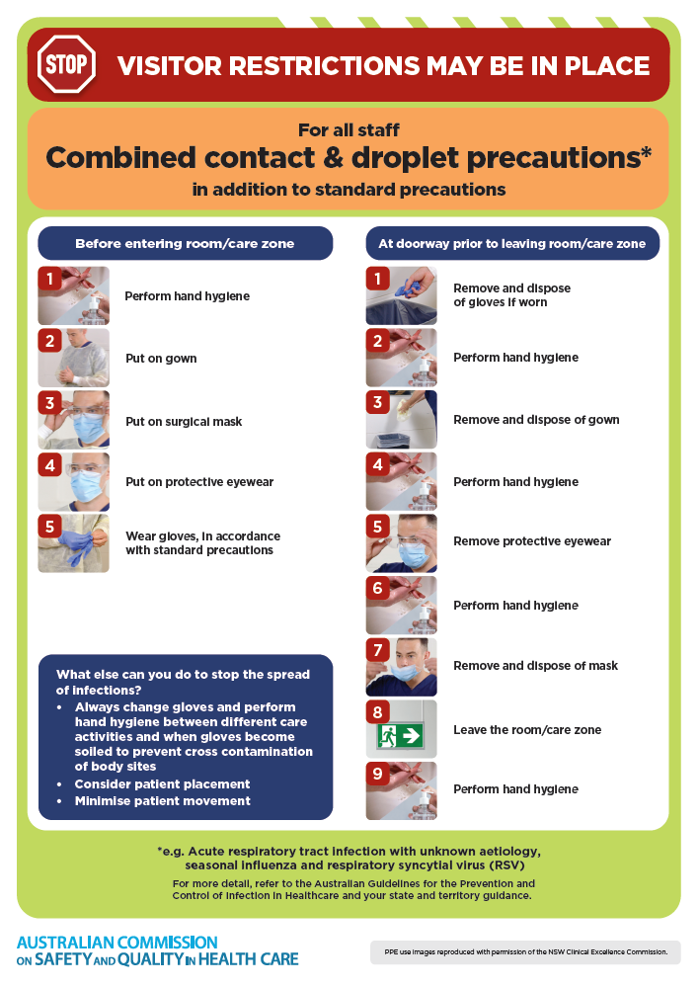](https://www.safetyandquality.gov.au/publications-and-resources/resource-library/infection-prevention-and-control-poster-combined-contact-and-droplet-precautions)
* ***Poster – Combined airborne and contact precautions*** <https://www.safetyandquality.gov.au/publications-and-resources/resource-library/poster-combined-airborne-and-contact-precautions>   
  [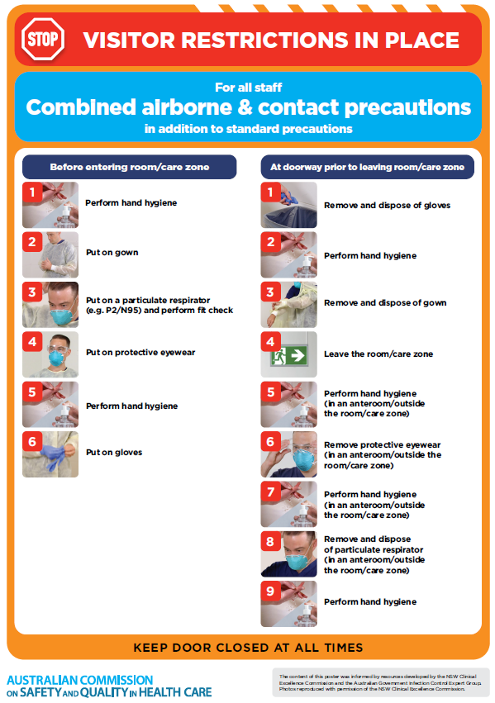](https://www.safetyandquality.gov.au/publications-and-resources/resource-library/poster-combined-airborne-and-contact-precautions)
* ***Environmental Cleaning and Infection Prevention and Control*** [www.safetyandquality.gov.au/environmental-cleaning](http://www.safetyandquality.gov.au/environmental-cleaning)
* ***COVID-19 infection prevention and control risk management – Guidance*** <https://www.safetyandquality.gov.au/publications-and-resources/resource-library/covid-19-infection-prevention-and-control-risk-management-guidance>
* ***Safe care for people with cognitive impairment during COVID-19***<https://www.safetyandquality.gov.au/our-work/cognitive-impairment/cognitive-impairment-and-covid-19>
* ***Stop COVID-19: Break the chain of infection*** posterhttps://www.safetyandquality.gov.au/publications-and-resources/resource-library/break-chain-infection-poster-a3  
  **[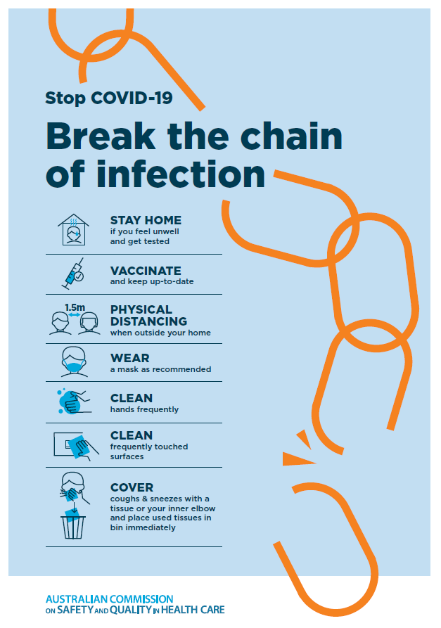](https://www.safetyandquality.gov.au/publications-and-resources/resource-library/break-chain-poster-a3https:/www.safetyandquality.gov.au/publications-and-resources/resource-library/break-chain-poster-a3)**
* ***COVID-19 and face masks – Information for consumers*** <https://www.safetyandquality.gov.au/publications-and-resources/resource-library/covid-19-and-face-masks-information-consumers>

[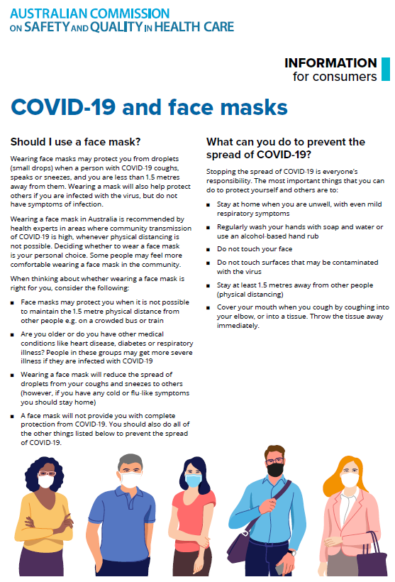](https://www.safetyandquality.gov.au/sites/default/files/2020-07/covid-19_and_face_masks_-_information_for_consumers.pdf)

**Disclaimer**

On the Radar is an information resource of the Australian Commission on Safety and Quality in Health Care. The Commission is not responsible for the content of, nor does it endorse, any articles or sites listed. The Commission accepts no liability for the information or advice provided by these external links. Links are provided on the basis that users make their own decisions about the accuracy, currency and reliability of the information contained therein. Any opinions expressed are not necessarily those of the Australian Commission on Safety and Quality in Health Care.