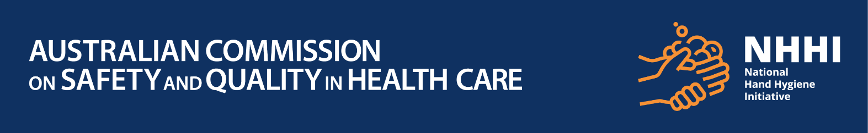

**World Hand Hygiene Day 2024 – Quiz**

**World Hand Hygiene Day 2024 – Quiz**

**Q1: True or false: Hand hygiene is the single most important intervention to prevent healthcare-associated infections**

1. True
2. False

**Q2: Who needs to practice hand hygiene in a healthcare environment?**

1. Only doctors and nurses
2. Only allied healthcare workers
3. Only office and clerical staff
4. Only cleaning and hospitality staff
5. Only visitors
6. Everybody

**Q3: True or false:** **Hand hygiene should be performed before and after entering a healthcare environment, healthcare zone and/or a patient’s/resident’s immediate area.**

1. True
2. False

**Q4: How long should you wash your hands with soap and water?**

1. At least 2 seconds
2. At least 5 seconds
3. At least 10 seconds
4. At least 20 seconds

**Q5: What hand hygiene products will help to stop the spread of infectious agents? (Two correct answers)**

1. Soap and water together
2. Water alone
3. Alcohol-based hand rub

**Q6: Hand hygiene is important because**

1. It protects patients/clients/ residents from infection
2. It protects the healthcare environment
3. It protects me
4. All of the above

**Q7:** **A nurse enters the patient /resident’s immediate area/ room to check their vital signs (non-invasive procedure), when should the nurse perform hand hygiene?**

1. Only before touching the patient
2. Only after touching the patient
3. Hand hygiene is not required
4. Always before and after touching the patient

**Q8:** **A doctor is about to insert a cannula into a patient’s wrist (invasive procedure), when should the doctor perform hand hygiene?**

1. Only before inserting the cannula (starting the procedure)
2. Only after they have finished inserting the cannula
3. Hand hygiene is not required
4. Always immediately before starting the procedure and after completing the procedure

**Q9:** **True or false: An allied health worker enters a patient’s/ resident’s room but only touches the curtain while talking to the patient/ resident. They did not touch the patient/ resident. The allied health worker does not need to do hand hygiene.**

1. True
2. False

**Q10: True or false: Clothing, jewellery, and nail treatments may harbour infectious agents that can be transferred to others and the healthcare environment, facilities, and equipment.**

1. True
2. False

|  |
| --- |
| For more information on what you can do to support hand hygiene in your organisation, visit [World Hand Hygiene Day 2024](https://www.who.int/campaigns/world-hand-hygiene-day) |