**Guidelines for NHHI Data Submission**

|  |
| --- |
| These guidelines outline the hand hygiene compliance data submission requirements for health service organisations, including the data collection process, clinical area selection, eligible areas, and the number of moments for hand hygiene compliance audits. |

## Background

[Hand](https://www.safetyandquality.gov.au/publications-and-resources/resource-library/nhhi-direct-observational-auditing-hand-hygiene-compliance-user-guide) hygiene auditing and performance feedback is considered a core element of the [National Hand Hygiene Initiative (NHHI)](https://www.safetyandquality.gov.au/our-work/infection-prevention-and-control/national-hand-hygiene-initiative). Auditing workforce compliance to hand hygiene serves multiple purposes, including assessing the quality of care, performance improvement, investigating outbreaks, and designing infrastructure.

The [5 Moments for Hand Hygiene](https://www.safetyandquality.gov.au/our-work/infection-prevention-and-control/national-hand-hygiene-initiative/what-hand-hygiene/5-moments-hand-hygiene) approach allows a comparison of hand hygiene performance across various healthcare settings and within organisations, including high and low-risk clinical environments.

## Data collection process

All hand hygiene compliance data submitted must:

* Be collected by validated [Hand Hygiene Auditors](https://www.safetyandquality.gov.au/our-work/infection-prevention-and-control/national-hand-hygiene-initiative/auditor-training-and-validation-nhhi/hand-hygiene-auditor-training-nhhi) and [Hand Hygiene Auditor Educators](https://www.safetyandquality.gov.au/our-work/infection-prevention-and-control/national-hand-hygiene-initiative/auditor-training-and-validation-nhhi/hand-hygiene-auditor-educator-training)
* Be collected from appropriate clinical areas
* Meet the minimum number of moments
* Be submitted at minimum two times a year (national audit period 1 and 3) to the NHHI database (For audit period 2, organisations should refer to their jurisdictional requirements at [Advisory AS23/01:Advice on national hand hygiene audit period 2](https://www.safetyandquality.gov.au/standards/nsqhs-standards/assessment-nsqhs-standards/nsqhs-standards-advisories/advisory-as2301-advice-national-hand-hygiene-audit-period-2)).

Once submitted, data validation processes are conducted to ensure accuracy of data.

## Clinical area selection

Several factors need to be considered when determining which clinical areas should be audited. As effective [hand hygiene](https://www.safetyandquality.gov.au/our-work/infection-prevention-and-control/national-hand-hygiene-initiative/what-hand-hygiene/5-moments-hand-hygiene) is the single most important strategy in preventing healthcare-associated infections (HAIs), clinical areas known to have greater potential for high infection rates should be targeted. Improvements in hand hygiene compliance rates in these areas will have the greatest impact on the prevention of infection and provide a safer environment for patients. These areas typically have more staff/patient activity and interaction, resulting in a greater number of 'Moments’ being audited in shorter durations.

Auditing clinical areas where there is less staff/patient activity and interaction (for example, non-acute settings) will result in a small number of moments being observed. For these settings, it is recommended to consider strategies such as assessing hand hygiene product placement, products use audits and staff education instead of direct observational auditing. The selection of clinical areas should be made in conjunction with the appropriate committee (for example, Infection Prevention and Control Committee and Quality Improvement Committee) at the health service organisation and with executive approval.

## Eligible areas for hand hygiene compliance auditing

Clinical areas providing acute care are eligible for hand hygiene compliance auditing. For the purposes of the NHHI, they are further stratified into ‘high risk’ and ‘standard risk’.

**High risk**

Eligible high risk clinical areas within a hospital include critical care, neonatal care, renal, transplantation, and oncology/haematology departments.

High risk may also include clinical areas with known or suspected high rates of HAIs, high prevalence of patients with multidrug-resistant organisms and previous low hand hygiene compliance.

**Standard risk**

Eligible standard risk clinical areas within a hospital include surgical, medical, maternity, paediatrics, acute aged care, perioperative, emergency departments, radiology, and sub-acute departments.

**Other clinical** **areas that can be included**

Based on a risk assessment, the following areas within an acute organisation could be included in national audits: ambulatory care, mental health, palliative care, and long-term care settings.

**Departments that should not be included**

|  |
| --- |
| Central sterile services department, kitchen, laundry, and other areas where there are no patients should not be included in national audits. |

## Numbers of hand hygiene moments

There are specific requirements on the number of hand hygiene observation moments that need to be submitted for different healthcare settings for each national audit period. For more information, see **‘**Guidelines for submission of data for specific settings’on the [National Hand Hygiene Initiative - Audit Requirements](https://www.safetyandquality.gov.au/our-work/infection-prevention-and-control/national-hand-hygiene-initiative/national-audits-and-hhcapp-nhhi/national-hand-hygiene-initiative-audit-requirements) web page.

Inevitably compliance data will be used for comparison, be it at a clinical area, organisational, jurisdictional, or national level. When data is used for comparison, it is important to remember that generally a higher number of Moments audited will generate a more reliable compliance rate, as demonstrated in Chart 1.

It is recommended that 95% confidence intervals are included when reporting compliance rates.

Chart 1. Comparison of 95% Confidence Intervals for different numbers of Moments at 50% Compliance and 75% Compliance

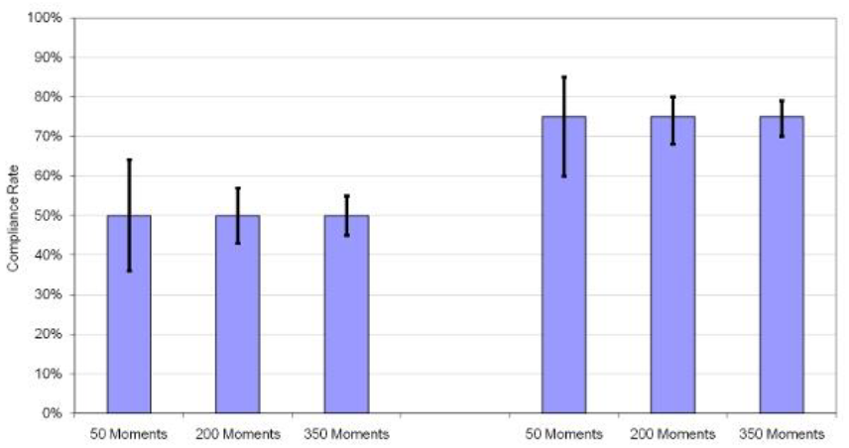

## More information

For more information, please see [National Hand Hygiene Initiative Implementation Guide](https://www.safetyandquality.gov.au/publications-and-resources/resource-library/national-hand-hygiene-initiative-implementation-guide).

For information on state and territory NHHI contacts and the NHHI Help Desk, please visit the [National Hand Hygiene Initiative Help Desk – contact details](https://www.safetyandquality.gov.au/our-work/infection-prevention-and-control/national-hand-hygiene-initiative/national-hand-hygiene-initiative-contact-details) web page.

[**safetyandquality.gov.au**](http://www.safetyandquality.gov.au)

© Australian Commission on Safety   
and Quality in Health Care 2024