# Australian Commission on Safety and Quality logotypeOn the Radar

Issue 648

6 May 2024

*On the Radar* is a summary of some of the recent publications in the areas of safety and quality in health care. Inclusion in this document is not an endorsement or recommendation of any publication or provider. Access to particular documents may depend on whether they are Open Access or not, and/or your individual or institutional access to subscription sites/services. Material that may require subscription is included as it is considered relevant.

*On the Radar* is available online, via email or as a PDF or Word document from <https://www.safetyandquality.gov.au/newsroom/subscribe-news/radar>

If you would like to receive *On the Radar* via email, you can subscribe on our website <https://www.safetyandquality.gov.au/newsroom/subscribe-news>  
or by emailing us at H[Umail@safetyandquality.gov.auU](mailto:mail@safetyandquality.gov.au).  
You can also send feedback and comments to H[Umail@safetyandquality.gov.auU](mailto:mail@safetyandquality.gov.au).

For information about the Commission and its programs and publications, please visit <https://www.safetyandquality.gov.au>

w

**On the Radar**

Editor: Dr Niall Johnson [niall.johnson@safetyandquality.gov.au](mailto:niall.johnson@safetyandquality.gov.au)

Contributors: Niall Johnson

**Books**

*Implementation playbook, pocket edition: A quick-reference guide to delivering impact for health, with tools and templates*

World Health Organization

Geneva: WHO; 2023. p. 121.

|  |  |
| --- | --- |
| URL | <https://www.who.int/publications/i/item/9789240085213> |
| Notes | The World Health Organization (WHO) has released this ‘pocket edition’ of their Implementation Playbook. The Implementation Playbook is designed to support effective implementation to achieve measurable progress toward health-related targets. The, the Implementation Playbook (including the Pocket Edition) guides teams on how to go about doing it: from identifying priority health issue(s) and setting measurable targets, through to problem-solving and creating an institutional culture of data-driven action.  [Diagram of the impact cycle from the WHO's Implementation playbook, pocket edition: A quick-reference guide to delivering impact for health, with tools and templates.](https://www.who.int/publications/i/item/9789240085213) |

**Journal articles**

*Intervention for reducing the overuse of upper endoscopy in patients <45 years: a protocol for a stepwise intervention programme*

Hernes SS, Høiberg M, Gallefoss F, Thoresen C, Tjomsland O

BMJ Open Quality. 2024;13(2):e002649.

|  |  |
| --- | --- |
| DOI | <https://doi.org/10.1136/bmjoq-2023-002649> |
| Notes | There has been an interest in value, variation and appropriateness of care that has led to a focus to attempts to identify unwarranted variation and possible overuse of some interventions. This paper reports on the development and implementation of ‘a protocol for reducing the overuse of upper endoscopy in a Norwegian health region’. The authors observe that ‘Most interventions targeting overuse and high utilisation rates are based on the assumption that knowledge of areas of unwarranted variation in healthcare automatically will lead to a reduction in unwarranted variation.’ However, awareness alone seems to rarely be enough. |

For information on the Commission’s work on healthcare variation, including the *Australian Atlas of Healthcare Variation* series, see <https://www.safetyandquality.gov.au/our-work/healthcare-variation>

*Australian Prescriber*

Volume 47, Issue 2, April 2024

|  |  |
| --- | --- |
| URL | <https://australianprescriber.tg.org.au/> |
| Notes | A new issue of *Australian Prescriber* has been published. Content in this issue of *Australian Prescriber* includes:   * Biologic therapies for **severe asthma** with persistent type 2 inflammation (S Chandrasekara, P Wark) * **Partnered pharmacist medication charting and prescribing in Australian** * **Hospitals** (EY Tong, G Yip) * Diagnosis and management of **obstructive sleep apnoea** in adults (D Hynes, D Mansfield) * Assessing, communicating and managing **cardiovascular disease risk**: a practical summary of the 2023 guideline (G Jennings, N Raffoul, M Nelson) * **New drugs**:  Andusomeran and raxtozinameran for prevention of COVID-19 disease Faricimab for neovascular age-related macular degeneration and diabetic macular oedema Relugolix+estradiol+norethisterone for symptomatic uterine fibroids |

*Patient Experience Journal*

Volume 11, Issue 1, 2024

|  |  |
| --- | --- |
| URL | <https://pxjournal.org/journal/vol11/iss1/> |
| Notes | A new issue of the *Patient Experience Journal (PXJ)* has been published. Articles in this issue of the *Patient Experience Journal* include:   * Editorial: Looking Back to Move Forward: The **Next Decade and Beyond for Human Experience** (Jason A. Wolf) * The **Evolution of Patient Experience**: From Holistic Care to Human Experience (Corey Adams, Reema Harrison, and Jason A Wolf) * Investing in the Bottom Line: The **Value Case for Improving Human Experience in Healthcare** (Jason A Wolf, Vishal Bhalla, Brian Carlson, Jennifer Carron, Lanie Dixon, Julie K Oehlert, and Brant J Oliver) * The **Legitimacy of the Patient Story**: The Unofficial Autoethnography (Kathy Saldana) * **A Patient’s Journey**: Navigating Life with Type 1 Diabetes (Maram Dalab) * “Not Your Father’s Heart”: How Healthcare Discrimination for **Neurodivergent Patients** Taught Me About the Human Experience (Cate Murphy) * The Use of **Patient Stories as a Knowledge Translation Strategy** to Facilitate the Sustainability of Evidence-Based Interventions (EBIs) in Healthcare (Rachel Flynn, Lauren Dobson, Ella Milne, Alyson Campbell, Kelly Mrklas, Tracy Wasylak, and Shannon D Scott) * **Lived Experiences of Cancer Patients** Who Chose to Stop Receiving Treatment (Amreen A Ali, Neena Kohli, and Shreshtha Yadav) * **Patient Experience Diagnosis**: Using Telemed Simulation to Assess Health Care Provider Verbal and Nonverbal Communication Issues to Prescribe Potential Interventions (Xiaowen Guan, Mike C Porter, and Paul G Omodt) * Healthcare Team Members’ Views on **Social Determinants of Health Screening and Referral Practices** in a Pediatric Emergency Department (Jadelynn Nagy, Natalie J Tedford, Sahlil Ahmed, Sofia Thoms, Akiko Kamimura, and Maija Holsti) * **Helping Patients Navigate the Emergency Department**: Assessing the Utility of a Poster Illustrating the Patient Journey (Lynette D Krebs, Cristina Villa-Roel, Maria B Ospina, Brian R Holroyd, and Brian H Rowe) * Refining Successful Implementation Strategies for the **Surgical Safety Checklist** in High-Income Contexts: Results of an International Mixed Methods Study (Meagan E Elam, Christopher J Louis, Jonathan Woodson, Nathan Turley, Denisa Urban, Mary E Brindle, and Jacey A Greece) * Acceptability of a New **Remote Monitoring Service** for Patients with COVID-19 Infection using Wearable BioStickers™: A Mixed Methods Study (Lynne Maher, Lisa K Blake, Karol J Czuba, and Mary E Seddon) * The **Mental Health Journey of Healthcare Workers** Returning to Work After COVID-19 in Pakistan: Recovery and Resilience (Fahad Ahmed, Ayesha Iqbal, Talal Khurshid, Hidayat Ullah, Sundas Sahar, Khurram Iqbal, Muhammad Ahmed Ali, and Rija Rizvi) * Evaluation of **Online Patient Complaints** Regarding City Hospitals in Türkiye During the COVID-19 Pandemic: A Content Analysis Study (Canan Çınar, Elif Erbay, Gökçen Çeliker, and Ahmet Selçuk Yıldırım) * **Covid-19 Vaccine** Perception and Hesitancy Among Uninsured Free Clinic Patients (Samin Panahi, Brenda Spearman, Justine Sundrud, Mason Lunceford, and Akiko Kamimura) * **Does Patient Experience Change with Age?** Exploring Associations Between Patient Experience, Gender and Age (Corey Adams, Ramya Walsan, Anthony Schembri, Anurag Sharma, Ramesh Walpola, and Reema Harrison) * Association Between **Clinicians’ Average Patient Length of Stay and Patient Experience Scores** (Diane Kuhn, Thomas Lardaro, Katherine Pollard, Carl Pafford, Steven K Roumpf, Christian C Strachan, Julia Vaizer, Nancy K Glober, and Benton R Hunter) * Patients’ Perceptions of **Interprofessional Collaboration**: A Scoping Review (Robynne Gilchrist, Aayesha Kholvadia, and William Burdick) * Co-designing of **Patient Safety Incident Disclosure Process in Primary Healthcare** System in Qatar (Nawal Khattabi, Reena Francis, Reem Abdul Malik, Amal Al Ali, and Mariam Abdul Malik) |

*Healthcare Policy*

Volume 19, Number 3, 2024

|  |  |
| --- | --- |
| URL | <https://www.longwoods.com/publications/healthcare-policy/27227/1/vol.-19-no.3-2024> |
| Notes | A new issue of *Healthcare Policy* has been published. Articles in this issue of *Healthcare Policy* include:   * Editorial: A Call for **Bigger Thinking and Meaningful Improvements in Health and Well-Being**: Time to Move on From Small-Scale Changes (Jason M. Sutherland) * Five Years After **Cannabis Legalization**, Is It Time to Ease Restrictions on Promotion? (Jean-François Crépault, Sergio Rueda and Victor Tang) * Commentary: The Conflict Between **Protecting Public Health and Raising Tax Revenue** (Wayne Hall) * The Eye-Opening Truth About **Private Surgical Facilities in Canada** (R Trafford Crump, Gunnar Siljedal, Ezekiel Weis, A Ragan and J M Sutherland) * Commentary: **Pricing Cataract (and Other Straightforward) Surgeries** – A Policy Perspective to Build Capacity, Value and Innovation (Will Falk) * Methadone Prescribing Regulation for **Opioid Use Disorder** in Canada: Evidence for an East–West Policy Divide (Chloe Campbell, Kellia Chiu and Abhimanyu Sud) * **Healthcare Service Utilization and Perceived Gaps**: The Experience of French-Speaking 2S/LGBTQI+ People in Manitoba (Danielle de Moissac, Kevin Prada, Ndeye Rokhaya Gueye, Jacqueline Avanthay-Strus and Stephan Hardy) * Rural-Urban Differences in **Healthcare Use in Persons With Dementia** Between 2000 and 2019: A Quebec Population-Based Study (Geneviéve Arsenault-Lapierre, Claire Godard-Sebillotte, Tammy Bui, Nadia Sourial, Louis Rochette, Victoria Massamba, Caroline Sirois, Julie Kosteniuk, Debra Morgan, Amélie Quesnel-Vallée and Isabelle Vedel) |

*Health Expectations*

Volume 27, Issue 2, April 2024

|  |  |
| --- | --- |
| URL | <https://onlinelibrary.wiley.com/toc/13697625/2024/27/2> |
| Notes | A new issue of *Health Expectations* has been published. Articles in this issue of *Health Expectations* include:   * **Patient readiness for shared decision making** about treatment: Conceptualisation and development of the ReadySDM (Sascha M Keij, Anne M Stiggelbout, Arwen H Pieterse) * Co-production and adaptation of a prison-based problem-solving workbook to support the **mental health of patients housed within a medium- and low-secure forensic service** (Amanda E Perry, Heather Baker, Anne Aboaja, Lindsey Wilson, Sarah Morris, Patient Public Involved Service User) * **Co-production of health and social science research** with vulnerable children and young people: A rapid review (Jo Erwin, Lorna Burns, Urshla Devalia, Robert Witton, Jill Shawe, Hannah Wheat, Nick Axford, Janine Doughty, Sarah Kaddour, Abigail Nelder, Paul Brocklehurst, Skye Boswell, Martha Paisi) * The challenges of **voluntary care provision for hospitalized patients with COVID-19**: A qualitative study of the public volunteers' experiences ( * Fatemeh Karami, Alireza Nikbakht Nasrabadi, Camellia Torabizadeh, Monir Mazaheri, Leila Sayadi) * Co-designing resources to support **older people with intellectual disabilities** and their families plan for parental death and transitions in care (Rebecca Anderson-Kittow, Richard Keagan-Bull, Jo Giles, I Tuffrey-Wijne) * Supported **decision-making interventions in mental healthcare**: A systematic review of current evidence and implementation barriers (Cathy J Francis, Amanda Johnson, Rhonda L Wilson) * **Patient and public involvement in the development of health services**: Engagement of underserved populations in a quality improvement programme for inflammatory bowel disease using a community-based participatory approach (Elena Sheldon, Naseeb Ezaydi, Melanie Ditmore, Olga Fuseini, Rachel Ainley, Kerry Robinson, Daniel Hind, Alan J Lobo) * ‘ALL ABOUT **MY IDEAL MENTAL HEALTH SERVICE’**: Users, family members and experts by experience discussing a co-designed service (Michele Rocelli, L Aquili, P Giovanazzi, A Puecher, M M Goglio, E Faccio) * Patient and public involvement in the development of the digital tool MyBoT to support **communication between young people with a chronic condition and care providers** (Femke van Schelven, Mara van Weele, Eline van der Meulen, Elise Wessels, Hennie Boeije) * Validating care and treatment scenarios for measuring decisional conflict regarding **future care preferences among older adults** (Craig Sinclair, Ling Yeoh, Ava Karusoo-Musumeci, Kirsten A Auret, Josephine M Clayton, Michelle Hilgeman, Elizabeth Halcomb, Ron Sinclair, Angelita Martini, Anne Meller, Rebecca Walton, Li Wei, Tiet-Hanh Dao-Tran, S Kurrle, T Comans) * Young people's priorities for the self-**management of distress after stoma surgery** due to inflammatory bowel disease: A consensus study using online nominal group technique (Benjamin Saunders, Kay Polidano, Lucy Bray, Tamsin Fisher, Nadia Corp, Megan McDermott-Hughes, Adam D Farmer, Beth Morris, Sahara Fleetwood-Beresford, Carolyn A Chew-Graham) * ‘Physical well-being is our top priority’: Healthcare professionals' challenges in supporting **psychosocial well-being in stroke services** (Felicity A S Bright, Claire Ibell-Roberts, K Featherstone, N Signal, B-J Wilson, A Collier, V Fu) * Accessing care for **Long Covid** from the perspectives of patients and healthcare practitioners: A qualitative study (Fidan Turk, Jennifer Sweetman, Carolyn A Chew-Graham, Mark Gabbay, Jessie Shepherd, Christina van der Feltz-Cornelis, STIMULATE-ICP Consortium) * Engaging patients in designing a transmural allied health pathway: A qualitative exploration of **hospital-to-home transitions** (Juul W M van Grootel, Romain J Collet, Suzanne Wiertsema, Hanneke van Dongen, Marike van der Leeden, Edwin Geleijn, Raymond Ostelo, Marike van der Schaaf) * What really is **nontokenistic fully inclusive patient and public involvement/engagement in research**? (Andrea Hilton, Molly Megson, Aidin Aryankhesal, Jessica Blake, George Rook, Anne Irvine, Jinpil Um, Anne Killett, Ian Maidment, Y Loke, J van Horik, C Fox, TIMES programme team) * Barriers to adopting **digital contact tracing for COVID-19**: Experiences in New Zealand (Phoebe Elers, Tepora Emery, Sarah Derrett, Tim Chambers) * ‘It is empowering and gives people dignity in a very difficult process’: A multistage, multimethod qualitative study to understand the views of end users in the cultural adaptation of a **dementia and driving decision aid** (Nadine Veerhuis, Alessandra Merizzi, S Papoulias, C Bradbury, K Sheret, V Traynor) * **Long-term smell loss experiences after COVID-19**: A qualitative study (Hafize Özdemir Alkanat, Selda Arslan) * **Emotion in public involvement**: A conceptual review (Kristin Liabo, Lauren Asare, Philip Ruthen, Julia Burton, Pamela Staunton, Joanne Day) * The expectations and experiences of patients regarding the **diagnostic workup at a specialized memory clinic**: An interview study (Malin Aspö, Maria Sundell, Myroslava Protsiv, Fleur Wiggenraad, Marie Rydén, Francesca Mangialasche, Miia Kivipelto, Leonie N C Visser) * Healthcare professionals' experiences of caring for women with **false-positive screening test results** in the National Health Service Breast Screening Programme (Hannah A Long, Joanna M Brooks, Anthony J Maxwell, Sarah Peters, Michelle Harvie, David P French) * Using focus groups to inform a **peer health navigator service** for people who are transgender and gender diverse in Saskatchewan, Canada (Gwen Rose, Michelle McCarron, Mel Reid, T Fayant-McLeod, Emily Gulka, James Young, Megan Clark, Stéphanie J Madill) * Fluctuating salience in those living with genetic risk of **motor neuron disease:** A qualitative interview study (Jade Howard, Fadhila Mazanderani, Karen Forrest Keenan, Martin R Turner, Louise Locock) * Balancing feeling ‘prepared’ without feeling ‘devoured’: A qualitative study of self-care from the perspective of **self-empowered persons living with Parkinson's disease** in Sweden (Jamie L Luckhaus, Anna Clareborn, Maria Hägglund, Sara Riggare) * **Advancing the Care Experience for patients receiving Palliative care as they Transition from hospital to Home (ACEPATH)**: Codesigning an intervention to improve patient and family caregiver experiences (Madeline McCoy, Taylor Shorting, Vinay Kumar Mysore, Edward Fitzgibbon, Jill Rice, Meghan Savigny, Marianne Weiss, Daniel Vincent, Meaghen Hagarty, Krystal Kehoe MacLeod, Natalie C Ernecoff, Rex Pattison, Mona Kornberg, Adrianna Bruni, Shirley H Bush, Kerry Kuluski, Valerie Fiset, Cecilia Li, Henrique A Parsons, Geneviève Lalumière, Tara Connolly, Colleen Webber, S R Isenberg) * Effects of a shared decision-making implementation programme on **patient-centred communication in oncology**—Secondary analysis of a randomised controlled trial (Anja Lindig, Lotta Mannagottera, Pola Hahlweg, Hannah Sigl, Anne Klimesch, Stefan Zeh, Levente Kriston, Isabelle Scholl) * Behaviour, barriers and facilitators of **shared decision making in breast cancer surgical treatment**: A qualitative systematic review using a ‘Best Fit’ framework approach (Hongying Zheng, Linning Yang, Jiale Hu, Yan Yang) * Novel motivational interviewing-based intervention improves engagement in physical activity and readiness to change among **adolescents with chronic pain** (Katalin Forgács-Kristóf MSc, Szilvia Ádám, Adrienn Vargay, J Major) * Investigating the impact of primary care networks on **continuity of care in English general practice**: Analysis of interviews with patients and clinicians from a mixed methods study (Mhorag Goff, Sally Jacobs, Jonathan Hammond, Ali Hindi, Kath Checkland) * #DryByChristmas: A patient and public involvement study on women's engagement with humorous **pelvic floor muscle training** digital nudges on social media (Rosie C Harper, Sally Sheppard, E Miller, C Stewart, C J Clark) * Engaging with peers to **integrate community care**: Knowledge synthesis and conceptual map (Andreea-Cătălina Panaite, Odile-Anne Desroches, Émilie Warren, Ghislaine Rouly, Geneviève Castonguay, Antoine Boivin) * Operationalizing the **Consolidated Framework for Implementation Research** to build and support the lived experience workforce in direct health service provision (Alayna Carrandi, Yanan Hu, Katherine McGill, Sarah Wayland, Shae Karger, Myfanwy Maple) * Advancing a collective vision for **equity-based cocreation through prototyping at an international forum** (Michelle Phoenix, Sandra Moll, Alexa Vrzovski, Le-Tien Bhaskar, Samantha Micsinszki, Emma Bruce, Lulwama Mulalu, P Hossain, B Freeman, G Mulvale, CoPro Consortium) * The role of multidisciplinary MS care teams in supporting lifestyle behaviour changes to optimise **brain health among people living with MS**: A qualitative exploration of clinician perspectives (Olivia Wills, Yasmine Probst, Jodi Haartsen, Anne-Therese McMahon) * Experiences of people with **Long Covid** with a digital physiotherapy intervention: A qualitative study (María-José Estebanez-Pérez, Rocío Martín-Valero, Pablo Pastora-Estebanez, José-Manuel Pastora-Bernal) * Exploring the lived experience of receiving **mental health crisis care at emergency departments**, crisis phone lines and crisis care alternatives (Helena Roennfeldt, Nicole Hill, Louise Byrne, Bridget Hamilton) * Gaining consensus on emotional wellbeing themes and preferences for digital intervention type and content to support the **mental health of young people with long-term health conditions**: A Delphi study (Jennie Brown, Lauren Cox, Kathleen Mulligan, Stephanie Wilson, Michelle Heys, Polly Livermore, Suzy Gray, Angeliki Bogosian) * Shaping research for people living with **co-existing mental and physical health conditions**: A research priority setting initiative from the United Kingdom (Olivia Taylor, E Newbronner, H Cooke, L Walker, R Wadman) * Assessing the impact of an **online dementia awareness initiative** co-created with and for English, Arabic and Vietnamese speaking communities: A case study (Yousra Ali, Gabriela E Caballero, Eman Shatnawi, Ann Dadich, Genevieve Z Steiner-Lim, Canterbury Bankstown Dementia Alliance, Michelle DiGiacomo, Diana Karamacoska) * A qualitative exploration of the barriers and facilitators to **self-managing multiple long-term conditions** amongst people experiencing socioeconomic deprivation (Abi Woodward, Danielle Nimmons, Nathan Davies, Kate Walters, Fiona A Stevenson, J Protheroe, C A Chew-Graham, M Armstrong) * The **First Nations experience of accessing rheumatology services** in a metropolitan hospital: A qualitative study (Taylor Cullen, Miki Griffith, Arvin Damodaran, Ebony Lewis, Faye McMillan, Anthony Sammel, Rhiana Honeysette, Brett Biles, Kim Beadman, Sally Nathan) * Decoding the persistence of **delayed hospital discharge**: An in-depth scoping review and insights from two decades (Alyaa Abdelhalim, Manaf Zargoush, Norm Archer, Mehrdad Roham) * Insights and recommendations for working collaboratively and improving care in Alzheimer's disease: Learnings from the **Finding Alzheimer's Solutions Together (F.A.S.T.) Council** (Jannice Roeser, Nikki Bayliss, Marco Blom, Ruth Croney, Lydia Lanman, Jerson Laks, Marco Lyons, Lea Proulx, Marianna Tsatali, Karin Westerlund, Jean Georges) * Barriers to healthcare access and experiences of stigma: Findings from a coproduced **Long Covid** case-finding study (Donna Clutterbuck, Mel Ramasawmy, Marija Pantelic, Jasmine Hayer, Fauzia Begum, Mark Faghy, Nayab Nasir, Barry Causer, Melissa Heightman, Gail Allsopp, Dan Wootton, M Asad Khan, Claire Hastie, Monique Jackson, Clare Rayner, Darren Brown, Emily Parrett, Geraint Jones, Rowan Clarke, Sammie Mcfarland, Mark Gabbay, Amitava Banerjee, N A Alwan, The STIMULATE-ICP Consortium) * A design thinking-led approach to develop a responsive feeding intervention for Australian families vulnerable to **food insecurity**: Eat, Learn, Grow (Kimberley A Baxter, Jeremy Kerr, Smita Nambiar, , Danielle Gallegos, Robyn A Penny, Rachel Laws, Rebecca Byrne) |

*BMJ Quality & Safety* online first articles

|  |  |
| --- | --- |
| URL | <https://qualitysafety.bmj.com/content/early/recent> |
| Notes | *BMJ Quality &Safety* has published a number of ‘online first’ articles, including:   * How **therapeutic relationships develop in group-based telehealth** and their perceived impact on processes and outcomes of a complex intervention: a qualitative study (Luis Fernando Sousa Filho, Melanie K Farlie, Terry P Haines, Peter Malliaras) * Assessing **quality of direct-to-consumer telemedicine** in China: a cross-sectional study using unannounced standardised patients (Zhen Zeng, Dong (Roman) Xu, Yiyuan Cai, Wenjie Gong) * Editorial: **Taking action on inequities**: a structural paradigm for quality and safety (Tara A Burra, Christine Soong, Brian M Wong) * Checking all the boxes: a checklist for **when and how to use checklists effectively** (Myrtede Alfred, Laura H Barg-Walkow, Joseph R Keebler, Alex Chaparro) |

**Online resources**

***Australian Living Evidence Collaboration***

<https://livingevidence.org.au/>

***[UK] NIHR Evidence***

https://evidence.nihr.ac.uk/

The UK’s National Institute for Health Research (NIHR) has posted new evidence alerts on its site. Evidence alerts are short, accessible summaries of health and care research which is funded or supported by NIHR. This is research which could influence practice and each Alert has a message for people commissioning, providing or receiving care. The latest alerts include:

* Surgery is better than nasal sprays for people with **severely blocked airways**
* **Kidney failure**: medical insertion of catheters for peritoneal dialysis is as safe as surgery
* **Pelvic organ prolapse**: self-management of pessaries can be a good option
* Hospice and palliative care services could encourage **eye donation**
* **Shoulder dislocation**: extra physiotherapy is no better than self-management
* What is the best way to identify people with **inherited high cholesterol**?

The NIHR has also produced a new Collection: ***Maternity services****: research can improve safety and quality of care* <https://doi.org/10.3310/nihrevidence_62672>

***[USA] AHRQ Perspectives on Safety***

<https://psnet.ahrq.gov/psnet-collection/perspectives>

The US Agency for Healthcare Research and Quality (AHRQ) publishes occasional Perspectives on Safety essays. Recent essays include:

* ***Patient Safety Amid Nursing Workforce Challenges*** <https://psnet.ahrq.gov/perspective/patient-safety-amid-nursing-workforce-challenges>

***[USA] Effective Health Care Program reports***

<https://effectivehealthcare.ahrq.gov/>

The US Agency for Healthcare Research and Quality (AHRQ) has an Effective Health Care (EHC) Program The EHC has released the following final reports and updates:

* ***Long COVID*** *Models of Care* *Technical Brief*  
  <https://effectivehealthcare.ahrq.gov/products/long-covid-models-care/tech-brief>

***[USA] Improving Nursing Home Care Quality***

<https://bettercareplaybook.org/collections/improving-nursing-home-care-quality>

The Better Care Playbook initiative has compiled a new collection: *Improving Nursing Home Care Quality*. The collection includes evidence for improving nursing home quality of care, including policy and practice reforms related to staffing levels, models of care, organizational factors, and transparency.

***[UK] Leading Improvement in Health and Care podcasts***

<https://www.nhsconfed.org/publications/podcasts/leading-improvement-health-and-care>

The Health Foundation, NHS Confederation and the Q community in the UK have launched a new podcast series*: Leading Improvement in Health and Care*. Each month, a new podcast will explore the learning and experiences of people making change across systems. The first episode – Morale –explores how to improve staff engagement.

**COVID-19 resources**

https://www.safetyandquality.gov.au/covid-19

The Australian Commission on Safety and Quality in Health Care has developed a number of resources to assist healthcare organisations, facilities and clinicians. These and other material on COVID-19 are available at <https://www.safetyandquality.gov.au/covid-19>

These resources include:

* ***OVID-19 infection prevention and control risk management*** This primer provides an overview of three widely used tools for investigating and responding to patient safety events and near misses. Tools covered in this primer include incident reporting systems, Root Cause Analysis (RCA), and Failure Modes and Effects Analysis (FMEA).   
  <https://www.safetyandquality.gov.au/publications-and-resources/resource-library/covid-19-infection-prevention-and-control-risk-management-guidance>
* ***Poster – Combined contact and droplet precautions*** <https://www.safetyandquality.gov.au/publications-and-resources/resource-library/infection-prevention-and-control-poster-combined-contact-and-droplet-precautions>  
   [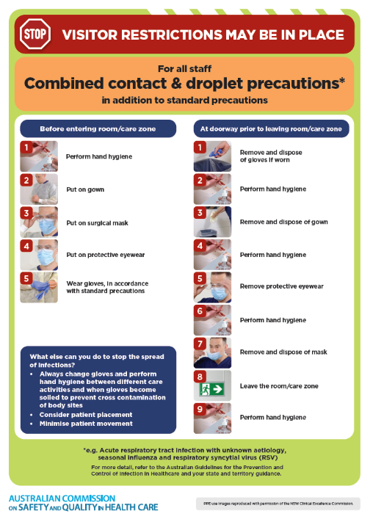](https://www.safetyandquality.gov.au/publications-and-resources/resource-library/infection-prevention-and-control-poster-combined-contact-and-droplet-precautions)
* ***Poster – Combined airborne and contact precautions***<https://www.safetyandquality.gov.au/publications-and-resources/resource-library/infection-prevention-and-control-poster-combined-airborne-and-contact-precautions>  
  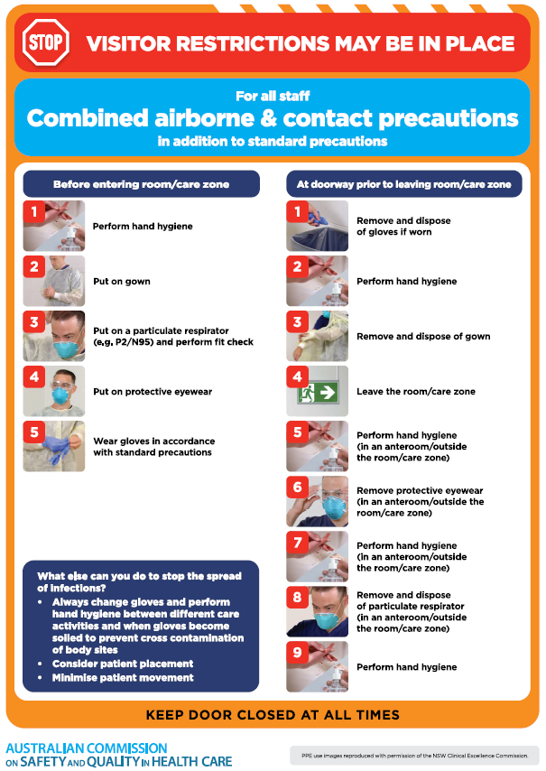
* ***Environmental Cleaning and Infection Prevention and Control*** [www.safetyandquality.gov.au/environmental-cleaning](http://www.safetyandquality.gov.au/environmental-cleaning)
* ***COVID-19 infection prevention and control risk management – Guidance*** <https://www.safetyandquality.gov.au/publications-and-resources/resource-library/covid-19-infection-prevention-and-control-risk-management-guidance>
* ***Safe care for people with cognitive impairment during COVID-19***<https://www.safetyandquality.gov.au/our-work/cognitive-impairment/cognitive-impairment-and-covid-19>
* ***Stop COVID-19: Break the chain of infection*** posterhttps://www.safetyandquality.gov.au/publications-and-resources/resource-library/break-chain-infection-poster-a3  
  **[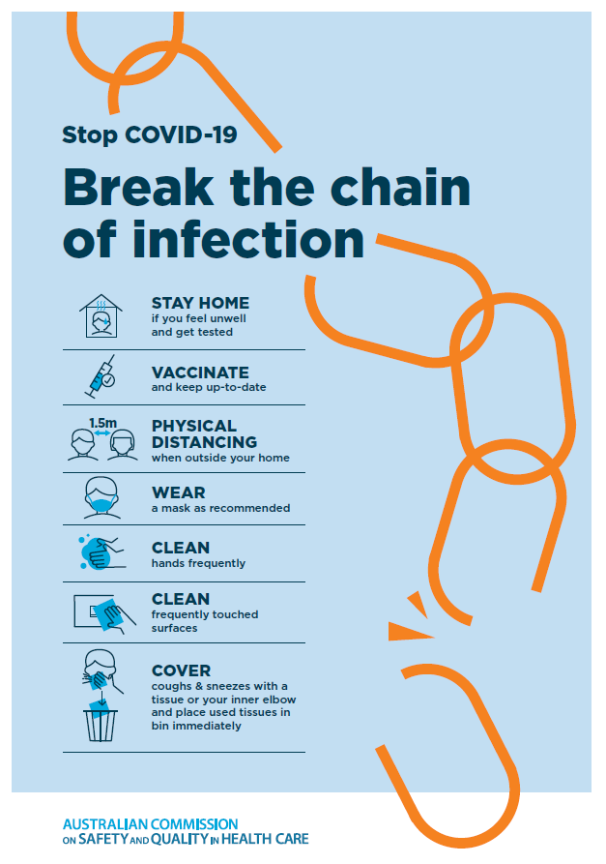](https://www.safetyandquality.gov.au/publications-and-resources/resource-library/break-chain-poster-a3https:/www.safetyandquality.gov.au/publications-and-resources/resource-library/break-chain-poster-a3)**
* ***COVID-19 and face masks – Information for consumers*** <https://www.safetyandquality.gov.au/publications-and-resources/resource-library/covid-19-and-face-masks-information-consumers>

[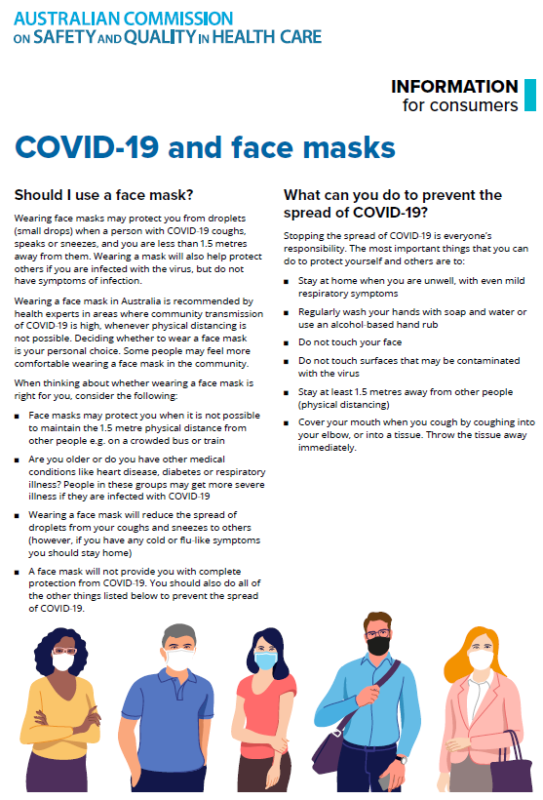](https://www.safetyandquality.gov.au/sites/default/files/2020-07/covid-19_and_face_masks_-_information_for_consumers.pdf)

**Disclaimer**

On the Radar is an information resource of the Australian Commission on Safety and Quality in Health Care. The Commission is not responsible for the content of, nor does it endorse, any articles or sites listed. The Commission accepts no liability for the information or advice provided by these external links. Links are provided on the basis that users make their own decisions about the accuracy, currency and reliability of the information contained therein. Any opinions expressed are not necessarily those of the Australian Commission on Safety and Quality in Health Care.