Australian Commission on Safety and Quality in Health Care logo 




CARAlert data update 36

1 January 2024–29 February 2024

May 2024

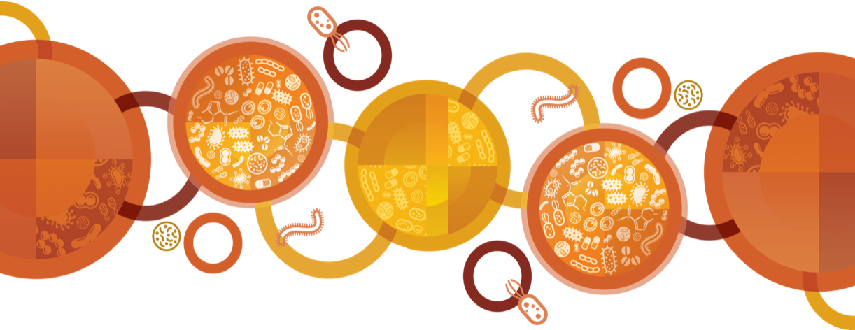

Published by the Australian Commission on Safety and Quality in Health Care  
Level 5, 255 Elizabeth Street, Sydney NSW 2000

Phone: (02) 9126 3600

Email: caralert@safetyandquality.gov.au   
Website: www.safetyandquality.gov.au

© Australian Commission on Safety and Quality in Health Care 2024

All material and work produced by the Australian Commission on Safety and Quality in Health Care (the Commission) is protected by copyright. The Commission reserves the right to set out the terms and conditions for the use of such material.

As far as practicable, material for which the copyright is owned by a third party will be clearly labelled. The Commission has made all reasonable efforts to ensure that this material has been reproduced in this publication with the full consent of the copyright owners.

With the exception of any material protected by a trademark, any content provided by third parties and where otherwise noted, all material presented in this publication is licensed under a [Creative Commons Attribution–NonCommercial–NoDerivatives 4.0 International licence](http://creativecommons.org/licenses/by-nc-nd/4.0/).



Enquiries about the licence and any use of this publication are welcome and can be sent to [communications@safetyandquality.gov.au](mailto:communications@safetyandquality.gov.au).

The Commission’s preference is that you attribute this publication (and any material sourced from it) using the following citation:

Australian Commission on Safety and Quality in Health Care. CARAlert data update 36: 1 January 2024–29 February 2024. Sydney: ACSQHC; 2024

**Disclaimer**

The content of this document is published in good faith by the Commission for information purposes. The document is not intended to provide guidance on particular healthcare choices. You should contact your healthcare provider for information or advice on particular healthcare choices.

The Commission does not accept any legal liability for any injury, loss or damage incurred by the use of, or reliance on, this document.

**Note regarding alternative descriptions**

No alternative descriptions have been provided. If you need assistance with the structure of any graphs or charts, please email the Australian Commission on Safety and Quality in Health Care at [CARAlert@safetyandquality.gov.au](mailto:CARAlert@safetyandquality.gov.au).

Contents

Data Summary 4

National summary 6

Summary by CAR 9

*Acinetobacter baumannii* complex 9

*Candida auris* 10

*Enterobacterales* 11

*Enterococcus* species 17

*Mycobacterium tuberculosis* 18

*Neisseria gonorrhoeae* 18

*Pseudomonas aeruginosa* 19

*Salmonella* species 21

*Shigella* species 21

*Staphylococcus aureus* 23

Appendix 24

Data Notes 24

About AURA and CARAlert 24

## Data Summary

This report provides an update on data submitted to the National Alert System for Critical Antimicrobial Resistances (CARAlert) for the reporting period: 1 January 2024 to 29 February 2024, and complements previous analyses of and updates on [CARAlert data](https://safetyandquality.gov.au/caralert).

**National overview**

* The total number of critical antimicrobial resistances (CARs) reported was up 7.8% compared to the previous two-month reporting period (*n* = 498 versus *n* = 462).
* A little over one-half of the CARs reported were carbapenemase-producing *Enterobacterales* (CPE) (including those with ribosomal methyltransferase) (274/498, 55.0%).
* The total number of CPE (either alone or in combination with other CARs) reported to date this year, compared with the same period last year, increased by 50.5% (*n =*274 versus *n =*182).
* Azithromycin-nonsusceptible (low-level resistance [LLR], minimum inhibitory concentration [MIC] < 256 mg/L) *Neisseria gonorrhoeae* was the second most reported CAR (104/498, 20.9%). The number of reports decreased compared to the previous two-month reporting period (*n* = 104 versus *n* = 139).
* Multidrug-resistant (MDR) *Shigella* species was the third most reported CAR (53/498, 10.6%). The number of reports increased slightly compared to the previous two-month reporting period (*n* = 53 versus *n* = 50).
* Four ceftriaxone-nonsusceptible *N. gonorrhoeae* were reported (either alone or with azithromycin-nonsusceptible), one less than in the previous two-month period.
* Where the setting was known, almost two-thirds of CARs were reported from hospitals (297/461, 64.4%). There were 164 (35.6%) reports from community settings, and no reports from aged care homes.

**Carbapenemase-producing *Enterobacterales***

* The total number of CPE (either alone or in combination with other CARs) increased compared to the previous two-month period (*n* = 274 versus *n* = 220, up 24.5%).
* IMP (120/274, 43.8%), NDM (104/274, 38.0%), OXA-48-like (31/274, 11.3%), and NDM+OXA-48-like (11/274, 4.0%) types accounted for 97.1% of all CPE reported during this period.
* The total number of IMP-types reported increased (*n* = 120) compared to the previous reporting period (*n* = 84); most notably in Queensland (*n* = 32 versus *n* = 12, up 167%).
* The total number of NDM-types reported (either alone or co-produced with other carbapenemase types) increased compared to the previous two-month period (*n* = 117 versus *n* = 108, up 8.3%), most notably in Victoria (*n* = 48 versus *n* = 30, up 60.0%). There was a slight decrease in NDM types (alone or co-produced) reported from Queensland (*n* = 14 versus 17, down 17.6%) and New South Wales (NSW) (*n* = 40 versus *n* = 47, down 14.9%).
* There was a 1.6-fold increase in OXA-48-like types in Victoria (*n* = 13 versus *n* = 8). The number has declined in Victoria since a peak in July-August 2023 (*n* = 39).
* Two KPC-producing *Klebsiella pneumoniae* were reported, one from NSW and one from Western Australia (WA).
* Where the setting was known, 14.1% (38/269) of CPE were reported from the community.
* Eighteen hospitals had more than one report of NDM-types; these were in Victoria (*n*= 7), NSW (*n* = 7), WA (*n* = 2), and Queensland (*n* = 2). Eight hospitals from NSW (*n* = 4), Queensland (*n* = 2) and Victoria (n = 2) had four or more reports.
* Twelve hospitals (*n* = 7 in NSW; *n* = 3 in Queensland, and one each in Victoria and WA) had more than two reports of IMP-types. A further nine hospitals had two notifications of IMP‑types: Queensland (*n* = 5), NSW (*n* = 2) and Victoria (*n* = 2). One hospital from NSW had 24 reports.

***Salmonella* and *Shigella* species**

* There were 14 ceftriaxone-nonsusceptible *Salmonella* species reported during this period: 13 non-typhoidal species from Queensland (extended-spectrum β-lactamase [ESBL], *n* = 3; AmpC, *n* = 1), South Australia (SA) (ESBL, *n* = 3); WA (ESBL, *n* = 3); Victoria (ESBL, *n* = 1, AmpC, *n* = 1); and NSW (ESBL, *n* = 1); and one *S*. Typhi from Victoria (ESBL, *n* = 1).
* There were 53 MDR *Shigella* species reported in this period: 30 *S. flexneri*, 20 *S. sonnei*, two *S. boydii*, and one *S. dysenteriae*. Almost all *S. sonnei* isolates were ceftriaxone/cefotaxime-resistant and produced an ESBL (19/20, 95.0%). A little over two-thirds of MDR *S. flexneri* were susceptible to ceftriaxone/cefotaxime (21/30, 70.0%).

**Azithromycin-nonsusceptible (low-level resistance, MIC < 256 mg/L) *Neisseria gonorrhoeae***

* The total number of reports of this CAR decreased compared with the previous two-month reporting period (*n* = 104 versus *n* = 139, down 25.2%). Just over two-thirds of the reports were from Victoria (70/104, 67.3%).

**Ceftriaxone- and/or azithromycin-nonsusceptible *Neisseria gonorrhoeae***

* There were four reports of ceftriaxone-nonsusceptible *N. gonorrhoeae*; three from NSW (one also had high-level resistance (HLR) to azithromycin (MIC > 256 mg/L), and one from Victoria that also had LLR to azithromycin (MIC < 256 mg/L).
* Seven azithromycin-nonsusceptible *N. gonorrhoeae* (HLR) were reported, four from NSW and three from Queensland.

**Gentamicin-resistant *Neisseria gonorrhoeae***

* No gentamicin-resistant *N. gonorrhoeae* were reported in this period.

**Ciprofloxacin-nonsusceptible *Neisseria meningitidis***

* One ciprofloxacin-nonsusceptible *N. meningitidis* was reported from NSW during this period.

**Carbapenemase-producing *Acinetobacter baumannii* complex and *Pseudomonas aeruginosa***

* Eleven carbapenemase-producing *Acinetobacter baumannii* complex were reported during this period. The reports were from Victoria *(bla*OXA-23, *n* = 6; *bla*OXA-23 + *bla*OXA-58, *n* = 1), WA (*bla*OXA-23, *n* = 1; *bla*OXA-23 + *bla*NDM-5, *n* = 1; *(bla*OXA-72 [OXA-24/40-like], *n* = 1), and NSW (OXA‑23-like, *n* = 1).
* The number of carbapenemase-producing *Pseudomonas aeruginosa* reports was slightly lower than the previous two-month reporting period (*n* = 10 versus *n* = 13). Reports were from NSW (*bla*GES, *n* = 2; *bla*NDM, *n* = 1; *bla*IMP, *n* = 1), Victoria (*bla*NDM‑1, *n* = 1; *bla*VIM-1, *n* = 1; *bla*KPC-2, *n* = 1), Queensland (*bla*NDM‑1, *n* = 1, *bla*NDM‑1+*bla*IMP-1 *n* = 1), and WA (*bla*NDM‑1, *n* = 1).

**Linezolid-resistant *Enterococcus* species**

* Fifteen linezolid-resistant *Enterococcus* species were reported during this period. There were nine *E. faecium* reports all from Victoria; and six *E. faecalis* reports from Victoria (*n* = 3), SA (*n* = 1), WA (*n* = 1) and the Australian Capital Territory (*n* = 1). All except one *E. faecium* harboured *optrA* genes.

***Candida auris***

* Three *Candida auris* were reported during this period. The reports were from Victoria (*n* = 2) and Queensland (*n* = 1).

**Linezolid- or vancomycin-nonsusceptible *Staphylococcus aureus* complex**

* There were no reports of linezolid- or vancomycin-nonsusceptible *Staphylococcus**aureus* complex isolates.

**Transmissible colistin resistance**

* There were no reports *Enterobacterales* with transmissible colistin resistance.

***Streptococcus pyogenes* with reduced susceptibility to penicillin**

* No cases of *Streptococcus pyogenes* withreduced susceptibility to penicillin were reported during this period.

## National summary

**Table 1:** Number of critical antimicrobial resistances, by state and territory, 1 January 2024–29 February 2024, and year to date 2023 and 2024

|  |  |  |  |  |  |  |  |  |  |  |  |  |  |  |  |
| --- | --- | --- | --- | --- | --- | --- | --- | --- | --- | --- | --- | --- | --- | --- | --- |
|  |  | State or Territory (January to February 2024) | | | | | | | | Bi-monthly | | | Year to date | | |
|  |  | **2023** | **2024** |  |
| **Species** | **Critical resistance** | **NSW** | **Vic** | **Qld** | **SA** | **WA** | **Tas** | **NT** | **ACT** | **Oct-Dec** | **Jan-Feb** | **Relative change\*** | **2023** | **2024** | **Relative change\*** |
| *Acinetobacter baumannii* complex | Carbapenemase-producing | 1 | 2 | 0 | 0 | 3 | 0 | 0 | 0 | 4 | 6 | ▲ 50.0% | 5 | 6 | ▲ 20.0% |
| Carbapenemase- and ribosomal methyltransferase-producing | 0 | 5 | 0 | 0 | 0 | 0 | 0 | 0 | 3 | 5 | ▲ 66.7% | 0 | 5 | – |
| *Candida auris* | – | 0 | 2 | 1 | 0 | 0 | 0 | 0 | 0 | 1 | 3 | ▲ 200% | 4 | 3 | ▼ 25.0% |
| *Enterobacterales* | Carbapenemase-producing | 120 | 61 | 45 | 9 | 16 | 1 | 2 | 1 | 204 | 255 | ▲ 25.0% | 167 | 255 | ▲ 52.7% |
| Carbapenemase- and ribosomal methyltransferase-producing | 1 | 12 | 4 | 0 | 2 | 0 | 0 | 0 | 16 | 19 | ▲ 18.8% | 15 | 19 | ▲ 26.7% |
| Carbapenemase- producing and transmissible resistance to colistin | 0 | 0 | 0 | 0 | 0 | 0 | 0 | 0 | 0 | 0 | – | 0 | 0 | – |
| Ribosomal methyltransferase-producing | 0 | 1 | 0 | 0 | 1 | 0 | 0 | 0 | 2 | 2 | 0.0% | 3 | 2 | ▼ 33.3% |
| Transmissible resistance to colistin | 0 | 0 | 0 | 0 | 0 | 0 | 0 | 0 | 0 | 0 | – | 0 | 0 | – |
| *Enterococcus* species | Linezolid-resistant | 0 | 12 | 0 | 1 | 1 | 0 | 0 | 1 | 12 | 15 | ▲ 25.0% | 4 | 15 | ▲ 275% |
| *Mycobacterium tuberculosis* | Multidrug-resistant – at least rifampicin- and isoniazid-resistant strains | 0 | 0 | 0 | 0 | 0 | 0 | 0 | 0 | 0 | 0 | – | 4 | 0 | ▼ 100% |
| *Neisseria gonorrhoeae* | Azithromycin-nonsusceptible (low-level)† | 11 | 70 | 7 | 2 | 14 | 0 | 0 | 0 | 139 | 104 | ▼ 25.2% | 109 | 104 | ▼ 4.6% |
| Azithromycin-nonsusceptible (high-level)§ | 4 | 0 | 3 | 0 | 0 | 0 | 0 | 0 | 2 | 7 | ▲ 250% | 1 | 7 | ▲ 600% |
| Ceftriaxone-nonsusceptible | 2 | 0 | 0 | 0 | 0 | 0 | 0 | 0 | 1 | 2 | ▲ 100% | 3 | 2 | ▼ 33.3% |
| Ceftriaxone-nonsusceptible and azithromycin-nonsusceptible | 1 | 1 | 0 | 0 | 0 | 0 | 0 | 0 | 2 | 2 | 0.0% | 2 | 2 | 0.0% |
| Gentamicin-resistant# | 0 | 0 | 0 | 0 | 0 | 0 | 0 | 0 | 0 | 0 | – | – | 0 | – |

Table 1 (continued)

|  |  |  |  |  |  |  |  |  |  |  |  |  |  |  |  |
| --- | --- | --- | --- | --- | --- | --- | --- | --- | --- | --- | --- | --- | --- | --- | --- |
|  |  | State or territory (January to February 2024) | | | | | | | | Bi-monthly | | | Year to date | | |
|  |  | **2023** | **2024** |  |
| **Species** | **Critical resistance** | **NSW** | **Vic** | **Qld** | **SA** | **WA** | **Tas** | **NT** | **ACT** | **Oct-Dec** | **Jan-Feb** | **Relative change\*** | **2023** | **2024** | **Relative change\*** |
| *Neisseria meningitidis* | Ciprofloxacin-nonsusceptible# | 1 | 0 | 0 | 0 | 0 | 0 | 0 | 0 | 1 | 1 | 0.0% | 2 | 1 | ▼ 50.0% |
| *Pseudomonas aeruginosa* | Carbapenemase-producing | 4 | 1 | 1 | 0 | 1 | 0 | 0 | 0 | 13 | 7 | ▼ 46.2% | 7 | 7 | 0.0% |
| Carbapenemase- and ribosomal methyltransferase-producing | 0 | 2 | 1 | 0 | 0 | 0 | 0 | 0 | 0 | 3 | – | 0 | 3 | – |
| *Salmonella* species | Ceftriaxone-nonsusceptible | 1 | 3 | 4 | 3 | 3 | 0 | 0 | 0 | 12 | 14 | ▲ 16.7% | 14 | 14 | 0.0% |
| *Shigella* species | Multidrug-resistant | 26 | 15 | 4 | 2 | 1 | 0 | 4 | 1 | 50 | 53 | ▲ 6.0% | 49 | 53 | ▲ 8.2% |
| *Staphylococcus aureus* complex | Linezolid-nonsusceptible | 0 | 0 | 0 | 0 | 0 | 0 | 0 | 0 | 0 | 0 | – | 0 | 0 | – |
| Vancomycin-nonsusceptible | 0 | 0 | 0 | 0 | 0 | 0 | 0 | 0 | 0 | 0 | – | 0 | 0 | – |
| *Streptococcus pyogenes* | Penicillin reduced susceptibility | 0 | 0 | 0 | 0 | 0 | 0 | 0 | 0 | 0 | 0 | – | 0 | 0 | – |
|  | **Total (reported by 01 May 2024)** | **172** | **187** | **70** | **17** | **42** | **1** | **6** | **3** | **462** | **498** | ▲ **7.8%** | **389** | **498** | ▲ **28.0%** |

CAR = critical antimicrobial resistances; MIC = minimum inhibitory concentration; ▲ = increase; ▼ = decrease; – = not applicable

* Relative change = absolute change between period in 2023 and same period in 2024, for each CAR, expressed as a percentage of 2023 base

† Azithromycin MIC < 256 mg/L

§ Azithromycin MIC ≥ 256 mg/L

# Reported to CARAlert from January 2023

Notes:

1. For this report, transmissible resistance to colistin refers to the presence of *mcr* genes other than *mcr-9*. This variant is not associated with a colistin resistant phenotype but is typically found on H12 plasmids which may carry *bla*IMP-4.
2. The number of CARs has been updated to include additional submissions received or removed after the previous publication date.
3. Reporting of daptomycin-nonsusceptible *S. aureus* was suspended from January 2023.

**Table 2:** Number of critical antimicrobial resistance isolates, by setting, national, 1 January 2024–29 February 2024

|  |  |  |  |  |  |  |  |
| --- | --- | --- | --- | --- | --- | --- | --- |
|  |  | Setting | | | | |  |
| **Species** | **Critical resistance** | **Public hospital** | **Private hospital** | **Aged care home** | **Community** | **Unknown** | **Total** |
| *Acinetobacter baumannii* complex | Carbapenemase-producing | 5 | 0 | 0 | 0 | 1 | 6 |
| Carbapenemase- and ribosomal methyltransferase-producing | 5 | 0 | 0 | 0 | 0 | 5 |
| *Candida auris* | – | 2 | 0 | 0 | 1 | 0 | 3 |
| *Enterobacterales* | Carbapenemase-producing | 202 | 18 | 0 | 30 | 5 | 255 |
| Carbapenemase- and ribosomal methyltransferase-producing | 11 | 0 | 0 | 8 | 0 | 19 |
| Carbapenemase- producing and transmissible resistance to colistin | 0 | 0 | 0 | 0 | 0 | 0 |
| Ribosomal methyltransferase-producing | 2 | 0 | 0 | 0 | 0 | 2 |
| Transmissible resistance to colistin | 0 | 0 | 0 | 0 | 0 | 0 |
| *Enterococcus* species | Linezolid-resistant | 11 | 0 | 0 | 4 | 0 | 15 |
| *Mycobacterium tuberculosis* | Multidrug-resistant – at least rifampicin- and isoniazid-resistant strains | 0 | 0 | 0 | 0 | 0 | 0 |
| *Neisseria gonorrhoeae* | Azithromycin-nonsusceptible (low-level)* | 6 | 0 | 0 | 84 | 14 | 104 |
| Azithromycin-nonsusceptible (high-level)† | 1 | 0 | 0 | 6 | 0 | 7 |
| Ceftriaxone-nonsusceptible | 0 | 0 | 0 | 1 | 1 | 2 |
| Ceftriaxone-nonsusceptible and azithromycin-nonsusceptible | 0 | 0 | 0 | 2 | 0 | 2 |
| Gentamicin-resistant§ | 0 | 0 | 0 | 0 | 0 | 0 |
| *Neisseria meningitidis* | Ciprofloxacin-nonsusceptible§ | 0 | 0 | 0 | 1 | 0 | 1 |
| *Pseudomonas aeruginosa* | Carbapenemase-producing | 6 | 0 | 0 | 1 | 0 | 7 |
| Carbapenemase- and ribosomal methyltransferase-producing | 3 | 0 | 0 | 0 | 0 | 3 |
| *Salmonella* species | Ceftriaxone-nonsusceptible | 3 | 1 | 0 | 9 | 1 | 14 |
| *Shigella* species | Multidrug-resistant | 20 | 1 | 0 | 17 | 15 | 53 |
| *Staphylococcus aureus* complex | Linezolid-nonsusceptible | 0 | 0 | 0 | 0 | 0 | 0 |
| Vancomycin-nonsusceptible | 0 | 0 | 0 | 0 | 0 | 0 |
| *Streptococcus pyogenes* | Penicillin reduced susceptibility | 0 | 0 | 0 | 0 | 0 | 0 |
|  | **Total (reported by 01 May 2024)** | **277** | **20** | **0** | **164** | **37** | **498** |

* Azithromycin MIC < 256 mg/L

† Azithromycin MIC ≥ 256 mg/L

§ Reported to CARAlert from January 2023

Notes:

1. Reporting of daptomycin-nonsusceptible *S. aureus* was suspended from January 2023.
2. Information on setting for *N. gonorrhoeae* is often not available.

## Summary by CAR

### *Acinetobacter baumannii* complex

#### National data

**Figure 1:** Carbapenemase-producing *Acinetobacter baumannii* complex, 24-month trend by specimen type, national, 1 March 2022–29 February 2024

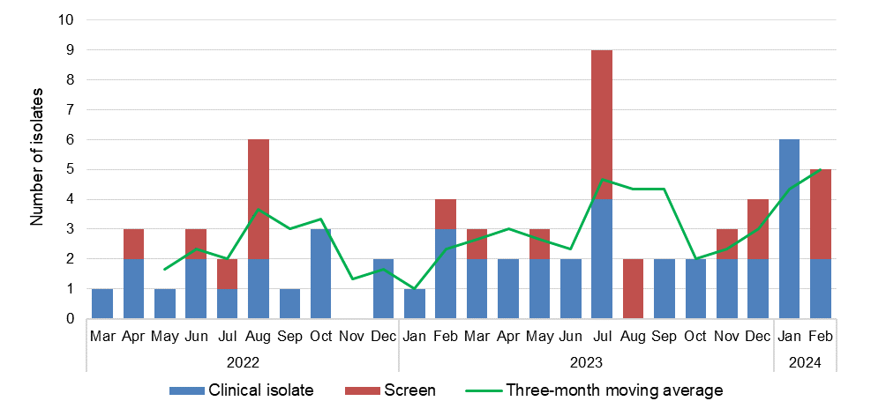

#### State and territory data

Figure 2: Carbapenemase-producing *Acinetobacter baumannii* complex, number reported by carbapenemase type and specimen type, by state and territory, 1 January 2024–29 February 2024

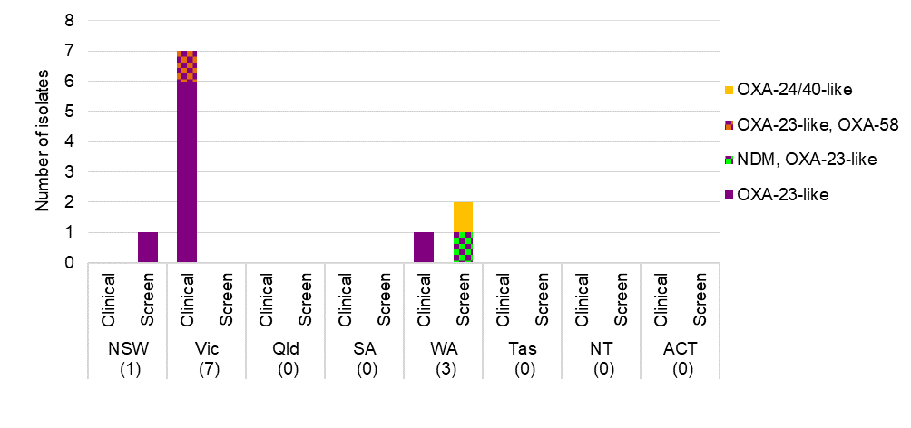

Table 3: Carbapenemase-producing *Acinetobacter baumannii* complex, number reported by setting, by state and territory, 1 January 2024–29 February 2024

|  |  |  |  |  |  |  |  |  |  |
| --- | --- | --- | --- | --- | --- | --- | --- | --- | --- |
|  | State or territory | | | | | | | |  |
| **Setting** | **NSW** | **Vic** | **Qld** | **SA** | **WA** | **Tas** | **NT** | **ACT** | **Total** |
| Total | 1 | 7 | 0 | 0 | 3 | 0 | 0 | 0 | 11 |
| Public hospital | 0 | 7 | 0 | 0 | 3 | 0 | 0 | 0 | 10 |
| Private hospital | 0 | 0 | 0 | 0 | 0 | 0 | 0 | 0 | 0 |
| Aged care home | 0 | 0 | 0 | 0 | 0 | 0 | 0 | 0 | 0 |
| Community | 0 | 0 | 0 | 0 | 0 | 0 | 0 | 0 | 0 |
| Unknown | 1 | 0 | 0 | 0 | 0 | 0 | 0 | 0 | 1 |

### *Candida auris*

#### National data

**Figure 3:** *Candida auris*, 24-month trend by specimen type, national, 1 March 2022–29 February 2024

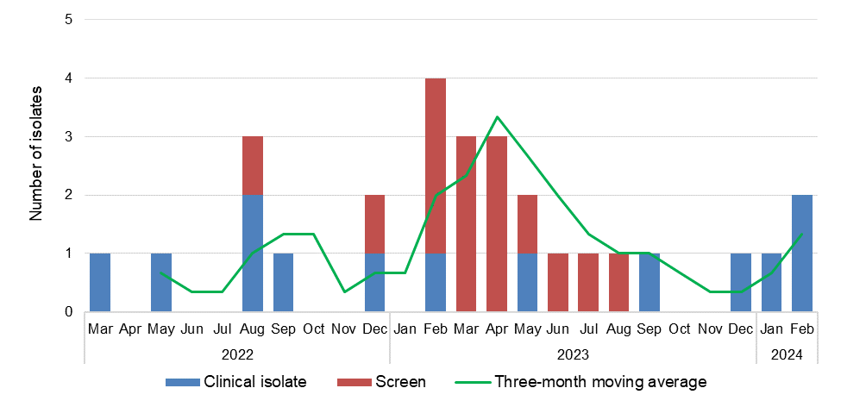

### *Enterobacterales*

#### National data

Figure 4: Carbapenemase-producing *Enterobacterales*\*, 24-month trend by specimen type, national, 1 March 2022–29 February 2024

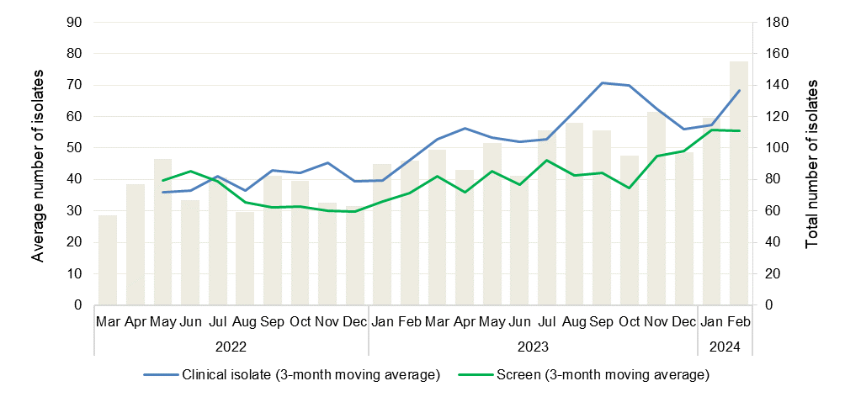

* Carbapenemase-producing alone or in combination with ribosomal methyltransferases or transmissible resistance to colistin

Figure 5: Ribosomal methyltransferase-producing *Enterobacterales*\*, 24-month trend, national, 1 March 2022–29 February 2024

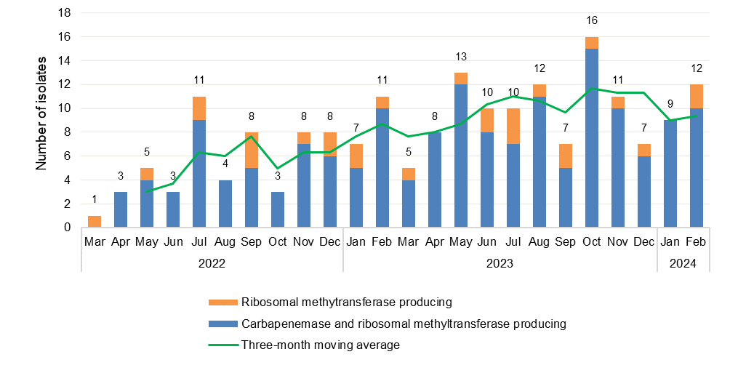

* Ribosomal methyltransferases alone, or in combination with carbapenemase(s)

**Figure 6:** Carbapenemase-producing *Enterobacterales*\*, number reported by carbapenemase type and species, national, 1 January 2024–29 February 2024

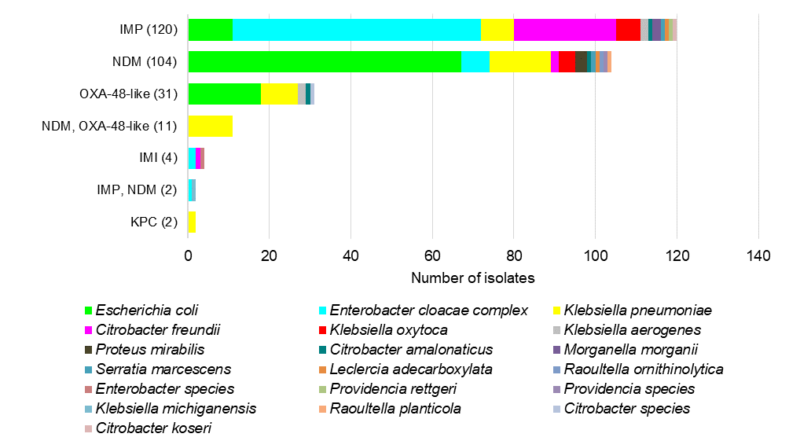

* Carbapenemase-producing (n = 255), carbapenemase and ribosomal methyltransferase-producing (n = 19)

Figure 7: Top four reported carbapenemase types*, 24-month trend, national, 1 March 2022–29 February 2024

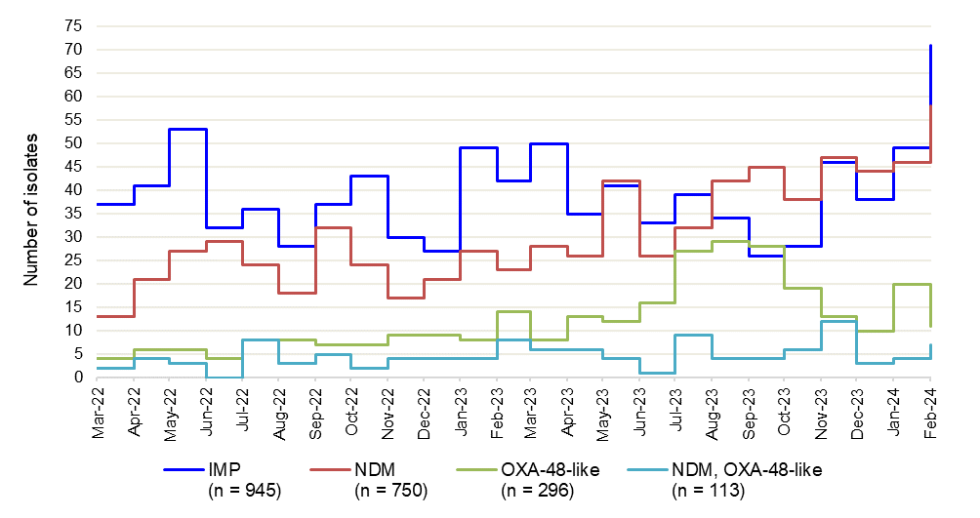

* Alone or in combination with another type for the reporting period indicated

#### State and territory data

Figure 8: Carbapenemase-producing *Enterobacterales*\**,* number reported by month, state and territory, 1 January 2024–29 February 2024

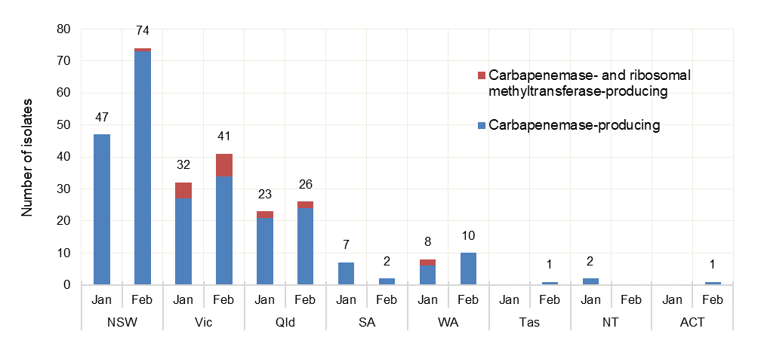

* Carbapenemase-producing (n = 255), carbapenemase and ribosomal methyltransferase-producing (n = 19)

Note: No carbapenemase-producing Enterobacterales with transmissible resistance to colistin were reported during this period.

**Figure 9:** Top four reported carbapenemase types from *Enterobacterales*, by state and territory andnationally, 24-month trend, (three-month moving average), 1 March 2022–29 February 2024

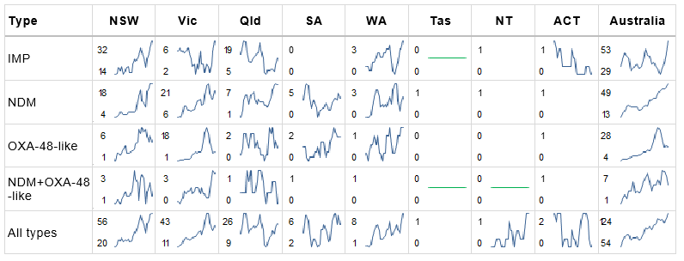Straight green line in cell = no carbapenemase type for that state or territory during the reporting period;   
Blank cell = maximum monthly average was one or less  
Notes:

1. Line graphs represent three-month moving average for the period 1 November 2021 to 31 October 2023, for each type, where maximum monthly average was greater than one.
2. Numbers in each cell represent maximum (top) and minimum (bottom) monthly average.

Figure 10: Carbapenemase-producing *Enterobacterales*\*, number reported by carbapenemase type and specimen type, by state and territory, 1 January 2024–29 February 2024

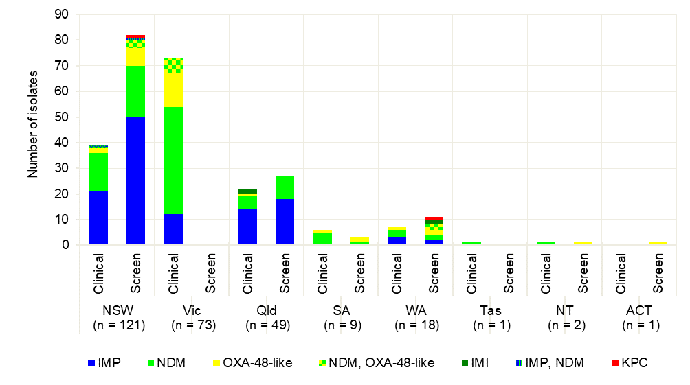

* Carbapenemase-producing (n = 255); carbapenemase- and ribosomal methyltransferase-producing (n = 19)

Figure 11: Top four reported carbapenemase-producing *Enterobacterales* types by specimen type, by state and territory, 1 January 2024–29 February 2024

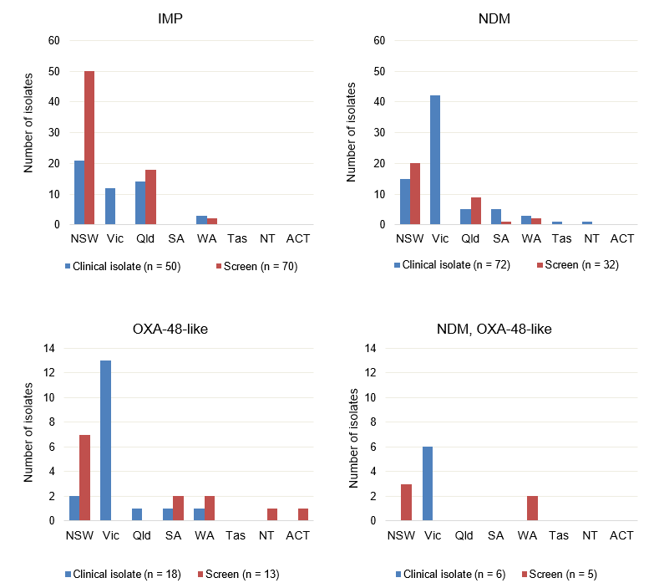

Note: Other types include IMI (*n* = 4; Queensland clinical [2], WA screen [2]); KPC (*n* = 2; NSW screen [1], WA screen [1]); IMP+NDM (*n* = 2; NSW clinical [1], screen [1]).

Table 4: Top five carbapenemase types from *Enterobacterales*, number reported by setting, by state and territory, 1 January 2024–29 February 2024

|  |  |  |  |  |  |  |  |  |  |  |
| --- | --- | --- | --- | --- | --- | --- | --- | --- | --- | --- |
| Carbapenemase type |  | State or territory | | | | | | | |  |
| **Setting** | **NSW** | **Vic** | **Qld** | **SA** | **WA** | **Tas** | **NT** | **ACT** | **Total** |
| IMP | Total | 71 | 12 | 32 | 0 | 5 | 0 | 0 | 0 | 120 |
|  | Public hospitals | 68 | 9 | 25 | 0 | 1 | 0 | 0 | 0 | 103 |
|  | Private hospitals | 0 | 2 | 7 | 0 | 4 | 0 | 0 | 0 | 13 |
|  | Aged care homes | 0 | 0 | 0 | 0 | 0 | 0 | 0 | 0 | 0 |
|  | Community | 3 | 1 | 0 | 0 | 0 | 0 | 0 | 0 | 4 |
|  | Unknown | 0 | 0 | 0 | 0 | 0 | 0 | 0 | 0 | 0 |
| NDM | Total | 35 | 42 | 14 | 6 | 5 | 1 | 1 | 0 | 104 |
|  | Public hospitals | 29 | 22 | 11 | 3 | 2 | 1 | 0 | 0 | 68 |
|  | Private hospitals | 0 | 2 | 1 | 0 | 2 | 0 | 0 | 0 | 5 |
|  | Aged care homes | 0 | 0 | 0 | 0 | 0 | 0 | 0 | 0 | 0 |
|  | Community | 3 | 18 | 2 | 3 | 1 | 0 | 1 | 0 | 28 |
|  | Unknown | 3 | 0 | 0 | 0 | 0 | 0 | 0 | 0 | 3 |
| OXA-48-like | Total | 9 | 13 | 1 | 3 | 3 | 0 | 1 | 1 | 31 |
|  | Public hospitals | 8 | 11 | 1 | 3 | 3 | 0 | 0 | 0 | 26 |
|  | Private hospitals | 0 | 0 | 0 | 0 | 0 | 0 | 0 | 0 | 0 |
|  | Aged care homes | 0 | 0 | 0 | 0 | 0 | 0 | 0 | 0 | 0 |
|  | Community | 0 | 2 | 0 | 0 | 0 | 0 | 1 | 0 | 3 |
|  | Unknown | 1 | 0 | 0 | 0 | 0 | 0 | 0 | 1 | 2 |
| NDM, OXA-48-like | Total | 3 | 6 | 0 | 0 | 2 | 0 | 0 | 0 | 11 |
|  | Public hospitals | 3 | 3 | 0 | 0 | 2 | 0 | 0 | 0 | 8 |
|  | Private hospitals | 0 | 0 | 0 | 0 | 0 | 0 | 0 | 0 | 0 |
|  | Aged care homes | 0 | 0 | 0 | 0 | 0 | 0 | 0 | 0 | 0 |
|  | Community | 0 | 3 | 0 | 0 | 0 | 0 | 0 | 0 | 3 |
|  | Unknown | 0 | 0 | 0 | 0 | 0 | 0 | 0 | 0 | 0 |
| IMI | Total | 0 | 0 | 2 | 0 | 2 | 0 | 0 | 0 | 4 |
|  | Public hospitals | 0 | 0 | 2 | 0 | 2 | 0 | 0 | 0 | 4 |
|  | Private hospitals | 0 | 0 | 0 | 0 | 0 | 0 | 0 | 0 | 0 |
|  | Aged care homes | 0 | 0 | 0 | 0 | 0 | 0 | 0 | 0 | 0 |
|  | Community | 0 | 0 | 0 | 0 | 0 | 0 | 0 | 0 | 0 |
|  | Unknown | 0 | 0 | 0 | 0 | 0 | 0 | 0 | 0 | 0 |

Note: Top five carbapenemase types account for 98.5% (270/274) of all carbapenemase-producing Enterobacterales reported for this period. Other types were IMP+NDM (*n* = 2; NSW); KPC (*n* = 2, NSW, WA).

### *Enterococcus* species

#### National data

Figure 12: Linezolid-nonsusceptible *Enterococcus* species, 24-month trend, national, 1 March 2022–29 February 2024

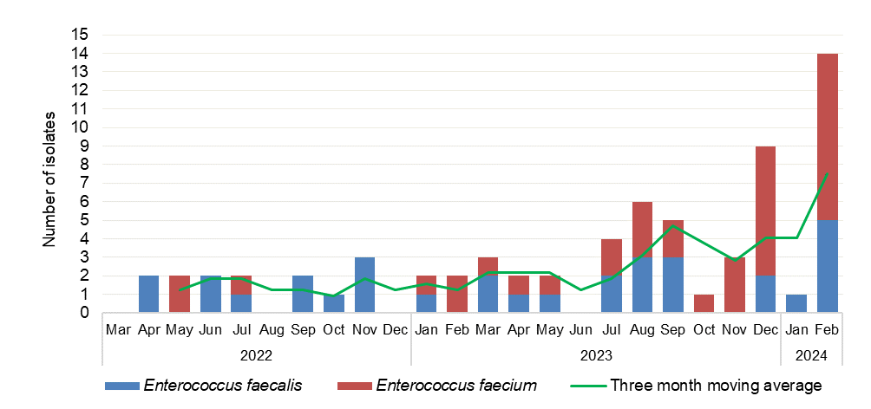

#### State and territory data

Figure 13: Linezolid-nonsusceptible *Enterococcus* species, number reported by state and territory, 1 January 2024–29 February 2024

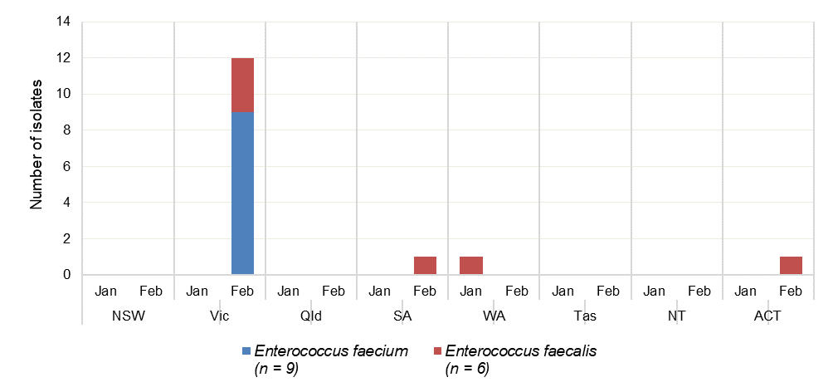

### *Mycobacterium tuberculosis*

#### National data

Figure 14: Multidrug-resistant *Mycobacterium tuberculosis,* 24-month trend, national, 1 March 2022–29 February 2024

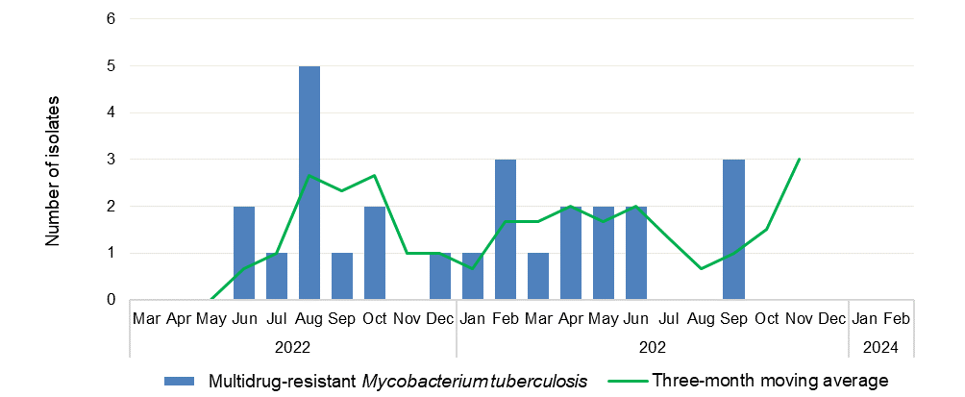

### *Neisseria gonorrhoeae*

#### National data

Figure 15: Ceftriaxone- and/or azithromycin-nonsusceptible *Neisseria gonorrhoeae*, 24-month trend, national, 1 March 2022–29 February 2024

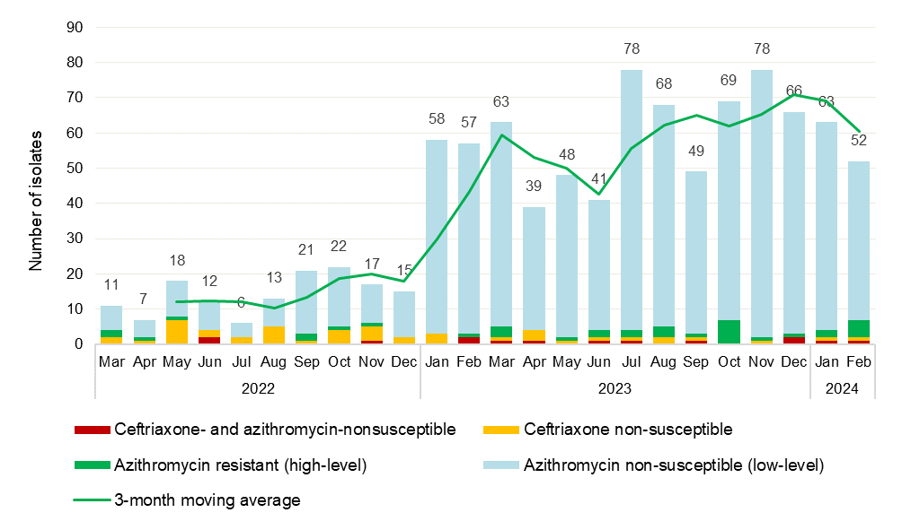

Note: Low-level = azithromycin MIC < 256 mg/L; high-level = azithromycin MIC ≥ 256 mg/L.

#### State and territory data

Figure 16: Ceftriaxone- and/or azithromycin-nonsusceptible *Neisseria gonorrhoeae,* number reported by month, state and territory, 1 January 2024–29 February 2024

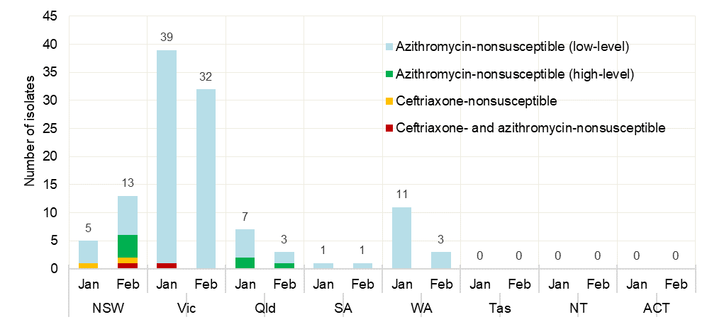

Note: Low-level = azithromycin MIC < 256 mg/L; high-level = azithromycin MIC ≥ 256 mg/L.

### *Pseudomonas aeruginosa*

#### National data

**Figure 17:** Carbapenemase-producing *Pseudomonas aeruginosa*, 24-month trend by specimen type, national, 1 March 2022–29 February 2024

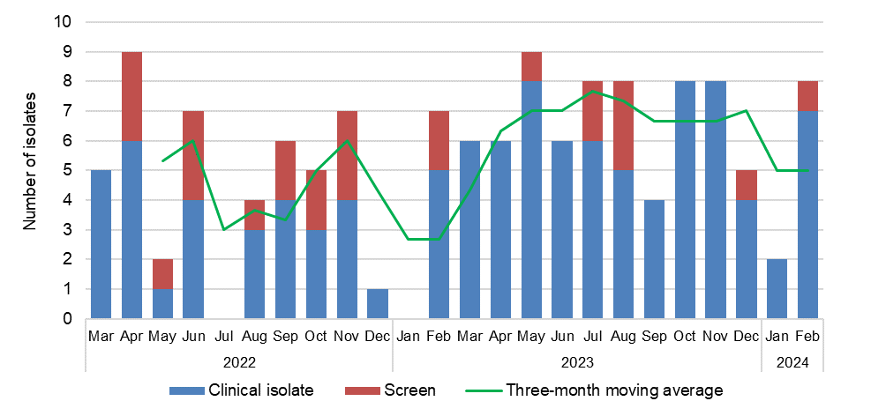

#### State and territory data

Figure 18: Carbapenemase-producing *Pseudomonas aeruginosa*, number reported by carbapenemase type and specimen type, by state and territory, 1 January 2024–29 February 2024

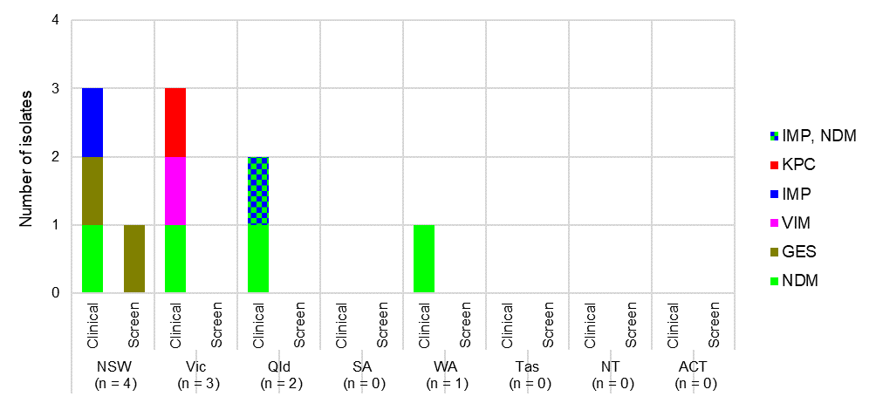

Table 5: Carbapenemase-producing *Pseudomonas aeruginosa*, number reported by setting, by state and territory, 1 January 2024–29 February 2024

|  |  |  |  |  |  |  |  |  |  |
| --- | --- | --- | --- | --- | --- | --- | --- | --- | --- |
|  | State or territory | | | | | | | |  |
| **Setting** | **NSW** | **Vic** | **Qld** | **SA** | **WA** | **Tas** | **NT** | **ACT** | **Total** |
| Total | 4 | 3 | 2 | 0 | 1 | 0 | 0 | 0 | 10 |
| Public hospital | 4 | 3 | 2 | 0 | 0 | 0 | 0 | 0 | 9 |
| Private hospital | 0 | 0 | 0 | 0 | 0 | 0 | 0 | 0 | 0 |
| Aged care home | 0 | 0 | 0 | 0 | 0 | 0 | 0 | 0 | 0 |
| Community | 0 | 0 | 0 | 0 | 1 | 0 | 0 | 0 | 1 |
| Unknown | 0 | 0 | 0 | 0 | 0 | 0 | 0 | 0 | 0 |

### *Salmonella* species

#### National data

Figure 19: Ceftriaxone-nonsusceptible *Salmonella* species, 24-month trend, national, 1 March 2022–29 February 2024

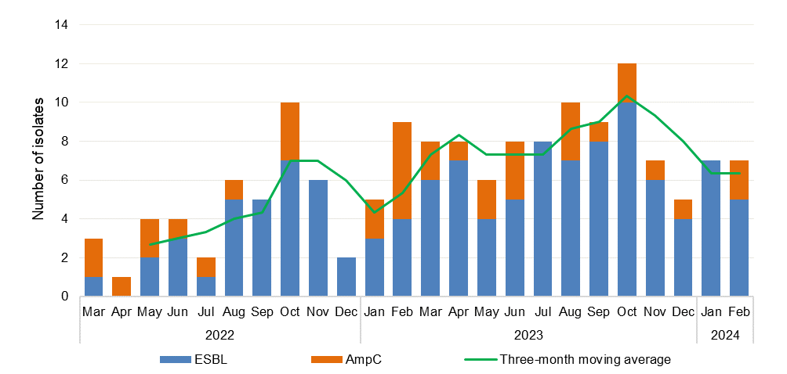

Note: (1 January 2024–29 February 2024) non-typhoidal *Salmonella* species (*n* = 15) and typhoidal *Salmonella* species (*n* = 3).

### *Shigella* species

#### National data

Figure 20: Multidrug-resistant *Shigella* species, 24-month trend, national, 1 March 2022–29 February 2024

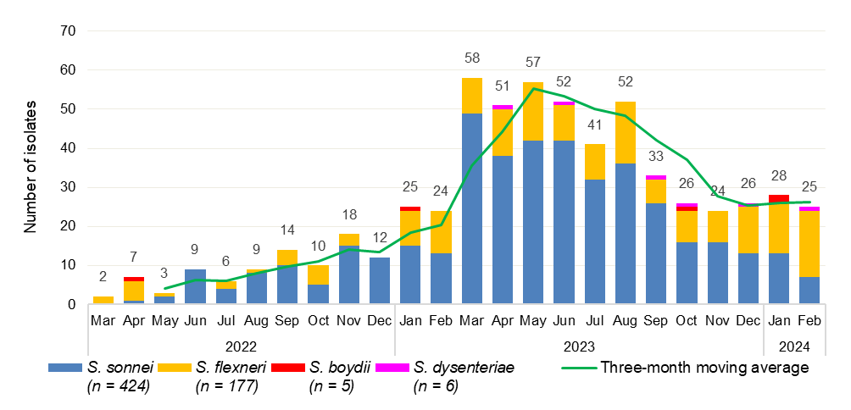

Figure 21: Multidrug-resistant *Shigella* species, number reported by month, national, 1 January 2024–29 February 2024

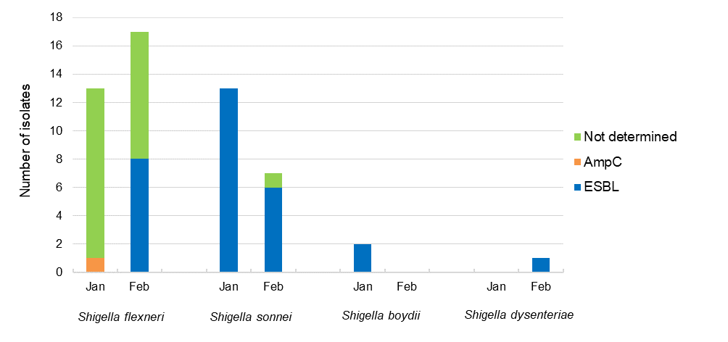

Note: Not determined = multidrug-resistant, ceftriaxone/cefotaxime-susceptible.

#### State and territory data

Figure 22: Multidrug-resistant *Shigella* species, number reported by state and territory, 1 January 2024–29 February 2024

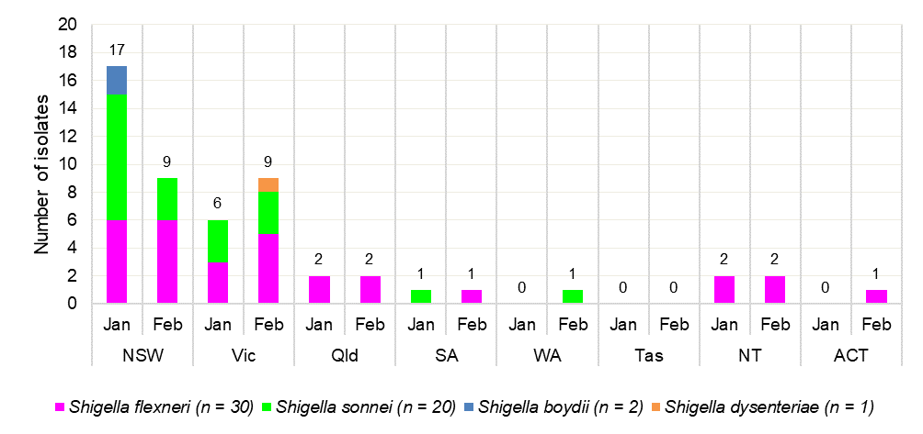

### *Staphylococcus aureus*

#### National data

Figure 23: Daptomycin-, linezolid- or vancomycin-nonsusceptible *Staphylococcus aureus,* 24‑month trend, national, 1 March 2022–29 February 2024

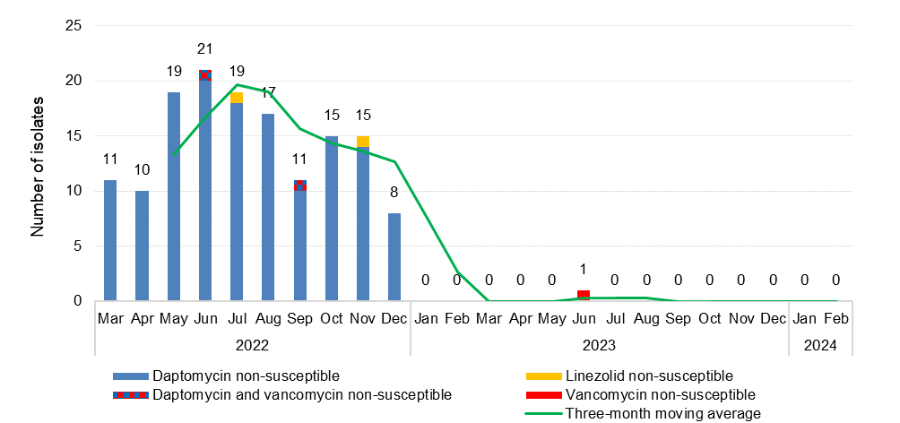

#### Note: Reporting of daptomycin-nonsusceptible *S. aureus* was suspended from January 2023.

#### State and territory data

There was no linezolid-nonsusceptible S. aureus reported during this period.

## Appendix

### Data Notes

The following are important considerations for interpreting National Alert System for Critical Antimicrobial Resistances (CARAlert) data:

* Participation in CARAlert is voluntary
* The data are based on the date that the isolate with the confirmed critical antimicrobial resistance (CAR) was collected
* States and territories refer to the state or territory within which the hospital is located, or within which the patient resides for isolates from the community. If place of residence is unknown or overseas, the state or territory of the originating laboratory is reported
* The same CAR/type/species is not submitted where the sample originated from the same patient who had the previous CAR, and the isolate was collected on the same day, or collected in the same admission or within three months
* Number of CARs reported does not always equal the number of patients, as patients may have more than one CAR, or species, detected in a specimen
* Cut-off date for data that are included in updates and reports is four weeks after the end of each reporting period
* Data may vary from that previously published as the reported number of CARs may have been updated to include additional submissions received or removed after the previous publication date. Comparison between reports may be influenced by delays in confirming laboratories reporting CARs to CARAlert due to late submission, which also means that the data analysed in this data update may not be complete for the time period at the time of publication
* National summary data is provided; comparison across states and territories is provided for organisms where there are large numbers reported and a comparison is meaningful
* Local operating procedures for laboratories may not currently include testing for all the critical resistances included in CARAlert; however, all laboratories are encouraged to actively screen for CARs
* Authorised officers in each state and territory health department can access the CARAlert web portal directly for further information about their jurisdiction, including the name of the public hospital in which a patient with a confirmed CAR was cared for, and to extract reports on their data.

### About AURA and CARAlert

The Antimicrobial Use and Resistance in Australia (AURA) surveillance program provides essential information to develop and implement strategies to prevent and contain antimicrobial resistance in human health and improve antimicrobial use across the acute and community healthcare settings. AURA is coordinated by the Australian Government Department of Health and Aged Care (the Department). AURA supports the [National Safety and Quality Health Service (NSQHS) Preventing and Controlling Infections Standard](https://www.safetyandquality.gov.au/our-work/healthcare-associated-infection-program/preventing-and-controlling-infections-standard) and [Australia’s National Antimicrobial Resistance Strategy – 2020 and beyond](https://www.amr.gov.au/news/australias-national-antimicrobial-resistance-strategy-2020-and-beyond).

CARAlert was established by the Australian Commission on Safety and Quality in Health Care (the Commission) in March 2016 as a component of the AURA surveillance program. Funding for CARAlert is provided by the Department, with contributions from the states and territories for the laboratory analysis and data submission processes.

CARAlert is based on routine processes used by pathology laboratories for identifying and confirming potential critical antimicrobial resistances (CARs). Participating confirming laboratories submit data to CARAlert on priority organisms with critical resistance to last-line antimicrobial agents, which can result in significant morbidity and mortality. Isolates collected from patients are reported to CARAlert as either a clinical isolate, that is a specimen (e.g., from blood, urine, wound) taken to guide clinical diagnosis, or as a screen for infection prevention and control purposes. No patient-level data are held in the CARAlert system.

CARAlert data on confirmed cases of CARs can be used to identify seasonal, geographic and national trends. The potential for CARAlert to act as an early warning system for CAR outbreaks to enable timely infection prevention and control responses is dependent on timely reporting of CARs by confirming laboratories.

The CARs reported to CARAlert are listed in Table A1. These CARs were drawn from the list of high-priority organisms and antimicrobials which are the focus of the AURA surveillance program.[1]

**Table A1: List of critical antimicrobial resistances reported to CARAlert, 2024**

|  |  |
| --- | --- |
| Species | Critical resistance |
| *Acinetobacter baumannii* complex | Carbapenemase-producing* |
| *Candida auris\** | – |
| *Enterobacterales* | Carbapenemase- and/or ribosomal methyltransferase-producing |
| Transmissible colistin resistance* |
| *Enterococcus* species | Linezolid-resistant |
| *Mycobacterium tuberculosis* | Multidrug-resistant – resistant to at least rifampicin and isoniazid |
| *Neisseria gonorrhoeae* | Ceftriaxone- or azithromycin-nonsusceptible |
| Gentamicin-resistant† |
| *Neisseria meningitidis* | Ciprofloxacin-nonsusceptible† |
| *Pseudomonas aeruginosa* | Carbapenemase-producing* |
| *Salmonella* species | Ceftriaxone-nonsusceptible |
| *Shigella* species | Multidrug-resistant |
| *Staphylococcus aureus* complex§ | Vancomycin- or linezolid-nonsusceptible# |
| *Streptococcus pyogenes* | Penicillin reduced susceptibility |

* Reported from July 2019

† Reported from January 2023

§ For CARAlert, *S. aureus* includes *S. argenteus* and *S. schweitzeri*

# Reporting of daptomycin-nonsusceptible *S. aureus* was suspended from January 2023

Note: Low level-azithromycin-nonsusceptible *N. gonorrhoeae* is reported to CARAlert but was excluded from the weekly digest following review in 2018.

In 2022, the Commission conducted a review of CARAlert to assess whether currently reported CARs continue to be priorities, and to identify any additional CARs for inclusion. The review followed a similar process to previous reviews in 2016 and 2018. In consultation with states and territories and a range of clinical experts, the 2022 review identified two new CARs that have been reported to CARAlert since 1 January 2023:

* Ciprofloxacin-nonsusceptible *Neisseria meningitidis*
* Gentamicin-resistant *N. gonorrhoeae*.

Additionally, reporting of daptomycin-nonsusceptible *Staphylococcus aureus* (DNSA) was suspended from 2023. Reintroduction of reporting of DNSA will be considered when more reliable testing methods are available.

The CARAlert system is based on the following routine processes used by pathology laboratories for identifying and confirming potential CARs:

1. Collection and routine testing – the isolate is collected from the patient and sent to the originating laboratory for routine testing
2. Confirmation – if the originating laboratory suspects that the isolate is a CAR, the isolate is sent to a confirming laboratory that has the capacity to confirm the CAR
3. Reporting to clinicians in accordance with usual laboratory processes – the confirming laboratory reports back to the originating laboratory, which in turn reports to the clinician who initially requested the microbiological testing
4. Submission to CARAlert – the confirming laboratory advises the originating laboratory of the result of the test, and the originating laboratory reports back to the health service that cared for the patient from whom the specimen was collected; the confirming laboratory then submits the details of the resistance and organism into the secure CARAlert web portal.

The CARAlert system generates a weekly summary email alert to report information on confirmed CARs to authorised users from confirming laboratories, state and territory health authorities, the Department and the Commission who also have access to the CARAlert web portal.

This page is left intentionally blank





Level 5, 255 Elizabeth Street, Sydney NSW 2000  
GPO Box 5480, Sydney NSW 2001

Phone: (02) 9126 3600

Email: CARAlert@safetyandquality.gov.au

Website: [www.safetyandquality.gov.au](http://www.safetyandquality.gov.au)

0BTwitter logo @ACSQHC

1. Australian Commission on Safety and Quality in Health Care. AURA 2021: fourth Australian report on antimicrobial use and resistance in human health. Sydney: ACSQHC; 2021.