# Australian Commission on Safety and Quality logotypeOn the Radar

Issue 653

17 June 2024

*On the Radar* is a summary of some of the recent publications in the areas of safety and quality in health care. Inclusion in this document is not an endorsement or recommendation of any publication or provider. Access to particular documents may depend on whether they are Open Access or not, and/or your individual or institutional access to subscription sites/services. Material that may require subscription is included as it is considered relevant.

*On the Radar* is available online, via email or as a PDF or Word document from <https://www.safetyandquality.gov.au/newsroom/subscribe-news/radar>

If you would like to receive *On the Radar* via email, you can subscribe on our website <https://www.safetyandquality.gov.au/newsroom/subscribe-news>  
or by emailing us at H[Umail@safetyandquality.gov.auU](mailto:mail@safetyandquality.gov.au).  
You can also send feedback and comments to H[Umail@safetyandquality.gov.auU](mailto:mail@safetyandquality.gov.au).

For information about the Commission and its programs and publications, please visit <https://www.safetyandquality.gov.au>

w

**On the Radar**

Editor: Dr Niall Johnson [niall.johnson@safetyandquality.gov.au](mailto:niall.johnson@safetyandquality.gov.au)

Contributors: Niall Johnson, Natalie Kahwajy, Nicola Bunt

**Women's Health: Heavy Menstrual Bleeding**

<https://www.safetyandquality.gov.au/newsroom/womens-health-hub-heavy-menstrual-bleeding>

**Women's Health Focus Report**

Australian Commission on Safety and Quality in Health Care

Sydney: ACSQHC; 2024.

<https://www.safetyandquality.gov.au/our-work/healthcare-variation/womens-health-focus-report>

**Heavy Menstrual Bleeding Clinical Care Standard**

Australian Commission on Safety and Quality in Health Care.

Sydney: ACSQHC; 2024. p. 56.

<https://www.safetyandquality.gov.au/standards/clinical-care-standards/heavy-menstrual-bleeding-clinical-care-standard>

The Commission has released a new interactive *Women’s Health Focus Report* examining trends in hysterectomy and endometrial ablation rates, two procedures commonly used to treat heavy menstrual bleeding. Alongside the report, the Commission has also released an updated *Heavy Menstrual Bleeding Clinical Care Standard* and supporting resources outlining best practice care to ensure that women with this condition can make an informed choice about the most appropriate treatment for their individual situation.

One in four women experience heavy menstrual bleeding which can have a serious impact on their quality of life. Hysterectomy is one option for treating heavy menstrual bleeding, but there are a number of associated risks. Less invasive treatments are available, including oral medicines, the hormonal IUD and procedures like endometrial ablation. Find out more about these resources on the Women’s Health: Heavy Menstrual Bleeding hub at <https://www.safetyandquality.gov.au/newsroom/womens-health-hub-heavy-menstrual-bleeding>

**Introduction to High Risk Medicines – Updated eLearning Module**

<https://www.safetyandquality.gov.au/our-work/medication-safety/high-risk-medicines>

The Commission’s Digital Health team, in partnership with the Medicines Safety and Quality team, has officially launched the recently revised and updated *Introduction to High Risk Medicines* eLearning Module.

This module was updated to help junior doctors, nurses and pharmacists learn more about the safe use of high risk medicines.

The module can be accessed by account holders on HRM Education website <https://hrmeducation.health.gov.au/login>

For more information, see the Commission’s High Risk Medicines webpage at <https://www.safetyandquality.gov.au/our-work/medication-safety/high-risk-medicines>

[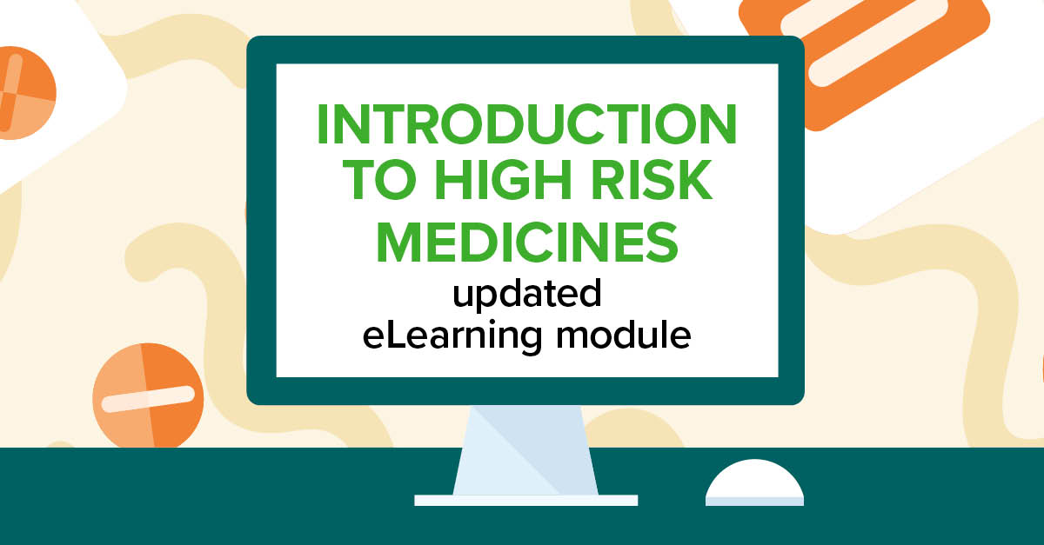](https://www.safetyandquality.gov.au/our-work/medication-safety/high-risk-medicines)

**Books**

*Global patient safety report 2024*

World Health Organization

Geneva: WHO; 2024. p. xxviii, 354.

|  |  |
| --- | --- |
| URL | <https://iris.who.int/handle/10665/376928> |
| Notes | The World Health Organization (WHO) has released the inaugural Global patient safety report. The WHO’s Director General notes in the foreword that while the report ‘sheds light on the commendable progress made by many countries, but also underscores the vast scope for further improvement.’  The report seeks to provide ‘a foundational understanding of the current state of patient safety globally’ while also offering ‘insights and information beneficial to health care professionals, policy-makers, patients and patient safety advocates, researchers – essentially anyone involved or interested in the improvement of health care and patient safety globally. It also contains ‘insights into specific areas that need attention and investment, recognizing that progress in patient safety measures has been uneven across different regions.’ |

*Design Creativity*

Elements of Improving Quality and Safety in Healthcare

Jun GT, Hignett S, Clarkson PJ

Cambridge: Cambridge University Press; 2024.

|  |  |
| --- | --- |
| DOI | <https://doi.org/10.1017/9781009325318> |
| Notes | This is the latest release in the Elements of Improving Quality and Safety in Healthcare series from The Healthcare Improvement Studies Institute (the THIS Institute) in Cambridge. This volume examines the role of design creativity within the context of healthcare improvement. Design creativity describes the process by which needs are explored and translated into requirements for change. The authors describe the characteristics of design thinking. They offer practical tools to support design creativity, including ethnographic/observational studies, personas and scenarios, and needs identification and requirements analysis. They also cover brainstorming, Disney, and six thinking hats techniques, the nine windows technique, morphological charts and product architecting, and concept evaluation. The volume includes examples of the use of these tools and techniques in healthcare improvement. |

**Reports**

*Mental Health Needs in the U.S. Compared to Nine Other Countries*Findings from the Commonwealth Fund 2023 International Health Policy Survey

Gunja MZ, Gumas ED, Williams RD II

New York: Commonwealth Fund; 2024.

|  |  |
| --- | --- |
| DOI | <https://doi.org/10.26099/w1d6-7v98> |
| otes | The latest iteration of the Commonwealth Fund’s comparative survey of health systems examined mental health. Using data from the 2023 Commonwealth Fund International Health Policy Survey of more than 21,000 adults age 18 and older in 10 countries, this report compared people’s mental health burden and ability to access and afford needed mental health care in ten high-income countries. Whereas in most of these comparisons of the health system in a collection of wealthy nations Australia rates rather well, here Australia joins the USA in being an outlier. The USA and Australia were found to have higher suicide rates and to have the highest proportion of adults reporting a mental health need.  [Figure showing the percentage of adults age 18 and older who reported having a mental health need. Values range from 20% for Germany to 41% for Australia.](https://doi.org/10.26099/w1d6-7v98) |

*Making Healthcare Safer IV—Summary of Findings on Year 1 Topics*

Bass EB, Shekelle P, Treadwell JR, Rosen M, Mull NK, Stewart CM, et al

Rockville, MD: Agency for Healthcare Research and Quality; 2024.

|  |  |
| --- | --- |
| URL | <https://effectivehealthcare.ahrq.gov/products/summary-findings> |
| Notes | The US Agency for Healthcare Research and Quality (AHRQ) has been undertaking work under the Making Healthcare Safer (MHS) banner for some years. The current program, MHSIV, is the fourth instalment. This report summarises the views of the program’s Technical Expert Panel (TEP) pm the findings from the first year of MHSIV.  The patient safety practices ‘strongly encouraged’ include:   * Preoperative and anaesthesia checklists to prevent operative and post-operative events * Bundles, including checklists to prevent central line-associated bloodstream infections * Interventions to reduce urinary catheter use * Bundles with head-of-bed elevation, sedation vacations, oral care with chlorhexidine, and subglottic suctioning tubes to prevent ventilator-associated pneumonia * Hand hygiene * “Do Not Use” list for hazardous abbreviations * Multicomponent interventions to reduce pressure ulcers * Barrier precautions to prevent healthcare-associated infections * Use of real-time ultrasound for central line placement * Interventions to improve prophylaxis for venous thromboembolism.   Other practices that are ‘encouraged’ include:   * Multicomponent interventions to reduce falls * Use of clinical pharmacists to reduce adverse drug events * Documentation of patient preferences for life-sustaining treatment * Obtaining informed consent to improve patients’ understanding of potential risks of procedures * Team training * Medication reconciliation * Practices to reduce radiation exposure from fluoroscopy & computed tomography * Use of surgical outcome measurements & report cards * Rapid response systems * Utilization of complementary methods for detecting adverse events/medical errors to monitor for patient safety problems * Computerized provider order entry * Use of simulation exercises in patient safety efforts. |

*Harnessing data to improve patient care and prevent hospital-acquired complications*  
Deeble Institute for Health Policy Research Issues Brief no: 55

Lovegrove J, Haddock R

Canberra: Australian Healthcare and Hospitals Association; 2024. p. 43.

|  |  |
| --- | --- |
| URL | <https://ahha.asn.au/resource/harnessing-data-to-improve-patient-care-and-prevent-hospital-acquired-complications/> |
| Notes | This issues brief from the Australian Healthcare and Hospitals Association’s Deeble Institute explores some of the issues around hospital acquired complications (HACs). The issues brief includes a number of recommendations, including:   1. To compliment local reporting, national agencies and organisations should be supported to publish comprehensive HAC data in a timelier manner through the streamlining of publication across fewer platforms and efforts to improve the timeliness of data release and transfer from local to national levels. 2. Nationally standardised process of care indicators for all HACs should be developed and nationally available for stakeholders 3. Requirements for the publication of comprehensive HAC data should be embedded in legislation and subsequent policies, frameworks and strategies. 4. Clear and transparent HAC data should be published for patients, and approaches to publication should be co-designed. |

For information on the Commission’s work on hospital-acquired complications (HACs) see <https://www.safetyandquality.gov.au/our-work/indicators-measurement-and-reporting/hospital-acquired-complications-hacs>

*Engaging stakeholders in healthcare innovation: How hard can it be?*

Deeble Institute for Health Policy Research Perspectives Brief no: 31.

Finch J, Gavaghan B, Cheung L, Clarke K, Davidson A, Hartley N

Canberra: Australian Healthcare and Hospitals Association; 2024.

|  |  |
| --- | --- |
| URL | <https://ahha.asn.au/resource/engaging-stakeholders-in-healthcare-innovation-how-hard-can-it-be/> |
| Notes | This perspectives brief from the Australian Healthcare and Hospitals Association’s Deeble Institute explores the challenge of successful innovation in health care. The authors of this brief observe that not only are innovations often ‘dependent on a wide range of stakeholders…all of whom hold diverse interests’ but they may fail due to a lack of successful engagement with those stakeholders. Thus, ‘Expertise in engaging stakeholders is often a missing link between success and failure in the healthcare setting.’ The brief examines the ‘lessons learnt from the implementation of three allied health-led service innovations with diverse stakeholder groups’ and then proposes ‘a more deliberate and strategic approach to stakeholder engagement to implement sustainable innovative practice in healthcare using a service logic.’ |

**Journal articles**

*Interventions to Prevent Falls in Community-Dwelling Older Adults: US Preventive Services Task Force Recommendation Statement*

U S Preventive Services Task Force

JAMA. 2024.

*Interventions to Prevent Falls in Older Adults: Updated Evidence Report and Systematic Review for the US Preventive Services Task Force*

Guirguis-Blake JM, Perdue LA, Coppola EL, Bean SI

JAMA. 2024.

*Preventing Falls in Older Persons: Steps in the Right Direction*

Reuben DB, Ganz DA

JAMA. 2024.

*Prevention of Falls in Older Adults*

Jin J

JAMA. 2024.

*Effectiveness of dance interventions for falls prevention in older adults: systematic review and meta-analysis*

Lazo Green K, Yang Y, Abaraogu U, Eastaugh CH, Beyer FR, Norman G, et al

Age and Ageing. 2024;53(5):afae104.

|  |  |
| --- | --- |
| DOI | US Preventive Services Task Force <https://doi.org/10.1001/jama.2024.8481>  Guirguis-Blake et al <https://doi.org/10.1001/jama.2024.4166>  Rueben and Ganz <https://doi.org/10.1001/jama.2024.9063>  Jin [c](https://doi.org/10.1001/jama.2024.9713)  Gren et al <https://doi.org/10.1093/ageing/afae104> |
| Notes | *JAMA* has published the Recommendation Statement from the US Preventive Services Task Force on interventions to prevent falls for older adults living in the community. Also published are the updated evidence report and systematic review that support that statement (Guirguis-Blake et al), an accompanying editorial (Rueben and Ganz)) and ‘patient page’ (Jin).  The Task Force ‘recommends exercise interventions to prevent falls in community-dwelling adults 65 years or older who are at increased risk for falls. (B recommendation) The USPSTF recommends that clinicians individualize the decision to offer multifactorial interventions to prevent falls to community-dwelling adults 65 years or older who are at increased risk for falls.’  [Infographic from JAMA's Patient Page on the Prevention of Falls in Older Adults.](https://doi.org/10.1001/jama.2024.9713)  Perhaps disappointingly for some, Green et al report finding that ‘There is very low certainty evidence for dance as an alternative to strength and balance training if the aim is to prevent falls.’ |

For information on the Commission’s work on preventing falls and harm from falls in the *Comprehensive Care Standard* within the *National Safety and Quality Health Service (NSQHS) Standards* see <https://www.safetyandquality.gov.au/standards/nsqhs-standards/comprehensive-care-standard>

For information on the Commission’s work on falls prevention, including the 2009 *Preventing Falls and Harm from Falls in Older People: Best Practice Guidelines*, see <https://www.safetyandquality.gov.au/our-work/comprehensive-care/related-topics/falls-prevention>

*Is ‘too much medicine’ a guideline-driven phenomenon? Ten years' report and reflections of the Guidelines International Network Multimorbidity Working Group*

Scherer M, Burgers JS, the Guidelines International Network Multimorbidity Working Group

Clinical and Public Health Guidelines. 2024 2024/07/01;1(3):e12016.

|  |  |
| --- | --- |
| DOI | <https://doi.org/10.1002/gin2.12016> |
| Notes | Paper from the Guidelines International Network (GIN) Multimorbidity Working Group. The group was established ‘to explore the questions of how and to what extent multimorbidity and its related constructs can be reflected in guideline development.’ Among the identified highlights of this paper are:   * Single disease guidelines contribute to ‘too much medicine’, including the abundance of diagnostic and therapeutic measures with potential harm to the patient. * The ‘less is more’ approach includes communication on patient outcomes, recommendations for deprescribing and awareness of climate impact. * Guidelines supporting person-centred care could reduce the risk of low-value care for multimorbid patients, which will benefit both individual and planetary health. |

*Predictors of mortality shortly after entering a long-term care facility*

Jorissen RN, Wesselingh SL, Whitehead C, Maddison J, Forward J, Bourke A, et al

Age and Ageing. 2024;53(5):afae098.

|  |  |
| --- | --- |
| DOI | <https://doi.org/10.1093/ageing/afae098> |
| Notes | Paper from a retrospective cohort study using data from the Registry of Senior Australians that sought to examine predictors of 90-day mortality. The study developed a prediction model for 90-day mortality and identified 51 predictors of mortality. The strongest predictors included activities of daily living category, high level of complex health conditions, several medication classes and male sex. The authors assert that the model ‘can moderately well identify individuals at high risk of mortality upon LTCF[long-term care facility] entry.’ |

*Australian Health Review*

Volume 48, Number 3, June 2024

|  |  |
| --- | --- |
| URL | <https://www.publish.csiro.au/ah/issue/11609> |
| Notes | A new issue of the *Australian Health Review* has been published Articles in this issue of the *Australian Health Review* include:   * Big talk, little action: the enduring narrative of **primary care reform** (Claire Jackson) * The impact of self-assessment and surveyor assessment on site visit performance under the **National General Practice Accreditation scheme** (David T McNaughton, Paul Mara and Michael P Jones) * Highlighting efficiency and redundancy in the **Royal Australian College of General Practice standards for accreditation** (David McNaughton, Paul Mara and Michael Jones) * The creation of Grampians Health – a case study focusing on lessons learned from a **health service merger** (Stephen Duckett, Rob Grenfell and Sharon Sykes) * Health systems model for **chronic disease secondary prevention in rural and remote areas** – Chronic disease: Road to health (Pat Field, Richard C Franklin, Ruth Barker, Ian Ring and Peter Leggat) * Using an under-utilised rural hospital to reduce **surgical waiting lists** (Tracey Edwards, Andrea Boerkamp, Kimberley J Davis and Steven Craig) * Lessons from the ‘legitimate’ misuse of **Medicare Benefits Schedule Item 45503** (Jonathon Bruce Ryan) * The **Medicines Repurposing Program** – a critical perspective (Narcyz Ghinea) * **Private health insurance incentives and passive adverse selection**: is Lifetime Health Cover responsible for the excess ageing of Australia’s hospital cover risk pool? (Jonathon Bruce Ryan) * What are the cost and resource implications of **voluntary assisted dying and euthanasia**? (Peter Hudson, David Marco, Richard De Abreu Lourenco and Jennifer Philip) * Personal and organisational attributes that support **transformational leadership in acute healthcare**: scoping review (Julie Considine, Jenny Dempster, Nga Man Wendy Wong, Noelleen Kiprillis and Leanne Boyd) * Workforce training needs to address social and emotional wellbeing in **home-based Aboriginal and Torres Strait Islander aged care** (Adriana Parrella, Jonathon Zagler, Matilda D’Antoine, Tina Brodie, Kate Smith, Aunty Martha Watts, Tameeka Ieremia, Graham Aitken, Alex Brown and Odette Pearson) * Is **HealthPathways** viewed as a useful and trustworthy source of information by health professionals? (Rebecca Tretheway, Victoria Visser and Sarah Mollard) * Familiarity, confidence and preference of **artificial intelligence feedback and prompts by Australian breast cancer screening** readers (Phuong Dung (Yun) Trieu, Melissa L Barron, Zhengqiang Jiang, Seyedamir Tavakoli Taba, Ziba Gandomkar and Sarah J Lewis) * A pilot model of care to achieve **next-day discharge in patients undergoing hip and knee arthroplasty** in an Australian public hospital setting (Marisa Delahunt, Rebekah McGaw and Andrew Hardidge) * Partnering with consumers and practising clinicians to establish **research priorities for public hospital maternity services** (Roni Cole, Lauren Kearney, Bec Jenkinson, Imogen Kettle, Beng Ng, Leonie Callaway and Rachael Nugent) * Isn’t it time for **health professionals** to shift their focus from preaching politics to **promoting peace**? (Naomi T Katz, Merav L Katz, Nikki R. Adler and Jack Green) |

*Healthcare Quarterly*

Volume 27, Number 1, April 2024

|  |  |
| --- | --- |
| URL | <https://www.longwoods.com/publications/healthcare-quarterly/27320/1/vol-27-no.-1-2024> |
| Notes | A new issue of *Healthcare Quarterly* has been published Articles in this issue of *Healthcare Quarterly* include:   * **Sex-Based Differences in Mental Health Service Use** Between Canadian Veterans and Non-Veterans Residing in Ontario (Kate St. Cyr and Alyson L Mahar)**Hospital Staffing and Hospital Harm Trends** Throughout the COVID-19 Pandemic (Sierra Campbell, Amanda Tardif, Tareq Ahmed, Salwa Akiki, Satya Challa, Kate Parson and Chantal Couris) * For an **Unremarkable Health System** (Neil Seeman) * **Refocusing on Patient Safety** (G Ross Baker) * Building a **Resilient Patient Safety Culture**: A Large Healthcare Organization’s Approach to Systematically Reviewing Serious Harm Events (Brian Harvey, Irfan Dhalla, Cathy O’Neill, Christine Léger and Heidi Hunter) * A Primer on **Artificial Intelligence for Healthcare Administrators** (Senthujan Senkaiahliyan, Jeremy Petch, Nigar Sekercioglu and Abi Sriharan) * “The Space Is as Much Yours as It Is Mine”: Insights From Health System Leaders About **Inclusive Leadership** (Aunima R. Bhuiya, Alyssa Kelly, Lorraine Pirrie, Danielle Toccalino, Whiwon Lee, Meghan McMahon and Beverly M Essue) * Bridge-to-Home: A Case Study of the Mutually Reinforcing Benefits of Patient Engagement–Focused Quality Improvement Initiatives for **Transitions out of Hospital** (Shoshana Hahn-Goldberg, Audrey L’Espérance, Brady Comeau, Alexandra Harrison and Carol Fancott) * Commentary: **Engagement for Research and Quality Improvement** – More Than Just Words (Kerry Kuluski, Katie Dainty and Kelly M Smith) * Routine Collection of **Patient-Reported Data** to Support the Needs of Primary Care Within an Integrated Healthcare System (Morgan Slater, Adhanom Gebreegziabher Baraki and Catherine Donnelly) |

*Health Policy*

Volume 145, July 2024

|  |  |
| --- | --- |
| URL | <https://www.sciencedirect.com/journal/health-policy/vol/145/> |
| Notes | A new issue of *Health Policy* has been published Articles in this issue of *Health Policy* include:   * Is the EU steering **national social and health policy making**? A case-study on Finland's national reform (Noora Heinonen, Meri Koivusalo, Ilmo Keskimäki, Liina-Kaisa Tynkkynen) * Impact of time of diagnosis on **out-of-pocket costs of cancer treatment**, a side effect of health insurance design in Australia (Maryam Naghsh-Nejad, Kees van Gool) * Are Polish **doctors ready to start working right after graduation**? The 2023 modification to physicians’ postgraduate internship and possible paths forward (Robert Kupis, Alicja Domagała) * **Healthcare utilisation by diabetic patients** in Denmark: the role of primary care in reducing emergency visits (Mauro Laudicella, Paolo Li Donni, Vincenzo Prete) * Enforcing the **right to health in private health systems** through Judicialization what can we learn from the scoping review of the cross-national perspective? (Evandro Antonio Sbalcheiro Mariot, Stela Barbas, Rui Nunes) * Germany's national public health gets reorganized: A new institute shall take center stage (Nicolai Savaskan, Benedikt M.J. Lampl, Mesut Yavuz, Peter Tinnemann) * Political determinants of **COVID-19 restrictions and vaccine rollouts**: The case of regional elections in Italy and Spain (Pablo Arija Prieto, Marcello Antonini, Mehdi Ammi, Mesfin Genie, Francesco Paolucci) * **Rural healthcare workforce preparation, response, and work during the COVID-19 pandemic in Australia**: Lessons learned from in-depth interviews with rural health service leaders (Vanessa J. Watkins, Anna Wong Shee, Michael Field, Laura Alston, ... Alison M. Hutchinson) |

*Health Affairs*

Volume 43, Number 6, June 2024

|  |  |
| --- | --- |
| URL | <https://www.healthaffairs.org/toc/hlthaff/43/6> |
| Notes | A new issue of *Health Affairs* has been published with the theme ‘**Reimagining Public Health**’. Articles in this issue of *Health Affairs* include:   * **Reimagining Public Health**: Mapping A Path Forward (Jonathan Samet, and Ross C Brownson) * Judicial Decisions Constraining **Public Health Powers During COVID-19**: Implications For Public Health Policy Making (Michelle M Mello, David H Jiang, and Wendy E Parmet) * The United States Needs A Better Testing Playbook For **Future Public Health Emergencies** (Jennifer B Nuzzo, Aquielle Person, Elizabeth Cameron, Jill Taylor, Ewa King, Mara Aspinall, and Scott Becker) * **Transforming Public Health Practice** With Generative Artificial Intelligence (Monica Bharel, John Auerbach, Von Nguyen, and Karen B DeSalvo) * **Spirituality As A Determinant Of Health**: Emerging Policies, Practices, And Systems (Katelyn N G Long, Xavier Symons, Tyler J VanderWeele, Tracy A Balboni, David H Rosmarin, Christina Puchalski, Teresa Cutts, Gary R Gunderson, Ellen Idler, Doug Oman, Michael J Balboni, Laura S Tuach, and Howard K Koh) * Reimagining **Rural Health Equity**: Understanding Disparities And Orienting Policy, Practice, And Research In Rural America (Anne N Sosin, and Elizabeth A Carpenter-Song) * Community Power–Building Groups And Public Health NGOs: Reimagining **Public Health Advocacy** (Sophia Simon-Ortiz, Sari Bilick, Maddy Frey, Solange Gould, Clara Long, Emma Waugh, and Lili Farhang) * **The Community As A Full Partner**: A New Model For Public Health (Alice T Chen, Denise O Smith, Bisola O Ojikutu, and John Auerbach) * Engaging **Antiracist And Decolonial Praxis** To Advance Equity In Oregon Public Health Surveillance Practices (Ryan J Petteway, Daniel López-Cevallos, Mira Mohsini, Andres Lopez, Roberta S Hunte, Tim Holbert, and Kusuma Madamala) * Minnesota Public Health Corps: A New Model For Building The **Governmental Public Health Workforce** (Chelsey Kirkland, Henry Stabler, Jaclyn Frank, Alana Stimes, Peter Nelson, Ben Suker, Sarah Sevcik Tummala, Craig Hedberg, Jonathon P Leider, and A J Pearlman) * Success Of The Rollins Epidemiology Fellowship In Rebuilding Georgia’s **Epidemiologic Workforce** (Allison T Chamberlain, Shelby T Rentmeester, Eve Rose, Grace Fletcher, Cherie Drenzek, Jessica G Pavlick, James W Curran, and Kathleen E Toomey) * When Money Is Not Enough: Reimagining **Public Health Requires Systematic Solutions To Hiring Barriers** (Valerie A Yeager, and Heather Krasna) * Not Only How Much But How: The Importance Of Diversifying **Funding Streams In A Reimagined Public Health System** (J Mac McCullough, Umesh Ghimire, Jason M Orr, Sezan O Onal, Ashley Edmiston, Krishna Patel, Timothy C McCall, and Jonathon P Leider) * Indiana’s **Public Health Investment** Holds Insights For Other States (Nir Menachemi, Lindsay Weaver, Virginia Caine, D Shane Hatchett, Kristina Box, and Paul K Halverson) * Oregon’s Approach To Demonstrating The Value Of A Modern **Public Health System Through Accountability Metrics** (Kusuma Madamala, Sara Beaudrault, Timothy Menza, and Cara Biddlecom) * Ohio Presents Opportunities For Understanding **Hospital Alignment With Public Health Agencies** On Community Health Assessments (Cory E Cronin, Simone Rauscher Singh, Ashlyn Burns, Valerie A Yeager, Neeraj Puro, Tatiane Santos, Anne Mathew, and Berkeley Franz) * **Colocating Syringe Services, COVID-19 Vaccination, And Infectious Disease Testing**: Baltimore’s Experience (Omeid Heidari, Diane Meyer, Kelly Lowensen, Amita Patil, Katie J. O’Conor, Jessica LaRicci, Derrick Hunt, Adam P Bocek, Victoria Cargill, and Jason E Farley) * Coming Up Short: How **Cancer Drug Shortages** Affect Care (Neha Verma) |

*Health Affairs Scholar*

Volume 2, Issue 5, May 2024

|  |  |
| --- | --- |
| URL | <https://academic.oup.com/healthaffairsscholar/issue/2/5> |
| Notes | A new issue of *Health Affairs Scholar* has been published. Articles in this issue of *Health Affairs Scholar* include:   * State **paid sick leave** mandates associated with increased mental health disorder prescriptions among Medicaid enrollees (Johanna C Maclean et al) * Piloting **racial bias training** for hospital emergency department providers treating patients with opioid use disorder (Jason B Gibbons et al) * Disparities in **telemedicine use** among Native Hawaiian and Pacific Islander individuals insured through Medicaid (Anna M Morenz et al) * The **business case for quality**: estimating lives saved and harms avoided in a value-based purchasing model (Peter Amico et al) * Medicaid spending and utilization of **gene and RNA therapies for rare inherited conditions** (Ilina C Odouard et al) * **Childcare disruptions and maternal health** during the COVID-19 pandemic (Colleen L MacCallum-Bridges et al) * **Multi-cancer early detection (MCED) tests**: prioritizing equity from bench to bedside (Sarah J Miller et al) * **Health and political economy**: building a new common sense in the United States (Victor Roy et al) * Use of artificial intelligence and the future of **peer review** (Howard Bauchner and Frederick P Rivara) * Paving the path for implementation of **clinical genomic sequencing** globally: Are we ready? (Deborah A Marshall et al) |

*BMJ Quality & Safety* online first articles

|  |  |
| --- | --- |
| URL | <https://qualitysafety.bmj.com/content/early/recent> |
| Notes | *BMJ Quality &Safety* has published a number of ‘online first’ articles, including:   * Closing the gap on healthcare quality for equity-deserving groups: a scoping review of **equity-focused quality improvement interventions** in medicine (Jane Jomy, Ke Xin Lin, Ryan S Huang, Alisia Chen, Aleena Malik, Michelle Hwang, Tahara D Bhate, Nazia Sharfuddin) * Global, regional and national time trends in **incidence of adverse effects** of medical treatment, 1990–2019: an age–period–cohort analysis from the Global Burden of Disease 2019 study (Liangquan Lin) * Rapid response systems, antibiotic stewardship and medication reconciliation: a scoping review on **implementation factors, activities and outcomes** (Jonas Torp Ohlsen, Eirik Søfteland, Per Espen Akselsen, Jörg Assmus, Stig Harthug, Regina Küfner Lein, Nick Sevdalis, Hilde Valen Wæhle, John Øvretveit, Miriam Hartveit) |

*International Journal for Quality in Health Care* online first articles

|  |  |
| --- | --- |
| URL | <https://academic.oup.com/intqhc/advance-articles> |
| Notes | *International Journal for Quality in Health Care* has published a number of ‘online first’ articles, including:   * How personnel diversity and affective bonds affect **performance-based financing**: a moderator analysis of difference-in-difference estimator (Sian Hsiang-Te Tsuei, Michaela June Kerrissey, Sebastian Bauhoff) * Attitude toward **perioperative safety among operation room clinicians** at Ethiopian University Hospital (Yophtahe Woldegrima Berhe, Yonas Admassu Ferede, Biresaw Ayen, Tadesse Belayneh Melkie, Aklilu Yiheyis, Nurhusen Riskey Arefayne, Yosef Belay Tiruneh) |

**Online resources**

***Australian Living Evidence Collaboration***

<https://livingevidence.org.au/>

***[USA] Effective Health Care Program reports***

<https://effectivehealthcare.ahrq.gov/>

The US Agency for Healthcare Research and Quality (AHRQ) has an Effective Health Care (EHC) Program The EHC has released the following final reports and updates:

* *Making Healthcare Safer IV: Summary of Findings on Year 1 Topics* <https://effectivehealthcare.ahrq.gov/products/summary-findings>

**COVID-19 resources**

https://www.safetyandquality.gov.au/covid-19

The Australian Commission on Safety and Quality in Health Care has developed a number of resources to assist healthcare organisations, facilities and clinicians. These and other material on COVID-19 are available at <https://www.safetyandquality.gov.au/covid-19>

These resources include:

* ***COVID-19 infection prevention and control risk management*** This primer provides an overview of three widely used tools for investigating and responding to patient safety events and near misses. Tools covered in this primer include incident reporting systems, Root Cause Analysis (RCA), and Failure Modes and Effects Analysis (FMEA).   
  <https://www.safetyandquality.gov.au/publications-and-resources/resource-library/covid-19-infection-prevention-and-control-risk-management-guidance>
* ***Poster – Combined contact and droplet precautions*** <https://www.safetyandquality.gov.au/publications-and-resources/resource-library/infection-prevention-and-control-poster-combined-contact-and-droplet-precautions>  
  [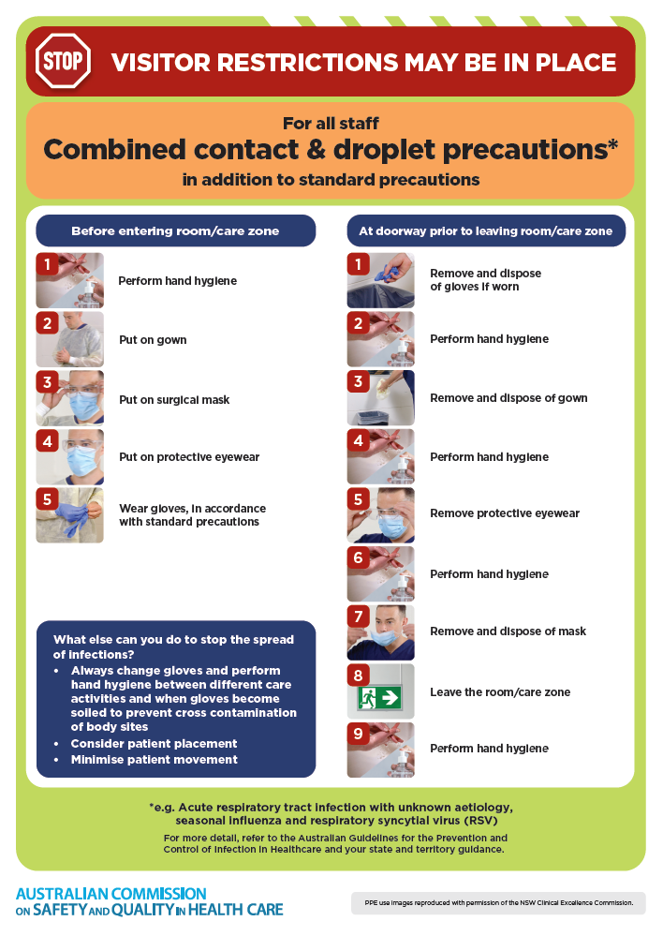](https://www.safetyandquality.gov.au/publications-and-resources/resource-library/infection-prevention-and-control-poster-combined-contact-and-droplet-precautions)
* ***Poster – Combined airborne and contact precautions***<https://www.safetyandquality.gov.au/publications-and-resources/resource-library/infection-prevention-and-control-poster-combined-airborne-and-contact-precautions>  
     
  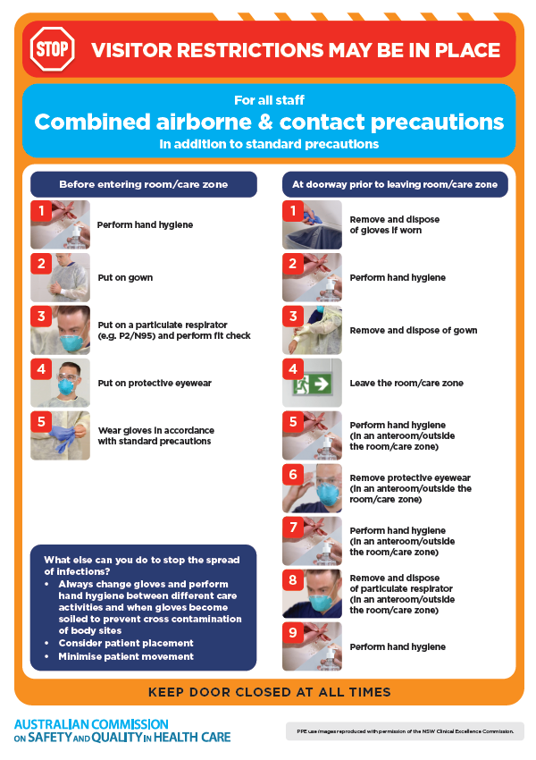
* ***Environmental Cleaning and Infection Prevention and Control*** [www.safetyandquality.gov.au/environmental-cleaning](http://www.safetyandquality.gov.au/environmental-cleaning)
* ***COVID-19 infection prevention and control risk management – Guidance*** <https://www.safetyandquality.gov.au/publications-and-resources/resource-library/covid-19-infection-prevention-and-control-risk-management-guidance>
* ***Safe care for people with cognitive impairment during COVID-19***<https://www.safetyandquality.gov.au/our-work/cognitive-impairment/cognitive-impairment-and-covid-19>
* ***Stop COVID-19: Break the chain of infection*** posterhttps://www.safetyandquality.gov.au/publications-and-resources/resource-library/break-chain-infection-poster-a3  
  **[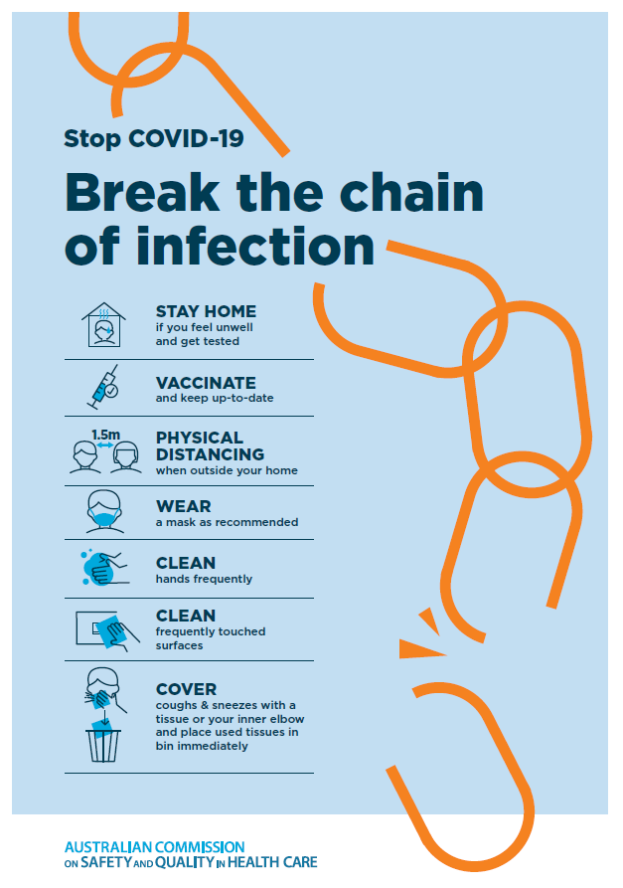](https://www.safetyandquality.gov.au/publications-and-resources/resource-library/break-chain-poster-a3https:/www.safetyandquality.gov.au/publications-and-resources/resource-library/break-chain-poster-a3)**
* ***COVID-19 and face masks – Information for consumers*** <https://www.safetyandquality.gov.au/publications-and-resources/resource-library/covid-19-and-face-masks-information-consumers>

[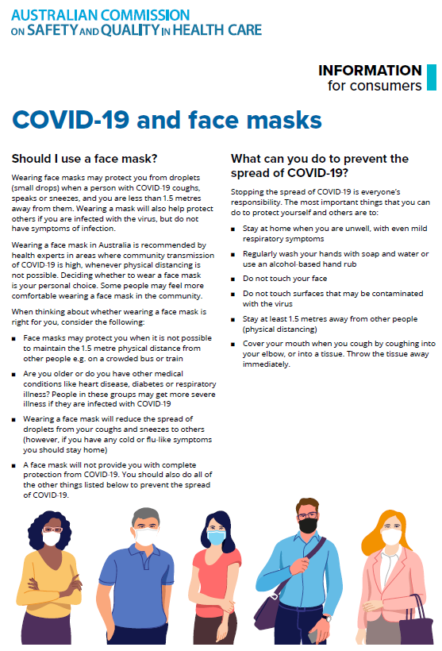](https://www.safetyandquality.gov.au/sites/default/files/2020-07/covid-19_and_face_masks_-_information_for_consumers.pdf)

**Disclaimer**

On the Radar is an information resource of the Australian Commission on Safety and Quality in Health Care. The Commission is not responsible for the content of, nor does it endorse, any articles or sites listed. The Commission accepts no liability for the information or advice provided by these external links. Links are provided on the basis that users make their own decisions about the accuracy, currency and reliability of the information contained therein. Any opinions expressed are not necessarily those of the Australian Commission on Safety and Quality in Health Care.