# Australian Commission on Safety and Quality logotypeOn the Radar

Issue 655

1 July 2024

*On the Radar* is a summary of some of the recent publications in the areas of safety and quality in health care. Inclusion in this document is not an endorsement or recommendation of any publication or provider. Access to particular documents may depend on whether they are Open Access or not, and/or your individual or institutional access to subscription sites/services. Material that may require subscription is included as it is considered relevant.

*On the Radar* is available online, via email or as a PDF or Word document from <https://www.safetyandquality.gov.au/newsroom/subscribe-news/radar>

If you would like to receive *On the Radar* via email, you can subscribe on our website <https://www.safetyandquality.gov.au/newsroom/subscribe-news>  
or by emailing us at H[Umail@safetyandquality.gov.auU](mailto:mail@safetyandquality.gov.au).  
You can also send feedback and comments to H[Umail@safetyandquality.gov.auU](mailto:mail@safetyandquality.gov.au).

For information about the Commission and its programs and publications, please visit <https://www.safetyandquality.gov.au>

w

**On the Radar**

Editor: Dr Niall Johnson [niall.johnson@safetyandquality.gov.au](mailto:niall.johnson@safetyandquality.gov.au)

Contributors: Niall Johnson

**Journal articles**

*Identifying and Measuring Administrative Harms Experienced by Hospitalists and Administrative Leaders*

Burden M, Astik G, Auerbach A, Bowling G, Kangelaris KN, Keniston A, et al

JAMA Internal Medicine. 2024.

*Administrative Harms—Common and Sometimes Preventable*

Ganguli I, Katz MH

JAMA Internal Medicine. 2024.

|  |  |
| --- | --- |
| DOI | Burden et al <https://doi.org/10.1001/jamainternmed.2024.1890>  Ganguli and Katz <https://doi.org/10.1001/jamainternmed.2024.1899> |
| Notes | Burden et al propose that administrative actions in health care can have adverse consequence. They term these ‘administrative harms’ (AH). These are defined ‘as the adverse consequences of administrative decisions within health care and directly influences patient care and outcomes, professional practice, and organizational efficiencies regardless of employment setting.’ From their qualitative study, including surveys and focus groups, they assert that AH ‘as noted to be pervasive and come from all levels of leadership with wide-reaching impact, that organizations lack mechanisms for identification, measurement, and feedback related to AH, and that organizational pressures drive administrative harms.’  In a related ‘Editor’s Note’, Ganguli and Katz observe that while ‘Readers may be unfamiliar with the term administrative …, the editors thought that clinicians who work in hospitals would nod their heads in recognition of many of the experiences that constitute it’. They also observe that a way to mitigating such harm is through ‘improved communication and collaboration. Administrators can listen to their clinicians and find ways to make it easier, not harder, for them to practice. They can also empower clinicians to identify problems that require solutions and speak up when interventions are not working’. |

*Need to systematically identify and mitigate risks upon hospitalisation for patients with chronic health conditions*

Pronovost PJ, Carrington EM

BMJ Quality & Safety. 2024.

|  |  |
| --- | --- |
| DOI | <https://doi.org/10.1136/bmjqs-2023-016807> |
| Notes | Paper observing that hospitals do not always cater for the chronic conditions that patients may also have. While some conditions, such as diabetes, may be noted and monitored, others go unregarded. The authors note that ‘people often have multiple morbidities and the interactions between them may increase their risk of harm when hospitalised.’ They also write that ‘The most effective way to prevent harm in patients hospitalised with chronic disease is to avoid admission when possible. Many medical admissions can be avoided with better access to and coordination of ambulatory care and enhanced use of home care, and by connecting patients in the emergency department to ambulatory services.’  The paper suggests ‘a framework to systematically identify and mitigate risks in hospitalised patients’ using Parkinson’s disease as an example. The framework includes:   1. Identify the combinations of admitting diagnosis or clinical condition and patient characteristics that create the highest risk. 2. Ensure there is a mechanism to identify these high-risk patients as close to admission as possible. 3. Identify and implement interventions to mitigate risk in the specific cohort of patients. 4. Review risk reduction in higher-risk patients and modify clinical protocols over time. |

*Listen to me, I really am sick! Patient and family narratives of clinical deterioration before and during rapid response system intervention*

Bucknall TK, Guinane J, McCormack B, Jones D, Buist M, Hutchinson AM

Journal of Clinical Nursing. 2024.

|  |  |
| --- | --- |
| DOI | <https://doi.org/10.1111/jocn.17310> |
| Notes | The authors of this paper observe that much of the literature on ‘clinical deterioration has mostly focused on clinicians' roles’. ‘Although patients and families can identify subtle cues of early deterioration, little research has focused on their experience of recognising, speaking up and communicating with clinicians during this period of instability.’ This paper reports on a narrative inquiry that involved 33 adult patients and 14 family members of patients, who had received a MET [Medical Emergency Team] call, in one private and one public academic teaching hospital in Melbourne. Patients and family members can be vital in detecting deterioration and facilities and clinicians ‘must create an environment that enables patients and families to speak up.’ |

For information on the Commission’s work on recognising and responding to deterioration <https://www.safetyandquality.gov.au/our-work/recognising-and-responding-deterioration>

*Collective Intelligence Increases Diagnostic Accuracy in a General Practice Setting*

Blanchard MD, Herzog SM, Kämmer JE, Zöller N, Kostopoulou O, Kurvers RHJM

Medical Decision Making. 2024;44(4):451-462.

|  |  |
| --- | --- |
| DOI | <https://doi.org/10.1177/0272989X241241001> |
| Notes | While much of the focus is on artificial intelligence (AI), this paper looks at collective intelligence, clinicians working collaborative to share their opinions. This paper reports on a study ‘examined whether aggregating independent diagnoses can also improve diagnostic accuracy for GP decision making’. The authors report that ‘Combining independent diagnoses may substantially improve a GP’s diagnostic accuracy and subsequent patient outcomes.’ |

*Long-Term Outcomes in Patients Using Protocol-Directed Active Surveillance for Prostate Cancer*

Newcomb LF, Schenk JM, Zheng Y, Liu M, Zhu K, Brooks JD, et al

JAMA. 2024;331(24):2084-2093.

|  |  |
| --- | --- |
| DOI | <https://doi.org/10.1001/jama.2024.6695> |
| Notes | The paper published in the *Journal of the American Medical Association* (JAMA) sought to examine the long-term outcomes for patients with prostate cancer whose cases are managed with protocol-directed active surveillance. The paper reports on a US cohort study that included 2155 individuals. The authors report that ‘In this study, 10 years after diagnosis, 49% of men remained free of progression or treatment, less than 2% developed metastatic disease, and less than 1% died of their disease.’ The authors also report ‘Later progression and treatment during surveillance were not associated with worse outcomes.’ These lead them to suggest that ‘Protocol-directed active surveillance is a safe management strategy for avoiding overtreatment and preventing undertreatment.’ |

*The Joint Commission Journal on Quality and Patient Safety*

Volume 50, Issue 7, July 2024

|  |  |
| --- | --- |
| URL | <https://www.sciencedirect.com/journal/the-joint-commission-journal-on-quality-and-patient-safety/vol/50/issue/7> |
| Notes | A new issue of *The Joint Commission Journal on Quality and Patient Safety* has been published. Articles in this issue of *The Joint Commission Journal on Quality and Patient Safety* include:   * Editorial: The Quest for **Diagnostic Excellence in the Emergency Department** (Michael S Pulia, Dimitrios Papanagnou, Pat Croskerry) * Editorial: The Challenge of **Improving Patient Safety**: This is Hard (Robin R Hemphill) * Frontline Providers’ and Patients’ Perspectives on Improving **Diagnostic Safety in the Emergency Department**: A Qualitative Study (Courtney W Mangus, Tyler G James, Sarah J Parker, E Duffy, P P Chandanabhumma, C M Cassady, F Bellolio, K S Pasupathy, M Manojlovich, H Singh, P Mahajan) * Putting the “Action” in RCA2: An Analysis of **Intervention Strength After Adverse Events** (Jessica A Zerillo, Sarah A Tardiff, Dorothy Flood, Lauge Sokol-Hessner, Anthony Weiss) * A Simple **Risk Adjustment for Hospital-Level Nulliparous, Term, Singleton, Vertex, Cesarean Delivery Rates** and Its Implications for Public Reporting (Benjamin D Pollock, Leslie Carranza, Elizabeth Braswell-Pickering, Christine M Sing, Lindsay L Warner, Regan N Theiler) * A Qualitative Study of Systems-Level Factors That Affect **Rural Obstetric Nurses’ Work** During Clinical Emergencies (Samantha L Bernstein, Maya Picciolo, Elisabeth Grills, Kenneth Catchpole) * Evaluation of a Structured Review Process for **Emergency Department Return Visits** with Admission (Zoe Grabinski, Kar-mun Woo, Olumide Akindutire, Cassidy Dahn, ... Silas W Smith) * The Impact of Using **Electronic Consents** on Documentation of Language-Concordant Surgical Consent for Patients with Limited English Proficiency (Karen Trang, Logan Pierce, Elizabeth C Wick) * Building Statewide Quality Improvement Capacity to Improve **Cardiovascular Care and Health Equity**: Lessons from the Tennessee Heart Health Network (Cori C Grant, Fawaz Mzayek, Hadii M Mamudu, Satya Surbhi, Umar Kabir, James E Bailey) * The Impact of a Novel Syringe Organizational Hub on **Operating Room Workflow** During a Surgical Case (Harrison Sims, David Neyens, Ken Catchpole, Joshua Biro, Coonor Lusk, James Abernathy) * The Joint Commission Journal on Quality and Patient Safety 50th Anniversary Article Collections: **Maternal and Perinatal Care**. |

*The Milbank Quarterly*

Volume 102, Number 2, June 2024

|  |  |
| --- | --- |
| URL | <https://www.milbank.org/quarterly/issues/june-2024/>  <https://onlinelibrary.wiley.com/toc/14680009/2024/102/2> |
| Notes | A new issue of *The Milbank Quarterly* has been published Articles in this issue of *The Milbank Quarterly* include:   * Multisector Collaboration vs. Social Democracy for **Addressing Social Determinants of Health** (Seth A Berkowitz) * Toward a **Climate-Ready Health Care System**: Institutional Motivators and Workforce Engagement (Caleb Dresser, Zachary Johns, Avery Palarfy, Sarah McKinnon, Suellen Breakey, Ana M Viamonte Ros, Patrice K Nicholas) * Revising the Logic Model Behind Health Care's **Social Care Investments** (Laura M Gottlieb Danielle Hessler, Holl Wing, Alejandra Gonzalez-Rocha, Yuri Cartier, Caroline Fichtenberg) * Policy Interventions to Enhance **Medical Care for People With Obesity** in the United States—Challenges, Opportunities, and Future Directions (James R Jolin, Minsoo Kwon, Elizabeth Brock, Jonathan Chen, Aisha Kokan, Ryan Murdock, Fatima C Standford) * Keeping It Political and Powerful: Defining the **Structural Determinants of Health** (Jonathan C Heller, Marjory L Givens, Sheri P Johnson, D A Kindig) * **Integrated Devices**: A New Regulatory Pathway to Promote Revolutionary Innovation (Ted Cho, Vrushab Gowda, Henning Schulzrinne, Brian J Miller) * Overcoming Common Anxieties in **Knowledge Translation**: Advice for Scholarly Issue Advocates (Paul Kershaw, Verena Rossa-Roccor) * Asking MultiCrit Questions: A Reflexive and Critical Framework to Promote **Health Data Equity for the Multiracial Population** (Tracy Lam-Hine, Sarah Forthal, Candice Y Johnson, Helen B Chin) * Assessing the Impact of the **340B Drug Pricing Program**: A Scoping Review of the Empirical, Peer-Reviewed Literature (Timothy W Levengood, Rena M Conti, Sean Cahill, Megan B Cole) * Changing US Support for **Public Health Data Use** Through Pandemic and Political Turmoil (Cason D Schmit, Brian N Larson, Thomas Tanabe, Mahin Ramezani, Qi Zheng, Hye-Chung Kum) * Is **White Evangelical Antistructural Theology** Related to Poor Health Outcomes? (David A Kindig, Yasmin Mohd Ariffin, Hannah Olson-Williams) |

*Journal for Healthcare Quality*

Volume 46, Number 4, July/August 2024

|  |  |
| --- | --- |
| URL | <https://journals.lww.com/jhqonline/toc/2024/08000> |
| Notes | A new issue of the *Journal for Healthcare Quality* (JHQ)has been published Articles in this issue of the *Journal for Healthcare Quality* include:   * **Differential Mortality Among Heart Failure Patients** Across Different COVID-19 Surges in New York City (Sheetal Vasundara Mathai, Samuel J Apple, Xiaobao Xu, Li Pang, Elie Flatow, Ari Friedman, Saul Rios, Cesar Joel Benites Moya, Majd Al Deen Alhuarrat, M Parker, S I Sokol, R T Faillace) * **Quality and Safety in Nursing**: Recommendations From a Systematic Review (Patricia A Patrician, Caitlin M Campbell, Mariyam Javed, Kathy M Williams, Lozay Foots, Wendy M Hamilton, Sherita House, Pauline A Swiger) * **Iron Deficiency** Among Hospitalized Patients With Congestive Heart Failure (Rick Foust, Stephen Clarkson, Megan Nordberg, J Joly, R Griffin, J May) * Improving **First Case Operating Room Efficiency** (Rebecca Afford, Megan Chan, Rana Garelnabi, Fariba Haji Ali Akbari, Sam M Wiseman) * EHR Smart Phrases Used as Enrollment Mechanism in **Diabetes Self-Management Support Programs**: Preliminary Outcomes (Parker A Rhoden, Luke Hall, Michelle Stancil, Windsor Westbrook Sherrill) * Multimodal Quality Initiatives in **Sepsis Care**: Assessing Impact on Core Measures and Outcomes (Marcos Garcia, Mohammed Al-Jaghbeer, James Morrison, Antoine Boustany, Bindesh Ghimire, Neel Tapryal, Komal Mushtaq, Kelly Orlosky, Amy Flowers-Surovi, Christopher Murphy, Palak Rath, Muhaimen Rahman, Corrine Kickel, Y-C Lee, K-Y Chang, F A Fadel) * **Ambulatory Quality Improvement** Despite COVID-19: Blueprint for a Successful System for Continuous Improvement (Anne H VanBuren, Tricia M Montgomery, John R McConaghy, Jeffrey Lawrence, Nazhat Taj-Schaal, Melissa Unger, Nate R Rogers) * Implementation of a **Patient-Reported Outcome Measure**: A Quality Improvement Project (Shana McGrath, M Howard, K Webber, L Juckett) * Pilot Process Evaluation of the **Supporting Older Adults at Risk** Model: A RE-AIM Approach (R L Trotta, A E Shoemaker, S R Greysen, M Boltz) * Implementing Behavioral Optimization and Outcomes Support Team in a **Medical/Surgical Telemetry Unit** (Chikaodi Kay, M Miller, B Buckingham) * Quality Coordinators’ Perspectives on **Quality Improvement in Primary Healthcare** in Kosovo: A Qualitative Study (Ardita Baraku, G Pavleković) |

*BMJ Quality & Safety* online first articles

|  |  |
| --- | --- |
| URL | <https://qualitysafety.bmj.com/content/early/recent> |
| Notes | *BMJ Quality &Safety* has published a number of ‘online first’ articles, including:   * Quantifying the cost savings and health impacts of **improving colonoscopy quality**: an economic evaluation (Stephen McCarthy, Matthew David Rutter, Peter McMeekin, Jamie Catlow, Linda Sharp, Matthew Brookes, Roland Valori, Rashmi Bhardwaj-Gosling, Tom Lee, Richard McNally, Andrew McCarthy, Joanne Gray) * Need to systematically identify and mitigate **risks upon hospitalisation for patients with chronic health conditions** (Peter J Pronovost, Eboné M Carrington) |

*International Journal for Quality in Health Care* online first articles

|  |  |
| --- | --- |
| URL | <https://academic.oup.com/intqhc/advance-articles> |
| Notes | *International Journal for Quality in Health Care* has published a number of ‘online first’ articles, including:   * Seeking systems-based facilitators of safety and healthcare resilience: a **thematic review of incident reports** (Catherine Leon, Helen Hogan, Yogini H Jani) * The **“Silent Threat” in Medical, Surgical, and Intensive Care Unit Wards**: A Daytime and Nighttime Study (M Emilia Monteiro et al) * Expanded Perspectives: Integrating Clinicians’ Insights for Comprehensive **Patient-Reported Outcomes** in Value-Based Healthcare (Serena Barello et al) |

**Online resources**

***Australian Living Evidence Collaboration***

<https://livingevidence.org.au/>

**COVID-19 resources**

https://www.safetyandquality.gov.au/covid-19

The Australian Commission on Safety and Quality in Health Care has developed a number of resources to assist healthcare organisations, facilities and clinicians. These and other material on COVID-19 are available at <https://www.safetyandquality.gov.au/covid-19>

These resources include:

* ***COVID-19 infection prevention and control risk management***   
  <https://www.safetyandquality.gov.au/publications-and-resources/resource-library/covid-19-infection-prevention-and-control-risk-management-guidance>
* ***Poster – Combined contact and droplet precautions*** <https://www.safetyandquality.gov.au/publications-and-resources/resource-library/infection-prevention-and-control-poster-combined-contact-and-droplet-precautions>  
  [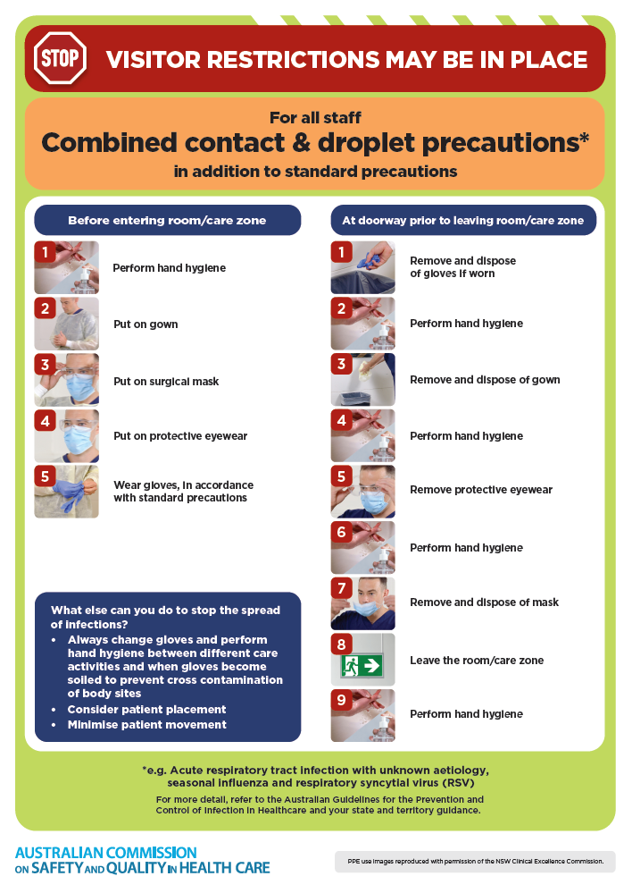](https://www.safetyandquality.gov.au/publications-and-resources/resource-library/infection-prevention-and-control-poster-combined-contact-and-droplet-precautions)
* ***Poster – Combined airborne and contact precautions***<https://www.safetyandquality.gov.au/publications-and-resources/resource-library/infection-prevention-and-control-poster-combined-airborne-and-contact-precautions>  
  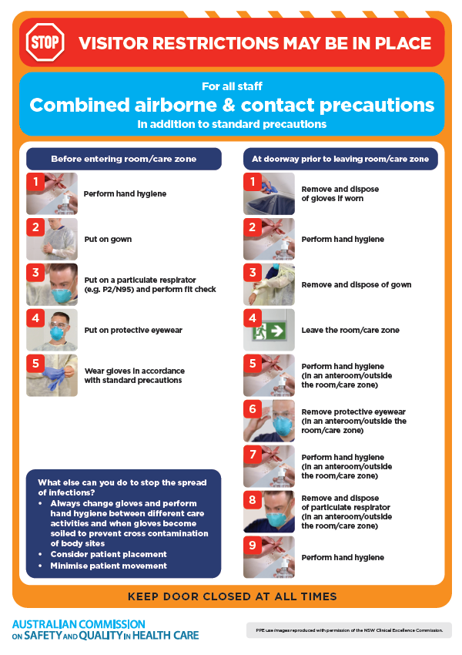
* ***Environmental Cleaning and Infection Prevention and Control*** [www.safetyandquality.gov.au/environmental-cleaning](http://www.safetyandquality.gov.au/environmental-cleaning)
* ***COVID-19 infection prevention and control risk management – Guidance*** <https://www.safetyandquality.gov.au/publications-and-resources/resource-library/covid-19-infection-prevention-and-control-risk-management-guidance>
* ***Safe care for people with cognitive impairment during COVID-19***<https://www.safetyandquality.gov.au/our-work/cognitive-impairment/cognitive-impairment-and-covid-19>
* ***Stop COVID-19: Break the chain of infection*** posterhttps://www.safetyandquality.gov.au/publications-and-resources/resource-library/break-chain-infection-poster-a3  
  **[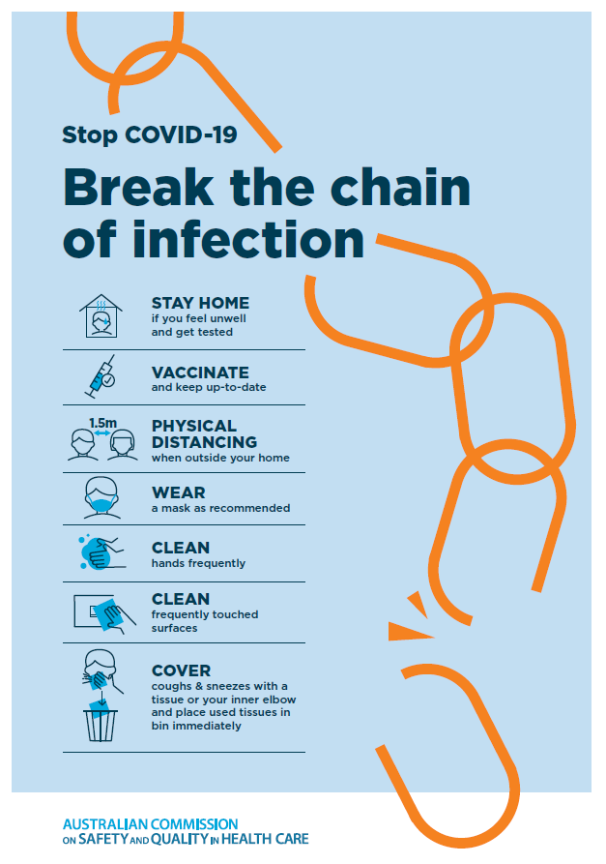](https://www.safetyandquality.gov.au/publications-and-resources/resource-library/break-chain-poster-a3https:/www.safetyandquality.gov.au/publications-and-resources/resource-library/break-chain-poster-a3)**
* ***COVID-19 and face masks – Information for consumers*** <https://www.safetyandquality.gov.au/publications-and-resources/resource-library/covid-19-and-face-masks-information-consumers>

[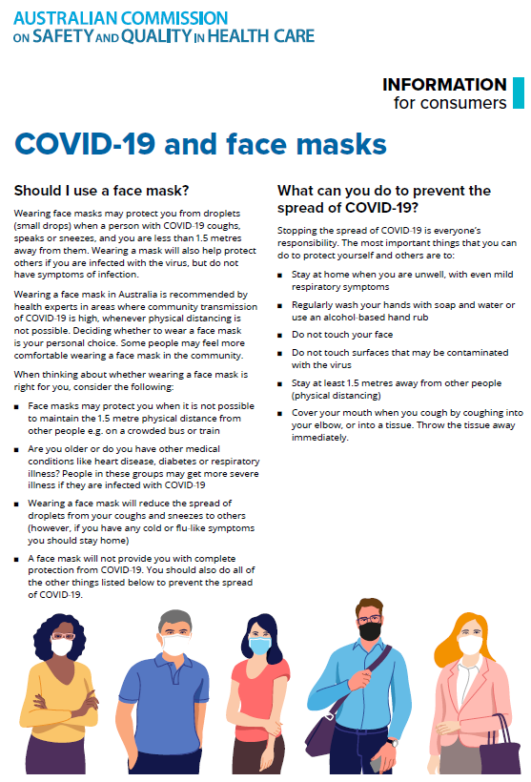](https://www.safetyandquality.gov.au/sites/default/files/2020-07/covid-19_and_face_masks_-_information_for_consumers.pdf)

**Disclaimer**

On the Radar is an information resource of the Australian Commission on Safety and Quality in Health Care. The Commission is not responsible for the content of, nor does it endorse, any articles or sites listed. The Commission accepts no liability for the information or advice provided by these external links. Links are provided on the basis that users make their own decisions about the accuracy, currency and reliability of the information contained therein. Any opinions expressed are not necessarily those of the Australian Commission on Safety and Quality in Health Care.