# Australian Commission on Safety and Quality logotypeOn the Radar

Issue 659

29 July 2024

*On the Radar* is a summary of some of the recent publications in the areas of safety and quality in health care. Inclusion in this document is not an endorsement or recommendation of any publication or provider. Access to particular documents may depend on whether they are Open Access or not, and/or your individual or institutional access to subscription sites/services. Material that may require subscription is included as it is considered relevant.

*On the Radar* is available online, via email or as a PDF or Word document from <https://www.safetyandquality.gov.au/newsroom/subscribe-news/radar>

If you would like to receive *On the Radar* via email, you can subscribe on our website <https://www.safetyandquality.gov.au/newsroom/subscribe-news>  
or by emailing us at H[Umail@safetyandquality.gov.auU](mailto:mail@safetyandquality.gov.au).  
You can also send feedback and comments to H[Umail@safetyandquality.gov.auU](mailto:mail@safetyandquality.gov.au).

For information about the Commission and its programs and publications, please visit <https://www.safetyandquality.gov.au>

w

**On the Radar**

Editor: Dr Niall Johnson [niall.johnson@safetyandquality.gov.au](mailto:niall.johnson@safetyandquality.gov.au)

Contributors: Niall Johnson, Orla Dempsey

***Australian Passive AMR Surveillance: An update of resistance trends in multidrug-resistant organisms – 2006 to 2023***

Australian Commission on Safety and Quality in Health Care

Sydney: ACSQHC; 2024. p. 38.

<https://www.safetyandquality.gov.au/publications-and-resources/resource-library/australian-passive-amr-surveillance-update-resistance-trends-multidrug-resistant-organisms-2006-2023>

The Australian Commission on Safety and Quality in Health Care has released an Australian Passive AMR Surveillance (APAS) report focussing on resistance trends in three multidrug-resistant organisms (MROs) across acute and community settings from 2006 to 2023. APAS collects de-identified patient-level antimicrobial resistance (AMR) data from routine susceptibility testing results from voluntarily contributing pathology services.

Key findings include:

* Vancomycin resistance in *Enterococcus faecium* (VRE) remains high, particularly in hospitals. There was marked variation among states and territories, but VRE was highest in Victoria
* Fluoroquinolone resistance in *Escherichia coli* has increased 7-fold since 2006. Resistance was similar across different settings but varied geographically, with the highest rates in Victoria and very remote Australia
* Methicillin resistance in *Staphylococcus aureus* (MRSA) has remained steady overall. MRSA was most prevalent in aged care homes, the Northern Territory and in remote and very remote Australia.

MROs are resistant to multiple antimicrobials and pose a significant risk to patient safety due to the increased risk of morbidity and mortality associated with these infections. This report highlights the importance of ongoing surveillance of AMR and infections, along with antimicrobial stewardship and infection prevention and control. This is particularly crucial for vulnerable populations including hospitalised patients, those in aged care homes and First Nations communities.

**Reports**

*Digital tools for online consultation in general practice. Investigation report*

Health Services Safety Investigation Body

Poole: HSSIB; 2024.

|  |  |
| --- | --- |
| URL | <https://www.hssib.org.uk/patient-safety-investigations/workforce-and-patient-safety/second-investigation-report/> |
| Notes | The latest report from the UK’s Health Services Safety Investigations Board (HSSIB) sought to examine patient safety risks associated with the use of online consultation tools in general practice. It is noted that ‘The investigation focussed on the use of these tools for ‘asynchronous’ consultation where the patient and healthcare professional are not in the same room, and the patient does not receive a response in real time.’ These online tools may used to triage patients.  For some this would not constitute appropriate telehealth. In Australia the Medical Board of Australia’s [guidelines on telehealth consultations with patients](https://www.medicalboard.gov.au/Codes-Guidelines-Policies/Telehealth-consultations-with-patients.aspx) state ‘Prescribing or providing healthcare for a patient without a real-time direct consultation, whether in-person, via video or telephone, is not good practice and is not supported by the Board. This includes asynchronous requests for medication communicated by text, email, live-chat or online that do not take place in the context of a real-time continuous consultation and are based on the patient completing a health questionnaire, when the practitioner has never spoken with the patient.’  The HSSIB’s investigation report noted that concerns that online consultation tools could contribute to risks to patient safety did exist. They found that ‘Although there is evidence these tools have benefits, the investigation also found evidence that they had contributed to some patient safety incidents.’ The investigation identified patient safety risks, including:   * Patients less likely to seek a consultation about a medical issue if they have to use an online tool, which are not always accessible or easy to use. * GPs unable to collect the information necessary to make decisions about a patient’s care. * Patient harm from missed or delayed care.   The report also made findings about access, training, implementation, design and configuration issues. The report also made a number of safety recommendations and observations, including the involvement of clinicians and consumers. |

*South Australia oral health workforce projections barriers: The importance of data*Deeble Institute for Health Policy Research Perspectives Brief no: 32.  
Lee, P

Canberra: Australian Healthcare and Hospitals Association; 2024. p. 20.

|  |  |
| --- | --- |
| URL | <https://ahha.asn.au/resource/south-australia-oral-health-workforce-projections-barriers-the-importance-of-data/> |
| Notes | Health systems have struggled with workforce issues for some time now. Many of these were exacerbated during the COVID-19 pandemic and have continued subsequently. This brief from the AHHA’s Deeble Institute focuses on workforce issues in South Australia’s oral health sector. The author of this brief seeks to highlight the ‘issues with workforce planning of the oral health sector in South Australia and indirectly nationally’; and to identify ‘potential policy options to improve oral health workforce planning.’ |

*Green physician toolkit*

Royal College of Physicians

London: Royal College of Physicians; 2024. p. 11.

|  |  |
| --- | --- |
| URL | <https://www.rcp.ac.uk/32302> |
| Notes | The Royal College of Physicians in the UK has published this *Green Physician Toolkit* that is designed to support doctors to play their part in tackling the climate crisis. The toolkit draws together the evidence on health and climate change, and suggests actions that physicians can take in their day-to-day practice.  [Supporting infographic for the Green Toolkit. Actions to reduce the environmental impact of healthcare delivery.](https://www.rcp.ac.uk/32302) |

**Journal articles**

*Influences of Leadership, Organizational Culture, and Hierarchy on Raising Concerns About Patient Deterioration: A Qualitative Study*

Vehvilainen E, Charles A, Sainsbury J, Stacey G, Field-Richards SE, Westwood G

Journal of Patient Safety. 2024;20(5):e73-e77.

|  |  |
| --- | --- |
| DOI | <https://doi.org/10.1097/PTS.0000000000001234> |
| Notes | Paper reporting on a UK study demonstrating how issues of leadership, culture, psychological safety can have impacts on patient safety. Here these factors can facilitate an environment in which people are more likely to respond to clinical deterioration. The authors note that ‘Raising concerns is essential for the early detection and appropriate response to patient deterioration’. The study sought to examine ‘how leadership, organizational cultures, and professional hierarchies in healthcare settings influence healthcare workers, patients, and caregivers in raising concerns about patient deterioration and their willingness to do so.’ This qualitative study included 27 group discussions and from their analysis the authors report ‘Positive leadership that challenged traditional professional hierarchies by embracing multidisciplinary teamwork, valuing the input of all stakeholders, and championing person-centered practice fostered a positive working culture. This culture has the potential to empower clinical staff, patients, caregivers, and family members to confidently raise concerns. Staff development, clinical supervision, and access to feedback, all underpinned by psychological safety, were viewed as facilitating the escalation of concerns and, subsequently, have the potential to improve patient safety.’ |

For information on the Commission’s work on recognising and responding to deterioration see <https://www.safetyandquality.gov.au/our-work/recognising-and-responding-deterioration>

*Association of* Staphylococcus aureus *bacterial load and colonization sites with the risk of postoperative* S. aureus *infection*

Troeman DPR, Hazard D, van Werkhoven CHW, Timbermont L, Malhotra-Kumar S, Wolkewitz M, et al.

Open Forum Infectious Diseases. 2024:ofae414.

|  |  |
| --- | --- |
| DOI | <https://doi.org/10.1093/ofid/ofae414> |
| Notes | Paper reporting on a Dutch study that sought to examine the relationship between *Staphylococcus aureus* bacterial load and colonization sites with the risk of postoperative *S. aureus* infection. This prospective cohort study enrolled 5,004 surgical patients, of whom 3,369 (67.3%) were *S. aureus* carriers. The study found 100 *S. aureus* surgical site infections (SSI) and postoperative bloodstream infections (BSI) events occurred during follow-up, and 86 (86 %) of these events occurred in carriers. The authors concluded that nasal carriage was associated with an increased risk of SSI/BSI and accounted for the majority of infections. Higher bacterial load, as well as colonization at multiple bodily sites, further increased this risk. |

For information on the Commission’s Healthcare-Associated Infection Program, see <https://www.safetyandquality.gov.au/our-work/healthcare-associated-infection-program>

For information on the Commission’s work on infection prevention and control see <https://www.safetyandquality.gov.au/our-work/infection-prevention-and-control>

*BMJ Quality & Safety*

Volume 33, Issue 8, August 2024

|  |  |
| --- | --- |
| URL | <https://qualitysafety.bmj.com/content/33/8> |
| Notes | A new issue of *BMJ Quality & Safety* has been published. Many of the papers in this issue have been referred to in previous editions of *On the Radar* (when they were released online). Articles in this issue of *BMJ Quality & Safety* include:   * Editorial: **Is hospital-onset bacteraemia and fungaemia an actionable quality measure**? (Chanu Rhee, Payal Patel, Julia Szymczak) * Editorial: Time for a rebalance: **psychological and emotional well-being in the healthcare workforce** as the foundation for patient safety (Kate Kirk) * Evaluation of **hospital-onset bacteraemia and fungaemia** in the USA as a potential healthcare quality measure: a cross-sectional study (Surbhi Leekha, Gwen L Robinson, Jesse T Jacob et al) * Comparing **secondary prevention for patients with coronary heart disease and stroke** attending Australian general practices: a cross-sectional study using nationwide electronic database (Jason Yue, Samia Kazi, Tu Nguyen et al) * **Consent and refusal of procedures during labour and birth**: a survey among 11 418 women in the Netherlands (Marit Sophia Gerardina van der Pijl, Margot Klein Essink, Tineke van der Linden et al) * Care Under Pressure 2: a realist synthesis of causes and interventions to mitigate **psychological ill health in nurses, midwives and paramedics** (Cath Taylor, Jill Maben, Justin Jagosh et al) * **Fixing patient safety**: Are we nearly there yet? (Peter McCulloch) |

*Journal of Patient Safety*

Volume 20, Issue 5, August 2024

|  |  |
| --- | --- |
| URL | <https://journals.lww.com/journalpatientsafety/toc/2024/08000> |
| Notes | A new issue of the *Journal of Patient Safety* has been published Articles in this issue of the *Journal of Patient Safety* include:   * **Healthcare Violence** and the Potential Promises and Harms of Artificial Intelligence (Kevin T Kavanagh, Christine Pontus, Lindsay E Cormier) * Supporting **Error Management and Safety Climate in Ambulatory Care Practices**: The CIRSforte Study (Beate S Müller, Dagmar Lüttel, Dania Schütze, Tatjana Blazejewski, Marina Pommée, Hardy Müller, Katharina Rubin, Christian Thomeczek, Romy Schadewitz, Reiner Heuzeroth, David Schwappach, Corina Güthlin, Michael Paulitsch, Ferdinand M Gerlach( * **Medical Students' Speak-Up Barriers**: A Randomized Controlled Trial With Written Vignettes (Jesper Dybdal Kayser, Annette Kjær Ersbøll, Michaela Kolbe, Doris Østergaard, Peter Dieckmann) * Enhancing **Patient Safety in Prehospital Environment**: Analyzing Patient Perspectives on Non-Transport Decisions With Natural Language Processing and Machine Learning (Hassan Farhat, Guillaume Alinier, Reem Tluli, Montaha Chakif, Fatma Babay EP Rekik, Ma Cleo Alcantara, Padarath Gangaram, Kawther El Aifa, Ahmed Makhlouf, Ian Howland, Mohamed Chaker Khenissi, Sailesh Chauhan, Cyrine Abid, Nicholas Castle, Loua Al Shaikh, Moncef Khadhraoui, Imed Gargouri, James Laughton) * Consequences of **Inpatient Falls in Acute Care**: A Retrospective Register Study (Anniina Heikkilä, Lasse Lehtonen, Kristiina Junttila) * Development and Evaluation of **Patient Safety Interventions**: Perspectives of Operational Safety Leaders and Patient Safety Organizations (Kylie M Gomes, Jessica Handley, Zoe M Pruitt, Seth Krevat, A Fong, R M Ratwani) * Patient Outcomes Compared Between **Admissions Coordinated by the Transfer Center and Emergency Department** at a U.S. Tertiary Care Hospital (Sandeep R Pagali, Alexander J Ryu, Karen M Fischer, Riddhi S Parikh, James S Newman, M Caroline Burton) * Assessing the Reproducibility of Research Based on the Food and Drug Administration Manufacturer and User Facility **Device Experience Data** (Xinyu Li, Yubo Feng, Yang Gong, You Chen) * **Fatal Adverse Events in Femoral Neck Fracture Patients** Undergoing Hemiarthroplasty or Total Hip Arthroplasty—A Retrospective Record Review Study in a Nationwide Sample of Deceased Patients (Bo Schouten, Mees Baartmans, Linda van Eikenhorst, Gooitzen P Gerritsen, Hanneke Merten, Steffie van Schoten, Prabath W B Nanayakkara, Cordula Wagner) * Influences of Leadership, Organizational Culture, and Hierarchy on Raising Concerns About **Patient Deterioration**: A Qualitative Study (Essi Vehvilainen, Ashleigh Charles, Jessica Sainsbury, Gemma Stacey, Sarah Elizabeth Field-Richards, Greta Westwood) * **Telehealth Safety Framework**: Addressing a New Frontier in Patient Safety (Kylie M Gomes, Nate Apathy, Seth Krevat, Ethan Booker, Raj M Ratwani) * Perceptions of U.S. and U.K. **Incident Reporting Systems**: A Scoping Review (Pamela J Gampetro, Anne Nickum, Celeste M Schultz) * Communication of **Incidental Imaging Findings on Inpatient Discharge Summaries** After Implementation of Electronic Health Record Notification System (Govind Mattay, Kushanth Mallikarjun, Paula Grow, Aaron Mintz, Thomas Ciesielski, Anthony Dao, Shivani Mattay, Geoffrey Cislo, Raghav Mattay, Vamsi Narra, Andrew Bierhals) * **High Reliability** in a Safety Net Hospital Leading to Operational Excellence (Lisa Didion, Candice Whitfield, Phyllis Bishop, A E Jones, J M Henderson) * Using Behavioral Insights to Strengthen **Strategies for Change**. Practical Applications for Quality Improvement in Healthcare (Rie Laurine Rosenthal Johansen, Simon Tulloch) |

*The Joint Commission Journal on Quality and Patient Safety*

Volume 50, Issue 8, August 2024

|  |  |
| --- | --- |
| URL | <https://www.sciencedirect.com/journal/the-joint-commission-journal-on-quality-and-patient-safety/vol/50/issue/8> |
| Notes | A new issue of *The Joint Commission Journal on Quality and Patient Safety* has been published. Articles in this issue of *The Joint Commission Journal on Quality and Patient Safety* include:   * Racial/Ethnic Disparities in **Peripartum Pain** Assessment and Management (Naomi H Greene, Sarah J Kilpatrick) * Enhancing Implementation of the **I-PASS Handoff Tool** Using a Provider Handoff Task Force at a Comprehensive Cancer Center (Maria C Franco Vega, Mohamed Ait Aiss, Marina George, Lakeisha Day, Anayo Mbadugha, Katie Owens, Colin Sweeney, Son Chau, Carmen Escalante, Diane C Bodurka) * Screening and Intervention to Prevent **Violence Against Health Professionals** from Hospitalized Patients: A Pilot Study (Kathryne Adams, Langley Topper, Isabelle Hashim, Aliysa Rajwani, Cristina Montalvo) * Evaluating Real-World Implementation of **INFORM (Improving Nursing Home Care through Feedback on Performance Data)**: An Improvement Initiative in Canadian Nursing Homes (Seyedehtanaz Saeidzadeh, Joel T Minion, Stirling Bryan, Peter G Norton, Carole A Estabrooks) * Improving Appropriate Use of **Peripherally Inserted Central Catheters** Through a Statewide Collaborative Hospital Initiative: A Cost-Effectiveness Analysis (Megan Heath, Steven J Bernstein, David Paje, Elizabeth McLaughlin, Jennifer K Horowitz, Amy McKenzie, Tom Leyden, S A Flanders, V Chopra) * Standardizing the Dosage and Timing of **Dexamethasone for Postoperative Nausea and Vomiting Prophylaxis** at a Safety-Net Hospital System (Andrew V Yurkonis, Luis Tollinche, Jonathan Alter, Samantha E Pope, Peyton Traxler, Hannah E Hill, Augusto Torres) * A Systemwide Strategy to Embed Equity into **Patient Safety Event Analysis** (Komal Chandra, Mariely Garcia, Komal Bajaj, Surafel Tsega, Joseph Talledo, Daniel Alaiev, Peter A Manchego, M Zaurova, H Jalon, E Wei, M Krouss) |

*BMJ Quality & Safety* online first articles

|  |  |
| --- | --- |
| URL | <https://qualitysafety.bmj.com/content/early/recent> |
| Notes | *BMJ Quality &Safety* has published a number of ‘online first’ articles, including:   * **Generative artificial intelligence, patient safety and healthcare quality**: a review (Michael D Howell) * **An anthropologist’s insight into healthcare data** – multiple and rich of contradictions (Valentina Lichtner) |

*International Journal for Quality in Health Care* online first articles

|  |  |
| --- | --- |
| URL | <https://academic.oup.com/intqhc/advance-articles> |
| Notes | *International Journal for Quality in Health Care* has published a number of ‘online first’ articles, including:   * Embracing the Use of **Artificial Intelligence** in Scientific Publishing (Phillip Phan et al) |

**Online resources**

***Australian Living Evidence Collaboration***

<https://livingevidence.org.au/>

**COVID-19 resources**

https://www.safetyandquality.gov.au/covid-19

The Australian Commission on Safety and Quality in Health Care has developed a number of resources to assist healthcare organisations, facilities and clinicians. These and other material on COVID-19 are available at <https://www.safetyandquality.gov.au/covid-19>

These resources include:

* ***Poster – Combined contact and droplet precautions*** <https://www.safetyandquality.gov.au/publications-and-resources/resource-library/infection-prevention-and-control-poster-combined-contact-and-droplet-precautions>  
  [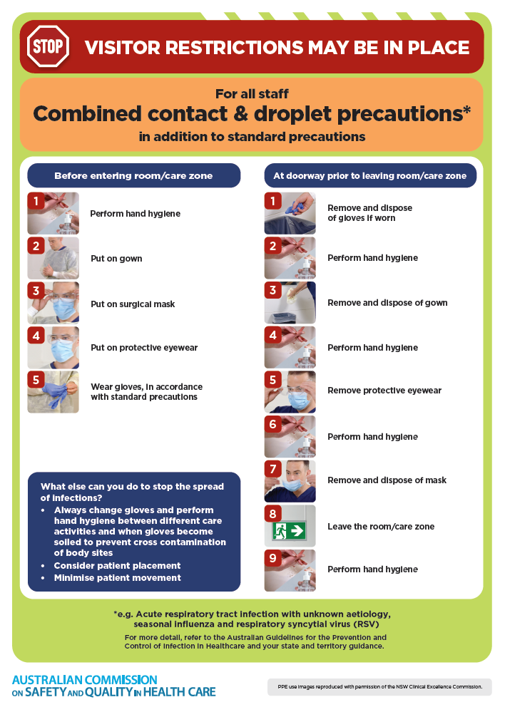](https://www.safetyandquality.gov.au/publications-and-resources/resource-library/infection-prevention-and-control-poster-combined-contact-and-droplet-precautions)
* ***Poster – Combined airborne and contact precautions***<https://www.safetyandquality.gov.au/publications-and-resources/resource-library/infection-prevention-and-control-poster-combined-airborne-and-contact-precautions>  
     
  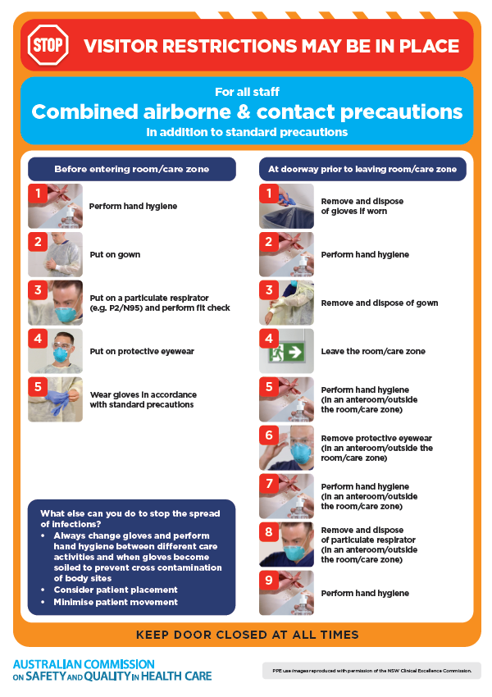
* ***Environmental Cleaning and Infection Prevention and Control*** [www.safetyandquality.gov.au/environmental-cleaning](http://www.safetyandquality.gov.au/environmental-cleaning)
* ***COVID-19 infection prevention and control risk management – Guidance*** <https://www.safetyandquality.gov.au/publications-and-resources/resource-library/covid-19-infection-prevention-and-control-risk-management-guidance>
* ***Safe care for people with cognitive impairment during COVID-19***<https://www.safetyandquality.gov.au/our-work/cognitive-impairment/cognitive-impairment-and-covid-19>
* ***Stop COVID-19: Break the chain of infection*** posterhttps://www.safetyandquality.gov.au/publications-and-resources/resource-library/break-chain-infection-poster-a3  
  **[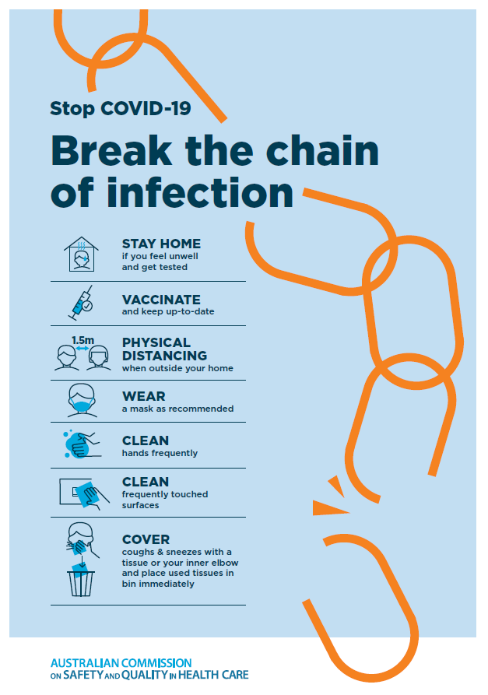](https://www.safetyandquality.gov.au/publications-and-resources/resource-library/break-chain-poster-a3https:/www.safetyandquality.gov.au/publications-and-resources/resource-library/break-chain-poster-a3)**
* ***COVID-19 and face masks – Information for consumers*** <https://www.safetyandquality.gov.au/publications-and-resources/resource-library/covid-19-and-face-masks-information-consumers>

[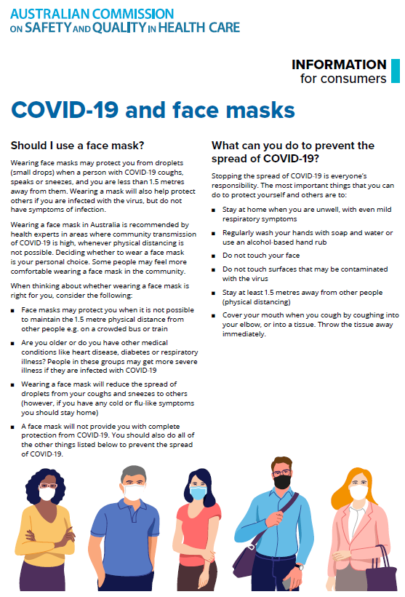](https://www.safetyandquality.gov.au/sites/default/files/2020-07/covid-19_and_face_masks_-_information_for_consumers.pdf)

**Disclaimer**

On the Radar is an information resource of the Australian Commission on Safety and Quality in Health Care. The Commission is not responsible for the content of, nor does it endorse, any articles or sites listed. The Commission accepts no liability for the information or advice provided by these external links. Links are provided on the basis that users make their own decisions about the accuracy, currency and reliability of the information contained therein. Any opinions expressed are not necessarily those of the Australian Commission on Safety and Quality in Health Care.