August 2024

Antimicrobial use in the community: 2023



Published by the Australian Commission on Safety and Quality in Health Care

Level 5, 255 Elizabeth Street, Sydney NSW 2000  
Phone: (02) 9126 3600   
Email: [mail@safetyandquality.gov.au](mailto:mail@safetyandquality.gov.au)   
Website: [www.safetyandquality.gov.au](http://www.safetyandquality.gov.au)

ISBN: 978-1-922880-76-5

© Australian Commission on Safety and Quality in Health Care 2024

All material and work produced by the Australian Commission on Safety and Quality in Health Care is protected by copyright. The Commission reserves the right to set out the terms and conditions for the use of such material.

As far as practicable, material for which the copyright is owned by a third party will be clearly labelled. The Commission has made all reasonable efforts to ensure that this material has been reproduced in this publication with the full consent of the copyright owners.

With the exception of any material protected by a trademark, any content provided by third parties, and where otherwise noted, all material presented in this publication is licensed under a [Creative Commons Attribution-NonCommercial-NoDerivatives 4.0 International licence](https://creativecommons.org/licenses/by-nc-nd/4.0/).

Creative Common logo

Enquiries about the licence and any use of this publication are welcome and can be sent to [communications@safetyandquality.gov.au](mailto:communications@safetyandquality.gov.au?subject=Enquiry).

The Commission’s preference is that you attribute this publication (and any material sourced from it) using the following citation:

Australian Commission on Safety and Quality in Health Care. Antimicrobial use in the community: 2023. Sydney; ACSQHC, 2024.

**Disclaimer**

The content of this document is published in good faith by the Australian Commission on Safety and Quality in Health Care for information purposes. The document is not intended to provide guidance on particular healthcare choices. You should contact your healthcare provider on particular healthcare choices.

**Note regarding alternative descriptions**

Due to the complexity of this document no alternative descriptions have been provided. If you need assistance with the structure of any graphs or charts, please email the Australian Commission on Safety and Quality in Health Care at [AURA@safetyandquality.gov.au](mailto:AURA@safetyandquality.gov.au).

**Contents**

Executive summary 4

Key findings and trends 4

What will be done to improve antimicrobial use and patient safety? 5

Introduction 7

About this report 7

About antimicrobials and surveillance of community antimicrobial use 8

Results 9

Prescription volume 9

State and territory and local area 15

Aged care and older Australians 21

International comparison 28

Conclusions 29

References 31

Appendix 1: Data source description 35

Appendix 2: Further analyses by local area 40

# Executive summary

Antimicrobials are an integral component of healthcare delivery and need to be readily available and effective. The more antimicrobials are used, the more likely it is that microorganisms will develop resistance. Antimicrobial resistance (AMR) is a critical risk to patient safety as it reduces the number of antimicrobials available to treat infections. It is a public health priority due to its serious and growing impact. AMR increases morbidity and mortality associated with infections caused by multidrug-resistant organisms. Hundreds of people in Australia die each year as a result of AMR.

The emergence of AMR and consequent reduction in the efficacy of antimicrobials has resulted in significant impacts on individuals receiving treatment for infections, and more broadly as AMR spreads through the community. As antimicrobials become ineffective, important treatments such as organ transplantation, a range of major surgical procedures, and chemotherapy for cancer may become limited, or no longer viable.

Since 2015, there has been a downward trend in overall antimicrobial use in the Australian community sector. There was a gradual decline in the number of antimicrobial prescriptions dispensed under the Pharmaceutical Benefits Scheme (PBS) and the Repatriation Pharmaceutical Benefits Scheme (RPBS) between 2015 and 2019. This was followed by a substantial decrease in dispensing in 2020. This decrease, which was sustained in 2021, coincided with the response to the COVID-19 pandemic in Australia. In 2022, there was a small uptick in antimicrobial use compared to 2021, however, this was still well below the volume dispensed prior to the pandemic. From 2022 to 2023, antimicrobial use in the community under the PBS and RPBS remained steady. However, there is an unknown quantity of antimicrobials dispensed privately and supplied over-the-counter because data on these activities are not reported nationally.

Within the context of the decline in community antimicrobial use, there is a high level of dispensing for residents of aged care homes and for older Australians aged 65 years and over, which is trending up.

The overall decline in antimicrobial use in the community is encouraging. The results from this report suggest that lower levels of antimicrobial use in Australia are achievable long-term. Targeted strategies are required to address the level of use and upward trend for residents of aged care homes and older Australians, and there are opportunities to further improve use of antimicrobials. Combined strategies of antimicrobial stewardship (AMS) and infection prevention and control are most effective in reducing community antimicrobial use to prevent and control AMR.

### Key findings and trends

#### PBS and RPBS: Overall (2015–2023)

* There were 22,126,604 antimicrobial prescriptions supplied in 2023 – an increase of 1.3% from 2022, but still 17% lower than 2019 and 24.4% lower than 2015.
* There was a very small drop in the number of prescriptions supplied per 1,000 people between 2022 and 2023.
* Just over a third of Australians had at least one antimicrobial dispensed, and rates were much higher for older Australians in 2023.
* Cefalexin, amoxicillin and amoxicillin–clavulanic acid remained the most frequently dispensed antimicrobials in 2023.
* Overall antimicrobial use across states and territories, local areas and age groups in 2023 remained comparable with distributions from 2015.
* Australia ranked in the middle for community antimicrobial use compared to European countries in 2022, and use remained more than double that reported for the Netherlands, which was the European country with the lowest reported use.

#### PBS and RPBS: Aged care homes and older Australians (2021–2023)

* There were 576,579 antimicrobial prescriptions supplied to residents of aged care homes in 2023 – 2.6% of all antimicrobials dispensed in Australia, and an 11.1% increase from 2022.
* Almost three-quarters of aged care home residents received at least one antimicrobial prescription in 2023.
* Cefalexin was the most frequently dispensed antimicrobial in aged care homes – a third of antimicrobial prescriptions from 2021 to 2023.
* Proportionally, cefalexin was more often dispensed to older Australians who resided in aged care homes than the community.
* Older Australians in aged care homes received more than double the number of J01 antibacterial prescriptions per person compared to older Australians in the community in 2023.

### What will be done to improve antimicrobial use and patient safety?

To promote ongoing reductions in antimicrobial use and improve appropriateness of antimicrobial prescribing in the community, the Australian Commission on Safety and Quality in Health Care (the Commission) will:

* Continue to report the results of surveillance of antimicrobial use, as well as AMR, infections, healthcare-associated complications and potentially preventable hospitalisations and use the data to inform quality improvement strategies across community healthcare
* Continue to explore opportunities with the Australian Government Department of Health and Aged Care (the Department) to increase the capacity to record and monitor private (non-PBS and non-RPBS) antimicrobial prescribing and the indications for which antimicrobials are prescribed
* Continue to support implementation of the National Safety and Quality Primary and Community Healthcare Standards (Primary and Community Healthcare Standards)1, to deliver safe, high-quality health care through dedicated actions for preventing and controlling infections and appropriate antimicrobial prescribing and use
* Consult with the Royal Australian College of General Practitioners (RACGP) about opportunities to promote AMS principles and practices as part of implementation of the RACGP accreditation standards
* Continue to collaborate with the Aged Care Quality and Safety Commission, aged care providers and general practitioners to promote appropriate personal and clinical care, AMS and antimicrobial prescribing for residents of aged care homes consistent with the requirements of the Aged Care Quality Standards2, and the strengthened Aged Care Quality Standards3
* Continue to support health and aged care services to prevent and control AMR and use antimicrobials appropriately through the implementation of strategies that address the quality statements of the Antimicrobial Stewardship and Sepsis Clinical Care Standards4,5, and reduce unwarranted variations in care
* Continue to collaborate with clinicians and professional bodies such as the RACGP, the Australian College of Rural and Remote Medicine (ACRRM), Primary Health Networks (PHNs), professional organisations that represent other prescribers and the Department and state and territory governments to develop targeted strategies to sustain improvements in antimicrobial use and appropriateness
* Promote the importance of AMS knowledge and skills as key competencies for all clinicians able to prescribe antimicrobials as part of their scope of practice
* Maintain the currency of the Commission’s decision support tools for clinicians and consumers in managing specific conditions6-10, including sore throat, acute bronchitis, middle ear infection and chronic obstructive pulmonary disease
* Continue to work with developers of prescribing guidelines, including Therapeutic Guidelines Limited, to ensure AMR data informs guidelines, including *Therapeutic Guidelines: Antibiotic*11; and for these to be promoted to prescribers through clear communications
* Reinforce messaging for consumers about the role of antimicrobials in AMR, the effects of antimicrobials on beneficial and harmful bacteria and that antibacterials are not required for the treatment of viral respiratory infections, and raise awareness of the impact of antimicrobials in the potential development of chronic conditions in children and adults
* Promote maintenance of public health actions including messaging related to infection prevention and control and vaccination, to reduce the risk of the spread of AMR, transmission of infection and use of antimicrobials in the community.

# Introduction

### About this report

This report presents analyses of antimicrobial use in the Australian community in 2023. It builds on reports developed by the Australian Commission on Safety and Quality in Health Care (the Commission) including *Antimicrobial use and appropriateness in the community: 2020–2021*12, *Analysis of 2015–2022 PBS and RPBS antimicrobial dispensing data*13 and the series of national reports, which use data captured by the Antimicrobial Use and Resistance in Australia (AURA) surveillance program from 2016 to 2023.14-18 Funding for the AURA surveillance program and for the preparation of this report is provided by the Australian Government Department of Health and Aged Care (the Department), with further contributions from the states and territories by the collection and submission of their data.

Data on antimicrobial use presented in this report are sourced from the Pharmaceutical Benefits Scheme (PBS) and the Repatriation Pharmaceutical Benefits Scheme (RPBS).19 The PBS and RPBS are Australian Government schemes that provide all Australians with subsidised access to many medicines and provide information on antimicrobials dispensed or supplied from pharmacies to the Australian population. Information about the PBS and RPBS and methodology and considerations for interpretation of these data and analyses are included in Appendix 1.

Between 2015 and 2023, a number of factors influenced the supply of antimicrobials under the PBS and RPBS:

* In January 2016, chloramphenicol eye drops were rescheduled to become available over-the-counter without a prescription. Other antimicrobials available over-the-counter, or without a prescription, such as antifungal treatments for oral or vaginal thrush and skin infections, are also not captured by the PBS and RPBS
* From March 2020, the World Health Organization (WHO) declared the global COVID-19 pandemic.20 In response, all Australian governments initiated a series of structural and policy decisions, along with clinical practice changes, to minimise the impact of the pandemic. This included the expansion of the Medicare Benefits Schedule (MBS) for telehealth consultations21,22, implementation of local community and state and territory lockdowns at various times and restricted interstate and international travel, which also impacted Australia’s population.23 There was also an increased emphasis on infection prevention and control measures24, which influenced the prevalence of other upper respiratory tract infections12
* In April 2020, the maximum prescribed quantity and access to repeats were restricted for the five most commonly dispensed PBS and RPBS antimicrobials at the time – amoxicillin, amoxicillin–clavulanic acid, cefalexin, doxycycline and roxithromycin25
* From June 2020, Queensland implemented a pharmacist prescribing trial for the over-the-counter treatment of uncomplicated urinary tract infections (UTIs) with select antimicrobials, which became permanent from October 2022.26,27 Subsequently, similar initiatives have also been adopted in all other jurisdictions.28-33 Volumes of antimicrobial use for these programs are currently not reported
* In December 2022, the Therapeutic Goods Administration (TGA) highlighted a number of antimicrobials that were in short supply due to manufacturing issues or unexpected and increased demand.34 Antimicrobial shortages continued into 2023 and may have influenced supply of alternative antimicrobials.

Over the nine-year reporting period, antimicrobial use in the community has declined by 24.4%. There was a gradual overall decline of 8.9% from 2015 to 2019. This was followed by a more dramatic decline of 24.6% from 2019 to 2020, which was sustained in 2021. Antimicrobial use increased slightly from 2021 to 2022 (up 9.6%) and remained steady into 2023 (up 1.3%).

Encouragingly, despite increases since 2021, the volume of antimicrobial use in the community remains well below pre-pandemic levels. This indicates lower levels of antimicrobial use in Australia are achievable long-term. Further analyses of PBS and RPBS antimicrobial dispensing by Statistical Area Level 3 (SA3) and Primary Health Network (PHN) are included in Appendix 2.

### About antimicrobials and surveillance of community antimicrobial use

686BAntimicrobials is the term used to refer to all antibiotics, antivirals, antifungals, and antiparasitic agents. The terms antibacterial and antibiotic have the same meaning, and they are used to treat and prevent infections caused by bacteria.

Almost all antimicrobials supplied under the PBS and RPBS are antibacterials for systemic use. This is per the World Health Organization (WHO) Anatomical Therapeutic Chemical (ATC) Classification, which groups medicines according to the organ or system on which they act, and their therapeutic, pharmacological, and chemical properties. Antibacterials for systemic use are ATC code J01. See Appendix 1 for information about methodology and antimicrobials used for these analyses.

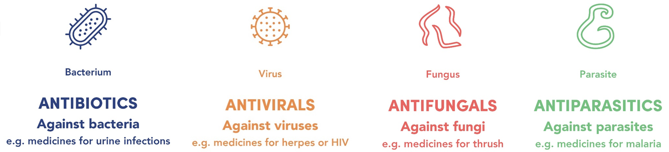

Community prescribing in general practice, community health services, aged care homes and other non-hospital settings accounts for the majority of antimicrobial use in Australia. Monitoring the overall volume of use of antimicrobials and the extent of inappropriate use is an important part of the approach to understand and address the risks associated with antimicrobial resistance (AMR).

The more antimicrobials are used, the more likely it is that microorganisms will develop resistance. AMR poses a risk to patient safety because it reduces the number of antimicrobials available to treat infections. In the community setting, this could mean that there are no oral antimicrobial options available, resulting in increased hospitalisations for parenteral therapy with broader-spectrum antimicrobials. Reducing the spread of AMR is a public health priority due to its serious and growing impact. It increases morbidity and mortality associated with infections caused by multidrug-resistant organisms. Hundreds of people in Australia die each year as a result of AMR.35,36 It may also limit future capacity for important treatments such as major surgeries, organ transplantation, cancer chemotherapy and diabetes management among others, due to a lack of effective antimicrobials.37

Surveillance of the volume of antimicrobial use and appropriateness of prescribing are essential to inform antimicrobial stewardship (AMS) and AMR prevention and control strategies. This includes providing feedback about prescribing to clinicians and information to consumers about safe and appropriate use of antimicrobials.

The PBS and RPBS are estimated to account for more than 90% of prescriptions issued in the community.38 However, the PBS and RPBS do not capture data on private prescriptions (that is prescriptions that are not subsidised under the PBS or RPBS), or many prescriptions dispensed by many Aboriginal and Torres Strait Islander health services. The lack of mechanisms to record and monitor rates of private antimicrobial prescribing at the time of dispensing, and the reason for why they are prescribed, continues to be an important gap in current surveillance of antimicrobial use in Australia. This is particularly important given the increasing proportion of private antimicrobial prescriptions issued in the community by medical and non-medical clinicians.18

# Results

### Prescription volume

In 2023, there were 22,126,604 antimicrobial prescriptions supplied under the PBS and RPBS, which was a 1.3% increase compared to 2022 (Table 1). While antimicrobial use was higher than 2020 and 2021, it was still below the use of antimicrobials prior to the COVID-19 pandemic.

In 2023, 36.4% (*n* = 9,699,404) of the Australian population had at least one antimicrobial supplied under the PBS and RPBS, compared to 36.6% (*n* = 9,502,834) in 2022.

Amongst people who received antimicrobials, the average number of prescriptions supplied per person was also similar: 2.30 in 2022 and 2.28 in 2023.

The vast majority (87.3%) of antimicrobial prescriptions were issued by GPs; with 7.9% issued by medical specialists and 4.2% by dentists. A combined less than 1% of antimicrobials supplied under the PBS and RPBS were prescribed by midwives, nurse practitioners and optometrists.

Almost all antimicrobials supplied under the PBS and RPBS were antibacterials for systemic use (ATC code J01) (Table 1). See Appendix 1 for information about the antimicrobials included in these analyses.

Table 1: Number of PBS and RPBS antimicrobial prescriptions dispensed*, 2015–2023

|  |  |  |  |
| --- | --- | --- | --- |
| Year | All antimicrobials (*n*) | J01 antibacterials (*n*) | Non-J01 antimicrobials (*n*) |
| 2015 | 29,264,932 | 26,813,587 | 2,451,345 |
| 2016 | 27,324,648 | 26,926,933 | 397,715 |
| 2017 | 26,553,451 | 25,924,324 | 629,127 |
| 2018 | 26,229,366 | 25,427,786 | 801,580 |
| 2019 | 26,669,561 | 25,871,075 | 798,486 |
| 2020 | 20,095,926 | 19,425,518 | 670,408 |
| 2021 | 19,931,271 | 19,208,986 | 722,285 |
| 2022 | 21,848,005 | 21,059,515 | 788,490 |
| 2023 | 22,126,604 | 21,364,753 | 761,851 |

J01 = antibacterials for systemic use; PBS = Pharmaceutical Benefits Scheme; RPBS = Repatriation Pharmaceutical Benefits Scheme

* Total number of all antimicrobial prescriptions (originals and repeats) dispensed under the PBS and RPBS in the given year (see Appendix 1)  
Note: Chloramphenicol eye drops were rescheduled to become available over-the-counter without a prescription in 2016. This contributed to the drop in the number of all antimicrobials and non-J01 antimicrobials dispensed from 2015 to 2016.

Source: Gadzhanova, Roughead19

Following an overall downward trend from 2015, the rate of all antimicrobials supplied in Australia remained stable from 2022 to 2023 at 16.8 defined daily doses (DDD) per 1,000 people per day (Figure 1).

Crude and age-standardised rates of antimicrobial prescriptions supplied per 1,000 people in Australia followed a similar trend to rate of supply. When controlled for population, there was just over a 1% drop in antimicrobial use per person from 2022 to 2023 (Figure 2).

Figure 1: Rate of PBS and RPBS antimicrobial prescriptions dispensed (DDD/1,000 people/day), 2015–2023

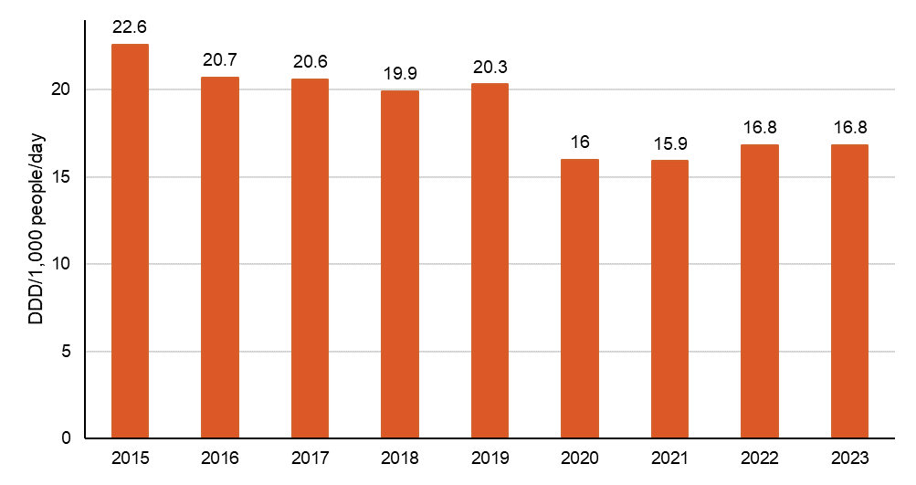

DDD = defined daily dose; PBS = Pharmaceutical Benefits Scheme; RPBS = Repatriation Pharmaceutical Benefits Scheme

Note: The DDD values determined by the World Health Organization Collaborating Centre for Drug Statistics Methodology for 2024 have been applied in this report, causing slight variation with results presented in previous reports.39  
Source: Gadzhanova, Roughead19

Figure 2: Proportion of PBS and RPBS antimicrobial prescriptions dispensed per 1,000 people, crude and age-standardised rates, 2015–2023

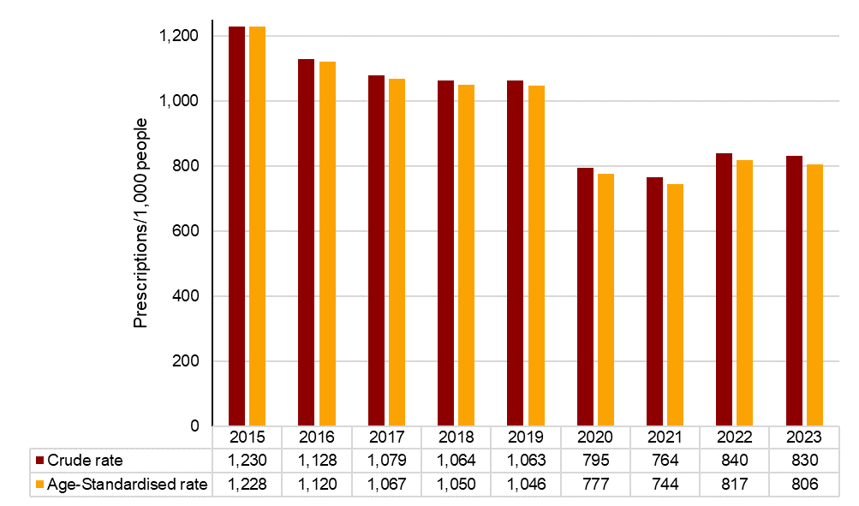

PBS = Pharmaceutical Benefits Scheme; RPBS = Repatriation Pharmaceutical Benefits Scheme  
Note: Age-standardised rates were based on the age structure of the Australian national population in 2013 for consistency with previous reports; national rates were based on the total number of prescriptions dispensed and people in Australia in the given year.

Source: Gadzhanova, Roughead19

The substantial difference in antimicrobial use across age groups (Figure 3) was consistent across states and territories13 and followed a similar pattern to previous years.12,18 Older Australians received the greatest number of antimicrobials. On average in 2023, people aged 65–79 years received 1–2 antimicrobial prescriptions, while those aged 80 years and over received  
2–3 antimicrobial prescriptions. The lowest number of antimicrobial prescriptions was supplied to Australians aged 10–14 years (Figure 3).

Figure 3: Proportion of PBS and RPBS antimicrobial prescriptions dispensed per 1,000 people, by age group, 2023

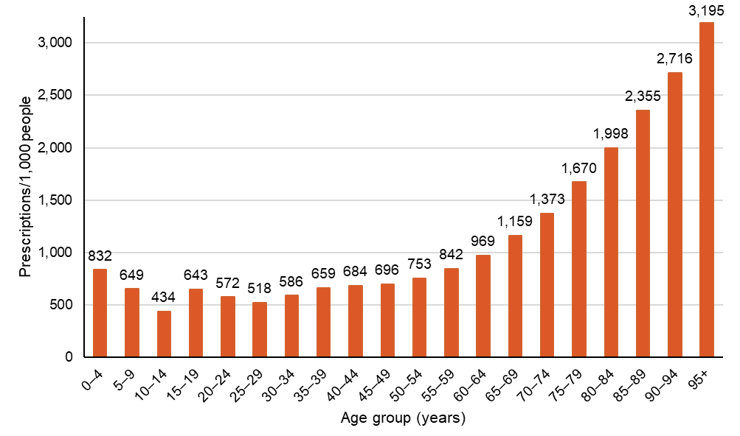

PBS = Pharmaceutical Benefits Scheme; RPBS = Repatriation Pharmaceutical Benefits Scheme  
Source: Gadzhanova, Roughead19

The 10 most commonly dispensed antimicrobials were generally consistent from 2015 to 2023.12,14-18 In 2023, these medicines accounted for a vast majority (85.3%) of all antimicrobials supplied in Australia. As in previous years, the three most commonly dispensed antimicrobials in 2023 were cefalexin, amoxicillin and amoxicillin–clavulanic acid (Figure 4).12,14-18

Figure 4: The 10 most commonly dispensed PBS and RPBS antimicrobial prescriptions, 2023

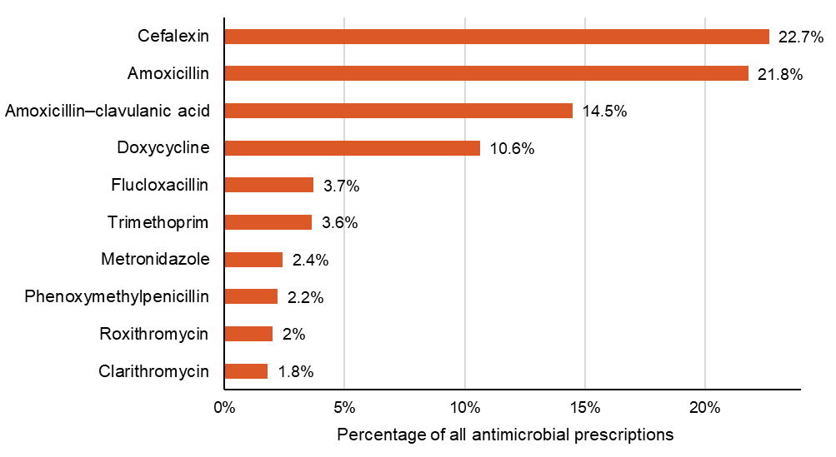

PBS = Pharmaceutical Benefits Scheme; RPBS = Repatriation Pharmaceutical Benefits Scheme

Source: Gadzhanova, Roughead19

The most commonly dispensed antimicrobial classes by DDD per 1,000 people per day in 2023 were tetracyclines followed by penicillins with extended spectrum, first-generation cephalosporins and β-lactamase inhibitor combinations (Figure 5).

Figure 5: Number of PBS and RPBS prescriptions dispensed (DDD/1,000 people/day), by antimicrobial class*, 2015–2023

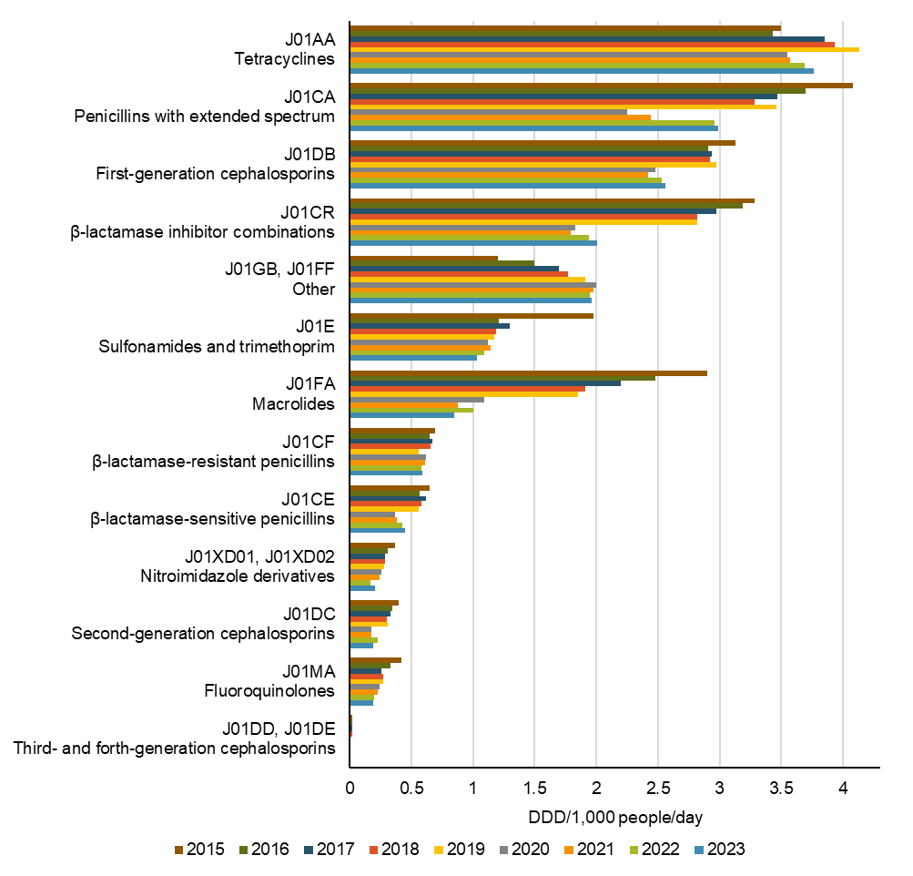

|  |  |  |  |  |  |  |  |  |  |  |  |  |  |
| --- | --- | --- | --- | --- | --- | --- | --- | --- | --- | --- | --- | --- | --- |
|  | J01AA | J01CA | J01DB | J01CR | J01GB, J01FF | J01E | J01FA | J01CF | J01CE | J01XD01, J01XD02 | J01DC | J01MA | J01DD, J01DE |
| 2015 | 3.50 | 4.08 | 3.13 | 3.28 | 1.2 | 1.98 | 2.9 | 0.69 | 0.65 | 0.37 | 0.4 | 0.42 | 0.02 |
| 2016 | 3.43 | 3.7 | 2.91 | 3.19 | 1.5 | 1.21 | 2.48 | 0.65 | 0.57 | 0.31 | 0.35 | 0.33 | 0.02 |
| 2017 | 3.85 | 3.47 | 2.94 | 2.97 | 1.7 | 1.3 | 2.2 | 0.67 | 0.62 | 0.29 | 0.33 | 0.26 | 0.02 |
| 2018 | 3.93 | 3.28 | 2.92 | 2.82 | 1.77 | 1.19 | 1.91 | 0.66 | 0.58 | 0.29 | 0.3 | 0.27 | 0.02 |
| 2019 | 4.13 | 3.46 | 2.97 | 2.82 | 1.91 | 1.17 | 1.85 | 0.56 | 0.56 | 0.28 | 0.31 | 0.27 | 0.01 |
| 2020 | 3.55 | 2.25 | 2.48 | 1.83 | 2 | 1.12 | 1.09 | 0.62 | 0.37 | 0.26 | 0.18 | 0.24 | 0.01 |
| 2021 | 3.57 | 2.44 | 2.42 | 1.79 | 1.98 | 1.14 | 0.88 | 0.61 | 0.38 | 0.24 | 0.18 | 0.23 | 0.01 |
| 2022 | 3.69 | 2.96 | 2.53 | 1.94 | 1.95 | 1.09 | 1 | 0.58 | 0.43 | 0.17 | 0.23 | 0.2 | 0.01 |
| 2023 | 3.76 | 2.99 | 2.56 | 2.01 | 1.96 | 1.03 | 0.85 | 0.59 | 0.45 | 0.21 | 0.19 | 0.19 | 0.01 |

* J01 antibacterials for systemic use

DDD = defined daily dose; PBS = Pharmaceutical Benefits Scheme; RPBS = Repatriation Pharmaceutical Benefits Scheme

Note: The DDD values determined by the World Health Organization Collaborating Centre for Drug Statistics Methodology for 2024 have been applied in this report, causing slight variation with results presented in previous reports.39

Source: Gadzhanova, Roughead19

Original prescriptions accounted for 86.6% of all prescriptions supplied for the top 10 antimicrobials in 2023. This is similar to 2022 (86.5%) but is a marked increase from 77.1% in 2019, which was before the PBS and RPBS policy changes to restrict repeat prescriptions came into effect in April 2020. This policy change was to encourage prescribers to issue repeat prescriptions for antimicrobials only when indicated.25 Since then, the majority of original prescriptions for amoxicillin, amoxicillin–clavulanic acid, cefalexin, doxycycline and roxithromycin were ordered without repeats, which reflects the marked decrease in the number of repeat prescriptions dispensed.19

Repeat prescriptions filled within 10 days usually indicate a continuation of the original course of treatment. If a repeat prescription is dispensed after 10 days, it may indicate an interruption of the original course and that use is likely to be inappropriate. The pattern of repeat dispensing remained similar from 2021 to 2023, except for phenoxymethylpenicillin, which increased in 2022 and 2023 compared to 2021 (Table 2).

Table 2: Number and percentage of PBS and RPBS repeat antimicrobial* prescriptions dispensed within 10 days of the original prescription, 2019 and 2021–2023

|  |  |  |  |  |  |  |  |  |
| --- | --- | --- | --- | --- | --- | --- | --- | --- |
| Antimicrobial | 2019 | | 2021 | | 2022 | | 2023 | |
| (*n*) | (%) | (*n*) | (%) | (*n*) | (%) | (*n*) | (%) |
| Cefalexin | 398,222 | 51.3% | 33,495 | 36.5% | 37,447 | 37.6% | 34,059 | 36.3% |
| Amoxicillin | 193,492 | 50.3% | 39,902 | 50.4% | 46,809 | 52.8% | 54,516 | 54.3% |
| Amoxicillin–clavulanic acid | 510,847 | 61.1% | 25,934 | 60% | 28,631 | 59.9% | 22,709 | 60.8% |
| Doxycycline | 102,562 | 32.8% | 66,969 | 24.1% | 76,934 | 26.8% | 73,713 | 25.6% |
| Flucloxacillin | 7,466 | 56.1% | 5,370 | 47.9% | 5,055 | 47.2% | 6,161 | 52.1% |
| Trimethoprim | 35,494 | 40.8% | 30,485 | 39.3% | 27,600 | 37.9% | 23,856 | 36.9% |
| Metronidazole | 14,613 | 44.8% | 12,381 | 40.3% | 7,879 | 41.8% | 8,971 | 39.2% |
| Phenoxymethylpenicillin | 2,582 | 32.5% | 1,709 | 27.3% | 2,264 | 34.3% | 2,079 | 35.4% |
| Roxithromycin | 142,145 | 69.9% | 144 | 6.4% | 123 | 5.9% | 89 | 5% |
| Clarithromycin | 54,748 | 55.8% | 28,456 | 49.5% | 31,705 | 49.4% | 27,844 | 48.7% |

PBS = Pharmaceutical Benefits Scheme; RPBS = Repatriation Pharmaceutical Benefits Scheme  
* Most commonly dispensed antimicrobials in 2023 (see Figure 4)  
Notes:

1. Number of repeat prescriptions dispensed within 10 days of the original prescription being dispensed, and as a percentage of number of repeat prescriptions dispensed in the given year (number of repeat prescriptions dispensed in the given year not shown).
2. From 1 April 2020, repeats were not allowed for amoxicillin, amoxicillin–clavulanic acid, cefalexin, doxycycline and roxithromycin (shaded) so 2020 data were excluded from Table 2 to enable full year-to-year comparison.
3. Repeats were not allowed for flucloxacillin capsules, but repeats were allowed for flucloxacillin powder for oral liquid.
4. Less than 10 days was chosen for analysis as most pack sizes provide courses for 5 to 10 days.

Source: Gadzhanova, Roughead13,19

### State and territory and local area

Following the national trend, antimicrobial use declined overall across all states and territories from 2015 to 2023 (Figures 6 and 7). However, there was variation between jurisdictions.

Comparatively lower rates of antimicrobial use in the Northern Territory (NT) observed in Figures 6–11 and Tables 3 and 4 may reflect the access to supply of antimicrobials outside the PBS and RPBS (see Appendix 1).

In 2023, the rate of antimicrobials supplied was highest in South Australia (SA) (17.6 DDD/1,000 people/day) and lowest in the NT (9.2 DDD/1,000 people/day) (Figure 6).

When analysed by aged-standardised rate, antimicrobial use was highest in Queensland (837 prescriptions/1,000 people) and lowest in the NT (562 prescriptions/1,000 people) in 2023 (Figure 7).

From 2022 to 2023, antimicrobial use increased in SA, Western Australia, Tasmania and the NT; the greatest increase was observed in Tasmania (Figures 6 and 7).

Figure 6: Rate of PBS and RPBS antimicrobial prescriptions dispensed (DDD/1,000 people/day), by patient’s state or territory, 2015–2023

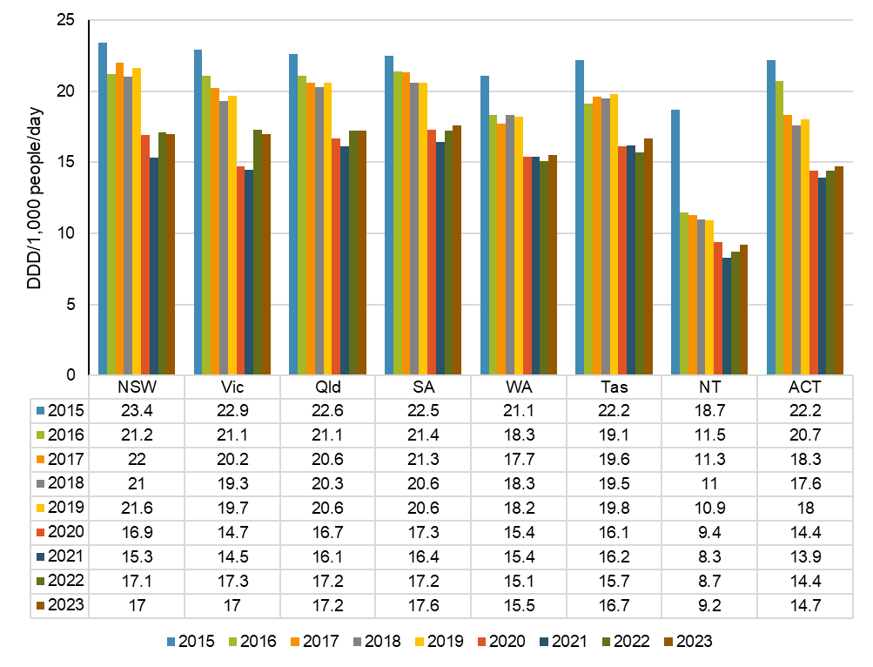

DDD = defined daily dose; PBS = Pharmaceutical Benefits Scheme; RPBS = Repatriation Pharmaceutical Benefits Scheme  
Notes:

1. The DDD values determined by the World Health Organization Collaborating Centre for Drug Statistics Methodology for 2024 have been applied in this report, causing slight variation with results presented in previous reports.39
2. Rate may have been influenced by the availability of other sources of supply of antimicrobials, such as Aboriginal and Torres Strait Islander health services.

Source: Gadzhanova, Roughead19

Figure 7: Proportion of PBS and RPBS antimicrobial prescriptions dispensed per 1,000 people, age-standardised rate by patient’s state or territory, 2015–2023

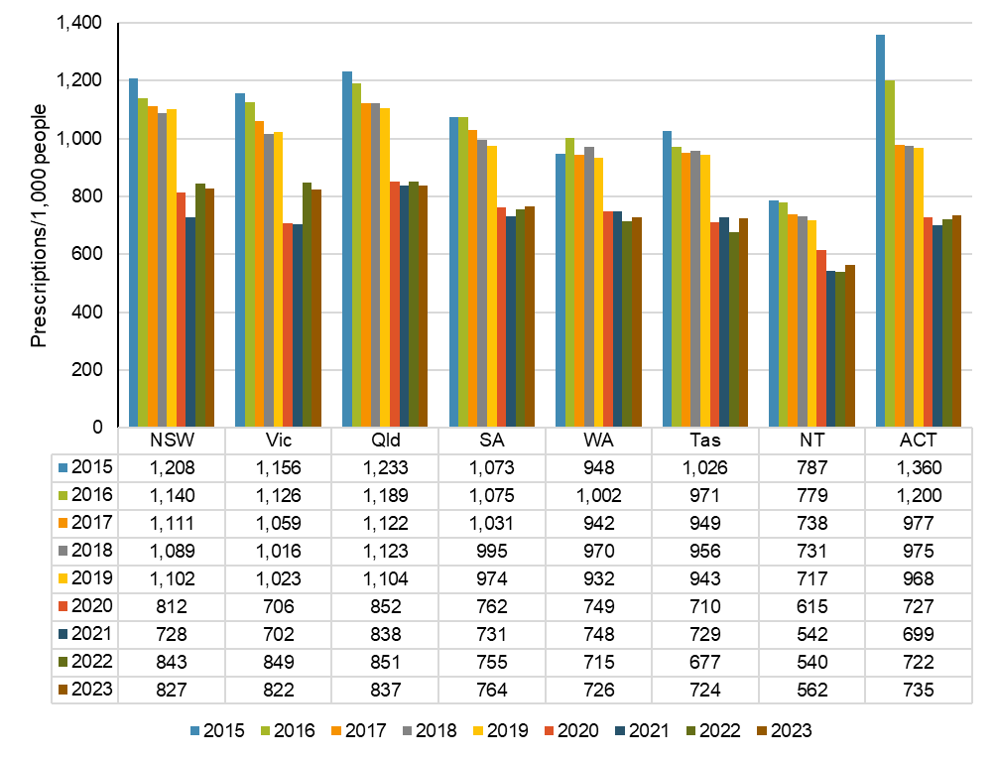

PBS = Pharmaceutical Benefits Scheme; RPBS = Repatriation Pharmaceutical Benefits Scheme

Notes:

1. Age-standardised rates were based on the age structure of the Australian national population in 2013 for consistency with previous reports.
2. Rate may have been influenced by the availability of other sources of supply of antimicrobials, such as Aboriginal and Torres Strait Islander health services.

Source: Gadzhanova, Roughead19

Tables 3 and 4 show antimicrobial use also varies by local area defined by both SA3 and PHN. The highest and lowest antimicrobial dispensing rates largely remained consistent from 2022 to 2023 and compared to previous years (see Appendix 2).12

Table 3: Highest and lowest number of PBS and RPBS antimicrobial prescriptions dispensed per 1,000 people, age-standardised rate by patient’s SA3, 2022–2023

|  |  |  |  |  |  |  |  |  |
| --- | --- | --- | --- | --- | --- | --- | --- | --- |
| State or territory | 2022 | | | | 2023 | | | |
| Lowest SA3 | Rate | Highest SA3 | Rate | Lowest SA3 | Rate | Highest SA3 | Rate |
| NSW | Botany | 369 | Richmond - Windsor | 1,508 | Botany | 363 | Richmond - Windsor | 1,501 |
| Vic | Melbourne City | 521 | Casey - South | 1,167 | Melbourne City | 531 | Casey - South | 1,172 |
| Qld | Far North | 250 | Beenleigh | 1,410 | Far North | 266 | Beenleigh | 1,400 |
| SA | Adelaide City | 548 | Playford | 912 | Adelaide City | 574 | Playford | 949 |
| WA | Kimberley | 273 | Canning | 961 | Kimberley | 293 | Canning | 1,005 |
| Tas | Central Highlands | 181 | Brighton | 1,028 | Central Highlands | 197 | Brighton | 1,075 |
| NT | East Arnhem | 33 | Palmerston | 642 | East Arnhem | 42 | Palmerston | 698 |
| ACT | North Canberra | 549 | Weston Creek | 951 | North Canberra | 559 | Weston Creek | 1,036 |

PBS = Pharmaceutical Benefits Scheme; RPBS = Repatriation Pharmaceutical Benefits Scheme; SA3 = Statistical Area Level 3  
Notes:

1. Age-standardised rates were based on the age structure of the Australian national population in 2013 for consistency with previous reports.
2. Rate may have been influenced by the availability of other sources of supply of antimicrobials, such as Aboriginal and Torres Strait Islander health services.
3. See Appendix 2 for further analyses of PBS and RPBS antimicrobial dispensing by SA3.

Source: Gadzhanova, Roughead19

Table 4: Highest and lowest number of PBS and RPBS antimicrobial prescriptions dispensed per 1,000 people, age-standardised rate by patient’s PHN, 2022–2023

|  |  |  |  |  |  |  |  |  |
| --- | --- | --- | --- | --- | --- | --- | --- | --- |
| State or territory | 2022 | | | | 2023 | | | |
| Lowest PHN | Rate | Highest PHN | Rate | Lowest PHN | Rate | Highest PHN | Rate |
| NSW | North Coast | 730 | Nepean Blue Mountains | 1,139 | Murrumbidgee | 700 | Nepean Blue Mountains | 1,118 |
| Vic | Western Victoria | 843 | South Eastern Melbourne | 910 | Western Victoria | 827 | South Eastern Melbourne | 889 |
| Qld | Western Queensland | 831 | Gold Coast | 897 | Central Queensland, Wide Bay, Sunshine Coast | 824 | Brisbane South | 878 |
| SA* | Adelaide | 760 | Country SA | 792 | Adelaide | 765 | Country SA | 810 |
| WA† | Country WA | 613 | Perth North | 747 | Country WA | 633 | Perth North | 764 |
| Tas§ | Tasmania | 684 | Tasmania | 684 | Tasmania | 721 | Tasmania | 721 |
| NT§ | Northern Territory | 427 | Northern Territory | 427 | Northern Territory | 451 | Northern Territory | 451 |
| ACT§ | Australian Capital Territory | 724 | Australian Capital Territory | 724 | Australian Capital Territory | 738 | Australian Capital Territory | 738 |

PBS = Pharmaceutical Benefits Scheme; PHN = Primary Health Network; RPBS = Repatriation Pharmaceutical Benefits Scheme  
* There are two PHN regions in South Australia

† There are three PHN regions in Western Australia

§ There is one PHN region in Tasmania, the Northern Territory and the Australian Capital Territory, respectively

Notes:

1. Age-standardised rates were based on the age structure of the Australian national population in 2013 for consistency with previous reports.
2. Rate may have been influenced by the availability of other sources of supply of antimicrobials, such as Aboriginal and Torres Strait Islander health services.
3. See Appendix 2 for further analyses of PBS and RPBS antimicrobial dispensing by PHN.

Source: Gadzhanova, Roughead19

The majority of antimicrobial prescriptions are supplied in the winter months, June to August. The age-standardised rate of antimicrobials supplied in winter follows a similar trend to yearly national and state and territory antimicrobial use. The age-standardised rate of antimicrobials supplied in winter has fallen overall since 2019. However, rates have consistently risen in SA and the NT since 2020 (Figure 8).

Figure 8: Number of PBS and RPBS antimicrobial prescriptions dispensed per 1,000 people in winter (June–August), age-standardised rate by prescriber’s state and territory, 2019–2023

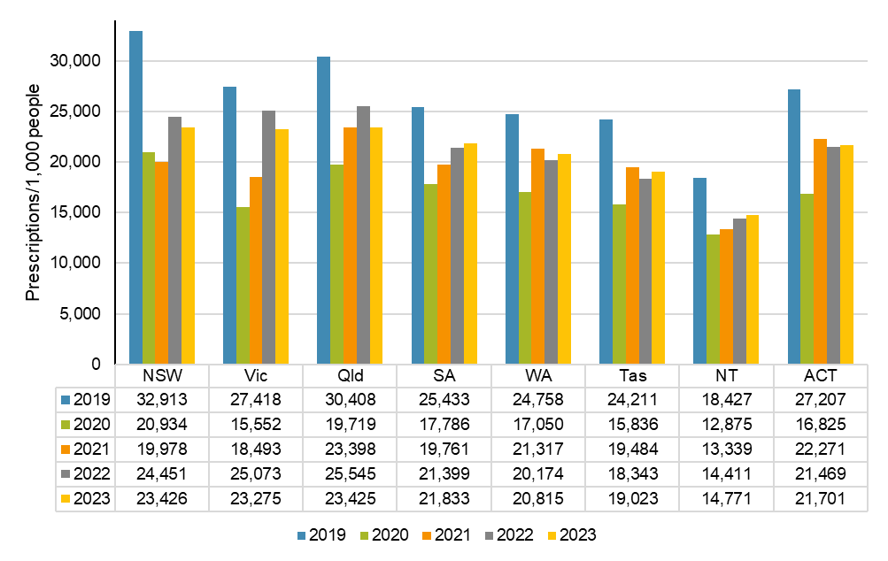

PBS = Pharmaceutical Benefits Scheme; RPBS = Repatriation Pharmaceutical Benefits Scheme  
Note:

1. Age-standardised rates were based on the age structure of the Australian national population in 2013 for consistency with previous reports.
2. Rate may have been influenced by the availability of other sources of supply of antimicrobials, such as Aboriginal and Torres Strait Islander health services.

Source: Gadzhanova, Roughead19

The age-standardised rates of antimicrobial use in the 2023 winter months are mapped to Australian SA3 and PHN regions in Figures 9 and 10. Further analyses of PBS and RPBS antimicrobial dispensing by local area level are included in Appendix 2.

Figure 9: Number of PBS and RPBS antimicrobial prescriptions dispensed per 100,000 people in winter (June–August), age-standardised rate by prescriber’s SA3, 2023

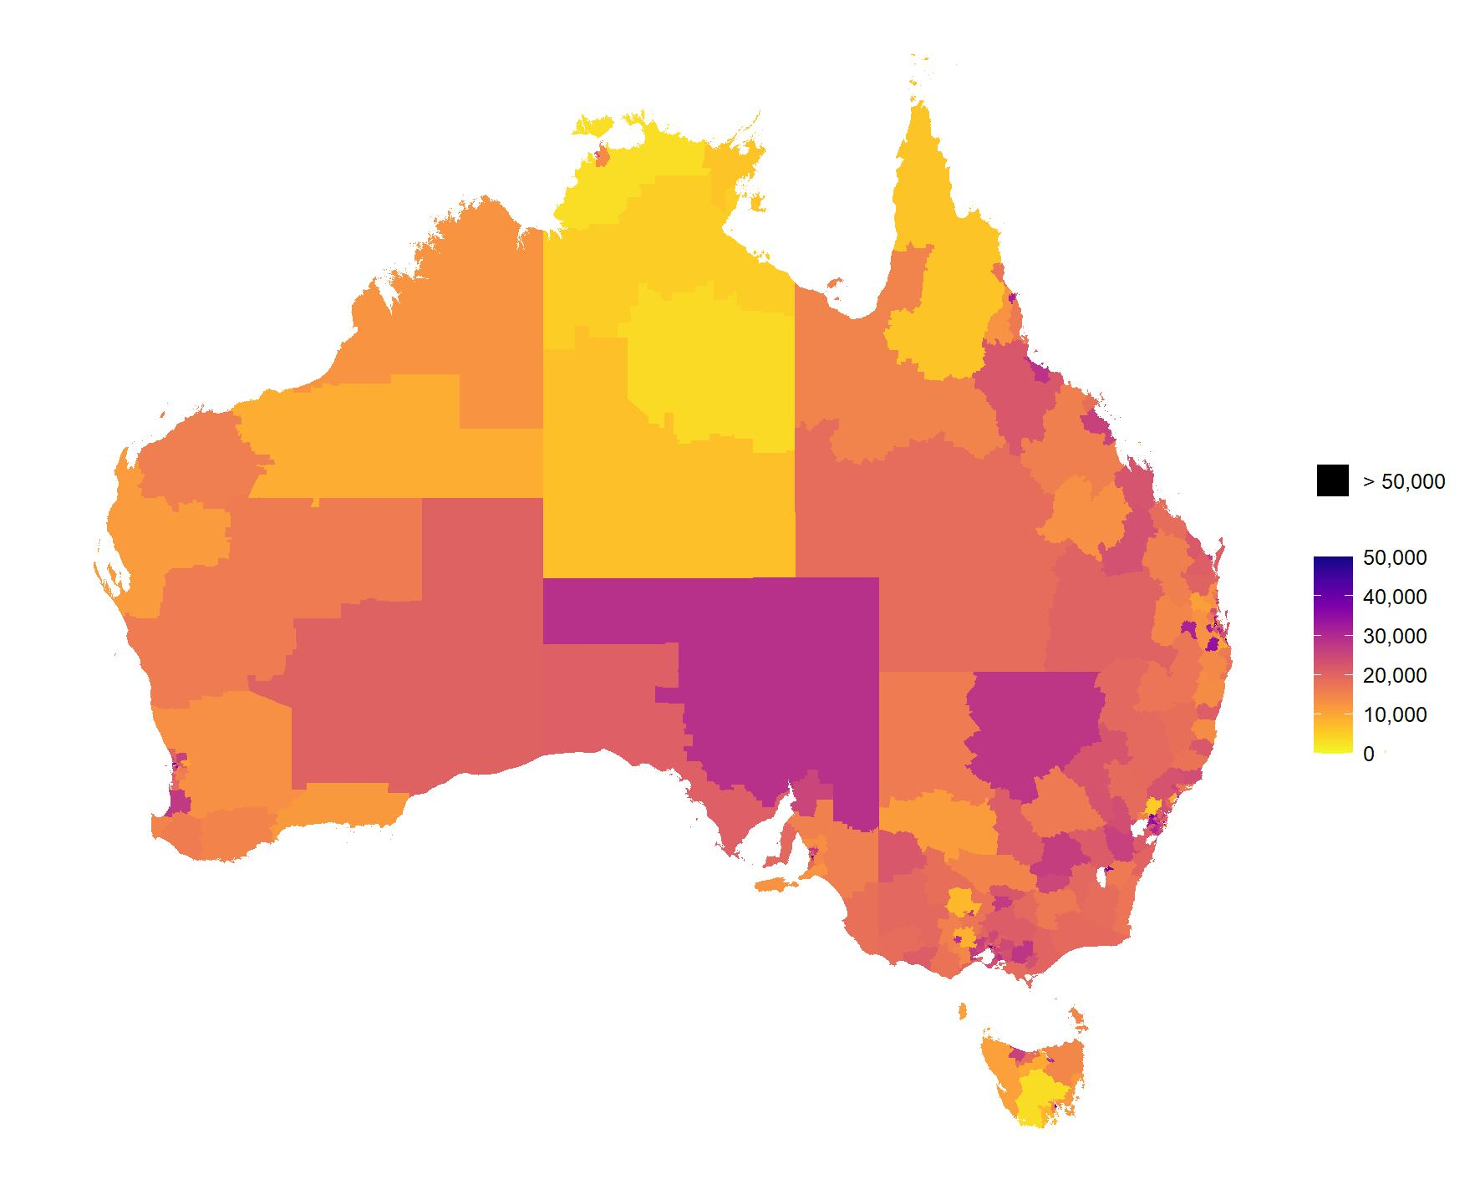

PBS = Pharmaceutical Benefits Scheme; RPBS = Repatriation Pharmaceutical Benefits Scheme; SA3 = Statistical Area Level 3  
Notes:

1. Age-standardised rates were based on the age structure of the Australian national population in 2013 for consistency with previous reports.
2. Rate may have been influenced by the availability of other sources of supply of antimicrobials, such as Aboriginal and Torres Strait Islander health services.
3. See Appendix 2 for further analyses of PBS and RPBS antimicrobial dispensing by SA3.

Source: Gadzhanova, Roughead19

Figure 10: Number of PBS and RPBS antimicrobial prescriptions dispensed per 100,000 people in winter (June–August), age-standardised rate by prescriber’s PHN, 2023

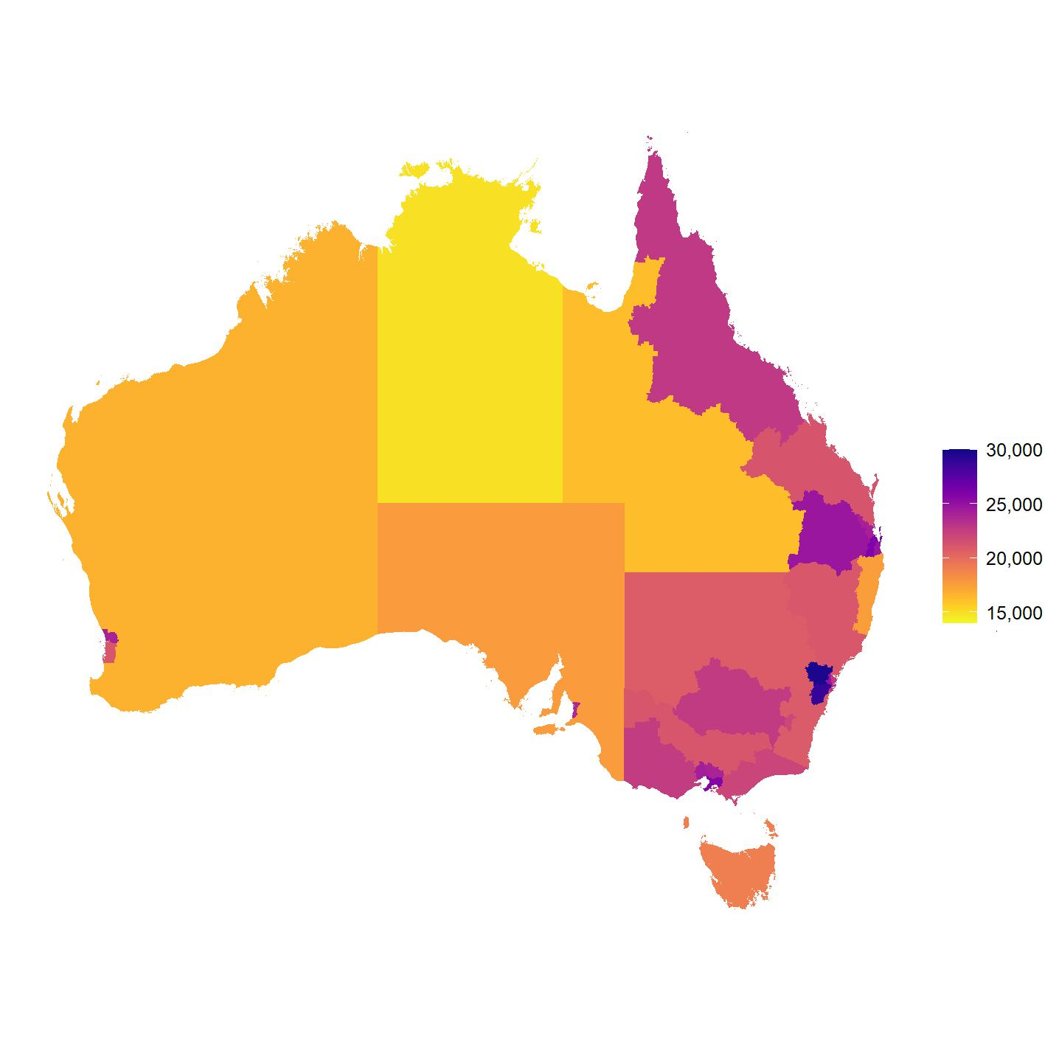

PBS = Pharmaceutical Benefits Scheme; PHN = Primary Health Network; RPBS = Repatriation Pharmaceutical Benefits Scheme  
Notes:

1. Age-standardised rates were based on the age structure of the Australian national population in 2013 for consistency with previous reports.
2. Rate may have been influenced by the availability of other sources of supply of antimicrobials, such as Aboriginal and Torres Strait Islander health services.
3. There is one PHN region in Tasmania, the Northern Territory and the Australian Capital Territory, respectively, two PHN regions in South Australia, and three PHNs regions in Western Australia.
4. See Appendix 2 for further analyses of PBS and RPBS antimicrobial dispensing by PHN.

Source: Gadzhanova, Roughead19

### Aged care and older Australians

#### Aged care homes

In 2023, there were 576,579 antimicrobial prescriptions supplied under the PBS and RPBS to residents of aged care homes. These prescriptions accounted for 2.6% of all antimicrobials supplied in Australia in 2023. There was an 11.1% increase in the number supplied from 2022 to 2023 (Table 5).

Of Australians who resided in aged care homes, 72.6% (*n* = 141,588) received at least one antimicrobial supplied under the PBS and RPBS in 2023.

The overall prescribing rate for antimicrobials supplied to Australians in aged care homes under the PBS and RPBS was 295 prescriptions per 100 people in 2023, that is approximately three antimicrobial prescriptions per aged care home resident. This was an 8.1% increase from 273 prescriptions per 100 people in 2022. The rate in 2021 was 283 prescriptions per 100 people.

The vast majority of antimicrobials supplied to residents of aged care homes were J01 antibacterials for systemic use. In 2023, there were 536,483 prescriptions for J01 antibacterials supplied under the PBS and RPBS to residents of aged care homes. There was an 11% increase compared to 2022 (Table 5).

Of Australians resided in aged care homes, 69.7% (*n* = 135,904) received at least one J01 antibacterial for systemic use supplied under the PBS and RPBS in 2023.

**Table 5:** Number of PBS and RPBS antimicrobial prescriptions dispensed, aged care homes, 2021–2023

|  |  |  |  |
| --- | --- | --- | --- |
| Year | All antimicrobials (*n*) | J01 antibacterials (*n*) | Non-J01 antimicrobials (*n*) |
| 2021 | 523,891 | 485,847 | 38,044 |
| 2022 | 518,917 | 483,275 | 35,642 |
| 2023 | 576,579 | 536,483 | 40,096 |

J01 = antibacterials for systemic use; PBS = Pharmaceutical Benefits Scheme; RPBS = Repatriation Pharmaceutical Benefits Scheme  
Note: The aged care indicator for a patient’s residence in an aged care home was introduced in July 2017 and became mandatory from July 2020. Therefore, analyses for data from 1 January 2021 to 31 December 2023 were included in this report to ensure complete and reliable data analysis.

Source: Gadzhanova, Roughead40

The J01 antibacterials were the most commonly dispensed antimicrobial class to aged care residents and represented 2.5% of all J01 antibacterials supplied in Australia under the PBS and RPBS in 2023. Figure 11 shows use of J01 antibacterials in aged care homes by month.

The next most commonly supplied antimicrobials under the PBS and RPBS in aged care homes were ATC codes S01 and S02, which were topical antimicrobials for eyes and ears, respectively (Figure 12). As the PBS and RPBS do not capture data on indication, it is difficult to comment on this finding.

**Figure 11:** Number of PBS and RPBS prescriptions for J01 antibacterials for systemic use dispensed, aged care homes, 2021–2023

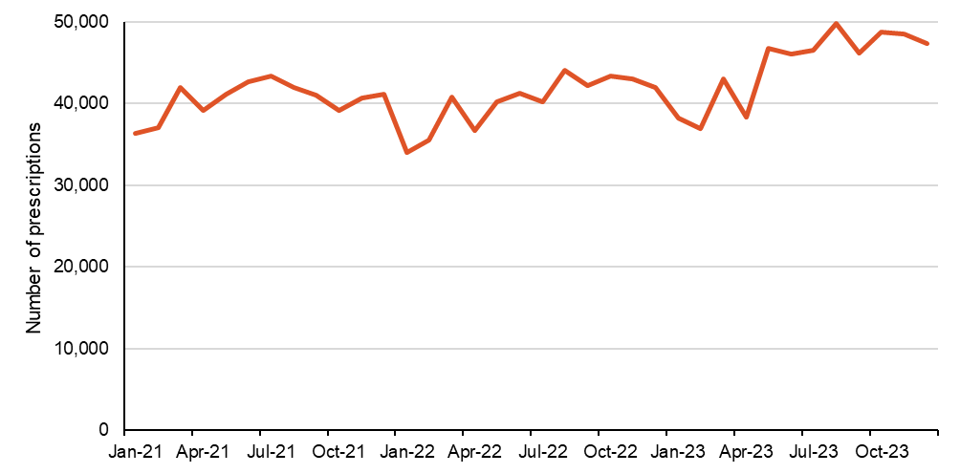

PBS = Pharmaceutical Benefits Scheme; RPBS = Repatriation Pharmaceutical Benefits Scheme

Source: Gadzhanova, Roughead40

**Figure 12:** Number of PBS and RPBS antimicrobial prescriptions dispensed, aged care homes, 2021–2023

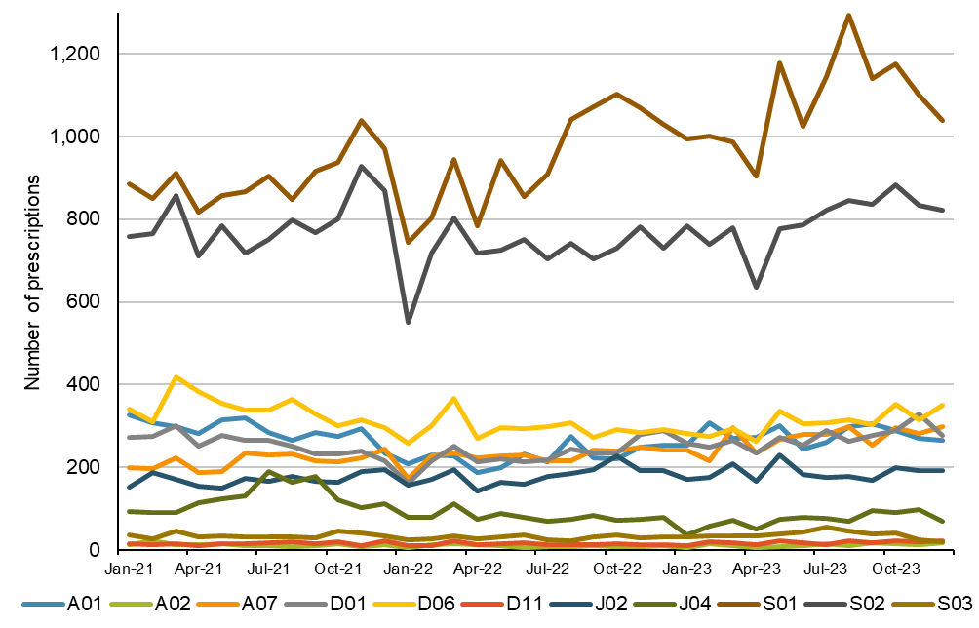

A01 = stomatological preparations; A02 = drugs for acid related disorders; A07 = antidiarrheals, intestinal anti-inflammatory/anti-infective agents; D01 = antifungals for dermatological use; D06 = antibiotics and chemotherapeutics for dermatological use; D11 = other dermatological preparations; J02 = antimycotics for systemic use; J04 = antimycobacterials; PBS = Pharmaceutical Benefits Scheme; RPBS = Repatriation Pharmaceutical Benefits Scheme; S01 = ophthalmologicals; S02 = otologicals; S03 = ophthalmological and otological preparations

Note: Many antimicrobials for skin conditions are available over-the-counter without a prescription so are not captured by the PBS and RPBS.

Source: Gadzhanova, Roughead40

The 10 most commonly dispensed antimicrobials accounted for more than 84% of all antimicrobials dispensed to aged care home residents in 2021 to 2023. As in previous years for overall antimicrobial use in Australia under the PBS and RPBS12,14-18, cefalexin was most frequently supplied (Figure 13).

The next most commonly dispensed antimicrobials were azithromycin, clarithromycin and metronidazole (data not shown).

**Figure 13:** The 10 most commonly dispensed PBS and RPBS antimicrobial prescriptions, aged care homes, 2021–2023

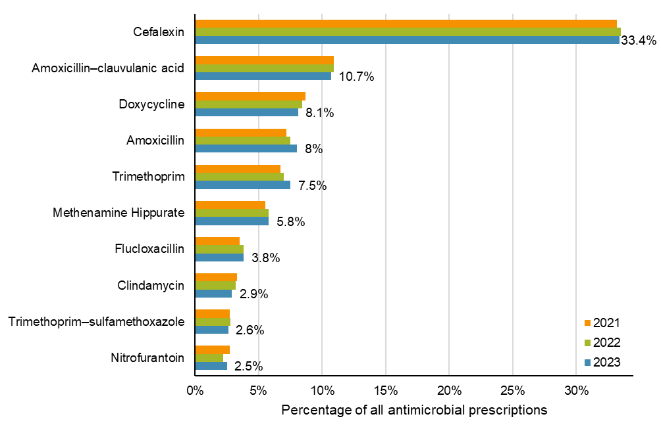

PBS = Pharmaceutical Benefits Scheme; RPBS = Repatriation Pharmaceutical Benefits Scheme  
Note: Data labels for 2023 are shown.

Source: Gadzhanova, Roughead40

#### Older Australians

When comparing antimicrobial use in older Australians aged 65 years and over, patterns vary depending on residence. It is also important to note the diversity of this age group and the difference in population size across settings. The healthcare needs of Australians across settings are also likely to vary. See Appendix 1 for considerations for interpreting data with respect to age and aged care.

Of all J01 antibacterials dispensed under the PBS and RPBS in 2023, 2.5% were supplied to older Australians in aged care homes, while 28.7% were supplied to older Australians in the community.

In 2023, 68.6% of older Australians in aged care homes were dispensed a J01 antibacterial, compared to 45.6% in the community.

The average number of J01 antibacterial prescriptions supplied per person in 2023 was much higher for older Australians who resided in aged care homes (2.76) than the community (1.34).

Cefalexin remained the most frequently dispensed antimicrobial for older Australians across settings. Proportionally, it was more often supplied to those in aged care homes than to those who resided in the community (Table 6).

**Table 6:** Number and percentage of PBS and RPBS antimicrobial prescriptions dispensed to people aged 65 years and over, by setting, 2023

|  |  |  |  |  |
| --- | --- | --- | --- | --- |
| Antimicrobial* | Aged care home | | Community | |
| (*n*) | (%) | (*n*) | (%) |
| Cefalexin | 189,372 | 36.1% | 1,633,604 | 26.6% |
| Amoxicillin–clavulanic acid | 59,983 | 11.4% | 884,745 | 14.4% |
| Doxycycline | 45,503 | 8.7% | 772,617 | 12.6% |
| Amoxicillin | 44,130 | 8.4% | 919,021 | 15% |
| Trimethoprim | 42,997 | 8.2% | 336,541 | 5.5% |
| Methenamine hippurate | 33,172 | 6.3% | 224,351 | 3.7% |
| Flucloxacillin | 21,043 | 4% | 209,971 | 3.4% |
| Clindamycin | 16,491 | 3.1% | 108,811 | 1.8% |
| Trimethoprim–sulfamethoxazole | 14,696 | 2.8% | 147,196 | 2.4% |
| Nitrofurantoin | 14,581 | 2.8% | 84,755 | 1.4% |

PBS = Pharmaceutical Benefits Scheme; RPBS = Repatriation Pharmaceutical Benefits Scheme

* Most commonly dispensed antimicrobials in aged care homes in 2023 (see Figure 13)

Note: Percentage of J01 antibacterials for systemic use dispensed in 2023.

Source: Gadzhanova, Roughead40

The rate of dispensing antimicrobials for UTIs for older Australians in aged care homes was also high – more than three times higher than for those in the community. Supply of intravenous antimicrobials and of antimicrobials for skin conditions is comparably very low and similar across the community and aged care settings (Figure 14).

**Figure 14:** PBS and RPBS antimicrobial prescriptions dispensed for people aged 65 years and over, by setting and classification*, 2023

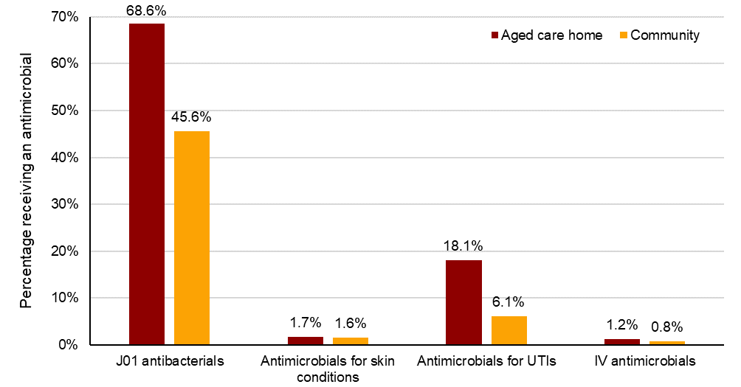

J01 = antibacterials for systemic use; UTI = Urinary tract infection; IV = Intravenous

* Per World Health Organization Anatomical Therapeutic Chemical Classification and PBS and RPBS listings

Notes:

1. PBS and RPBS data do not indicate the diagnosis or condition of the patient or the indication for prescription. Antimicrobials for UTI include methenamine hippurate, nitrofurantoin, norfloxacin and trimethoprim. Other antimicrobials, including J01 antibacterials for systemic use, may also be used for urinary tract infections but this cannot be determined from the dataset.
2. Many antimicrobials for skin conditions are available over-the-counter without a prescription so are not captured by the PBS and RPBS.

Source: Gadzhanova, Roughead40

##### Antimicrobials for urinary tract infections in aged care homes and the community

Of all antimicrobials for UTIs supplied under the PBS and RPBS in 2023, 7% were for older Australians in aged care homes, while 50.9% were supplied to older Australians in the community.

Just over one-third (34.1%) of prescriptions for UTIs across both settings were for methenamine hippurate, which is indicated for prophylaxis (Table 7).

It is important to note that indication for prescribing cannot be determined from the PBS and RPBS dataset. Other antimicrobials may be used for UTIs including cefalexin and amoxicillin–clavulanic acid, which are J01 antibacterials.

**Table 7:** Number and percentage of PBS and RPBS antimicrobial prescriptions for urinary tract infections dispensed to people aged 65 years and over, by setting, 2023

|  |  |  |  |  |
| --- | --- | --- | --- | --- |
| Antimicrobial* | Aged care home | | Community | |
| (*n*) | (%) | (*n*) | (%) |
| Trimethoprim | 42,997 | 46.8% | 336,541 | 50.7% |
| Methenamine hippurate | 33,172 | 36.1% | 224,351 | 33.8% |
| Nitrofurantoin | 14,581 | 15.9% | 84,755 | 12.8% |
| Norfloxacin | 1,183 | 1.3% | 17,944 | 2.7% |

PBS = Pharmaceutical Benefits Scheme; RPBS = Repatriation Pharmaceutical Benefits Scheme

* Antimicrobials used for urinary tract infections per World Health Organization Anatomical Therapeutic Chemical Classification and PBS and RPBS listing

Notes:

1. Percentage of antimicrobials listed.
2. PBS and RPBS data do not indicate the diagnosis or condition of the patient or the indication for prescription. Other antimicrobials, including J01 antibacterials for systemic use, may be used for urinary tract infections.

Source: Gadzhanova, Roughead40

##### Antimicrobials for skin conditions in aged care homes and the community

Of all antimicrobials for skin conditions supplied under the PBS and RPBS in 2023, 3.6% were for older Australians in aged care homes, while 34.8% were supplied to older Australians in the community.

For residents of aged care homes who received a topical antifungal, 66.8% received one prescription in 2023, while 20.3% received two prescriptions. This suggests that a majority of aged care home residents used topical antifungals available under the PBS and RPBS for a limited duration. However, more than 3% received six or more supplies in the year.

It is important to note that many antimicrobials for skin conditions, such as topical antifungals, are available over-the-counter without a prescription. These antimicrobials are not captured by the PBS and RPBS and are likely to influence the comparatively low numbers of prescriptions shown in Table 8. This is despite skin conditions being the most common indication for antimicrobial prescriptions in aged care homes.41

**Table 8:** Number and percent of PBS and RPBS antimicrobial prescriptions dispensed for skin conditions* to people aged 65 years and over, by setting, 2023

|  |  |  |  |  |
| --- | --- | --- | --- | --- |
| Antimicrobial* | Aged care home | | Community | |
| (*n*) | (%) | (*n*) | (%) |
| Silver sulfadiazine | 2,730 | 41% | 16,464 | 25.4% |
| Miconazole | 801 | 12% | 13,961 | 21.5% |
| Griseofulvin | 739 | 11.1% | 2,314 | 3.6% |
| Mupirocin | 657 | 9.9% | 5,284 | 8.1% |
| Terbinafine (topical) | 607 | 9.1% | 3,948 | 6.1% |
| Ketoconazole | 390 | 5.9% | 2,413 | 3.7% |
| Terbinafine (systemic) | 349 | 5.2% | 15,774 | 24.3% |
| Dapsone | 222 | 3.3% | 3,618 | 5.6% |
| Clotrimazole | 99 | 1.5% | 752 | 1.2% |
| Amorolfine | 63 | 0.9% | 365 | 0.6% |

PBS = Pharmaceutical Benefits Scheme; RPBS = Repatriation Pharmaceutical Benefits Scheme

* Antimicrobials used for skin conditions per World Health Organization Anatomical Therapeutic Chemical Classification and PBS and RPBS listing

Notes:

1. Percentage antimicrobials listed.
2. PBS and RPBS data do not indicate the diagnosis or condition of the patient or the indication for prescription.
3. Many antimicrobials for skin conditions are available over-the-counter without a prescription so are not captured by the PBS and RPBS.

Source: Gadzhanova, Roughead40

##### Intravenous antimicrobials in aged care homes and the community

Of all intravenous antimicrobials supplied under the PBS and RPBS in 2023, 2.7% were for older Australians in aged care homes, while 52.6% were supplied to older Australians in the community.

Ceftriaxone accounted for a little over two-thirds of all intravenous antimicrobials supplied to residents of aged care homes (Table 9). Despite this, overall numbers were low as most intravenous antimicrobial use occurs in acute inpatient settings.

**Table 9:** Number and percentage of PBS and RPBS intravenous antimicrobial prescriptions dispensed to people aged 65 years and over, by setting, 2023

|  |  |  |  |  |
| --- | --- | --- | --- | --- |
| Antimicrobial | Aged care home | | Community | |
| (*n*) | (%) | (*n*) | (%) |
| Ceftriaxone | 2,436 | 72.7% | 21,528 | 34.6% |
| Gentamicin | 382 | 11.4% | 3,302 | 5.3% |
| Cefazolin | 193 | 5.8% | 19,962 | 32.1% |
| Tobramycin | 185 | 5.5% | 1,677 | 2.7% |
| Benzylpenicillin | 70 | 2.1% | 4,369 | 7% |
| Flucloxacillin | 47 | 1.4% | 1,879 | 3% |
| Vancomycin | 36 | 1.1% | 9,554 | 15.3% |

PBS = Pharmaceutical Benefits Scheme; RPBS = Repatriation Pharmaceutical Benefits Scheme

Note: Percentage of antimicrobials listed.

Source: Gadzhanova, Roughead40

### International comparison

Australia is estimated to have consistently high antimicrobial prescribing rates relative to most other countries in the Organisation for Economic Co-operation and Development (OECD).42,43 Many countries, including Australia, Canada, the United States, New Zealand and European countries reported substantial reductions in antimicrobial use during the COVID-19 pandemic.18,44-48

Australia’s use of antimicrobials in the community increased from 15.9 to 16.8 DDD per 1,000 people per day from 2021 to 2022.19 This upward trend was also reported by European countries, England and Scotland.49-51 In comparison to these countries, Australia ranked in the middle for community antimicrobial use in 2022. However, use was more than double that reported for the Netherlands (Figure 15).

From 2022 to 2023, Australia’s use of antimicrobials remained consistent at 16.8 DDD per 1,000 people per day.19 Complete international data for 2023 were not available for comparison in this report.

Figure 15: Community antimicrobial use in Australia, European countries, England and Scotland, 2022

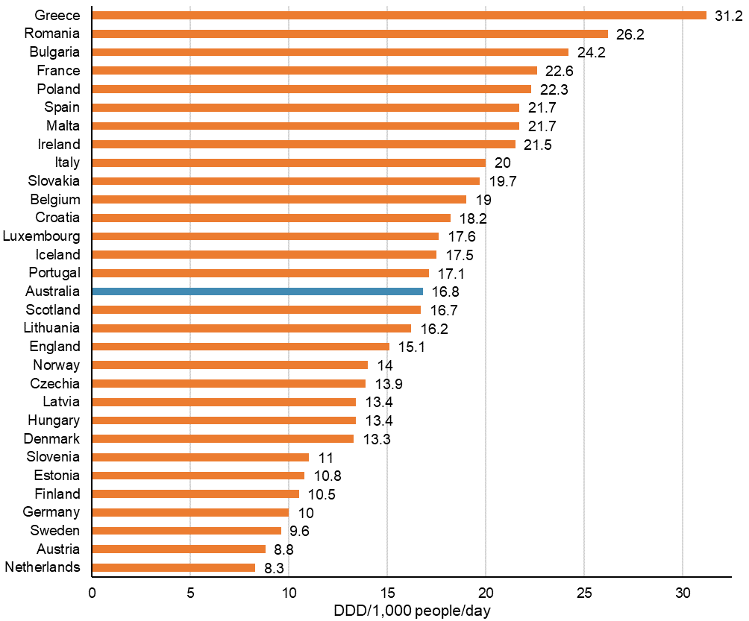

DDD = defined daily dose

Notes:

1. The DDD values determined by the World Health Organization Collaborating Centre for Drug Statistics Methodology for 2024 have been applied in this report, causing slight variation with results presented in previous reports.39
2. There are some variation in data collection between countries that cannot be displayed.
3. Complete international data for 2023 were not available for comparison.

Sources: Gadzhanova, Roughead19; European Centre for Disease Prevention and Control49; UK Health Security Agency50; Antimicrobial Resistance and Healthcare Associated Infection Scotland51

# Conclusions

It is encouraging that overall antimicrobial use in the community in 2023 has remained steady. Compared to 2022, there was minimal difference in the patterns of prescribing under the PBS and RPBS across age groups, states and territories and local areas, the most frequently prescribed antimicrobials and the use of repeats. The marginal increase of 1.3% from 2022 to 2023 may, at least in part, reflect an increase in the Australian population over that period.19 Nevertheless, usage rates in Australia remained higher than comparable European countries and England and Scotland, and more than double that of the Netherlands.19,49-51

The overall decline in antimicrobial use in the community from 2015 to 2023, particularly from 2020, indicates that lower levels of antimicrobial use are achievable in the long-term. The COVID-19 pandemic had a profound global impact on antimicrobial use52,53 that appears to have been sustained in Australia. There are several factors that are likely to have influenced the decline in antimicrobial use in Australia, including PBS and RPBS policy changes for repeats.25 However, it is likely that local prescriber preference is a major influence on antimicrobial use given the ongoing trends in supply by local area.

There is an opportunity to enhance consumers’ understanding of the role of antimicrobials in treating infections, particularly the lack of benefit of antibiotics for viral infections, and other conditions for which antimicrobials provide little to no benefit. The Commission will continue to reinforce messaging for consumers about the role of antimicrobials in AMR, the effects of antimicrobials on beneficial and harmful bacteria, and raise awareness of the potential impact of antimicrobials on development of chronic conditions in children and adults.54-57 The Commission will also promote infection prevention and control practices in the community to reduce the spread of AMR.

This approach is adopted because combined strategies of AMS and infection prevention and control in the community appear to be most effective in reducing antimicrobial use and improving prescribing appropriateness. However, strategies must be dynamic to adapt to challenges like ongoing medicines shortages, and to particular settings and populations.

Although antimicrobial use in aged care homes accounts for a very small proportion of overall use in the community, the very high dispensing rates per person and the volume of use are cause for concern. Antimicrobial use is notably higher for older Australians who reside in aged care homes than for those who reside in the community. It is well documented that aged care home residents are susceptible to infections for a variety of reasons, including advanced age, multiple comorbidities, poor functional status and compromised immune status.18 Being residential, these facilities are a close living environment for residents in which they will likely be in frequent contact with potentially colonised or infected staff, visitors or other residents, and environmental surfaces. Residents may also have multiple or prolonged hospitalisations for the same reasons that make them susceptible to infections.18

Despite the contributing factors that increase the risk of infection for aged care home residents, high levels of inappropriate antimicrobial prescribing and use in aged care homes are also well documented.41 The gap in surveillance of indication and non-prescription antimicrobials in the PBS and RPBS dataset is also important to note in this context. This is especially for skin conditions, which are often treated with over-the-counter antimicrobials and are the most common reason for antimicrobial prescribing in aged care homes according to the Aged Care National Antimicrobial Prescribing Survey.41 Targeted AMS and infection prevention and control strategies are important for improving the safety of care provided to aged care home residents.

The Commission will continue to work with health service providers and clinicians and local and professional organisations across the community and aged care settings, and use surveillance data to inform targeted strategies for improving antimicrobial use and resident and patient safety. In addition, the Commission will continue to support the implementation of the national safety and quality standards for the primary and community and aged care sectors1-3 to promote effective infection prevention and control and AMS programs.

The Commission will also continue to explore opportunities with the Department to enhance surveillance of the volume and appropriateness of antimicrobial use in Australia to support the prevention and control of AMR. This could include important gaps in current surveillance efforts including repeat prescriptions; the indications for use and supply of antimicrobials outside the PBS and RPBS, namely private prescriptions and emerging models of service delivery involving community pharmacy prescribing; and in Aboriginal and Torres Strait Islander health services.

# References

1. Australian Commission on Safety and Quality in Health Care. National Safety and Quality Primary and Community Healthcare Standards. Sydney: ACSQHC; 2021.

2. Aged Care Quality and Safety Commission. Aged Care Quality Standards. [Internet] Sydney: ACQSC; 2021 [cited June 2024] Available from: <https://www.agedcarequality.gov.au/providers/quality-standards>.

3. Aged Care Quality and Safety Commission. Stronger Standards, Better Aged Care Program. [Internet] Sydney: ACQSC; 2021 [cited June 2024] Available from: <https://www.agedcarequality.gov.au/providers/quality-standards/stronger-standards-better-aged-care-program>.

4. Australian Commission on Safety and Quality in Health Care. Antimicrobial Stewardship Clinical Care Standard. Sydney: ACSQHC; 2020.

5. Australian Commission on Safety and Quality in Health Care. Sepsis Clinical Care Standard. Sydney: ACSQHC; 2022.

6. Australian Commission for Safety and Quality in Health Care. Sore throat: should I take antibiotics? Sydney: ACSQHC; 2023.

7. Australian Commission for Safety and Quality in Health Care. Acute bronchitis: should I take antibiotics? Sydney: ACSQHC; 2023.

8. Australian Commission for Safety and Quality in Health Care. Middle ear infection: should my child take antibiotics? Sydney: ACSQHC; 2023.

9. Australian Commission for Safety and Quality in Health Care. Sinusitis: Should I take antibiotics? Sydney: ACSQHC; 2024.

10. Australian Commission for Safety and Quality in Health Care. Chronic obstructive pulmonary disease exacerbation (flare-up): Should I take antibiotics? Sydney: ACSQHC; 2024.

11. Antibiotic Expert Group. Antibiotic [published 2019 Apr]. In: *Therapeutic Guidelines*. [Internet] Melbourne: Therapeutic Guidelines Limited; 2019 [cited Jan 2024] Available from: <https://www.tg.org.au/>.

12. Australian Commission on Safety and Quality in Health Care. Antimicrobial use and appropriateness in the community: 2020–2021. Sydney: ACSQHC; 2022.

13. Gadzhanova S and Roughead E on behalf of the Australian Commission on Safety and Quality in Health Care. Analysis of 2015–2022 PBS and RPBS antimicrobial dispensing data. Sydney: ACSQHC; 2023.

14. Australian Commission on Safety and Quality in Health Care. AURA 2016: first Australian report on antimicrobial use and resistance in human health. Sydney: ACSQHC, 2016.

15. Australian Commission on Safety and Quality in Health Care. AURA 2017: second Australian report on antimicrobial use and resistance in human health. Sydney: ACSQHC, 2017.

16. Australian Commission on Safety and Quality in Health Care. AURA 2019: third Australian report on antimicrobial use and resistance in human health. Sydney: ACSQHC, 2019.

17. Australian Commission on Safety and Quality in Health Care. AURA 2021: fourth Australian report on antimicrobial use and resistance in human health. Sydney: ACSQHC; 2021.

18. Australian Commission on Safety and Quality in Health Care. AURA 2023: fifth Australian report on antimicrobial use and resistance in human health. Sydney: ACSQHC; 2023.

19. Gadzhanova S and Roughead E. Analysis of 2015–2023 PBS and RPBS data for the National Report on Antimicrobial Use and Resistance (unpublished).

20. World Health Organization. WHO Director-General's opening remarks at the media briefing on COVID-19 - 11 March 2020. [Internet] Geneva: WHO; 2020 [cited Feb 2024] Available from: <https://www.who.int/director-general/speeches/detail/who-director-general-s-opening-remarks-at-the-media-briefing-on-covid-19---11-march-2020>.

21. Prime Minister, Minister for Health, Minister for Aged Care and Senior Australians, Minister for Youth and Sport. $2.4 billion health plan to fight COVID-19. [Internet] Canberra: Commonwealth of Australia; 2020 Available from: <https://parlinfo.aph.gov.au/parlInfo/download/media/pressrel/7234737/upload_binary/7234737.PDF;fileType=application%2Fpdf#search=%22media/pressrel/7234737%22>.

22. Prime Minister, Minister for Health, Minister for Foreign Affairs and Minister for Women. $1.1 billion to support more mental health, Medicare and domestic violence services [Internet] Canberra: Commonwealth of Australia; 2020 [cited Feb 2024] Available from: <https://formerministers.dss.gov.au/19287/prime-minister-joint-media-release-1-1-billion-to-support-more-mental-health-medicare-and-domestic-violence-services/>.

23. Australian Bureau of Statistics. Population and COVID-19. [Internet] Canberra: ABS; 2020 Available from: <https://www.abs.gov.au/articles/population-and-covid-19>.

24. Australian Government Department of Health and Aged Care. National 2020 Influenza Season Summary. Canberra: Department of Health and Aged Care; 2020.

25. Australian Government Department of Health and Aged Care. Revised PBS listings for Antibiotic use. [Internet] Canberra: Department of Health and Aged Care; 2020 [cited Feb 2024] Available from: <https://www.pbs.gov.au/news/2020/03/files/Antibiotics-factsheet-2020.pdf>.

26. Queensland Government. Medicines and Poisons (Medicines) Amendment Regulation (No.2) 2022. Brisbane: Queensland Government; 2022.

27. Queensland Health. Health (Drugs and Poisons) Regulation 1996 Drug Therapy Protocol – Pharmacist UTI Trial. Brisbane: Queensland Health; 2020.

28. Northern Territory Government. Medicines, Poisons and Therapeutic Goods Legislation Amendment Act 2022. Darwin: Northern Territory Government; 2022.

29. NSW Health. NSW Pharmacy Trial. Sydney: NSW Health; 2023.

30. Government of Western Australia Department of Health. Treatment of urinary tract infection (UTIs) by pharmacists. Perth: Government of Western Australia Department of Health; 2023.

31. Victorian Government Department of Health. Victorian community pharmacist statewide pilot. Melbourne: Victorian Government Department of Health; 2023.

32. SA Health. Access to UTI treatment in community pharmacies. Adelaide: SA Health; 2023.

33. Tasmanian Government Department of Health. Tasmanian Community Pharmacy Program. Hobart: Tasmanian Government Department of Health; 2024.

34. Therapeutic Goods Administration. About the antibiotics shortage 2022–2023. [Internet] Canberra: TGA; 2023 [cited May 2024] Available from: <https://www.tga.gov.au/safety/shortages/information-about-major-medicine-shortages/about-antibiotics-shortage-2022-2023>.

35. Wozniak T, Nguyen A, Rollin A, Brock J, Bowskill A, Morgan B, et al. Antimicrobial Resistance (AMR) Impact Report: How big is Australia’s AMR threat? Australia: CSIRO and MTPConnect; 2022.

36. Organisation for Economic Co-operation and Development. Stemming the superbug tide: just a few dollars more. Paris: OECD, 2018.

37. World Health Organization. Antimicrobial resistance. [Internet] Geneva: WHO; 2023 [cited Jan 2024] Available from: <https://www.who.int/news-room/fact-sheets/detail/antimicrobial-resistance>.

38. Drug Utilisation Sub Committee (DUSC). Antibiotics: PBS/RPBS utilisation, Oct 2014 and Feb 2015. [Internet] Canberra: Department of Health and Aged Care; 2015 [cited Jan 2024] Available from: <http://www.pbs.gov.au/info/industry/listing/participants/public-release-docs/antibiotics/antibiotics-oct-14-feb-15>.

39. WHO Collaborating Centre for Drug Statistics Methodology, Norwegian Institute of Public Health. DDD alterations from 2005–2024. [Internet] Norway: WHO CC; 2024 [cited May 2024] Available from: <https://www.whocc.no/atc_ddd_alterations__cumulative/ddd_alterations/>.

40. Gadzhanova S, Roughead E. Analysis of 2021–2023 PBS and RPBS data for the National Report on Antimicrobial Use and Resistance with a special focus on aged care (unpublished).

41. Royal Melbourne Hospital and the National Centre for Antimicrobial Stewardship. Infections and antimicrobial prescribing in Australian residential aged care facilities. Results of the 2022 Aged Care National Antimicrobial Prescribing Survey. Canberra: Department of Health and Aged Care; 2024.

42. Organisation for Economic Co-operation and Development. OECD Health Statistics 2023. Paris: OECD; 2023.

43. Organisation for Economic Co-operation and Development (OECD). Antimicrobial Resistance in the EU/EEA: A One Health Response. [Internet] Paris: OECD; 2022 [cited Feb 2024] Available from: <https://www.ecdc.europa.eu/en/publications-data/antimicrobial-resistance-eueea-one-health-response>.

44. NPS MedicineWise. General Practice Insights Report July 2019–June 2020 including analyses related to the impact of COVID-19. Sydney: NPS MedicineWise, 2021.

45. Buehrle DJ, Nguyen MH, Wagener MM, Clancy CJ. Impact of the Coronavirus Disease 2019 Pandemic on Outpatient Antibiotic Prescriptions in the United States. Open Forum Infect Dis. 2020 Dec;7(12):ofaa575.

46. Buehrle DJ, Wagener MM, Nguyen MH, Clancy CJ. Trends in Outpatient Antibiotic Prescriptions in the United States During the COVID-19 Pandemic in 2020. JAMA Network Open. 2021;4(9):e2126114-e2126114.

47. Duffy E, Thomas M, Hills T, Ritchie S. The impacts of New Zealand's COVID-19 epidemic response on community antibiotic use and hospitalisation for pneumonia, peritonsillar abscess and rheumatic fever. Lancet Reg Health West Pac. 2021 Jul;12:100162.

48. Högberg LD, Vlahović-Palčevski V, Pereira C, Weist K, Monnet DL. Decrease in community antibiotic consumption during the COVID-19 pandemic, EU/EEA, 2020. Euro Surveill. 2021 Nov;26(46).

49. European Centre for Disease Control. Antimicrobial consumption in the EU/EEA (ESAC-Net) - Annual Epidemiological Report for 2022. Stockholm: ECDC; 2023.

50. UK Health Security Agency. English surveillance programme for antimicrobial utilisation and resistance (ESPAUR) Report 2022 to 2023. London: UK Health Security Agency; 2023.

51. Antimicrobial Resistance and Healthcare Associated Infection Scotland. Scottish One Health Antimicrobial Use and Antimicrobial Resistance in 2022. Scotland: ARHAI; 2023.

52. Khouja T, Mitsantisuk K, Tadrous M, Suda KJ. Global consumption of antimicrobials: impact of the WHO Global Action Plan on Antimicrobial Resistance and 2019 coronavirus pandemic (COVID-19). J Antimicrob Chemother. 2022 Apr 27;77(5):1491-1499.

53. Vermeulen H, Hens N, Catteau L, Catry B, Coenen S. Impact of the COVID-19 pandemic on community antibiotic consumption in the EU/European Economic Area: a changepoint analysis. J Antimicrob Chemother. 2023;78(10):2572-2580.

54. Duong QA, Pittet LF, Curtis N, P Z. Antibiotic exposure and adverse long-term health outcomes in children: a systematic review and meta-analysis. J Infect. 2022 Sep;85(3):213-300.

55. Aversa Z, Atkinson E, Schafer M, Theiler R, Rocca W, Blaser M, et al. Association of infant antibiotic exposure with childhood health outcomes. Mayo Clin Proc. 2021 Jan;96(1):66-77.

56. Trasande L, Blustein J, Liu M, Corwin E, Cox LM, Blaser M. Infant antibiotic exposures and early-life body mass. Int J Obes (Lond). 2013 Jan;37(1):16-23.

57. Queen J, Zhang J, Sears CL. Oral antibiotic use and chronic disease: long-term health impact beyond antimicrobial resistance and Clostridioides difficile. Gut Microbes. 2020 Jul 3;11(4):1092-1103.

58. Australian Government Department of Health and Aged Care. National Medicines Policy 2022. Canberra: Department of Health and Aged Care; 2022.

59. Australian Government Department of Health and Aged Care. About the PBS. [Internet] Canberra: Department of Health and Aged Care; 2024 [cited Jan 2024 ] Available from: <https://www.pbs.gov.au/info/about-the-pbs>.

60. Australian Government Department of Veterans' Affairs. Concessional medicines under RPBS. [Internet] Canberra: Department of Veteran's Affairs; 2024 [cited Jan 2024] Available from: <https://www.dva.gov.au/health-and-treatment/help-cover-healthcare-costs/manage-medicine-and-keep-costs-down/concessional>.

61. Australian Institute of Health and Welfare. Older Australians. [Internet] Canberra: AIHW; 2023 [cited June 2024] Available from: <https://www.aihw.gov.au/reports/older-people/older-australians/contents/aged-care>.

62. Australian Bureau of Statistics. Australian Statistical Geography Standard (ASGS) Edition 3: Main Structure and Greater Capital City Statistical Areas. [Internet] Canberra: ABS; 2021 Available from: <https://www.abs.gov.au/statistics/standards/australian-statistical-geography-standard-asgs-edition-3/jul2021-jun2026/main-structure-and-greater-capital-city-statistical-areas>.

63. Australian Government Department of Health and Aged Care. Primary Health Networks. [Internet] Canberra: Department of Health and Aged Care; 2023 [cited June 2024] Available from: <https://www.health.gov.au/our-work/phn>.

64. Australian Bureau of Statistics. Estimates of Aboriginal and Torres Strait Islander Australians. [Internet] Canberra: ABS; 2020 [cited Jan 2024] Available from: <https://www.abs.gov.au/statistics/people/aboriginal-and-torres-strait-islander-peoples/estimates-aboriginal-and-torres-strait-islander-australians/latest-release>.

65. Australian Government Department of Health and Aged Care. Pharmaceutical Benefits Scheme (PBS). [Internet] Canberra: Department of Health and Aged Care; 2024 [cited Jan 2024] Available from: <http://www.pbs.gov.au/pbs/home>.

# Appendix 1: Data source description

#### About the Pharmaceutical Benefits Scheme and Repatriation Pharmaceutical Benefits Scheme

The Pharmaceutical Benefits Scheme (PBS) provides timely, reliable and affordable access to necessary medicines for Australians. The PBS is part of the Australian Government’s broader National Medicines Policy. The aim of the National Medicines Policy58 is to meet medication and related service needs, so that both optimal health outcomes and economic objectives are achieved. Under the PBS, the Australian Government subsidises the cost of medicine for most medical conditions. Most of the listed medicines are dispensed by pharmacists, and used by patients at home.59

The Repatriation Pharmaceutical Benefits Scheme (RPBS) provides eligible people, as designated by the Australian Government Department of Veterans’ Affairs, with access to a wide range of medicines and wound care items at a concession rate.60

The proportion of prescriptions written in the community that are captured by the PBS and RPBS is estimated to be more than 90%38, although the exact percentage is not known. The PBS and RPBS also capture public hospital outpatient and discharge prescriptions in all states and territories except New South Wales. The PBS and RPBS do not capture data on private prescriptions (that is non-PBS or non-RPBS prescriptions that are not subsidised under the PBS or RPBS), or those dispensed by many Aboriginal and Torres Strait Islander health services.

The Australian Government Department of Health and Aged Care (the Department) analyses PBS and RPBS data to inform economic analyses and policy development. Comprehensive medicine usage data are required for several purposes, including pharmacosurveillance and targeting, and evaluation of initiatives for the quality use of medicines. The data are also needed by regulatory and financing authorities, and the pharmaceutical industry.

#### Data source and criteria

This report analyses data on antimicrobials dispensed under the PBS and RPBS, from 1 January 2015 to 31 December 2023 and includes all prescriptions priced under the patient co-payment which are prescriptions that do not attract a reimbursement (Table A1.1).

These data were obtained from Services Australia following approval for disclosure from the Department and the Australian Government Department of Veterans’ Affairs. The Department collects data on antimicrobial dispensing in the community through the PBS and RPBS from the Medicare pharmacy claims database. The data do not contain details on any prescriptions supplied privately or on antimicrobials provided over-the-counter (i.e. without the need for a prescription).

For reporting on antimicrobial use in aged care, the data include an indicator for patient’s residence in an aged care home. The aged care indicator was introduced in July 2017 and became mandatory from July 2020. Therefore, analyses for data from 1 January 2021 to 31 December 2023 were included in this report to ensure complete and reliable data analysis. The aged care indicator does not capture multi-purpose services.

Table A1.1: PBS and RPBS community antimicrobial use data source

|  |  |
| --- | --- |
| Subject and type of surveillance | Passive surveillance of antimicrobial use in the community |
| Data source | Pharmaceutical Benefits Scheme (PBS) and Repatriation Pharmaceutical Benefits Scheme (RPBS) |
| Type of data | Dispensed volume, trends |
| Setting | Australian general practices and community health services*†#§ |
| Coverage | National  2015: 29,264,932 prescriptions for all antimicrobials  2016: 27,324,648 prescriptions for all antimicrobials  2017: 26,553,451 prescriptions for all antimicrobials  2018: 26,229,366 prescriptions for all antimicrobials  2019: 26,669,561 prescriptions for all antimicrobials  2020: 20,095,926 prescriptions for all antimicrobials  2021: 19,931,271 prescriptions for all antimicrobials  2022: 21,848,005 prescriptions for all antimicrobials  2023: 22,126,604 prescriptions for all antimicrobials |

PBS = Pharmaceutical Benefits Scheme; RPBS = Repatriation Pharmaceutical Benefits Scheme

* Data include all antimicrobials dispensed through the PBS and RPBS; therefore, antimicrobials dispensed from some inpatient and outpatient services, and some community health services, and Aboriginal and Torres Strait Islander health services may not be captured

†Private prescriptions (i.e. prescriptions that are not subsidised under the PBS or RPBS) including pharmacist prescribing initiatives are not captured by this dataset

§ Antimicrobials available over-the-counter or without a prescription are not captured by this dataset

#PBS and RPBS data do not indicate the diagnosis or condition of the patient or the indication for prescription

Source: Gadzhanova, Roughead19

#### Data development and analysis

The Australian Commission on Safety and Quality in Health Care (the Commission) engaged the University of South Australia to perform the analyses as part of the development of this report.

The antimicrobials included in the analyses are shown in Tables A1.2 and A1.3 and are listed by World Health Organization (WHO) Anatomical Therapeutic Chemical (ATC) Classifications. ATC codes group medicines according to the organ or system on which they act, and their therapeutic, pharmacological, and chemical properties. Almost all antimicrobials supplied under the PBS and RPBS are ATC code J01, antibacterials for systemic use. The codes included in addition to J01 antibacterials ensure that data captured better reflect antimicrobial exposure in the community and aged care settings.

Table A1.2: Antimicrobials included in the overall analyses of PBS and RPBS data, 2015–2023

|  |  |
| --- | --- |
| **ATC codes** | **Description** |
| J01 | Antibacterials for systemic use |
| A02BD | Combinations for eradication of *Helicobacter pylori* |
| A07AA09 | Vancomycin (intestinal anti-infectives) |
| A07AA11 | Rifaximin (intestinal anti-infectives) |
| D06AX09 | Mupirocin (cream/ointment) |
| D06BA01 | Sulfadiazine silver (cream) |
| S01AA01, S01AA07, S01AA11, S01AA12, S01AE01, S01AE03 | Ophthalmological antibiotics: chloramphenicol, framycetin (alternatively S03AA), gentamicin, tobramycin, ofloxacin, ciprofloxacin |
| S02AA01, S02AA15 | Otological anti-infectives: chloramphenicol, ciprofloxacin |

ATC = Anatomical Therapeutic Chemical; PBS = Pharmaceutical Benefits Scheme; RPBS = Repatriation Pharmaceutical Benefits Scheme

**Table A1.3:** Additional antimicrobials included in the analyses of PBS and RPBS data for aged care homes and older Australians, 2021–2023

|  |  |
| --- | --- |
| **ATC codes** | **Description** |
| J01EA01, J01MA06, J01XE01, J01XX05* | Antibacterials for urinary tract infections: trimethoprim, norfloxacin, nitrofurantoin, methenamine hippurate |
| A01 | Stomatological preparations |
| D01* | Antifungals for dermatological use |
| D06* | Antibiotics and chemotherapeutics for dermatological use |
| D11* | Other dermatological preparations |
| J02 | Antimycotics for systemic use |
| J04 | Antimycobacterials |
| S03 | Ophthalmological and otological preparations |

ATC = Anatomical Therapeutic Chemical; PBS = Pharmaceutical Benefits Scheme; RPBS = Repatriation Pharmaceutical Benefits Scheme

* Antimicrobials further analysed as a focus for antimicrobial use in aged care homes and older Australians

For reporting of age-standardised rates, the reference population was the Australian population in mid-2013 for consistency with previous AURA reports.14-18 Where population data were used, the mid-year (30 June) estimates for each calendar year were used as provided by the Australian Bureau of Statistics (ABS).

For aged care analyses, population estimates for bed days were not available to estimate the rates of antimicrobial use. In the absence of this, the estimated population as described by the Australian Institute of Health and Welfare (AIHW) was used. Most of the analysis was restricted to older Australians aged 65 years and over as AIHW provides population data on older Australians who reside in aged care homes. According to the latest AIHW report61, there were 185,000 older Australians in aged care at 30 June 2022, with an annual increase of approximately 2%.

For all analyses requiring population estimates in 2023, based on the AIHW estimate of 2% growth, it was assumed 190,000 older Australians resided in aged care homes in 2023. The community population was estimated based on the age-specific ABS estimates excluding the aged-care estimates. For analysis on rates of prescriptions per 100 people, it was assumed that there were around 5,000 additional people aged less than 65 years who resided in aged care homes. The following estimates were used: 185,000 for 2021; 190,000 for 2022 and 195,000 for 2023.

For analyses by location, postcode was used to stratify the data by state or territory and Statistical Area Level 3 (SA3) using the ABS Australian Statistical Geography Standard (AGSC)62, and by Primary Health Network (PHN).63 For SA3 analyses, some data were not published due to suppression of nominal populations or antimicrobial use.

#### Considerations for interpreting data

This report focusses on data on antimicrobials dispensed, or supplied, under the PBS and RPBS. Prescribing data can differ from dispensing data because not all prescriptions are dispensed, sometimes under the instruction of the treating doctor not to have the prescription filled unless the condition worsens. Similarly, dispensing data may differ from consumption data because not all prescriptions dispensed are consumed, as patients may not use any or all of the antimicrobials provided.

Issues that need to be considered when interpreting PBS and RPBS data include the following:

* The principal source of dispensing data in the community in Australia is the PBS and RPBS. These data are estimated to capture more than 90% of all antimicrobial prescriptions dispensed in the community38
* PBS and RPBS listings for some antimicrobials changed to restrict the maximum quantity and number of repeats from April 202025
* The defined daily dose (DDD) values determined by the WHO Collaborating Centre for Drug Statistics Methodology for 2024 have been applied in this report, causing slight variation with results presented in previous reports
* Percentages and other data relating to 2015 to 2023 may have changed compared to previous reports as more data have become available.

Antimicrobials dispensed from most inpatient and some outpatient services, some community health services, and some Aboriginal and Torres Strait Islander health services may not be captured in the PBS and RPBS dataset. This may impact findings between states and territories as approximately 30% of the Northern Territory population identify as Aboriginal or Torres Strait Islander, compared to approximately 5% or less in other jurisdictions.64

Prescriptions may be dispensed privately or provided over-the-counter, meaning that the PBS and RPBS does not subsidise the cost of the medicine. Antimicrobials prescribed by medical practitioners, dental practitioners, nurse practitioners and optometrists may not be captured in this dataset if a prescription was issued privately for:

* An antimicrobial for a non-subsidised indication or for travel
* A quantity that exceeds the PBS and RPBS maximum for quantities or number of repeats.

Antimicrobials prescribed by other clinicians are not captured in the PBS and RPBS dataset as they are supplied privately. This includes pharmacist prescribing initiatives, which are not subsidised by the PBS and RPBS. Volumes of antimicrobial use for these programs are currently not reported.

Antimicrobials available over-the-counter or without a prescription are also not captured by the PBS and RPBS, such as antifungal treatments for oral or vaginal thrush and skin infections.

For aged care analyses in this report, people aged 65 years and over are referred to as ‘older Australians’. It is important to note the diversity of this age group and the difference in population size across settings. The majority of those who reside in aged care homes are aged 85 years and over, while very few residents of aged care homes are aged less than 65 years. The healthcare needs of Australians across these settings are also likely to vary. Australians who reside in aged care homes may have higher-level care needs and be more likely to require treatment with antimicrobials compared with those who reside in the community.

Additionally for residents of aged care homes, the limitation of using population estimates rather than bed days is that use, as measured by volume measures, may be under-estimated if there were periods where an aged care home was not at capacity. Alternatively, use may be over-estimated, as measured by population rates, if there was significant turn-over of residents in the year. The lack of complete population capture also means all rates and proportions are estimates.

The capability to assess appropriateness of antimicrobial use in the PBS and RPBS dataset is limited. The diagnosis or condition of the patient and the indication for prescription is not captured by the PBS and RPBS but may be inferred with consideration to PBS and RPBS listings, WHO ATC Classifications and current evidence-based Australian therapeutic guidelines and resources on antimicrobial prescribing.

The Commission has previously analysed appropriateness of antimicrobial use in the community using data captured by the MedicineInsight program.12,15-18 As part of the 2022–23 Budget initiative that included the redesign of the Quality Use of Diagnostics, Therapeutics and Pathology Program, responsibility for the operation of the MedicineInsight program was transferred to the Commission from 2023. The Commission continues to seek contributor consent and undergo data validation processes for the continuation of the program. As a result, MedicineInsight data were not available for analysis and inclusion in this report.

Further information on the PBS and RPBS can be found on the PBS website.65 A more accurate estimate of the proportion of dispensing through the PBS and RPBS will provide a more complete picture of dispensing in Australia.

# Appendix 2: Further analyses by local area

Further analyses of antimicrobials supplied under the Pharmaceutical Benefits Scheme (PBS) and Repatriation Pharmaceutical Benefits Scheme (RPBS) by Statistical Area Level 3 (SA3) and Primary Health Network (PHN) are included in this Appendix. These data can be used by health services, PHNs, general practitioners and other clinicians to review antimicrobial use in their local area and compare to other areas.

Appendix 2 is provided as a separate file on the Commission’s [website](https://safetyandquality.gov.au/community-antimicrobial-use-2023):

* Table A2.1: Number of PBS and RPBS antimicrobial prescriptions dispensed per 1,000 people, age-standardised rate by patient's SA3, 2015–2023
* Table A2.2: Number of PBS and RPBS antimicrobial prescriptions dispensed per 1,000 people, by patient's age and SA3, 2023
* Table A2.3: Percentage of original antimicrobial prescriptions with maximum repeats ordered for the most commonly used antimicrobials as a proportion of all original antimicrobial prescriptions for the given antimicrobial ordered, by prescriber's SA3, 2023
* Table A2.4: Number of PBS and RPBS antimicrobial prescriptions dispensed per 100,000 people in winter (June–August), age-standardised rate by prescriber's SA3, 2023
* Table A2.5: Number of PBS and RPBS antimicrobial prescriptions dispensed per 1,000 people, age-standardised rate by patient's PHN, 2019–2023
* Table A2.6: Number of PBS and RPBS antimicrobial prescriptions dispensed per 1,000 people, by patient's age and PHN, 2023
* Table A2.7: Percentage of original antimicrobial prescriptions with maximum repeats ordered for the most commonly used antimicrobials as a proportion of all original antimicrobial prescriptions for the given antimicrobial ordered, by prescriber's PHN, 2023
* Table A2.8: Number of PBS and RPBS antimicrobial prescriptions dispensed per 100,000 people in winter (June–August), age-standardised rate by prescriber's PHN, 2023.

This page was left intentionally blank

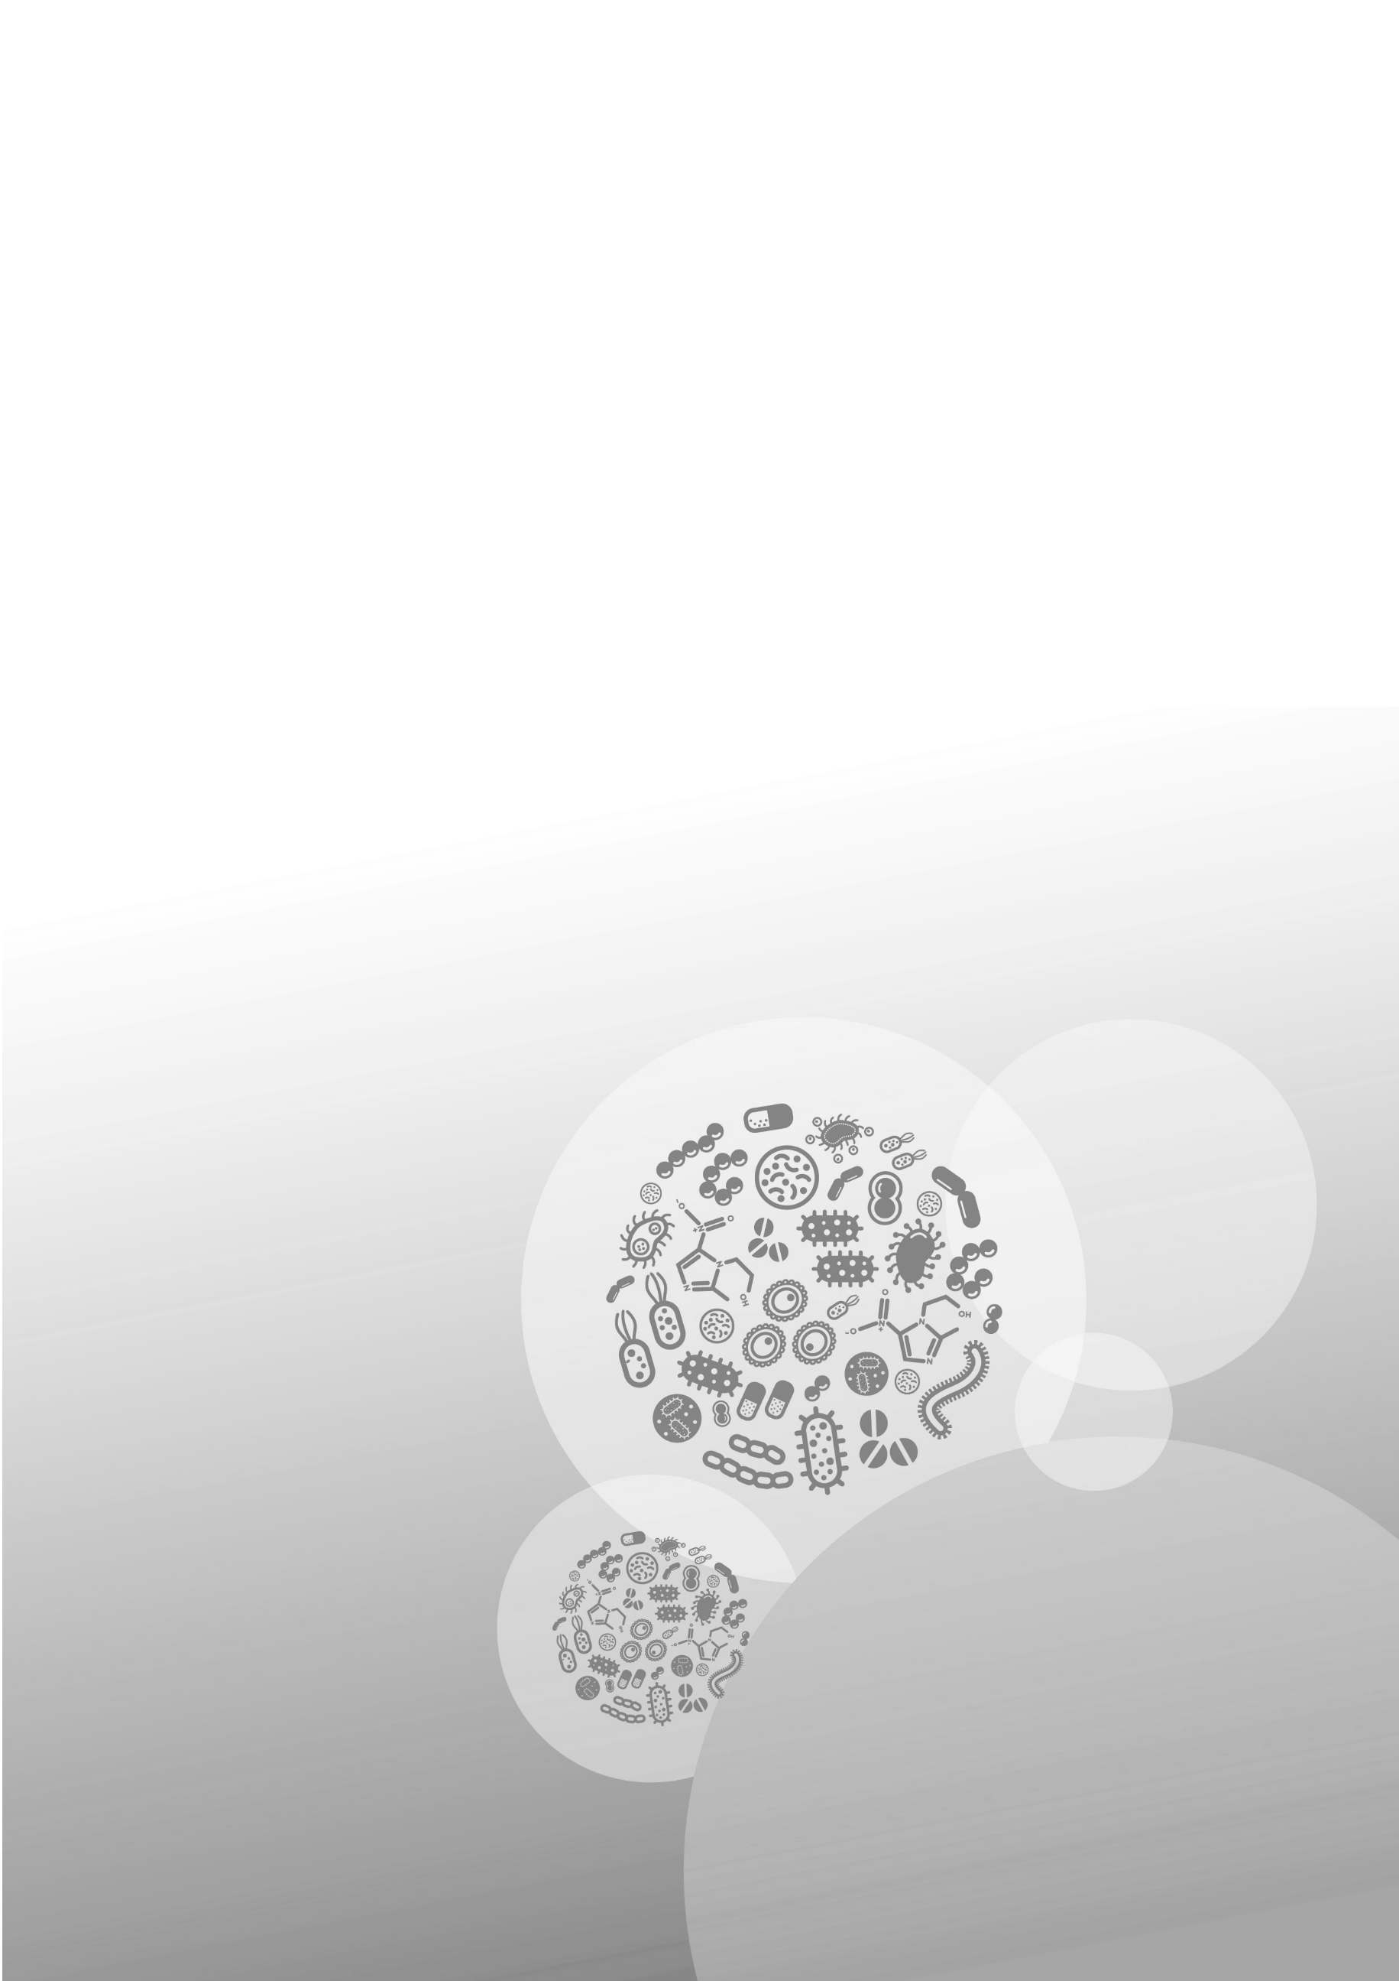



Level 5, 255 Elizabeth Street, Sydney NSW 2000  
GPO Box 5480, Sydney NSW 2001

Phone: (02) 9126 3600

Email: [mail@safetyandquality.gov.au](mailto:mail@safetyandquality.gov.au)   
Website: [www.safetyandquality.gov.au](http://www.safetyandquality.gov.au/)