# Australian Commission on Safety and Quality logotypeOn the Radar

Issue 660

5 August 2024

*On the Radar* is a summary of some of the recent publications in the areas of safety and quality in health care. Inclusion in this document is not an endorsement or recommendation of any publication or provider. Access to particular documents may depend on whether they are Open Access or not, and/or your individual or institutional access to subscription sites/services. Material that may require subscription is included as it is considered relevant.

*On the Radar* is available online, via email or as a PDF or Word document from <https://www.safetyandquality.gov.au/newsroom/subscribe-news/radar>

If you would like to receive *On the Radar* via email, you can subscribe on our website <https://www.safetyandquality.gov.au/newsroom/subscribe-news>  
or by emailing us at H[Umail@safetyandquality.gov.auU](mailto:mail@safetyandquality.gov.au).  
You can also send feedback and comments to H[Umail@safetyandquality.gov.auU](mailto:mail@safetyandquality.gov.au).

For information about the Commission and its programs and publications, please visit <https://www.safetyandquality.gov.au>

**On the Radar**

Editor: Dr Niall Johnson [niall.johnson@safetyandquality.gov.au](mailto:niall.johnson@safetyandquality.gov.au)

Contributors: Niall Johnson, Broni Smith

[](https://www.safetyandquality.gov.au/our-work/partnering-consumers/partnering-consumers-guide-consumers)

**Case studies and education package to support *Partnering with Consumers: A guide for consumers***

<https://www.safetyandquality.gov.au/our-work/partnering-consumers/partnering-consumers-guide-consumers>

Understanding how to build and strengthen partnerships between healthcare consumers and health service organisations can improve the experience and outcomes of care. The Commission recently released *Partnering with Consumers: A guide for consumers* (the Guide) and now four case studies and an education package are available to support consumers and health services to use the Guide.

The case studies align with the content of the Guide, focusing on how strong partnerships have been developed across a range of different care settings and services.

The education package includes a Facilitator Guide and a presentation, with training designed to be delivered by a consumer, in partnership with health service staff. The sessions cover an introduction to the Guide, how it can be used and encourage discussion about how to work together to strengthen partnerships across all levels of the health service.

The case studies, education package and the Guide have been developed by consumers for consumers, with Consumers Health Forum of Australia engaged to undertake the co-design process.

The case studies, education package and the Guide are available at <https://www.safetyandquality.gov.au/our-work/partnering-consumers/partnering-consumers-guide-consumers>

***Decision support tools on antibiotic use in COPD and sinusitis***

<https://www.safetyandquality.gov.au/our-work/partnering-consumers/shared-decision-making/decision-support-tools-specific-conditions>

Shared decision making is a key part of person-centred care that underpins the Partnering with Consumers National Safety and Quality Health Service Standards standard. Using decision support tools during a clinical encounter supports shared decision making and patient engagement in their own care.

The Commission has released two new decision support tools on antibiotic use in **Chronic Obstructive Pulmonary Disease** (COPD) and **acute rhinosinusitis** (sinusitis). They expand the existing suite of decision support tools on antibiotic use in sore throat, middle ear infection in children and acute bronchitis.

[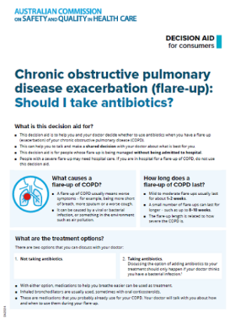](https://www.safetyandquality.gov.au/our-work/partnering-consumers/shared-decision-making/decision-support-tools-specific-conditions) [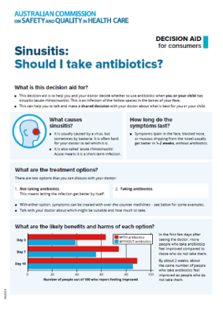](https://www.safetyandquality.gov.au/our-work/partnering-consumers/shared-decision-making/decision-support-tools-specific-conditions)

The five decision support tools are designed to be used by a healthcare professional with patients in a clinical encounter. They contain the best-available evidence on the benefits and harms of antibiotic use in common conditions and were developed according to international quality standards.

All five decision support tools are available here: <https://www.safetyandquality.gov.au/our-work/partnering-consumers/shared-decision-making/decision-support-tools-specific-conditions>

**Reports**

*Reinforcing the role of eye care practitioners in falls prevention among older adults*

Deeble Institute for Health Policy Research Issues Brief no: 57

Ho KC, Haddock R

Canberra: Australian Healthcare and Hospitals Association; 2024. p. 41.

|  |  |
| --- | --- |
| URL | <https://ahha.asn.au/resource/reinforcing-the-role-of-eye-care-practitioners-in-falls-prevention-among-older-adults/> |
| Notes | Falls are a common and significant hazard – in the home as well as in care facilities.  This issues brief from the Australian Healthcare and Hospitals Association’s Deeble Institute examines the role eye health can have in falls risks. The authors observe that ‘The cause of falls in the older adults is multifactorial however older adults with impaired vision are twice as likely to fall than older adults without impaired vision. Around 75% of the patients admitted to hospital following a fall has a correctable vision problem, either by updating a spectacle prescription or the surgical removal of cataract’. The issues brief examines the issues around appropriate eye care, including coordination and delivery of care, guidelines and funding. The brief includes a series of recommendations, including:   1. Development and implementation of a data quality feedback tool for My Health Record (long-term) and an appropriate digital platform for optometrists (short-term) 2. Standardisation of medical terminologies and diagnostic coding systems for Falls Risk Assessment 3. Enhance quality control and data-driven decision-making in eyecare 4. Integrate optometrists in multi-disciplinary falls prevention programs 5. Implement a comprehensive monitoring and evaluation framework 6. Standardising the cataract referral process and Integrating community and hospital care 7. Set targets for reducing waiting times for second eye cataract surgery 8. Enhance funding for public ophthalmology services 9. Increase funding for outreach cataract surgeries |

*Documenting Diagnosis: Exploring the Impact of Electronic Health Records on Diagnostic Safety*

Issue Brief 18

Miller K, Biro J, Gold JA, Hose B-Z, Singh H, Ratwani R

Rockville, MD: Agency for Healthcare Research and Quality; 2024.

|  |  |
| --- | --- |
| URL | <https://www.ahrq.gov/diagnostic-safety/resources/issue-briefs/dxsafety-ehr-impact.html> |
| Notes | The Agency for Healthcare Research and Quality (AHRQ) in the USA has published this Issue Brief that, according to the email from AHRQ, ‘explores the history of documentation legislation, outstanding challenges and best practices to improve documentation, and identifies future developments and opportunities for improvement.’ |

*Principles for acute patient care*Practical guidance for services to improve patient care, flow and inter-specialty working in acute care services

Getting It Right First Time (GIRFT)

London: NHS England; 2024. p. 12.

|  |  |
| --- | --- |
| URL | <https://gettingitrightfirsttime.co.uk/girft-issues-principles-to-improve-the-flow-and-experience-of-patients-through-urgent-and-emergency-care/> |
| Notes | In the UK the Getting It Right First Time (GIRFT) initiative, along with the Royal College of Physicians and NHS Impact, have developed this guidance that includes ten core principles to guide actions and behaviours for effective front door acute patient care. The overarching principle is that ‘Patients should have equitable access to professionals with the skills required for their individual care, independent of the location of their bed or the nominal admitting specialty.’ The document includes the principles, practical guidance and examples of patient dispositions for common conditions which can be modified locally.  [Image listing the Principles for Acute Patient Care.](https://gettingitrightfirsttime.co.uk/girft-issues-principles-to-improve-the-flow-and-experience-of-patients-through-urgent-and-emergency-care/) |

*Imaging support for procedures in theatre*: Good practice guide. v3.

Getting It Right First Time (GIRFT)  
NHS England; 2024. p. 16.

|  |  |
| --- | --- |
| URL | <https://gettingitrightfirsttime.co.uk/good-practice-guide-aims-to-maximise-the-efficiency-of-imaging-in-the-operating-theatre/> |
| Notes | In the UK the Getting It Right First Time (GIRFT) initiative, along with the Society of Radiographers, have developed this guide outlining good practice for imaging in the operating theatre. |

**Journal articles**

*Medication administration in aged care facilities: A mixed-methods systematic review*

Garratt S, Dowling A, Manias E

Journal of Advanced Nursing. 2024.

|  |  |
| --- | --- |
| DOI | <https://doi.org/10.1111/jan.16318> |
| Notes | Paper by a group of Australian researchers who reviewed 128 studies of medication administration in aged care facilities. A number of themes were identified, including staffing concerns, role of residents, medication-related decision-making, use of electronic medication administration records and medication administration errors. The authors observed that ‘It is important that medication administration in aged care facilities be more clearly acknowledged as both a clinical and interpersonal task. More attention is warranted regarding aged care workers clinical decision-making, particularly concerning dose form modification, covert administration and medication omissions. Resident-centred care approaches that support resident and family engagement around medication administration may improve adherence, satisfaction and quality of care.’ |

For information on the Commission’s work on medication safety see <https://www.safetyandquality.gov.au/our-work/medication-safety>

*Exploring the fear of clinical errors: associations with socio-demographic, professional, burnout, and mental health factors in healthcare workers – A nationwide cross-sectional study*

Boyer L, Wu AW, Fernandes S, Tran B, Brousse Y, Nguyen TT, et al

Frontiers in Public Health. 2024;12.

|  |  |
| --- | --- |
| DOI | <https://doi.org/10.3389/fpubh.2024.1423905> |
| Notes | The study of errors in health care has included examining the impact on health care workers. This has usually been when an error has occurred and has seen health care workers referred to as “second victims”. This paper reports on a study that examined health care workers fears and concerns about clinical errors. The study included a nationwide, online, cross-sectional study of health care workers in France from May to June 2021 that involved more than 10,000 health care workers. The authors report that ‘To assess the fear of making clinical errors, HCW were asked: “During your daily activities, how often are you afraid of making a professional error that could jeopardize patient safety?”’ A significant proportion, 25.9%, reported ‘High fear’, with ‘higher odds of “High Fear” among males, younger individuals, and those with less professional experience’. The study found associations between “High Fear” and burnout, low professional support, major depressive disorder, and sleep disorders. The authors conclude ‘Fear of clinical errors is associated with factors that also influence patient safety, highlighting the importance of this experience. Incorporating this dimension into patient safety culture assessment could provide valuable insights and could inform ways to proactively enhance patient safety.’ |

*A systematic review of the impacts of remote patient monitoring (RPM) interventions on safety, adherence, quality-of-life and cost-related outcomes*

Tan SY, Sumner J, Wang Y, Wenjun Yip A

npj Digital Medicine. 2024;7(1):192.

|  |  |
| --- | --- |
| DOI | <https://doi.org/10.1038/s41746-024-01182-w> |
| Notes | Focusing on 29 studies from 16 countries this review sought to examine Remote Patient Monitoring (RPM) in the context of care transitions from an inpatient hospital setting to a home environment. The included studies ‘examined seven types of RPM interventions (communication tools, computer-based systems, smartphone applications, web portals, augmented clinical devices with monitoring capabilities, wearables and standard clinical tools for intermittent monitoring)’. The reviewers found that ‘RPM interventions demonstrated positive outcomes in patient safety and adherence. RPM interventions also improved patients’ mobility and functional statuses, but the impact on other clinical and quality-of-life measures, such as physical and mental health symptoms, remains inconclusive.’ |

*Healthcare Papers*

Volume 22, Special Issue, 2024

|  |  |
| --- | --- |
| URL | <https://www.longwoods.com/publications/healthcarepapers/27363> |
| Notes | A new special issue of *Healthcare Papers* has been published with a theme of ‘Nurturing engagement-capable environments: Strengthening relationships with partners and communities’. Articles in this special issue of *Healthcare Papers* include:   * **Nurturing Engagement-Capable Environments** (Maggie Keresteci and Amy Lang1) * **Patient and Caregiver Engagement** in an Era of COVID-19: What Did We Learn and How Do We Move Forward? (Kerry Kuluski, Carol Fancott, Maggie Keresteci and G Ross Baker) * Creating a **Sustaining Culture for Patient Engagement** (G Ross Baker, Carol Fancott and Adrienne Zarem) * The **Power of Partnership** Beyond Social Prescribing (Andrew Boozary and Maggie Keresteci) * **First Peoples Wellness** Circle and the Indigenous Mental Wellness and Trauma-Informed Specialist Workforce During COVID-19 (Naomi Trott, Becky Carpenter, Despina Papadopoulos and Brenda Restoule) * Resilience and Engagement in Crisis: Fostering **Trauma-Informed Care and Patient Partnerships** Into the Future (B C Pomeroy) * **Meaningful Engagement or Co-Production, or Both?** (Christian von Plessen and Paul Batalden) * **Nurturing Resilient Health Ecosystems**: What Can We Learn From Patient and Professional Experience? (Ghislaine Rhouly and Antoine Boivin) * Beyond the Crisis: Transforming Health Systems Through **Community Engagement** (Kerry Kuluski, Carol Fancott, Maggie Keresteci, Amy Lang1 and G Ross Baker) |

*BMJ Quality & Safety* online first articles

|  |  |
| --- | --- |
| URL | <https://qualitysafety.bmj.com/content/early/recent> |
| Notes | *BMJ Quality &Safety* has published a number of ‘online first’ articles, including:   * Decoding behaviour change techniques in **opioid deprescribing strategies** following major surgery: a systematic review of interventions to reduce postoperative opioid use (Neetu Bansal, Christopher J Armitage, Rhiannon E Hawkes, Sarah Tinsley, Li-Chia Chen, Darren M Ashcroft) * **General practitioners retiring or relocating** and its association with healthcare use and mortality: a cohort study using Norwegian national data (Kristin Hestmann Vinjerui, Andreas Asheim, Kjartan Sarheim Anthun, Fredrik Carlsen, Bente Prytz Mjølstad, Sara Marie Nilsen, Kristine Pape, Johan Håkon Bjørngaard) * Editorial: Measuring gist-based perceptions of **medication benefit-to-harm ratios** (Olga Kostopoulou) |

*International Journal for Quality in Health Care* online first articles

|  |  |
| --- | --- |
| URL | <https://academic.oup.com/intqhc/advance-articles> |
| Notes | *International Journal for Quality in Health Care* has published a number of ‘online first’ articles, including:   * Understanding what it will take to **sustain improvement in healthcare** (Peter Lachman et al) * How Should Medical Society Face **Patient Feedback in Online Review Platforms**? (Yudai Kaneda et al) * Navigating the **complex terrain of patient safety**: challenges, strategies, and the importance of ongoing evaluation and knowledge sharing (Hugh MacLeod and David Greenfield) * **Virtue ethics**, the next step in quality improvement? How virtue ethics supports medical professionals’ character development (Pleuntje M.B Verstegen et al) |

**Online resources**

***Australian Living Evidence Collaboration***

<https://livingevidence.org.au/>

***[UK] NIHR Evidence***

https://evidence.nihr.ac.uk/

The UK’s National Institute for Health Research (NIHR) has posted new evidence alerts on its site. Evidence alerts are short, accessible summaries of health and care research which is funded or supported by NIHR. This is research which could influence practice and each Alert has a message for people commissioning, providing or receiving care. The latest alerts include:

* Vaccines reduce the risk of **long COVID**
* How to **deprescribe in primary care**
* Why do **South Asian people self-harm**?
* How do **community first responders** help in an emergency?
* Improving mood reduces inflammation in **inflammatory bowel disease**.

The NIHR has also produced a new Collection: ***Mental health*** *crises: how to improve care* <https://evidence.nihr.ac.uk/collection/mental-health-crises-how-to-improve-care/>

***[UK] NICE Guidelines and Quality Standards***

<https://www.nice.org.uk/guidance>

The UK’s National Institute for Health and Care Excellence (NICE) has published new (or updated) guidelines and quality standards The latest reviews or updates include:

* Quality Standard QS119 ***Anaphylaxis*** <https://www.nice.org.uk/guidance/qs119>

***[USA] Effective Health Care Program reports***

<https://effectivehealthcare.ahrq.gov/>

The US Agency for Healthcare Research and Quality (AHRQ) has an Effective Health Care (EHC) Program The EHC has released the following final reports and updates:

* *Nonpharmacologic Treatments for* ***Maternal Mental Health Conditions*** <https://effectivehealthcare.ahrq.gov/products/mental-health-pregnant/research>
* *Genitourinary Syndrome of* ***Menopause****: A Systematic Review* <https://effectivehealthcare.ahrq.gov/products/genitourinary-syndrome/research>

**COVID-19 resources**

https://www.safetyandquality.gov.au/covid-19

The Australian Commission on Safety and Quality in Health Care has developed a number of resources to assist healthcare organisations, facilities and clinicians. These and other material on COVID-19 are available at <https://www.safetyandquality.gov.au/covid-19>

These resources include:

* ***Poster – Combined contact and droplet precautions*** <https://www.safetyandquality.gov.au/publications-and-resources/resource-library/infection-prevention-and-control-poster-combined-contact-and-droplet-precautions>  
  [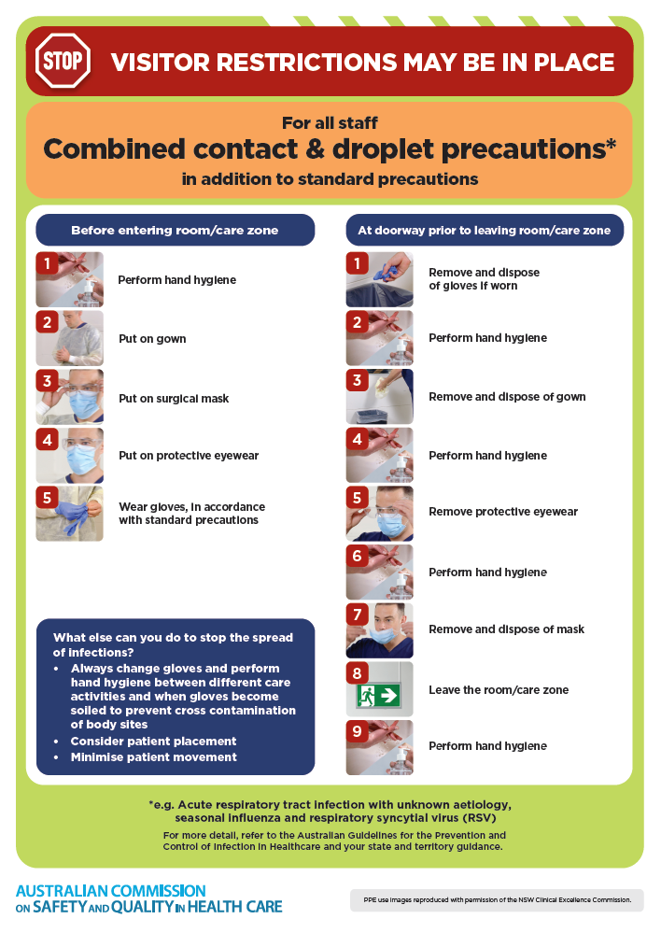](https://www.safetyandquality.gov.au/publications-and-resources/resource-library/infection-prevention-and-control-poster-combined-contact-and-droplet-precautions)
* ***Poster – Combined airborne and contact precautions***<https://www.safetyandquality.gov.au/publications-and-resources/resource-library/infection-prevention-and-control-poster-combined-airborne-and-contact-precautions>  
     
  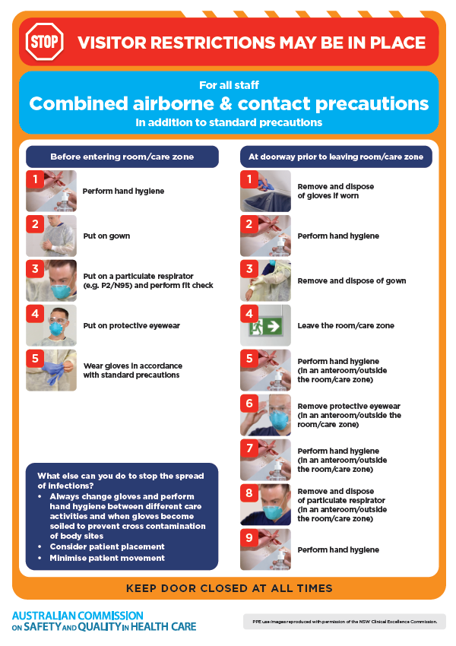
* ***Environmental Cleaning and Infection Prevention and Control*** [www.safetyandquality.gov.au/environmental-cleaning](http://www.safetyandquality.gov.au/environmental-cleaning)
* ***COVID-19 infection prevention and control risk management – Guidance*** <https://www.safetyandquality.gov.au/publications-and-resources/resource-library/covid-19-infection-prevention-and-control-risk-management-guidance>
* ***Safe care for people with cognitive impairment during COVID-19***<https://www.safetyandquality.gov.au/our-work/cognitive-impairment/cognitive-impairment-and-covid-19>
* ***Stop COVID-19: Break the chain of infection*** posterhttps://www.safetyandquality.gov.au/publications-and-resources/resource-library/break-chain-infection-poster-a3  
  **[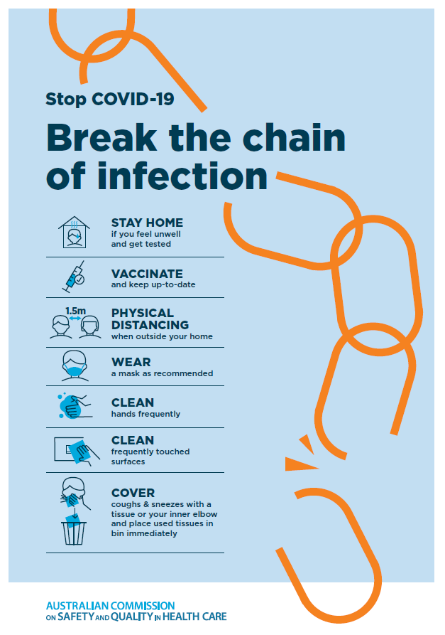](https://www.safetyandquality.gov.au/publications-and-resources/resource-library/break-chain-poster-a3https:/www.safetyandquality.gov.au/publications-and-resources/resource-library/break-chain-poster-a3)**
* ***COVID-19 and face masks – Information for consumers*** <https://www.safetyandquality.gov.au/publications-and-resources/resource-library/covid-19-and-face-masks-information-consumers>

[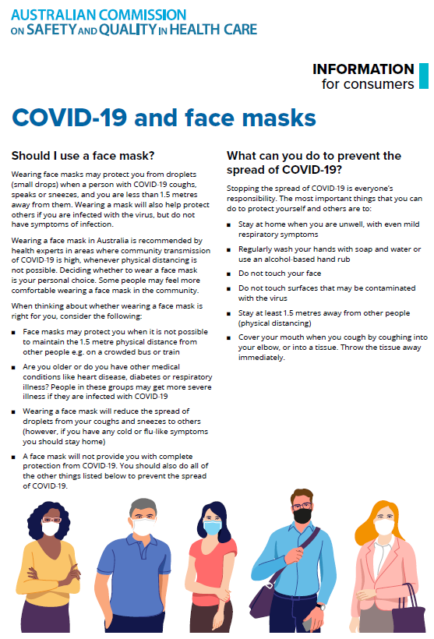](https://www.safetyandquality.gov.au/sites/default/files/2020-07/covid-19_and_face_masks_-_information_for_consumers.pdf)

**Disclaimer**

On the Radar is an information resource of the Australian Commission on Safety and Quality in Health Care. The Commission is not responsible for the content of, nor does it endorse, any articles or sites listed. The Commission accepts no liability for the information or advice provided by these external links. Links are provided on the basis that users make their own decisions about the accuracy, currency and reliability of the information contained therein. Any opinions expressed are not necessarily those of the Australian Commission on Safety and Quality in Health Care.