# Australian Commission on Safety and Quality logotypeOn the Radar

Issue 661

12 August 2024

*On the Radar* is a summary of some of the recent publications in the areas of safety and quality in health care. Inclusion in this document is not an endorsement or recommendation of any publication or provider. Access to particular documents may depend on whether they are Open Access or not, and/or your individual or institutional access to subscription sites/services. Material that may require subscription is included as it is considered relevant.

*On the Radar* is available online, via email or as a PDF or Word document from <https://www.safetyandquality.gov.au/newsroom/subscribe-news/radar>

If you would like to receive *On the Radar* via email, you can subscribe on our website <https://www.safetyandquality.gov.au/newsroom/subscribe-news>  
or by emailing us at H[Umail@safetyandquality.gov.auU](mailto:mail@safetyandquality.gov.au).  
You can also send feedback and comments to H[Umail@safetyandquality.gov.auU](mailto:mail@safetyandquality.gov.au).

For information about the Commission and its programs and publications, please visit <https://www.safetyandquality.gov.au>

**On the Radar**

Editor: Dr Niall Johnson [niall.johnson@safetyandquality.gov.au](mailto:niall.johnson@safetyandquality.gov.au)

Contributors: Niall Johnson, Paul Miles, Hayley Warren

[](https://www.safetyandquality.gov.au/NSQMI-Standards)

***Consultation now open on the new National Safety and Quality Medical Imaging Standards***

<https://www.safetyandquality.gov.au/NSQMI-Standards>

The Australian Commission on Safety and Quality in Health Care has, for the fist time, developed *National Safety and Quality Medical Imaging* (NSQMI) Standards. These standards will replace the existing Diagnostic *Imaging Accreditation Scheme Standards*.

Medical imaging is a crucial tool applied by various clinical disciplines for an expanding number of healthcare services.

The NSQMI Standards aim to protect patients from harm and improve the safety and quality of health care by outlining a nationally consistent framework for delivering medical imaging services. The Standards set out the level of care patients expect.

These Standards were informed by a literature review, other national and international standards and expert advice from imaging practitioners, professional and industry groups.

Public consultation on the Standards is now open. To share your feedback, complete a survey, interview or provide a written submission, visit <https://www.safetyandquality.gov.au/NSQMI-Standards> The consultation is open until **27 September 2024**.

**Reports**

*AI Implementation in Hospitals: Legislation, Policy, Guidelines and Principles, and Evidence about Quality and Safety. Literature Review and Environmental Scan Report*

Australian Institute of Health Innovation, Macquarie University and Australian Centre for Health Engagement, Evidence and Value, University of Wollongong

Sydney: Australian Commission on Safety and Quality in Health Care; 2024. p. 193.

|  |  |
| --- | --- |
| URL | <https://www.safetyandquality.gov.au/publications-and-resources/resource-library/ai-implementation-hospitals-legislation-policy-guidelines-and-principles-and-evidence-about-quality-and-safety> |
| Notes | The Australian Commission on Safety and Quality in Health Care engaged Macquarie University and the University of Wollongong to undertake a literature review and environmental scan to identify principles that enable the safe and responsible implementation of artificial intelligence (AI) in healthcare. It presents evidence from the contemporary published literature about AI implemented in acute care as well as current, published legislation, policies, guidelines, and principles for AI implementation in healthcare. |

*The reality of, and potential for, digitally enabled care in the community*

Mistry P

London: The King's Fund; 2024.

|  |  |
| --- | --- |
| URL | <https://www.kingsfund.org.uk/insight-and-analysis/long-reads/reality-potential-digitally-enabled-care-community> |
| Notes | This ‘long read’ piece from The King’s Fund in the UK examines how primary or community services use digital technology and what the future could – and should – hold. |

*Simulation To Improve Patient Safety: Getting Started. Issue Brief*

Deutsch ES, Bajaj K

Rockville, MD: Agency for Healthcare Research and Quality; 2024. P. 16.

|  |  |
| --- | --- |
| URL | <https://www.ahrq.gov/sites/default/files/wysiwyg/patient-safety/resources/simulation/simulation-issue-brief.pdf> |
| Notes | The Agency for Healthcare Research and Quality (AHRQ) in the USA has published this Issue Brief that describes how simulation can be a valuable asset, how to use simulation resources to improve patient safety and how to collaborate with simulationists. |

**Journal articles**

*Preventing falls and fall-related injuries in older people*

Cameron ID, Kurrle SE, Sherrington C

Medical Journal of Australia 2024;221:140-4.

|  |  |
| --- | --- |
| DOI | <https://doi.org/10.5694/mja2.52374> |
| Notes | This piece in the *Medical Journal of Australia* notes the *World guidelines for falls prevention and management for older adults: a global initiative* (<https://doi.org/10.1093/ageing/afac205>) – that were noted in a previous issue of *On the Radar*. This piece then focuses on effective interventions and assessment to prevent falls in older people. |

*‘None of Them Know Me’: A Qualitative Study of the Implications of Locum Doctor Working for Patient Experience*

Ferguson J, Stringer G, Walshe K, Donnelly A, Grigoroglou C, Allen T, et al.

Health Expectations 2024;27:e14156.

|  |  |
| --- | --- |
| DOI | <https://doi.org/10.1111/hex.14156> |
| Notes | A recent issue of *On the Radar* (Issue 646) included a couple of pieces on locum doctors and the possible safety and quality implications. This accompanying piece looks at the issue from the patient experience perspective. From the analyses of interviews ‘with 130 participants including locums, people working with locums and patients with experience of being seen or treated by locums’ a number of themes were identified. These included:   1. ‘Awareness and disclosure; patients were not always aware if their doctor was a locum, and there was some debate about whether patients had a right to know, particularly if locum working presented quality and safety risks. 2. Continuity and accessibility of care; access was regarded as priority for acute conditions, but for long-term or serious conditions, patients preferred to see a permanent doctor who knew their history, although it was acknowledged that locums could provide fresh perspectives. 3. Communication and practice; locums and patients described how consultations were approached differently when doctors worked as locums. Patients evaluated their interactions based on how safe they felt with practitioners.’ |

*Associations between negative patient safety climate and infection prevention practices*

Johnson CT, Hessels AJ

American Journal of Infection Control. 2024.

|  |  |
| --- | --- |
| DOI | <https://doi.org/10.1016/j.ajic.2024.06.010> |
| Notes | Paper from a US study that used data from 43 medical-surgical units from 13 hospitals across 6 US states to examine the relationship between negative perceptions of safety climate, health worker behaviour and infection control. The authors report that negative nurse perceptions of patient safety climate are associated with poor adherence to best practices such as standard precautions. They suggest that this demonstrates a ‘need for targeted interventions to improve safety climate.’ |

For information on the Commission’s work on infection prevention and control see <https://www.safetyandquality.gov.au/our-work/infection-prevention-and-control>

*Patient Experience Journal*

Volume 11, Issue 2, 2024

|  |  |
| --- | --- |
| URL | <https://pxjournal.org/journal/vol11/iss2/> |
| Notes | A new issue of the *Patient Experience Journal* (PXJ)has been published Articles in this issue of the *Patient Experience Journal* include:   * Editorial: **A Commitment to Experience** Must Reach Across the Continuum of Care (Jason A Wolf) * Research Imitates Life: **Researching Within Your Lived Experience** (Bethany Donaghy and Delane Linkiewich) * Listening to the Unsaid: Utilizing **Patient-Reported Outcome Measures (PROMs)** to Manage the Dental Anxiety of a Special Child (Asiya Attar and Kasturi Shukla) * The Perceived Usefulness of **Patient Narrative Feedback** in Primary Care Settings (Sasmira Matta, Y S H Lee, R Grob, M Schlesinger, and I Nembhard) * **Primary Care Productivity and Patient Satisfaction** Community Practice: What is the Relationship? (Thomas G Howell Jr) * Is Timing Everything?: The Role of Time on the Relationship between **Patient-Centered Communication and Provider Empathy** (Shanequa S Roscoe-Nelson and Geoffrey A Silvera) * Investigating the Perceived Impact of Surgeons' Burnout on **Surgical Physician Associates' Wellness** in United States Ambulatory Surgery Centers (Rhionna J Smith, Lihua Dishman, John W Fick, and K M Thomas) * We did our Best!: The Experience of **Frontline Workers in Long-Term Care during COVID-19** Outbreaks (Jillian M Gratton, Lenora Duhn, Rosemary Wilson, and Pilar Camargo-Plazas) * **Accompanying People Affected by Cancer** in Their Return to Life After Treatment: A Report on an Experiment Conducted in Canada (Christine Arsenault, Saskia Hazout, John Calogerinis, Françoise Poirier, Louise Normandin, Cécile Vialaron, Monica Iliescu Nelea, and Marie-Pascale Pomey) * Examining the **Impact of Telehealth Visits on Patient and Family Experience** in a Pediatric Emergency and Urgent Care Center (Abigail Gauthier; Callie Krentz; Shiran Chan; Michelle Widecan; and A A Vukovic) * **Patient Experience and Virtual Reality**: The Use of an MRI Exam Simulator (Jaqueline Maria da Silva, Marcus Antonio Medeiros de Souza, Mônica Augusta Reis dos Santos, Milena Loureiro de Melo, Lorena de Fátima lucena Almeida, Alayde Ricardo da Silva, Êmilly Vitória dos Santos Vieira, Alessandra Nascimento Pontes, and Jandson de Oliveira Soares) * **Patient Experiences with an mHealth App** for Complex Chronic Disease Care: Connections Despite Lack of Traditional Clinical Interactions (Jenney Lee, Melissa Cheyney, Michael A May, and Marit L Bovbjerg) * **Foundational Patient Experience**: Analyzing 10 Years of Patient Experience Research (Geoffrey A Silvera; Courtney Haun; and V Natarajan) * Improving Patient Care: **Expansion of Access to Free Clinics** (Anahis H Davidian and Gail M Bloom) |

*Health Policy*

Volume 147, September 2024

|  |  |
| --- | --- |
| URL | <https://www.sciencedirect.com/journal/health-policy/vol/147/> |
| Notes | A new issue of *Health Policy* has been published Articles in this issue of *Health Policy* include:   * From mono to multi-causality: Towards a comprehensive perspective on **understanding death** (Peter Harteloh) * Constitutional enshrinement as a way of safeguarding **abortion rights**: The case of France (Neva Bojovic, Jovana Stanisljevic) * Healthcare professionals as change agents: Factors influencing bottom-up, personal initiatives on **appropriate care**, a qualitative study in the Netherlands (Marcel Krijgsheld, Eduard (J.E.T.) Schmidt, Edwin Levels, Marieke (M.J.) Schuurmans) * Advancements in **defensive medicine research**: Based on current literature (Minhui Wen, Limin Li, Yuqing Zhang, Jiayi Shao, Zhen Chen, Jinian Wang, Liping Zhang, Jiangjie Sun) * Sources of **specialist physician fee variation**: Evidence from Australian health insurance claims data (Jongsay Yong, Adam G Elshaug, Susan J Mendez, Khic-Houy Prang, Anthony Scott) * Assessing the equity and coverage policy sensitivity of **financial protection indicators** in Europe (Jonathan Cylus, Sarah Thomson, Lynn Al Tayara, José Cerezo Cerezo, Marcos Gallardo Martínez, Jorge Alejandro García-Ramírez, Marina Karanikolos, María Serrano Gregori, Tamás Evetovits) * **New Zealand's world-first smokefree legislation** 'goes up in smoke': A setback in ending the tobacco epidemic (Albert Andrew) * **Digital health policy** decoded: Mapping national strategies using Donabedian's model (Tahereh Saheb, Tayebeh Saheb) * The effect of **community diagnostic centres** on volume and waiting time for diagnostic procedures in the UK (Peter Sivey, Jinglin Wen) |

*Health Affairs*

Volume 43, Number 7, August 2024

|  |  |
| --- | --- |
| URL | <https://www.healthaffairs.org/toc/hlthaff/43/8> |
| Notes | A new issue of *Health Affairs* has been published with the theme ‘Meeting Care Needs, Pharmaceuticals, And More’. Articles in this issue of *Health Affairs* include:   * A MINDful Path To **Better Dementia Care** For Dual-Eligible Adults (Michele Cohen Marill) * The Continuing Quest To **Integrate Care** For Dual-Eligible Enrollees (Harris Meyer) * Most **State Medicaid Programs** Cover Routine Eye Exams For Adults, But Coverage Of Other Routine Vision Services Varies (Brandy J Lipton, Jenna Garcia, Michel H Boudreaux, Petros Azatyan, and Melissa Powell McInerney) * Percentage Of **Dentists And Dental Practices Affiliated With Private Equity** Nearly Doubled, 2015–21 (K Nasseh, A T LoSasso, and M Vujicic) * **Transportation As A Determinant Of Health**: Evaluating The Veterans Affairs Rideshare Program For Homeless Patients (Jack Tsai, Dorota Szymkowiak, Hind Beydoun, and Leandro Dasilva) * Meeting The Needs Of **Socially Vulnerable Patients**: Views Of ACO Leaders On Moving From Intent To Action (Dhruv Khullar, W L Schpero, L P Casalino, R Pierre, S Carter, Y Civelek, M Zhang, and A M Bond) * Identifying **Under- And Overutilization Patterns** For Idaho Youth With Serious Emotional Disturbance (Olga A. Vsevolozhskaya, Madison Merzke, Wiley T. Turner, Xiaoran Tong, Seth Himelhoch, and John S. Lyons) * **Adverse Childhood Experiences**: Health Care Utilization And Expenditures In Adulthood (Thomas M Selden, D M Bernard, S L Decker, and Z Fang) * **Disability Mortality Disparity**: Risk Of Mortality For Disabled Adults Nearly Twice That For Nondisabled Adults, 2008–19 (Scott D Landes) * State Out-Of-Pocket Caps On **Insulin** Costs: No Significant Increase In Claims Or Utilization (Kelly E Anderson, Nathorn Chaiyakunapruk, Eric J Gutierrez, H Weston Schmutz, M R Rose, D Brixner, and R B McQueen) * Colorado **Insulin** Copay Cap: Lower Out-Of-Pocket Payments, Increased Prescription Volume And Days’ Supply (Benjamin D Ukert, Theodoros V Giannouchos, and Thomas C Buchmueller) * State Mandates To Cap Out-Of-Pocket **Insulin** Costs Are No Longer Necessary (Dana P Goldman) * **Biosimilar Uptake** In The US: Patient And Prescriber Factors (Dongzhe Hong, Aaron S Kesselheim, Ameet Sarpatwari, and Benjamin N Rome) * The Risk Of **Perpetuating Health Disparities** Through Cost-Effectiveness Analyses (Sanjay Basu, Atheendar S Venkataramani, and Dean Schillinger) * **Hospital Nurse Staffing Legislation**: Mixed Approaches In Some States, While Others Have No Requirements (Nithya Krishnamurthy, Neha Mukherjee, Bevin Cohen, Melissa Mazor, and Jacob M Appel) * **Trauma Activation Fees** Vary Widely Across US Trauma Centers (Kirstin Woody Scott, Pooja U Neiman, Mitchell Mead, Angela Chisolm, Andrew M Ibrahim, Eileen M Bulger, and John W Scott) * **COVID-19 Federal Funding To Health Centers**: Tracking Distribution, Locations, And Patient Characteristics (Megan B Cole, Brad Wright, Paula M Kett, Hannah Johnson, Jonathan Staloff, and Bianca K Frogner) * Waiting For **On-Call Care** (Forrest Bohler) |

*BMJ Quality & Safety* online first articles

|  |  |
| --- | --- |
| URL | <https://qualitysafety.bmj.com/content/early/recent> |
| Notes | *BMJ Quality &Safety* has published a number of ‘online first’ articles, including:   * Why a sociotechnical framework is necessary to address **diagnostic error** (Meagan M Ladell, Sarah Yale, Brett J Bordini, Matthew C Scanlon, Nancy Jacobson, Elizabeth Lerner Papautsky) * Understanding the challenges and successes of **implementing ‘hybrid’ interventions in healthcare settings**: findings from a process evaluation of a patient involvement trial (Sarah Hampton, Jenni Murray, Rebecca Lawton, Laura Sheard) * Role of remediation in **cases of serious misconduct** before UK healthcare regulators: a qualitative study (Tristan Price, Ellie Reynolds, Tim O’Brien, Thomas Gale, Oliver Quick, Marie Bryce) |

**Online resources**

***Australian Living Evidence Collaboration***

<https://livingevidence.org.au/>

**COVID-19 resources**

https://www.safetyandquality.gov.au/covid-19

The Australian Commission on Safety and Quality in Health Care has developed a number of resources to assist healthcare organisations, facilities and clinicians. These and other material on COVID-19 are available at <https://www.safetyandquality.gov.au/covid-19>

These resources include:

* ***Poster – Combined contact and droplet precautions*** <https://www.safetyandquality.gov.au/publications-and-resources/resource-library/infection-prevention-and-control-poster-combined-contact-and-droplet-precautions>  
  [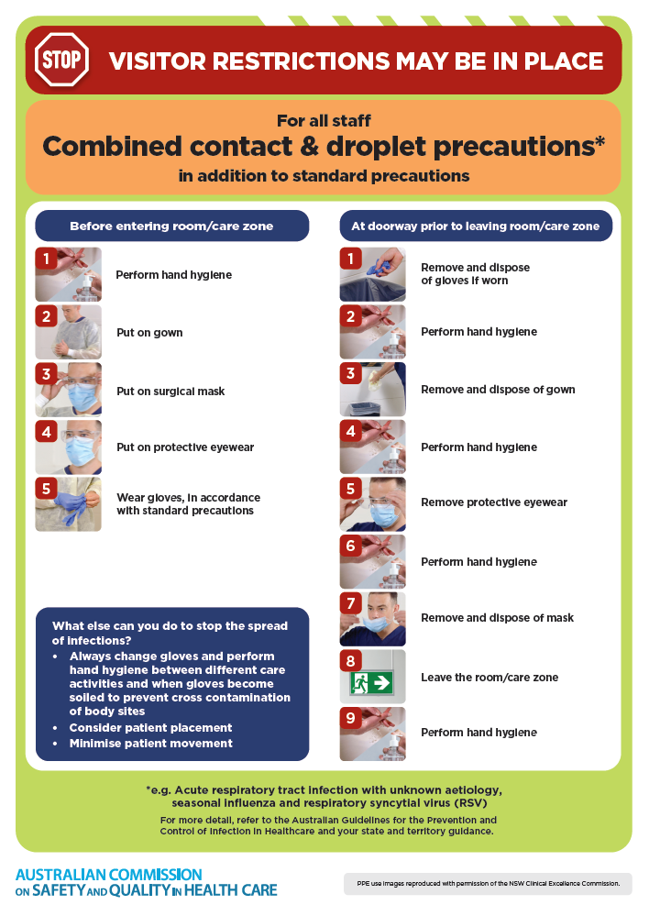](https://www.safetyandquality.gov.au/publications-and-resources/resource-library/infection-prevention-and-control-poster-combined-contact-and-droplet-precautions)
* ***Poster – Combined airborne and contact precautions***<https://www.safetyandquality.gov.au/publications-and-resources/resource-library/infection-prevention-and-control-poster-combined-airborne-and-contact-precautions>  
     
  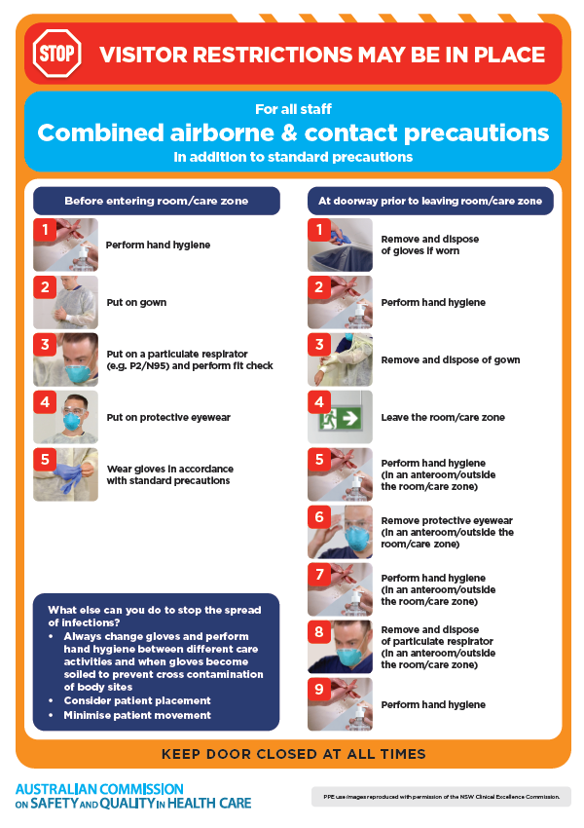
* ***Environmental Cleaning and Infection Prevention and Control*** [www.safetyandquality.gov.au/environmental-cleaning](http://www.safetyandquality.gov.au/environmental-cleaning)
* ***COVID-19 infection prevention and control risk management – Guidance*** <https://www.safetyandquality.gov.au/publications-and-resources/resource-library/covid-19-infection-prevention-and-control-risk-management-guidance>
* ***Safe care for people with cognitive impairment during COVID-19***<https://www.safetyandquality.gov.au/our-work/cognitive-impairment/cognitive-impairment-and-covid-19>
* ***Stop COVID-19: Break the chain of infection*** posterhttps://www.safetyandquality.gov.au/publications-and-resources/resource-library/break-chain-infection-poster-a3  
  **[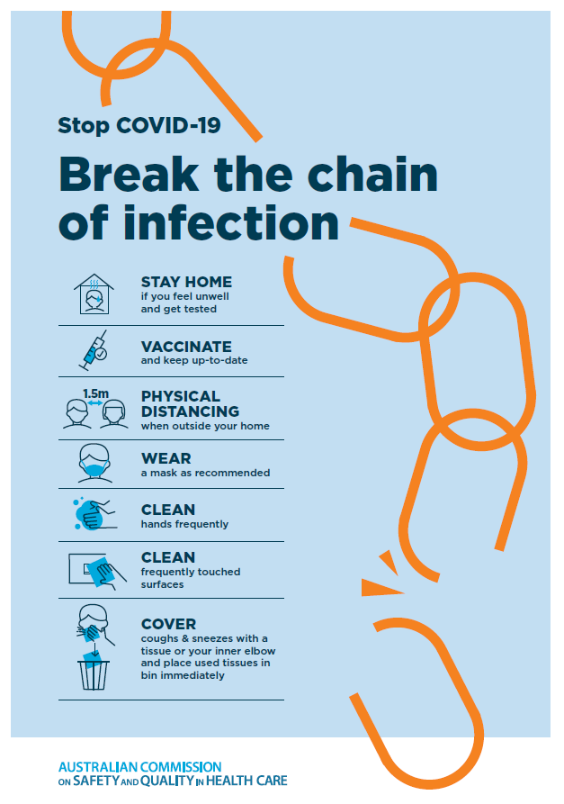](https://www.safetyandquality.gov.au/publications-and-resources/resource-library/break-chain-poster-a3https:/www.safetyandquality.gov.au/publications-and-resources/resource-library/break-chain-poster-a3)**
* ***COVID-19 and face masks – Information for consumers*** <https://www.safetyandquality.gov.au/publications-and-resources/resource-library/covid-19-and-face-masks-information-consumers>

[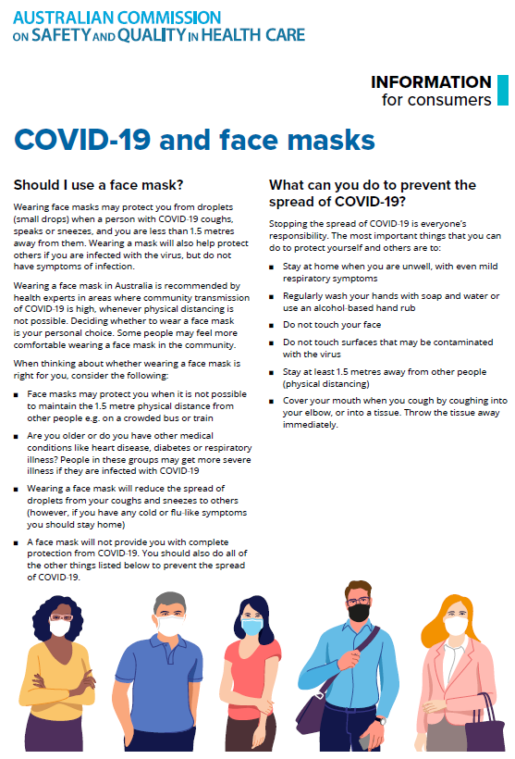](https://www.safetyandquality.gov.au/sites/default/files/2020-07/covid-19_and_face_masks_-_information_for_consumers.pdf)

**Disclaimer**

On the Radar is an information resource of the Australian Commission on Safety and Quality in Health Care. The Commission is not responsible for the content of, nor does it endorse, any articles or sites listed. The Commission accepts no liability for the information or advice provided by these external links. Links are provided on the basis that users make their own decisions about the accuracy, currency and reliability of the information contained therein. Any opinions expressed are not necessarily those of the Australian Commission on Safety and Quality in Health Care.