# Just think: could it be sepsis?

Sepsis for Consumer – fact sheet

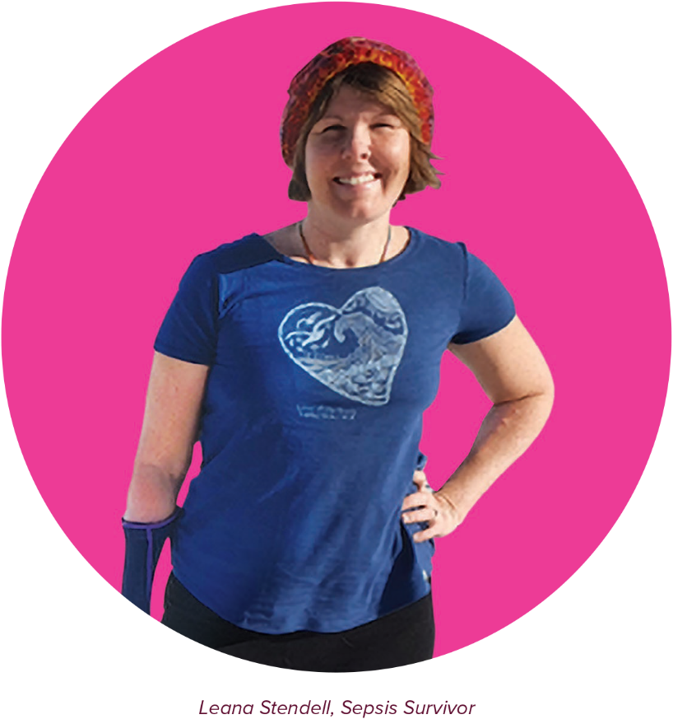

## WHAT IS SEPSIS?

Sepsis is a life-threatening condition that arises when the body’s response to an infection damages its own tissues and organs. Sepsis is also a medical emergency, requiring rapid treatment to increase a patient’s chance of survival.

## HIGH RISK GROUPS

Sepsis can affect anyone. However, some people are at greater risk of the condition than others. These groups include:

* Newborns and young children
* Older Australians
* Aboriginal and Torres Strait Islander peoples
* People with complex health conditions
* People with COVID-19
* Patients with poor immune systems
* Pregnant women, both during pregnancy and following childbirth
* People being treated for cancer with chemotherapy
* Sepsis survivors, previously diagnosed with sepsis.

## WHAT ARE THE SIGNS OF SEPSIS?

| In adults: | In children: |
| --- | --- |
| * Fast breathing or breathlessness * Fever and chills * Low body temperature * Low or no urine output * Fast heartbeat * Nausea and vomiting * Diarrhoea * Fatigue, confusion or sleepiness * A lot of pain or “feeling worse than ever” | * Fast breathing or long pauses in breathing * Blotchy or discoloured skin * Skin abnormally cold to touch * Rash that doesn’t fade when pressed * Infrequent wet nappies * Drowsy, difficult to wake up or confused * Restlessness or floppy limbs * Vomiting * Fits or convulsions * A lot of pain |

A significant change in any single sign may not always be visible. There are several red flags to watch out for:

* Subtle changes in several signs
* Prolonged generalised illness with no improvement
* The person expressing they “feel worse than ever”
* Concern about children more than usual
* Any chance of an infection..

**Remember!** Many of the signs of sepsis can be mild and not all need to be present.

## WHAT CAN I DO TO PREVENT GETTING SEPSIS?

Unfortunately, sepsis is not always preventable. However there are simple things you can do to reduce the risk of getting sepsis or it worsening and leading to long-term health problems.

There are several ways to stop sepsis in its tracks:

* Practice good hand hygiene
* Keeping up to date with vaccinations
* Getting medical attention early if you suspect sepsis.

## SPEAK UP!

If you are concerned about a family member or friend and feel they either might have sepsis or are at higher risk, it is important to speak up. Ask your GP or healthcare worker:



so the necessary urgency can be created to commence life-saving treatment.

[](https://www.safetyandquality.gov.au/our-work/partnering-consumers/national-sepsis-program)



## NEED TO KNOW MORE?

For more information on sepsis, review your local clinical policies or any of the following resources:

**Australian Commission of Safety and Quality in Health Care**

<https://www.safetyandquality.gov.au/our-work/partnering-consumers/national-sepsis-program>

**Australian Sepsis Network**

<https://www.australiansepsisnetwork.net.au/>

**Children’s Health Queensland Hospital and Health Service**

<https://www.childrens.health.qld.gov.au/sepsis/>

**Clinical Excellence Queensland**

[https://clinicalexcellence.qld.gov.au/priority-areas/ safety-and-quality/sepsis/sepsis-pathways-and-resources](https://clinicalexcellence.qld.gov.au/priority-areas/safety-and-quality/sepsis/sepsis-pathways-and-resources)

**NSW Clinical Excellence Commission**

<https://www.cec.health.nsw.gov.au/keep-patients-safe/sepsis>

**Global Sepsis Alliance**

<https://www.global-sepsis-alliance.org/>





