The Aged Care Infection Prevention and Control Guide: summary

### July 2024

Highlighting the key points

#### An introduction to the Guide

*The Aged Care Infection Prevention and Control Guide* (the Guide) aims to support the prevention and control of infections in all settings where aged care is provided. The Guide supplements the [*Australian Guidelines for the Prevention and Control of Infection in Healthcare*](https://www.safetyandquality.gov.au/publications-and-resources/resource-library/australian-guidelines-prevention-and-control-infection-healthcare) in aged care settings.

The Guide is intended to support aged care organisations to meet the infection prevention and control (IPC) actions of the [strengthened Aged Care Quality Standards](https://www.agedcarequality.gov.au/providers/quality-standards/stronger-standards-better-aged-care-program) and to minimise the risk of infection for older people and the workforce.

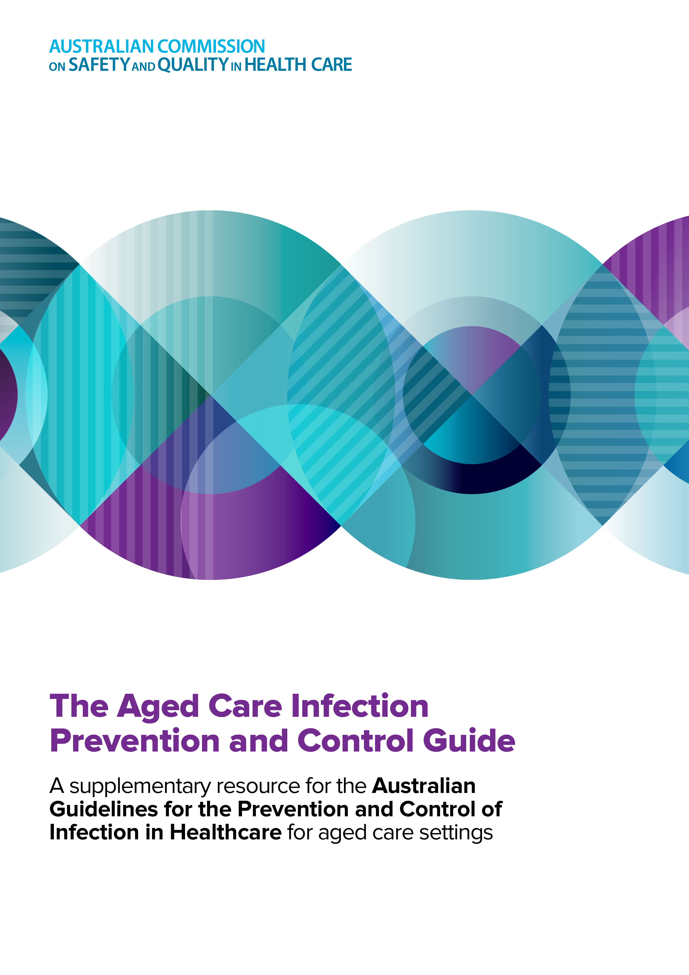

#### Summary of the Guide

This Summary provides aged care workers and aged care providers with a concise overview of the following topics and includes links to individual chapters for detailed information:

* IPC systems in aged care
* Risk assessment and management in IPC in aged care
* The basics of microbiology and IPC
* Standard and transmission-based precautions
* Wound care, procedures and invasive devices
* Clean, safe and hygienic environments
* Staff health and safety
* Infection prevention and the wellbeing of older persons
* Monitoring and continuous quality improvement
* Antimicrobial stewardship in aged care.

**This summary is designed to be used** **as a quick reference tool in conjunction with the Aged Care IPC Guide. For more information visit the Commissions** [**website**](https://www.safetyandquality.gov.au/our-work/infection-prevention-and-control/infection-prevention-and-control-aged-care)**.**

## Key points from the Aged Care Infection Prevention and Control Guide

| Topic | Key points |
| --- | --- |
| An infection prevention and control system in aged care | * An IPC system is an overarching program that details how an aged care organisation plans to prevent, reduce, and control infections. * There is no ‘one size fits all’ for an IPC system. Each system should be structured to reflect the service context, availability of resources, the older person’s care needs and the workforce. * An IPC system should be built around the core IPC components, including guidelines and policies, audits and feedback, infection monitoring and education and training. * IPC systems should consider the care environment, availability of equipment, workload, staffing and service capacity, and how these factors impact IPC practices. * Processes for IPC systems in aged care should outline the key roles and responsibilities of the IPC leads (or the person responsible for IPC), the management team, the aged care workforce, the older person, jurisdictional and national bodies, and local health service networks. * An IPC system should be regularly evaluated to measure its effectiveness and ensure continuous quality improvement.   For more information, refer to **Chapter 1: Infection prevention and control in aged care.** |
| Risk assessment and management | * Risk assessment and management is essential to achieving a balanced approach to IPC. * Whilst it is important for aged care organisations and workers to aim to reduce all infection risks, this is often not achievable without impacting on an older person’s quality of life. IPC-related risk assessments must consider the rights of the older person and the rights of the workforce. * There are four primary steps involved in risk management: identifying a hazard, assessing the risk of harm, controlling the risk and reviewing the effectiveness of controls. * All aged care settings differ in complexity and in local requirements. Therefore, organisations must be able to useand adapt this process to develop individualised risk management plans and strategies. * The [hierarchy of controls](https://www.safetyandquality.gov.au/publications-and-resources/resource-library/use-hierarchy-controls-infection-prevention-and-control-factsheet) is a model that involves a step-by-step approach to controlling risk, ranking controls from most to least effective. * As most infection risks cannot be completely eliminated, a level of risk will usually need to be accepted. * This is known as ‘risk acceptance’ which is an important element of risk management in aged care. Risk acceptance is achieved by open discussion and planning.   For more information, refer to **Chapter 2: Risk assessment and management in infection prevention and control in aged care.** |
| The basics of microbiology and infection prevention and control | * Microorganisms, including bacteria, viruses, fungi and some parasites, exist naturally in animals, people and the environment and have the ability to cause infection. * Multidrug-resistant organisms (MROs) are types of microorganisms that are resistant to more than one type of antimicrobial (including antibiotics, antivirals, antifungals and antiparasitic medicines). Infections caused by MROs are extremely difficult to treat. * Once a microorganism enters a person’s body, **either colonisation** (the microorganism is present on or in the body without causing infection or disease), **or** **infection can occur** (the microorganism enters the body, multiplies, and usually causes clinical symptoms). * Microorganisms that are spread through aged care services are usually from human sources such as older people, aged care workers and carers/visitors. * The chain of infection is an important concept that helps to explain how an infection spreads. There are six elements in the chain of infection, and all six elements must be present for an infection to occur. * The aim of IPC is to interrupt the chain of infection to stop the spread of infection. Effective IPC in aged care settings is essential for a safe working environment.   For more information, refer to **Chapter 3: The basics of microbiology and infection prevention and control.** |
| Standard and transmission-based precautions | * There are two types of precautions that should be used to prevent and control infections in aged care: standard precautions and transmission-based precautions. * Standard precautions are practices that should be used during routine care, regardless of whether an infection is present. These precautions include hand hygiene, personal protective equipment (PPE), aseptic technique, waste management, respiratory hygiene and cough etiquette, environmental cleaning, sharps management, linen management and reprocessing of reusable equipment. * Transmission-based precautions are used in addition to standard precautions for a limited time period, when someone has a suspected or confirmed infection. The Guide focuses on two broad types of transmission-based precautions: contact and respiratory precautions. * **Contact precautions:** PPE required for contact precautions includes a gown and gloves, in addition to standard precautions. * **Respiratory precautions:** PPE recommended for respiratory precautions will generally include a surgical mask and facial/eye protection, in addition to standard precautions. * For most situations when an aged care worker is caring for a person with a respiratory infection, a surgical mask with eye protection is worn.   In some higher risk situations, the use of a particulate filter respirator (PFR) may be appropriate instead of a surgical mask.   * The IPC lead or person responsible for IPC should be consulted before a PFR is used in aged care settings. * Isolation is sometimes used as a strategy to prevent infections from spreading. Prolonged periods of isolation can cause harm to the physical and psychological health of older people. Isolation and visitor restrictions should only be implemented when necessary and the risk of transmission is high. [Essential visitor access](https://www.agedcarequality.gov.au/providers/clinical-governance/infection-prevention-control/supporting-visitors-and-partners-care-ipc) should always be maintained.   For more information, refer to **Chapter 4: Standard and transmission-based precautions.** |
| Wound care, procedures, and invasive devices | * Invasive devices are those devices which in whole or part enter the body through an opening (such as the mouth or nose or skin) or through any surface of the body (such as a stoma), including catheters inserted for drainage, catheters for intravascular access or devices for feeding. * Invasive medical devices (such as urinary catheters and percutaneous endoscopic gastrostomy tubes) are a common source of infections and provide a route for microorganisms to enter the body. * Many clinical procedures performed in aged care settings require the insertion, removal, or management of invasive devices. These invasive clinical procedures should be performed by trained aged care workers (such as an enrolled or registered nurse). * Using an aseptic technique is essential to protect older people from developing an infection during invasive clinical procedures. * Invasive devices should only be used when absolutely necessary and for the shortest period of time necessary. * There should be clear documentation of the insertion, and maintenance of these devices and a plan for removal. If the device is temporary or short term, a daily review should occur to assess the ongoing need for the device.   For information, refer to **Chapter 5: Wound care, procedures, and invasive devices** |
| Clean, safe and hygienic environments. | * Environmental cleaning is a basic part of standard precautions and is an essential part of any IPC system. * Cleaning involves the use of neutral detergent, water and physical scrubbing to remove microorganisms from surfaces. Disinfection is the process of using a disinfectant, a chemical that rapidly kills most microorganisms and that is usually only effective in the absence of organic material. * Reprocessing of reusable equipment in aged care primarily includes cleaning and disinfection. * Cleaning schedules should be tailored according to the level of risk in each setting, and should clearly outline worker responsibilities, the frequency of cleaning required and the products that should be used to clean specific areas. * Regular auditing of environmental cleaning and cleaning of equipment helps toreduce the spread of infections. * **All workers** who provide cleaning services in aged care settings should receive initial and ongoing IPC training, including information on the basic principles of IPC, IPC signage, correct selection of cleaning products, handling and storage of cleaning solutions. * The risk of infection changes depending on the type of service and the settings where care is provided, therefore, risk assessment is essential to support an effective cleaning program.   For more information, refer to **Chapter 6: Clean, safe and hygienic environments**. |
| Staff health and safety | * All aged care workers have a right to work in a safe environment. In Australia, work health and safety is regulated by states, territories and the Australian Government. * [Vaccination](https://immunisationhandbook.health.gov.au/) should be actively promoted for aged care workers and older people. * A workforce screening and vaccination program in an aged care setting can significantly reduce the burden and transmission of vaccine-preventable diseases. * Workforce screening programs aid in identifying workers with vaccine-preventable diseases or those at higher risk. * Workforce vaccination programs promote vaccination and help to reduce an aged care worker’s risk of acquiring and spreading an infectious disease to other workers or older people. * Aged care organisations should establish processes to address seasonal and ongoing infection risks such as influenza and COVID-19. * Each aged care organisation should have a policy on the management of needlestick and other sharps injuries. The policy should address immediate first aid, risk assessment and provision of immediate post-exposure advice for sharps injuries and other blood or body-substance exposures involving aged care workers and older people.   For more information, refer to **Chapter 7: Staff health and safety** |
| Infection prevention and the wellbeing of older persons | * IPC must always be balanced with achieving a good quality of life for older people and be focused on preventing infections. Infection prevention interventions include immunisation, good skin care, nutrition and hydration, regular oral care, falls prevention, supporting good mental health and wellbeing and maintaining quality end of life care. * Older people often have a decreased immune response, which means they may not be able to fight off infections easily or develop natural immunity. Vaccination (or vaccine-induced immunity) is one of the most effective strategies to reduce the risk of infection. * Maintaining healthy skin is essential for older people to prevent wounds such as skin tears that can lead to openings for microorganisms to cause infections. * Poor nutrition can lead to weight loss and lowered immunity; both are significant and often associated with a variety of health risks. * Taking care of the older person’s teeth, dentures, and gums is essential to prevent oral infections. * Falls can indirectly increase an older person’s likelihood of developing an infection due to complications from the associated injuries. * Isolation measures should only be implemented for the minimum duration that is clinically necessary, and visitor access should always be maintained. * Generally, visiting for older people at or approaching the end-of-life should be accommodated and should not be time limited.   For more information, refer to **Chapter 8: Infection prevention and the wellbeing of older persons** |
| Monitoring and continuous quality improvement | * Monitoring infections (also known as infection surveillance) involves collecting information of how and why infections are spread in an aged care organisation or service. * Monitoring infections helps aged care organisations identify issues that may be leading to infections. * Identifying the methods to use to monitor infections should be targeted to the needs and the context of the service.Monitoring can focus on specific infections (such as the number of older people with influenza) or IPC practices (such as vaccination rates). * There are a variety of approaches that can be used to collect information about an infection or IPC activity. Data collection is an essential component of infection monitoring. The elements of data collection include defining the activity, collecting the data, reviewing the data and communicating the results of the data – and which should be used to drive change. * Monitoring infections should always be linked to a prevention strategy or a continuous quality improvement activity to drive change. [Continuous quality improvement](https://www.agedcarequality.gov.au/providers/assessment-monitoring/continuous-improvement) aims to make a difference to the health and wellbeing of older people by improving the safety, effectiveness, and experience of care.   For more information, refer to **Chapter 9: Monitoring and continuous quality improvement.** |
| Antimicrobial stewardship in aged care | * [Antimicrobial stewardship (AMS)](https://www.agedcarequality.gov.au/older-australians/health-wellbeing/medication-its-your-choice) is an ongoing effort to reduce the risk of antimicrobial resistance (AMR) by improving the appropriate use of antimicrobial medicines. * AMR occurs when microorganisms possess or develop the ability to defeat the antimicrobial medicines used to kill them, leading to the antimicrobial becoming ineffective at killing the microorganism. * AMR makes infections more difficult to treat and often leads to worse clinical outcomes. * Older people receiving aged care services experience higher rates of infection and have a much higher overall rate of antimicrobial use compared to the general population. * An AMS program is a group of strategies that promote the appropriate use of antimicrobial medicines. AMS programs should be tailored to the [residential](https://www.agedcarequality.gov.au/resource-library/antimicrobial-stewardship-self-assessment-tool-and-user-guide) or community setting where care is provided. * A successful AMS program requires a multidisciplinary team approach, in which relevant aged care workers contribute to AMS within their scope of practice and responsibilities. * Frequent and regular communication between AMS team members about priorities, results of testing and monitoring and the use of relevant guidelines is a key feature of effective AMS.   For more information, refer to **Chapter 10: Antimicrobial stewardship in aged care.** |

For more information, please visit: [Infection prevention and control in aged care](https://www.safetyandquality.gov.au/our-work/infection-prevention-and-control/infection-prevention-and-control-aged-care)

[**safetyandquality.gov.au**](http://www.safetyandquality.gov.au)

© Australian Commission on Safety   
and Quality in Health Care 2024