# Australian Commission on Safety and Quality logotypeOn the Radar

Issue 666

16 September 2024

*On the Radar* is a summary of some of the recent publications in the areas of safety and quality in health care. Inclusion in this document is not an endorsement or recommendation of any publication or provider. Access to particular documents may depend on whether they are Open Access or not, and/or your individual or institutional access to subscription sites/services. Material that may require subscription is included as it is considered relevant.

*On the Radar* is available online, via email or as a PDF or Word document from <https://www.safetyandquality.gov.au/newsroom/subscribe-news/radar>

If you would like to receive *On the Radar* via email, you can subscribe on our website <https://www.safetyandquality.gov.au/newsroom/subscribe-news>  
or by emailing us at H[Umail@safetyandquality.gov.auU](mailto:mail@safetyandquality.gov.au).  
You can also send feedback and comments to H[Umail@safetyandquality.gov.auU](mailto:mail@safetyandquality.gov.au).

For information about the Commission and its programs and publications, please visit <https://www.safetyandquality.gov.au>

**On the Radar**

Editor: Dr Niall Johnson

**Reports**

*Cultural safety in Australia, Discussion paper*

Mohamed J, Stacey K, Chamberlain C, Priest N

Melbourne: Lowitja Institute; 2024. p. 88.

|  |  |
| --- | --- |
| URL | <https://www.lowitja.org.au/news/discussion-paper-cultural-safety-in-australia/> |
| Notes | The Lowitja Institute has released this discussion paper highlighting the need to improve access to quality healthcare, addressing the social determinants of health, and elevating the importance of the cultural determinants of health for Aboriginal and Torres Strait Islander peoples. The paper’s purpose includes proposing recommended and nationally consistent standards, setting a platform for the accreditation of workplace-based cultural safety training, and calling for further action that can lead to cultural safety being embedded and measured at individual and institutional levels in practice and policy across health and human services. |

**Journal articles**

*Impact of automated alerts on discharge opioid overprescribing after general surgery*

Rizk E, Kaur N, Duong PY, Fink E, Wanat MA, Thornton JD, et al.

American Journal of Health-System Pharmacy. 2024:zxae185.

|  |  |
| --- | --- |
| DOI | <https://doi.org/10.1093/ajhp/zxae185> |
| Notes | Report of a US study that sought to see if an electronic health record (EHR) alert could address discharge opioid overprescribing following surgery. The project ‘included patients undergoing one of the identified target procedures—laparoscopic cholecystectomy, unilateral open inguinal hernia repair, and laparoscopic appendectomy—at an academic medical center.’ The authors report that ‘A total of 1,478 patients were included in the preimplementation cohort, and 141 patients were included in the postimplementation cohort. The proportion of patients with discharge opioid overprescribing decreased from 48% in the preimplementation cohort to 3% in the postimplementation cohort, with an unadjusted absolute reduction of 45% (95% confidence interval, 41% to 49%; P < 0.001) and an adjusted odds ratio of 0.03 (95% confidence interval, 0.01 to 0.08; P < 0.001)’ It was also noted that for those patients who received opioids, there was a decrease in the average supply at discharge. Thus, the authors conclude ‘Implementation of an EHR alert along with provider education can reduce discharge opioid overprescribing following general surgery.’ |

For information on the Commission’s work on medication safety see <https://www.safetyandquality.gov.au/our-work/medication-safety>

*Relationships between medications used in a mental health hospital and types of medication errors: A cross-sectional study over an 8-year period*

Lebas R, Calvet B, Schadler L, Preux P-M, Laroche M-L

Research in Social and Administrative Pharmacy. 2024;20(7):597-604.

|  |  |
| --- | --- |
| DOI | <https://doi.org/10.1016/j.sapharm.2024.03.006> |
| Notes | French study on medication use and errors in mental health. Using data from a French psychiatric hospital for 2014–2021, this retrospective register based cross-sectional study identified 609 medication errors:   * wrong dose (32.2%), wrong drug (30.3%), omission (14.2%) and wrong patient (12.9%) were frequently observed. * occurrence stages were prescribing (55.3%) and administration (30.2%).   Among the findings that the authors highlight were:   * ‘Long-acting injectable antipsychotics are associated with a higher risk of wrong dose. * Liquid medicines in psychiatry are associated with a higher risk of wrong patient. * Restrictive regulation induced a higher risk of omission with controlled medicines.’ |

*An Exploratory Analysis of the Association between Healthcare Associated Infections & Hospital Financial Performance*

Beauvais B, Dolezel D, Shanmugam R, Wood D, Pradhan R

Healthcare. 2024; 12(13).

|  |  |
| --- | --- |
| DOI | <https://doi.org/10.3390/healthcare12131314> |
| Notes | Paper reporting on the impact of healthcare-associated infections (HAIs) and hospital financial performance. The study examined ‘Data for calendar year 2022 for active short-term acute care hospitals (n = 1454) in the US’ to examine operating expense per staffed bed and operating expense per discharge against ‘four healthcare-associated infection rates: methicillin-resistant *Staphylococcus aureus* (MRSA) infection rate, *Clostridium difficile* (*C. diff*) infection rate, Catheter-Associated Urinary Tract Infection (CAUTI) rate, and Central Line Associated Blood Stream Infections (CLABSI)’. From their analyses, the authors report finding ‘The results revealed that *C. diff* (β: 0.037, p < 0.05) and CAUTI (β: 0.031, p < 0.05) rates were positively associated with an increase in operating expense per staffed bed, while increases in MRSA (β: 0.042, p < 0.001), *C. diff* (β: 0.062, p < 0.001), and CAUTI rates (β: 0.039, p < 0.001) were correlated with increased operating expenses per discharge.’ The authors observe that ‘targeting these infections through tailored interventions may lead to reduced hospital costs, improved financial performance, and economic stability.’ |

For information on the Commission’s Healthcare-Associated Infection Program, see <https://www.safetyandquality.gov.au/our-work/healthcare-associated-infection-program>

*Health Policy*

Volume 148, October 2024

|  |  |
| --- | --- |
| URL | <https://www.sciencedirect.com/journal/health-policy/vol/148/> |
| Notes | A new issue of *Health Policy* has been published. Articles in this issue of *Health Policy* include:   * **Population stratification based on healthcare trajectories**: A method for encouraging adaptive learning at meso level (Anne-Sophie Lambert, Catherine Legrand, B Scholtes, S Samadoulougou, H Deconinck, L Alvarez, J Macq) * **Early access programs for medical devices** in France: Overview of recent reforms and outcomes (2015-2022) (Tess Martin, Alexandra Hervias, Xavier Armoiry, Nicolas Martelli) * Taking a health economic perspective in **monitoring health inequalities**: A focus on excess weight (Fiorella Parra Mujica, Paolo Candio) * Stimulating **implementation of clinical practice guidelines in hospital care** from a central guideline organization perspective: A systematic review (Andrea C Thoonsen, Steffie M van Schoten, Hanneke Merten, Ilse van Beusekom, Linda J Schoonmade, Diana M J Delnoij, Martine C de Bruijne) * Can **revenue collection for public funding in health care** be progressive? An assessment of 29 Countries (Thomas Rice, Karsten Vrangbæk, Ingrid S Saunes, Nicolas Bouckaert, Lucie Bryndová, Fidelia Cascini, Andres Võrk, A Dimova, E Kocot, L Murauskiene, D Bricard, M Blumel, P Gaál, P Pažitný) |

*JBI Evidence Synthesis*

Volume 22, Issue 9, September 2024

|  |  |
| --- | --- |
| URL | <https://journals.lww.com/jbisrir/toc/2024/09000> |
| Notes | A new issue of *JBI Evidence Synthesis* has been published. Articles in this issue of *JBI Evidence Synthesis* include:   * Editorial: “Doing it, that’s something else”: a glimpse into **self-management after lung transplantation** (Anne Rebafka, Clare Bennett, Deborah Edwards) * **Lung transplant recipients’ experiences** of and attitudes towards self-management: a qualitative systematic review (Anne Rebafka, Clare Bennett, Catherine Dunn, Dominic Roche, Clare Hawker, Deborah Edwards) * Effectiveness and safety of **self-management interventions** for improving glycemic control and health-related quality of life among adults with **type 2 diabetes mellitus** in sub-Saharan Africa: a systematic review and meta-analysis (Naomi Carter, Gamze Nalbant, Prit Chahal, Kaushik Chattopadhyay) * Capability as a concept in **advanced practice nursing and education**: a scoping review (Martha M. Whitfield, Paulina Bleah, Jovina Concepcion Bachynski, D Macdonald, T Klein, A Ross-White, M Mimirinis, R Wilson) * Quality indicators to monitor the **quality and safety of care for older people**: a scoping review protocol (Timothy J H Lathlean, Maria C Inacio, Johanna Westbrook, Len Gray, Jeffrey Braithwaite, Peter Hibbert, T Comans, M Crotty, S Wesselingh, J K Sluggett, S Ward, N Wabe, G E Caughey) * Experiences of school-age children living with **food allergies**: a qualitative systematic review protocol (Noriko Nishida, Yuki Maeda, Shingo Ueki) * Early rehabilitation after **spinal cord injury**: a scoping review protocol (Florence Martinache, Adéla Foudhaïli, Bernard Vigué) * Cost and cost-effectiveness of treatments for **rheumatic heart disease** in low- and middle-income countries: a systematic review protocol (Mona Thangamma AG, Bhavya Vidyadharan, Roshan P. Daniel, Andria Sirur, Praveen Kumar, Girish Thunga P, Pooja Gopal Poojari, Muhammed Rashid, Nirmalya Mukherjee, Paramita Bhattacharya, Denny John) |

*International Journal for Quality in Health Care* online first articles

|  |  |
| --- | --- |
| URL | <https://academic.oup.com/intqhc/advance-articles> |
| Notes | *International Journal for Quality in Health Care* has published a number of ‘online first’ articles, including:   * **Heeding frontline voice for better quality, safer care** (Russell Mannion and David Greenfield) * **Anti-Indigenous racism** in Canadian healthcare: A scoping review of the literature (Martin Cooke and Tasha Shields) * The **Second Victim Phenomenon**: Comprehensive Support and Systemic Change in Healthcare (Reinhard Strametz et al) |

**Online resources**

***Good virtual care practices***

<https://www.ahpra.gov.au/News/2024-08-01-Good-virtual-care-practices.aspx>

Ahpra and the National Boards have published virtual care information for health practitioners, the public and employers about accessing and providing safe and effective virtual care. These include:

* Information for practitioners who provide virtual care
* Information for people about virtual care
* Information for practice managers and employers about virtual care.

***Health Innovation Series - e-Medication Safety***

<https://www.mq.edu.au/research/research-centres-groups-and-facilities/healthy-people/centres/australian-institute-of-health-innovation/our-projects/Health-Innovation-Series/health-innovation-series-e-medication-safety>

The Health Innovation Series from the Australian Institute of Health Innovation at Macquarie University has had a number of recent issues, including:

* The devil is in the detail – safe paracetamol dosing for under- and overweight children and adults
* So many options in the Dose Calculator, which dose is right?
* The curious case of the 100-fold overdose
* The dangers of copying a previous order. Don’t be a copycat
* Does your drop-down menu present safe options?
* What time is the next dose due? Avoid errors by updating the schedule!
* Is your administration documentation accurate? Check fields that auto-populate!

***Australian Living Evidence Collaboration***

<https://livingevidence.org.au/>

**COVID-19 resources**

https://www.safetyandquality.gov.au/covid-19

The Australian Commission on Safety and Quality in Health Care has developed a number of resources to assist healthcare organisations, facilities and clinicians. These and other material on COVID-19 are available at <https://www.safetyandquality.gov.au/covid-19>

These resources include:

* ***Poster – Combined contact and droplet precautions*** <https://www.safetyandquality.gov.au/publications-and-resources/resource-library/infection-prevention-and-control-poster-combined-contact-and-droplet-precautions>  
  [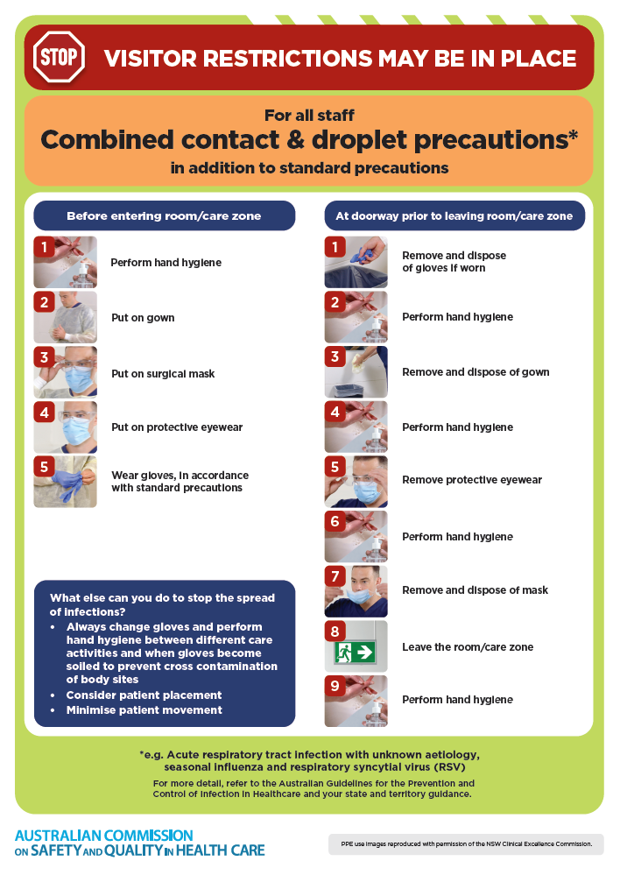](https://www.safetyandquality.gov.au/publications-and-resources/resource-library/infection-prevention-and-control-poster-combined-contact-and-droplet-precautions)
* ***Poster – Combined airborne and contact precautions***<https://www.safetyandquality.gov.au/publications-and-resources/resource-library/infection-prevention-and-control-poster-combined-airborne-and-contact-precautions>  
     
  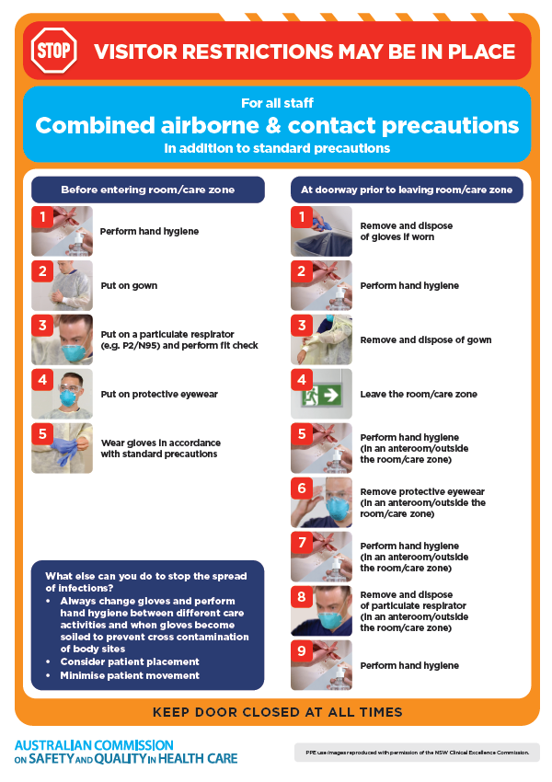
* ***Environmental Cleaning and Infection Prevention and Control*** [www.safetyandquality.gov.au/environmental-cleaning](http://www.safetyandquality.gov.au/environmental-cleaning)
* ***COVID-19 infection prevention and control risk management – Guidance*** <https://www.safetyandquality.gov.au/publications-and-resources/resource-library/covid-19-infection-prevention-and-control-risk-management-guidance>
* ***Safe care for people with cognitive impairment during COVID-19***<https://www.safetyandquality.gov.au/our-work/cognitive-impairment/cognitive-impairment-and-covid-19>
* ***Stop COVID-19: Break the chain of infection*** posterhttps://www.safetyandquality.gov.au/publications-and-resources/resource-library/break-chain-infection-poster-a3  
  **[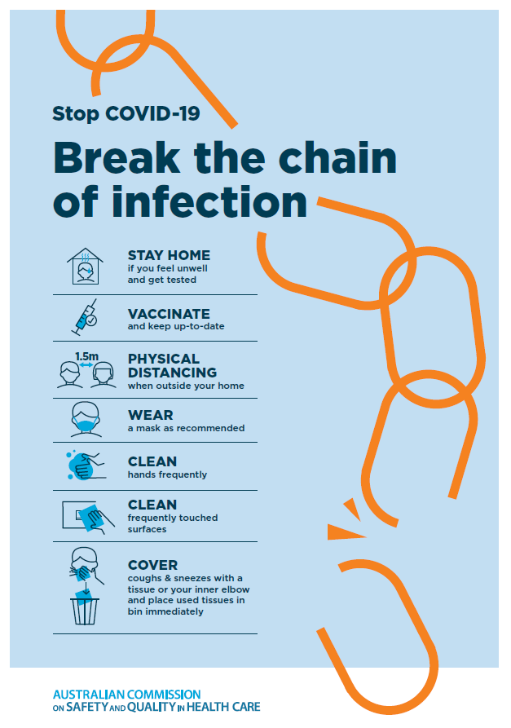](https://www.safetyandquality.gov.au/publications-and-resources/resource-library/break-chain-poster-a3https:/www.safetyandquality.gov.au/publications-and-resources/resource-library/break-chain-poster-a3)**
* ***COVID-19 and face masks – Information for consumers*** <https://www.safetyandquality.gov.au/publications-and-resources/resource-library/covid-19-and-face-masks-information-consumers>

[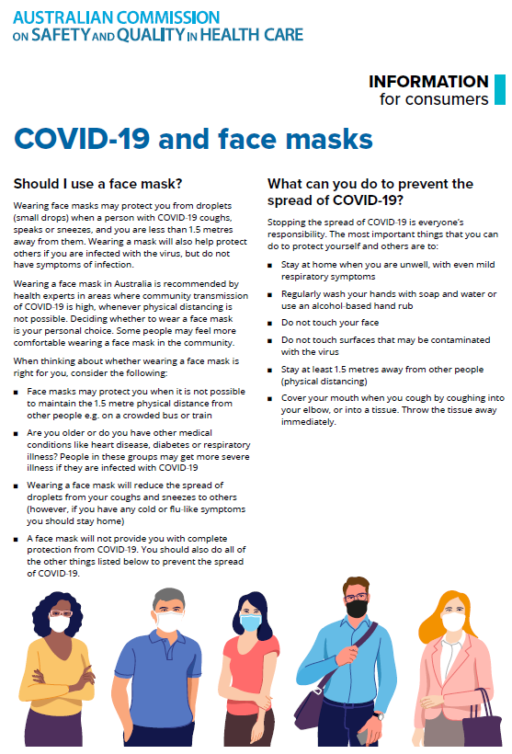](https://www.safetyandquality.gov.au/sites/default/files/2020-07/covid-19_and_face_masks_-_information_for_consumers.pdf)

**Disclaimer**

On the Radar is an information resource of the Australian Commission on Safety and Quality in Health Care. The Commission is not responsible for the content of, nor does it endorse, any articles or sites listed. The Commission accepts no liability for the information or advice provided by these external links. Links are provided on the basis that users make their own decisions about the accuracy, currency and reliability of the information contained therein. Any opinions expressed are not necessarily those of the Australian Commission on Safety and Quality in Health Care.